Stabby Sharpblade
A living table copy for The Guardians of Elaria. Regenerated from the campaign source.
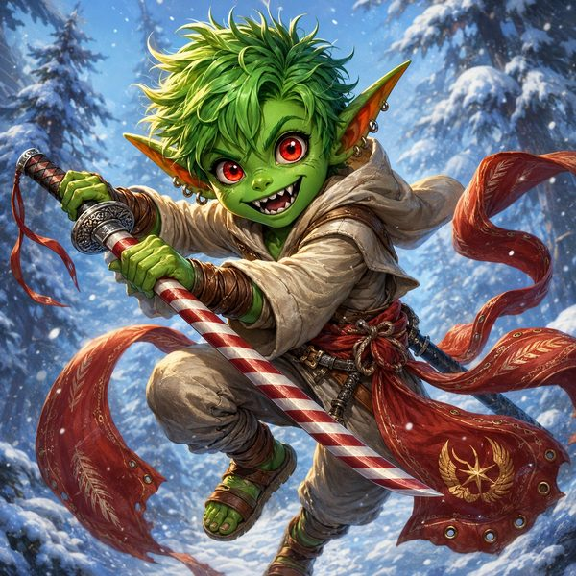
Goblin Monk (Way of the Kensei), Level 5. The wild one. Stabby is a tiny, lightning-fast goblin who fights with a candy-striped katana and his own two fists. Chaos with a smile.
▶ Armor Class 18 Hit Points 43 Speed 50 ft. Initiative +5 Proficiency +3
▶ STR 8 (-1) DEX 20 (+5) CON 16 (+3) INT 8 (-1) WIS 14 (+2) CHA 8 (-1)
▶ Focus save DC 13. All Focus Points come back on a short rest. AC 18 normally; it jumps to 20 right after Stabby punches and swings his katana the same turn (Agile Parry). Speed and AC include his Sash.
Focus Points ● ● ● ● ●
Saving Throws & Skills
Saving Throws. Str +2, Dex +8, Con +3, Int -1, Wis +2, Cha -1 (bold = proficient; his best are Dex and Str).
Skills. Acrobatics +8, Animal Handling +2, Arcana -1, Athletics +2, Deception -1, History -1, Insight +2, Intimidation -1, Investigation -1, Medicine +2, Nature -1, Perception +2, Performance -1, Persuasion -1, Sleight of Hand +5, Stealth +8, Survival +5 (bold = trained; his best are Acrobatics and Stealth, +8: sneaky and springy!).
What Stabby Does in a Fight
Candyfang Katana +1. Melee, +9 to hit: 1d10 + 6 slashing + 2 cold.
Unarmed Strike (fist or foot). Melee, +8 to hit: 1d8 + 5 bludgeoning.
Repeating Longbow +1. Ranged, +9 to hit: 1d8 + 6 piercing; +1d4 via Kensei's Shot.
▶ How Stabby's turn works. He gets 2 attacks with his Attack action, PLUS 1 extra punch as a bonus action (Martial Arts). Spend Focus on Flurry of Blows for even more: up to 3 or 4 hits a turn!
Stabby's Special Moves
Focus Moves (1 Focus each)
Flurry of Blows. Spend 1 Focus as a bonus action to make two extra punches. His big damage button.
Stunning Strike. When he hits, spend 1 Focus to try to stun the enemy (Con save vs DC 13). Fail: stunned until his next turn, huge in a boss fight! Success: the enemy is still slowed (speed halved) and the next attack against it has advantage.
Patient Defense. Bonus action to Disengage for free (house rule). Spend 1 Focus to also Dodge (enemies hit him with disadvantage).
Step of the Wind. Bonus action to Dash for free. Spend 1 Focus to also Disengage and double his jump. Super zoomy.
Deflect Attack. Reaction when hit by a punch, arrow, or blade: lower the damage by 1d10 + 10. If it hits 0, spend 1 Focus to fling it back at another enemy within 5 ft (DC 13 Dex save, 2d8 + 5).
Kensei, Monk & Goblin Traits
Agile Parry. After he punches and swings his katana the same turn, he gets +2 AC until his next turn. (House rule: his bonus-action punch counts.)
Kensei's Shot. Bonus action: his next longbow hit this turn deals an extra 1d4 damage.
Slow Fall. Reaction to take 25 less falling damage.
Uncanny Metabolism. Once a day, when he rolls initiative: regain all Focus and heal 5 + 1d8 HP.
Fury of the Small. When he hits a creature bigger than him (almost everyone!), deal +3 extra damage. 3 times per long rest, once per turn.
Nimble Escape. He can Disengage or Hide as a bonus action every turn. Slippery little goblin.
Fey Ancestry. A touch of fey blood: advantage on saves to avoid or shake off the charmed condition.
Senses & Languages. Sees in the dark 60 ft. Speaks Common, Goblin, and Orc.
Stabby's Signature Gear
Stabby's Stuff
Candyfang Katana +1. His prized candy-striped katana. +1 to hit and damage, +2 cold. Sugar Rush: once a day, lick the blade (bonus action) for 2d8 + 3 temporary HP and a jolt of chaos energy.
Repeating Longbow +1. A magic bow that makes its own arrows; it never runs out. +1 to hit and damage. (Lilly made it for him.)
Sash of the Swift Current (Elaria's gift). Scarlet stage-silk from the Wraithpine chest. +1 AC, +10 ft. speed, plus Air Dance (fly for 1 minute, 1/day) and Feather Fall (1/day). Attuned.
Explorer's Pack. Backpack, bedroll, rope, torches, rations: the usual adventuring kit.
▶ Fun facts. Stabby is a boy goblin, age 8, just 2 feet 4 inches tall and 30 pounds: small but mighty! Green skin, red eyes, green hair. He carries a creepy little idol that gives him strange dreams, and his old clan, the Bloodfang, are part of his past (and maybe future allies).

