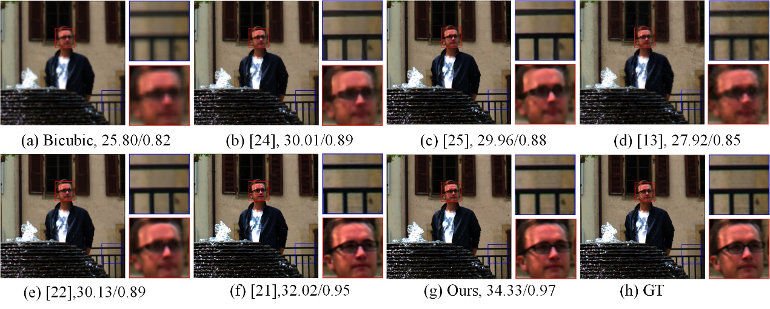

**图1 光场图像超分辨率结果比较 (场景1)**

**Fig.1 Comparison of super-resolution results of light field images (scene 1)**

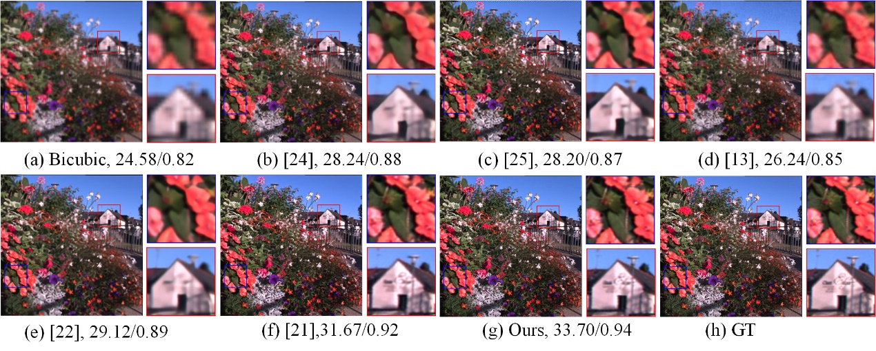

**图2 光场图像超分辨率结果比较 (场景2)**

**Fig.2 Comparison of super-resolution results of light field images (scene 2)**

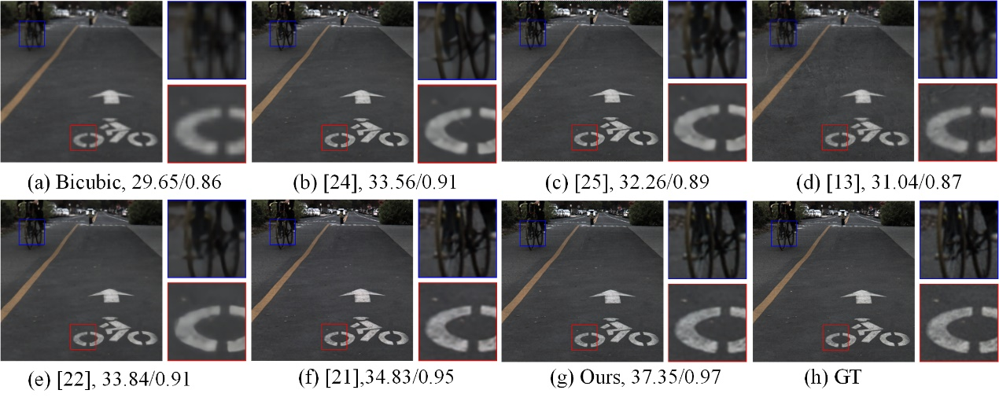

**图3 光场图像超分辨率结果比较 (场景3)**

**Fig.3 Comparison of super-resolution results of light field images (scene 3)**

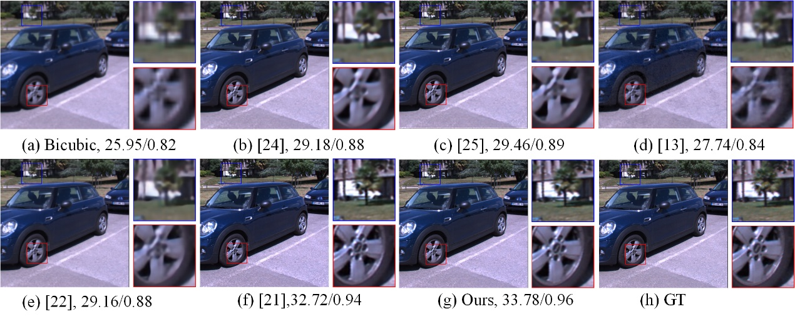

**图4 光场图像超分辨率结果比较 (场景4)**

**Fig.4 Comparison of super-resolution results of light field images (scene 4)**

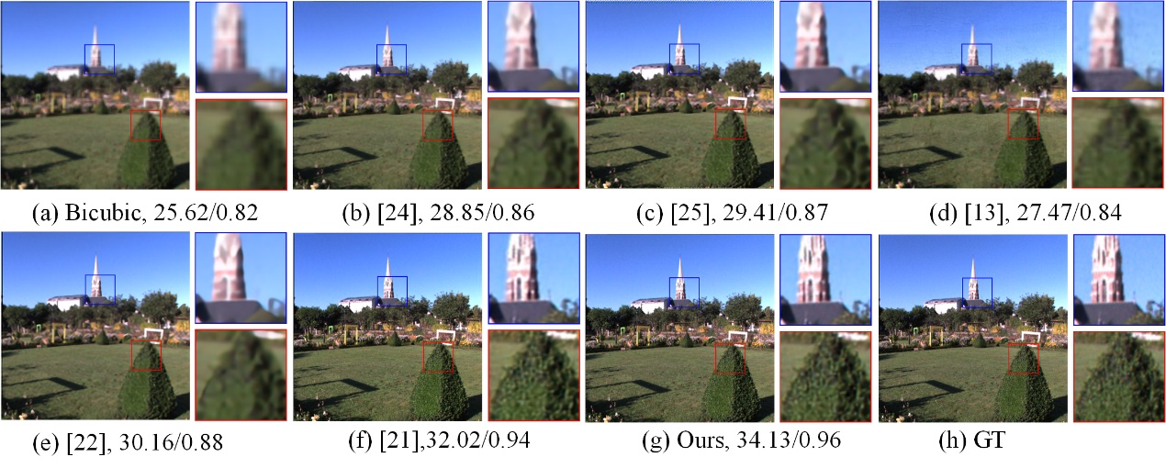

**图5 光场图像超分辨率结果比较 (场景5)**

**Fig.5 Comparison of super-resolution results of light field images (scene 5)**

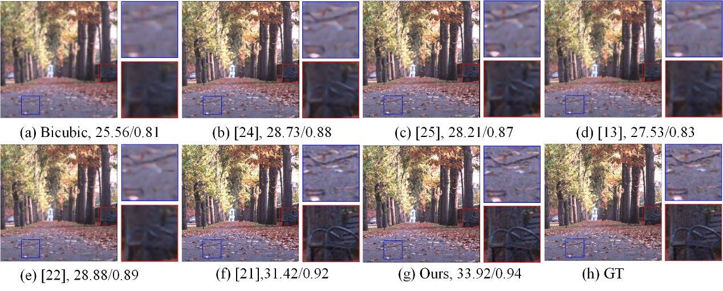

**图6 光场图像超分辨率结果比较 (场景6)**

**Fig.6 Comparison of super-resolution results of light field images (scene 6)**

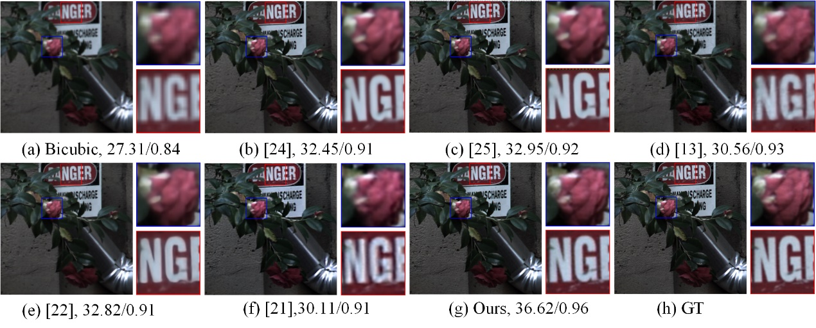

**图7 光场图像超分辨率结果比较 (场景7)**

**Fig.7 Comparison of super-resolution results of light field images (scene 7)**

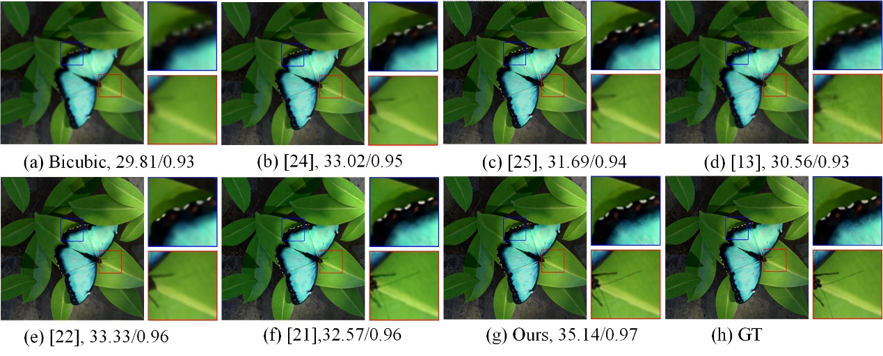

**图8 光场图像超分辨率结果比较 (场景8)**

**Fig.8 Comparison of super-resolution results of light field images (scene 8)**

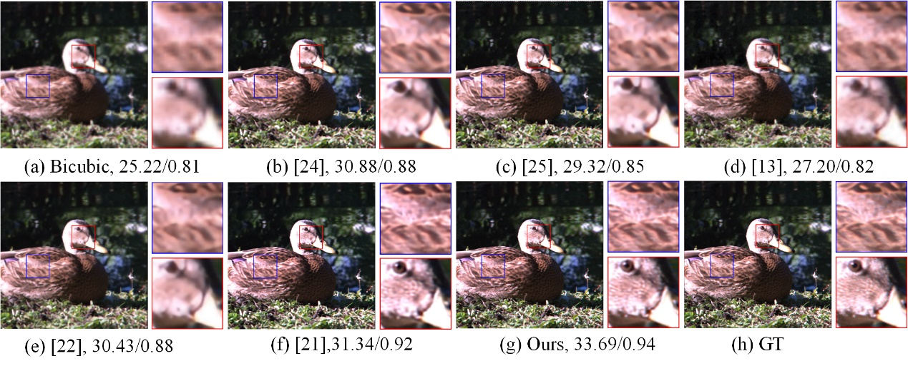**图9 光场图像超分辨率结果比较 (场景9)**

**Fig.9 Comparison of super-resolution results of light field images (scene 9)**

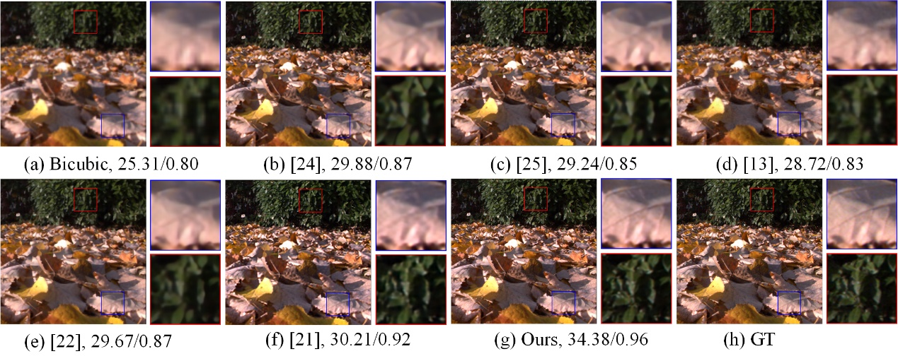

**图10 光场图像超分辨率结果比较 (场景10)**

**Fig.10 Comparison of super-resolution results of light field images (scene 10)**

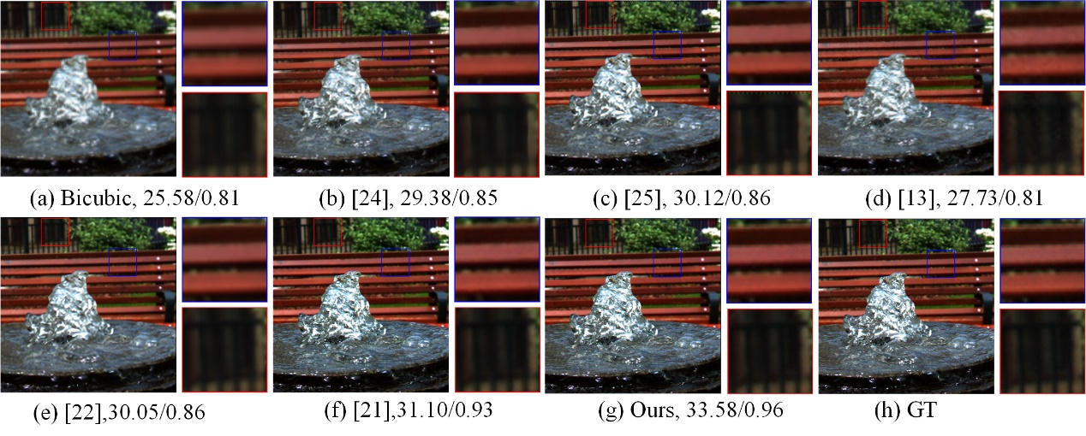

**图11 光场图像超分辨率结果比较 (场景11)**

**Fig.11 Comparison of super-resolution results of light field images (scene 11)**

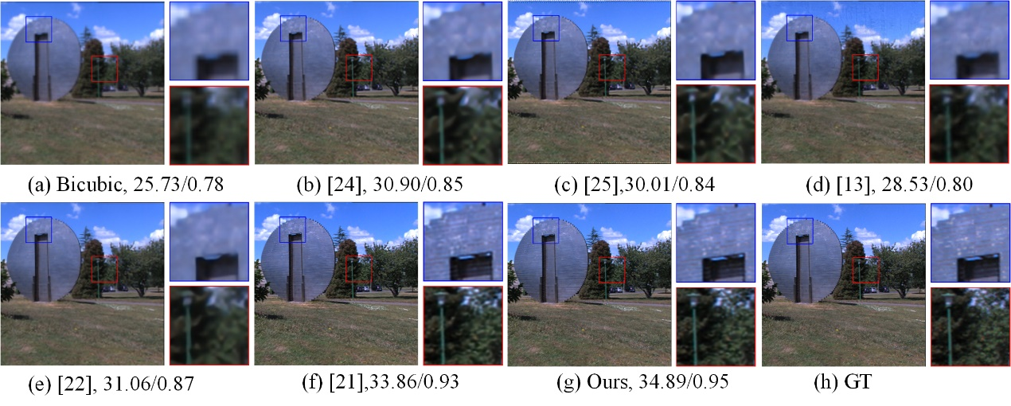

**图12 光场图像超分辨率结果比较 (场景12)**

**Fig.12 Comparison of super-resolution results of light field images (scene 12)**