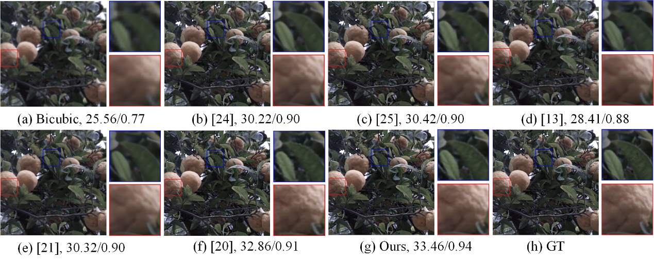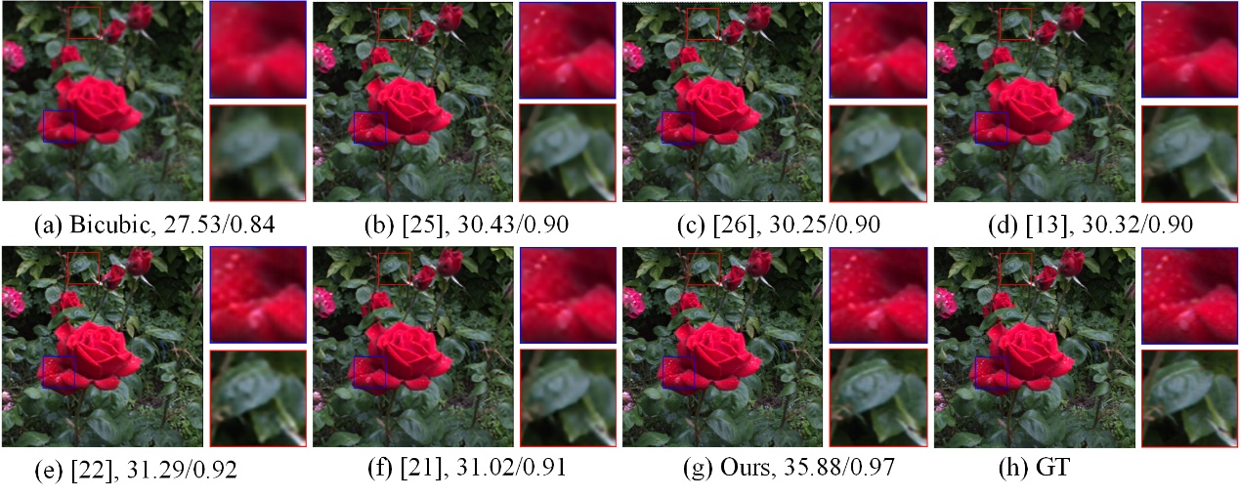

**图1 光场图像超分辨率结果比较 (场景1)**

**Fig.1 Comparison of super-resolution results of light field images (scene 1)**

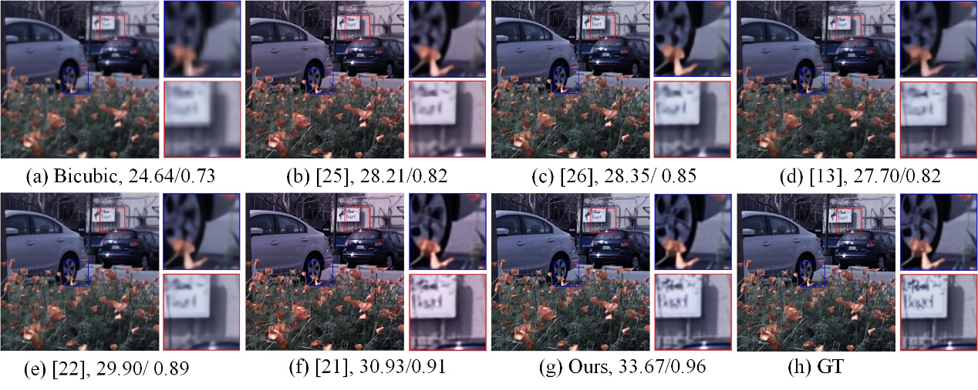**图1 光场图像超分辨率结果比较 (场景2)**

**Fig.2 Comparison of super-resolution results of light field images (scene 2)**

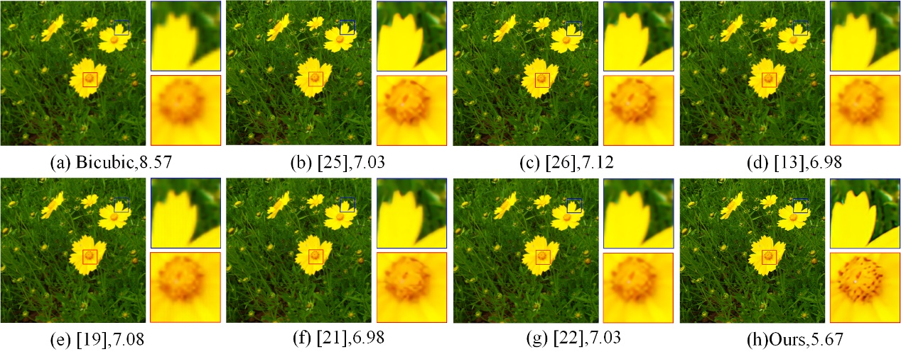

**图3 光场图像超分辨率结果比较 (场景3)**

**Fig.3 Comparison of super-resolution results of light field images (scene 3)**