**Kindly follow the following steps to install tensorflow in your system:**

**1. Open anaconda prompt and run the following command**

**conda create -n tf python=3.6**

This will prompt for some new libraries to be installed in the system. Simply press **Enter** and proceed. This will install the libraries required for creating a new environment.

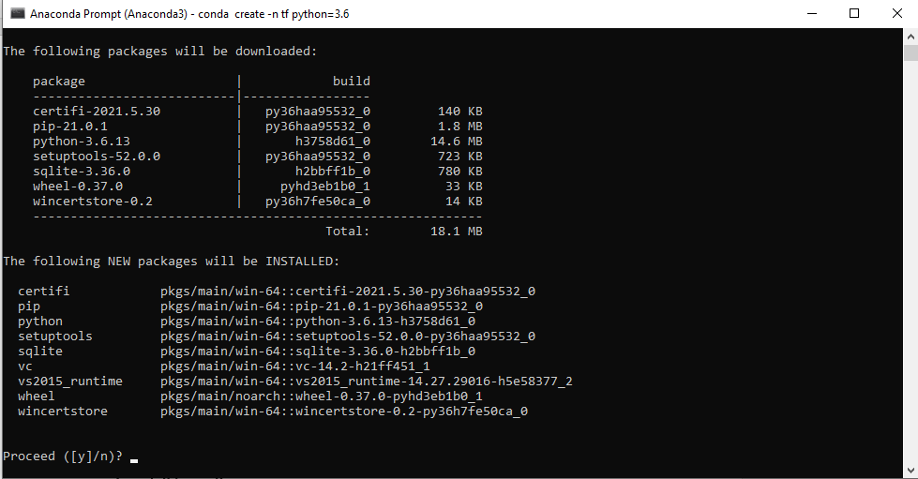

**2. Activate the newly created environment using:**

**conda activate tf**

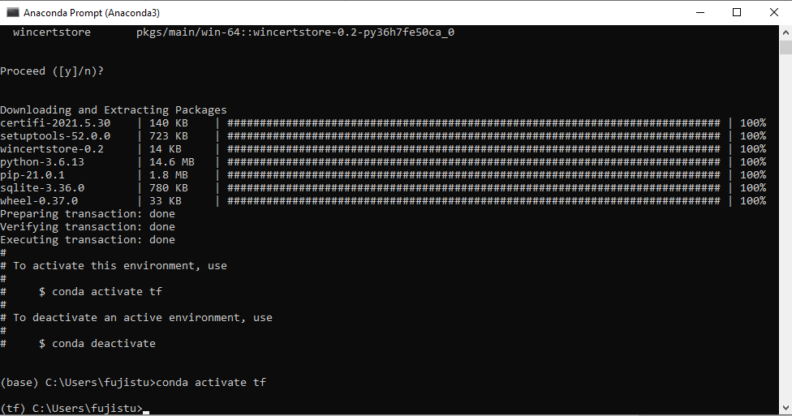

The current environment can be seen in the starting of command line in anaconda prompt (encircled in the image above). The current environment has been changed from “base” to “tf”.

**3. Install python kernel and jupyter notebook in this environment**

**conda install ipykernel**

**conda install jupyter**

*allow for any permissions to install additional libraries

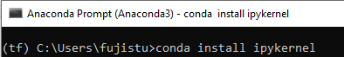



**4. Install tensorflow using the following command**

**conda install tensorflow**



**The steps above will create a new environment in your anaconda navigator and install tensorflow in that environment. Next launch the jupyter notebook in the same environment.**



**You can start using the tensorflow library now.**

NOTE – Since this is the first time, hence we are creating a new environment. Once created, this will exist forever (until deleted). To launch, jupyter notebook in tf environment from next time onwards, simply go to start and type Jupyter notebook. You will see multiple jupyter notebooks (one for each environment), launch the one with tf in its name. Below is the image attached.

