CIS150 - FTC Online Games

|  |  |  |
| --- | --- | --- |
| **Name:** | Hoffman | Jessica |
| **CIS150 -** | 77 | **Minutes: 17** |
| **Date:** | March 29, 2016 | |

|  |  |
| --- | --- |
| 1 | If you have not already done so, update the required identification information (last name, first name, and section number) in the shaded area above as well as in the page header at the top of the next page. Now click the *Insert* tab, then the Date & Time button and select ***month dd, yyyy*** format that is near the top of the list. |
| Note that many of the steps in these instructions will require you to copy and paste the contents of the active window (which is typically the window highlighted in dark blue) on your PC. Perform this copy using the Alt+ Print Screen key sequence (or via Fn + Prnt Screen on some laptop PCs) you learned in CIS100 to first copy the image, then paste it into this Word document using the Ctrl + letter v shortcut or Snipping Tool (Windows 7 or 8) or Cmd + Ctrl + Shift + 3 (Mac OS X).  ***Be sure to review the important information at the top of page 2 as well as the directions for each portion of FTC Online Games. When done, be sure to back-up your digital file as noted on the final page.*** | |

The purpose of this final Homework Assignment   
in CIS150 is to:

* **Enhance student knowledge about common computer security issues in the workplace environment and with their personal computers**
* **Provide students with some additional information about information security topics and threats, including:**
  + **Identity Theft**
  + **Spyware**
  + **Online Safety**
  + **Wireless Security**
  + **Phishing (Email)**

***Students will be awarded up to 25 points for FTC Online Games and OpenDNS Phishing Quiz for providing the required images.***

***Note : You should expect that a couple of questions pertaining to FTC Online Games and OpenDNS Phishing Quiz may be included   
on the Final Exam.***

## IMPORTANT

This assignment makes the assumption that students are using a desktop PC or laptop with one of the more recent versions of the Microsoft® Windows® operating systems (7, 8, XP, Vista®) installed on it. ***Apple® users can complete Assignment 7 on their Mac or a Windows-based PC such as those found in the CoB computer labs, Ekstrom Library (specifically the PCs installed in REACH/CRC), or other such facility at UofL.***

Not having a personal computer does NOT excuse you from your responsibility to finish any InClass Activity or Essay Assignment in CIS150. Computer labs in CoB 045 and REACH/CRC are generally available and acceptable to use in completing CIS150 Assignments, including this one. It is highly recommended that this Assignment be done on your own desktop or laptop PC, however, you have the option of using UofL PCs, including the CoB virtual environment.

***While this assignment is optional for all students in CIS150, the score you earn may be used to replace a lower score an earlier Essay, Homework or Quiz - possibly including a score of zero for missing one of these earlier in the semester.***

## IMPORTANT

Students must use Microsoft® Word 2007/2010 (or Office for Mac 2011) software to complete this Assignment. Your completed solution files must be submitted into Blackboard for grading in PDF format (reference final page for details). Note that no solution PDF is provided. Mac users should be able to fully complete *FTC Online Games* using their own PCs. ***Note:***  *Feel free to email your instructor if you have questions about any Assignment or Assessment in CIS150.*

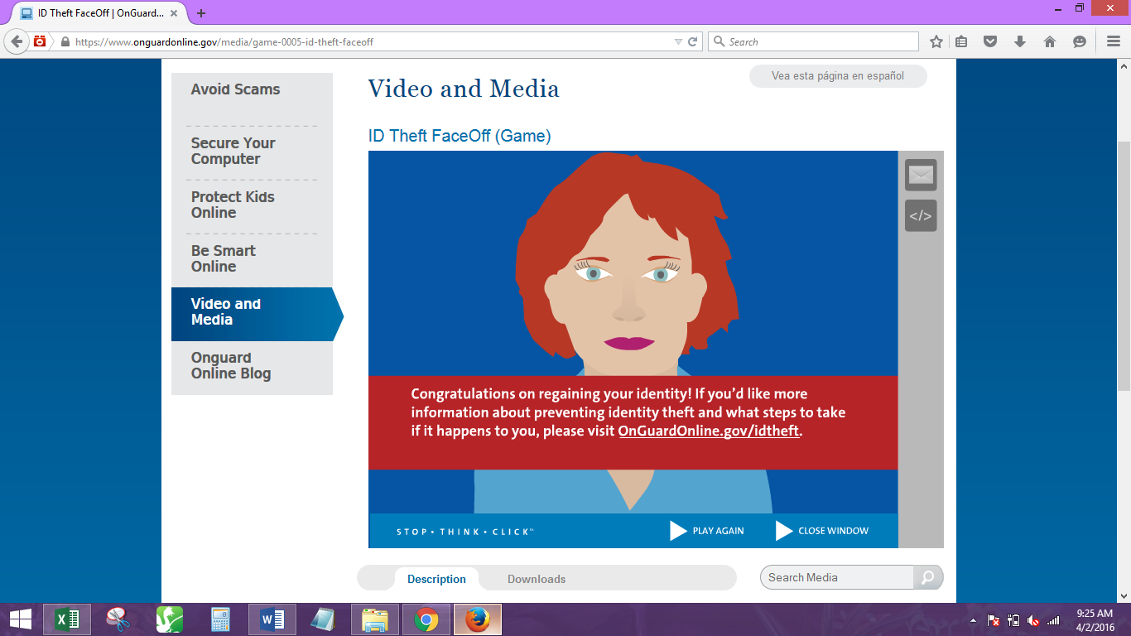

|  |  |  |
| --- | --- | --- |
| 2a | [*Click here*](http://www.onguardonline.gov/media/game-0005-id-theft-faceoff) to complete four (4) relatively short computer security quizzes created in the form of online games by the U.S. Federal Trade Commission (FTC). In sequence, select the *ID Theft FaceOff, Beware of Spyware, Friend Finder, and Invasion of the Wireless Hackers* “games” - you will need to click the **Video  and Media** link on the left side of the page to play each of these games, which will test out and enhance your knowledge about these vitally important computer security topics. If a game does not load when clicking on it, then click the link directly below the respective image.  After you have finished each of the FTC games, copy the image of your results into the answer space below and on the next two pages, placing the first image (*ID Theft FaceOff*) below, followed by the middle two pairs in sequence on the subsequent page. Be sure to re-size all of the images so they fit nicely into the blank spaces provided below. Each of these is worth 5 points towards the final score that you will earn.  Note that the scores you earn on each of these four quizzes will not be considered when grading this specific Assignment, but you must complete all four of the *FTC Online Games* and provide the respective images in order to earn full credit for *Homework 4*. | |
| 2b | | Paste the next two images (*Beware of Spyware* and *Friend Finder*) into the blank space directly below.  Re-size the images on this page to ensure that they fit properly into the area provided. |

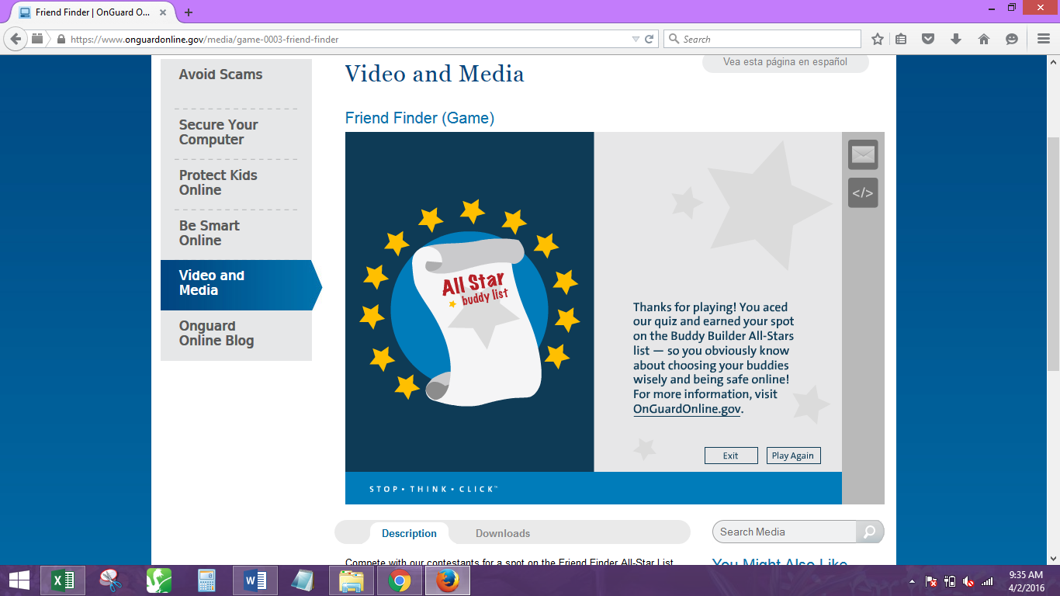

|  |  |
| --- | --- |
| 2c | Paste the last image (*Invasion of the Wireless Hackers*) into the blank space directly below. Re-size the images on this page to ensure that they fit properly into the area provided. |

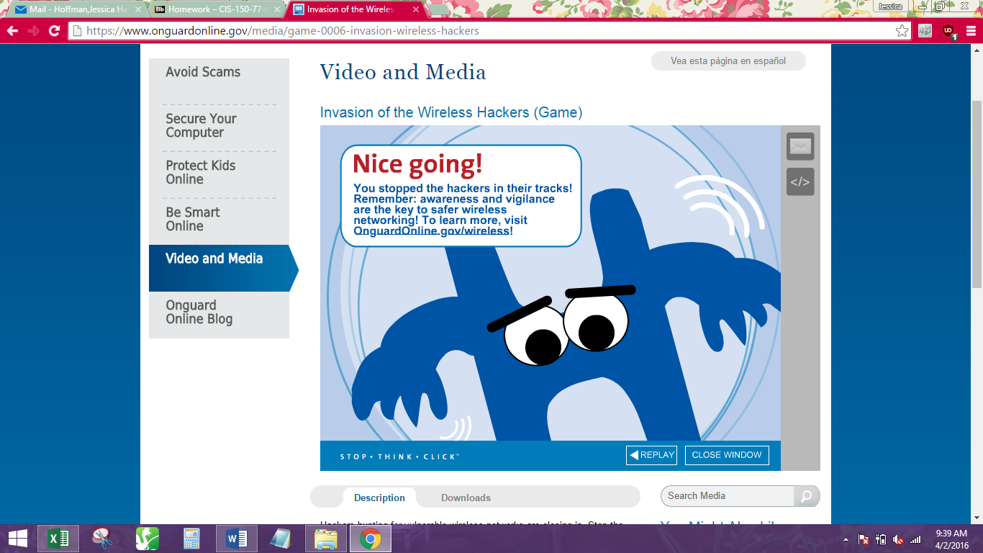

|  |  |
| --- | --- |
| 3 | [Click here](https://www.opendns.com/phishing-quiz/) to read the information and statistics about “phishing” e-mail messages and take the *OpenDNS Phishing Quiz*. score that you earn on the *OpenDNS Phishing Quiz* will not be considered when grading this new Assignment, but you must complete it in order to earn the full credit for this specific step. |

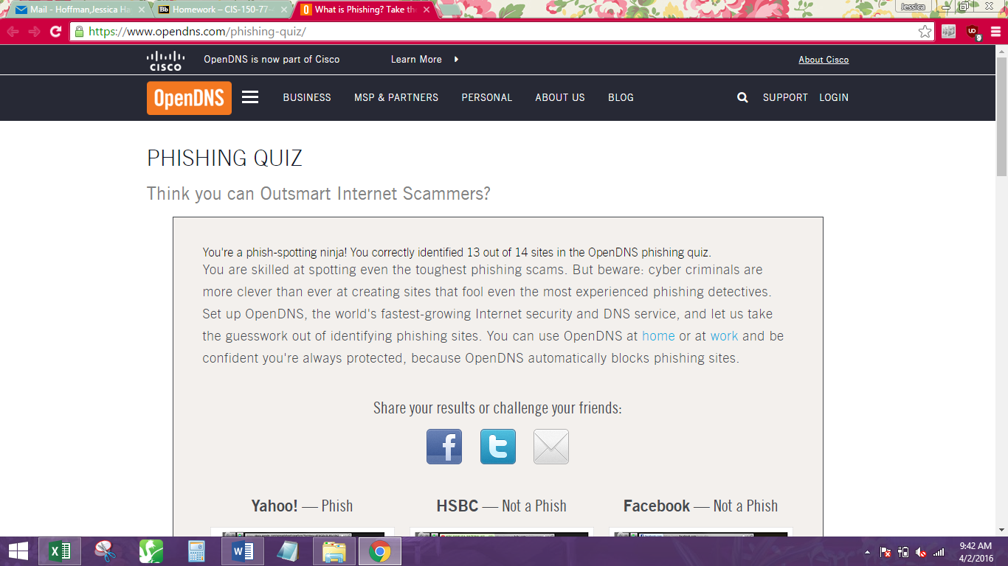

|  |  |
| --- | --- |
|  | **Congratulations - you are nearly done now! Perform one final review of this**  **Microsoft® Word document and its accompanying instructions to ensure you have successfully completed all steps. During the review process, be sure to note the  actual number of minutes (elapsed clock time) that you spent on *FTC Online Games*  and *OpenDNS Phishing Quiz* at the top of the first page in the designated box.  Then save this Microsoft® Word document to your PC hard drive, USB thumb drive,  or the CoB virtual environment, creating a backup copy of it for future reference.** |
| MCj04348050000[1] | ●●●  **Be sure to rename your Microsoft® Word document template file beginning with your first and middle initials concatenated with your last name, followed by a dash, and then the text "FTC-Online-Games" only before the ".docx” file extension. For example, if you have a first name of Ann, a middle name of Ophelia, and last name of "Smith" then you would name the file "AOSmith-FTC-Online-Games.docx" - once you have done this, you will need to convert your solution file to a PDF using the respective Microsoft® Office Add-In, Adobe Acrobat, or even a freeware utility such as** [***PrimoPDF***](http://download.cnet.com/PrimoPDF/3000-18497_4-10264577.html)**. Finally, post your completed solution file into Blackboard under the respective *Submit Work Here* folder item in Blackboard for grading purposes no later than the due date/time that was announced.**  ●●● |
| *Due dates and times for all Assignments are documented in the* ***Course Schedule****,* ***Assignment Due Dates****, and under* ***My Grades*** *in* ***Blackboard****. No CIS150 assignment will be accepted after the due date/time unless you have notified your instructor in advance of an extenuating circumstance as originally noted in the* ***Course Syllabus****.**Please feel free to email your instructor should you have questions or concerns about any assigned work. Alternatively, if you have any comments about this particular Assignment, you should make note of them only in the Comments area directly below, not in the* ***Submit Work Here*** *folder item in Blackboard.* | |

***Note: The completed file for FTC Online Games must be submitted in Adobe PDF document format for grading.***

The elapsed time I put (17 minutes) can be verified by the timestamps on the screenshots