|  |
| --- |
| **Homework 3 – CareerTrak and Career Fair**  Name: Jessica Hoffman  Course: CIS150-77  Date: 3/27/2016 |

Jessica Hoffman

|  |  |
| --- | --- |
|  |  |
|  | Louisville, KY | 224-558-2434 (mobile) | jhhoff02@cardmail.louisville.edu |

OBJECTIVE

|  |  |
| --- | --- |
|  |  |
|  | As an undergraduate student at the College of Business at the University of Louisville, I am currently pursuing a bachelor’s degree in CIS (Computer Information Systems). My past job experiences primarily involved interacting with customers and coding applications for the .Net/Mobile team at LG&E Center. In addition to years of customer service experience, I have utilized computers in multiple jobs and academic settings. Presently, I am interested in finding a CIS-related part-time, co-op, or internship opportunity to build my skills and CIS experience. |

Computer Skills

|  |  |  |
| --- | --- | --- |
|  |  | |
|  | Java – 1 semester of experience creating Java classes and programs  C# - 1 semester of experience building classes in Visual Studio | HTML5 and CSS – 2 years of experience practicing HTML5 and CSS  JavaScript, TypeScript, AngularJS 2.0 – 1 semester of experience |
|  | Software   * Excel – Intermediate experience using Excel (functions, cell references, interactive worksheets) * MS Office – Expert experience using all other Microsoft Office programs such as MS Word, Paint, PowerPoint, OneDrive, Outlook, Lync * MS Visual Studio – Intermediate experience using VS to build mobile applications * WallabyJS – Intermediate experience using Wallaby to unit-test applications * Skype, WebEx, Jabber, Lync for internal business communications | |
|  | Operating Systems   * Windows – 10 years of experience, very familiar with Windows XP, Windows Vista, Windows 7, Windows 8 (and 8.1) * Linux – 2 years of experience using Linux Mint distro on a personal PC | |
|  | Other   * Between 75-90 average wpm typing - best speed: 121 on play.typeracer.com * Agile – 1 semester experience using Agile techniques to develop apps in a team | |

JOB Experience

|  |  |
| --- | --- |
|  |  |
| 2013-2015 | Employee of Dairy Queen,  Round Lake Beach, IL   * Primarily customer service (ensuring customer satisfaction, resolving issues, promoting positivity, handling receipts and cash using a register, preparing desserts and meals) * Assisted the manager in training/supervising/advising new employees 2014-2015 * Ran errands for manager |
| 2014-2015 | Work-study employee,  University of Massachusetts Astronomy Dept., Amherst, MA   * Worked in an office setting using computers to communicate with faculty, archive information for the Astronomy Department * Helped plan and set up for Astronomy Dept. colloquiums |
| 2015 | Work-study employee receptionist,  University of Louisville Arts and Sciences Advising Office, Louisville, KY   * Worked in an office setting at the receptionist desk, assisting students in making academic advising appointments to see their advisors and resolving small issues that don’t require advisors * Daily use of GradesFirst program, Lync for communication with advisors and co-workers, and phones |
| 2016-Present | LG&E IT Intern for .Net/Mobile Team,  LG&E Center, Louisville, KY   * Currently work in an office setting developing corporate applications in a team. * Daily use of Agile: meet with end users every day to discuss app progress. Meet every other week to demo the app so far * Daily use of Angular 2.0, SQL, C#, TypeScript, and Jabber. |

Education

|  |  |
| --- | --- |
|  |  |
| 2015-Present | Currently attending University of Louisville (Expected Graduation: May 2018),  Louisville, KY |
| 2014-2015 | Attended University of Massachusetts,  Amherst, MA |
| 2010-2015 | Attended and graduated from Round Lake Senior High School,  Round Lake Beach, IL |

other skills and achievements

|  |  |
| --- | --- |
|  |  |
| Calculus | Earned a 5 on the AP Calculus test |
| English | Earned a 4 on the AP English Language and Composition test and a 4 on the AP English Literature and Composition test |
| ACT | Earned a 30 on the ACT twice |
| GPA | Earned 4.0+ in HS, 3.8 first semester at UMass, and 3.7+ current U of L GPA |
| Illinois State Scholar | Earned this title resulting from ACT and GPA in HS |
| Section  Leader | Earned position of flute section leader in HS Concert Band after 8+ years of playing |
| Center for Conservation Leadership Program | Accepted into CCL centered in Lake Forest, IL, and participated in the 2 year program involving volunteer work and stewardship projects |
| Accounting | 1 semester experience mastering basic principles of accounting and GAAP |
| Statistics | 1 semester experience working with data, probabilities, ANOVA, and regression analysis |

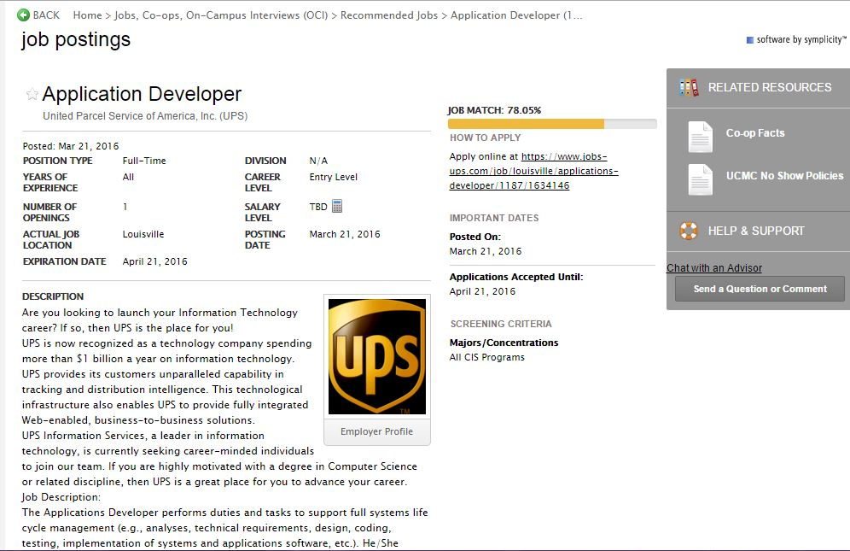

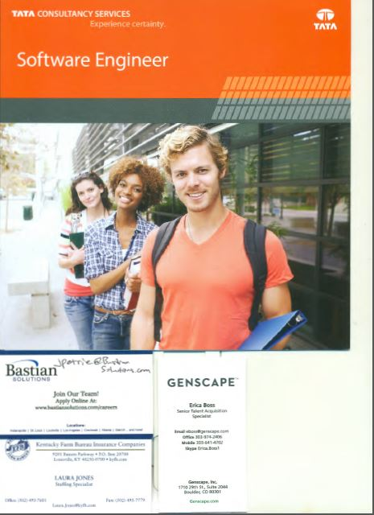I attended the CIS/CECS Career Fair on March 9th held at the University Club building on campus. If these are unreadable I would be happy to show you the materials in person.