CIS310-02

Assignment 6

Jessica Hoffman

1. Original dependency diagram

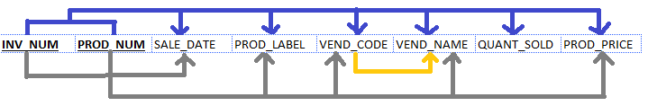

1. Yes, it is in 1NF because each row is uniquely identifiable by a composite primary key.

3. No, it is not in 2NF because there are partial dependencies. Partial dependencies form when a non-key attribute is determined by a key attribute that is only part of the primary/composite key.

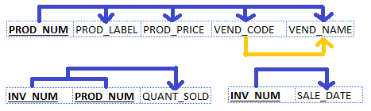

4. No, it is not in 3NF because there is a transitive dependency. Transitive dependencies form when a non-key attribute determines another non-key attribute.

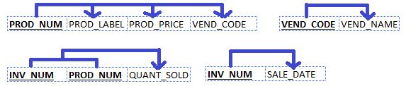

5. Crow’s Foot Diagram

