Assignment 7

CIS 310-02

Jessica Hoffman

Due 10/23/17

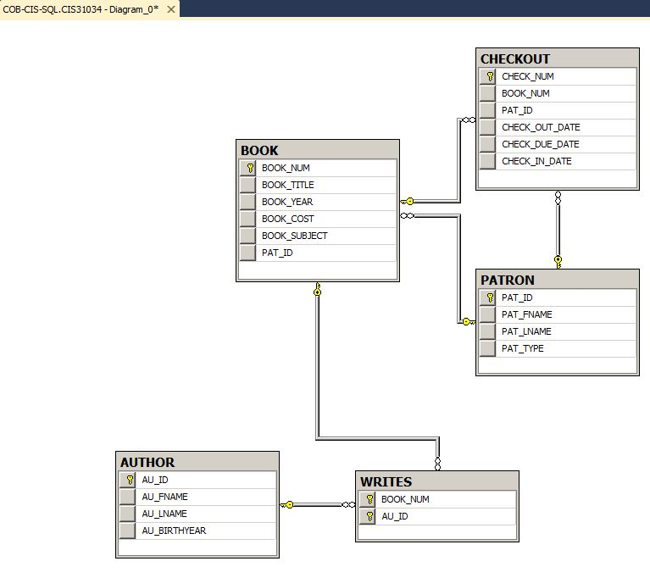ER Diagram SQL