Patient Intake Form – Requirements (React/Node)

1. Overview & Scope
This document specifies functional and non-functional requirements for a patient intake form to be implemented in a React frontend with a Node.js backend. The solution supports configurable clinician prompts, EDI pre-population with confirmation, auto-formatting/validation, and accessibility. Fields that are struck through or annotated as ‘Move to disability’ in the source notes are excluded from this scope.

2. Inclusion / Exclusion Rules
Include:
All standard demographic and intake fields listed below that are not marked as struck-through or ‘Move to disability’.
Exclude:
Fields explicitly struck through (Income, Source) and those annotated as ‘Move to disability’ (If Divorce/Widowed and related follow-up, Height, Weight, Education). Any disability-specific prompts are out of scope for this form.

3. Field Catalog (Included)
Notes: Source defaults to Manual, but if EDI provides a value it will pre-populate as "Boxed" and require confirmation.
Field Name | Data Type | Source | State | Required | Format / Validation | Prompt Text (Configurable) | Dependencies / Logic
FirstName | Varchar | EDI (if available) / Manual | Pending or Boxed (EDI) | Yes | Alphabetic incl. hyphen/apostrophe; auto Title Case; max 30 | Can you confirm your legal First Name as it appears on your ID? | None
MiddleName | Varchar | EDI (if available) / Manual | Pending or Boxed (EDI) | No | Alphabetic incl. hyphen/apostrophe; auto Title Case; max 30 chars |  | None
LastName | Varchar | EDI (if available) / Manual | Pending or Boxed (EDI) | Yes | Alphabetic incl. hyphen/apostrophe; auto Title Case; max 30 chars | Can you confirm your legal Last Name as it appears on your ID? | None
SSN | US SSN (masked) | Manual / EDI (if present) | Pending or Boxed (EDI) | Org policy (default: Optional) | 9 digits; display as XXX-XX-1234 after blur; disallow 000, 666, 900-999 prefixes | May we record the last four of your SSN for identity verification? | None
Gender | Select (values configurable) | EDI / Manual | Pending or Boxed (EDI) | Org policy (default: Optional) | Select from configured list | How do you describe your gender? | None
Deceased | Date | EDI / Manual | Pending or Boxed (EDI) | No | MM/DD/YYYY; no future dates; age >= 0 | Is the patient deceased? | None
Address Line 1 | Text | EDI / Manual | Pending or Boxed (EDI) | Yes | USPS format; no PO Box if policy disallows; max 100 chars | What is your current street address? | If Homeless = Yes, treat as mailing address; living location captured separately
Address Line 2 | Text (optional) | EDI / Manual | Pending or Boxed (EDI) | No | Apt/Unit/Suite; max 100 chars | Apartment, unit, or suite (if any) | None
City | Text | EDI / Manual | Pending or Boxed (EDI) | Yes | Alphabetic; max 50 chars | City | None
State | US State (2-letter code) | EDI / Manual | Pending or Boxed (EDI) | Yes | Two-letter uppercase (e.g., TX) | State | None
ZIP Code | US ZIP | EDI / Manual | Pending or Boxed (EDI) | Yes | 5 or 9 digits; auto-hyphen for ZIP+4 | ZIP code | Validate against State/City if service available (optional)
County | Select (filtered by State) | Manual | Pending | No (Required if Homeless = Yes) | List populated by config for selected State | Which county do you primarily stay in? | If Homeless = Yes, this becomes required
Marital Status | Select (values configurable) | Manual / EDI | Pending or Boxed (EDI) | No | Select from configured list | What is your current marital status? | If Married/Domestic Partnership, show Spouse fields
DOB (Date of Birth) | Date | EDI / Manual | Pending or Boxed (EDI) | Yes | MM/DD/YYYY; no future dates; age >= 0 | What is your date of birth? | Drives calculated Age field
Age | Number (read-only) | Calculated | Read-only | n/a | Calculated from DOB as full years; auto-updates client-side |  | Updates when DOB changes
D  ate of Onset | Date | Manual | Pending | No | MM/DD/YYYY; cannot be after current date | When did the condition or symptoms begin? | None
Birth City | Text | Manual / EDI | Pending or Boxed (EDI) | No | Alphabetic; max 50 chars | Birth city (optional) | None
Birth State | US State (2-letter) | Manual / EDI | Pending or Boxed (EDI) | No | Two-letter uppercase code | Birth state (optional) | None
Primary Language | Select (configurable list) | Manual | Pending | Org policy (default: Optional) | Pick from configured languages; allow "Other" with free text | What is your preferred language for care? | If Other selected, show free-text field (out of scope)
Mother's Maiden Name | Text | Manual | Pending | No | Alphabetic; max 50 chars | What is your mother's maiden name? (optional) | None
Primary Phone | Phone (US) | Manual / EDI | Pending or Boxed (EDI) | Org policy (default: Yes) | (XXX) XXX-XXXX; numeric only input; allow E.164 storage | Best number to reach you? | None
Secondary Phone | Phone (US) | Manual | Pending | No | (XXX) XXX-XXXX; numeric only input; allow E.164 storage | Secondary phone (optional) | None
Citizenship Status | Select (values configurable) | Manual / EDI | Pending or Boxed (EDI) | No | Select from configured list | What is your citizenship or immigration status? | None
Spouse (if applicable) | Composite Name (First, Last, Suffix) | Manual / EDI | Pending or Boxed (EDI) | No | Alphabetic; title case; max 50 chars per part | What is your spouse/partner’s name? | Shown if Marital Status indicates Married/Domestic Partnership
Spouse Primary Phone | Phone (US) | Manual / EDI | Pending or Boxed (EDI) | No | (XXX) XXX-XXXX; numeric only input | Spouse/partner’s primary phone (optional) | Shown if Spouse is provided
Additional Information | Long Text | Manual | Pending | No | Max 1000 chars; spell-check enabled | Is there anything else we should know to coordinate your care? | None
Homeless – Indicate Residence / Where Patient Stays | Select (Not Homeless / Homeless) | Manual | Pending | No | If Homeless = Yes, require County; allow free-text location notes (optional) | Where are you staying most nights? | If Homeless = Yes → County required; treat Address lines as mailing address

4. Page Level Filters

5. UI Behavior
• Red text = clinician prompts (configurable per field via config file).
• Light grey fields = awaiting data entry.
• Boxed fields = pre-populated via EDI; require user confirmation (Confirm / Edit / Reject).
• Read-only calculated fields (e.g., Age) have subdued styling and no input affordance.

6. Validation & Auto-formatting
Dates: MM/DD/YYYY; auto-insert slashes; pad leading zeros; prevent future dates where noted.
Phone: enforce numeric input; format to (XXX) XXX-XXXX on blur; store canonical E.164 if configured.
SSN: input mask ###-##-####; show last four only post-entry; client-side and server-side validation.
Name/Address: auto Title Case; preserve user-applied casing where necessary (e.g., McDonald).
ZIP: auto-hyphen ZIP+4; validate 5 or 9 digits.
Accessibility: inline errors with ARIA live regions; clear helper text; keyboard navigable controls.

9. Security & Compliance
• PHI encryption in transit (TLS 1.2+) and at rest.
• Role-based access control; least privilege; session timeout.
• Audit logging for all create/update/confirm actions with user and timestamp.
• Error messages avoid echoing PHI; logs redacted.

10. Accessibility & UX
• WCAG 2.1 AA color contrast for red/grey/boxed states; non-color cues (icons/labels).
• Full keyboard support and visible focus; screen reader-friendly labels and statuses (e.g., ‘Requires confirmation’).
• Clear, inline validation messages and summary on submit.

11. Non-functional Requirements
• Performance: Initial load < 2s on broadband; field updates < 100ms perceived.
• Reliability: Autosave drafts every 10s or on blur; optimistic UI with retry.
• Observability: Structured logs, request IDs, and metrics for confirmation actions.

12. Notes Template
The system shall provide a Notes section accessible from the form screen with the following behavior:
- Trigger: A button labeled “Add Notes” is displayed at the bottom(location up for discussion) of the form.
- Action: Tapping “Add Notes” opens a full-screen modal or side panel optimized for tablet use.
- Content:
  - A large multi-line text area for free-form note entry.
  - Optional Save and Cancel buttons with touch-friendly sizing.
- Save Behavior:
  - Saves the note with:
    - Timestamp
    - Author
    - Linkage to the current record (Patient, Account, or Insurance)
- UI Considerations:
  - Responsive layout for tablet (minimum 44px touch targets).
  - Keyboard auto-focus when modal opens.
  - Scrollable if content exceeds screen height.

Example of POC
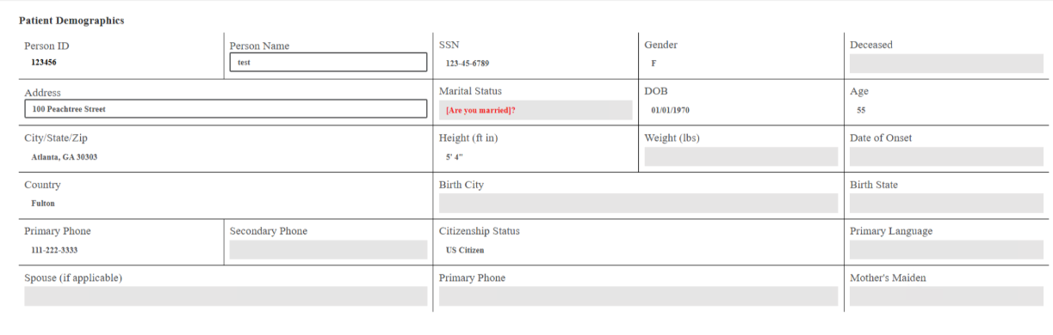
Original POC src code for Reference
++RCM_EAE_PacePatientPortalHCRView-US9103247.zip

