**Application Design Document**

**Storyboard for viewing and adding an item to order:**

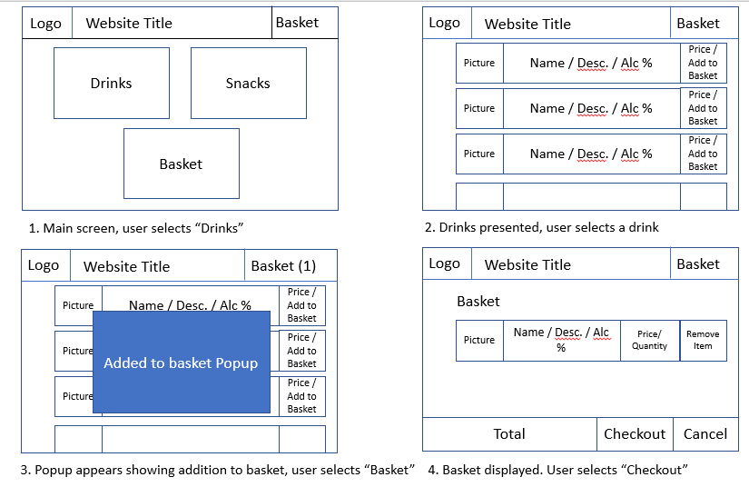

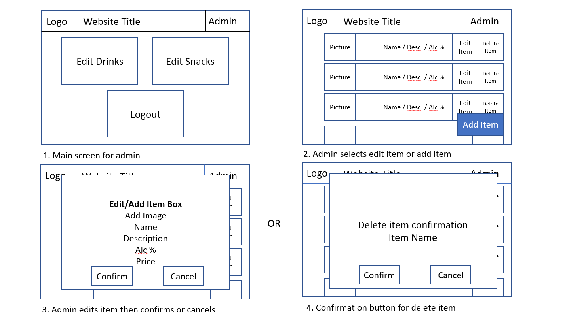

**Relationship diagram:**

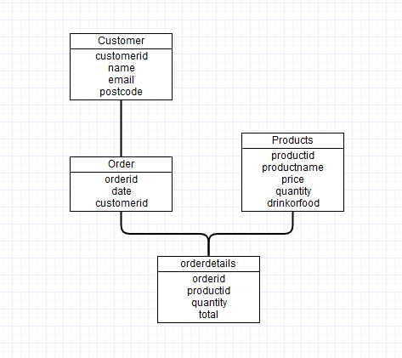

**Web Accessibility Initiative:**

**User Keyboard Input:**

The only keyboard input required for a customer user would be the login, the remainder of the application requires only mouse (or touch) input, the user does not need to manually enter order ID’s as these are retrieved and placed in a dropdown box for the user. There are no administrator functions, but should they be added then the editing or adding of Product information would require keyboard input.

**Usability across platforms:**

Bootstraps inbuilt window size compatibility for the div and card elements allows for a relatively streamlined experience on all sized devices. The cards will exceed the window size on devices with a very small width, but overall elements will resize and rearrange accordingly.

**Navigation:**

Navigation is incredibly simple, the landing page has three buttons for food, drink and orders. There is also a header throughout all the application which gives the user the ability to jump to home or orders from any place. Some users may not instantly figure out that selecting a product card will add to their order, however there are no prompts that would suggest that that system works other ways.

**Visuals:**

The visuals of the application are incredibly simple with distinct and clearly visible functions. For example, the orders page clearly prompts the user to select an old order, it also clearly defines what their current order is. The current order table could be displayed first as when reading from top to bottom, the current order would be more useful information than old orders. However, I believe the distinction between the two is clear enough.

**Audio Transcripts:**

There is no audio for the application, so this feature is not required.

**Peer Reviews**

**Review 1 – Peer review of storyboard**

**Date:** 22.10.2019

**Peer Review carried out by:** Dan S

**Task Conducted:** Adding an item as a customer

**Was the task easy to carry out?**

Yes, it was very easy.

**Did you encounter any errors?**

No errors were apparent from following the story

**Did the author have to explain how to use anything?**

No, the applications layout was simple and the required function buttons were easy to find.

**Did you gain any inspiration for your own practice?**

N/A

**What constructive advice would you give the author?**

None, all good

**Review 2 – Peer review of application**

**Date:** 02.01.2020

**Peer Review carried out by:** Matt H

**Task Conducted:** Adding an item then cancelling order as a customer

**Was the task easy to carry out?**

Yes, it was very easy.

**Did you encounter any errors?**

No errors were apparent from following the story, some “echos” most likely from testing would pop up. Like (current user = 5)

**Did the author have to explain how to use anything?**

No issues. The application was very navigable.

**Did you gain any inspiration for your own practice?**

N/A

**What constructive advice would you give the author?**

Make sure test logs are removed before product is released

**Changes if I had more time:**

**Admin system** – I fell under time constraints so pooled my resources into having a smooth and bug free customer system which would cleanly append, delete and read to the database.

**More detail when retrieving an orders details** – The way I created the order details table meant that when reading in the table the user would get arbitrary ID’s of little relevance unless they knew what product the id corresponded to, as shown below.

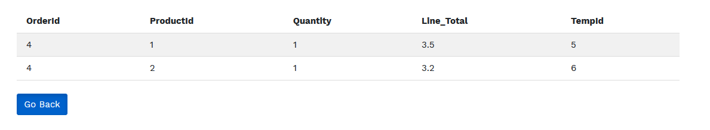

This is rectified by adding in SQL logic to select the products name where the id’s match and then append the name to the table instead of the ID. But under MVP (minimum viable product) constraints this is a feature that wasn’t necessary.

**Images for items** – Again as previously stated to keep the application in line with the requirements the products are given a generic image. This would be solved by adding an “image name” column to the products database that would have the file name. This file would be referenced to an image stored in the assets folder

**A background image!!** – Something I couldn’t get working at the start of development and then never got around to fixing. Would be nice.

**Links**

**Github -** <https://github.com/jhicks5/ISAD251_CW.git>

**Bootstrap -** <https://maxcdn.bootstrapcdn.com/bootstrap/4.0.0/css/bootstrap.min.css>

**Stylesheet -** <https://www.w3schools.com/w3css/4/w3.css>