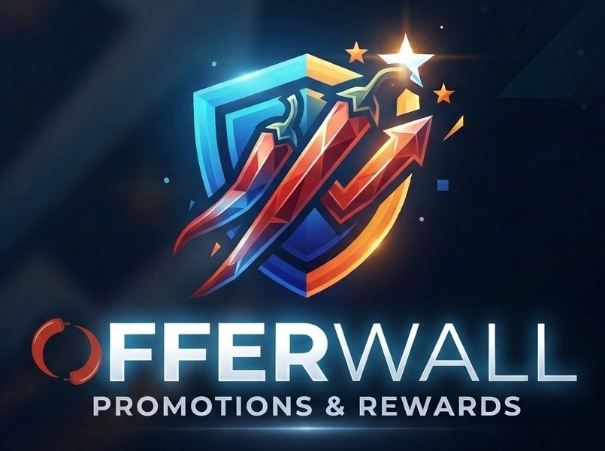
BUSINESS REQUIREMENTS DOCUMENT
GFT Offer Wall
Promotions, Inventory Intelligence, GFT Rewards Campaign Build, and Chili Rewards Activation
INPUT  Brand-funded offer | STORE DECISION  Fit + inventory | OUTPUT  GFT campaign + CHI

PURPOSE
Define the business, product, workflow, data, and acceptance requirements for a grocer-facing Offer Wall that converts brand opportunities into store-approved GFT Rewards campaign drafts with Chili Rewards attached.

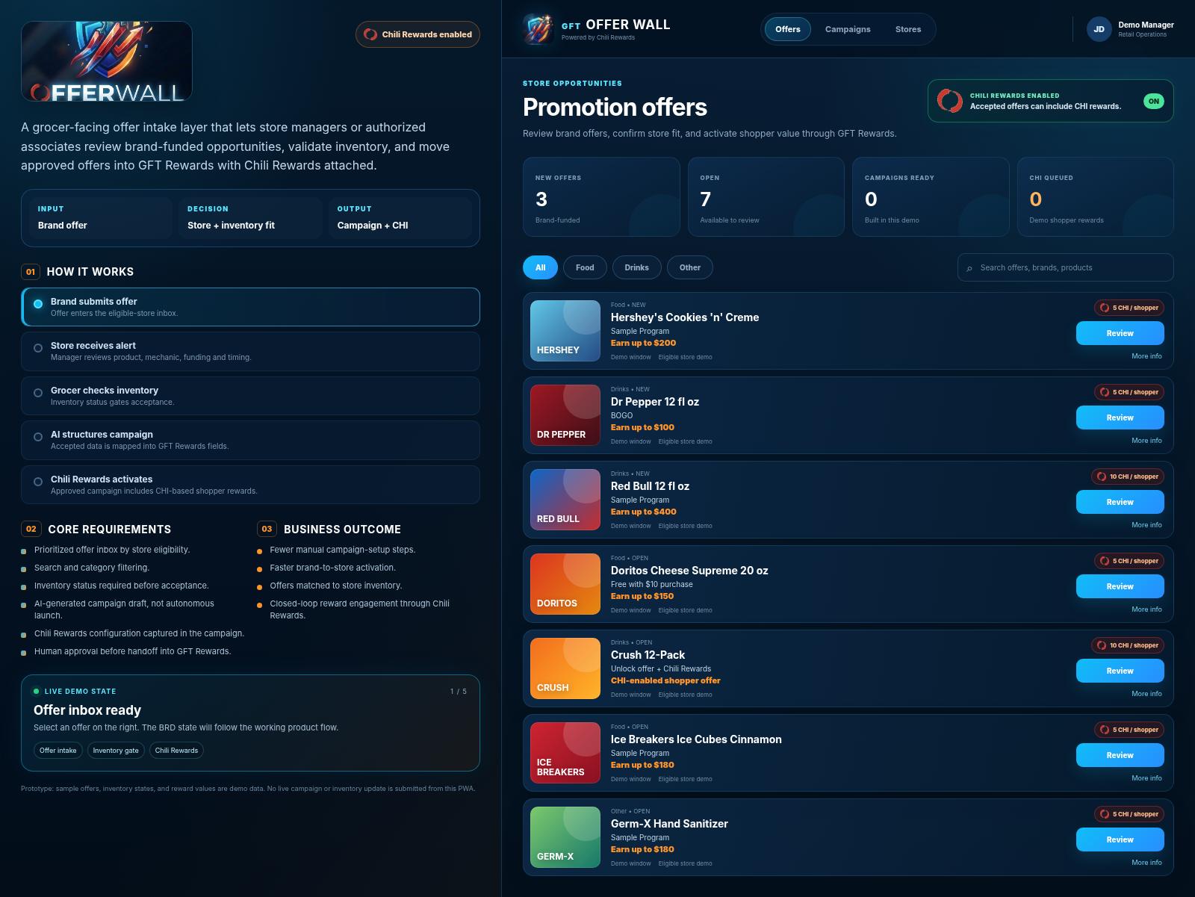
Working PWA concept implemented with the BRD on the left and the interactive product on the right.

1. Executive Summary
GFT Offer Wall is the store-facing decision layer between a brand or agency promotion and a GFT Rewards campaign. A store manager or authorized associate receives a new offer, reviews the offer terms, checks inventory, and decides whether the store can support the promotion. Once accepted, AI structures the offer into a campaign draft and carries the store eligibility and Chili Rewards settings into GFT Rewards.
CORE PRODUCT PRINCIPLE
AI prepares and structures the campaign; the grocer retains the approval decision. The prototype does not autonomously launch a live promotion.

1.1 Objectives
- Give store teams one clear inbox for eligible brand-funded offers.
- Reduce the operational effort required to turn a brand offer into a store-ready GFT Rewards campaign.
- Use inventory status as an explicit gate before campaign creation.
- Attach Chili Rewards to qualifying shopper activity as part of the campaign configuration.
- Create a traceable handoff from brand opportunity to store decision to campaign draft.
1.2 Scope of the working PWA
- Split-screen BRD + interactive product experience using the Offer Wall navy / blue / orange visual system.
- Offer search and category filtering.
- Offer review drawer with structured campaign terms.
- Inventory controls: In stock, Low stock, Out of stock.
- Chili Rewards display with demo CHI-per-shopper and demo reward budget values.
- AI-assisted build animation that produces a campaign draft state.
- Session-persistent demo campaigns stored in the browser and a handoff link to GFT Rewards.
- Installable PWA shell with manifest, responsive layout, and offline caching of the app shell.
1.3 Prototype boundary
The current PWA is a functional front-end prototype. Offer dates, inventory states, CHI quantities, budgets, eligibility, and campaign results shown in the demo are sample values. Production integrations to POS, inventory, GFT Rewards APIs, messaging, wallet services, and blockchain services are not implemented in the front-end prototype.
2. Users and Actors
Actor | Primary job | Offer Wall responsibility | Decision right
Brand / Agency | Create funded promotion | Submit offer terms, eligible products, funding, timing and reward inputs | Proposes offer
Store Manager | Protect store operations | Review fit, validate inventory, accept or defer | Accepts / defers
Authorized Associate | Support manager workflow | Review and confirm inventory if permissioned | Role dependent
GFT Rewards | Campaign system | Receive structured, approved campaign draft and continue campaign management | Launch after approval
Chili Rewards | Shopper reward layer | Provide CHI reward configuration tied to qualifying shopper action | Executed per campaign rules

3. End-to-End Workflow
# | Stage | Actor | Required behavior | Output
1 | Offer intake | Brand / Agency | Brand submits an offer for specific products, stores or eligibility criteria. | Offer record
2 | Store alert | Offer Wall | Eligible manager / associate sees a new opportunity in the Offer Wall. | Review task
3 | Offer review | Store | Review product, mechanic, funding, timing, audience and Chili Rewards configuration. | Store-fit decision context
4 | Inventory gate | Store | Manager selects In stock, Low stock, or Out of stock before the build button can unlock. | Inventory eligibility
5 | AI campaign build | Offer Wall / GFT | Normalize accepted data into GFT Rewards campaign fields and reward rules. | Campaign draft
6 | Human handoff | Store / GFT | Manager continues into GFT Rewards for final campaign review / launch workflow. | Approved draft handoff
7 | Shopper reward | GFT + Chili Rewards | When the campaign qualifying action occurs, reward logic can trigger the configured CHI value. | CHI reward event
4. Functional Requirements
ID | Requirement | Definition / behavior | Priority
OW-001 | Offer inbox | Display eligible brand offers with product, category, offer mechanic, funding, status, value and reward indicator. | Must
OW-002 | Offer alerts | Support a new-offer notification state for store managers and authorized associates. | Must
OW-003 | Search + filter | Search by brand, product, mechanic and headline; filter by All / Food / Drinks / Other. | Must
OW-004 | Offer details | Open an offer review surface with structured terms before an accept decision. | Must
OW-005 | Inventory gate | Require one inventory state before acceptance; Out of stock blocks campaign build. | Must
OW-006 | Low-stock constraint | Allow Low stock to advance while preserving the constraint in the campaign draft. | Should
OW-007 | AI campaign structuring | Convert accepted offer inputs into normalized GFT Rewards campaign fields. | Must
OW-008 | Chili Rewards | Show CHI-per-shopper and reward-budget inputs / outputs as part of the campaign configuration. | Must
OW-009 | Human approval | Do not autonomously launch. Preserve a human review / approval point before production activation. | Must
OW-010 | GFT handoff | Provide an explicit continuation path into GFT Rewards after campaign draft creation. | Must
OW-011 | Campaign status | Show accepted / draft-ready offers in a campaign view. | Should
OW-012 | Store eligibility | Associate offers with eligible store(s) and store permission context. | Must
OW-013 | Audit events | Record offer opened, inventory selected, accepted, deferred, draft created, approved and reward-trigger events. | Must
OW-014 | Responsive PWA | Support desktop and mobile layouts and an installable web-app shell. | Should
OW-015 | Brand consistency | Use the approved Offer Wall / Chili Rewards visual system and exclude unrelated third-party assistant branding. | Must

5. Chili Rewards Requirements
Chili Rewards is not a separate afterthought in the Offer Wall. It is part of the accepted campaign payload and shopper-value model.
- Every CHI-enabled offer must expose the configured CHI amount tied to a qualifying shopper action.
- The campaign must carry the reward budget or limit needed to control total CHI exposure.
- The reward configuration must be visible during store review so the grocer understands the shopper value attached to the offer.
- The production system must record the reward-trigger event, wallet destination reference, amount, status, and campaign / store linkage.
- If reward funding, wallet eligibility, or campaign limits prevent distribution, the system must surface an exception rather than silently treating the reward as complete.
DEMO VALUES
The PWA uses sample CHI quantities and reward budgets to demonstrate the workflow. Production values must come from approved campaign terms and production reward configuration.

6. AI Requirements and Guardrails
ALLOWED AI FUNCTIONS
Extract and normalize brand offer details; suggest campaign field mappings; summarize store-fit context; preserve inventory constraints; prepare a draft payload.

HUMAN-CONTROLLED FUNCTIONS
Store acceptance / defer decision, inventory confirmation, final campaign approval, and production launch.

REQUIRED EXPLAINABILITY
The UI should show the source offer terms and the structured fields used to build the draft so the manager can verify what is being created.

FAILURE BEHAVIOR
If required data is missing or conflicting, the build must stop and request resolution rather than inventing values.

7. Data and Event Model
Object / event | Minimum fields | Purpose
Offer | offer_id, brand, product, category, mechanic, funding, timing, eligibility, status | Source opportunity shown to the store
Store eligibility | store_id, offer_id, eligible flag, reason / rule, timestamp | Determines where the offer appears
Inventory decision | store_id, offer_id, state, actor_id, timestamp, optional note | Store gate before build
Reward configuration | campaign_id / offer_id, CHI amount, budget / cap, qualifying action, status | Defines Chili Rewards behavior
Campaign draft | campaign_id, offer_id, store_id, normalized terms, inventory constraint, reward config, status | GFT Rewards handoff payload
Audit event | event_id, actor, action, object_id, timestamp, previous state, new state | Traceability and operational review
Reward event | campaign_id, store_id, shopper / wallet reference, CHI amount, status, timestamp | Closed-loop reward record
8. Integration Requirements
- POS / inventory: production Offer Wall should read an authoritative store inventory or availability signal where supported; the front-end must not contain privileged credentials.
- GFT Rewards: accepted campaign data should be posted through authenticated server-side APIs or workflow services, not directly from browser-held secrets.
- Messaging / alerts: offer notifications should be role- and store-aware and should preserve a traceable link back to the offer record.
- Chili Rewards / wallet services: reward execution should use production wallet and reward services with explicit success / failure status and idempotent event handling.
- Audit: production acceptance, handoff, launch, and reward events should be persisted server-side.

9. Business Rules
BR-01 An offer cannot advance to campaign build without an inventory state.
BR-02 Out of stock blocks campaign build in the default workflow.
BR-03 Low stock may advance only if the low-stock constraint is preserved in the campaign payload.
BR-04 AI may propose campaign configuration but may not invent missing required commercial terms.
BR-05 A campaign draft does not equal a live campaign; final launch remains a separate approval state.
BR-06 CHI reward amount and budget must be associated with the same offer / campaign / store context used for shopper qualification.
BR-07 A repeated accept / build request for the same logical campaign should not create duplicate production campaigns without an explicit duplication action.
BR-08 Store and user permissions must determine who can review, accept, defer, or approve.
BR-09 The product visual language must remain consistent with the approved GFT Offer Wall branding and Chili Rewards mark.
10. Acceptance Criteria
ID | Acceptance test | Result
AC-01 | Seven demo offers render; category filters and search reduce the visible offer set. | Implemented
AC-02 | Selecting an offer opens a review drawer with structured offer terms and Chili Rewards values. | Implemented
AC-03 | Build button is disabled until inventory is selected. | Implemented
AC-04 | Selecting Out of stock keeps build disabled and displays the blocked state. | Implemented
AC-05 | Selecting In stock or Low stock unlocks the build action. | Implemented
AC-06 | Build action visibly progresses through offer normalization, inventory eligibility, Chili Rewards mapping and GFT campaign creation. | Implemented
AC-07 | Completed build shows Draft ready, CHI reward information, and a direct GFT Rewards continuation button. | Implemented
AC-08 | Completed demo campaigns appear in Campaigns and persist in browser local storage where storage is available. | Implemented
AC-09 | PWA includes a manifest, app icons, responsive layout, and service-worker app-shell cache. | Implemented
AC-10 | No live POS, GFT, wallet, or blockchain write is performed from the prototype. | By design
11. Non-Functional Requirements
- Security: no private keys, signing secrets, API tokens, or privileged credentials in the client bundle.
- Performance: initial offer-wall shell should remain lightweight enough for fast store use on ordinary desktop and mobile browsers.
- Reliability: campaign creation and reward execution must return explicit success / failure states in production.
- Accessibility: keyboard-operable controls, visible focus states, semantic labels, readable contrast, and responsive layouts.
- Auditability: production state changes should be attributable to an actor or system identity and timestamp.
- Observability: production integrations should expose request IDs / event IDs sufficient to troubleshoot failed handoffs or reward events.
12. Production Roadmap
Phase | Goal | Scope
P0 | Working demo | Static PWA, store review flow, inventory gate, Chili Rewards demo, GFT handoff link.
P1 | Connected staging | Authenticated user / store context, offer API, staging inventory signal, campaign-draft API, staging audit events.
P2 | Production operations | Role permissions, production POS / inventory, resilient campaign orchestration, notifications, monitoring, reward controls.
P3 | Closed-loop intelligence | Offer performance, store acceptance analytics, inventory-aware targeting, CHI reward / conversion analytics, retargeting inputs.
13. Working PWA Reference
DELIVERABLE
The companion GitHub/Vercel project is named GFT Offer Wall. The prototype is packaged as plain HTML, CSS, JavaScript, PWA manifest, service worker, and local image assets.

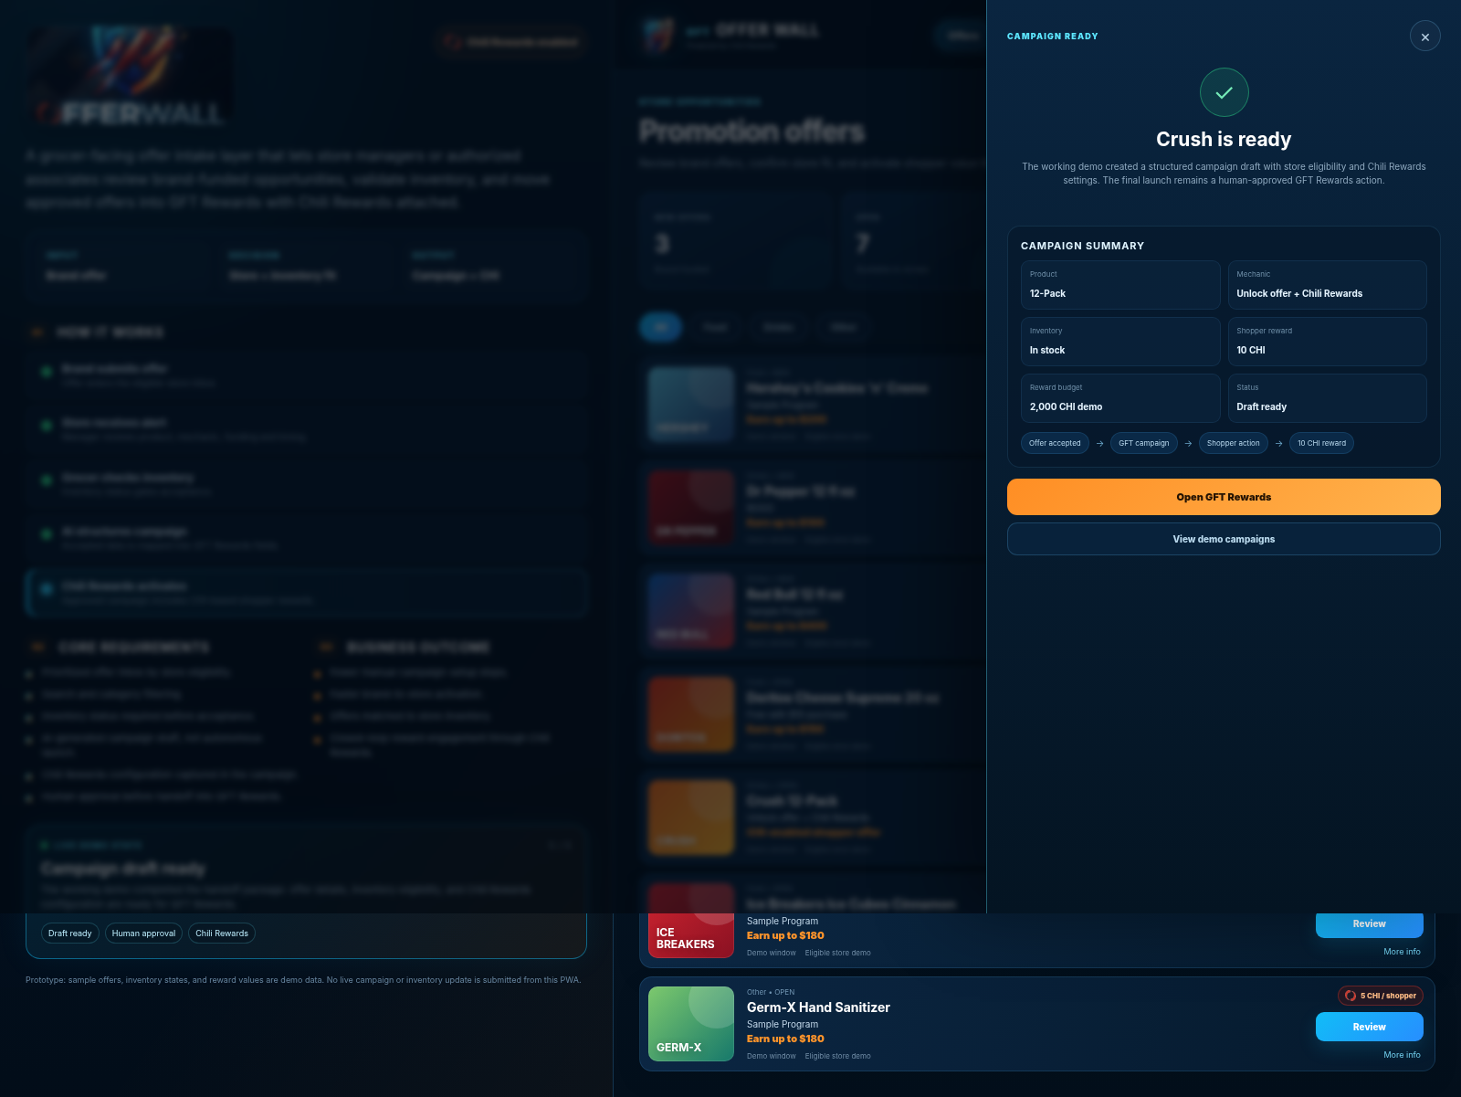
Completed demo state: campaign draft ready with inventory eligibility and Chili Rewards configuration.

