Explicit the needs and objectives or the work

Be clear on what we not intend to do : hot plasma, core/edge physics, sheaths physics

Modeling the plasma as a dielectric: recipe ? Can an increasing permittivity dielectric could compare coupling on an increasing density edge plasma?

Gyrotropic plasma : sigma trick to deal with boundaries.

Loss : recipe to define the sigma increase ? Does it depends of the power ?

45° plasma with Master/Slave BC.

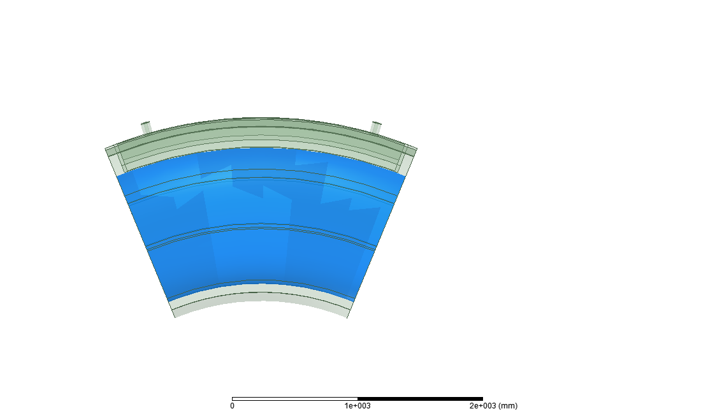 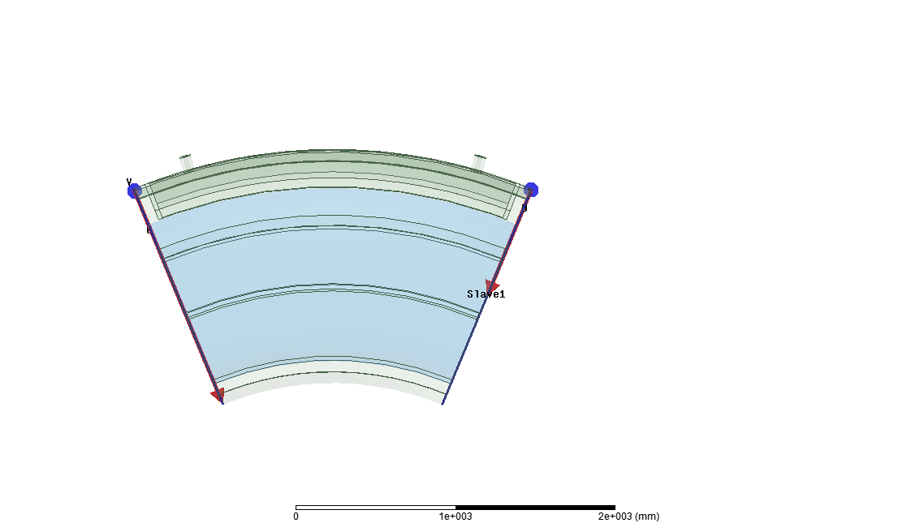

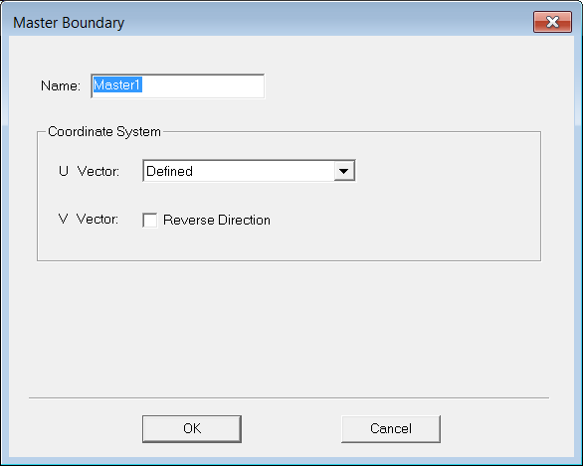 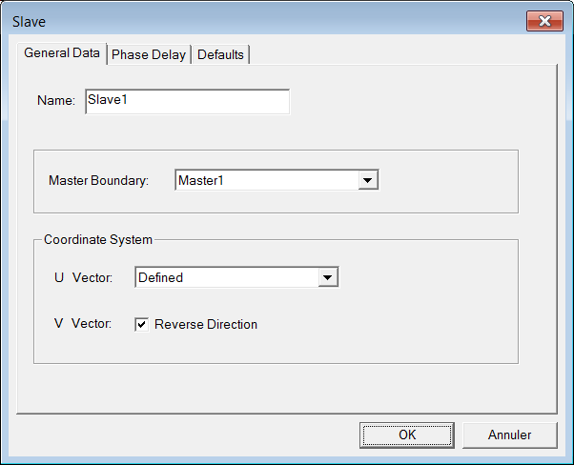 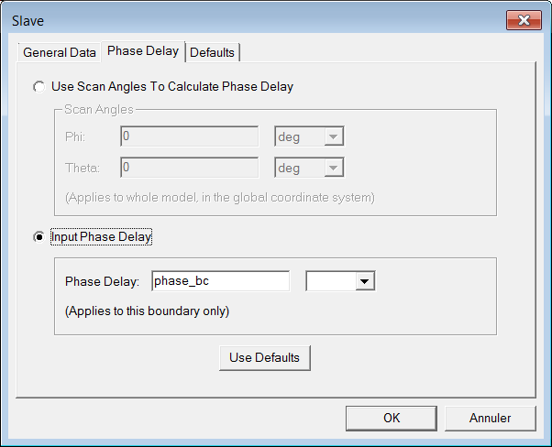

How do these results extrapolate to largest structure ? Impact of n// vs sigma and size of plasma volume?

# References

MFEM FE plasma [1]

Salted water as dielectric[2] [3]

Dielectric as plasma [4]

PML [5,6]

[1] S. Shiraiwa, J.C. Wright, P.T. Bonoli, T. Kolev, M. Stowell, RF wave simulation for cold edge plasmas using the MFEM library, EPJ Web Conf. 157 (2017) 3048. doi:10.1051/epjconf/201715703048.

[2] G.L. Ravera, S. Ceccuzzi, F. Mirizzi, A.A. Tuccillo, R. Maggiora, Analysis of the FAST ICRH antenna with salted water load using HFSS code, in: 2012 42nd Eur. Microw. Conf., IEEE, 2012: pp. 822–825. doi:10.23919/EuMC.2012.6459364.

[3] H. Bottollier-Curtet, S. Champeaux, P. Gouard, M. Primout, A. Bécoulet, X. Litaudon, R. Magne, Ferroelectric materials and metamaterials for a new approach to ITER–ICRH loads, Fusion Eng. Des. 86 (2011) 2651–2654. doi:10.1016/j.fusengdes.2010.12.053.

[4] A.M. Messiaen, R. Weynants, ICRH antenna coupling physics and optimum plasma edge density profile. Application to ITER, Plasma Phys. Control. Fusion. 53 (2011) 85020. doi:10.1088/0741-3335/53/8/085020.

[5] J. Jacquot, L. Colas, F. Clairet, M. Goniche, S. Heuraux, J. Hillairet, G. Lombard, D. Milanesio, 2D and 3D modeling of wave propagation in cold magnetized plasma near the Tore Supra ICRH antenna relying on the perfecly matched layer technique, Plasma Phys. Control. Fusion. 55 (2013) 115004. doi:10.1088/0741-3335/55/11/115004.

[6] E. Bécache, P. Joly, M. Kachanovska, Stable perfectly matched layers for a cold plasma in a strong background magnetic field, J. Comput. Phys. 341 (2017) 76–101. doi:10.1016/j.jcp.2017.03.051.