

Welcome to History 101

Home

Discussion

Grades

Files

Homework

Lab

Schedule

Test Assignments

1. Let
2. 2

**After the 1) Bronze Age collapse, most city-states in ancient Greece were governed by _____.**

**◙ Tyrannies ◙ Oligarchies**

**◙ Monarchies ◙ Democracies**

#### 

#### **2) Although the Romans claimed to be descendants from the civilized people of Troy,**

#### **it is much more likely that they were descendants of Latins, who were _____.**

◙ **Greek Colonist ◙ Etruscan natives**

**◙ Northern Barbarians ◙ Egyptian traders**

1. and
2. ( ) 2
3. gxx
4. =

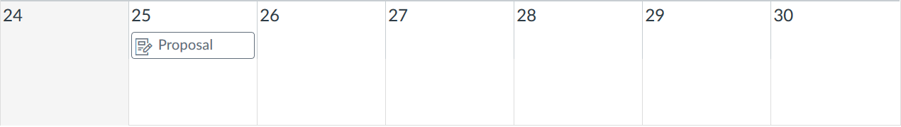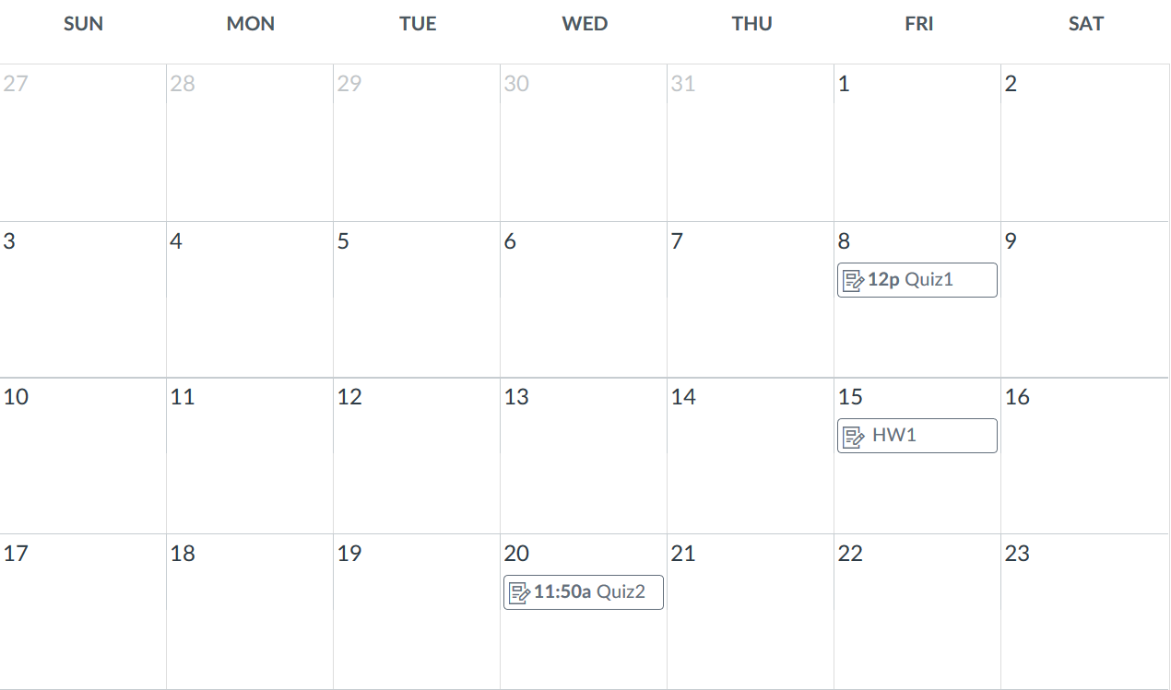

Welcome to History 101

Home

Discussion

Grades

Files

Homework

Lab

Schedule

Test Assignments

Returning users:

**An Educator: LOGIN**

**A Student: LOGIN**

New users:

**If you are an educator and you want to create a course: LOGIN**

**If you are a student and want to take a course: LOGIN**

Welcome to Learning Content Management System



HOME

ABOUT

HELP

© Teacher Tools 2017