**DON’T USE SASS or any other framework.**

**Just use HTML, CSS, and JS/PHP only!!!!**

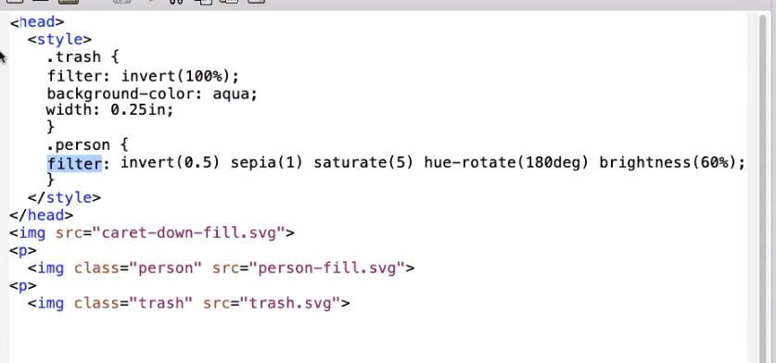

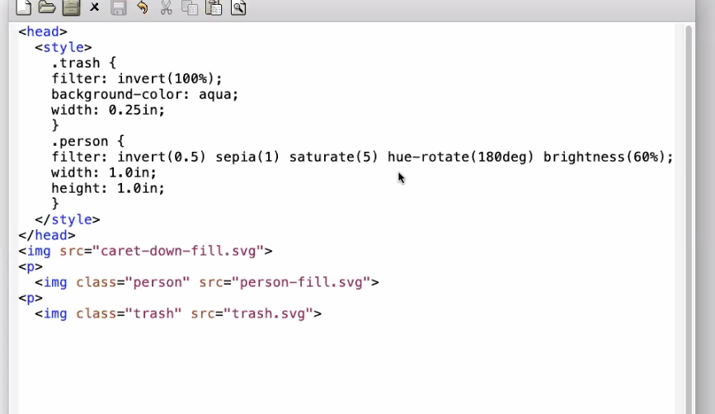

Here is CSS for the **trashcan** and **person** icon. He said we should copy this code. These imgs should also be included in our project.

<http://web.eecs.utk.edu/~bvanderz/cs465/web_project/img/>

He wants use to do our layout using

Flexbox, or Grid layouts as explained in Zybook.

NOTE:

He find that using **position** property problematic (section 5.3 in Zybook). He wants us to avoid using it!

He recommends instead of relative positioning, just use alignment from Flexbox/grid from 5.3

He recommends rounded borders from Zybook 5.4

Also, animations are better accomplished with JS

Styling forms will be very helpful in forms from 5.6

5.1, 5.2, 5.6 are what he recommends for our forms

@11:59

He shows basic layout

First use Flexbox, then gridbox

@12:17, he explains his solution

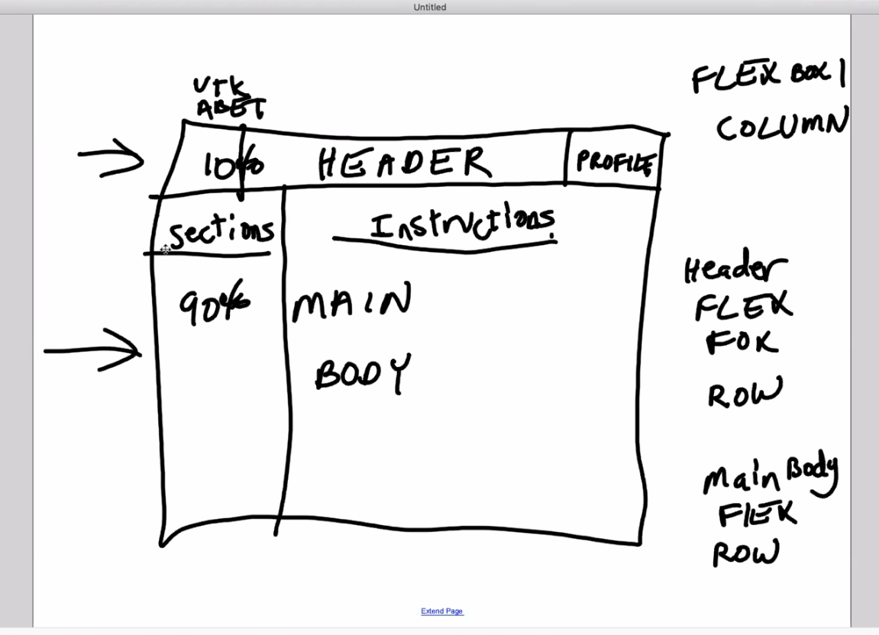

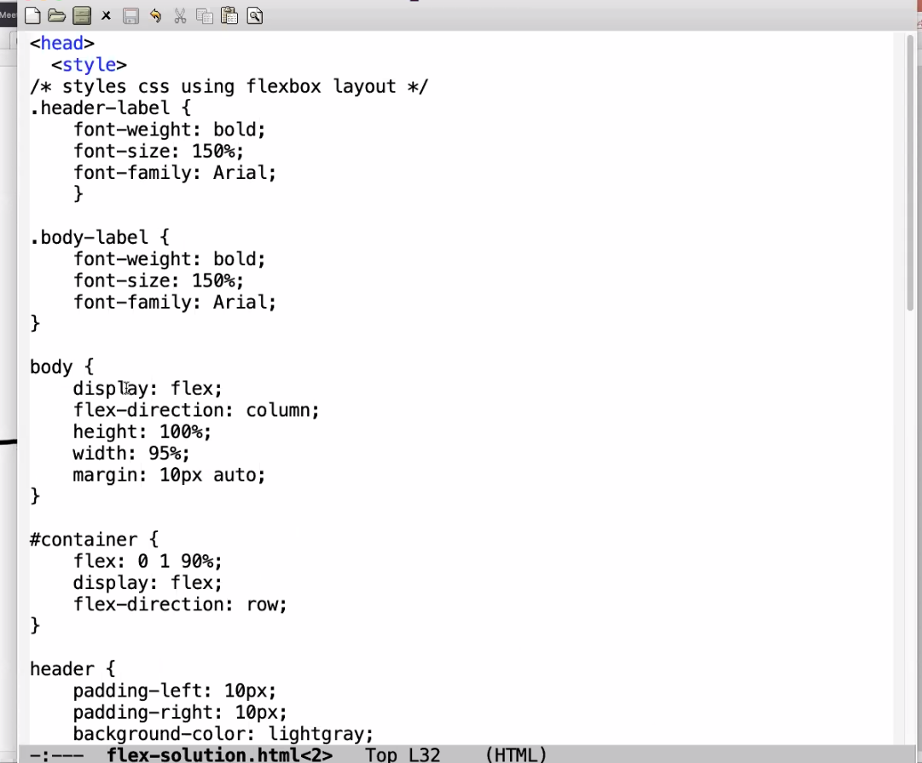

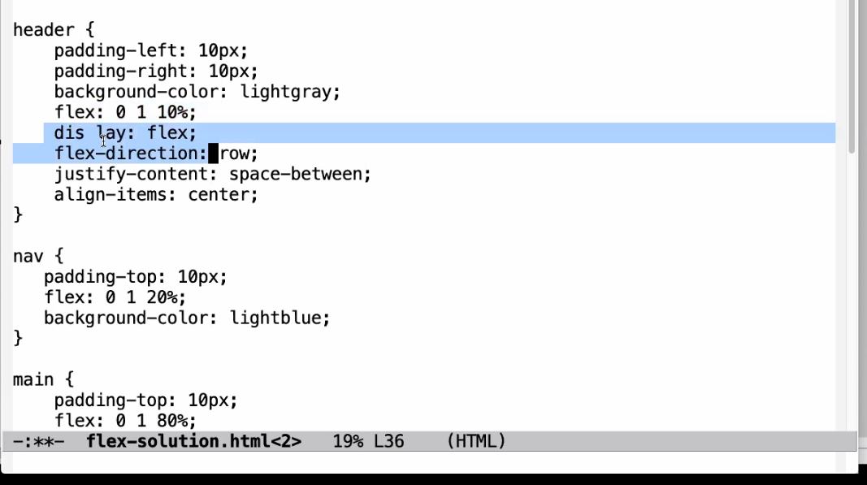

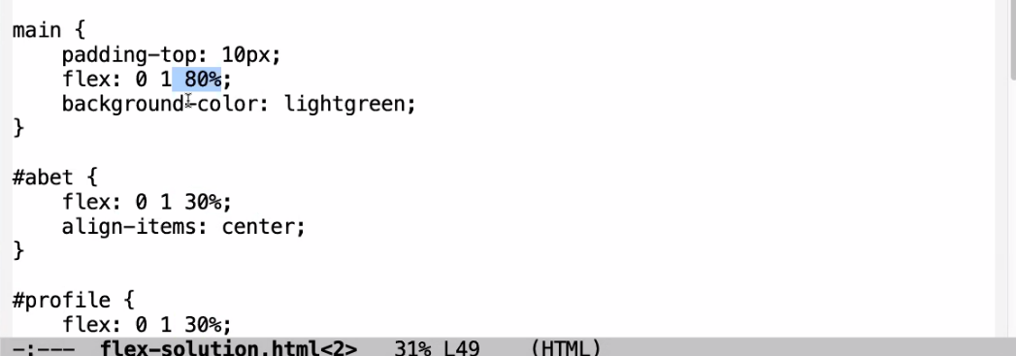

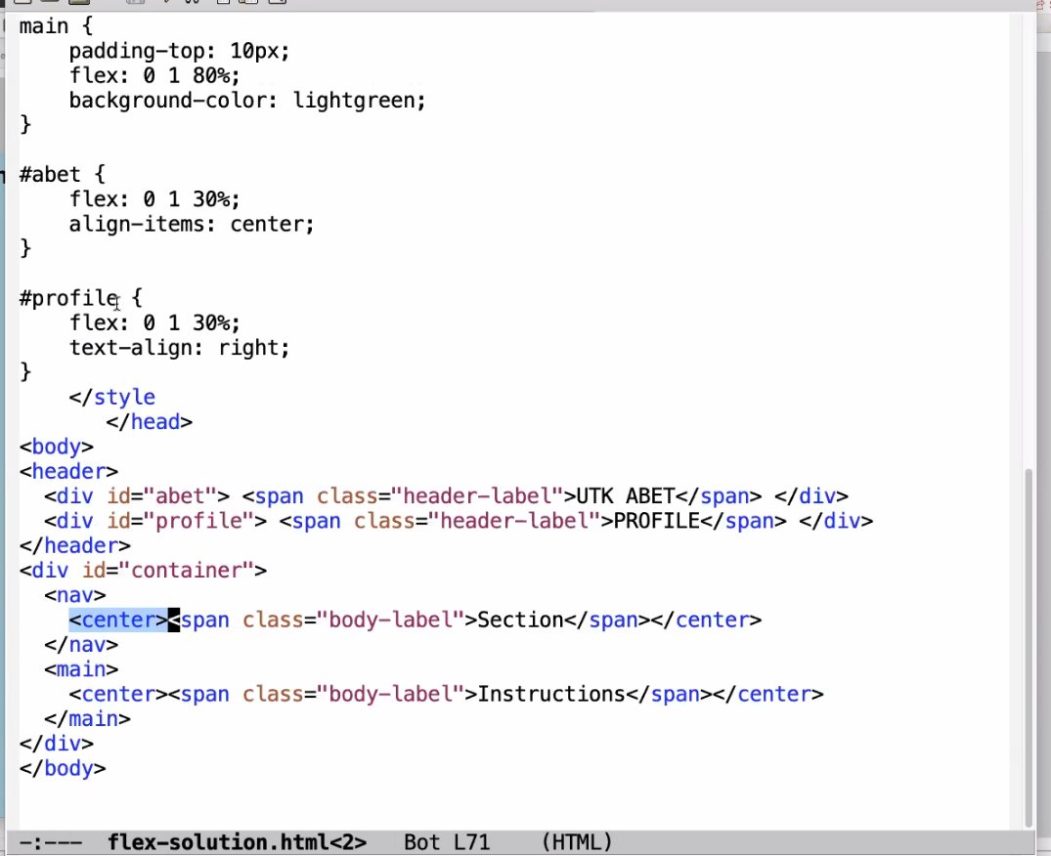

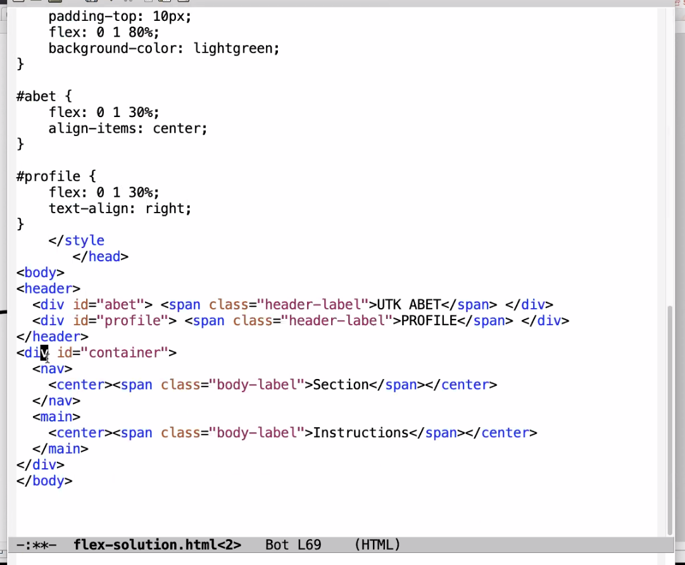

BORDERS ARE USEFUL FOR DEBUGGING WEBPAGE!!!

@12:28 he mentions this!

**WAIT WAIT WAIT!!!**

**This is obsolete idea. Ctrl + shift + I (or f12 I think) brings up the Inspector which is WAY more powerful for debugging/testing your webpage.**

**USE THIS EXTENSIVELY**

**And use GRID!!!!!!!!**

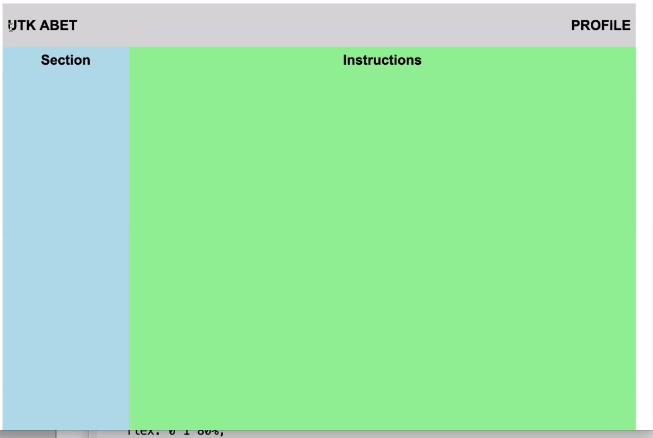

Missed out on things until 12:41

He says grid is simplier

