Software Requirements Specification (SRS)
AI-Driven Career Recommendation & Skill Pathway System
Version 1.0
Prepared by: Jhilmil Bansal, Nitika Thakral, Stuti Trivedi
Date: 17th November, 2025

1. Introduction
1.1 Purpose
This SRS describes the complete software requirements for the AI-Driven Career Recommendation & Skill Pathway System, a web-based intelligent guidance platform that analyses user academic data, interests, and skills to generate personalized career recommendations and learning roadmaps. This SRS covers all modules, interfaces, constraints, and performance expectations.
1.2 Document Conventions
- FR-x denotes Functional Requirements.
- NFR-x denotes Non-Functional Requirements.
- Bold text represents mandatory requirements.
- UML diagrams follow standard notation (IEEE/ISO conventions).
1.3 Intended Audience and Reading Suggestions
- Developers: Refer to Sections 2, 3, and 4 for functional and interface requirements.
- Testers: Refer to detailed functional requirements in Section 4.
- Project Managers: Refer to constraints and dependencies in Section 2.
- Users/Admin: Refer to Section 3 (UI and functionalities).
Reading order suggestion: Sections 1 → 2 → 4 → 5.
1.4 Product Scope
The system helps students and professionals identify suitable careers by analysing academic performance, personality traits, and skills using AI/ML algorithms. It also provides skill gap analysis and course recommendations. Benefits include improved career clarity, personalized guidance, and data-driven insights for institutions.
1.5 References
- IEEE SRS Standard (IEEE 830-1998)
- Project UML Diagrams (Analysis Models)
- Academic datasets, personality trait models
- Online Course Provider API Docs

2. Overall Description
2.1 Product Perspective
The system is a new, standalone web application using microservice architecture. It interacts with:
- ML model server for predictions
- External education APIs (Coursera, Udemy, etc.)
- Internal databases for users, profiles, skills, recommendations
2.2 Product Functions
- User registration & authentication
- Academic data input
- Interest & psychometric tests
- Career prediction (AI)
- Skill gap analysis
- Personalized roadmap generation
- Course recommendation
- Progress tracking dashboard
2.3 User Classes and Characteristics
- Student (Primary User): Basic computer and internet literacy.
- Professional: Familiar with skill development & online resources.
- Admin: Responsible for monitoring model performance, database management.
- Institution Counsellor: Uses aggregated reports.
2.4 Operating Environment
- Browser-based UI (Chrome, Edge, Firefox)
- Cloud-hosted backend services
- Linux-based servers (Docker/Kubernetes)
2.5 Design and Implementation Constraints
- Must use microservices
- Must support HTTPS communication
- Must comply with user privacy standards
- ML model must be deployable independently
2.6 User Documentation
- User Manual
- Online Help/FAQ
- Quick Start Guide
- Admin Guide
2.7 Assumptions and Dependencies
- Users provide accurate information
- Stable API access to course providers
- ML model performance depends on available datasets

3. External Interface Requirements
3.1 User Interfaces
- Modern dashboard with graphs & cards
- Profile completion interface
- Quiz interfaces (interest & personality assessment)
- Recommendation cards with scores
- Skill pathway timeline view
- Consistent header/footer, help button
3.2 Hardware Interfaces
- Compatible with desktops, laptops, tablets, and smartphones
- No specialized hardware required
3.3 Software Interfaces
- External course provider APIs
- ML model server (REST API)
- Database systems (SQL/NoSQL)
3.4 Communications Interfaces
- HTTPS over TLS 1.2+
- REST APIs for microservice communication
- SMTP/Push notification service

4. System Features
4.1 User Management
4.1.1 Description and Priority
High priority. Allows users to register, authenticate, and manage profiles.
4.1.2 Stimulus/Response
User submits credentials → System validates → Grants access.
4.1.3 Functional Requirements
- FR1: System shall allow users to register via email/phone.
- FR2: System shall validate credentials securely.
- FR3: Passwords must be hashed.
4.2 Academic & Skill Data Collection
Priority: High
Functional Requirements
- FR4: Users shall enter academic information.
- FR5: System shall store skill sets.
4.3 Career Recommendation Engine
Priority: High
Functional Requirements
- FR6: System shall process profile data and generate top 3–5 career choices.
- FR7: System shall show score justification.
- FR8: System shall handle missing data errors.
4.4 Skill Pathway Generator
Priority: Medium
- FR9: System shall perform skill gap analysis.
- FR10: System shall generate personalized learning path.
4.5 Course Recommendation Module
Priority: Medium
- FR11: System shall fetch course lists via APIs.
- FR12: System shall map skills to courses.
4.6 Progress Tracker
Priority: Medium
- FR13: Users shall update progress.
- FR14: System shall adjust recommendations.
4.7 Admin Panel
Priority: Low
- FR15: Admin shall update ML models.
- FR16: Admin shall manage database entries.

5. Other Nonfunctional Requirements
5.1 Performance Requirements
- NFR1: Career suggestions must load ≤ 3 seconds.
- NFR2: Handle 10,000 concurrent users.
5.2 Safety Requirements
- No harmful recommendations should be displayed.
- System shall warn when data is incomplete.
5.3 Security Requirements
- NFR3: Passwords hashed using SHA-256 or better.
- NFR4: Role-based access control.
5.4 Software Quality Attributes
- Availability ≥ 99% uptime
- Maintainability ensured via microservices
- High usability & accessibility
5.5 Business Rules
- Only Admin can modify ML rules.
- Users cannot edit generated recommendations.

6. Other Requirements
- Data storage must follow privacy laws.
- System logs analytical events.
- Databases must support ACID/BASE based on service type.

Appendix A: Glossary
- Skill Gap: Difference between existing and required skills.
- Career Pathway: A structured learning route.
- Psychometric Analysis: Personality assessment.

Appendix B: Analysis Models
- Behavioural Modelling

- Use-Case Diagram

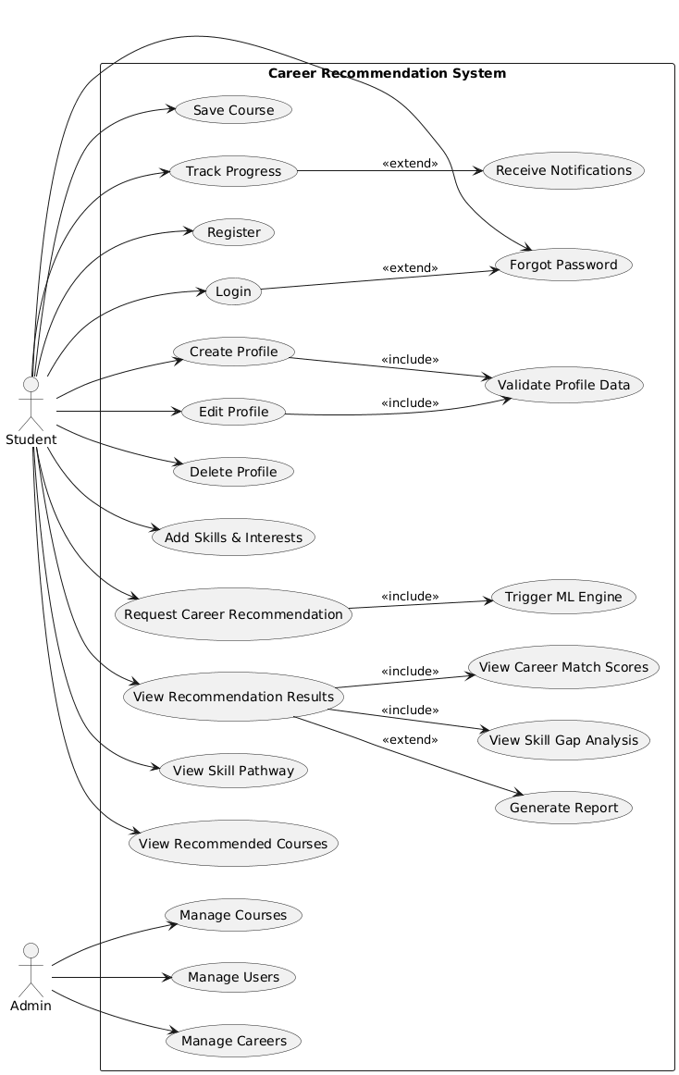

- Activity Diagram

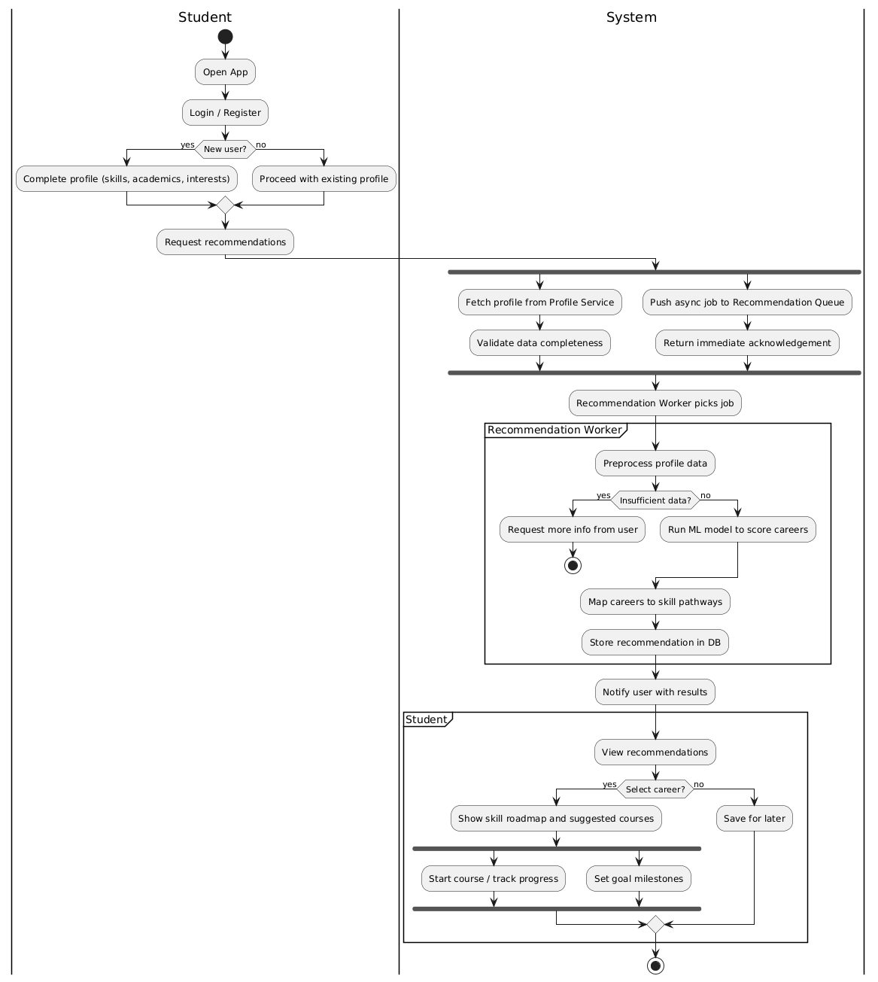

- State Diagram

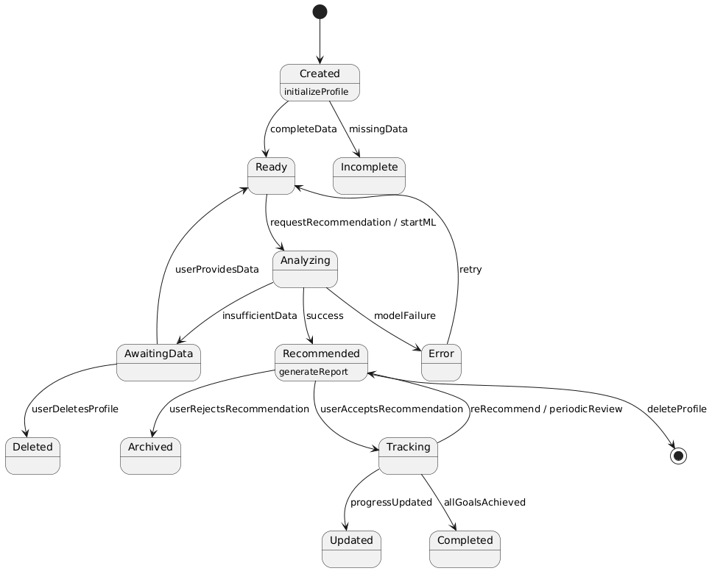

- Sequence Diagram

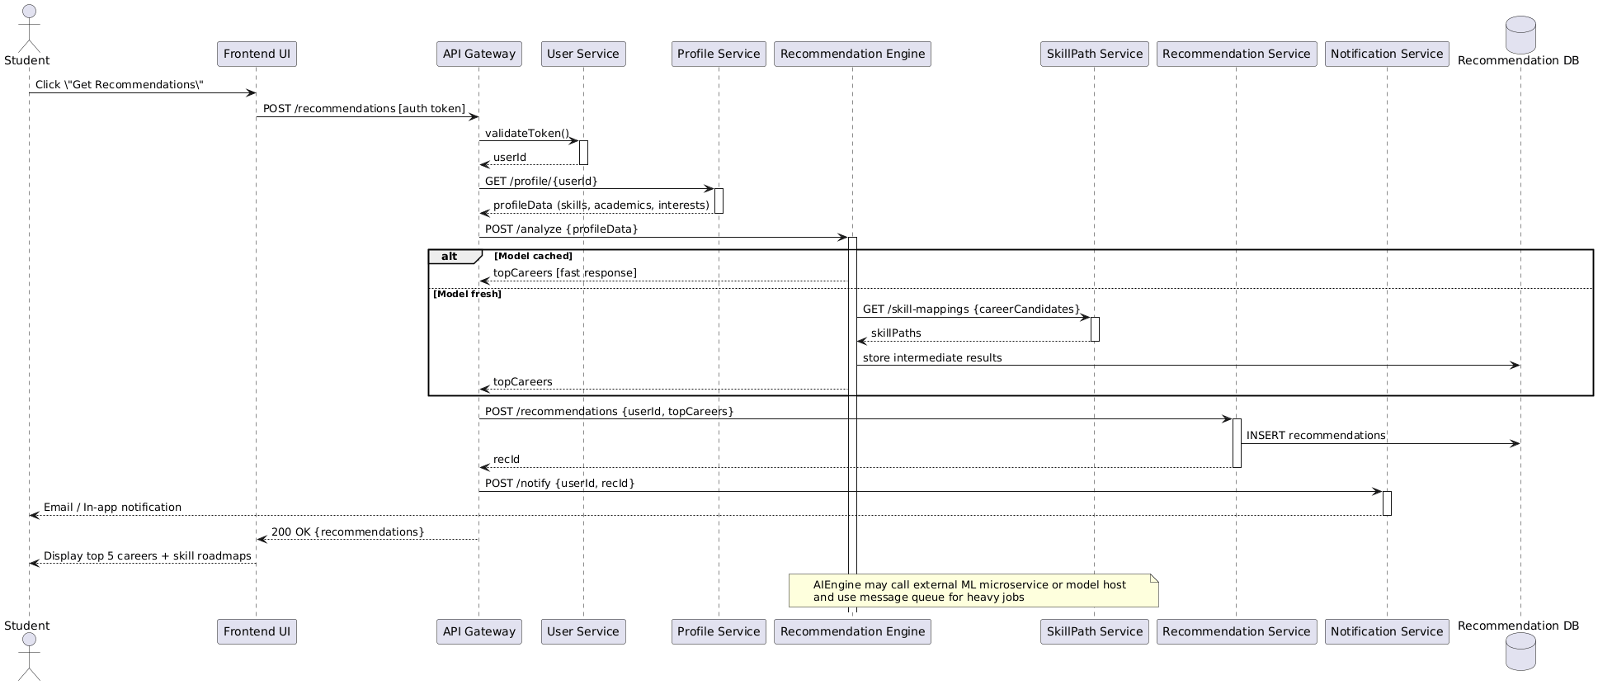

- Structural Modelling

a) Class Diagram

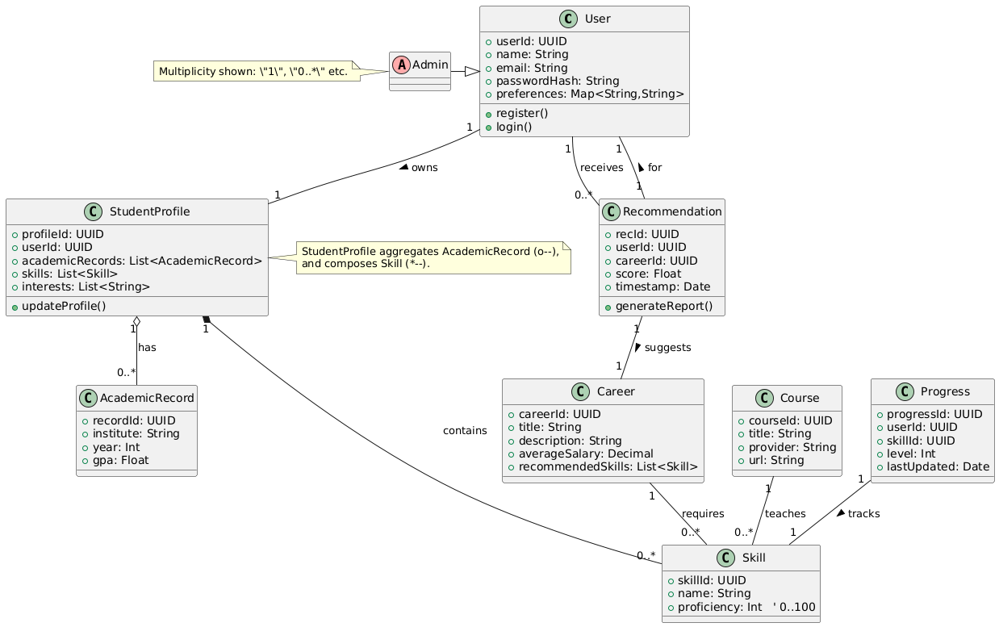

- Architecture Modelling

a) Component Diagram

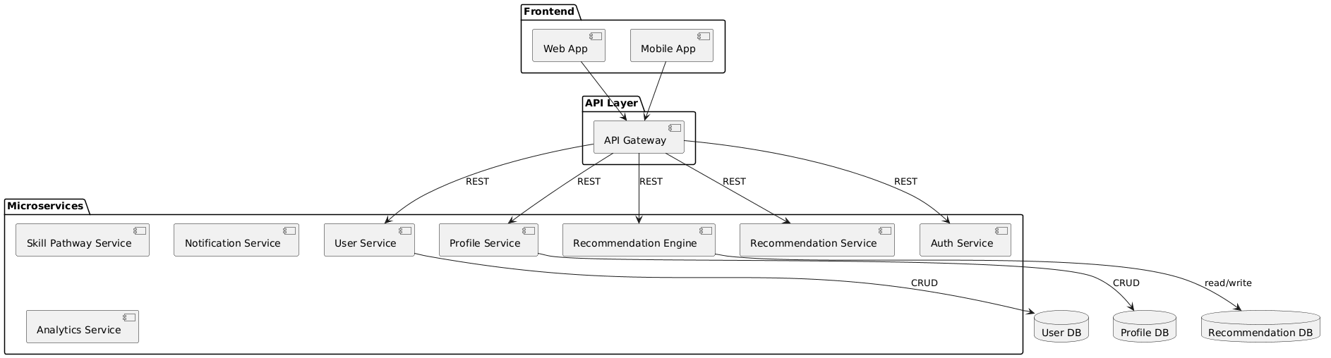

b) Deployment Diagram

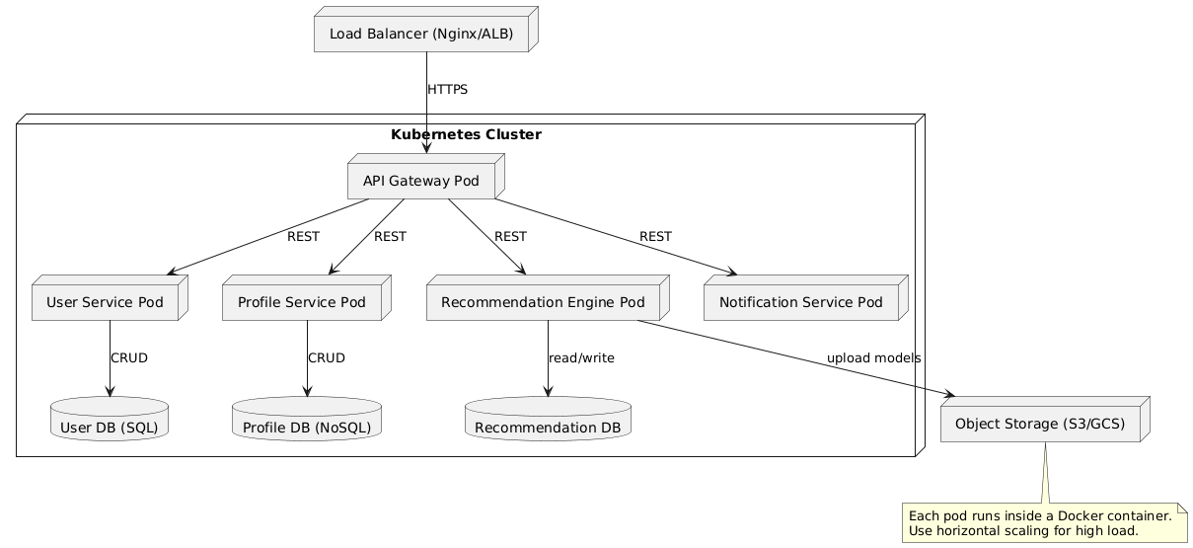

Appendix C: To Be Determined List
- TBD-1: Final ML algorithm selection
- TBD-2: API integrations with specific platforms

