Jhil’s scripts

During my internship here, I’ve made 3 scripts. They were made with the goal to avoid as much of manual actions as possible They are all located on my virtual machine which is on the TIGER PC. I use VSCode’s remote SSH extension to run them, but you can also do the same within the terminal.
1: JP_Anonymiser.py (inside DICOMTransit/)
2: MRN_Finder.py (inside Automatic/)
3: DB_MRN_Checker.py (inside Automatic/)

JP_Anonymizer.py
This script’s goal is to be able to anonymize all DICOM files (*.dcm) at a given repository and register the records in a local DB called LoggingDB. This script works separately from the current pipeline present on the BEAST PC, which enables the practicality of anonymizing patients manually. The DB contains a table called Anonymized_Patients, which is structured like this:
MRN: PatientID before anonymization
CNBPID: PatientID provided by LORIS API
StudyDate: Patient Study Date (JSON list format)
Folder: Name of folder where patient is located during anonymisation (JSON list format)
StudyDate: StudyInstanceUID (JSON list format)
StudyDate: SeriesInstanceUID (JSON list format)
* Currently, the script works with Erjun Zhang’s way of naming folders (“sub-”). A same patient could be found in multiple folders, hence a list. Same logic for StudyID and SeriesID, a same patient could have multiple.

How to use JP_Anonymizer.py
Simply run the script through a terminal or with VSCode. You will be prompted to enter a repository path. Enter the path where the DICOM files are located. Optionally, you can run the script with a single action by providing the folder path directly when running the script:
$ python3 JP_Anonymizer.py [folder_path]
The repository given should be structured as such:
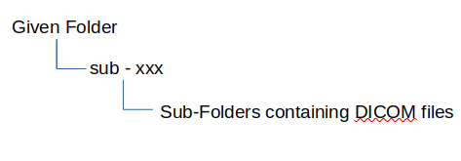

Be careful, my script doesn’t create backups and it overwrites the DICOM files. The changes are PERMANENT.
Bonus: With VSCode, there is an option to export the DB as an .html file. Dr. Lodygensky could use this to keep track of the newly anonymized patients if we can setup a way for him to access this page
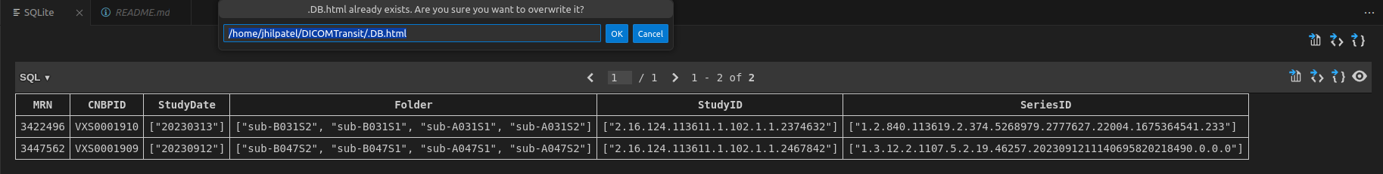

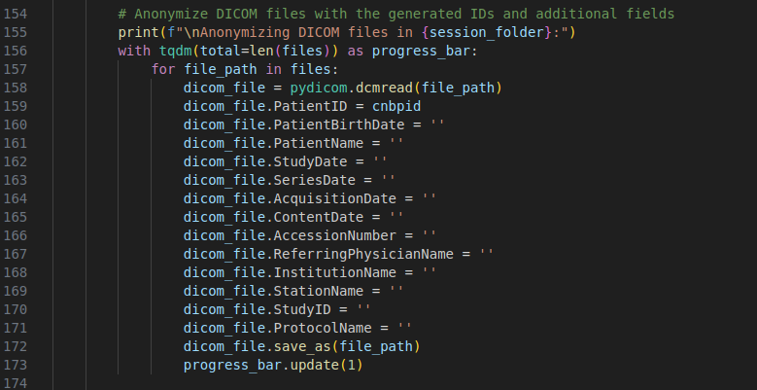
Additional fields to be anonymized can be added here:

Note: If the program crashes during anonymization, it probably means that the fields to be anonymized are empty or are missing in the DICOM files. My script assumes they exist. Also, if you see an error concerning LORIS create_candidates() , it probably means that something is wrong with LORIS, Restart the “Prod” Virtual Machine on Vuyo Bhembe’s account if needed.

MRN_Finder.py
This script’s goal is to be able to find patients on a drive by providing a list of MRN to search. It’s intend is to be used when you don’t know where patients are and you want to find them. The script works by searching in DICOM files (*.dcm) for MRNs from the list. Hence, this script could give false positives since it requires a patient folder to contain DICOM files.

How to use MRN_Finder.py
Before running the script, you must specify what MRNs you are trying to find and where you want to search here :
run the script through a terminal or with VSCode
root_folder: repository path where you want to search for patients
mrn_list: MRN you are trying to find.
Once the parameters are set, run the script through a terminal or with VSCode.
$ python3 MRN_Finder.py
The terminal will display each folder being searched and will also display when a MRN is found. At the end, it will display those that weren’t found. A text file called mrn_search_results.txt is also created once the script ends. It will contains the path of the patients found and list those that weren’t found. Keep in mind that the same text file will get overwritten if you run the script again, so copy it somewhere if needed.

DB_MRN_Checker.py
This script’s goal is to be able to check existing patients on a given database by providing a list of MRNs. The goal was to avoid any manual search and to automatize the process. The script doesn’t necessarily need MRNs to work, it can be used universally (meaning with other search values than MRNs), it just needs to be adapt for such scenarios. The script also creates text files with the found and missings MRNs in case you want to share this information.

How to use DB_MRN_Checker.py
Before running the script, you must specify what MRNs you are trying to find and what database you want to search in here :
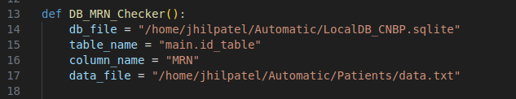
db_file: path to the database
table_name: table name in database where you want to search
column_name: column name where you want to search
data_file: path to the data.txt file

data.txt:
When I made this script, the goal was to find all MRNs from a Excel sheet. Instead of typing all the MRNs out, I simply copied the column in this text file in a folder called Patients/ to simplify the process further:

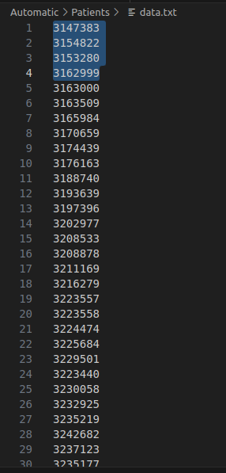

The structure of the data.txt file must be like this or else the script wont work. A list of values vertically.

Once the parameters are set, run the script through a terminal or with VSCode.
$ python3 DB_MRN_Checker.py
The script will display in the terminal the total amount of MRNs in the data.txt file, the amount found in the database and the amount that wasn’t found in the database. Two text files are created in the Log/ folder, where it lists all MRNs from the data.txt found in found_ids.txt and those that weren’t found in missing_ids.txt.

:)

