2.1

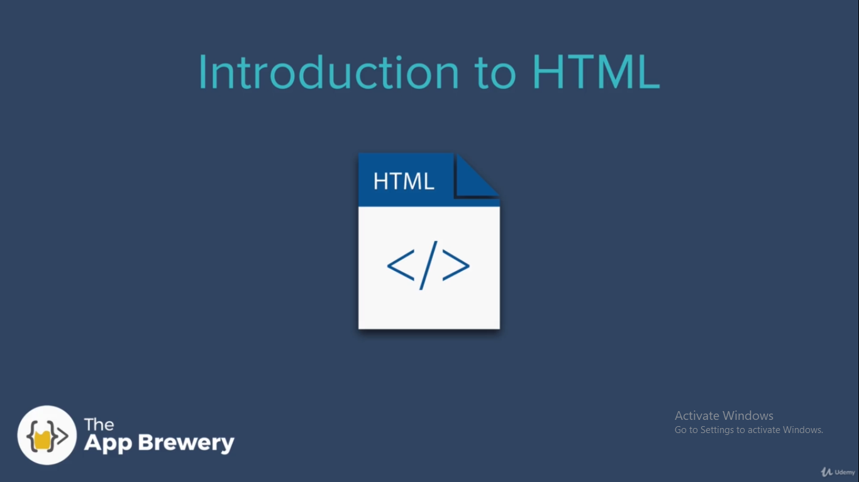
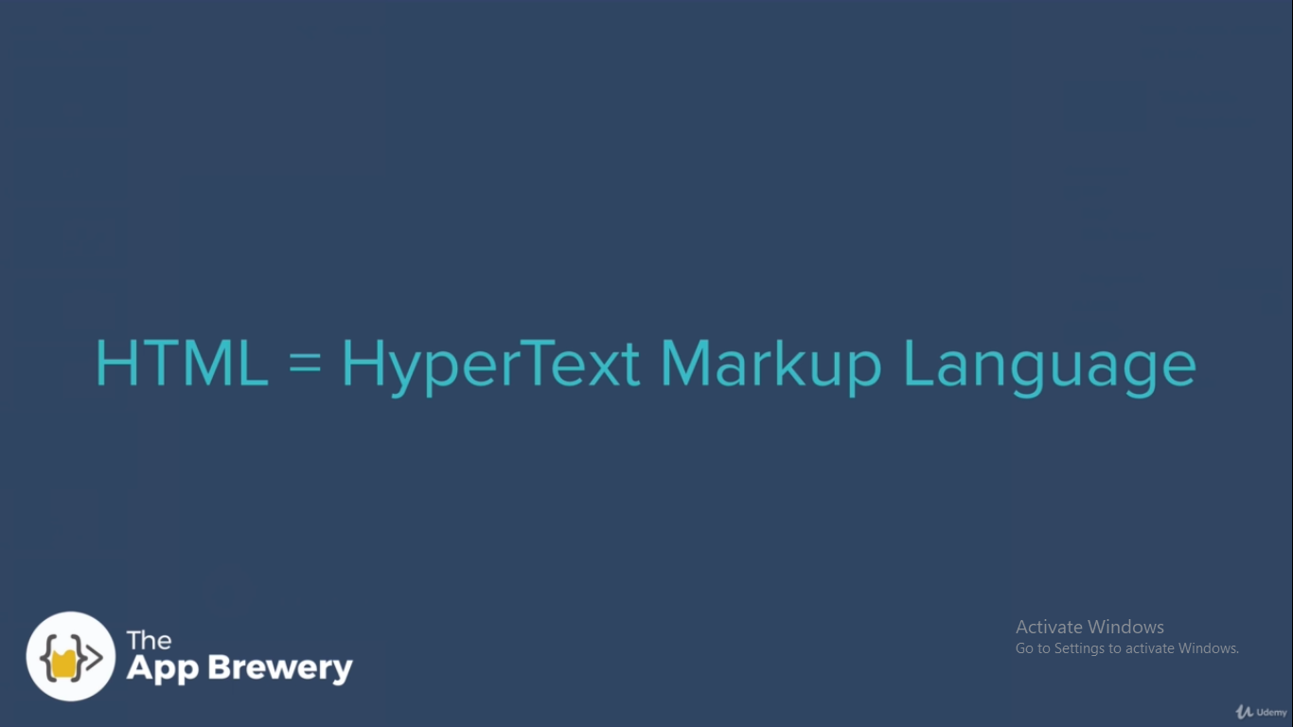

headings → h1,h2, .. , h6 (<h1> </h1>)
for line break → <br>

2.2

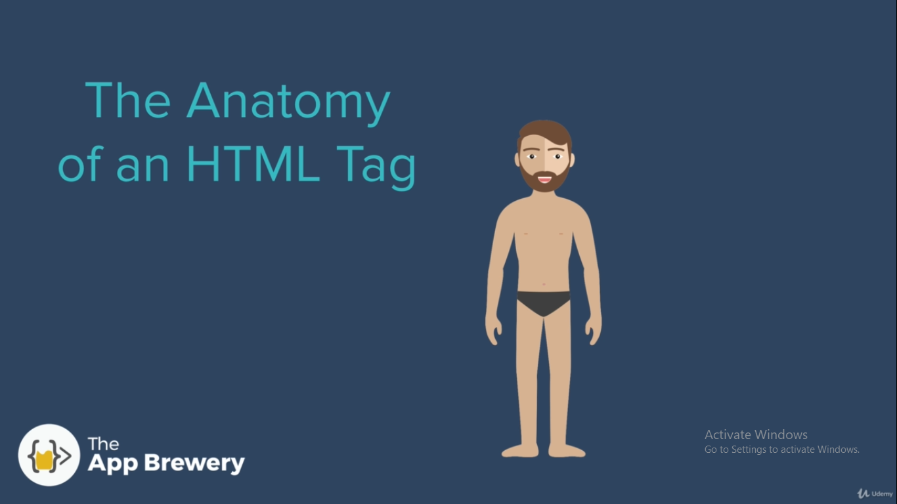
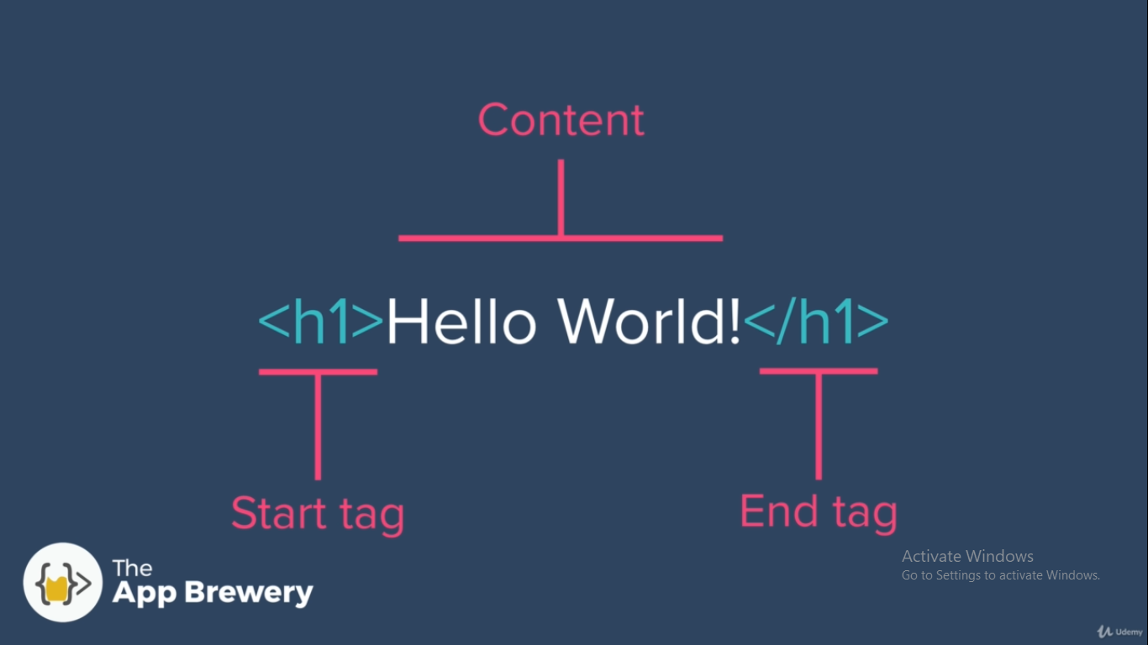
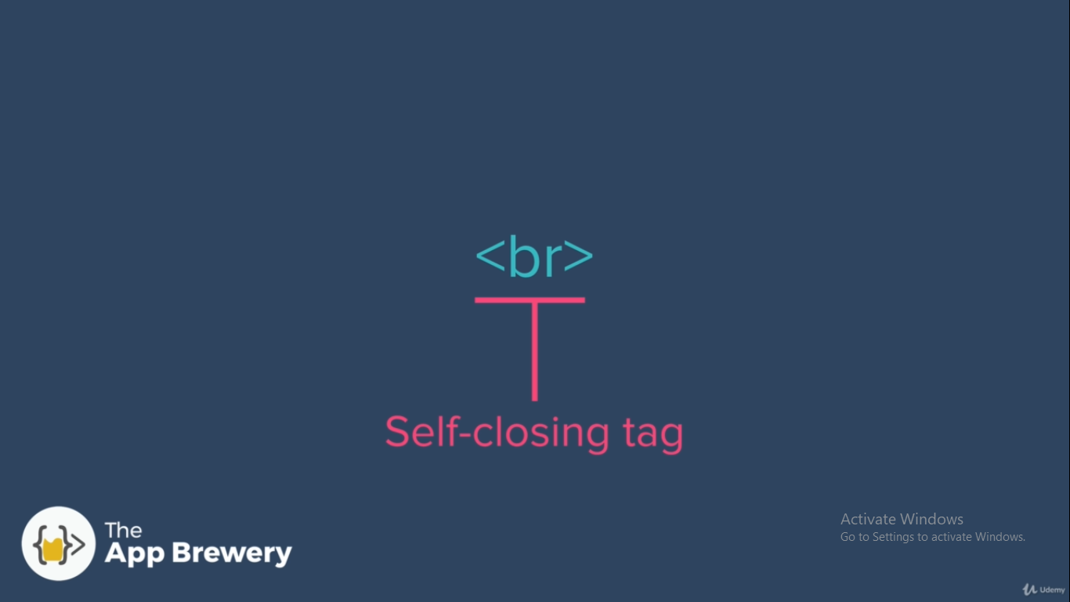
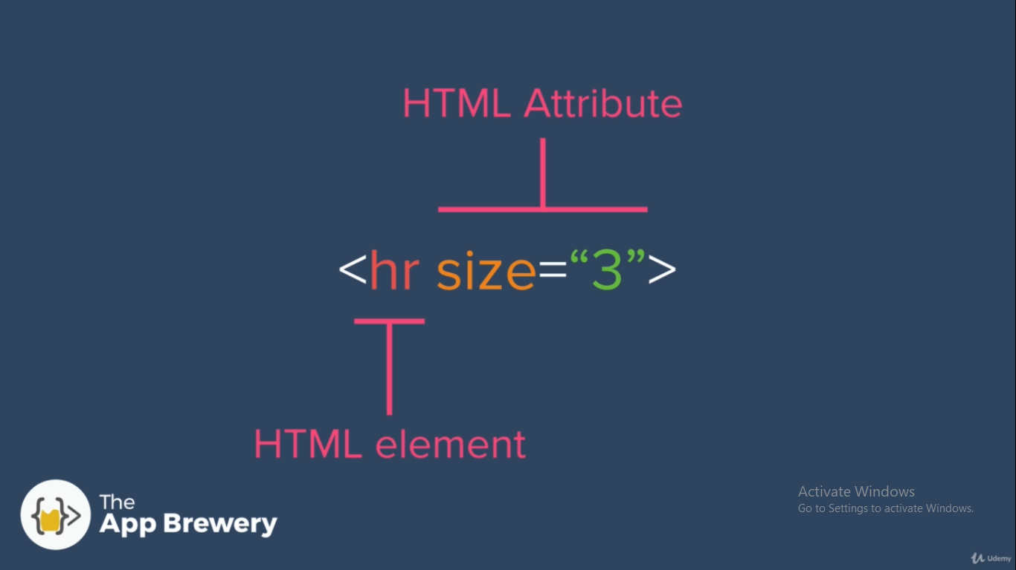
<hr> → for horizontal line
<center></center> → to allign all inside it in center

2.3
2.4

<meta> → meta information about the webpage, like description of web page
<meta charset=”utf8”> → all the text is encoded with utf8 encoded format, utf8 is a standard includes all the international characters

2.5

<em> → to emphasize text , to italisize text
<i> → to italisize text, it is just a styling
<strong> → to mark text important by bold
<bold> → to bold text , it is just a styling

2.6

<ul>
<li>
<ol>

2.7

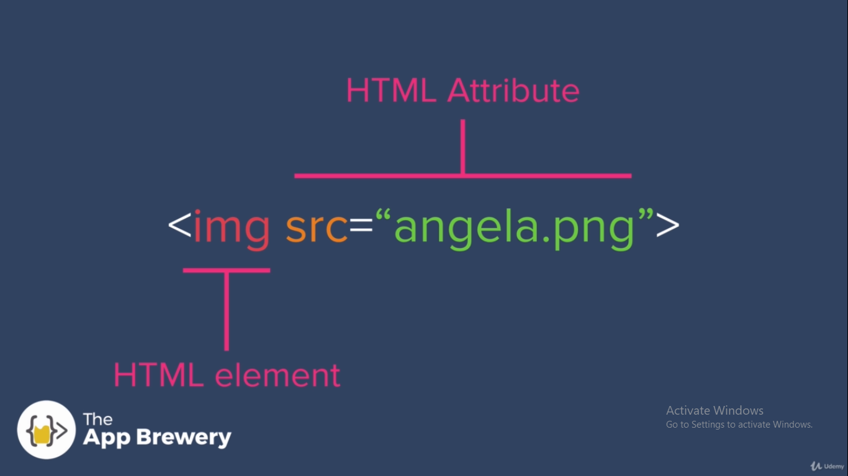
alt → if image not available , it shows this alt text. This is also used in search engine optimization to fetch keywords from site

2.8

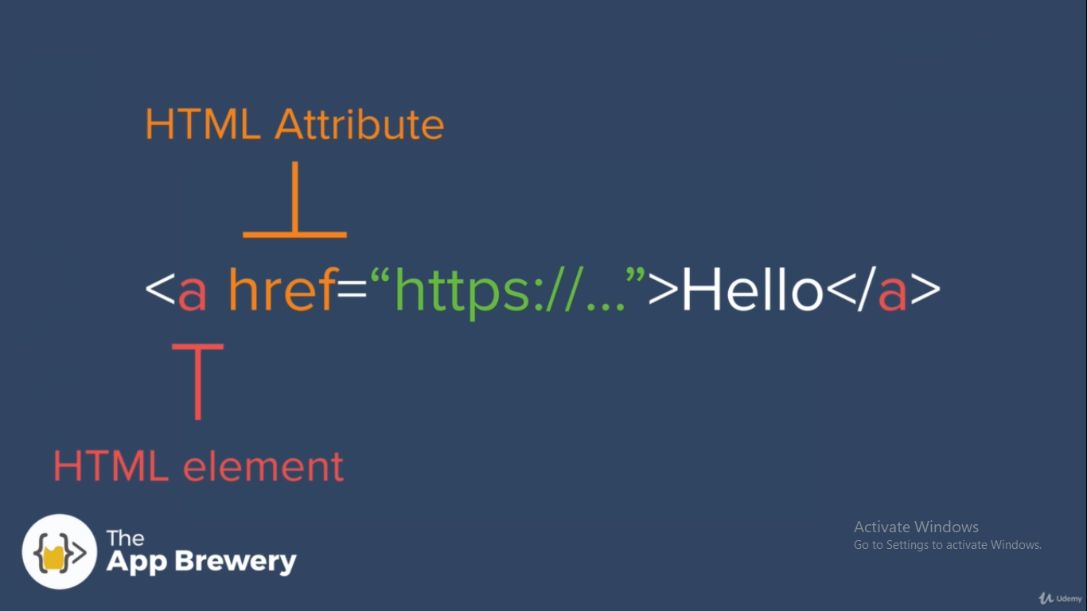
href → links to external site as well as internal site

3.1

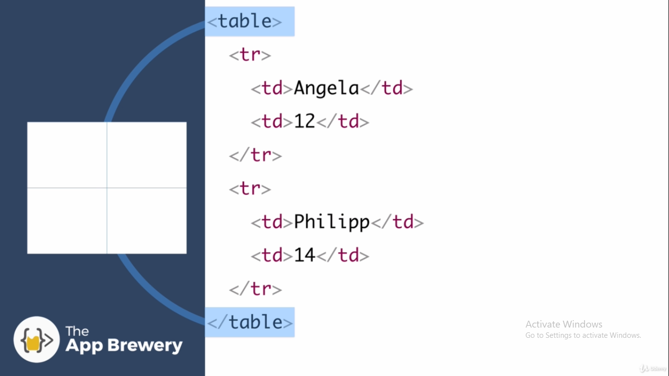
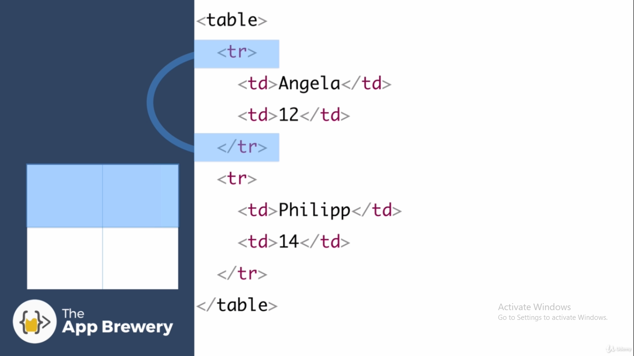
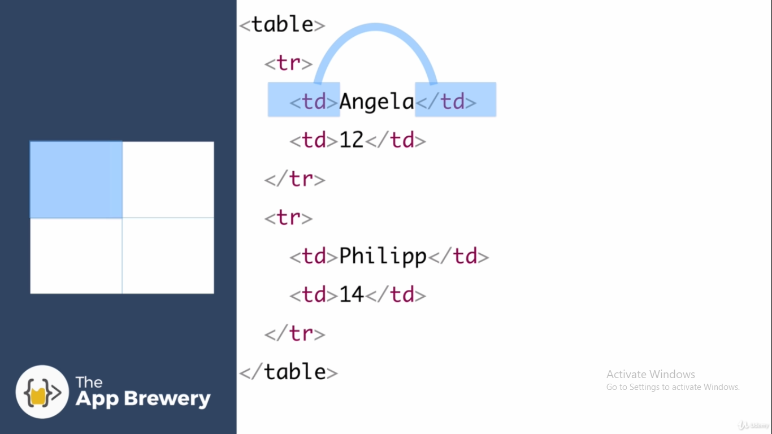
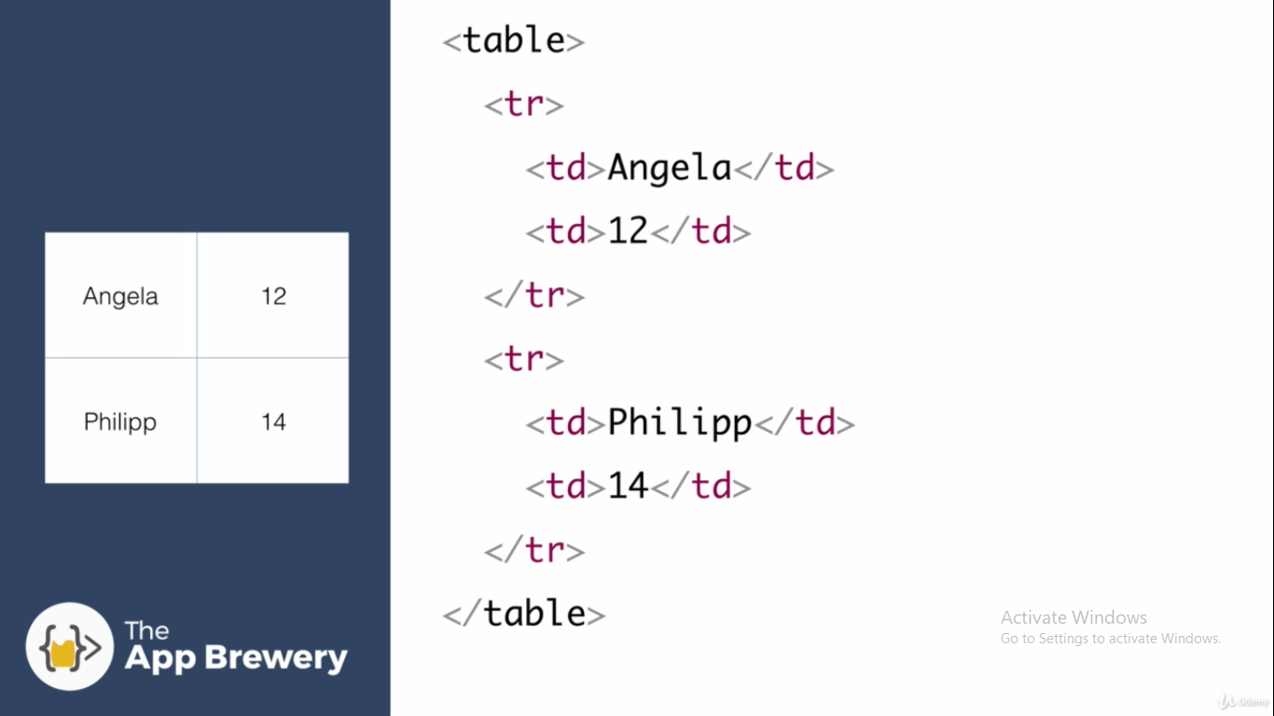

3.6

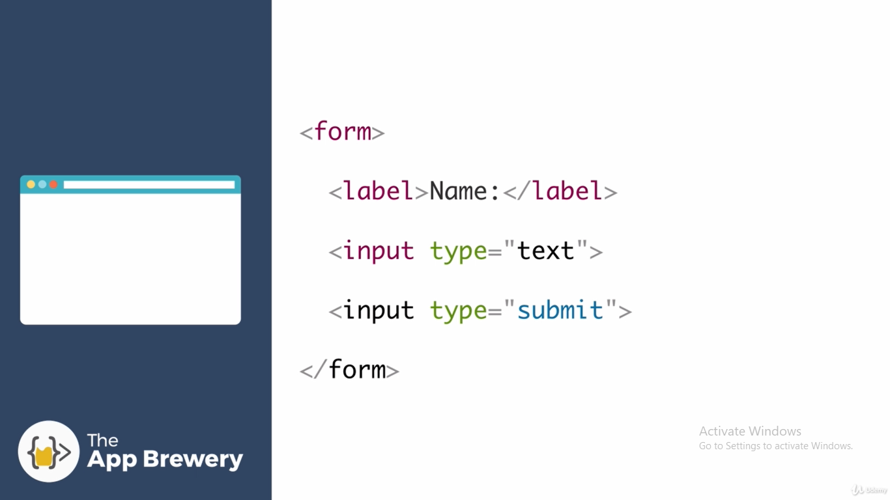
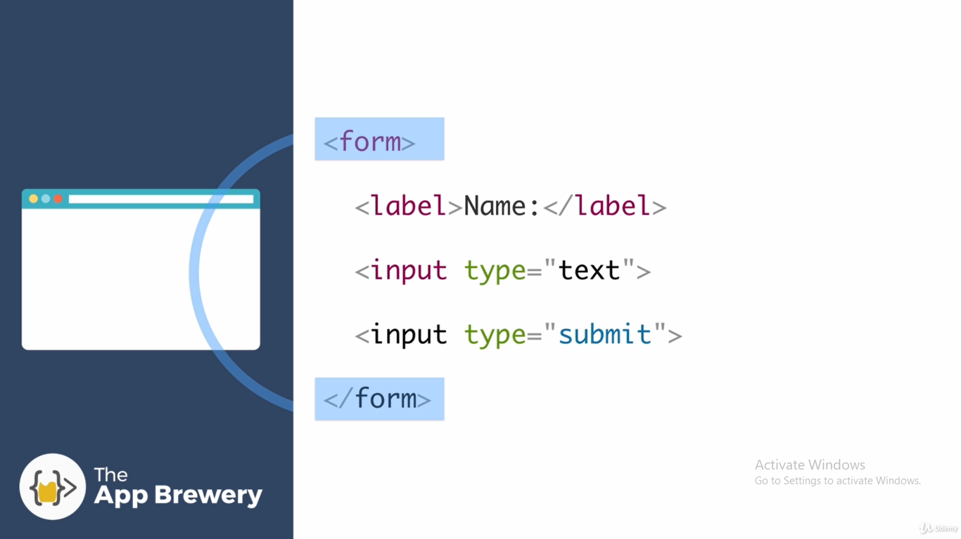
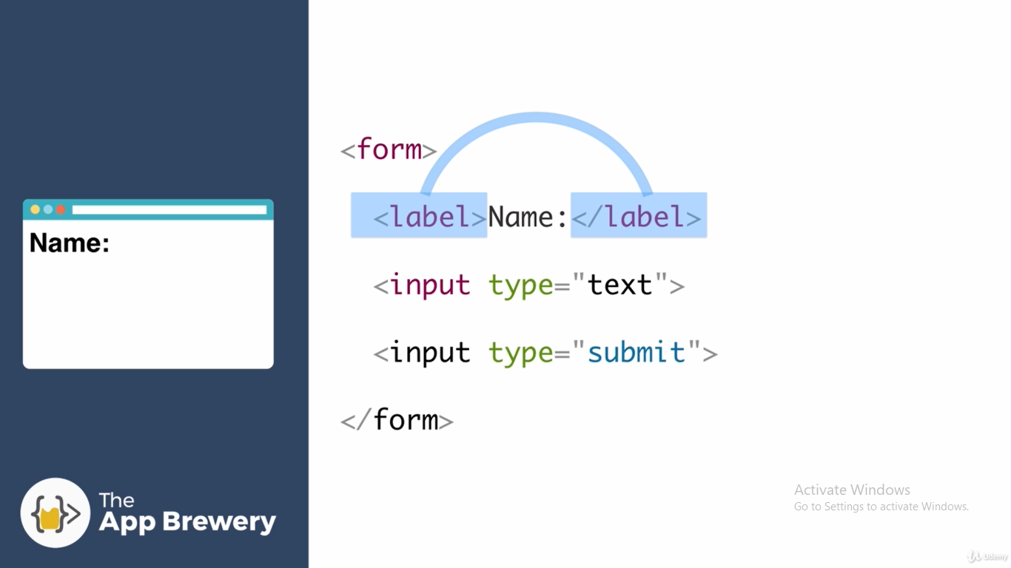
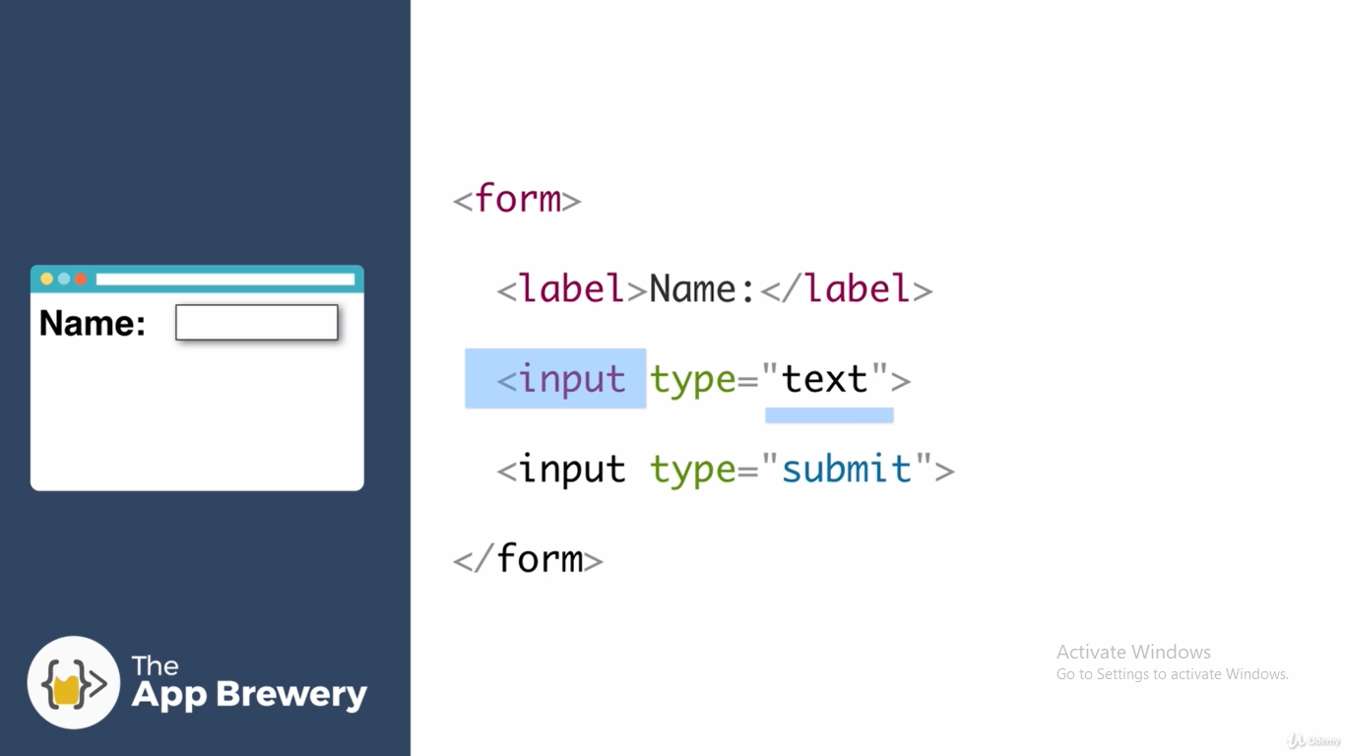
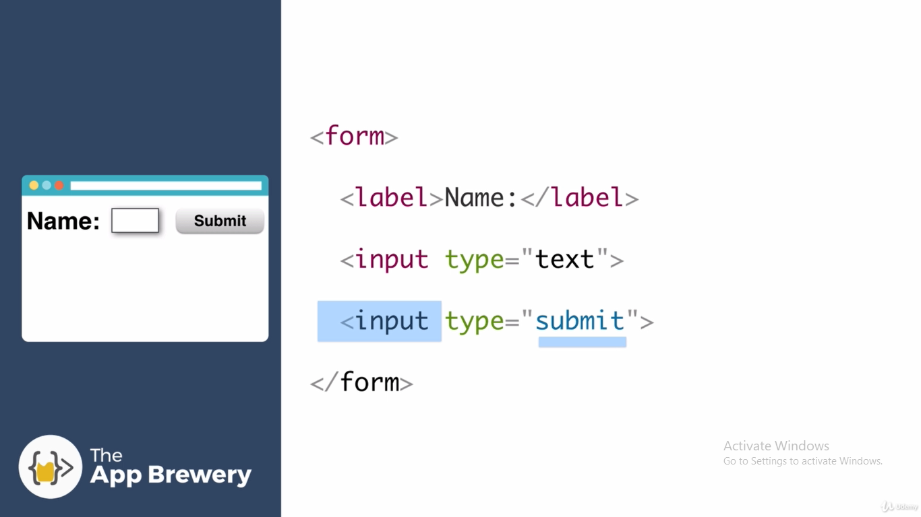
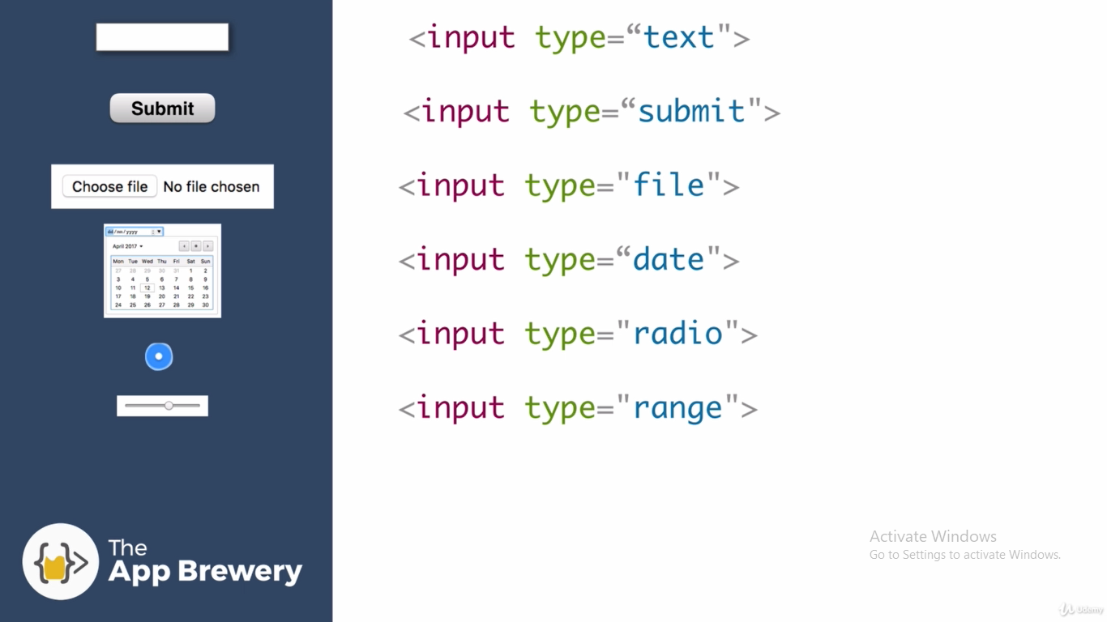

3.7
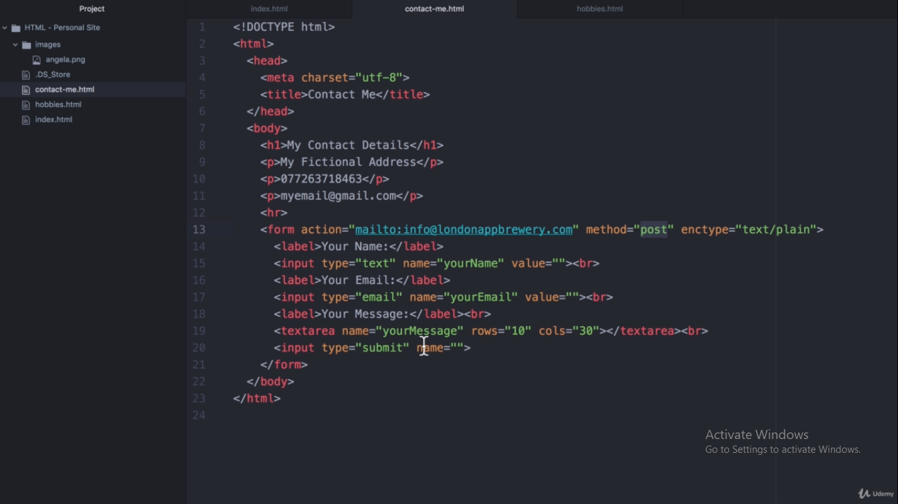
name → to receive data with that name, where we are sending data
enctype=text/plain → to set encoding to be plain text, to remove % or other unnecessary characters from data

