This package contains a version of the Subversion Integration that supports multiple Subversion repositories.

Depends on the Spring 2009 release of VersionOne (build 9.1.xxxx.x)

Configuration:

1. Configure VersionOne:
   1. Add a custom text field on ChangeSets to hold the Subversion Repository UUID. Note the System name for this field.
   2. Add a custom text field on ChangeSets to hold the Subversion Repository Friendly Name. Note the System name for this field.
   3. Publish these changes

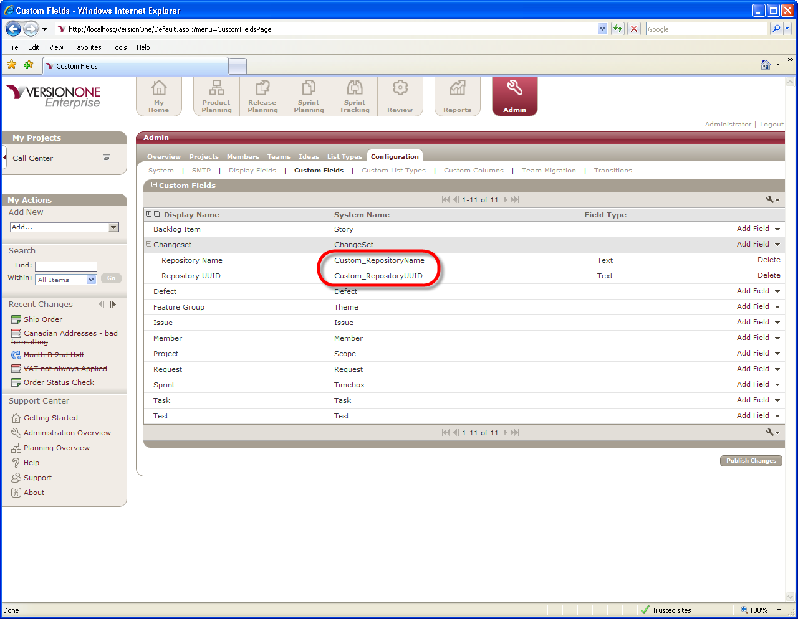

1. Configure the integration

The integration is configured in a file called VersionOne.ServiceHost.exe.config.

* 1. Configure the Subversion Reader (SvnReaderService)

This element describes how to connect with a Subversion Repository, and by default the element name is SvnReaderService. This element is configured directly when you only access one Subversion Repository. If you want to access multiple repositories, you need to copy and rename this element (don’t forget to rename both the begin tag and the end tag). Use the following table to configure each SvnReaderService regardless of name.

| Element Name | Description | Example |
| --- | --- | --- |
| RepositoryPath | Full path to Subversion Repository | svn://cidemo/Development |
| UserName | Optional. Username for a Subversion user with read permission to the specified URL | Ciserver |
| Password | Password for supplied user | Ciserver |
| ReferenceExpression | RegEx expression used when parsing commit comments to locate VersionOne asset identifiers | [A-Z]{1,2}-[0-9]+ |
| Link | This element defines how to create a VersionOne URL link to a Subversion ChangeSet. Typically this is in a Subversion Repository viewer such as ViewVC. See details below |  |
| FriendlyRepositoryNameSpec | This element defines what value will appear in the VersionOne custom text field for the Subversion Repository Name. See details below. | #URL# |

The following table describes the elements nested under Link

| Element Name | Description | Example |
| --- | --- | --- |
| Name | The Text Name used on the Link. You can specify the Subversion Change number in this name using the notation {0} | ChangeSet: {0} |
| URL | The link URL. You can specify the Subversion Change number in this name using the notation {0} | [http://cidemo/viewvc/viewvc.cgi/development/Trunk?view=rev&amp;revision={0}](http://cidemo/viewvc/viewvc.cgi/development/Trunk?view=rev&amp;revision=%7b0%7d) |
| OnMenu | Determines if the link appears as a tab on the Asset details page | True |

FriendlyRepositoryNameSpec – The following table describes the valid values for this element.

|  |  |
| --- | --- |
| Name | Description |
| #URL# | The Friendly Name custom text field in Version is populated with the Subversion URL |
| #Root# | The Friendly Name custom text field in Version is populated with the Subversion Root |
| #Path# | The Friendly Name custom text field in Version is populated with the Path |
| Text | The Friendly Name custom text field in Version is populated with the text provided |

* 1. Configure the ChangeSetWriterService

This element is used to configure the connection with VersionOne. The following tables describe how to configure this element

| Element Name | Description | Example |
| --- | --- | --- |
| Settings | This element describes how to connect to VersionOne. See details below | ChangeSet: {0} |
| ReferenceAttribute | The VersionOne attribute that will be used as a reference for the story or defect. | Number |
| RepositoryIdField | The name of the VersionOne custom text field used to hold the Subversion Repository UUID. Use the name from VersionOne, without the Custom_ prefix. | RepositoryUUID |
| RepositoryFriendlyNameField | The name of the VersionOne custom text field used to hold the Subversion Repository Friendly Name. Use the name from VersionOne, without the Custom_ prefix. | RepositoryName |
| ChangeComment | The change comment put into history for any modifications the service makes in VersionOne | Updated by VersionOne.ServiceHost |
| AlwaysCreate | False to only create a ChangeSet Asset if there are related workitems. True to always create ChangeSets. | false |

The following table describes the elements nested under Settings

| Element Name | Description | Example |
| --- | --- | --- |
| ApplicationUrl | URL to your VersionOne applications | <http://localhost/VersionOne> |
| Username | The VersionOne account username, if using native VersionOne security. If using Windows Integrated Security, leave empty. | admin |
| Password | The VersionOne account password, if using native VersionOne security. If using Windows Integrated Security, leave empty. | admin |
| APIVersion | The minimum application version required for this hosted service. | 6.5.0.0 |
| IntegratedAuth | False if using VersionOne native security, true is using Windows Integrated Security. If VersionOne is configured to use Windows Integrated Security, the account the service is running as must be a configured VersionOne user with a project role of Team Member or higher. Also, Username and Password should be empty if IntegratedAuth is true. | false |

Example:

The file V1Demo.VersionOne.ServiceHost.exe.config contains the configuration we use when demoing this integration. It shows how to configure this integration to communicate with 2 Subversion Repositories; one called Development and one called ProductSpecialists.