Supplementary materials

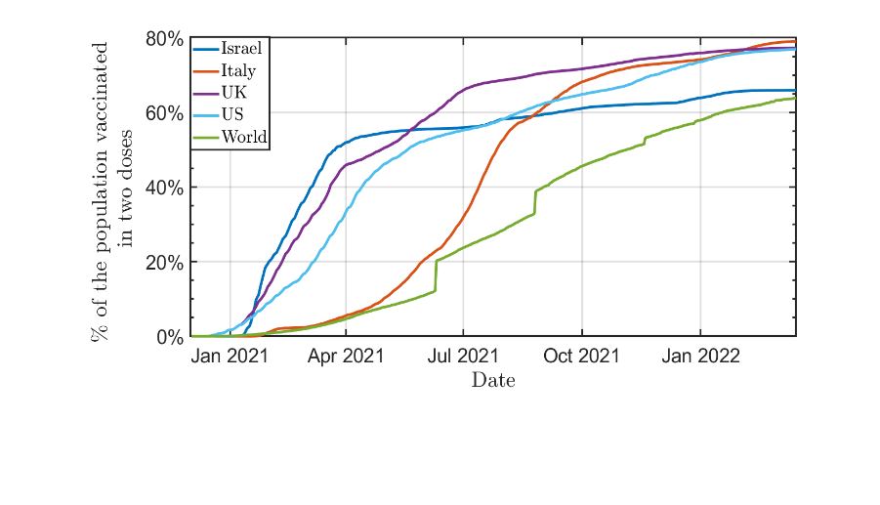
Supplementary figures
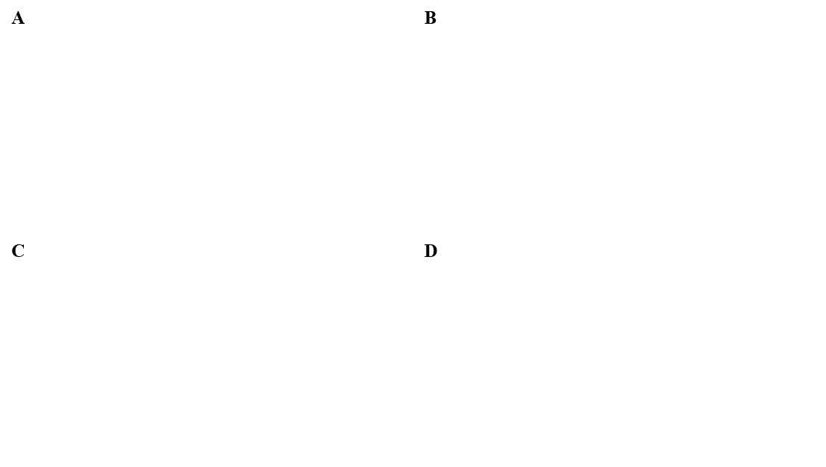

Figure S1. Time-dependent features of COVID-19 spread and detection A. The normalized number of confirmed cases as a function of time in various countries (data taken OurWorldInData). B. Variants of COVID-19 in Israel over time (data taken from CoVariants and is available in https://github.com/hdeleon1/MAM---Flexible-Monte-Carlo-Agent-based-Model-for-Modelling-COVID-19-Spread/ ). C. Percentage of the daily tested population (data taken from OurWorldInData). D. The percentage of people who have received at least two doses of vaccination (data taken from OurWorldInData).
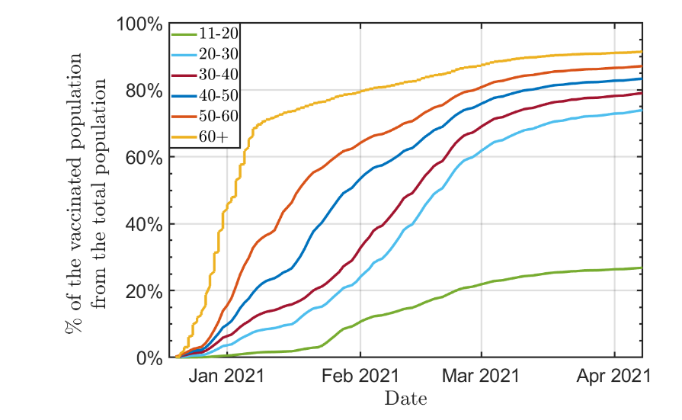  A | B
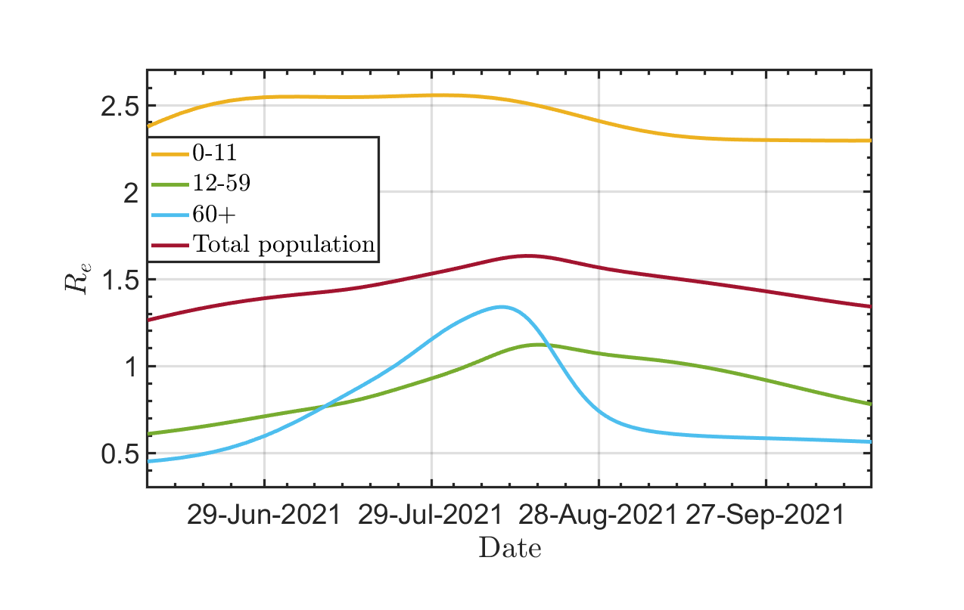  C | D
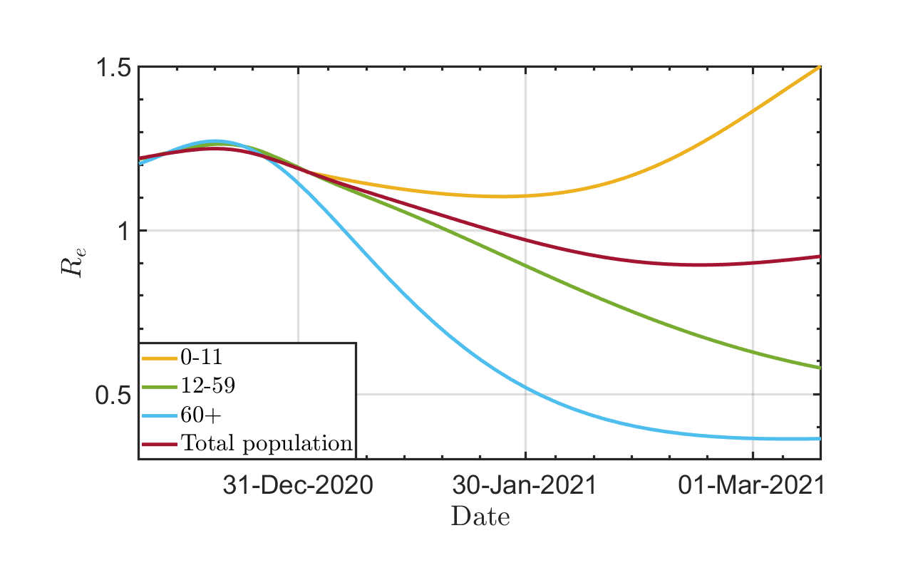
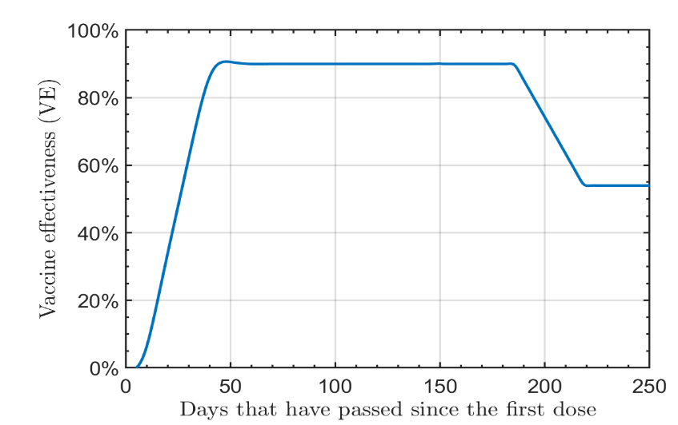
Figure S2. Data required for modeling COVID-19 in Israel. A. Vaccine effectiveness as function of time [31, 32]. B. The rate of vaccination in Israel for different age groups (data was taken from Israel MoH and available in https://github.com/hdeleon1/MAM---Flexible-Monte-Carlo-Agent-based-Model-for-Modelling-COVID-19-Spread/ ). C and D. The $R_{e}$ that was used to model the spread of COVID-19 in Israel using naive and multi-age SIR models.

Supplementary Methods

The Monte Carlo Agent-based Model (MAM) pseudocode
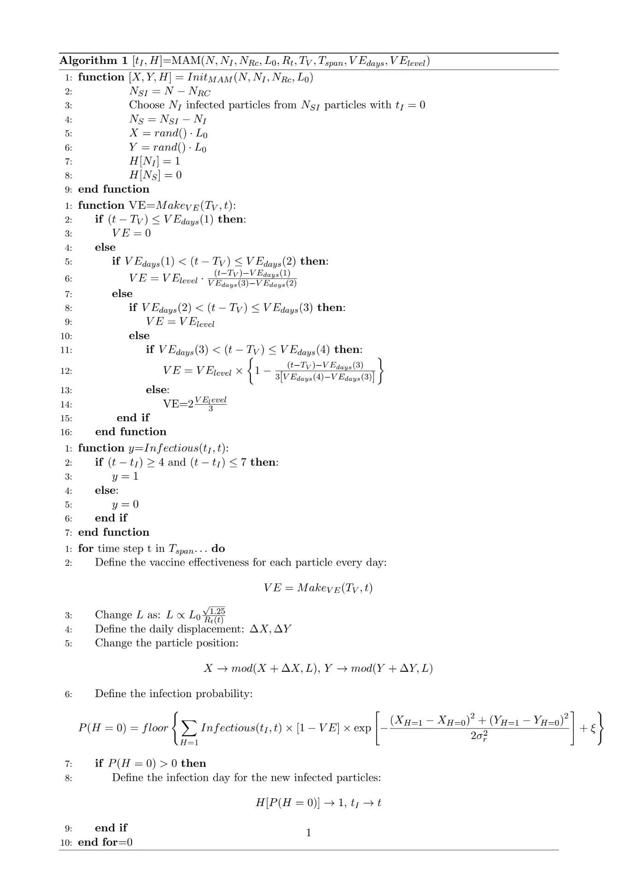
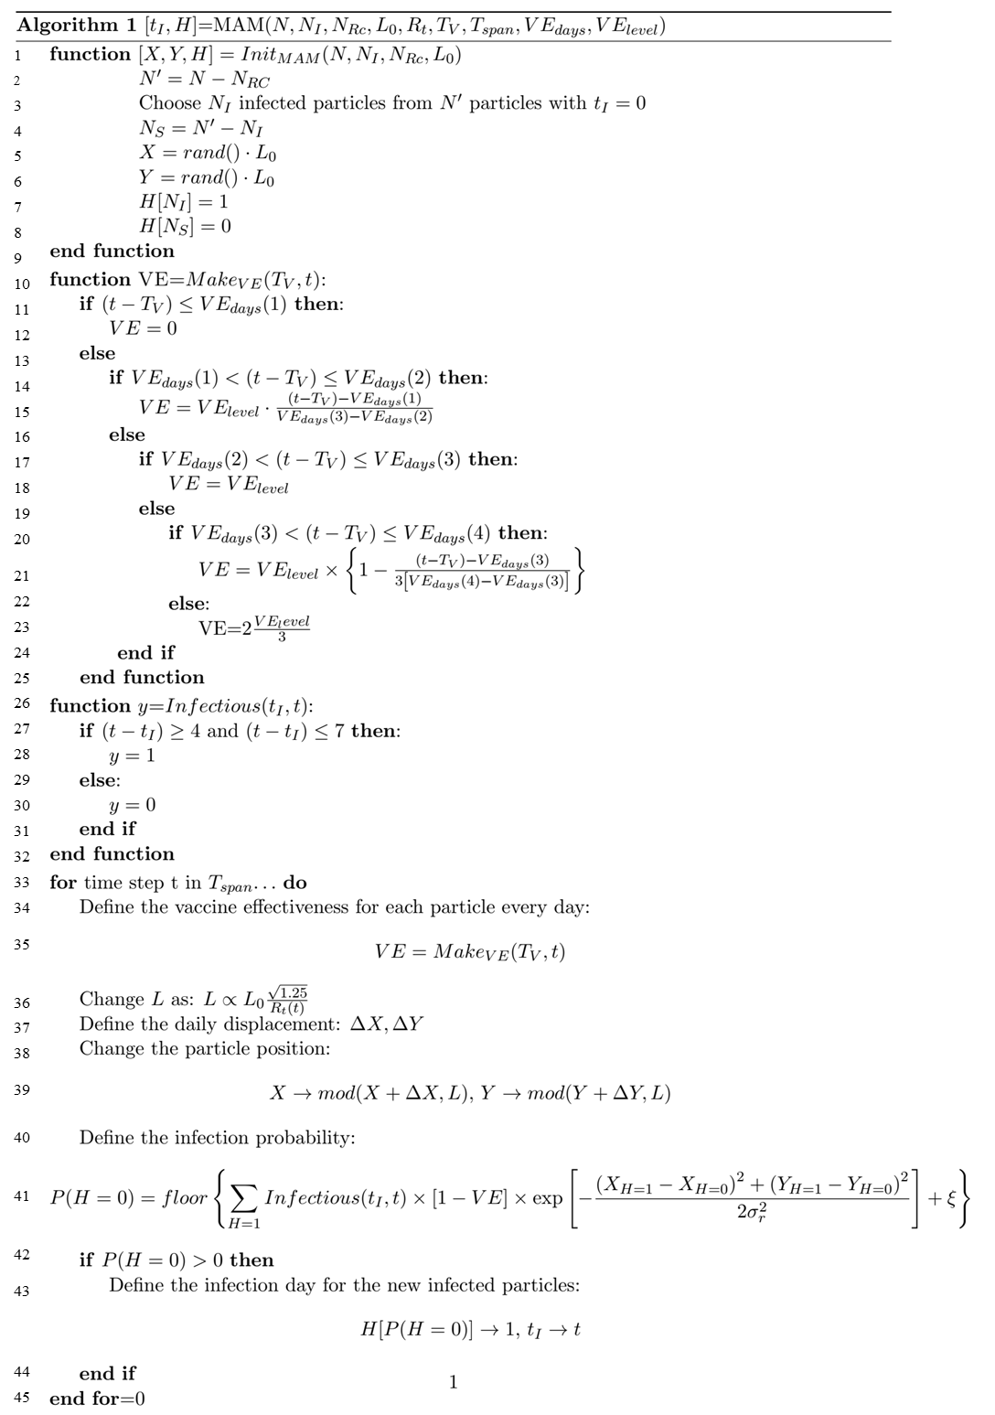

Where:
- $H$ is the health status (0 for susceptible and 1 for infected) of each particle.
- $t_{I}$ donates the particle day of infection.
- $Infectious\left(t,t_{I}\right)$is a binary function for the infection period. During the Alpha and Delta variants, the infectious period for a particle is between the fourth and seventh day after infection. During the Omicron variant, the infectious period for a particle is between the second and fifth day after infection.
- $N$ is the total number of particles, $N_{I}$ is the initial number of infected particles and $N_{RC}$ is the initial number of recovered particles. Here the simulation is set with $1·1×{10}^{4}$ particles, in which the serial number of the particle denotes its age, i.e., the top 17% numbers are the 60+ population, and the bottom 20% numbers are the 0-11 population. For simulating the population in Israel ($9.2×{10}^{6}$ people), the simulation runs ~ 840 times.
- $L_{0}$ is the initial length of the simulation area, $A$, such that $R_{t}$ is represented by the particles’ density. For the case of $N=1·1⋅{10}^{4}$ particles we find that for $R_{t}≈ 1,25, L=L_{0}=124$ meter and $L=L_{0}× \sqrt{\frac{1.25}{R_{t}}}$ , and $A=L^{2}=A_{0}×\frac{1.25}{R_{t}}$ .
- $T_{V}$ indicates the day of immunization for each particle ($T_{V}=∞$ for unvaccinated particles). We us here actual daily immunization rate by age groups taken from [40].
- $T_{span}$ is the simulation duration time
- $VE_{days}$ are the days after the first dose when vaccine effectiveness changes with $VE_{level}$ being the maximal vaccine effectiveness, i.e., for this work $VE_{days}\left(1\right)=7$ days, $VE_{days}(2)=28$ days, $VE_{days} (3)=150$ days and $VE_{days}(4)=180$ days with $VE_{level}=90\%$(see Figure S2 A).
- $X$ and $Y$ are the daily x and y positions for each particle where $Δx$and $Δy$ distribute normally with$μ=0$ and $σ =\frac{L_{0}}{2}.$ For each direction, we apply a periodic boundary condition such that: $X=\left\{\begin{aligned}X \\ X-L\end{aligned} \right.\begin{aligned}X≤L \\ X>L\end{aligned}$.
- $ξ$ is a uniformly distributed number between 0 and 1. The purpose of adding xi is to convert a continuous number to a binary number. For example, let's assume that $P=0.3$; this means that in 3 out of 10 cases, this interaction will end in infection. We transform $P$ into a binary variable (0 or 1) by adding $ξ$ to $P$ and taking only the integer part of the sum (i.e., 0.8 turns to 0 and 1.3 turns to 1). In the case of $P=0.3$, 70% of the times $ξ$ is less than 0.7, so the sum will be less than 1, and the encounter won't result in an infection.

Pseudocode for multiage SIR model:
${SIR}^{i}=$SIR_multi ($N_{I}^{i},N_{Rc}^{i},R_{e}^{i},X^{i},T_{span},I_{period},X$):

Input parameters:
n | Number of distinct groups (i.e., age groups)
$$[N_{I},N_{RC}]$$ | Number of infected and recovered population
$$X = [x^{1},...,x^{n}]$$ | Fraction of the $i^{th}$ group of the total population
$[R_{e}^{1}\left(t\right)$,… $R_{e}^{n}\left(t\right)]$ | Daily effective reproduction for each age group
$$T_{span}$$ | Simulation duration time
$$I_{period}$$ | Duration of infectious period
$$N$$ | Total population

Variables:
$$μ = \frac{1}{I_{period}}$$
$$β^{i}=R_{e}^{i}⋅\frac{μ}{N}$$ | Infection rate
$$N_{I}^{i} = I_{0}⋅x^{i}$$ | Initial infected population for the $i^{th}$ group
$$N_{RC}^{i} = N_{RC}^{i}⋅x^{i}$$ | Initial recovered population for the $i^{th}$group
$$N_{SI}^{i} = Ni⋅- N_{I}^{i} - N_{RC}^{i}$$ | Initial susceptible population for the $i^{th}$group

The code: Using solver of coupled equation (such as ode45) for solving ${SIR}^{i}$ for $t_{span}$ with the defined initial conditions $([N_{SI}^{i},N_{I}^{i},N_{RC}^{i}]$):
${SIR}^{i}=\left[\begin{matrix}\frac{dI^{i}\left(t\right)}{dt}=-μ⋅I^{i}\left(t\right)+S^{i}\left(t\right)⋅β^{i}⋅\sum_{j=1}{I^{j}\left(t\right)} \\ \frac{dS^{i}\left(t\right)}{dt}=-S^{i}\left(t\right)⋅β^{i}⋅\sum_{j=1}{I^{j}\left(t\right)} \\ \frac{dR^{i}\left(t\right)}{dt}=μ⋅I^{i}\left(t\right)\end{matrix}\right]$

Alpha outbreak
 | MAM |  | SIR
Initial number of susceptible people at Dec 1st 2020 | $$N_{SI}=N×0·95=9·2 ×{10}^{6}×0.95$$ | $$N_{SI}=N×0·95=9.2 ×{10}^{6}×0.95$$
Initial number of infectious people at Dec 1st 2020 | $$N_{I} =2000$$ | $$N_{I}=2000$$
Initial number of recovered people at Dec 1st 2020 | $$N_{RC}=N×0·05=9.2 ×{10}^{6}×0.05$$ | $$N_{RC}=N×0.05=9.2×{10}^{6}×0.05$$
Adding vaccines
$R_{t},$Represents the number of potential infections without vaccines | $R_{t}=1.1-1.2$ [30]  Represented by particle density | $$R_{t}=1.1-1.2 [30]$$
$R_{e},$Represents the number of potential infections without vaccines | There is no adaptation of $R_{e}$.  For each particle is a chance of infection if now a function of its age- group’s immunization rate which is combined with the vaccine effectiveness. | $R_{e}$ is pre calculated using the immunization rate and the vaccine effectiveness for each age group.  $R_{e}$ as function of time serves as an input for the model) Figure S2)
Vaccine rate | Until January 8 2021, the vaccination rate was taken from: https://datadashboard.health.gov.il/COVID-19/general. Form January 9 2021 and on, It is assumed that population vaccination is at a decreasing rate (separate rate for each age group) | Until January 8 2021, the vaccination rate was taken from: https://datadashboard.health.gov.il/COVID-19/general. From January 9, 2021, and on, it is assumed that population vaccination is at a decreasing rate (separate rate for each age group)
Vaccine effectiveness | 0% on days 0-7 after the first dose of vaccination and increases linearly up to 90% on the next 21 days.[31–33] | 0% on days 0-7 after the first dose of vaccination and increases linearly up to 90% on the next 21 days. [31–33]

Table S1. Parameters needed for modeling the Alpha outbreak in Israel for both sir and MAM models.
Delta outbreak
Initial number of susceptible people on July 15th 2021 | $$N_{SI}=N×0.9=9.2×{10}^{6}×0.9$$ | $$N_{SI}=N×0.9=9.2×{10}^{6}×0.9$$
Initial number of infectious people on July 15th 2021 | $$N_{I} =2000$$ | $$N_{I}=2000$$
Initial number of recovered people on July 15th 2021 | $$N_{RC}=N×0.1=9.2× {10}^{6}×0.1$$ | $$R_{RC}=N×0.1=9.2× {10}^{6}×0.1$$
Adding waning immunity and booster dose
$R_{t}$ Represents the number of potential infections without vaccines | $$R_{t}=2.2-2.5,$$  Represented by particle density | $$R_{t}=2.2-2.5$$
$$R_{e}$$  Represents the number of potential infections without vaccines | There is no adaptation of $R_{e}$.  For each particle is a chance of infection if now a function of its age- group’s immunization rate which is combined with the vaccine effectiveness and waning immunity. | $R_{e}$ is pre-calculated using the immunization rate and the vaccine effectiveness and waning immunity for each age group.  $R_{e}$ as function of time serves as an input for the model) Figure S2)
Vaccine rate | Assuming the same rate as the alpha outbreak (https://datadashboard.health.gov.il/COVID-19/general.) | Assuming the same rate as the alpha outbreak (https://datadashboard.health.gov.il/COVID-19/general.)
Vaccine effectiveness | 0% on days 0-7 after the first dose of vaccination and increases linearly up to 90% on the next 21 days. [31–33]  Decline to 60% effectiveness starting from 180 days after the first dose.[34] | 0% on days 0-7 after the first dose of vaccination and increases linearly up to 90% on the next 21 days. [31–33]  Decline to 60% effectiveness starting from 180 days after the first dose. [34]
Vaccine effectiveness – booster dose | Increase to 90% 7 days after the booster dose. [35] | Increase to 90% 7 days after the booster dose. [35]

Table S2. Parameters needed for modeling the Alpha outbreak in Israel for both sir and MAM models.

Omicron outbreak
 | MAM | SIR
Initial number of susceptible people at Dec 1st 2021 | $$N_{SI}=N×0.95=9.2×{10}^{6}×0.95$$  Assuming that there is less protection from infection for recovered people with Omicron | $$N_{SI}=N×0.95=9.2×{10}^{6}×0.95$$  Assuming that there is less protection from infection for recovered people with Omicron
Flux of new infected people with the BA.1 variant from Dec 1st to Dec 14th (BA.1) | $$F_{omicron}\left(t\right)=$$  $$30\exp\left(\frac{t-Dec 1^{st} }{10}\right)$$ | Assuming only Omicron form Jan 1st, 2022, with I=4000
Initial number of recovered people at Dec 1st, 2021 | $$RC=N×0.05=9.2×{10}^{6}×0.05$$ | -  $$RC=N×0.05=9.2×{10}^{6}×0.05$$
BA.1 Infection time, $t_{I}$ | $$\left\{\begin{matrix}1 & 5≥ \left(t-t_{I}\right)≥2 \\ 0 & else\end{matrix}\right.$$ | $\frac{1}{μ}$ =4 days
$$R_{t}$$  Represents the number of potential infections without vaccines | $$R_{t}=2.2-2.5$$  Represented by particle density | $$R_{t}=2.2-2.5$$
Risk of infection from the BA.1 variant | Twice as the Delta variant | Twice as the Delta variant
Vaccine effectiveness against the BA.1 variant | Protection against infection reduced to 30% (compared to Delta) | Protection against infection reduced to 30% (compared to Delta)
Flux of new infected people with the BA.2 variant from Jan 19th to Feb 2nd | $$F_{omicron}\left(t\right)=$$  $$80\exp\left(\frac{t-Jan {19}^{th } }{10}\right)$$ | -
BA.2 Infection time, $t_{I}$ | $$\left\{f\left(t,t_{I}\right)=\left\{\begin{matrix}1 & 5≥ \left(t-t_{I}\right)≥2 \\ 0 & else\end{matrix}\right.\right.$$ | -
$$R_{t}$$  Represents the number of potential infections without vaccines | $$R_{t}=2.5$$  Represented by particle density | -
Risk of infection from the BA2 variant | 50% more than BA.1 | -
Vaccine effectiveness against the BA.12variant | As BA.1 | -
Modeling the daily and active severe cases | Assuming a 0.25% chance of a confirmed case to become a severe case with an average hospitalization time of 6 days [48]

Table S3. Parameters needed for modeling the Alpha outbreak in Israel for both sir and MAM models.

