# Name __________________________ Period _____ FORM: B

**IB Physics HL2**

**Paper 1 – Topic 4 and 9**

23 minutes

**Instruction to candidates**

* Answer all the questions.
* **NO CALCULATOR** is allowed.
* For each question, choose the answer you consider to be the best and indicate your choice on the answer sheet provided. Students must use PENCIL to draw a large "**X**" in the rectangle of the letter choice they like.
* A clean copy of the **physics data booklet** is required for this paper.
* The maximum mark for this examination paper is **[15 marks]**.

1. Photovoltaic cells and solar heating panels are used to transfer the electromagnetic energy of the Sun’s rays into other forms of energy. What is the form of energy into which solar energy is transferred in photovoltaic cells and solar heating panels?

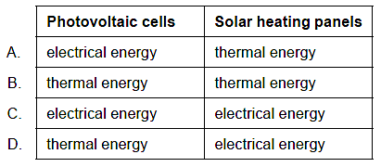

2. The Sankey diagram shows the energy transfers in a nuclear power station.

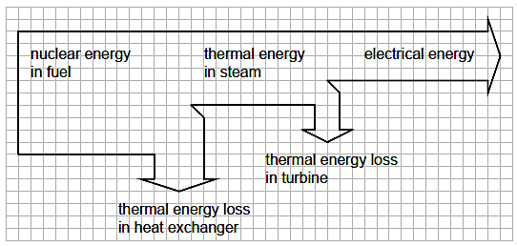

Electrical power output of the power station is 1000 MW.

What is the thermal power loss in the heat exchanger?

A.  2500 MW

B.  500 MW

C.  1500 MW

D.  1000 MW

3. A model of an ideal wind turbine with blade length $l_{0}$ is designed to produce a power $P$ when the average wind speed is $v$. A second ideal wind turbine is designed to produce a power $\frac{P}{2}$ when the average wind speed is $\frac{v}{2}$. What is the blade length for the second wind turbine?

A. $\frac{l_{0}}{2}$

B. $4 l_{0}$

C. $l_{0}$

D. $2 l_{0}$