ISMIP6 - Ice sheet model initialisation experiments InitMIP (GrIS)

Heiko Goelzer, Sophie Nowicki, Helene Seroussi, Ayako Abe-Ouchi, Jonathan Gregory, Eric Larour, Bill Lipscomb, Andy Shepherd, and Tony Payne, 6 October 2015

# Motivation

Earlier large-scale Greenland ice sheet (GrIS) experiments e.g. those run during ice2sea and SeaRISE initiatives have shown that ice sheet initialisation can have a large effect on sea-level projections and gives rise to important uncertainties. Improving initialisation techniques is currently a field of active research, which makes it difficult to prescribe one technique as the method of choice for ISMIP6. Instead, we first propose a “Come as you are”- approach, which allows participants to contribute with their currently used model setup and initialisation technique for intercomparison (initMIP). This, we hope, allows getting modellers involved early in the ISMIP6 process and keeps the workload for participants as low as possible. Furthermore, the proposed schematic experiments may facilitate to document on-going model development. Starting early in the CMIP6 process implies relying on schematic forcing for the initiation experiments that is independent from CMIP6 AOGCM output, which will only become available later on. The initMIP is the first in a series of ISMIP6 ice sheet model intercomparison activities.

# Goals

* Compare and evaluate the initialisation methods used in the ice sheet modelling community
* Estimate uncertainty associated with initialisation
* Get the ice sheet modelling community started with ISMIP6 activities
* Document on-going model development, as the simple experiments could be repeated with new model versions

# Experimental setup

Experiments are for the large scale GrIS and are designed to allow intercomparison between models of 1) the initial state itself and 2) the response in two schematic forward experiments:

1. **init**: Initialisation to present day with method of choice
2. Schematic forward experiments
   1. **ctrl**: Unforced control run (40 years minimum)
   2. **asmb**: Prescribed schematic surface mass balance anomaly (40 years minimum)

The two forward experiments serve to evaluate the initialisation in terms of model drift (2a, ctrl) and response to a large perturbation (2b, asmb). For 2a, the models are run forward without any anomaly forcing, such that whatever surface mass balance (SMB) was used in the initialization technique would continue unchanged. The perturbation in 2b consists of a given surface mass balance anomaly, which has to be applied relative to the initial SMB inherent to the individual initialisation technique. The SMB anomaly in 2b (the same for each model) is schematic and should not be considered as a realistic projection. The core experiment duration is 40 years to minimize the cost for models with computational limitations. Prolongation of the forward experiments with constant forcing up to 100 years duration (or more) is encouraged for models with the computational resources to do so. The length of the unforced control and prescribed schematic SMB anomaly experiments should be the same.

Requirements for the experiments:

* Participants can and are encouraged to contribute with different models and/or initialisation methods
* Models have to be able to prescribe a given SMB anomaly
* No adjustment of SMB due to geometric changes in forward experiments (i.e. no elevation – SMB feedback is allowed)
* No bedrock adjustment in forward experiment
* The choice of model input data is unconstrained to allow participants the use of their preferred model setup without modification. Modelers without preferred data set choice can have a look at the ISMIP6 wiki for possible options:

<http://www.climate-cryosphere.org/wiki/index.php?title=Datasets>

* The specific year of initialization (between 1950 and 2014) is equally unconstrained to allow the use of different observational data sets that may be tied to certain time periods.

The SMB anomaly can be obtained via the ISMIP6 ftp server (email [ismip6@gmail.com](mailto:ismip6@gmail.com) to obtain the log in information). Modeling groups should ideally use the 1km version to conservatively interpolate to their model native grid (see Appendix 1, below). Files of lower resolution (5km, 10km, and 20km) are provided for groups using the standard output grid (Bamber et al., 2001) as “native grid”.

For 2b, the SMB anomaly is to be implemented as a time dependent function, that takes the form of a linear function which **increases stepwise every full year** (it is therefore independent of the time step in the model):

SMB(t) = SMB_initialization + SMB_anomaly * (floor (t) / 40); for t in year from 0 to 40

SMB(t) = SMB_initialization + SMB_anomaly * 1.0; for t > 40 years

# Specific uncertainty analysis

At a later stage and informed by the diversity and similarities of participating models, ISMIP6 will suggest further experiments to explicitly address certain aspects of uncertainty in the initialisation. It is hoped that participating groups will contribute to these additional experiments, which apply specific perturbations to the initialisations.

These would take the form of repeating the experiments with systematic perturbations of the initialization choices, for example:

* + Boundary conditions and other datasets
  + Parameters
  + Model structure
  + Methods and judgments, e.g. tolerance for data mismatch or drift
  + ...

# Requested output and information

All requested output serves to evaluate and compare the different models and initialisation techniques. Requested variables (including units) are listed in Appendix A.2.3. Some variables may not be applicable in each model, in which case they are to be omitted (with explanation). Additional information is requested that details the initialization methods, used approximations for ice flow, datasets, model parameters, omitted variables etc. These are collected in form of a questionnaire or “readme file”, which forms an important part of the contribution (see Appendix A.2.4).

For the initial state (init): scalar output variables, such as total ice mass, should contain a one year time average of the last year of initialization, if applicable. Output variables in 2D, such as ice thickness, would be the values at the end of the initialization procedure, and are requested on a given diagnostic grid (Bamber et al, 2001, 2013, details in Appendix 1). While some models may already run natively on that grid, others are required to interpolate their output to that standard grid to facilitate the intercomparison. A standard interpolation technique is suggested by ISMIP6 (Details in Appendix 1). If your initialization method is a short transient (say a run from 1960-2010 for an initialization at 2010), then your submission could contain time varying information, in addition to what you consider your initial state for the forward experiment. How much information to share with initMIP is left to modelling group to decide.

For the forward experiments (ctrl and asmb), scalar output variables are requested with a yearly time resolution (which should represent time averages, not snapshots). Output variables in 2D, are requested as snapshots every five years. The first entry in the files should be the t=0 values, which are equivalent to the values at the end of the initialization procedure. If your simulation last 40 years, your files would therefore have 41 yearly values and 9 five-yearly snapshots.

# References

Bamber, J. L., Layberry, R. L., and Gogineni, S.: A new ice thickness and bed data set for the Greenland ice sheet 1. Measurement, data reduction, and errors, J. Geophys. Res.-Atmos., 106, 33773–33780 (2001).

Bamber, J.L., Griggs, J.A., Hurkmans, R.T.W.L., Dowdeswell, J. A., Gogineni, S. P., Howat, I., Mouginot, J., Paden, J., Palmer, S., Rignot, E., and Steinhage, D.: A new bed elevation dataset for Greenland. Cryosphere 7, 499–510 (2013).

# Appendix 1 – Standard output grid definition and interpolation

All 2D data is requested on a standard regular grid with the following description. Polar stereo-graphic projection with standard parallel at 71**°** N and a central meridian of 39**°** W (321**°** E) on datum WGS84. The lower left corner is at (-800000 m, -3400000 m) and the upper right at (700000 m, -600000 m). The output is requested on 5 km resolution (nx=301, ny=561). This is the grid used in Bamber et al. (2001), and for the 5km SMB anomaly file.

If interpolation is required in order to transform the SMB forcing grid (1km, same as Bamber et al. 2013) to your native grid is required, or transform your model variables to the initMIP output grid (5km, Bamber et al. 2001), it is recommended that *conservative interpolation* is used. The motivation for using a common method for all models is to minimize model to model differences due to the choice of interpolation methods. Conservative interpolation is available from the Climate Data Operator (CDO) project. Examples on how to use CDO for a variety of grids will soon be posted on the wiki, and a notification email will be send to the ismip6 mailing list. CDO can be downloaded from: <https://code.zmaw.de/projects/cdo>

# Appendix 2 – Naming conventions, upload and model output data.

Please provide:

* one variable per file for all 2D fields
* all variables in one file for the scalar variables
* a completed readme file

## A2.1 File name convention

File name convention for 2D fields:

<variable>_<IS>_<GROUP>_<MODEL>_<EXP>.nc

File name convention for scalar variables:

scalar_<IS>_<GROUP>_<MODEL>_<EXP>.nc

File name convention for readme file:

README_<IS>_<GROUP>_<MODEL>.doc

where

<variable> = netcdf variable name (e.g. lithk)

<IS> = ice sheet (AIS or GIS)

<GROUP> = group acronym (all upper case or numbers, no special characters)

<MODEL> = model acronym (all upper case or numbers, no special characters)

<EXP> = experiment name (init, ctrl or asmb)

For example, a file containing the scalar variables for the Greenland ice sheet, submitted by group “JPL” with model “ISSM” for experiment “ctrl” would be called:

scalar_GIS_JPL_ISSM_ctrl.nc

If JPL repeats the experiments with a different version of the model (for example, by changing the sliding law), it could be named ISSM2, and so forth.

## A2.2 Uploading your model output

Please upload your model output on the FTP server cryoftp1.gsfc.nasa.gov, and email [ismip6@gmail.com](mailto:ismip6@gmail.com) for the user name and latest password. Note sftp does not work!

After log in, go to the ISMIP6/initMIP/output directory via:

ftp> cd /ISMIP6/initMIP/output

and create a directory named <GROUP> with the following sub-directory structure:

initMIP

output/

<GROUP>/

<MODEL>/

init/

ctrl/

asmb/

Create additional <MODEL> directories when participating with more than one model or model version.

## A2.3 Model output variables

Please submit variables using the naming conventions and units indicated in the table below.

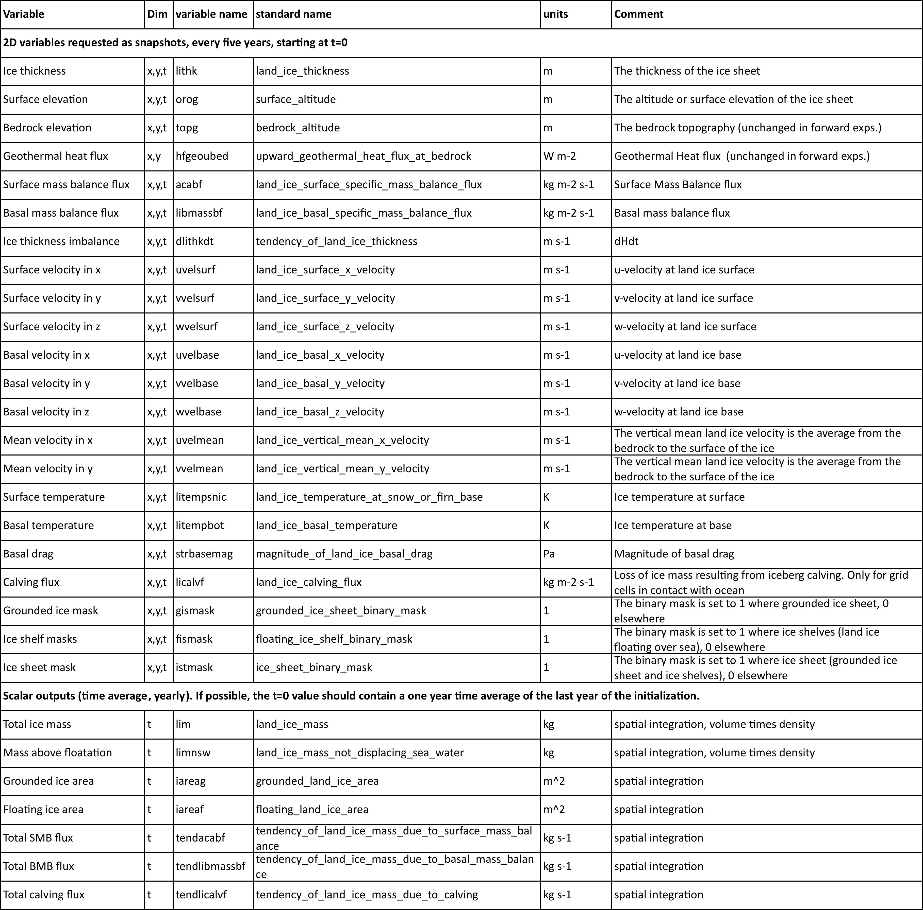

**A2.4 README_<IS>_<GROUP>_<MODEL>.doc file**

Contributor name, affiliation and email:

Date of submission:

1. Describe the technique that you would use to create an initial condition for projections of the ice sheet to 2100 in general terms, in particular does it assimilate observations of the present-day ice sheet or spin the ice sheet up over a longer (glacial-interglacial) period, or another method?

Assimilations methods

1. What information do you assimilate? Please give variable names (e.g. horizontal speed) and an indication of the data source (web address or reference).
2. What other information is required (for instance, surface mass budget, bedrock elevation etc.)? Again please indicate data sources.
3. What are the outputs of your assimilation procedure that are either created or altered by the process?

Spin-up methods

1. Over what period do you spin your model up and using what forcing data? Again please indicate data sources.
2. What other data are required in your procedure? Again please indicate data sources.
3. What are the output of your spin-up method that are altered by the process (for example, bedrock adjustment)?

Other methods

If your initialization method does not fit in the two methods described above, for example a combination of Assimilation and Spin-up methods, please indicate below the answers to the questions 2-8 that are relevant to your procedure:

Other questions for all methods

1. Do you have tuning targets? Please provide a description.
2. Do you apply corrections, such as SMB corrections? Please provide a description.
3. What procedures do you use to validate this initial condition, or tests that you apply to the final state of your initialization method?
4. What additional data (if any) are used? For example: Geothermal heat flux
5. How difficult would it be for you to change the datasets that you are currently using for initialization? (easy, moderate amount of work, complicated/very time consuming, or not possible; Distinguish different variables if necessary, bedrock, ice thickness, velocities, …)
6. Would you be willing to participate in further experiments to explicitly address certain aspect of uncertainty in the initialization?

1. Are there other data sets that you would like to use, that you wished you had access to?
2. Please list any additional papers or reports that document your procedure, or model.
3. Please complete the following Model Characteristic Table:

|  |  |  |  |
| --- | --- | --- | --- |
| Characteristic | Sample answer | <IS>_<GROUP>_<MODEL> | Reference, if applicable |
| Numerical Method | Triangular finite element, Arbitrary Lagrangian eulerian |  |  |
| Native Grid (horizontal and vertical) | H: anisotropic (between 1km on fast ice stream to 15km in the interior)  V: 17 layers (terrain following) |  |  |
| Native Projection | same as Bamber 2001 |  |  |
| Interpolation method to diagnostic grid | ISMIP6 suggested procedure |  |  |
| Time Step | 2 months |  |  |
| Ice Flow Mechanics | Higher order (Blatter-Pattyn) |  |  |
| Basal Sliding | Weertman sliding law (m=3) |  |  |
| Basal Hydrology | None |  |  |
| Ice shelves | Yes |  |  |
| Advance and Retreat | Freely evolving grounded ice margin, grounding line, and calving front |  |  |
| Grounding Line: Determination, Parameterization | floating criterion |  |  |
| Calving | calving occurs if thickness falls below threshold of 50m |  |  |
| Initial Surface Mass Balance | Positive degree day (Reeh, 1991) with temperature dependent factors following Tarasov and Peltier (2002) |  |  |
| Year (or range of years) assigned to initial condition | 2000 |  |  |
| Forward experiments duration | 100 years |  |  |
| Parameters for ice and water density (rho_i, rho_w), gravitational acceleration (g), etc | rho_i= 900kg m-3  rho_w= 1000kg m-3  g = 9.8 m s-2 |  |  |
| Variable in data request not included and reason | None |  |  |
| Other comments | None |  |  |