samplePlaybackTest.vi
See: http://zone.ni.com/devzone/cda/tut/p/id/4877

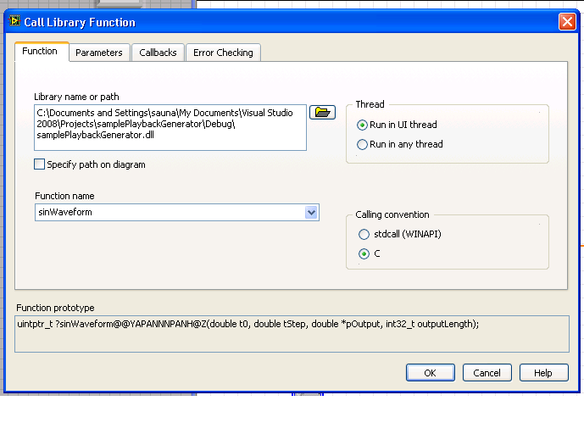Illustration 1: Dll properties,Double-clip dll-object to get to here.
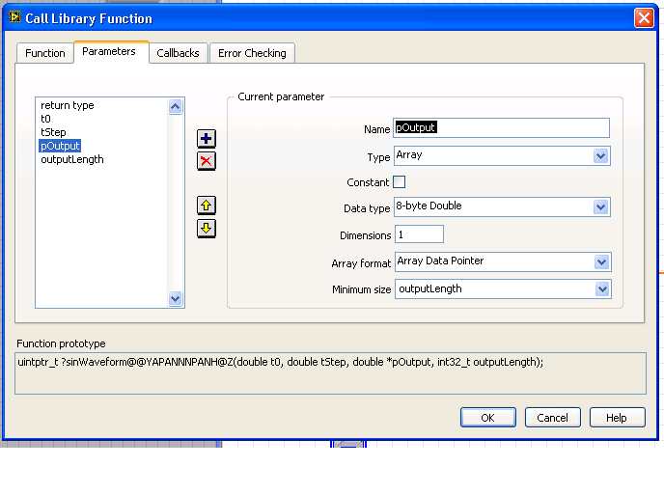Illustration 3: Dll-properties, pane 2, array.
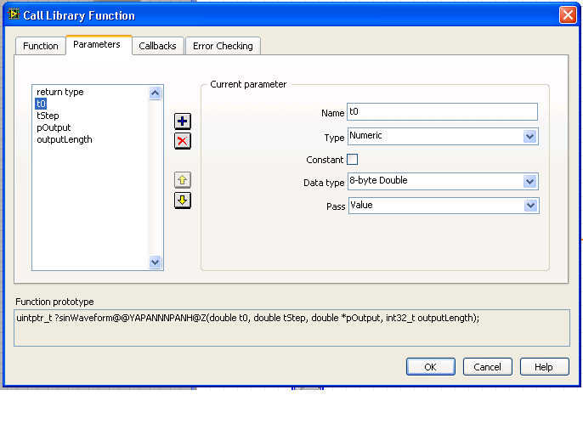Illustration 2: Dll-properties, pane 2, double (integer is signed, 32 or 64 bit depending on your machine)
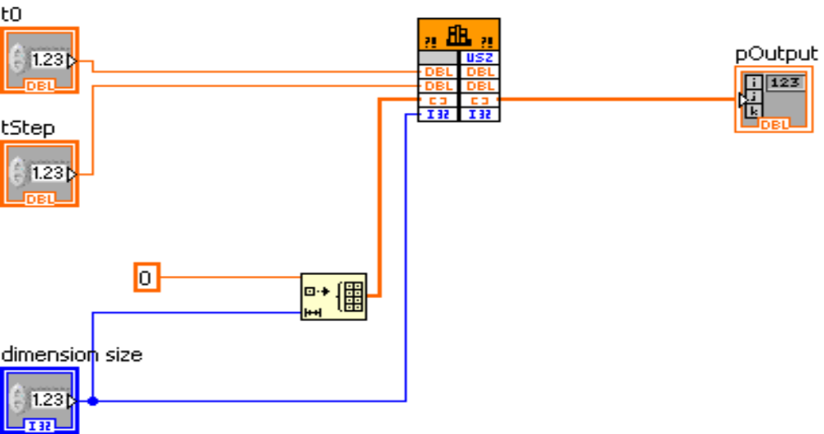Illustration 4: Double inputs for t0 and tStep. Memory for double array is reserved in labview side, Object in the middle is “Call Library Node” in

