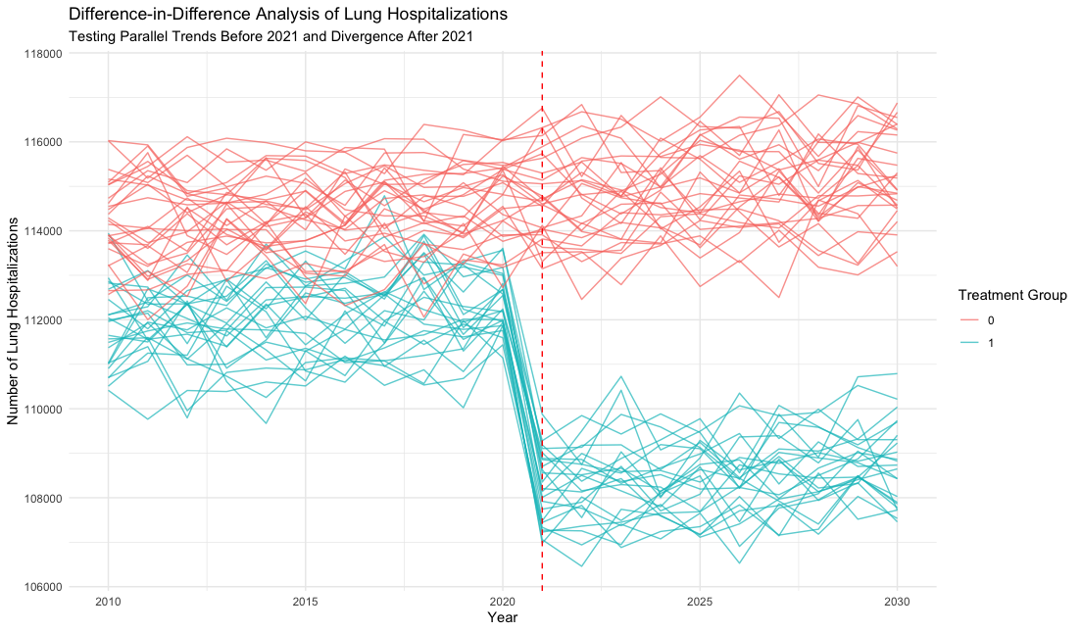

Figure. Difference-in-Difference Analysis of Lung Hospitalizations

The figure displays the trends in lung-related hospitalizations from 2010 to 2030 for two groups of states: the control group (red lines), representing states that did not adopt anti-vaping laws, and the treated group (blue lines), consisting of states that implemented anti-vaping laws beginning in 2021. The vertical dashed red line marks 2021, the year when the anti-vaping laws were introduced. The plot indicates that before 2021, the treated and control groups exhibited similar trends in lung-related hospitalizations, supporting the parallel trends assumption crucial for the Difference-in-Differences (DnD) analysis. After 2021, the trends diverge, with the treated group showing a noticeable decline in lung-related hospitalizations compared to the control group.

Table. Difference-in-Differences Regression Results on Lung Hospitalizations

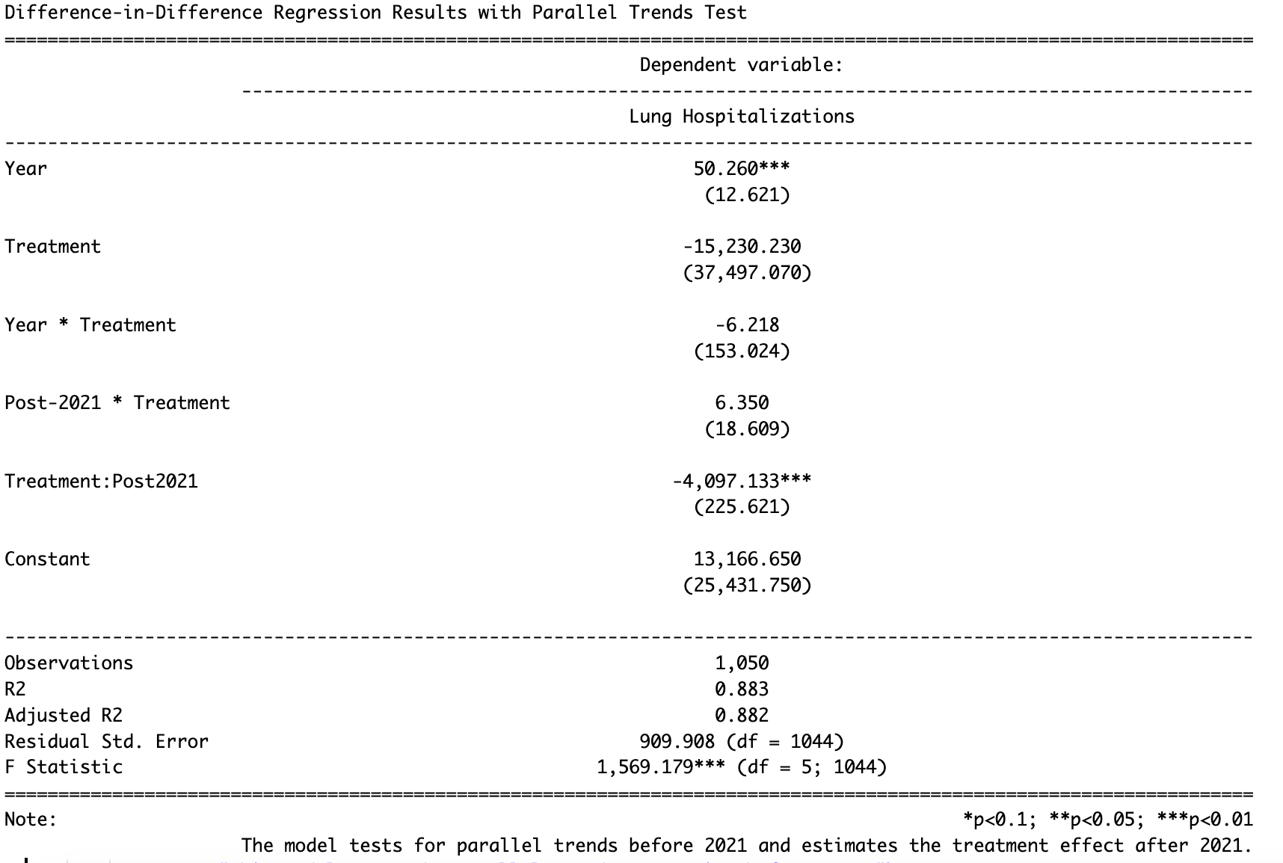

The table above presents the results of a Difference-in-Differences (DnD) regression analysis estimating the impact of anti-vaping laws on lung-related hospitalizations. The model includes both time and treatment effects, as well as an interaction term for the post-2021 period when the laws were implemented. The coefficient for the interaction term is statistically significant and negative, indicating a significant reduction of approximately 4,097 hospitalizations in states that adopted the anti-vaping laws compared to those that did not. The pre-treatment interaction is not significant, suggesting similar trends in lung hospitalizations for treated and control states before the laws were enacted, further statically supporting the parallel trends assumption necessary for valid DnD analysis. Overall, the results indicate a strong treatment effect after 2021, with a significant decrease in hospitalizations for the states implementing the anti-vaping policies.

1.How many state-level fixed effects are there?

There are 49 state-level fixed effects. This is because, one state is omitted as the reference category.

2. What is the interpretation of the coefficient for each state-level fixed effect?

The coefficient for each state-level fixed effect represents the average difference in lung-related hospitalizations for that specific state compared to the reference state, after controlling for the effects of treatment, year, and other variables in the model.

3. Can you reject the hypothesis that state fixed effects are all zero?