Tabel 2. Effect of Attending an Elite School on Job Application Callback Rates Controlling for Gender

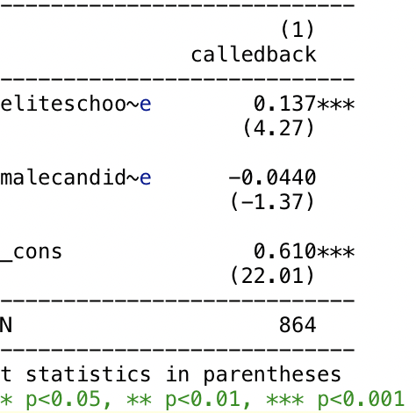

**Note:** This table presents the results of an OLS regression analysis with a gender control (malecandidate). The inclusion of gender control allows us to account for potential differences in callback rates based on the candidate’s gender. The independent variable of interest remains eliteschoolcandidate, which indicates whether the candidate graduated from an elite college (1 = elite, 0 = non-elite). The coefficient for eliteschoolcandidate is still positive and statistically significant after controlling for the effect of gender. Therefore, the significant effect of eliteschoolcandidate we found in our earlier analysis is not confounded by differences in callback rates between male and female candidates.