**Auto-unlocking your computer with a facial recognition system**

**(Proposed by Jianhua Li, Feb 20 2017)**

1. Domain background

As the built in cameras becomes more and more common in cell phones and personal computers, images and videos are piling up. The desire to understand what is in these images and thus to apply this information to facilitate our daily life becomes more and more strong. Computer vision is an interdisciplinary field and provide a powerful solution in high-level image as well as videos understanding.

2. Problem statement

For security reasons, we are required to lock our computer when we leave our desk. When we come back to our desk, we have to unlock it. Although there are multiple ways to do it, all of them require to manipulate through keyboard. So it is kind of annoying to repeat these locking/unlocking steps. For this project, I propose to develop an auto-facial recognition system. This system uses the built in camera in the computer to capture the image in front of it and can be automatically activate the command to unlock the system.

3. Datasets and inputs

I will use my own or friends images taken by cell phones with other available online images. Image will be labeled with predesigned names which directly linked with user names for my computer.

4. Solution statement

First of all, I need to collect a large number of my own images under different conditions. For example, different light condition. The images of mine will be labeled as an authorized user. Other images other than mine will be labelled as unauthorized users. Then the relative small image dataset will be preprocessed and learned by machine learning algorithms. Image captured with the camera with be examined with learned model. Decision will be made based on the predicted result.

5. Benchmark model

Since this project deals with a sensitive security problem and the images pool is only limited to a specific user, one would expect the accuracy should close to hundred percent.

6. Evaluation metrics

The system will be directly evaluated with the presence of a user in front of the computers. If an authorized user shown up in front of the computer, the computer will be automatically unlock so that the user does not need to manually unlock it. Otherwise, the computer will not do any thing.

7. Project design

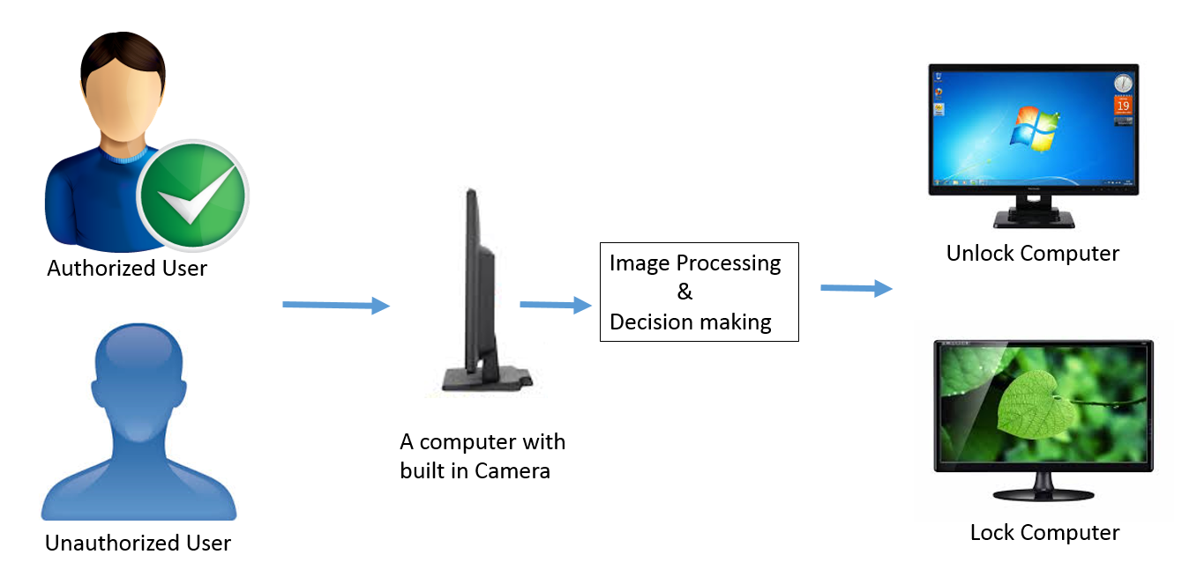

References:

1. [Deep Learning Enables You to Hide Screen when Your Boss is approaching](http://ahogrammer.com/2016/11/15/deep-learning-enables-you-to-hide-screen-when-your-boss-is-approaching/)

2. [Computer Vision Capstone Project](https://docs.google.com/document/d/1y-XfjkPFgUQxFIQ9bBncUSjs4HOf5E-45FrLYNBsZb4/pub)