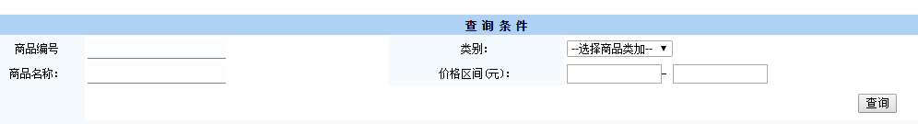

String sql = "SELECT * FROM book WHERE 1=1";

List list = new ArrayList();
if(!"".equals(name)){
sql+=" and name=?";
list.add(name);
}

if(!"".equals(category)){
sql+=" and category=?";
list.add(category);
}

qr.query(sql,list.toArray());

