

Design Document for:

RPG Hero

The best mobile RPG money can buy

“It’s dangerous to go alone, take RPG Hero with you!”™

All work Copyright ©(2014) by Walk Home Games

Version # 3.00

November 28th, 2014
Table of Contents
Design History 4
Version 1.10 4
Version 1.20 4
Version 1.30 4
Version 2.00 4
Version 2.10 4
Version 2.20 5
Version 2.30 5
Version 3.00 5
Game Overview 6
Philosophy 6
Philosophical point #1 6
Philosophical point #2 6
Philosophical point #3 6
Common Questions 6
What is the game? 6
Why create this game? 6
Where does the game take place? 6
What do I control? 6
What is the main focus? 7
What’s different? 7
Feature Set 8
General Features 8
Gameplay 8
The Game World 9
Overview 9
Level Based World 9
Unique Combat System 9
The Physical World 9
Overview 9
Key Locations 9
Travel 10
Scale 10
Objects 10
Weather 10
Day and Night 10
Rendering System 10
Overview 10
Camera 10
Overview 10
Game Engine 11
Overview 11
Game Engine Detail #1 11
Collision Detection 11
Lighting in Game 11
The World Layout 12
Game Characters 13
Overview 13
Character Customization 13
Enemies and Monsters 13
Core Game Loop 14
User Interface 14
Initial Screen 14
In-Game Menu 15
Combat Wireframe 18
Combat Interface 18
Level Up Interface 20
Inventory Interface (WIP) 21
Store Wireframe 22
Store Interface 22
Weapons 23
Overview 23
Weapons Details #1 23
Weapons Details #2 23
Musical Scores and Sound Effects 24
Overview 24
Sound Design 24
Single-Player Game 25
Overview 25
Single-Player Game Detail #1 25
Single-Player Game Detail #2 25
Story 25
Hours of Gameplay 25
Victory Conditions 25
Icons Appendix 26
Stats Appendix 26
Objects Appendix 26

Design History

This section shows all the changes this document has undergone

Version 1.10

Version 1.10 includes some tuning and tweaking that I did after making my initial pass at the design. Here is what I changed:

- I added a picture of the game map, gameplay, inventory system, main menu
- Added more monsters and enemies for the player to encounter

Version 1.20

Here is what I changed:

- Objects appendix added
- Expanded the weapons and single player sections

Version 1.30

Changes:

- Stats appendix added
- Added the Store Wireframe

Version 2.00

Changes:

- In-Game Menu updated to include store option
- Online store image and description added into user interface
- In-game interface updated to include a pull down tab to hide status bar and player options

Version 2.10

Changes:

- Updated Table of Contents
- Updated Quest Interface

Version 2.20

Changes:

- Improved Mini Map Interface
- Made slight change to Create A Character interface
- Improved Inventory Interface
- Improved In-Game Store Interface
- Updated Store Wireframe

Version 2.30

Changes:

- Edited Combat Interface description for clarification
- Updated Travel
- Added Game Loop
- Added Online Store Wireframe
- Added Combat Wireframe

Version 3.00

Changes:

- Multiple changes made and sections removed

Game Overview

Philosophy

Philosophical point #1

This game is trying to be a fun and easy to play RPG. I am trying to achieve this with a unique combat system.

Philosophical point #2

This game is made for mobile phones and tablet computers.

Philosophical point #3

I am trying to design a game that will show 2D mobile rpgs can be enjoyable on mobile devices by taking elements of typical RPGs and mixing it with mobile game elements.

Common Questions

What is the game?

RPG Hero is a RPG with a first person perspective when engaging in combat. Starting in the town of Mastolf, you play as the son of legendary knight Arthur Calden, who must now hunt down the dragon that attacked his town and captured his family.

Why create this game?

I am creating this game because I am a big fan of RPG games and also a fan of the mobile gaming platform and want to create a fun and unique RPG game for mobile devices.

Where does the game take place?

RPG Hero starts in the town of Mastolf, in the country of Riverium. The player will continue to explore the sections of Riverium as they complete more levels.

What do I control?

The player controls the main character aka the hero of the game who must free his family from the dragon. The player will control the choices the character makes throughout the game such the weapons they use, stats they increase, and how they spend their coins.

What is the main focus?

The main focus of RPG Hero is to complete the various levels, in order to advance to the next level. The goal is to reach the final level and free your family from the dragon.

What’s different?

The difference in this game is primarily the combat system, rather than have a traditional combat system seen in many games, this game features a guitar hero style combat system requiring the player to touch, drag, and/or throw icons at their opponent or themselves to attack, defend, heal, and collect coins.

Feature Set

General Features

- Pixel art style 2D graphics
- Made for Android and iOS devices
- Inventory system featuring a slot for a ranged weapon, melee weapon, shield, and 2 magic attacks
- 20 levels to explore in the 4 sections of Riverium
- Easy, medium, and hard difficulties
- Auto and lock rotation options
- Volume settings for sound effects and background music

Gameplay

- 7 stats for the player to upgrade throughout the game such as, Health, Luck, and more
- Numerous monsters and humans to encounter such as, trolls, spiders, rats, bandits, and orcs
- Various weapons and shields to obtain throughout the game such as, bows, swords, axes, and maces
- Unique combat system featuring two rotating circles of icons
- Coins to collect through fighting enemies and selling items
- Buy and sell with local merchants and blacksmiths
- Stat for shield and weapons to determine how often a shield or weapon can be used in combat
- Use potions in combat to heal the player and repair hammers to repair weapons or shields

The Game World

Overview

RPG Hero takes place in the country of Riverium, a fairly large area made up of four sections, each section having five levels.

Level Based World

Complete the game by defeating the increasingly difficult levels.

Unique Combat System

Defeat enemies using the unique combat system; players will tap and throw the icons at opponents and themselves as they appear in rotating circles. The player will also be able to attack and defend using the shield and weapon icons.

The Physical World

Overview

The world of Riverium will be split into different sections each offering a new change of scenery to the player and a change in enemy types. The first section of the game will be the forest area, in here the player can expect to find bandits, bears, wolves, and spiders.
The second section is the mountain range which will consist of trolls, wolves, and mountain lions. The third section is the winter section which will consist of yetis. The final section is the cave section, the cave will contain skeletons, rats, ghosts, and of course the dragon.

The following describes the key components of the physical world.

Key Locations

Mastolf - The first town the player will experience, is the home town of the hero, and will serve as a tutorial area for the user to become familiar with the user interface and combat system

Lahtrom – The first major city the player will encounter, features a town hall, bar, inn, blacksmith, merchant area, and some housing for the residents of the city. Will serve as an area the player can always return to for more quests.

Axport City – The other major city in RPG Hero that the player will encounter later on. Similar to Lahtrom but twice as big with more quests available to the player and a military barrack that helps protect the city from various enemies.

Travel

The player travels by selecting the level they wish to play, players can go back to previous levels if they wish to gain more experience and coins.

Scale

See the map in “The World Layout” section for an idea of scale

Objects

Weapons- Some of the various weapons the player can find or purchase in the game will be bows, swords, daggers, maces, clubs, throwing knives, axes

Armour/Protective Gear – Helmets, cuirass, leggings, boots, shields, steel armour, iron armour, chainmail armour, cloth armour, leather armour, gold armour

Miscellaneous Items – Coins, repair hammers, health potions

See the “Objects Appendix” for more detail on these objects.

Weather

The game will feature a weather system that will have varying effects on the player (i.e will be harder to see in snow)

Day and Night

The game will have a pseudo day and night cycle.

Rendering System

Overview

All the graphics in RPG Hero will be rendered using Unity

Camera

Overview

The camera will be set to a first person view when the player is in combat and a top down view when looking at the level select screen.

Game Engine

Overview

RPG Hero will use unity as its game engine

Game Engine Detail #1

Unity will be used to manage all aspects of the world including all the graphics and sound

Collision Detection

RPG Hero will use Unity for collision detection

Lighting in Game

RPG Hero will use the time of day, current weather and local to determine what the lighting will look like in a given area.

The World Layout

The world consists of 4 sections. One section will be a mountain range that will give the player a different terrain to battle on and also different monsters to fight. The first area (Mastolf) is where the player will begin their journey and learn how to interact with the game.

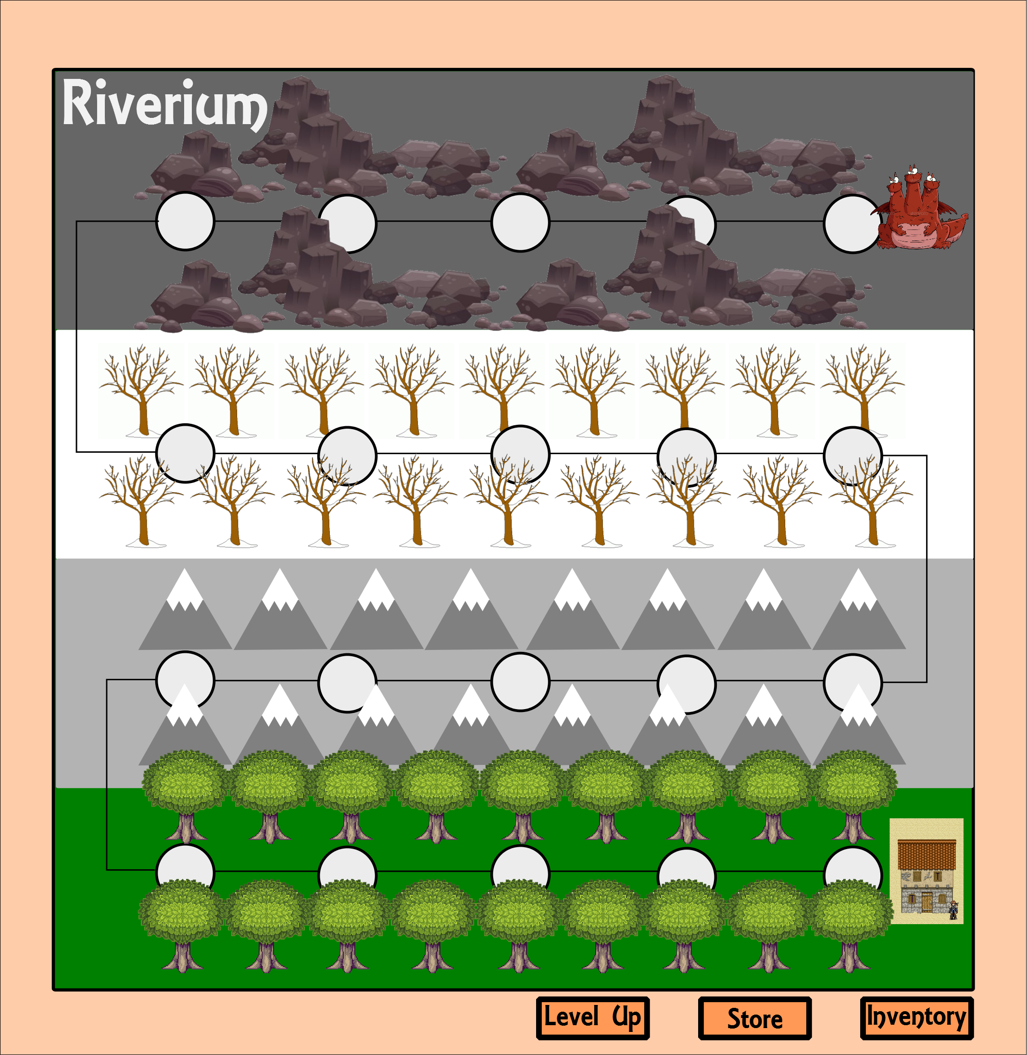

Game Characters

Overview

The player will interact with enemies

Character Customization

The player may customize the character by equipping the various items they collect or purchase throughout the game such as: weapons and shields. The player will also be able to customize the main character’s stats as they level up (a description of each stat can be found in the stats appendix).

Enemies and Monsters

The main enemy in RPG Hero is the three headed dragon Ocard, He can breathe fire and fly.

Other monsters and enemies

Wolves – like to travel in packs will have to face multiples at once. Move in close for attacks
Rats – not very intelligent and easy for even the most amateur of knights to kill
Spiders – very dangerous, able to poison the player and disable the icons on the players screen for a length of time by trapping the player in a web.
Bears – found only in the woods, charge the player quickly, cause great damage.
Bandits – easiest of the human opponents the player will face, will generally have equipment that is not as powerful as the players, could be archers, one handed weapon opponents or two handed weapon opponents
Skeletons – come in different variations (armored, ranged, etc.)
Orcs – tend to use heavy weapons and heavy armor
Trolls – live in the mountain ranges, primarily attack with clubs, never live by other trolls

Core Game Loop(WIP)

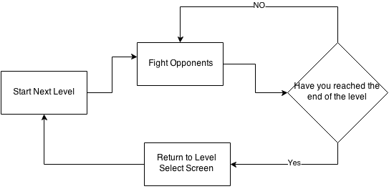

User Interface

Initial Screen

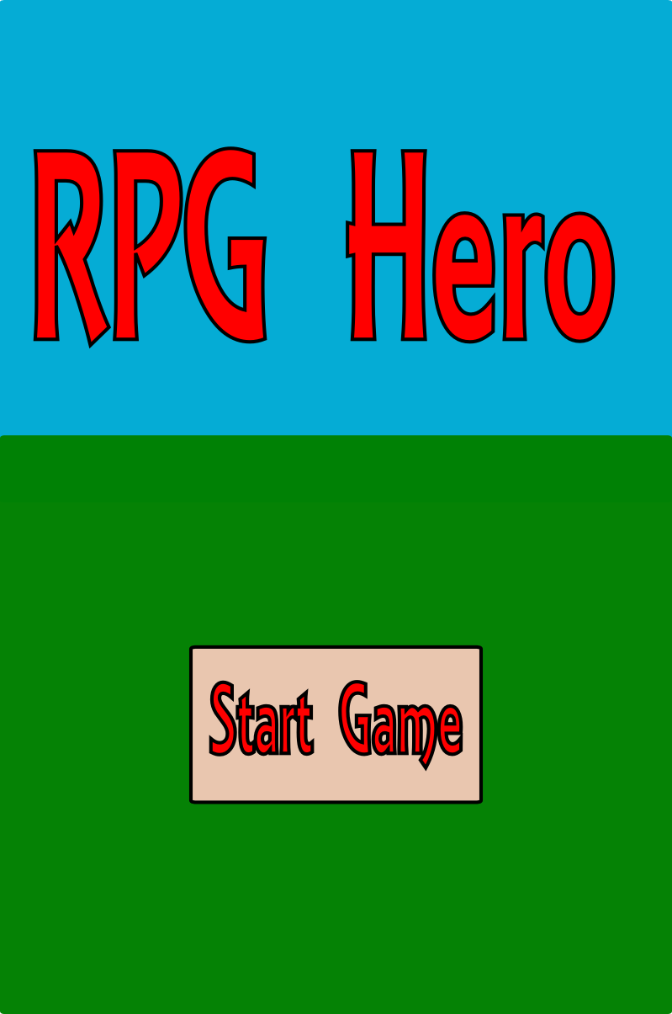

On the previous page is the screen the player sees when they first launch the game. From there they can continue their current game, start a new game, adjust some options, quit the game or view the game credits.

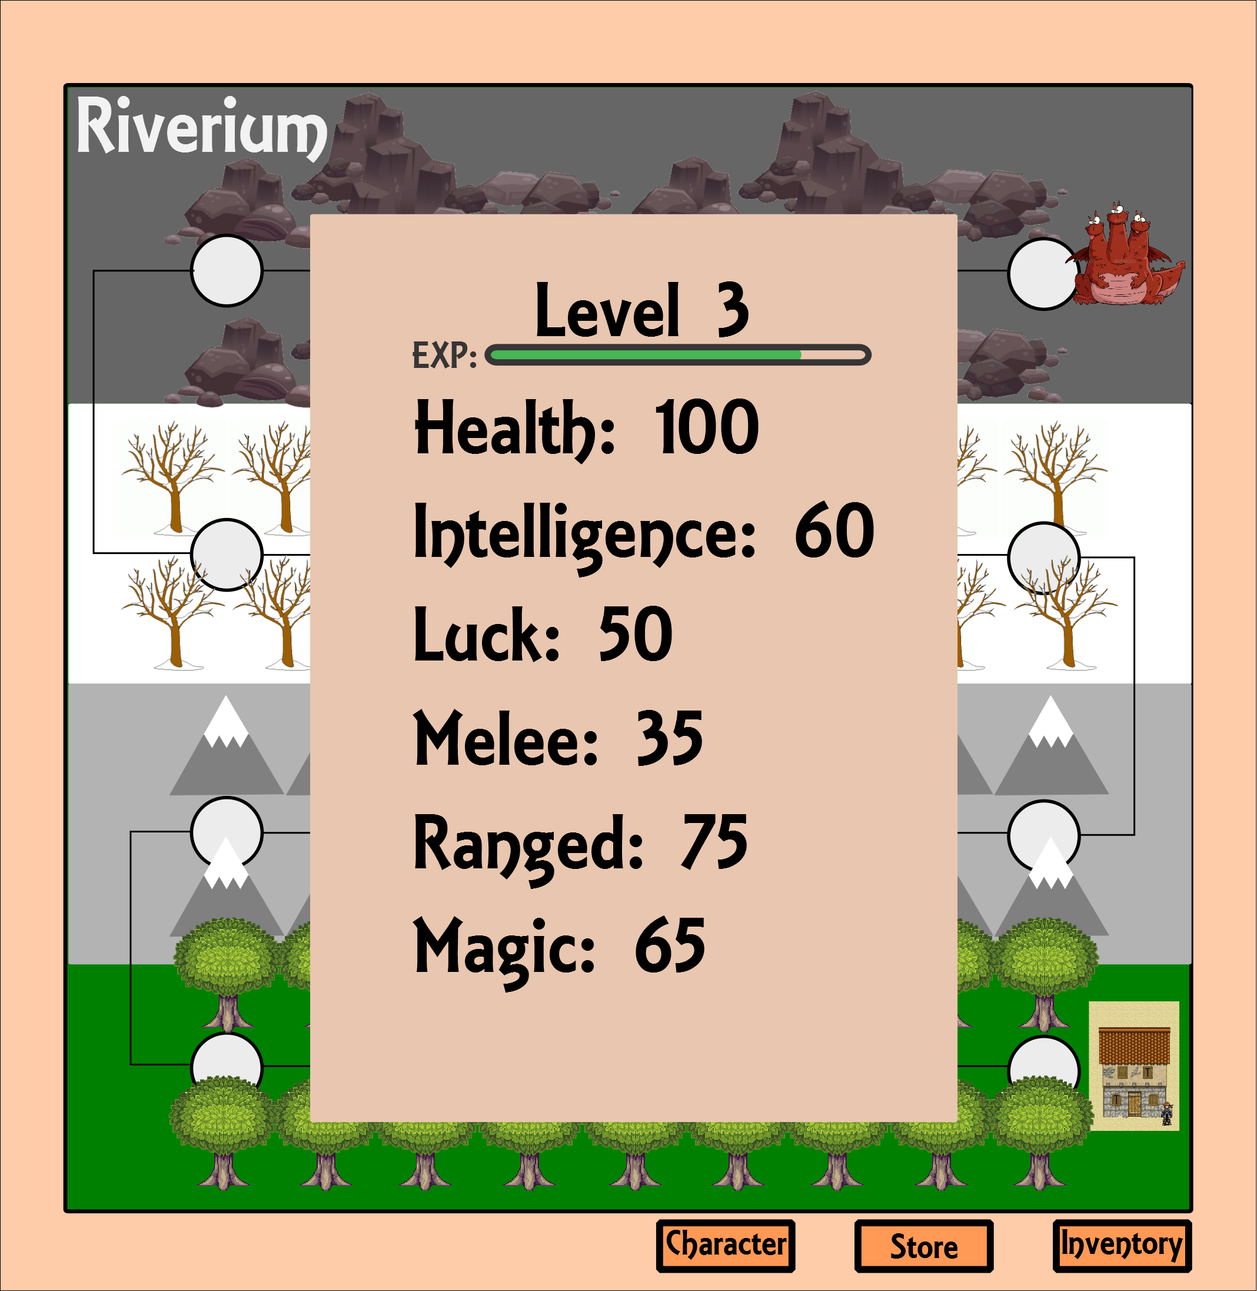

Above is the character screen, the character screen shows the player’s stats and their current experience. The character screen can be viewed by pressing the character button.
On the next page is the options interface, which allows the player to change the difficulty of the game, adjust the volume for the game sounds and the background music, and an option to lock the screen orientation.

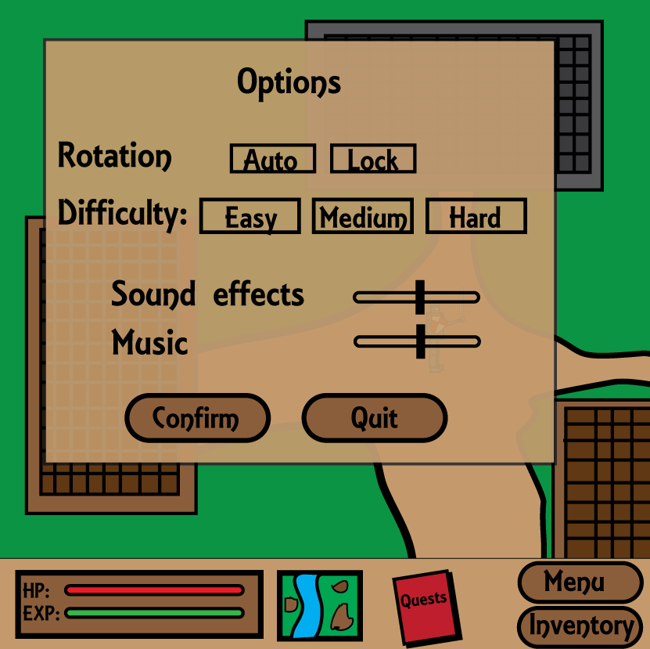

Combat Wireframe
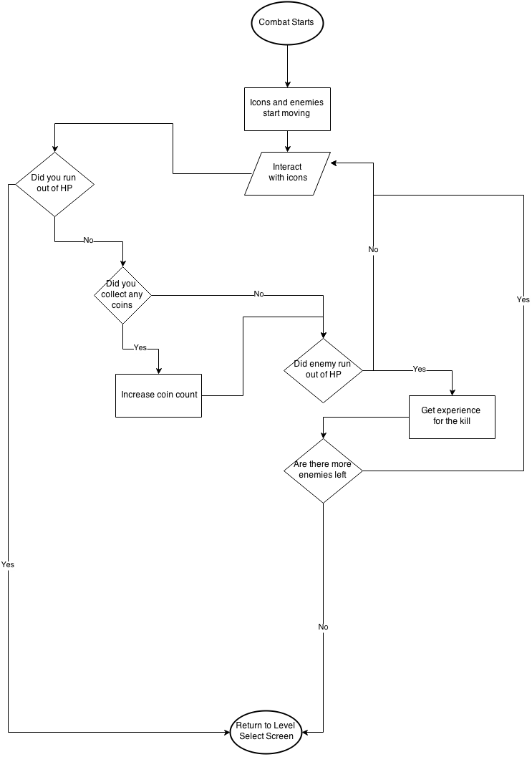

Combat Interface
The combat interface (shown on the next page) is a first person perspective. The interface will feature two rotating circles with 7 slots each. As an icon is used a new icon will appear after a certain period of time. For sword icons the player will have grab the icon and swing it at the enemies to attack them (they have a limited number of uses). To defend, the player will have to slide the shield to block the enemy’s incoming attack (they have a limited number of uses). Arrows can be pulled back and launched at enemies. Magic icons can be thrown to attack enemies. Coins can be thrown at the left corner to be collected. The health potion in the left corner allows the player to regain some HP but has a cool down period until the next potion can be used. Lastly, the player can use the repair hammer to restore their sword or shield (this also has a cool down period until the next repair hammer can be used. Health potions and repair hammers have to be purchased before the level starts.
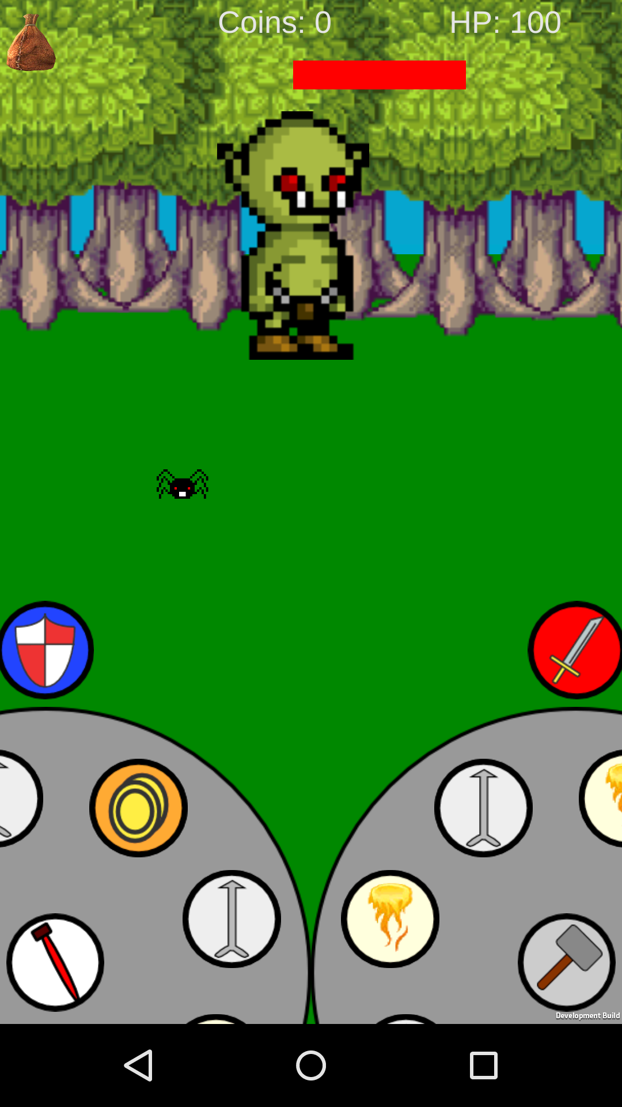

Level Up Interface

When the player’s experience bar fills they will be able to level up after completing the current game level (level up interface shown below). The level up interface will allow them to choose the skills they want to increase and can confirm there changes when they finish.
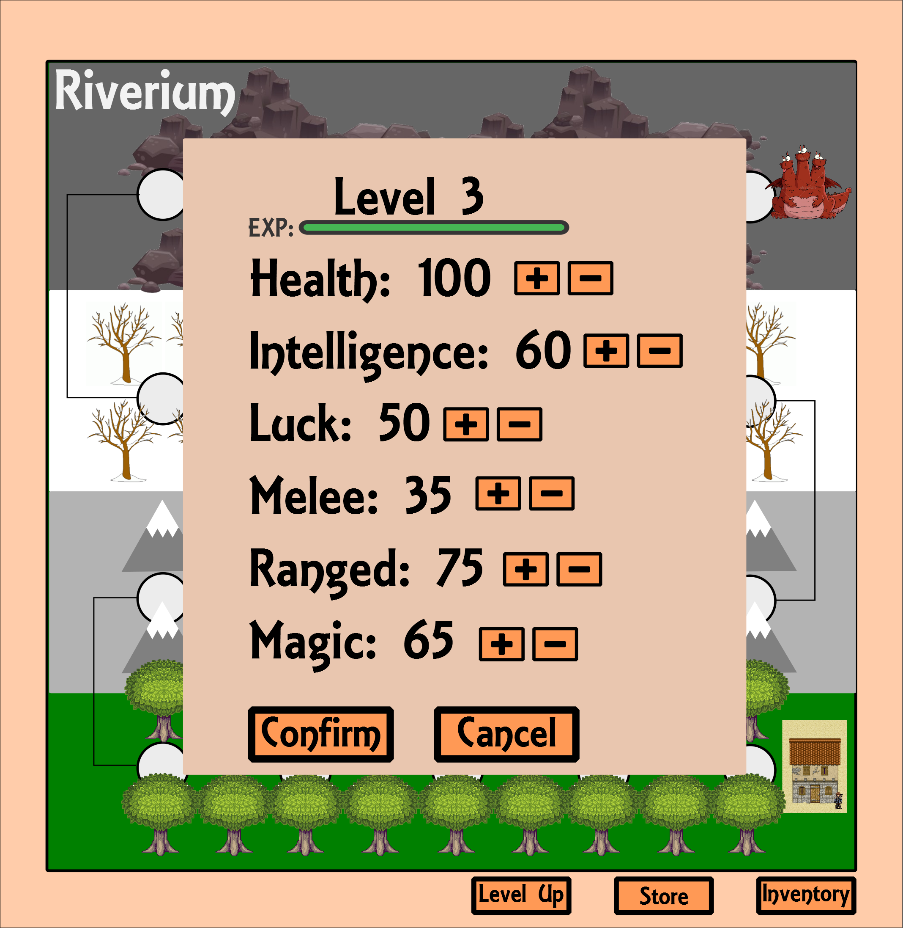

Inventory Interface (WIP)

After the player taps inventory they will be presented with the inventory interface (shown below). The inventory screen features slots to equip a ranged weapon, shield, melee weapon, and two magic spells. a spot to show the current equipped item and its stats, above that is a model of the character showing what is currently equipped. Below the inventory grid is the weight that the player can carry. For the player to equip a new item they drag the item into the correct square and the item will be equipped, returning the previously equipped item to the inventory. If the player no longer wants an item or they need to free up space in their inventory they can drag an item off the right of the grid to drop it.
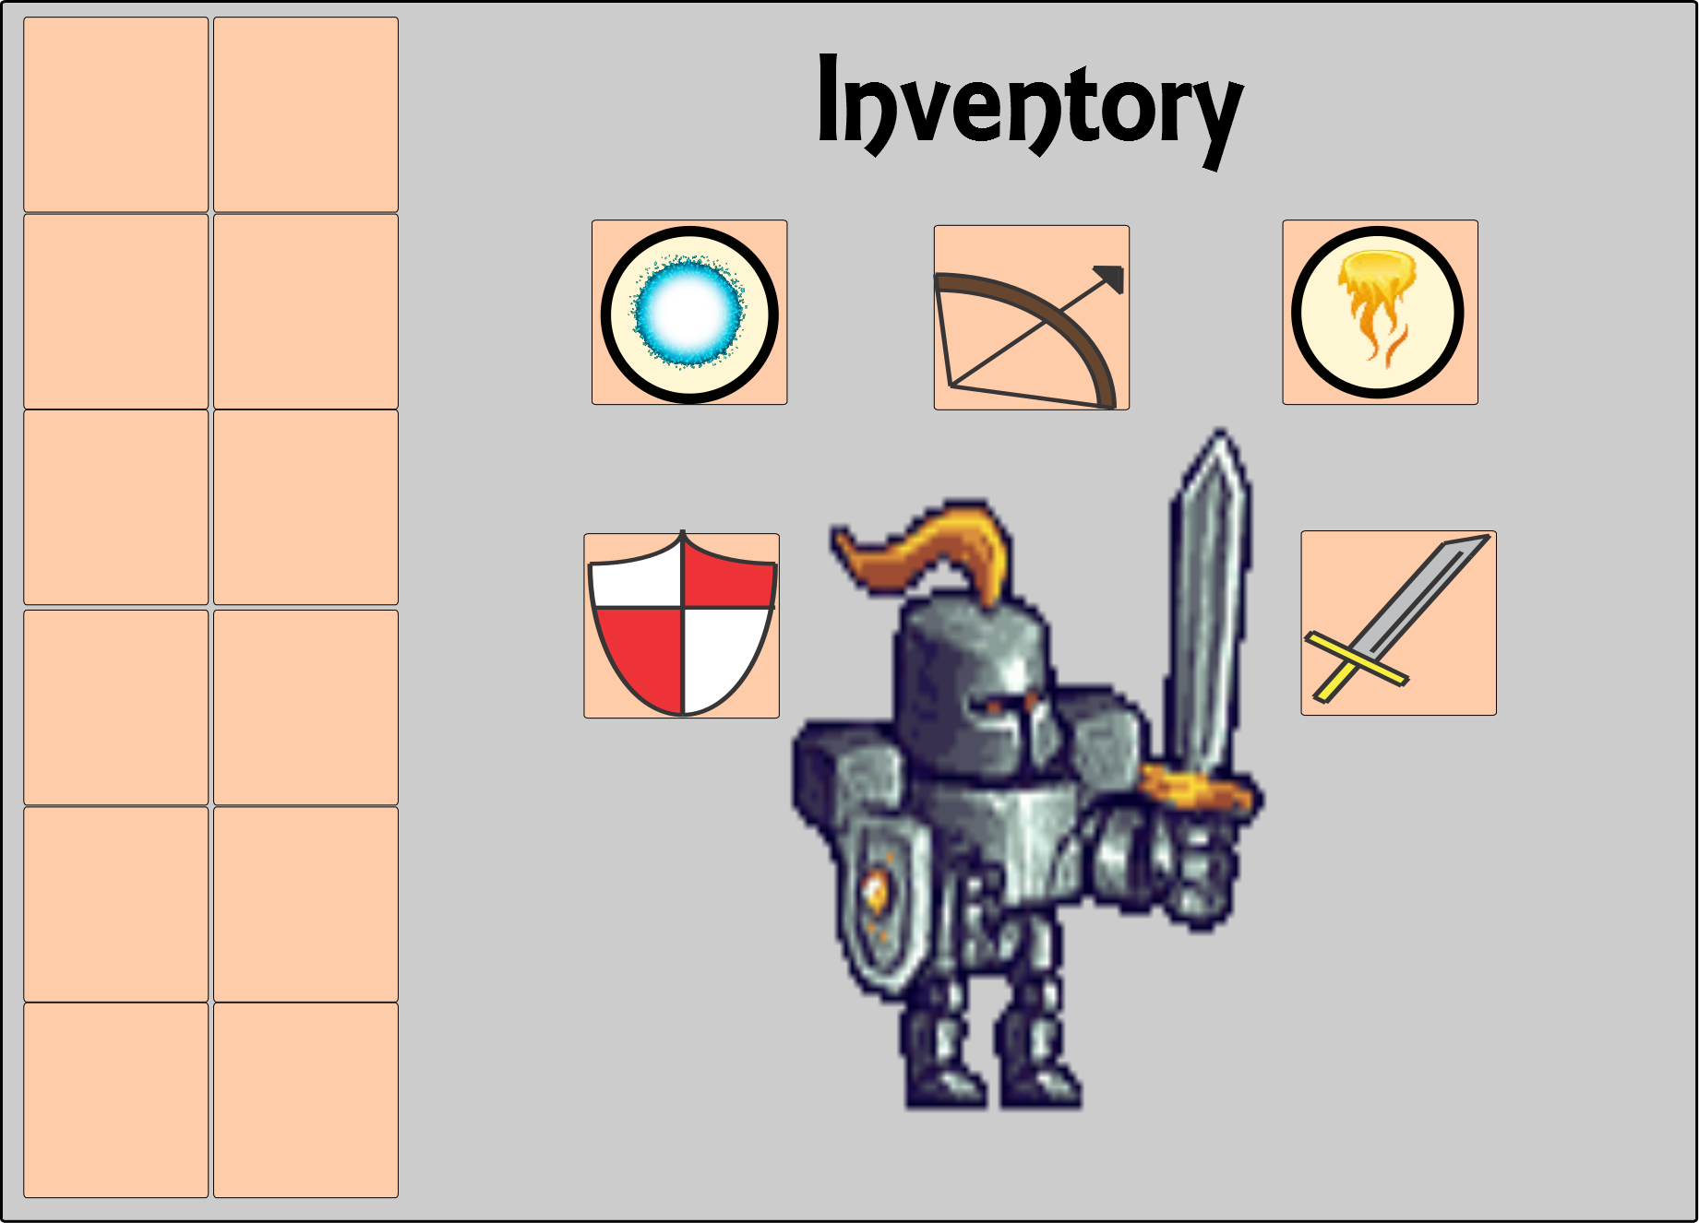

Store Wireframe
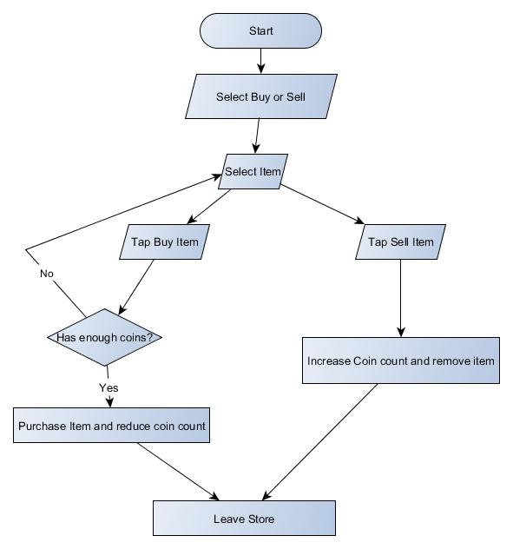

Store Interface

When the player wants to buy or sell an item they will be shown the store interface (shown on the next page). The store interface is fairly similar to the inventory interface, featuring a spot for the current item equipped and the current chosen item but also features buttons to buy sell or repair items. The player can choose an item by tapping on it. They can also go back to the level select screen by pressing back or go to the menu by pressing menu.
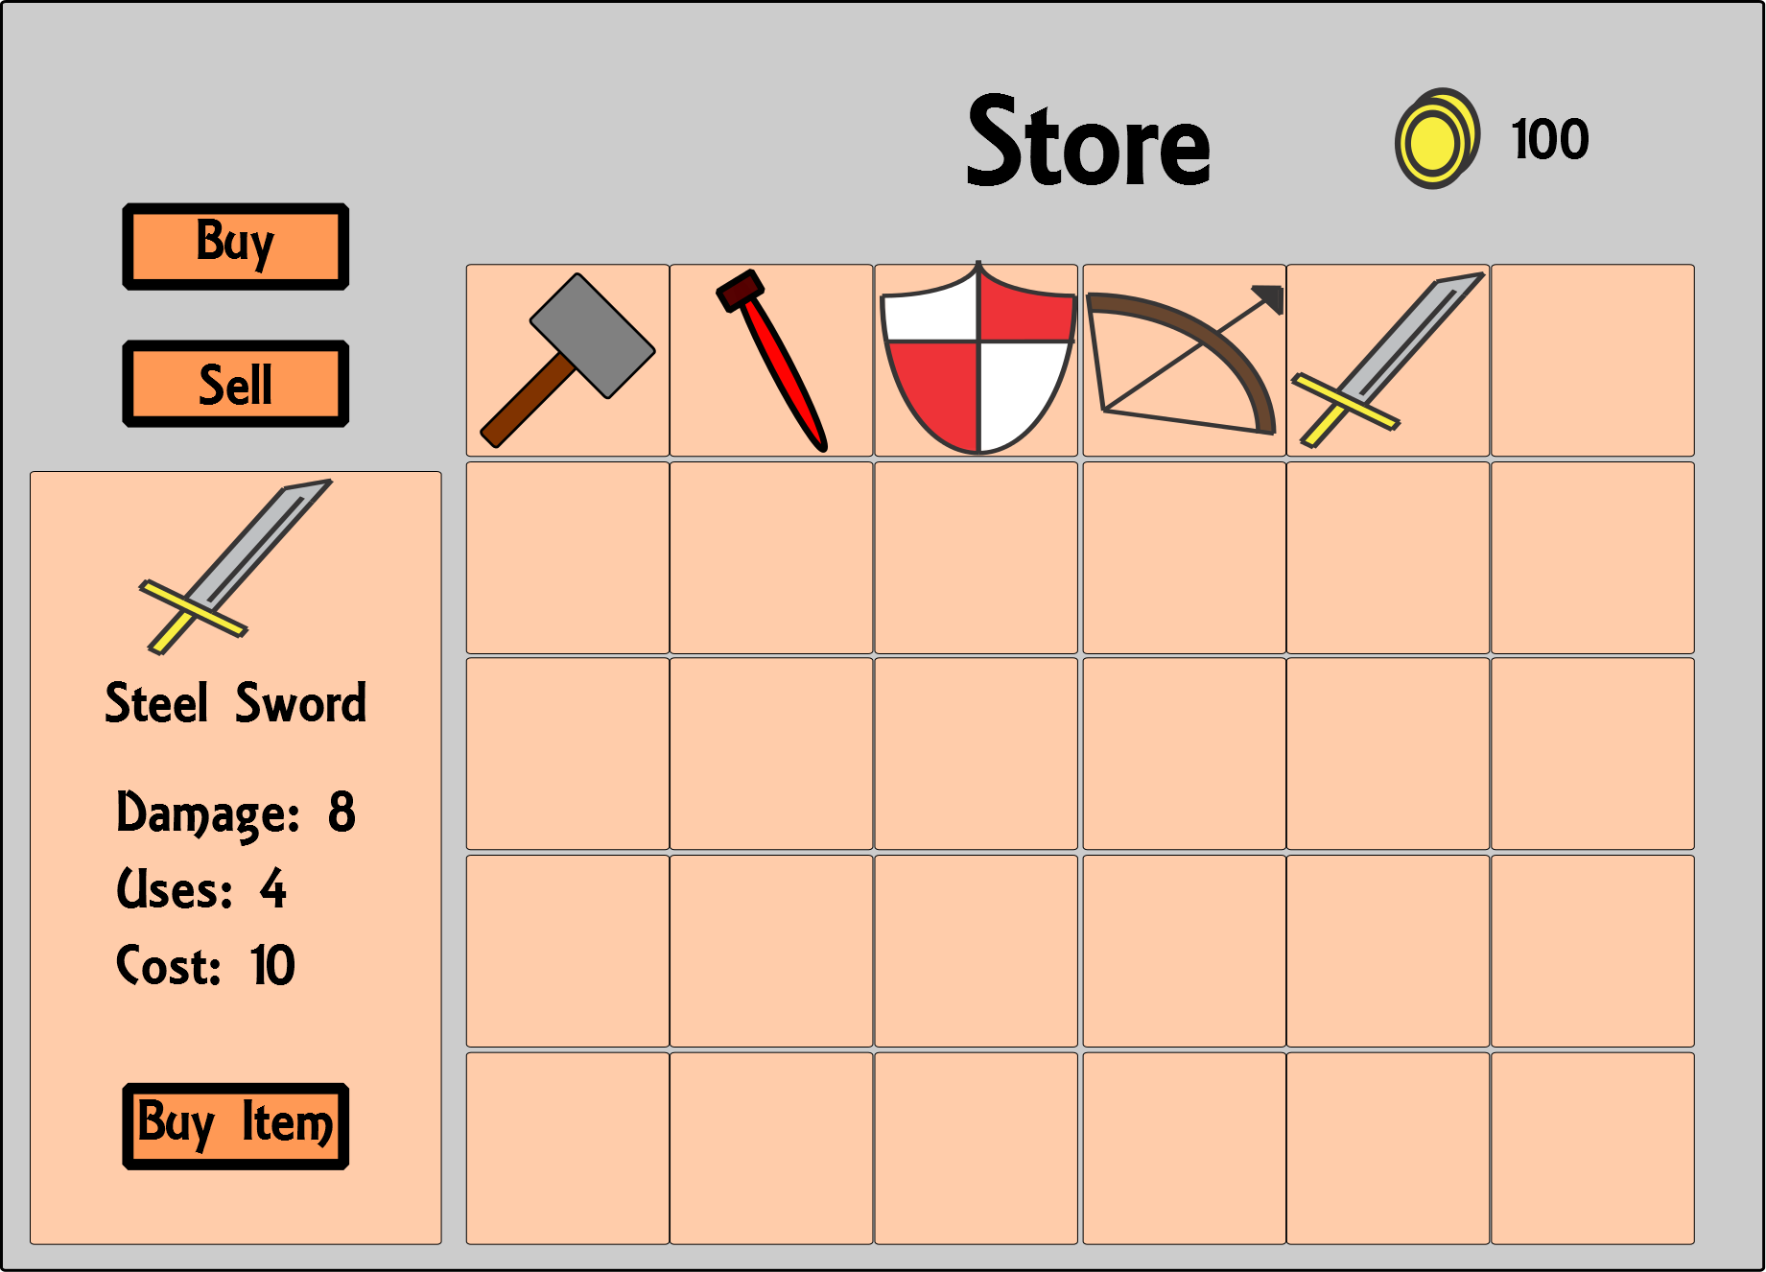

Weapons

Overview

Each weapon has a damage stat, use stat, and a cost. The damage stat is used to show how much damage the weapon will cause, the use stat determines how many uses the weapon has and finally the cost stat represents how much the weapon is worth.
Shields will be similar except they will feature a defense stat instead of a damage stat

Weapons Details #1

When a weapon reaches 0 uses the player will be unable to use it until it recharges or they repair it with a repair hammer.

Weapons Details #2

Additionally the amount of damage a player does will also depend on the player’s own stats.

Musical Scores and Sound Effects

Overview

The music for RPG Hero will be similar to the game Kingdoms of Amalur: Reckoning and sound effects will be recorded in house or by using sound effects from the public domain. Additionally there will be sound effects for the enemies, the player, the weapons and spells.

Sound Design

Here are some examples of music that could be featured in the game or music styles that could be featured in the game.

Reckoning Main Theme - http://www.youtube.com/watch?v=MtP8vT4oY0Y&list=PL27114B60511669DB

Crafting Hall - http://www.youtube.com/watch?v=1-zyMpZ6NuE&feature=related

The Strongholds - http://www.youtube.com/watch?v=TYnZTsjFEls&feature=related

The Ships - http://www.youtube.com/watch?v=blxswTBbYEA&feature=relmfu

Mines & Caves - http://www.youtube.com/watch?v=3TjMbhIVwXQ&feature=relmfu

It End Here - http://www.youtube.com/watch?v=FtUWTP0lUnw&feature=relmfu

Single-Player Game

Overview

The player will defeat levels of monsters in various areas.

Single-Player Game Detail #1

Throughout the game, the player will only have control over the main character

Single-Player Game Detail #2

When in combat if the player dies they will lose their coins but will keep their experience and will be brought back to the level select screen.

Story

The story begins in the town of Mastolf, you are training in the fields with your father, legendary knight Arthur Calden. After finishing your training and returning back to town with your father, the three headed dragon Ocard arrives in search of Sir Calden, to challenge him. Unaware of how powerful Ocard is, Calden refuses the fight feeling the dragon is not worthy of fighting him. Angered, Ocard flies away. As night falls upon the town, Ocard returns and destroys the town while capturing Sir Calden and his wife (your parents), leaving the player all alone. Determined to find your parents, you set off to the city of Lahtrom hoping to find out where Ocard has taken your parents.

Hours of Gameplay

If the player completes all the levels. Meaning the game should average around 10-15 TBD hours of gameplay.

Victory Conditions

The player wins by defeating the last level and freeing their family from the dragon, showing that they have become a great knight like their father.

Icons Appendix

This appendix is added to provide additional details on the various icons the player can use in the game.

Weapon – icon for using the player’s weapon
Shield – icon for using the player’s shield
Arrow – icon for using the player’s bow
Fireball – icon for using a fireball attack that damages the enemy over time
Fire Blast – icon for using a fire blast attack that damages all enemies within an area
Iceball – icon for using an iceball attack the slows down the enemies movement
Ice Blast – similar to the fire blast
Lightning – icon for using a lightning attack that attacks targets close to one another
Health – icon for healing the player
Coin- icon for collecting coins
Repair Hammer – icon for repairing the shield or weapon

Stats Appendix

This appendix is added to provide additional details on the various stats the player can increase in the game.

Health – This stat will the determine the player’s health in-game, by having more health the player can live longer but will also require more health potions to heal fully
Luck – Will determine the chances of getting more coins per fight
Melee – How effective the player is with melee weapons
Two Handed – How effective the player is with two handed weapons
Ranged – How effective the player is with ranged weapons
Magic – How effective the player is with magic

Objects Appendix

This appendix is added to provide additional details on the various objects found throughout the world.

RANGED WEAPONS
Bows – There will be a number of different bows for the player to find, such as crossbows, elven bows, and orc bows
Throwing Knives – throw able knives that have limited supply

ONE HANDED WEAPONS
Swords – Will vary based on sword material (iron, steel, gold, etc)
Maces or clubs – effective against shields, vary on material
Daggers – More uses than a sword but are smaller and do less damage
Axes – similar to a mace

TWO HANDED WEAPONS
Longsword – Larger variant of a sword, very heavy only can be used a few times per turn
Axes – Very heavy only can be used a few times per turn.

DEFENSE
Armours – Armours, such as steel, iron, and gold will be fairly heavy but offer more protection against sharp and blunt weapons. Chainmail armour will offer more protection against blunt attacks but less against sharp weapons. Light armour, such as cloth and leather will offer very little protection but will allow the player to move faster and block quicker

Shields – Will vary on shape (round, rectangle, etc), size, and material. The bigger the shield is the more effective it will be but the harder it will be to move.

MISCELLANEOUS ITEMS

Health Potions – Will heal the player
Repair Hammers – Will repair a weapons or shield

