**Enterprise Integration (MEIC-A, 2019-20, 2º semestre)**

Instituto Superior Técnico – MEIC-A

*Sprint 2 Report*

1. **Definition of the microservices needed for the MaaS functionality**

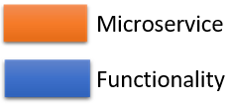

Fig. 1 – Microservices and functionalities

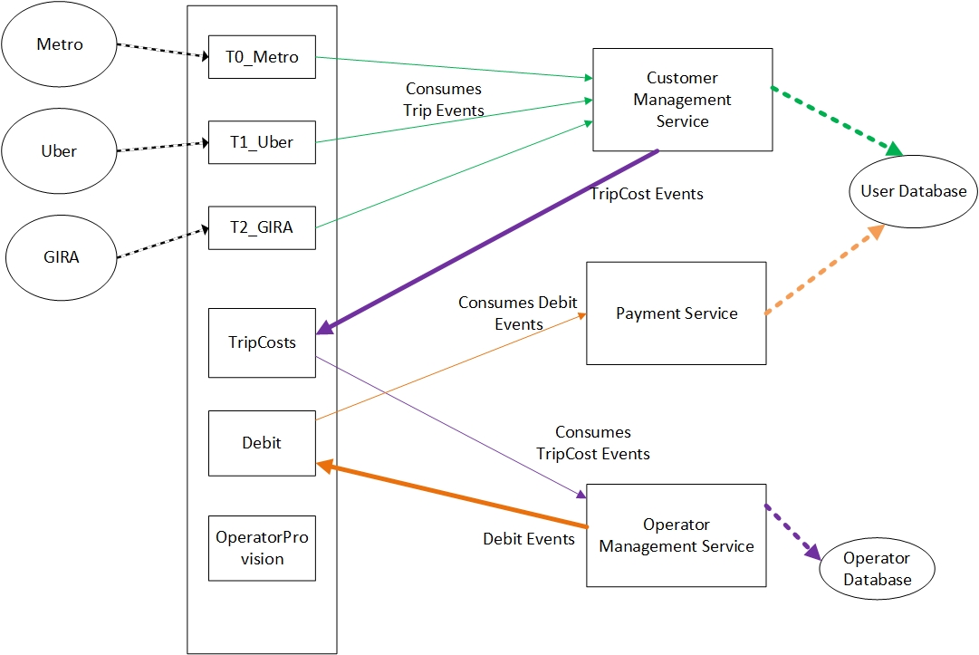

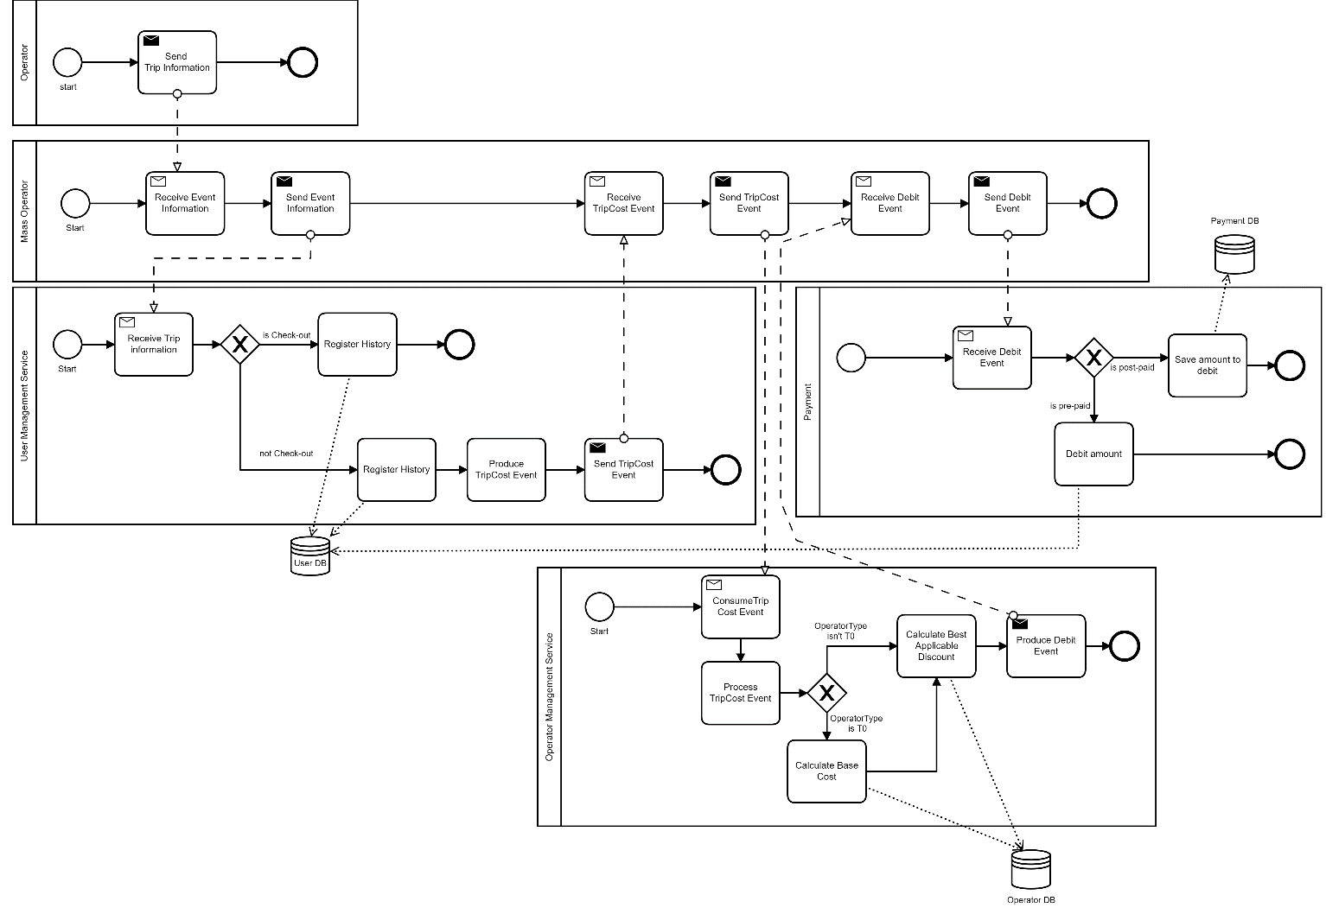Fig. 2 – Taxation Event flows diagram

Fig. 3 – Taxation Process diagram

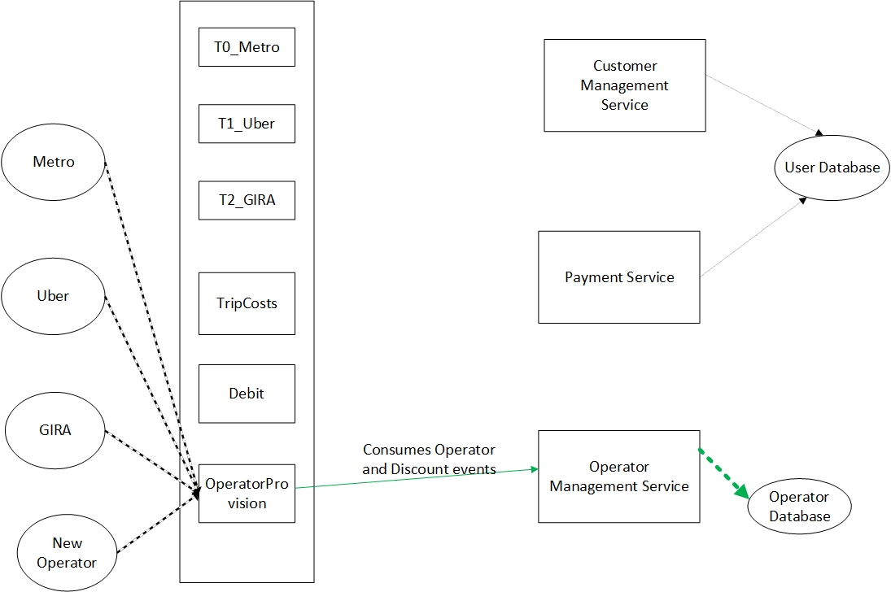

Fig. 4 – Operator and Discount Event flows diagram

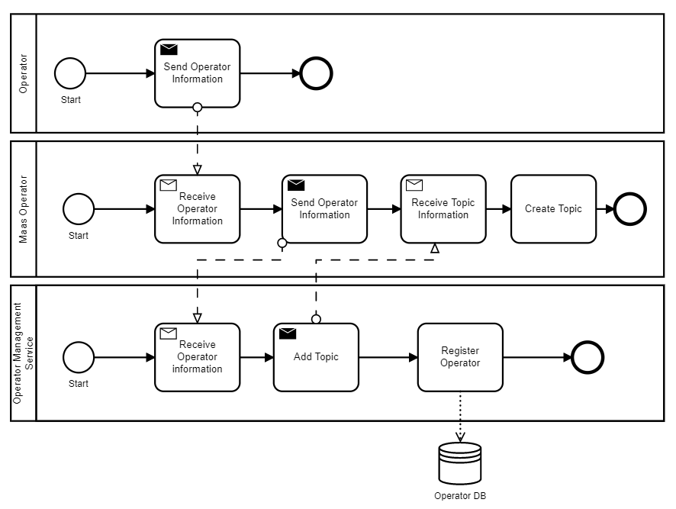

Fig. 5 – Operator Registration Process diagram

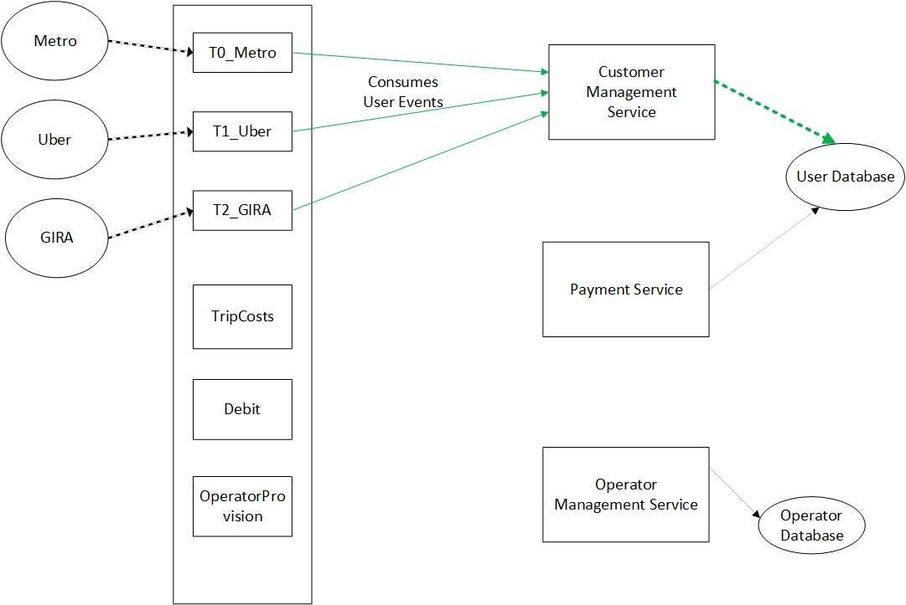Fig. 6 – User Event flows diagram

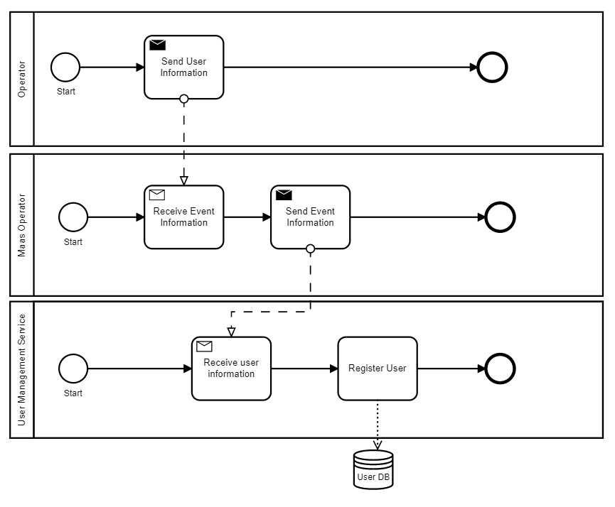

Fig. 7 – User Registration Process diagram

1. **Chosen microservices**

Our project plans the usage of 5 microservices to provide all the needed functionalities:

* **Customer Management Service:** this service aggregates all the functionalities that have to do with the users like consuming trip events, provide information about the trips to Operator Management Service, creation of users and maintain user history about the trips
* **Payment Service:** this service has the responsibility of debiting from the user accounts considering all the business rules
* **Operator Management Service:** this service aggregates all the functionalities that have to do with the operators and discounts. It deals with the creation of all them and consumes the events produced by the User Management Service, processes them by applying the available discounts and produces a debit event for the Payment Service to consume
* **Inspector:** this service has the responsibility of checking if there is any abnormality in the system like for example a user making a checkout without having checked in
* **Customer Support:** this service handles complaints and provides help to the user when there is some problem

We have decided to implement the User Management Service and the Operator Management Service because we consider them the core of the Maas Operator. These services comprise the functionalities that deal with customer accounts, operators, discounts, and the processing of trip events.

1. **Microservices input and output**

Customer Management Service:

**Input**

This service takes as input NewUser events and Trip events that are consumed from the operator topics.

* **Trip Events**

There are 3 types of trip events:

* **Type 0 operators** (Check in and check out method)

These events contain as main fields:

* **eventType** to say if it is a check-in or a check-out
* **operator** that contains the name of the operator
* **info** that contains information about a trip. Inside this field there are fields with the token of the customer, station, and a timestamp.

Examples:

Check-in in metro

**JSON**

{

    "event": {

        "eventType": "t0-check-in",

        "operator": "Metro",

        "info": {

            "Token": "t15345",

            "Station": "Odivelas",

            "Timestamp": "2020-02-29 18:23:41.278"

        }

    }

}

**XML**

<event>

  <eventType>t0-check-in</eventType>

  <info>

      <Station>Odivelas</Station>

      <Timestamp>2020-02-29 18:23:41.278</Timestamp>

      <Token>t15345</Token>

  </info>

  <operator>Metro</operator>

</event>

Check-out in metro

**JSON**

{

    "event": {

        "eventType": "t0-check-out",

        "operator": "Metro",

        "info": {

            "Token": "t5431",

            "Station": "Alameda",

            "Timestamp": "2020-02-29 18:23:47.718"

        }

    }

}

**XML**

<event>

  <eventType>t0-check-out</eventType>

  <info>

      <Station>Alameda</Station>

      <Timestamp>2020-02-29 18:23:47.718</Timestamp>

      <Token>t5431</Token>

  </info>

  <operator>Metro</operator>

</event>

* **Type 1 operators** (Distance and time dependent method)

These events contain as main fields:

* **eventType** that says “t1”
* **operator** that contains the name of the operator
* **info** that contains information about a trip. Inside this there are fields with the token of the customer, price, and a timestamp.

Example:

**JSON**

{

    "event": {

        "eventType": "t1",

        "operator": "Uber",

        "info": {

            "Token": "t243",

            "Price": "20.63",

            "Timestamp": "2020-02-29 19:45:58.638"

        }

    }

}

**XML**

<event>

  <eventType>t1</eventType>

  <info>

      <Price>20.63</Price>

      <Timestamp>2020-02-29 19:45:58.638</Timestamp>

      <Token>t2</Token>

  </info>

  <operator>Uber</operator>

</event>

* **Type 2 operators** (Time dependent method)

These events contain as main fields:

* **eventType** that says “t2”
* **operator** that contains the name of the operator
* **info** that contains information about a trip. Inside this field there are fields with the token of the customer, time spent with the vehicle, price of the ride and a timestamp.

Example:

**JSON**

{

    "event": {

        "eventType": "t2",

        "operator": "Gira",

        "info": {

            "Token":"t1",

            "Time":"3600",

            "Price": "12.60",

            "Timestamp":"2020-02-29 20: 57: 10.294"

        }

    }

}

**XML**

<event>

  <eventType>t2</eventType>

  <info>

      <Price>12.60</Price>

      <Time>3600</Time>

      <Timestamp>2020-02-29 20: 57: 10.294</Timestamp>

      <Token>t1</Token>

  </info>

  <operator>Gira</operator>

</event>

* **New User Events**

These events contain as main fields:

* **eventType** that says “new-user”
* **user** that contains information about the user. This field contains information about a user: id, email, plan type, first name, last name, and balance
* The plan type is used by the Payment Service to define how he should charge the costumer:
  + **pre-paid –** costumers that load their account with a certain amount and are charged per each trip
  + **post-paid –** costumers who accumulate a debt and at the end of the month are debited that amount
  + **generalPass –** costumers who pay a monthly subscription to have a pass that can be used for every operator
  + **passTN –** costumers who pay a monthly subscription to have a pass that can be used for every operator of type TN
  + **combined_TX_TY -** costumers who pay a monthly subscription to have a pass that can be used for every operator of type TX and TY

Example:

**JSON**

{

    "event":{

        "eventType": "new-user",

        "info": {

            "id": "69c594cfdeeaedd220",

            "email": "user@gmail.com",

            "planType": "pre-paid",

            "firstName": "Paulo",

            "lastName": "Neves",

            "balance": "500"

        }

    }

}

**XML**

<event>

  <eventType>new-user</eventType>

  <info>

      <balance>500</balance>

      <email>user@gmail.com</email>

      <firstName>Paulo</firstName>

      <id>69c594cfdeeaedd220</id>

      <lastName>Neves</lastName>

      <planType>pre-paid</planType>

  </info>

</event>

**Output**

This service has as output a TripCost Event. This event has the goal provide information to the Operator Management Service compute the how much money goes to the operator and how much money should be debited from the user account.

* + **TripCost Events**

These events contain as main fields:

* + **eventType** that says “trip-cost”
  + **info** that contains information about a trip and the user that made that trip. The info field contains: cost of the trip (null if operator type is t0), token of the user, plan type, operator name and timestamp.

Example:

**JSON**

{

    "event": {

        "eventType": "trip-cost",

        "info": {

            "cost": "23",

            "token": "69c594cfdeeaedd220",

            "planType": "pre-paid",

            "operatorName": "Uber",

            "timeStamp": "2020-02-29 20:57:10.294"

        }

    }

}

**XML**

<event>

  <eventType>trip-cost</eventType>

  <info>

      <cost>23</cost>

      <operatorName>Uber</operatorName>

      <planType>pre-paid</planType>

      <timeStamp>2020-02-29 20:57:10.294</timeStamp>

      <token>69c594cfdeeaedd220</token>

  </info>

</event>

Operator Management Service:

This service has as input TripCost Event, Operator events and Discount events. This event has the goal provide information to the Operator Management Service compute the how much money goes to the operator and how much money should be debited from the user account.

**Input**

* + **TripCost Events**

(Described before)

* + **Operator Events**

These events contain as main fields:

* **eventType** that says “new-operator”
* **operator** that contains the name of the operator
* **info** that contains information about the operator. The info field contains the type of the operator and the base cost of their service (null if type of the operator is t1 or t2)

Example:

**JSON**

{

    "event": {

        "eventType": "new-operator",

        "operator": "Carris",

        "info": {

            "operatorType": "t0",

            "baseCost": "2.25"

        }

    }

}

**XML**

<event>

  <eventType>new-operator</eventType>

  <info>

      <baseCost>2.25</baseCost>

      <operatorType>t0</operatorType>

  </info>

  <operator>Carris</operator>

</event>

* + **Discount Events**

These events contain as main fields:

* **eventType** that says “new-discount”
* **operator** the name of the operators that benefit from this discount
* **info** that contains information about the discount. The info field contains the name of the discount, discountId, value of the discount, period where the discount is applicable and a field containing which plan types does this discount apply to.

Example:

**JSON**

{

    "event": {

        "eventType": "new-discount",

        "operator": [

            {

                "operator": "Gira"

            }

        ],

        "info": {

            "name": "Dia do Ambiente",

            "discountId": "Gira-1-12",

            "value": "20",

            "beginAt": "2020-06-05 00:00:0.000",

            "endAt": "2020-06-05 23:59:59.999",

            "appliesToPlanType": [

                {

                    "plan": "generalPass"

                },

                {

                    "plan": "pre-paid"

                }

            ]

        }

    }

}

**XML**

<event>

  <eventType>new-discount</eventType>

  <info>

      <appliesToPlanType>

        <element>

            <plan>generalPass</plan>

        </element>

        <element>

            <plan>pre-paid</plan>

        </element>

      </appliesToPlanType>

      <beginAt>2020-06-05 00:00:0.000</beginAt>

      <discountId>Gira-1-12</discountId>

      <endAt>2020-06-05 23:59:59.999</endAt>

      <name>Dia do Ambiente</name>

      <value>20</value>

  </info>

  <operator>

      <element>

        <operator>Gira</operator>

      </element>

  </operator>

</event>

**Output**

This service has as output a Debit Event. This event has the goal to provide information to the Payment Service to debit money from the user account.

* **Debit Events**

These events contain as main fields:

* **eventType** that says “debit”
* **info** that contains information about the debit. The info field contains information about the amount to debit, plan type and the token of the user.

Example:

**JSON**

{

    "event": {

        "eventType": "debit",

        "info": {

            "token": "69c594cfdeeaedd220",

            "planType": "pre-paid",

            "amount": "20"

        }

    }

}

**XML**

<event>

  <eventType>debit</eventType>

  <info>

      <amount>20</amount>

      <planType>pre-paid</planType>

      <token>69c594cfdeeaedd220</token>

  </info>

</event>

1. **Functional integration of the two microservices with the previous Kafka topics**

We started by deleting the topic that we created in the first sprint because we will not need it anymore:

sudo /usr/local/kafka/bin/kafka-topics.sh --zookeeper <Public_DNS>:2181, <Public_DNS>:2182, <Public_DNS>:2183 --delete --topic Discounts

Then we created three new topics: TripCosts, Debit and OperatorProvision

sudo /usr/local/kafka/bin/kafka-topics.sh --create --zookeeper *localhost:*2181, localhost:2182, localhost:2183 -replication-factor 3 --partitions 3 --topic TripCosts

sudo /usr/local/kafka/bin/kafka-topics.sh --create --zookeeper *localhost:*2181, localhost:2182, localhost:2183 -replication-factor 3 --partitions 3 --topic Debit

sudo /usr/local/kafka/bin/kafka-topics.sh --create --zookeeper localhost:2181, localhost:2182, localhost:2183 -replication-factor 3 --partitions 3 --topic OperatorProvision

The TripCosts topic will be used for the TripCosts events, the Customer Management Service will produce this type of events to this topic for them to be consumed by the Operator Management Service.

The Debit topic will be used for the Debit events, the Operator Management Service will produce this type of events to this topic for them to be consumed by the Payment Service.

The OperatorProvision topic will be used for the Operator, Service and Discount events, the operators will produce these types of events to update the Service Catalogue.

We decided to create just one topic for each purpose for simplicity, but we added a replication factor of 3 to ensure some redundancy. The 3 partitions are just to allow the same degree of parallelism that the other topics have.

The operator topics created in the first sprint remained with the same configurations.

1. **Functional integration of the two microservices with the previous Kafka topics**

We’ve decided to use an AWS Lambda function to implement the User Management Service and javax.jws.WebService library to implement Operator Management Service.

**User Management Service pseudo code:**

**function handleRequest:**

startService <- beginEvent

bd_connect <- connectToDatabase

consumer <- prepareConsumer

**while(true):**

consumerRecords <- consumer.poll()

**for each** record in consumerRecords **do**

message <- record.value

extractedEvent <- parse(message)

**if** extractedEvent != null and bd_connect == ok **do**

processEvent(extractedEvent)

**else**

throw exception

**endif**

**endfor**

consumer commit offset

**endwhile**

**end**

**function processEvent:**

eventType <- extractedEvent.type

eventInfo <- extractedEvent.info

**switch**(eventType):

**case** "t0-check-in":

insertT0InfoInDB <- eventInfo

break

**case** "t0-check-out":

insertT0InfoInDB <- eventInfo

break

**case** "t1":

insertT1InfoInDB <- eventInfo

break

**case** "t2":

insertT2InfoInDB <- eventInfo

break

**case** "new-user":

insertUserInDB <- eventInfo

break

**default:**

log

break

**endswitch**

**end**

**Note:** in the insertInfo functions a tripCost event will be sent after inserting data in the database

**Operator Management Service pseudo code:**

**function startService:**

bd_connect <- connectToDatabase

consumer <- prepareConsumer

producer <- prepareProducer

**while(true):**

consumerRecords <- consumer.poll()

**for each** record in consumerRecords **do**

message <- record.value

extractedEvent <- parse(message)

**if** extractedEvent != null and bd_connect == ok **do**

processEvent(extractedEvent)

**else**

throw exception

**endif**

**endfor**

consumer commit offset

**endwhile**

**end**

**function processEvent:**

eventType <- extractedEvent.type

eventInfo <- extractedEvent.info

**switch**(eventType):

**case** "trip-cost":

processTripCost <- eventInfo

break

**case** "new-operator":

insertNewOperatorInDB <- eventInfo

break

**case** "new-discount":

insertNewDiscountInDB <- eventInfo

break

**default:**

log

break

**endswitch**

**end**

**function processTripCost:**

**if** tripCost event cost ==”null” **do**

baseCost <- getOperatorBaseCost

**else**

baseCost <- tripCost event cost

**endif**

discount <- searchBestApplicableDiscount

debitamount <- basecost * discount

produceDebitEvent <- debitInfo

**end**

1. **Implementation of the two microservices**

UserDB Database configurations:

* + Engine Type: MySQL
  + Version: 5.7.22
  + Template: Free Tier
  + DB instance identifier: userdb
  + DB instance size: db.t2.micro
  + Storage type: General Purpose (SSD)
  + Allocated storage: 20 GiB
  + Enable storage autoscaling: true
  + Maximum storage threshold: 1000 GiB
  + Virtual Private Cloud (VPC): Default VPC
  + Subnet group: default-vpc-8af6c4f0
  + Publicly accessible: Yes
  + VPC Security Groups: default and launch-kafka
  + Availability zone: No preference
  + Database port: 3306
  + Database authentication options: Password Authentication

OperatorDB Database configurations:

* + Engine Type: MySQL
  + Version: 5.7.22
  + Template: Free Tier
  + DB instance identifier: OperatorDB
  + DB instance size: db.t2.micro
  + Storage type: General Purpose (SSD)
  + Allocated storage: 20 GiB
  + Enable storage autoscaling: true
  + Maximum storage threshold: 1000 GiB
  + Virtual Private Cloud (VPC): Default VPC
  + Subnet group: default-vpc-8af6c4f0
  + Publicly accessible: Yes
  + VPC Security Groups: default and launch-kafka
  + Availability zone: No preference
  + Database port: 3306
  + Database authentication options: Password Authentication

We also added an inbound rule in launch-kafka security group on port 3306 for the database connections and another on port 9997 for OperatorManagementService.

**Relational Model of customerManagementDB**

**Info:**

**FK:** Foreign key

**__:** Primary key

* userInfo(token, email, firstName, lastName, planType)
* userBalance(token, balance)
  + token: FK(userInfo)

We’ve decided to separate the balance from the userInfo table because the balance is going to be accessed by Payment Service and the rest of the tables are going to be accessed by User Management Service, this way we can provide some isolation.

* history(tripID, time_stamp, token, operatorName)
  + token: FK(userInfo)
* T0_History(tripID, time_stamp, station, isCheckIn)
  + tripID,time_stamp: FK(history)
* T1_History(tripID, time_stamp, price)
  + tripID,time_stamp: FK(history)
* T2_History(tripID, time_stamp, time, price)
  + tripID,time_stamp: FK(history)

**Relational Model of operatorManagementDB**

* operator(operatorName, operatorType,price)
* discount(discountId, discountName, value, beginAt, endAt)
  + operatorId: FK(service)
* planType(plan)
* discount_planType(discountId,plan)
  + plan:FK(planType)
* operator_discount(operatorName,discountId)
  + operatorName: FK(operator)
  + discountId: FK(discount)

1. **Functional testing**

* **We started by creating two producers, one for Metro trip events and another for GIRA trip events:**

java -jar ProducerProvider2-0.0.1-SNAPSHOT.jar --provider-name Metro --broker-list 34.228.247.65:9093,34.228.247.65:9094,34.228.247.65:9095 --topic T0_Metro --token-list jjdgdjs --throughput 200 --typeMessage JSON

java -jar ProducerProvider2-0.0.1-SNAPSHOT.jar --provider-name GIRA --broker-list 34.228.247.65:9093,34.228.247.65:9094,34.228.247.65:9095 --topic T2_GIRA --token-list jjdgdjs --throughput 200 --typeMessage JSON

* **Then we started the UserManagementService with StartService test event:**

StartService event:

{

"action": "begin"

}

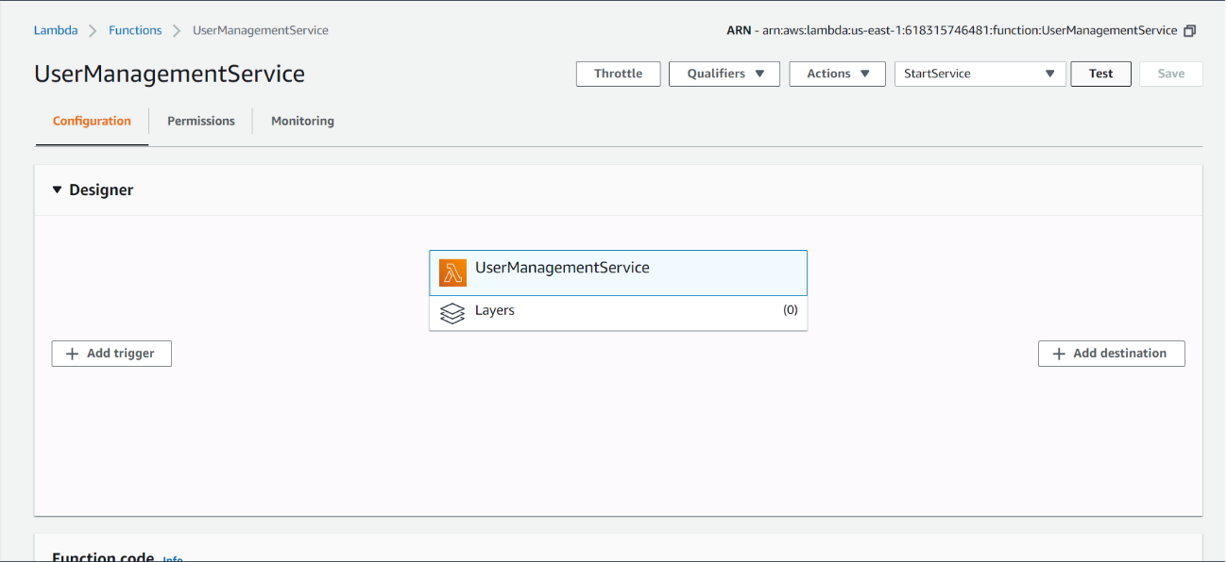

* **Then we started the OperatorManagementService with the command:**

mvn exec:java -D"exec.mainClass"="Webservice.OperatorManagementServicePublisher"

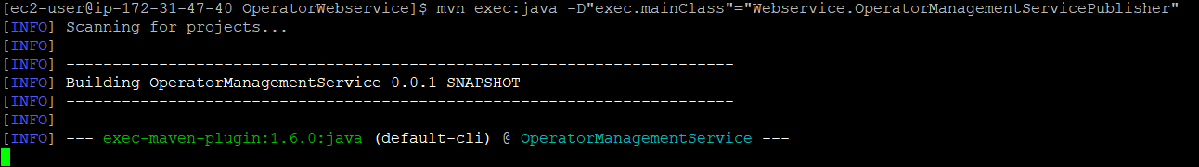

We also used an event that invoked the startService method to start this service:

<soapenv:Envelope xmlns:soapenv="http://schemas.xmlsoap.org/soap/envelope/" xmlns:web="http://Webservice/">

<soapenv:Header/>

<soapenv:Body>

<web:startService>

</web:startService>

</soapenv:Body>

</soapenv:Envelope>

* **We also created a consumer for the Debit topic to represent the PaymentService with the command:**

/usr/local/kafka/bin/kafka-console-consumer.sh --bootstrap-server <Public_DNS>:9093, <Public_DNS>:9094, <Public_DNS>:9095 --topic Debit

* **At this point the system is completely running:**
  + producers were sending events

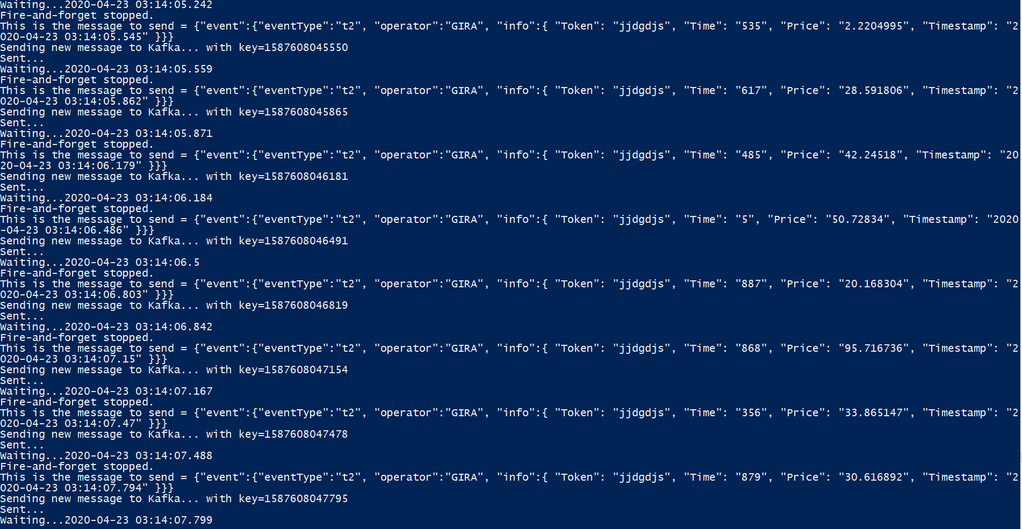

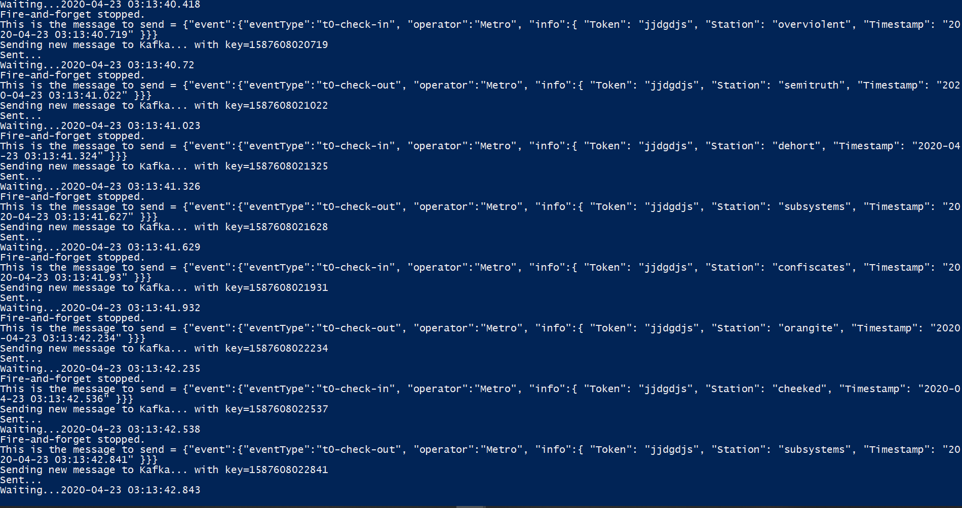

* + UserManagementService was consuming events:



* + 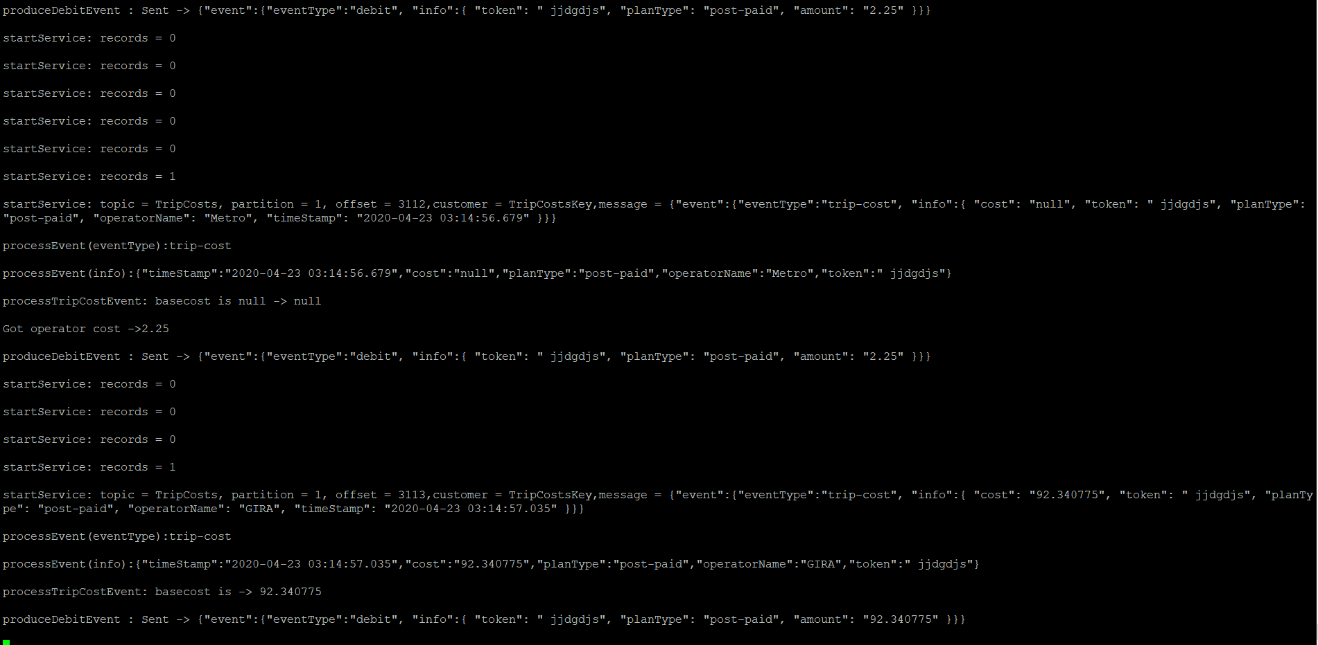OperatorManagementService was consuming the Trip events produced by UserManagementService:
  + OperatorManagementService was also creating entries in the history tables

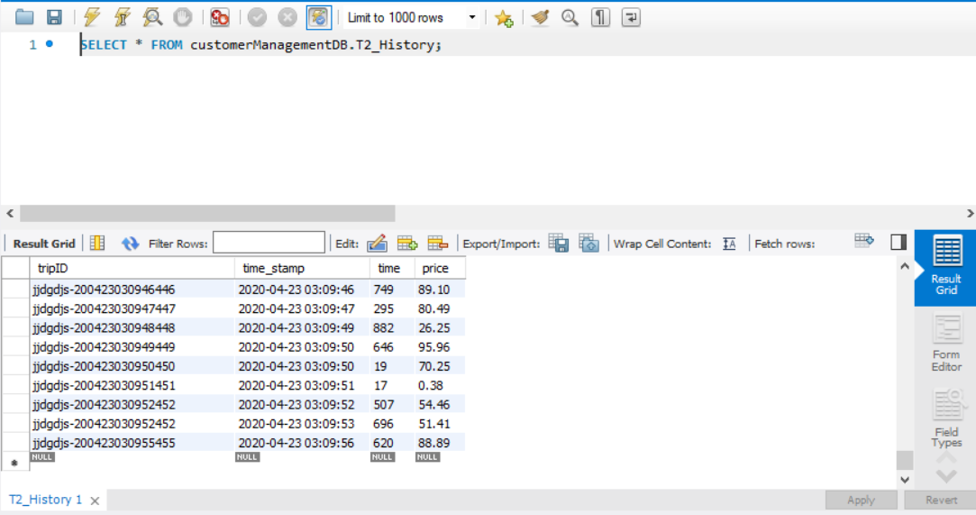T2 specific History table

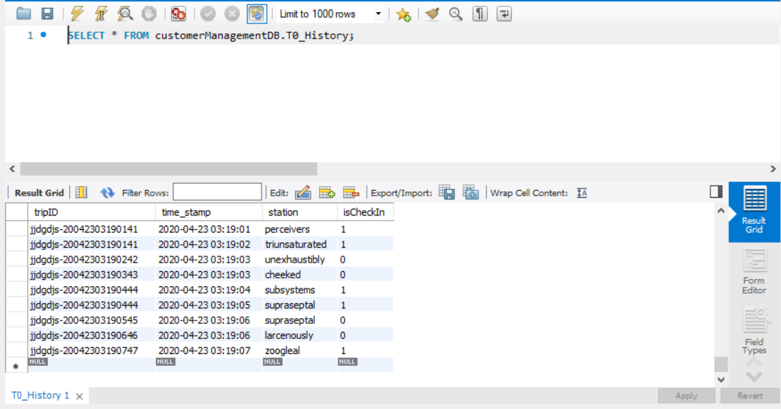T0 specific History table

* + Finally, the consumer of the Debit Topic was consuming debit events produced by the OperatorManagementService

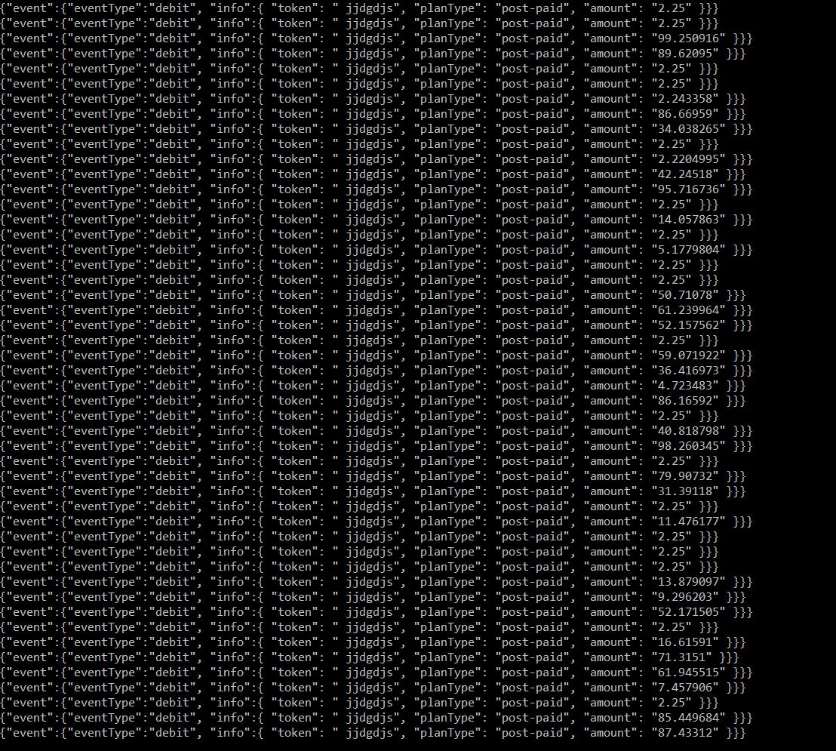

* **In addition, we stopped one Kafka broker at 03:15 but the consuming and producing of events did not stop:**

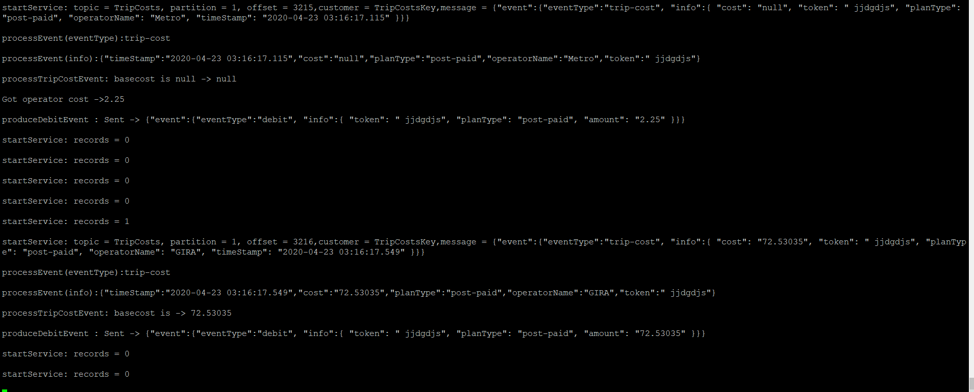

**Analytics**

**Note:** the graphs were made using a different timezone(-1 hour)

* Trip events started being sent at 03:05. We can notice that read throughput and write throughput start rising around that time. Read Latency starts increasing and maintains an exponential increase until the end of the test. Write Latency starts to drop but some minutes after starts rising.
* We stopped the Kafka Broker at 03:15. We can notice a drop in the write throughput and write latency around this time, but the system continued working with a smaller read throughput as well.

