Software Testing and Validation

**Project Report - 2019-2020**

Group 10 - João Freitas (87671), Diogo Faustino (97081)

**Test cases for computeCreditBill method**

To test this method, we applied the Combinational Functional Test Pattern because of the complex logic behind de process of choosing the discount value.

We elaborated a decision tree:

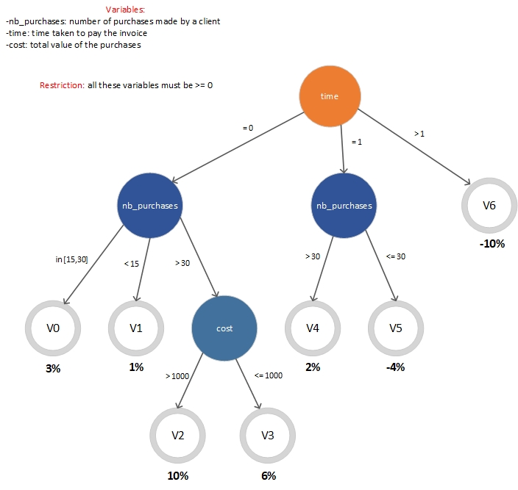

Fig. 1 – Decision tree regarding discount value

Boundary conditions for each variant:

* V0 -> time = 0 & 15 <= nb_purchases <= 30
* V1 -> time = 0 & nb_purchases < 15
* V2 -> time = 0 & nb_purchases > 30 & cost > 1000
* V3 -> time = 1 & nb_purchases > 30 & cost <= 1000
* V4 -> time = 1 & nb_purchases > 30
* V5 -> time = 1 & nb_purchases <= 30
* V6 -> time > 1

Domain matrixes for variants















* In total we have 21 test cases.
* The expected results marked with an X are test cases that contain an invalid value for time (-1) which isn’t supposed to happen because the time variable must be >= 0. As it was said in the project description, the expected result for these test cases is that they throw an InvalidOperationException exception.

**Test cases for PostOffice class**

We identified the type of this class as non-modal because the constraints are not related to the history nor the message sequences. As a result, we applied the Non-modal Test Pattern.

We started by identifying the class invariant by analyzing the restrictions:

* It is impossible to have two products with the same name registered in the same post office **(for any p1,p2 in PostOffice.products, p1.name = p2.name => p1 = p2)**
* The total amount of products presented at a post office cannot exceed a given threshold(…) This maximum number of products can vary between 2 and 20 and it is specified when you create a post office **(for each PostOffice as po, po.products.size() <= po.maxNumberOfProducts & 2 <= po.maxNumberOfProducts <= 20)**
* The unit price and the number of units of a product cannot be a negative number **(for each p in PostOffice.products, p.price >=0 & p.quantity >= 0)**

PostOffice class invariant: **for any p1,p2 in PostOffice.products, p1.name = p2.name => p1 = p2 & for each PostOffice as po, po.products.size() <= po.maxNumberOfProducts & 2 <= po.maxNumberOfProducts <= 20 & for each p in PostOffice.products, p.price >=0 & p.quantity >= 0**

**Domain matrix for PostOffice class**

