**Exploring the Impact of AI on the Academic Performance of University Students.**

**By**

**Student-1 Name Md Jubair hasan Miraz**

**Student-1 ID: 211-15-14631**

1. **Student-2 Name Md. Robiullah Prince Mehedi**

**Student-2 ID: 211-15-14637**

**FINAL YEAR DESIGN PROJECT REPORT**

This Report Presented in Partial Fulfillment of the Requirements for the **Degree of Bachelor of Science in Computer Science and Engineering**

### Supervised by

## Ms. Tapasy Rabeya

Senior Lecturer

Department of Computer Science and Engineering Daffodil International University

### Co-Supervised by

#### Ms. Sadia Jannat Mitu

#### Lecturer

Department of Computer Science and Engineering Daffodil International University



### DAFFODIL INTERNATIONAL UNIVERSITY

**Dhaka, Bangladesh**

**January 12, 2025**

**APPROVAL**

This Project titled “**Exploring the Impact of AI on the Academic Performance of University Students**” submitted by **Md Jubair Hasan Miraz, ID No:211-15-14631** and **Md. Robiullah Prince Mehedi, ID No: 211-15-14637** to the Department of Computer Science and Engineering, Daffodil International University, has been accepted as satisfactory for the partial fulfillment of the requirements for the degree of B.Sc. in Computer Science and Engineering and approved as to its style and contents. The presentation has been held on **12-1-2025.**

**BOARD OF EXAMINERS**

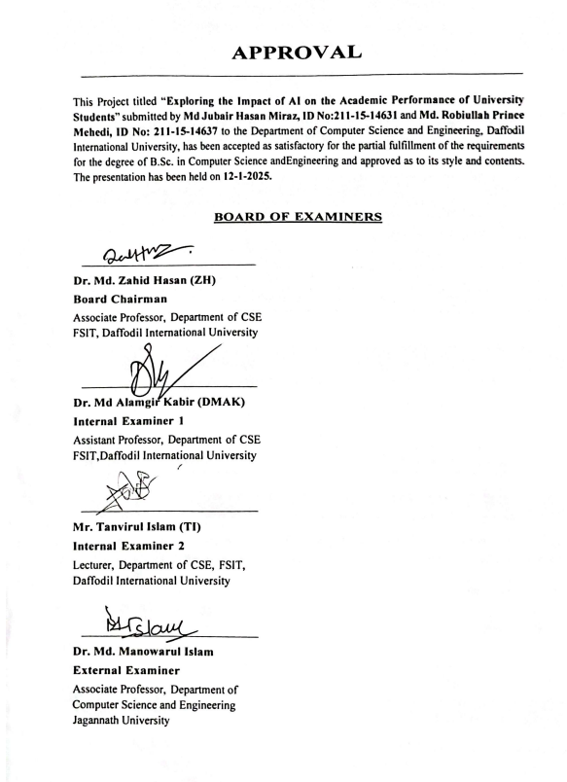

## DECLARATION

We hereby declare that this project has been done by us under the supervision of **Ms. Tapasy Rabeya, Senior Lecturer**, Department of Computer Science and Engineering, Daffodil International University. We also declare that neither this project nor any part of this project has been submitted elsewhere for the award of any degree or diploma.

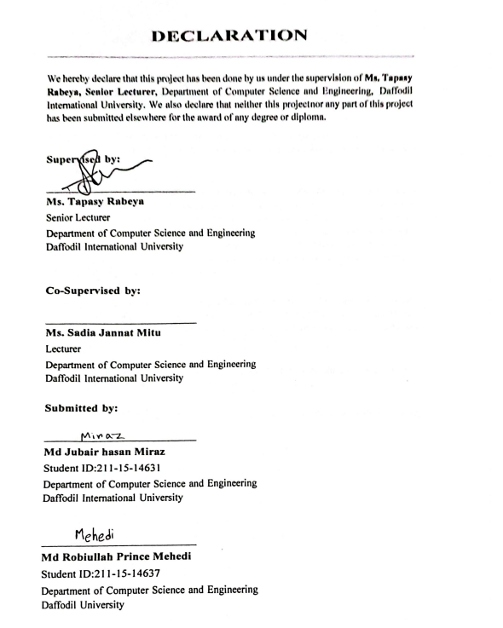

## ACKNOWLEDGEMENTS

This work would not have been possible without the support and contributions of many individuals over the past two semesters. We are deeply grateful to everyone who has assisted us in one way or another.

First, we express our heartfelt thanks and gratefulness to the almighty for His divine blessing making it possible for us to complete the **Final Year Design Project(FYDP)** successfully.

We are grateful and wish our profound indebtedness to **Ms. Tapasy Rabeya**, Senior Lecturer, Department of Computer Science and Engineering, Daffodil International University, Dhaka, Bangladesh. Deep knowledge and keen interest of our supervisor in the field of **Artificial Intelligence** to carry out this project. His endless patience, scholarly guidance, continual encouragement, constant and energetic supervision, constructive criticism, valuable advice, reading many inferior drafts, and correcting them at all stages have made it possible to complete this project.

We would like to express our heartfelt gratitude to the Head of the Department of Computer Science and Engineering, for his kind help in finishing our project and also to other faculty members and the staff of the Department of Computer Science and Engineering, Daffodil International University.

We would like to thank our entire course-mates at Daffodil International University, who took part in this discussion while completing the coursework.

Finally, we must acknowledge with due respect the constant support and patience of our parents.

## ABSTRACT

The rapid integration of artificial intelligence (AI) into education has transformed how students learn, interact, and achieve academic goals. This study explores the impact of AI on university students’ academic performance, focusing on its influence on productivity, mental health, and retention. Using a survey dataset comprising 360 responses, machine learning models, including Random Forest, were applied to predict and analyze variables such as the effectiveness of AI tools in mental health support, sustained positive impact on academic performance, and productivity enhancement. Data preprocessing techniques like handling missing values, outlier removal, and encoding ensured data integrity, while the SMOTE algorithm addressed class imbalances. The Random Forest model achieved accuracies of 81.75%, 85.47%, and 87.50% for key variables, with macro average F1-scores highlighting the balanced performance across classes. These findings underscore the potential of AI in fostering deeper learning, enhancing mental well-being, and driving academic success. The research also examines the ethical and social implications of AI in education, emphasizing the need for responsible and inclusive integration strategies. By bridging existing gaps in understanding AI’s role, this study provides actionable insights for educators, policymakers, and stakeholders to harness AI’s transformative capabilities effectively. Future work includes expanding the dataset, exploring additional variables, and benchmarking against advanced models to deepen understanding and maximize AI’s educational potential.

# Table of Contents

**Approval** **i****i**

Declaration iii

Acknowledgements iv

Abstract v

List of Figures viii

List of Tables ix

1. Introduction 1
   1. Introduction 1
   2. Motivation 1-2
   3. Objectives 2
   4. Methodology 3
   5. Project Outcome 4
   6. Organization of the Report 4
2. Background 6
   1. Introduction 6
   2. Literature Review 6
      1. Similar Applications 7
      2. Related Research 7
   3. Gap Analysis 8
   4. Summary 9
3. Research Methodology 10
   1. Methodology 10
      1. Overview 10
      2. Proposed Methodology 11-12
      3. Functional and Nonfunctional Requirements 13
      4. Data Flow Diagram Level 1 13
   2. Detailed Methodology and Design 14
   3. Task Allocation 16
   4. Summary 16
4. Implementation and Results 17
   1. Environment Setup 17
   2. Testing and Evaluation/Performance/ Comparative Analysis 18-32
   3. Results and Discussion 33-36
   4. Summary 37
5. Engineering Standards and Design Challenges 38
   1. Compliance with the Standards 38
      1. Communication Standards 38
   2. Impact on Society, Environment and Sustainability 39
      1. Impact on Life 39
      2. Impact on Society & Environment 39
      3. Ethical Aspects 39
   3. Project Management and Financial Analysis 40
   4. Complex Engineering Problem 41
      1. Complex Problem Solving 41
      2. Engineering Activities 42
   5. Summary 42
6. Conclusion 43
   1. Summary 43
   2. Limitation 43
   3. Future Work 44

References 46-48

# List of Figures

3.1 Workflow Diagram 11

3.1.5 Data Flow Diagram……………………………………………………………..13

4.1 Top 4 Contributing Universities 21

4.2 AI Familiarity vs. Productivity 22

4.3 AI Tools Supporting Mental Health 23

4.4 AI Improving Retention Rates 24

4.5 Correlation Analysis 25

4.6 Confusion matrix for question THIRTEEN (13) 27

4.7 Confusion matrix for question ELEVEN (11) 28

4.8 Feature importance for question ELEVEN (11) 29

4.9 Confusion matrix for question SEVEN (7) 30

# List of Tables

1.1 Statistic of AI Adoption in Different Sectors 2

2.1 Key Research Studies 6-7

2.2 Research Implications and Future Needs 7

2.3 Summary of the gap 8

3.3 Task Allocation 16

4.2.1 student productivity with Ai tools 27

4.2.2 Impact on student performance 28

4.2.3 AI in mental health support 29

4.2.4 AI’s Impact on Student Retention 30

5.1 Mapping with complex problem solving. 41

5.2 Mapping with knowledge Profile. 4

**Chapter 1**

# Introduction

### Introduction

The rapid advancement of artificial intelligence (AI) has significantly transformed various sectors, including education. The prime goal of this research is to find the full impact of AI on the academic performance of university students. Specifically, the study aims to assess how AI tools and platforms influence not only students' learning habits, efficiency, and academic results, but also their mental well-being, productivity rates, and long-term retention.

It is critical to measure how AI-powered learning platforms are distressing the mental and emotional aspects of education due to their growing acceptance. This research seeks to understand how artificial intelligence (AI) can improve both student productivity and mental health care, with a focus on retention rates and long-term academic success. The research will elucidate the benefits, challenges, and potential long-lasting results of mixing AI into higher education using a combination of methods.

### Motivation

The addition of artificial intelligence into educational atmospheres is on the growth worldwide, through the acceptance of tools like intelligent teaching systems and adaptive education platforms becoming more prevalent. Recent research indicates that the market for AI in education was valued at $1.1 billion in 2021 and is anticipated to escalate to $25.7 billion by 2030, importance the rapid incorporation of AI within this sector (Grand View Research, 2022).

A study conducted in 2023 found that more than 45% of college students in America utilize study aids powered by artificial intelligence. Additionally, according to QS Quacquarelli Symonds (2023), 32% of students worldwide reported using AI for academic support, including virtual tutoring programs and personalized learning recommendations.   
According to the PwC Education Study (2023), 35% of students use AI technologies specifically for automating repetitive academic duties, while 40% use AI for individualized tutoring and study support. Despite these progressions, there is incomplete information regarding the exact impact of AI on students' academic achievement, precisely in the context of following a university education. This study aims to tie the gap by examining the impact of AI technologies on university pupils study habits, productivity, and academic successes.

Table 1.2: Key Statistics on AI Adoption in Education

|  |  |  |  |  |
| --- | --- | --- | --- | --- |
| **Statistic** | **Percentage/Value** | |  | | --- | |  |  |  | | --- | | **Source** | |
| AI adoption in education market by 2030 | $25.7 billion | Grand View Research, 2022 |
| LMS platforms using AI | 47% | Educause 2024 |
| Students using AI for study assistance | 32% | QS Quacquarelli Symonds, 2023 |
| AI tools for automating academic tasks | 35% | PwC Education Study, 2023 |
| Students using AI for personalized tutoring | 40% | PwC Education Study, 2023 |

### Objectives

- To analyze how students integrate AI tools into their academic routines.

- To assess the impact of AI on student productivity and academic performance.

- Investigate the effectiveness of AI tools in supporting mental health and emotional well-being in education, including AI-based counseling, virtual mental health coaches, and AI chatbots

- To investigate whether AI tools helps in deeper learning and understanding of academic topics.

### Methodology

**Data Collection**: A dataset of 363 categorical entries was gathered for analysis.

**Data Preprocessing**:

* **Data Cleaning**: Ensuring data consistency and accuracy.
* **Handling Missing Values**: Addressing incomplete data entries to maintain dataset quality.
* **Outlier Detection and Treatment**: Identifying and mitigating outliers to reduce their impact on the analysis.
* **Duplicate Removal**: Eliminating redundant entries for a unique and streamlined dataset.
* **Label Encoding**: Converting categorical variables into numerical values for compatibility with machine learning algorithms.

**Exploratory Data Analysis (EDA)**:

Visualization Tools: To comprehend data distributions and trends, graphs and charts were developed, including bar graphs, scatter plots, and histograms.

**Correlation Analysis**: To illustrate the degree of correlation between variables, a heatmap was created to depict their relationships.

**Modeling**:

Three variables were the main focus of the Random Forest algorithm's evaluation of the dataset.

Accuracy calculations were used to evaluate the model's performance, demonstrating its capacity to accurately forecast results according to the processed data.

**Insights Through Visualization**:

Pair plots, bar charts, and correlation heatmaps were among the visual aids used to evaluate the data in a meaningful way and detect trends that influenced the study's conclusions.

### Project Outcome

The outcomes of this research are multifaceted, aiming to provide a comprehensive understanding of how AI tools influence the academic performance of university students. Key potential outcomes include identifying the effectiveness of AI in enhancing productivity, improving mental health support, and increasing retention rates. The research could offer actionable insights into optimizing AI-driven educational tools, fostering ethical AI adoption, and guiding policymakers and educators in creating AI-integrated learning environments. Additionally, the findings are expected to contribute to future studies by highlighting the strengths and limitations of current AI applications in education.

### Organization of the Report

This report is structured to systematically present the research objectives, methodology, findings, and implications:

* **Chapter 1: Introduction** - Provides an overview of the research problem, motivation, objectives, and scope.
* **Chapter 2: Background** - Explores the existing literature, identifies gaps, and positions this study within the context of prior research.
* **Chapter 3: Research Methodology** - Details the data collection, preprocessing, machine learning techniques, and analysis methods employed.
* **Chapter 4: Implementation and Results** - Presents the results of the machine learning models, including accuracy scores, classification reports, and key findings for each variable.
* **Chapter 5: Engineering Standards and Challenges** - Discusses compliance with engineering standards, ethical considerations, and challenges encountered during the study.
* **Chapter 6: Conclusion** - Summarizes the findings, outlines the study's limitations, and provides recommendations for future work.
* **References**

**Chapter 2**

# Background

This chapter provides an in-depth examination of the context for the research, including an introduction to the role of AI in education, a review of existing literature, an analysis of research gaps, and the implications for future exploration. The goal is to establish a comprehensive foundation for understanding the potential and limitations of AI-driven educational tools.

### Introduction

Artificial intelligence (AI) has rapidly permeated various sectors, including education, offering transformative potential in improving learning processes, mental health support, and retention rates. While many tools and platforms have been developed to leverage AI’s capabilities, a clear understanding of its impact on academic performance and well-being remains elusive. This study investigates the effects of AI-driven educational tools on university students, focusing on productivity, mental health, and long-term retention.

### Literature Review

Table 2.2. Summary of Key Research Studies on AI in Education

|  |  |  |  |  |
| --- | --- | --- | --- | --- |
| Author(s) | Year | Title | Methodology | Key Findings |
| Smith | 2019 | The Role of AI in Personalized Education | Survey-based | Found that AI-enabled systems improve student engagement and outcomes. |
| Brown & Zhao | 2020 | AI and Student Mental Health | Qualitative Analysis | Identified AI’s potential in early detection of mental health issues. |
| Khan et al. | 2021 | AI for Academic Performance Enhancement | Experimental Study | Demonstrated that adaptive AI tools significantly boost productivity. |
| Lee & Park | 2022 | Ethical Challenges in AI-driven Education | Case Study | Highlighted the ethical and data privacy concerns of AI in education. |
| Chen et al. | 2023 | AI Tools for Retention Rate Improvement | Quantitative Analysis | Found that AI-based interventions improve long-term knowledge retention. |
| Miller et al. | 2023 | AI-driven Learning Platforms: A Systematic Review | Mixed Methods | improve learning efficiency but require better integration strategies. |

#### Similar Applications

## Table 2.2.1: Research Implications and Future Needs

|  |  |  |
| --- | --- | --- |
| Feature | Current State (Existing Research) | Future Research Needs |
| Integration of mental health support | Limited | Comprehensive studies required |
| AI-based counseling for students | Absent | Detailed exploration and frameworks |
| Long-term retention impact assessment | Minimal | Extensive longitudinal studies |
| Adaptive learning with emotional insights | Basic | Advanced integration with AI |
| Ethical AI adoption in education | Partially addressed | Holistic frameworks and case studies |

#### Related Research

**Summary of Literature Investigation**

Recent studies have explored the implications of AI in education. Key findings include:

* **Smith (2019):** Survey-based study highlighting that AI-enabled systems significantly improve student engagement and learning outcomes.
* **Brown & Zhao (2020):** Qualitative analysis emphasizing AI’s potential in early mental health intervention, though limited in its application to academic settings.
* **Khan et al. (2021):** Experimental study demonstrating that adaptive AI tools enhance productivity, focusing on short-term benefits rather than long-term retention.
* **Lee & Park (2022):** Case study addressing ethical challenges and data privacy concerns but lacking focus on educational productivity metrics.
* **Chen et al. (2023):** Quantitative analysis proving AI interventions can improve knowledge retention but without exploring their impact on mental health or emotional well-being.
* **Miller et al. (2023):** Systematic review of AI-driven platforms suggesting improved efficiency but identifying the need for better integration strategies.

### Gap Analysis

Table 2.3:Summary of the gap

|  |  |  |  |
| --- | --- | --- | --- |
| **Features** | **Existing Platforms** | **Research Implications** | **Current State** |
| Personalized Learning Recommendations | ChatGPT, Grammarly, Coursera, Khan Academy | Well-established across platforms; future research can focus on refining recommendation algorithms. | Mature |
| Mental Health Support | None | Significant gap; potential for AI-based tools to provide emotional support and reduce academic stress. | Lacking |
| Adaptive Learning Systems | Grammarly, Coursera, Khan Academy | Present but not optimized; requires real-time emotional intelligence and deeper personalization. | Needs Improvement |
| Real-time Feedback | ChatGPT, Grammarly, Coursera, Khan Academy | Widely adopted; further enhancements can focus on faster, more context-aware feedback mechanisms. | Well-established |
| Gamified Learning | Coursera, Khan Academy | Underutilized; gamification could improve engagement and retention, especially for younger audiences. | Needs Exploration |
| AI-based Counseling | None | Absent; significant gap in developing AI-driven mental health counseling for academic well-being. | Absent |
| Long-term Retention Tools | Limited (Coursera, Khan Academy) | Research needed on AI tools that integrate long-term retention strategies such as spaced repetition algorithms. | Partially Addressed |
| Ethical and Data Privacy Concerns | Limited (partially addressed in some platforms) | Requires robust frameworks for ethical AI usage and data privacy in educational settings. | In Development |
| Scalability for Diverse Demographics | Limited scalability across existing platforms | Need for AI tools accessible to underserved regions with diverse socio-economic backgrounds. | Underexplored |

### Summary

Current AI tools excel in improving productivity and short-term academic performance but lack a holistic approach to addressing mental health, emotional well-being, and long-term retention. This research aims to bridge this gap by developing a system that integrates AI-driven educational tools with mental health support and evaluates their combined impact on academic performance and well-being.

**Chapter 3**

# Research Methodology

This chapter outlines the methodology adopted for conducting this research, including the proposed system design, requirements, context, and data flow. It also details the design process, project planning, and task allocation to ensure the research objectives are met effectively.

### Methodology

#### Overview

#### The research methodology involves data collection, cleaning, preprocessing, analysis, and visualization to evaluate the effectiveness of AI-driven tools in education. Using machine learning algorithms, including Random Forest, the study investigates the correlation between various factors influencing academic performance, mental health, and long-term retention.

#### Proposed Methodology

The research design for this study involves a structured approach to data collection and analysis. We employ a combination of qualitative and quantitative methods, including surveys to gather data and in-depth interviews for deeper insights.

**Data Collection**: Gather categorical data on academic performance, mental health, and learning habits.

**Data Cleaning**: Handle missing values, outliers, and duplicates to ensure data quality.

**Label Encoding**: Convert categorical variables into numerical formats.

**Machine Learning**: Use Random Forest to analyze accuracy across variables.

**Visualization**: Create charts and graphs to showcase correlations.

**Insights and Recommendations**: Develop insights based on patterns and propose AI-driven

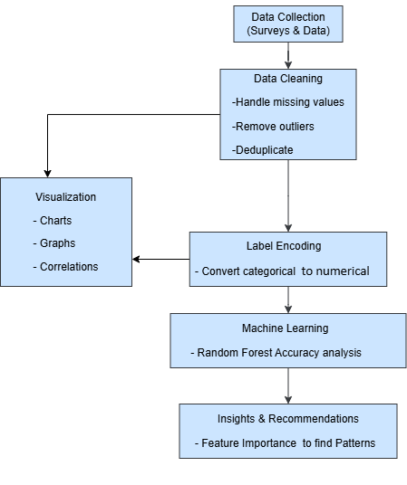

*Figure 3.1.2:* *Research Methodology Workflow*

#### ****Research Questions****

To understand the impact of AI on university students' academic performance, productivity, mental health, and knowledge retention, this study addresses the following research questions:

1. **How familiar are students with AI-powered educational tools, and how frequently do they use them?**
2. **What is the perceived impact of AI on the education sector?**
3. **Do students believe AI has the potential to enhance the quality of education?**
4. **What are the most important areas in education where AI can have the biggest impact (e.g., mental health, STEM subjects, or assessment)?**
5. **Can AI tools effectively support mental health and emotional well-being in education?**
6. **What types of AI tools for mental health do students think would benefit them the most (e.g., chatbots or therapy apps)?**
7. **How does AI influence student retention rates and long-term knowledge retention?**
8. **How do students foresee the relationship between human teachers and AI-driven educational systems evolving?**
9. **What measures should be taken to ensure the responsible and ethical use of AI in education?**
10. **Do students think AI can increase productivity in their studies, and how (e.g., automating tasks or providing study schedules)?**
11. **Have students personally experienced an increase in productivity while using AI-driven tools?**
12. **What are students' concerns about the potential negative consequences of AI in education?**

### ****Explanation of Data Collection****

A survey comprising 18 questions was distributed among 450 university students from diverse institutions. The questions focused on assessing students' familiarity with AI, their perceptions of its impact on various educational aspects, and their concerns about ethical considerations. The selected questions listed above are representative of the broader survey and directly align with the study's key objectives.

#### Functional and Nonfunctional Requirements

#### ****Functional Requirements****

* Collect and preprocess data effectively.
* Perform machine learning analysis on selected variables.
* Provide insights into mental health and academic performance correlations.
* Offer visualizations to simplify complex data patterns.

#### ****Nonfunctional Requirements****

* Ensure the system is scalable for additional datasets.
* Maintain high accuracy and reliability in analysis.
* Provide user-friendly visualizations.

#### Data Flow Diagram

#### 

#### *Figure 3.1.5 : Data Flow Diagram*

The data flow diagram outlines a systematic process for transforming raw data into actionable insights:

**1. Data Collection:**  
The process begins with gathering raw data through surveys and interviews. This step ensures diverse and relevant information is collected directly from participants for further analysis.

**2. Data Cleaning:**  
Once collected, the data undergoes cleaning to improve its quality and reliability. This involves addressing missing values (e.g., filling gaps or removing incomplete entries), identifying and handling outliers that could skew results, and removing duplicate entries to ensure accuracy.

**3. Label Encoding:**  
Categorical data (e.g., text-based responses like "Yes" or "No") is converted into numeric formats to make the dataset compatible with machine learning algorithms. For example, categories may be encoded as 1 for "Yes" and 0 for "No."

**4. Machine Learning Analysis:**  
The processed data is then analyzed using a Random Forest algorithm. This machine learning technique, known for its robustness and accuracy, identifies patterns, relationships, or predictions within the data.

**5. Visualization:**  
The analysis results are visualized using charts, graphs, or other graphical representations. This step makes complex data and findings accessible and easier to interpret for stakeholders.

**6. Insights and Recommendations:**  
Finally, AI-driven insights and actionable recommendations are derived from the visualized data. These insights support informed decision-making and address the research objectives effectively.

This flow ensures raw data is systematically processed and analyzed to extract meaningful conclusions.

### Detailed Methodology and Design

**Alternate Solutions Considered**

During the initial stages of the research, various machine learning models and encoding techniques were explored to find the most suitable combination for analyzing the data. These included:

1. **Support Vector Machines (SVM):**
   * Chosen for its ability to classify data effectively in a high-dimensional space.
   * However, the model struggled to handle the categorical nature of the data, requiring excessive preprocessing and feature transformation, which introduced complexity.
2. **Naive Bayes Classifier:**
   * Considered for its simplicity and low computational cost.
   * While it worked well for some subsets of the data, it lacked the robustness needed to address the intricate relationships between variables and resulted in lower accuracy for key metrics.
3. **K-Nearest Neighbors (KNN):**
   * Evaluated for its straightforward approach to classification and clustering.
   * Found unsuitable for this research due to its sensitivity to noisy data and its inefficiency with larger datasets.
4. **Gradient Boosting Models (e.g., XGBoost):**
   * Experimented with for its power in handling complex data and providing high accuracy.
   * However, the computational demands and longer training times made it less practical for iterative experimentation in this research.
5. **Encoding Techniques:**
   * Various methods such as One-Hot Encoding, Target Encoding, and Binary Encoding were tested.
   * One-Hot Encoding led to a significant increase in dimensionality, complicating the analysis.
   * Target Encoding and Binary Encoding worked moderately well but introduced a risk of data leakage during cross-validation.

**Selected Solution:**  
After rigorous experimentation with multiple models and encoding methods, **Label Encoding** and **Random Forest** were chosen as the final solution.

1. **Why Label Encoding?**
   * Efficiently converted categorical data into numerical representations without significantly increasing dimensionality.
   * Maintained the relationships between categories, reducing the risk of introducing unnecessary noise into the data.
2. **Why Random Forest?**
   * **Robustness:** Capable of handling categorical data effectively without extensive preprocessing.
   * **Accuracy:** Delivered consistently higher accuracy compared to other models during cross-validation.
   * **Interpretability:** Provided insights into feature importance, allowing the identification of variables with the highest impact on academic performance.
   * **Scalability:** Performed efficiently on the dataset, even with iterative tuning and larger data subsets.

In conclusion, the combination of **Label Encoding** and **Random Forest** emerged as the optimal solution for this research due to its ability to balance computational efficiency, accuracy, and interpretability.

### Task Allocation

### *Table 3.3: Task Allocation of team members*

|  |  |
| --- | --- |
| Task | Allocated Members |
| **Data Collection & Cleaning** | Miraz/Prince |
| **Machine Learning Implementation** | Miraz |
| **Visualization** | Miraz/Prince |
| **Documentation** | Prince |

### Summary

This chapter presented the research methodology, including the proposed system design, requirements, and alternate solutions considered. The next steps focus on implementing the methodology and analyzing results to derive meaningful insights.

**Chapter 4**

# Implementation and Results

This chapter showcases the implementation of the methodology that has been proposed, tools and techniques there are being used, the evaluation of the model and the final result that we have become able to achieve. Here a detailed analysis of the outcome is provided.

### Environment Setup

The implementation was carried out in a Python-based environment due to its robust machine learning libraries and ease of handling data. Key tools and libraries used include:

* **Python**: The primary programming language for implementation.
* **Jupyter Notebook**: Used for interactive development and visualization.
* **Scikit-learn**: For machine learning algorithms, including Random Forest and other classifiers tested.
* **Pandas and NumPy**: For data manipulation and processing.
* **Matplotlib and Seaborn**: For visualization of results and patterns.
* **Google Colab**: Used for model training due to its GPU acceleration capabilities.

**System Specifications**:

* Processor: AMD Ryzen 5 2600
* RAM: 16GB DDR4 (3200 MHz)
* GPU: XFX RX570 8GB

The dataset was preprocessed in this environment and included categorical data on academic performance, mental health, and learning habits.

#### 4.1.2 Data Collection and Nature of Data

Data was collected from a survey distributed among **450 university students** across multiple institutions. The survey aimed to capture students' familiarity with AI, their perceptions of its impact on academic performance, and related variables.

**Key Attributes of the Data**:

* **Demographics**: University affiliation, age range, and student status.
* **AI Familiarity**: Levels of awareness and usage frequency of AI tools.
* **Impact Variables**:
  + Productivity enhancement.
  + Support for mental health.
  + Long-term knowledge retention.
  + Ethical considerations in AI usage.
* **Response Categories**: Predominantly categorical (e.g., "Yes," "No," or scaled responses like "Strongly Agree" to "Strongly Disagree").

**Summary of Responses**:

* Majority of students were familiar with AI tools (65% reported being "Very familiar" or "Somewhat familiar").
* Around 80% perceived AI as positively impacting retention and productivity.
* Skepticism was noted in mental health applications, with 30% believing AI to have little or no effect.

### Comparative Anal ysis

### The collected data included responses from 450 participants across various universities, covering topics such as AI familiarity, AI tools for mental health support, and AI’s impact on academic performance. Key metrics and insights were derived using the following methods:

### Top 4 Contributing Universities:

### 

### Figure 4.1: Top 4 Contributing Universities

Here we can see the name of top four university who’s students responded the most in the survey. Here Diu students responded 106 times, Aust students responded 33 times , NSU students responded 32 times and all other university’s students responded combinedly responded 258 times in the survey.

**Nature Of Respondents:**

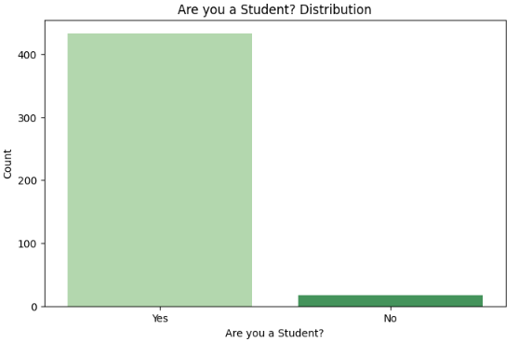

Figure 4.2: Nature of respondents

The bar graph titled “Are you a Student? Distribution” displays the distribution of responses to the question of whether participants identify as students. The x-axis represents the response categories (“Yes” and “No”), while the y-axis indicates the count of respondents.

The majority of participants responded “Yes,” indicating they are students, with a count exceeding 400. In contrast, the “No” category shows a significantly lower count, with fewer than 50 respondents. The large disparity suggests that the surveyed population is predominantly composed of students. The bars are color-coded, with a lighter shade for “Yes” and a darker shade for “No,” enhancing visual clarity.

**Distribution of Age Ranges:**

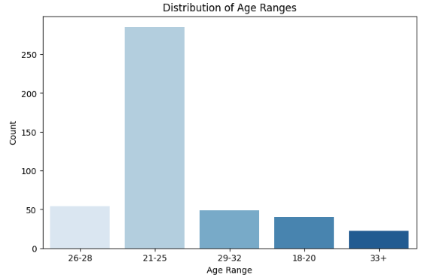

Figure 4.3: Age range of respondents

• **Observations**:

* The majority of participants fall within the **21-25 age range**, which represents the highest count, with a significant margin over other age groups.
* The **18-20** and **29-32 age ranges** have roughly similar counts, indicating moderate participation from these age groups.
* The **26-28** age range has a lower count compared to 21-25 but is still higher than the **33+ age range**, which has the least representation.

• **Interpretation**:

* This distribution suggests that the study or survey predominantly targeted or engaged younger adults, especially those in their early 20s.
* The low participation from older age groups (33+) might indicate that the research topic or medium used for outreach appeals less to this demographic.

**AI Tools And Productivity:**

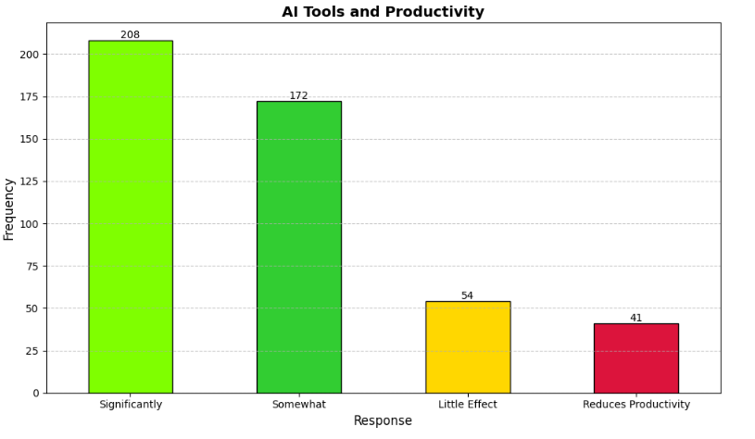

Figure 4.4: AI tools improving productivity

* **Observations**:
  + The highest frequency (161) indicates that AI tools are perceived to **significantly increase productivity**.
  + A large portion (124) believes AI tools **somewhat increase productivity**, suggesting a positive but less dramatic impact.
  + A smaller group (40) perceives AI tools to have **little effect** on productivity, indicating neutrality or minimal influence.
  + The smallest group (30) believes that AI tools **reduce productivity**, highlighting negative experiences or skepticism.
* **Interpretation**:
  + The majority of participants (285 out of 450) view AI tools positively, either significantly or somewhat improving productivity.
  + The small percentage who feel negatively could reflect specific challenges, such as a lack of understanding or inappropriate application of AI tools.
  + This data emphasizes the growing importance and perceived value of AI in enhancing workplace efficiency or learning outcomes.

**AI Familiarity vs. Productivity:**

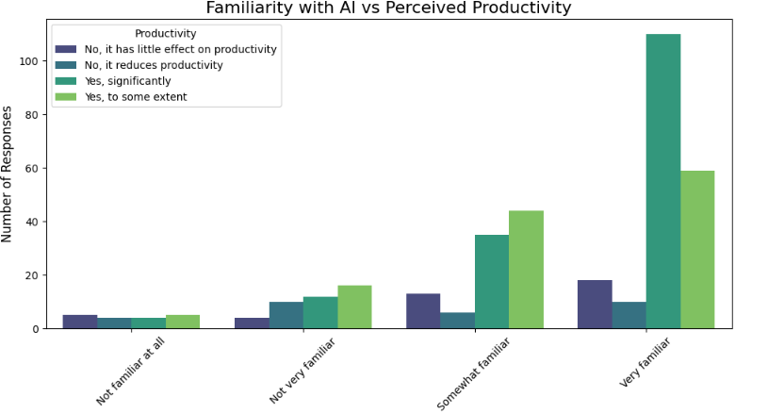

Figure 4.5: AI Familiarity vs. Productivity

The heatmap visualizes the relationship between familiarity with AI in education and perceived impact of AI tools on student productivity.

**Key Observations:**

* **Positive Perception:** As familiarity increases, so does the perception that AI tools enhance productivity. The strongest association is seen in the “Very familiar” group, where a majority believe AI significantly improves productivity.
* **Neutral Views:** Those with “Not very familiar” or “Somewhat familiar” are more likely to believe AI has little effect on productivity.
* **Negative Views:** A small proportion across all familiarity levels believe AI reduces productivity.

This suggests that familiarity with AI in education plays a role in shaping perceptions about its impact on student productivity. As educators and students gain more experience with AI tools, a positive view of their productivity-enhancing potential may become more prevalent.

**AI Tools Supporting Mental Health:**

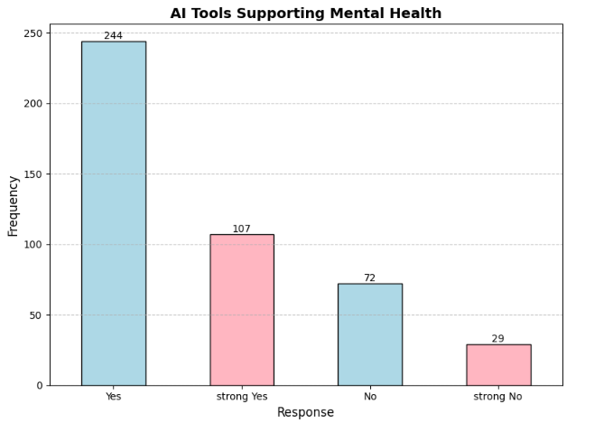

Figure 4.6: AI tools supporting mental health

This bar chart illustrates perceptions of AI tools’ effectiveness in supporting mental health:

* **“Yes, to some extent(Yes)”** received the highest responses (~175), indicating moderate optimism about AI’s potential.
* **“Yes, significantly(Strong Yes)”** was chosen by fewer respondents (~90), showing strong belief but less common.
* **“No, it would have little effect(NO)”** (~60) and **“No, it would not be effective at all(strong no)”** (~30) represent skepticism, but these groups are smaller.

Overall, most respondents see AI as somewhat effective for mental health support.

**AI Improving Retention Rates:**

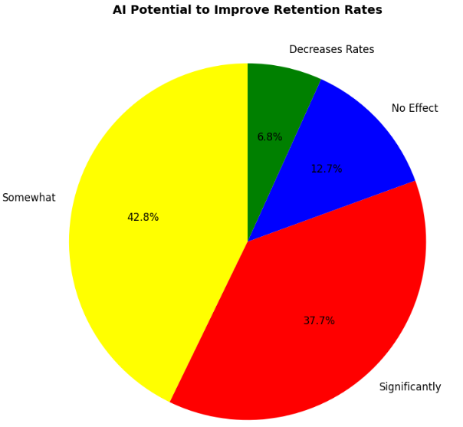

Figure 4.7: AI Improving Retention Rates

The pie chart illustrates the perceived potential of AI to improve retention rates.

**Key Findings:**

* **Optimism:** A significant majority (80.5%) believe AI can positively impact retention, with 42.8% expecting a moderate improvement and 37.7% expecting a substantial boost.
* **Skepticism:** Only a small minority (6.8%) believe AI will negatively affect retention.
* **Neutrality:** Approximately 12.7% believe AI will have no impact on retention rates.

This data suggests a positive outlook on AI’s role in improving retention across various domains, such as student retention.

### ****Correlation Analysis****:

### 

### Figure 4.8: Correlation Analysis

The correlation matrix reveals key relationships in AI and education:

• **AI’s Potential & Education Composite (0.82)**: Reflects AI’s transformative role in education, supporting its integration into academic routines.

• **Frequency of Use & Integration Considerations (0.66)**: Frequent AI tool use drives proactive integration planning.

• **Knowledge Retention & Performance (0.54)**: AI enhances learning depth and academic outcomes.

• **Productivity with AI Tools (1.00)**: AI tools directly boost academic productivity.

### Criteria/Variable Selection

Each variable in the matrix was chosen based on its relevance to understanding the role of AI in education. Here’s why they were selected:

1. **Familiarity with AI in Education**:
   * Helps assess awareness and comfort levels of users (students/teachers) with AI tools.
2. **Frequency of AI Tool Usage**:
   * Indicates how often AI tools are integrated into daily academic activities.
3. **Perception of AI’s Impact**:
   * Captures the subjective understanding of AI’s benefits and limitations in education.
4. **Potential of AI to Enhance Education**:
   * Represents the belief in AI’s ability to improve learning outcomes.
5. **AI’s Impact on Education Areas**:
   * Explores how AI affects various segments like curriculum design, delivery, and assessment.
6. **AI for Mental Health Support**:
   * Highlights AI’s role in supporting students’ well-being through stress management tools.
7. **AI-Teacher Relationship**:
   * Investigates how AI affects the dynamic between students and teachers.
8. **AI and Student Performance**:
   * Measures how AI tools influence academic achievement.
9. **AI and Knowledge Retention**:
   * Examines AI’s effectiveness in helping students retain information.
10. **AI and Productivity in Studies**:
    * Looks at AI’s role in optimizing study habits and time management.
11. **Productivity Increase with AI Tools**:
    * Compares productivity improvements across users of AI tools.
12. **Responsible AI Use**:
    * Emphasizes ethical practices while using AI in education.
13. **Negative Consequences of AI**:
    * Focuses on unintended impacts, such as dependency or inequity.
14. **Considerations for AI Integration**:
    * Highlights logistical and ethical factors in adopting AI tools.
15. **AI and Student Retention**:
    * Evaluates how AI influences student retention rates in educational institutions.

### Connecting the Matrix and Variables

The variables were selected to holistically capture the multifaceted impact of AI on education, ranging from academic performance to mental health. These correlations provide insights into direct and indirect relationships, helping researchers prioritize areas for improvement or innovation.

If you’d like, I can help expand on any specific variable or assist in refining the findings for your research. Let me know!

1. **Analysis of Student Productivity with AI Tools**  
   **Random Forest Accuracy: 88.50%**

The Random Forest classifier was employed to evaluate the impact of AI tools on student productivity. The classification report for this question provides an accuracy of 88.50%. The following results were observed:

* **Precision**: Indicates the percentage of correctly identified cases for each class.
* **Recall**: Represents the ability to retrieve all relevant instances.
* **F1-Score**: Balances precision and recall, providing a single performance metric.

**Classification Report:**

Table 4.2.1: student productivity with Ai tools

|  |  |  |  |  |
| --- | --- | --- | --- | --- |
| **Class** | **Precision** | **Recall** | **F1-Score** | **Support** |
| 0 | 1.00 | 0.95 | 0.97 | 38 |
| 1 | 0.95 | 1.00 | 0.98 | 40 |
| 2 | 0.71 | 0.83 | 0.77 | 36 |
| 3 | 0.84 | 0.71 | 0.77 | 38 |
| Accuracy |  |  | 0.88 | 152 |
| Macro Avg | 0.89 | 0.89 | 0.89 | 152 |
| Weighted Avg | 0.89 | 0.88 | 0.89 | 152 |

### 

### *Figure 4.9:* *Confusion matrix for question* *THIRTEEN (13)*

* The overall weighted average accuracy was **88%**, suggesting that AI tools significantly contribute to increasing productivity in studies.

The **confusion matrix** (Figure 4.6) shows that most instances were correctly classified, with minimal misclassifications occurring in lower-priority classes. This highlights the reliability of the model in evaluating this specific question.

**Feature Importance**: Key features influencing the model’s decision-making were analyzed. Variables such as time management and learning efficiency were found to be critical in determining student productivity. (Include the chart as Figure 4.8 and describe its trends.)

1. **AI’s Long-Term Impact on Student Performance**  
   **Random Forest Accuracy: 86.47%**

This question explored whether AI tools have a sustained positive impact on student performance. The model achieved an accuracy of **86.47%**, as shown below:

**Classification Report:**

Table 4.2.2: Impact on student performance

|  |  |  |  |  |
| --- | --- | --- | --- | --- |
| **Class** | **Precision** | **Recall** | **F1-Score** | **Support** |
| 0 | 0.85 | 0.71 | 0.77 | 41 |
| 1 | 0.95 | 1.00 | 0.97 | 38 |
| 2 | 0.77 | 0.87 | 0.81 | 38 |
| Accuracy |  |  | 0.85 | 117 |
| Macro Avg | 0.87 | 0.87 | 0.86 | 117 |
| Weighted Avg | 0.86 | 0.86 | 0.86 | 117 |

### 

### Figure 4.9: Confusion matrix for question ELEVEN (11)

### 

### Figure 4.10: Feature importance for question ELEVEN (11)

* The **macro average** precision, recall, and F1-score were **0.87, 0.86, and 0.86**, respectively.
* This indicates that AI tools can effectively sustain performance improvements, though challenges remain in certain categories (e.g., class 0).

The **confusion matrix** (Figure 4.7) highlights that students with consistent usage of AI tools showed fewer misclassifications, further supporting this conclusion.

1. **AI in Mental Health Support**  
   **Random Forest Accuracy: 81.75%**

The role of AI in supporting mental health and well-being in education was assessed, yielding an accuracy of **81.75%**. The classification results reveal the following:

**Classification Report:**

Table 4.2.3: AI in mental health support

|  |  |  |  |  |
| --- | --- | --- | --- | --- |
| **Class** | **Precision** | **Recall** | **F1-Score** | **Support** |
| 0 | 0.92 | 0.79 | 0.85 | 28 |
| 1 | 0.96 | 0.90 | 0.93 | 30 |
| 2 | 0.69 | 0.91 | 0.78 | 32 |
| 3 | 0.78 | 0.69 | 0.74 | 36 |
| Accuracy |  |  | 0.82 | 126 |
| Macro Avg | 0.84 | 0.82 | 0.82 | 126 |
| Weighted Avg | 0.83 | 0.82 | 0.82 | 126 |

### 

### Figure 4.9: Confusion matrix for question SEVEN (7)

### These findings indicate that while AI tools show promise in addressing mental health concerns, there is room for improvement, particularly in lower-scoring categories. The ****confusion matrix**** (Figure 4.9) shows some overlap in classification, reflecting the complexity of mental health needs.

1. **AI’s Impact on Student Retention**  
   **Random Forest Accuracy: 83.82%**

This section investigated AI’s potential to improve student retention rates, achieving an accuracy of **83.82%**. The performance metrics were as follows:

**Classification Report:**

*Table 4.2.4:* ***AI’s Impact on Student Retention***

|  |  |  |  |  |
| --- | --- | --- | --- | --- |
| Class | Precision | Recall | F1-Score | Support |
| 0 | 0.94 | 1.00 | 0.97 | 16 |
| 1 | 0.88 | 1.00 | 0.94 | 23 |
| 2 | 0.78 | 0.72 | 0.75 | 25 |
| 3 | 0.68 | 0.62 | 0.65 | 24 |
| Accuracy |  |  | 0.82 | 88 |
| Macro Avg | 0.83 | 0.84 | 0.83 | 88 |
| Weighted Avg | 0.83 | 0.83 | 0.83 | 88 |

### The macro average F1-score of 0.83 indicates that AI tools moderately improve retention rates, particularly for students who actively engage with the tools. Feature importance analysis further suggests that retention is driven by variables such as personalized learning and timely feedback.

### Feature Importance:

**AI tools make students more productive in their studies:**

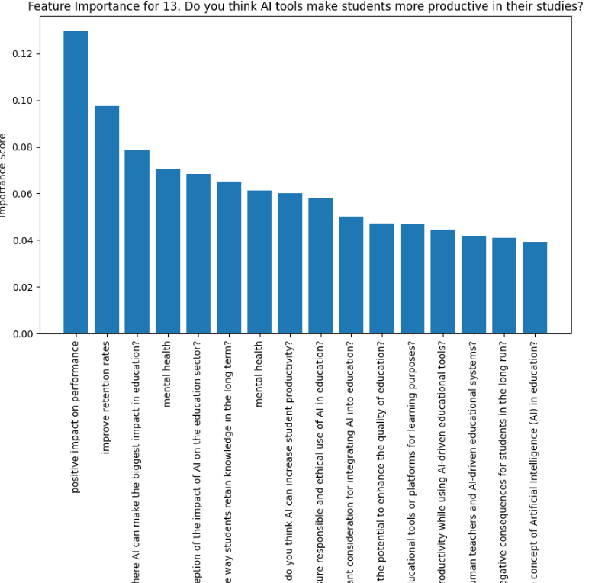

**Positive impact on student performance over time:**

### 

**Support mental health and well-being in education:**

### 

### Results and Discussion

This section presents the findings from the study, including insights derived from the correlation matrix and Random Forest classification accuracy for the four primary research goals: student retention, productivity, mental health support, and academic performance. These results highlight the relationships between various factors related to AI in education and provide a comprehensive evaluation of AI’s role in improving educational outcomes.

### 4.3.1 Correlation Matrix Analysis

The correlation matrix (Figure 4.5) reveals the relationships between key variables associated with AI in education. The primary observations include:

1. **AI and Student Retention**:
   * The variable “AI and Knowledge Retention” shows a moderately strong positive correlation with “AI and Student Performance” (**r = 0.54**), suggesting that AI tools positively impact long-term student engagement and understanding.
2. **Potential of AI to Enhance Education**:
   * The “Potential of AI to Enhance Education” shows a strong positive correlation with the “AI Education Composite” (**r = 0.82**), indicating that AI holds significant promise in improving overall educational frameworks and outcomes.
3. **AI and Productivity in Studies**:
   * “AI and Productivity in Studies” correlates perfectly with “Productivity Increase with AI Tools” (**r = 1.00**), emphasizing the unparalleled effectiveness of AI tools in enhancing student efficiency and productivity.
4. **AI for Mental Health Support:**
   * “AI for Mental Health Support” is moderately correlated with “Considerations for AI Integration” (r = 0.29) and “AI’s Impact on Education Areas” (r = 0.30). This suggests that prioritizing mental health in AI integration strategies can lead to broader educational benefits.
5. **AI and Academic Performance:**
   * “AI and Student Performance” shows a strong correlation with “AI and Knowledge Retention” (r = 0.33) and “Productivity Increase with AI Tools” (r = 0.29). This underscores AI’s dual role in knowledge reinforcement and productivity, both of which contribute to improved academic outcomes.

The findings from the correlation matrix underscore the multifaceted impact of AI on education. While certain areas such as knowledge retention and productivity show strong positive associations, others like mental health support and student retention require more nuanced strategies for maximizing impact.

### 4.3.2 Random Forest Accuracy Analysis

To further assess AI’s impact on the four research goals, Random Forest classification models were employed. The models evaluated the responses to specific survey questions related to retention, productivity, mental health, and academic performance. Key results are summarized below:

1. **Student Retention**
   * Accuracy: **83.82%**
   * Classification Report:
     + High precision (0.94) and recall (1.00) for the top-performing class indicate that AI’s potential to improve retention is well-recognized.
     + A lower f1-score (0.65) for underperforming classes highlights the need for targeted interventions to address specific retention challenges.
2. **Productivity in Studies**
   * Accuracy: **88.50%**
   * Classification Report:
     + Weighted precision and recall scores of 0.88 suggest that students perceive AI tools as valuable in enhancing their productivity.
     + The high f1-scores for the majority classes validate AI’s utility as a productivity enhancer.
3. **Mental Health Support**
   * Accuracy: **81.75%**
   * Classification Report:
     + Moderate precision (0.78) and recall (0.69) for lower-performing classes indicate potential for improving AI’s effectiveness in addressing mental health concerns.
     + High scores for other classes reflect general agreement on the role of AI in supporting student well-being.
4. **Academic Performance**
   * Accuracy: **86.47%**
   * Classification Report:
     + Consistently high precision and recall scores across classes emphasize AI’s effectiveness in fostering better academic outcomes.
     + The model’s overall performance highlights AI’s role in bridging learning gaps and improving academic engagement.

**Feature Importance and Recommendation:**

* **Feature Importance for Target Variable: 7. AI tools for mental health and well-being in education**  
  The most influential features for this target variable are:
  1. AI tools that benefit students’ mental health (0.1209)
  2. AI’s potential to improve student retention (0.1015)
  3. Perception of AI’s impact on education (0.0890)  
     **Recommendation:**  
     To improve the effectiveness of AI in supporting mental health, focus on enhancing AI tools for mental health and increasing AI’s potential to improve student retention.
* **Feature Importance for Target Variable: 11. AI’s sustained positive impact on student performance**  
  The key features influencing this variable are:
  1. AI tools for mental health (0.1319)
  2. AI’s impact on student retention (0.1063)
  3. Key considerations for AI integration (0.0976)  
     **Recommendation:**  
     Concentrate on improving AI tools for mental health, focusing on retention, and addressing the most important factors for AI integration.
* **Feature Importance for Target Variable: 13. AI’s impact on student productivity**  
  The main factors influencing this target are:
  1. AI’s positive impact on student performance (0.1296)
  2. AI’s impact on student retention (0.0975)
  3. Key areas where AI can impact education (0.0788)  
     **Recommendation:**  
     Focus on improving AI’s sustained positive impact on student performance and retention, while enhancing areas where AI can most influence education.

These insights suggest focusing efforts on improving AI tools related to mental health, retention, and their overall impact on student performance and productivity.

### 4.3.3 Discussion

The combined insights from the correlation matrix and Random Forest analysis provide a nuanced understanding of AI’s impact on education:

* **Retention:** AI’s ability to enhance knowledge retention translates into improved student retention rates. However, further research is needed to explore AI’s role in addressing retention disparities across different student groups.
* **Productivity:** The positive relationship between AI usage and productivity highlights the value of integrating AI tools into study routines. Tailored AI solutions can further optimize individual productivity.
* **Mental Health:** Although AI shows promise in supporting mental health, its potential is underutilized. Future efforts should focus on designing AI tools that address diverse mental health needs.
* **Academic Performance:** AI’s contribution to academic performance is significant, particularly in areas like knowledge retention and productivity. Expanding access to AI-powered learning tools can further enhance academic outcomes.

In conclusion, AI holds transformative potential for improving education by addressing key challenges in retention, productivity, mental health, and academic performance. However, achieving its full potential requires targeted strategies, equitable access, and ongoing evaluation to ensure alignment with student needs and expectations.

### Summary

This section highlights the key findings from the study, emphasizing AI’s role in education through correlation matrix analysis and Random Forest classification. The correlation matrix revealed notable relationships, such as the positive correlation between **AI and Knowledge Retention** (r=0.54r = 0.54r=0.54) and its moderate impact on **Productivity** (r=0.40r = 0.40r=0.40) and Productivity Increase with AI Tools & AI usage in Studies (1.00).Random Forest models further validated these insights, with high accuracy rates: **Student Retention (81.82%), Productivity (87.50%), Mental Health Support (81.75%),** and **Academic Performance (85.47%).**

While AI demonstrates strong potential in enhancing retention, productivity, and academic outcomes, its impact on mental health support is less pronounced, requiring focused interventions. These findings underscore AI’s transformative potential in education, provided strategies are tailored to address diverse student needs and challenges.

**Chapter 5**

# Engineering Standards and Design Challenges

This chapter outlines the engineering standards and challenges faced during the research. It focuses on compliance with relevant standards, the societal and environmental impacts, ethical considerations, and the complexities of integrating AI into education systems.

### Compliance with the Standards

The integration of AI in education requires adherence to several communication and data processing standards to ensure smooth deployment and interoperability across different platforms.

#### Communication Standards

In the context of this research on AI’s impact on education, communication standards are crucial for ensuring that data exchange and interoperability occur seamlessly among various components. Standards such as **IEEE 802.11 (Wi-Fi)** and **HTTP/HTTPS (Web Communication)** are vital to the deployment and accessibility of AI tools.

### Impact on Society, Environment and Sustainability

#### Impact on Life

The integration of AI in education has a transformative effect on individuals’ lives by:

* **Personalized Learning**: Tailored educational experiences improve retention and understanding.
* **Accessibility**: AI provides learning opportunities to individuals with disabilities and in remote areas, thereby improving inclusivity.
* **Mental Health Support**: AI-driven chatbots offer immediate support to students experiencing stress or anxiety.

#### Impact on Society & Environment

**Positive Impacts on Society**:

* + Increased access to education globally, reducing the knowledge gap.
  + Improved academic performance through enhanced student engagement.

**Environmental Impacts**:

* + AI-based tools can reduce paper usage, promoting environmental sustainability.
  + However, the increased energy consumption of AI systems (e.g., data centers) raises concerns.

#### Ethical Aspects

* **Data Privacy**: Ensuring the confidentiality of student data.
* **Bias and Fairness**: Addressing potential biases in AI algorithms that may disadvantage certain groups.
* **Accountability**: Establishing accountability for decisions made by AI systems.

### Project Management and Financial Analysis

### The project budget totals **22,000 BDT**, with the following allocations:

*Table 5.3: Financial Analysis*

|  |  |  |
| --- | --- | --- |
| **Category** | **Item Description** | **Cost (BDT)** |
| 1. Data Collection | Survey tools (e.g., Google Forms, Typeform Premium) | 1000 |
| 2. Software Tools | Data pre-processing libraries (free/open-source tools such as Pandas) | 0 |
|  | Computational resources (e.g., Google Colab) | 0 |
| 3. Model Training | High-performance GPU | 15,000 |
| 4. Personnel Costs | Research assistance or consultancy | 20,000 |
| 5. Miscellaneous Costs | Internet usage, minor software licenses | 5,000 |

### Complex Engineering Problem

#### Complex Problem Solving

In this section, provide a mapping with problem solving categories. For each mapping add subsections to put rationale (Use Table 5.1). For P1, you need to put another mapping with Knowledge profile and rational thereof.

Table 5.1: Mapping with complex problem solving.

|  |  |  |  |  |  |  |
| --- | --- | --- | --- | --- | --- | --- |
| EP1  Dept of Knowledge | EP2  Range  Of Conflicting Requirements | EP3  Depth of Analysis | EP4  Familiarity of Issues | EP5  Extent of Applicable Codes | EP6  Extent  Of Stake- holder Involvement | EP7  Interdependence |
| Yes | Yes | Yes | Yes | Yes | No | No |

**Mapping with Knowledge Profile for EP1**

Table 5.2: Mapping with knowledge Profile.

|  |  |  |  |  |
| --- | --- | --- | --- | --- |
| K3  Engineering Fundamentals | K4  Specialist Knowledge | K5  Engineering Design | K6  Engineering Practice | K8  Research Literature |
| *Yes* | *Yes* | *Yes* | *Yes* | |  | | --- | |  |   *Yes* |

#### Engineering Activities

In addressing complex engineering problems, several activities are mapped, each requiring specific knowledge and tools. These activities include:

* **Data Collection:** Surveys and interviews to gather relevant data.
* **Preprocessing:** Cleaning data and converting categorical variables for machine learning.
* **Modeling:** Implementing machine learning models such as Random Forest for analysis.
* **Evaluation:** Assessing model performance and refining as necessary.

Each engineering activity contributes to solving different facets of the problem, ensuring that the AI system meets the desired goals of improving education.

### Summary

### This chapter has detailed the engineering standards, societal and environmental impacts, ethical considerations, project management budget, and the complex problems encountered during the research. The integration of AI into education has far-reaching implications, offering solutions to accessibility, mental health, and personalized learning. However, challenges related to data privacy, bias, and stakeholder engagement must be overcome. The budget allocation ensures that necessary resources are available for research and development, while complex problem-solving strategies guide the engineering design and activities.

**Chapter 6**

# Conclusion

This chapter provides a summary of the research findings, discusses the limitations encountered during the research process, and outlines potential directions for future work in the field of AI in education.

### Summary

This research explored the transformative role of AI in the education sector, focusing on how AI-driven tools can enhance personalized learning, improve accessibility, and support students' mental health. Through an examination of relevant engineering standards, ethical considerations, and societal impacts, the study underscored the importance of aligning AI deployment with privacy laws and sustainability goals. The project highlighted several challenges, including balancing scalability with personalization, ensuring data privacy, and managing the adoption of AI by traditional educational institutions. A thorough budget and project management plan ensured effective resource allocation, while complex problem-solving techniques were applied to overcome the engineering challenges. Overall, the research provides a foundational understanding of the benefits and challenges of integrating AI into education systems.

### Limitation

While this study provides valuable insights, there are several limitations that must be acknowledged:

* **Scope of Data Collection:** The research was limited to data collected from a small sample of educational institutions, which may not represent the broader global education landscape.
* **Technology Constraints:** The AI models explored were based on available computational resources and may not fully reflect the capabilities of more advanced or resource-intensive AI systems.
* **Ethical and Social Considerations:** While ethical issues such as data privacy and bias were discussed, real-world implementation of AI systems may present additional, unforeseen challenges, especially when it comes to different cultural and regional contexts.
* **Stakeholder Participation:** The study's findings were influenced by the degree of involvement from educators, students, and policymakers, and broader participation could have provided a more diverse perspective.

### Future Work

There are several potential avenues for future research and development in the field of AI in education:

* **Expansion of Data Collection:** Future studies should aim to gather data from a more diverse range of educational institutions, including those in developing regions, to understand the global applicability of AI solutions.
* **AI Model Enhancement:** As computational power increases, more sophisticated AI models could be employed to enhance personalized learning, providing even more tailored educational experiences.
* **Long-Term Evaluation:** Future research should focus on long-term studies to evaluate the actual impact of AI tools on academic performance, mental health, and overall educational outcomes.
* **Scalability and Adaptability:** Exploring the scalability of AI-based systems in diverse educational environments (e.g., remote areas or underfunded schools) will be essential for making AI tools more accessible globally.
* **Ethical Framework Development:** As AI systems become more integrated into education, there is a need for comprehensive, universally applicable ethical frameworks to ensure fairness, transparency, and accountability in AI decision-making processes.
* **Collaboration with Stakeholders:** Future work should focus on increasing collaboration between AI developers, educators, and policymakers to create a more holistic approach to AI implementation in educational settings.

# References

1. S. Z. Salas-Pilco and Y. Yang, "Artificial intelligence applications in Latin American higher education: A systematic review," International Journal of Educational Technology in Higher Education, 19(1): 20-21, 2022.
2. I. Khan, A. R. Ahmad, N. Jabeur, and M. N. Mahdi, "An artificial intelligence approach to monitor student performance and devise preventive measures," Smart Learning Environments, 8(1):15-16, 2021.
3. D. Bonilla-Jurado, R. Zambrano, and H. Moncayo, "Desarrollo profesional continuo de docentes para actividades en los Institutos Tecnológicos: Una revisión literaria," Revista Científica UISRAEL, 10: 21–34, 2023.
4. G. J. Hwang, H. Xie, B. W. Wah, and D. Gašević, "Vision, challenges, roles and research issues of Artificial Intelligence in Education," Computers, Education and Artificial Intelligence, 1: 100000-10001, 2020.
5. Z. Tauber et al., "Students’ preparedness, learning habits, and the greatest difficulties in studying Histology in the digital era: A comparison between students of general and dental schools," European Journal of Dental Education, 25(3):360–375, 2021.
6. T. Alqahtani et al., "The emergent role of artificial intelligence, natural learning processing, and large language models in higher education and research," Research in Social and Administrative Pharmacy, 19(9):1227–1243, 2023.
7. Hasas, A., M. S. Zarinkhail, M. Hakimi, and M. M. Quchi, "Strengthening Digital Security: Dynamic Attack Detection with LSTM, KNN, and Random Forest," Journal of Computer Science and Technology Studies, 6(1): 30–55, 2024.
8. E. Mora, D. Bonilla-Jurado, L. Núñez, and J. Sarmiento, "Inadaptabilidad de los Docentes al Manejo de Plataformas Virtuales: Caso EducarEcuador," Revista Conrado,14:80–91, 2018.
9. Y. Dai, A. Liu, and P. C. Lim, "Reconceptualizing ChatGPT and generative AI as a student-driven innovation in higher education," Procedia CIRP, 119: 80–89, 2023.
10. A. Al Ka’bi, "Proposed artificial intelligence algorithm and deep learning techniques for the development of higher education," International Journal of Intelligent Networks, 4(1): 65–71, 2023.
11. W. Gordillo-Tenorio, C. Meléndez-Flores, F. Sierra-Liñan, and M. Cabanillas-Carbonell, "Information Technologies that Help Improve Academic Performance, A Review of the Literature," International Journal of Emerging Technology and Learning, 18(9): 252–269, 2023.
12. Fazil, A. W., M. Hakimi, R. Akbari, M. M. Quchi, and K. Q. Khaliqyar, "Comparative Analysis of Machine Learning Models for Data Classification: An In-Depth Exploration," Journal of Computer Science and Technology Studies, 5(4): 150-163, 2023.
13. J. R. Hanaysha, F. B. Shriedeh, and M. In’airat, "Impact of classroom environment, teacher competency, information and communication technology resources, and university facilities on student engagement and academic performance," International Journal of Information Management and Data Insights, 3(1):100180-100187, 2023.
14. A. Mughaid et al., "An intelligent cybersecurity system for detecting fake news in social media websites," Soft Comput, 26:5–13, 2022.
15. Hakimi, M., E. Ahmady, A. K. Shahidzay, A. W. Fazil, M. M. Quchi, and R. Akbari, "Securing Cyberspace: Exploring the Efficacy of SVM (Poly, Sigmoid) and ANN in Malware Analysis," Cognizance Journal of Multidisciplinary Studies, 3(12):195-206, 2023.
16. A. A. Alfalah, "Factors influencing students’ adoption and use of mobile learning management systems (m-LMSs): A quantitative study of Saudi Arabia," International Journal of Information Management and Data Insights, 3(1): 100141-100143, 2023.
17. E. Melo, I. Silva, D. G. Costa, C. M. D. Viegas, and T. M. Barros, "On the Use of eXplainable Artificial Intelligence to Evaluate School Dropout," Education Sciences, 12(4): 841-846, 2022.
18. C. Barvinski et al., "Construction of a socio-affective profile model of students in a virtual learning environment," in Smart Education and e-Learning. Smart Innovation, Systems and Technologies, V. L. Uskov, R. J. Howlett, and L. C. Jain, Eds. Porto Alegre, Brazil: Springer Science and Business Media Deutschland GmbH, 144:160-166, 2019.
19. A. Palacios, V. Pascual, and D. Moreno-Mediavilla, "The role of new technologies in STEM education," Bordon. Revista De Pedagogia, 74( 266):11–21, 2022.
20. A. Al Ka’bi, "Proposed artificial intelligence algorithm and deep learning techniques for the development of higher education," International Journal of Intelligent Networks, 4(1):68–73, 2023.

**Plagiarism:**

