Topic: Project Update: Network Reconstruction Under Non-Random Missingness
Dear Kathleen,
I wanted to send a brief update on the network reconstruction work extending Daniele's confidence/credible-interval framework for network measures. The attached note summarizes the current results, compares the new estimate-based reconstruction method against the proportional-allocation baseline (Daniele's original approach), and discusses what these initial validation tests do—and do not—tell us about expected performance in practice.
The principal finding is that prior information about the missingness process can be used to recover network structure that is otherwise unrecoverable from the observed data alone. These are best-case demonstrations—the reconstruction is given a correct description of the missingness—so the immediate next step is to quantify how much that advantage erodes under a mis-specified prior, including across a corpus of 18 synthetic and real-world networks.
Beyond improving accuracy on weighted networks, the prior-informed approach also extends the framework to binary networks: the proportional method cannot reconstruct a binary network at all—there is no weight to redistribute and no node-substitution step—whereas model-based node replacement recovers the shape of the degree distribution even under heavy missingness.
Summary: Recovering missing network structure depends on what is known about how the data were lost. If the missingness mechanism is unknown, the safest approach is to redistribute observed weight proportionally across the network as done by Bellutta (2026). This preserves the evidence that remains but cannot undo structural losses. If missingness follows a centrality-correlated process summarized by a single parameter, (ρ), we can estimate each edge's pre-removal weight and direct the recovered weight toward those estimates, recovering some of the structure lost to missingness.
This note compares the two allocation strategies and evaluates the estimate-based deficit method against the proportional ("Bellutta") baseline on synthetic networks. The results should be interpreted as a best-case benchmark; an analysis of prior misspecification is currently underway.
Network recovery is assessed using two complementary summary statistics. The first is maximum in-strength, the incoming weight of the most central nodes (weighted in-degree), which captures an extreme feature of the network. The second is the Gini coefficient of in-strength, which captures inequality in the distribution of incoming weight across nodes. Reported estimates are posterior medians with 95% credible intervals from 300 reconstructions, averaged across 15 degradation replicates at each missingness level. Missingness ranges from 5% to 50% of edges removed.
1. THE BASELINE: PROPORTIONAL ALLOCATION WHEN THE MECHANISM IS UNKNOWN
Degradation removes a fraction of a network's edge weight; the reconstruction must place a budget of weight back onto the surviving structure. Bellutta's reconstruction distributes that budget in proportion to current (observed) edge weight — the natural and conservative choice when nothing is known about which edges lost weight. We reproduce that baseline on a structureless Erdos–Renyi network (n = 50) under missing-completely-at-random loss, ρ = 0.
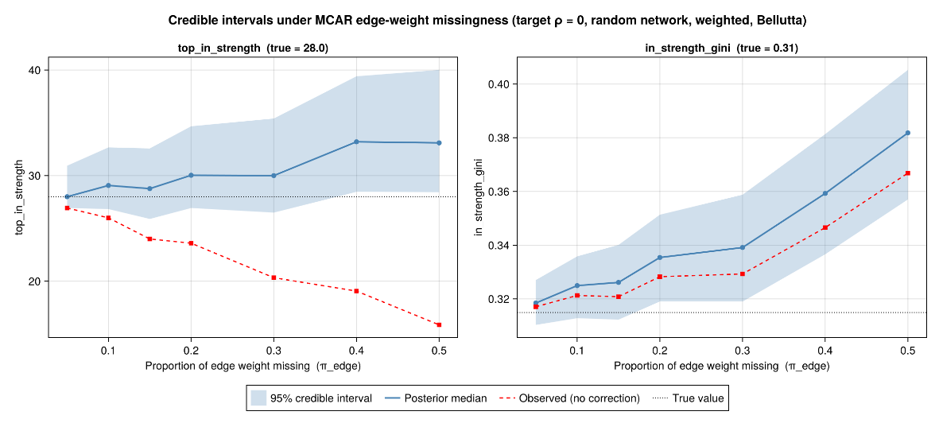
The reconstructed weights are mean-unbiased: each edge returns to its true weight in expectation. Yet both summaries climb steadily above their true values as the missing fraction grows — top in-strength from a true 28 to a median near 33 at 50% missing, Gini from 0.31 to 0.38.
This apparent over-shoot—the visible accumulation of weight on the surviving structure—is not caused by allocating weight to the wrong edges. At ρ = 0 the reconstruction is unbiased: on average, the weight added back to each edge equals the weight that was removed. The over-shoot arises instead from bootstrap variability interacting with the shape of the two summaries we report. The maximum in-strength is a convex function of the node strengths, so by Jensen's inequality the bootstrap scatter biases it upward—the maximum responds more to upward fluctuations of the leading node than to downward ones. The Gini coefficient is not convex, but it is an inequality measure that rises under any mean-preserving spread of the strengths (it is Schur-convex); because each reconstruction redistributes a fixed total of weight across the nodes, the bootstrap scatter is exactly such a spread, and the Gini registers it as added inequality. By either route, bootstrap noise produces a systematic upward shift in these statistics even when the underlying weight estimates are unbiased.
This effect is independent of the allocation rule. At ρ = 0 the estimate-based and proportional methods are mathematically identical, so neither can eliminate the over-shoot. The result illustrates the fundamental limit of the baseline case: when nothing is known about the missingness mechanism, proportional allocation is the only defensible strategy, and the remaining over-shoot is simply the cost of estimating these summaries from bootstrap reconstructions.
2. THE ESTIMATE-BASED CORRECTION
The intuition is straightforward. When missingness is correlated with centrality, some parts of the network are more likely than others to lose weight. If we can estimate which edges were most affected, we should direct the recovered weight toward those edges rather than spreading it across the surviving structure in proportion to whatever weight happens to remain.
We summarize the missingness process with a single parameter, ρ — the rank correlation between a node's centrality and its tendency to lose ties or weight. From ρ we derive an edge-specific adjustment, τ, that captures how strongly each edge is expected to be affected. Under a proportional-hazard model, an edge's surviving fraction is approximately
exp(-λ * τ), where lambda controls the overall severity of the loss.
We solve for the single value of λ at which the total estimated loss matches the known amount of missing weight, W_add:
sum over edges of w_obs * ( exp(λ * τ) - 1 ) = W_add
Because this relationship is monotone in λ, the solution is straightforward (a single bisection). Once λ is known, each edge receives an estimated deficit,
deficit = w_obs * ( exp(λ * τ) - 1 )
and the recovered weight is allocated in proportion to these deficits. In expectation, each edge is restored to its estimated pre-removal weight,
w_obs * exp((λ * τ)
This differs fundamentally from proportional allocation. Proportional allocation asks, "Where is the weight now?" and distributes the recovered weight according to the degraded network that remains after loss; as missingness increases, that target becomes progressively more distorted. The deficit method instead asks, "Where was the weight before it was lost?" and allocates the recovered weight toward that estimated target. Its objective therefore stays fixed regardless of how much data is missing.
Two properties make the method safe to adopt. When ρ = 0 the adjustment is flat and the correction reduces exactly to proportional allocation, so it introduces no spurious change when there is nothing to exploit (we verified this on both networks). And a fully drained edge — one with no observed weight left — receives zero deficit: the method restores depleted-but-surviving structure, not edges that vanished entirely, which are handled by the node-replacement stages in Section 4.
3. WHERE IT PAYS OFF: A DEGREE-CORRELATED MECHANISM (WEIGHTED)
MCAR is rarely the operative mechanism. In many empirical settings prominent, high-degree actors are more likely to be observed, producing a negative correlation between degree and missingness. We test that case on a degree-heterogeneous Barabasi–Albert hub network (n = 60), oriented so in-degree concentrates on a few hubs, degraded at target ρ = -0.35. We compare faithful Bellutta — proportional allocation, mechanism unknown, ρ assumed 0 (Figure 2) — against deficit allocation told the realized ρ (Figure 3).
A note on terminology is helpful here. In this experiment, we remove edges not nodes in order to compare to Belutta’s method. The framework supports both edge- and node-missingness, but the results reported below come from the edge-missingness condition. Under edge removal, the realized value of (ρ) is not fixed across the missingness sweep. As more edges are removed, peripheral nodes tend to lose a larger share of their connections, which strengthens the observed relationship between centrality and missingness. Consequently, the realized (ρ) drifts from approximately 0 at low levels of missingness to about (-0.62) at the highest levels. The label "target (ρ =-0.35)" should therefore be interpreted as describing the middle of the sweep rather than every point along it.
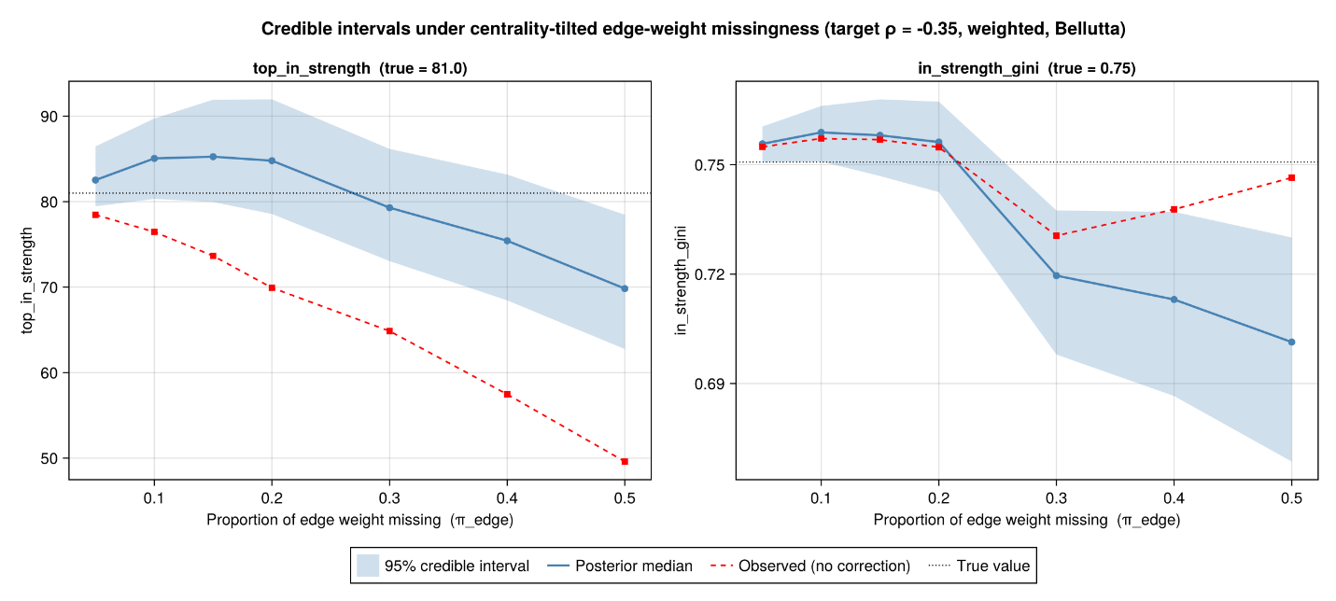
For the extremal measure—maximum in-strength, whose true value is 81—the two allocation methods perform almost identically. Both methods recover much of the weight lost from the dominant hub and produce credible intervals that contain the true value well into severe missingness — through roughly 44% of edge weight missing for proportional allocation, and 48% for the deficit method. Only at the most extreme level tested (50% missing) do both begin to fall systematically below the truth.
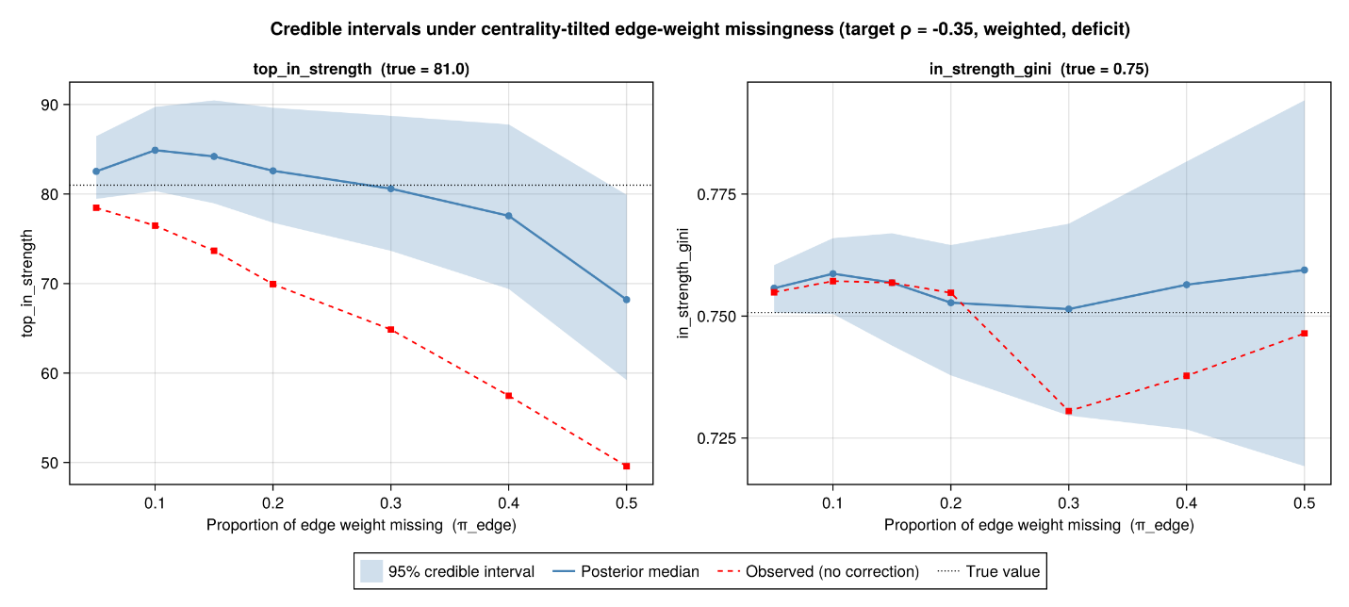
The deficit method is the more robust of the two here, though its margin is narrower than on the inequality measure below, and for a clear reason: the top in-strength is governed by a single, highly central node that both methods restore well, so there is little room for the deficit method's targeting to pull ahead. Its advantage is real but modest where a measure rests on one node; it is on the inequality measure, which depends on the shape of the whole distribution, that the two separate decisively.
On inequality (in-strength Gini, true 0.751) they diverge. Deficit holds the Gini at its true value across the whole range. Proportional flattens it — the median falls below true, and below even the uncorrected observed, past 30% missing. A flat allocation spreads the recovered budget across the many peripheral edges, where most of the edge-weight mass lives, diluting the hub's dominance and erasing the inequality the network actually has. So under a plausible degree-correlated mechanism, the estimate-based correction recovers the inequality structure that proportional allocation destroys, at no cost to the extremal estimate.
4. TOPOLOGY RECOVERY: NODE REPLACEMENT (BINARY NETWORK)
To isolate the topology machinery from the weight machinery, we binarize the same hub network (all weights set to 1) and repeat at target ρ = -0.35 (Figure 4). With weights collapsed, the weight-allocation stage is inert and the reconstruction reduces to pure topology recovery. There is no Bellutta comparison in this experiment: his method redistributes observed weight and has no node-substitution analog.
Node replacement addresses two different kinds of missingness. In some cases, a node is still visible in the data because other actors mention or connect to it, but its own outgoing ties are missing. In other cases, the node disappears entirely, along with all of its incoming and outgoing ties. The algorithm handles these two situations separately.
Both draw on a single statistical profile of the observed network, computed once and reused across every replicate: where each node sits in the centrality hierarchy, and the pattern by which ties attach between those positions. That profile is built from the same ρ model used to describe how weight was lost — one model governs both where weight went missing and where whole nodes went missing. It also fixes a simple weight budget for each reconstruction: the total weight is the observed weight, plus a floor of one unit for every tie that must be put back, plus a diffuse remainder. Node replacement supplies the topology and that floor; distributing the remainder is the weight-allocation step of Section 2. In the binary network the remainder is zero — there is no weight beyond the ties themselves — which is exactly why this experiment isolates node replacement from weight allocation.
The first case involves partially observed nodes. These nodes appear in the network because others connect to them, but their own reported ties are absent. Because some information about their position remains, we can reconstruct their missing outgoing connections from the surrounding attachment pattern. The restored ties include reciprocal connections to actors who already named the node, as well as additional ties suggested by the observed structure of the local neighborhood.
The second case involves fully lost nodes. Here, the node and all of its connections have disappeared. To reconstruct them, the algorithm uses the same centrality-correlated missingness model (ρ) that governed their removal. The model first estimates where the missing node likely belonged in the network hierarchy, then assigns it a typical number of incoming and outgoing ties for that position, and finally uses the attachment pattern to determine which other nodes those ties most likely connect to. In both stages, the newly imputed ties enter at that unit-weight floor, reflecting the assumption that missing ties are more likely weak than strong.
The key idea is that the reconstruction mirrors removal. When ρ is negative, missingness disproportionately removes low-centrality nodes on the network periphery. The replacement procedure therefore restores nodes to those same peripheral positions rather than placing them uniformly throughout the network. As a result, the overall shape of the degree distribution — including measures such as the Gini coefficient — can be recovered even when a large fraction of edges is missing.
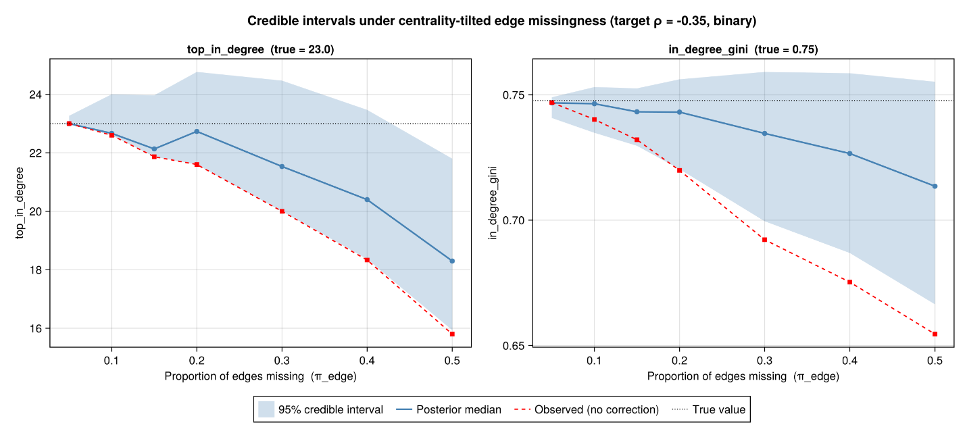
Top in-degree (true 23) is recovered through 40% missing, the median above the uncorrected observed throughout and slipping below true only at 50%. In-degree Gini (true 0.748) is covered across the entire range — though here coverage holds through appropriately widening intervals rather than a median that tracks truth: the median drifts down with missingness while the interval widens to contain the true value. With no weight to redistribute, bin-targeted node re-addition preserves the inequality structure almost for free, and the single extreme point becomes the relatively weaker recovery.
That this works at all is arguably the more demanding test, because binary reconstruction is the harder problem — not because there is more to estimate, but because there is less to estimate from. In the weighted case the surviving structure carries a residual signal: a degraded edge still has an observed weight, and the deficit method estimates its true value directly from that residual. In the binary case there is no residual — a removed tie leaves no trace on its dyad, and an annihilated node leaves nothing at all — so the reconstruction cannot adjust magnitudes on a scaffold that largely survived. It must regenerate the structure itself, deciding which dyads exist rather than how heavy they are, working only from the positional model: where the model expects lost nodes to sit, and how ties attach to those positions. That the credible intervals continue to bracket the true degree-inequality across the entire missingness range under those conditions is, to our eye, the strongest evidence in the set that the positional model is carrying real structural information, rather than the residual weights doing the work.
A scope note: because the hub orientation made every organic loss a full removal (no nominations), this run exercised Stage 1 alone; Stage 0.5's nomination path is tested elsewhere in the suite.
5. SCOPE AND ONGOING WORK
An important limitation is that these results represent a best-case scenario. In every experiment, the reconstruction algorithm is given the true value of (ρ), the parameter that governs the missingness process. In practice, that quantity is unknown and must itself be estimated.
What these experiments demonstrate is therefore limited but important: when the assumptions are correct, the reconstruction machinery can successfully reverse the effects of the degradation process. This is a necessary validation step. On small synthetic networks (roughly 50–60 nodes), in the edge-missingness condition, the method recovers the two summary measures examined here when supplied with the correct prior information.
What these results do not show is how the method will perform on real data, where the missingness process is uncertain and the prior information may be wrong. The central practical question is not whether the method works when (ρ) is known, but how sensitive it is when (ρ) is misestimated.
I am working on that now and expect to have results within a few days. The current study measures the effects of misspecifying both (ρ) and the missing-fraction priors across the synthetic test networks and a larger corpus of empirical and synthetic networks spanning weighted and unweighted, directed and undirected, and highly centralized and decentralized structures. I am evaluating not only bias in the reconstructed measures, but also interval coverage and whether reconstruction actually improves upon the degraded network.
The objective is to move from best-case validation to a characterization of operating performance. The key question is not whether the framework works when the prior is correct, but how sensitive its conclusions are to errors in the prior. In practice, the method must always rely on assumptions about the missingness process; the issue is whether moderate misspecification still yields useful corrections or whether the reconstruction becomes dominated by the prior itself.

