Covid State Trends

John Morse

8/16/2020

## COVID-19 Trends by State

This file shows trends in COVID-19 daily cases and deaths by State within the US.

### Daily Confirmed Cases

You can also embed plots, for example:

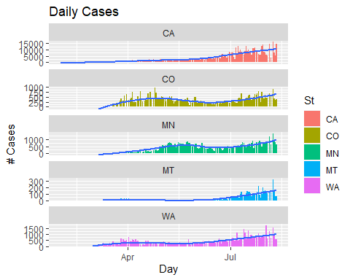

### Daily Deaths

You can also embed plots, for example:

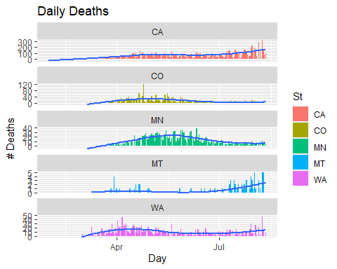

### Cummulative Results

You can also embed plots, for example:

