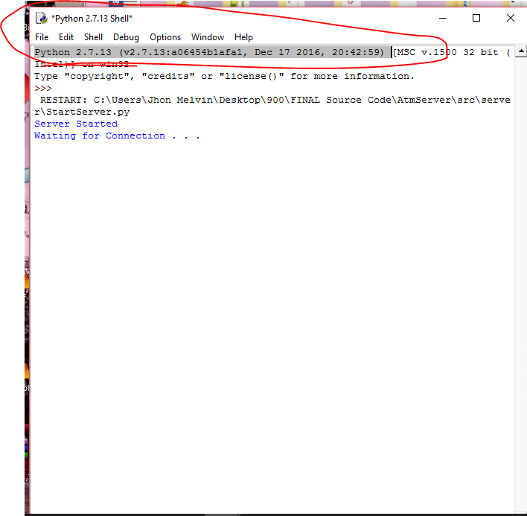

* Must run thru python 2.7.13 IDLE

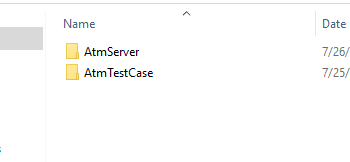

* Project folders
* In “AtmServer” look for (StartServer.py)
* In “AtmTestCase” look for (Main.py)
* Right click and edit with idle
* 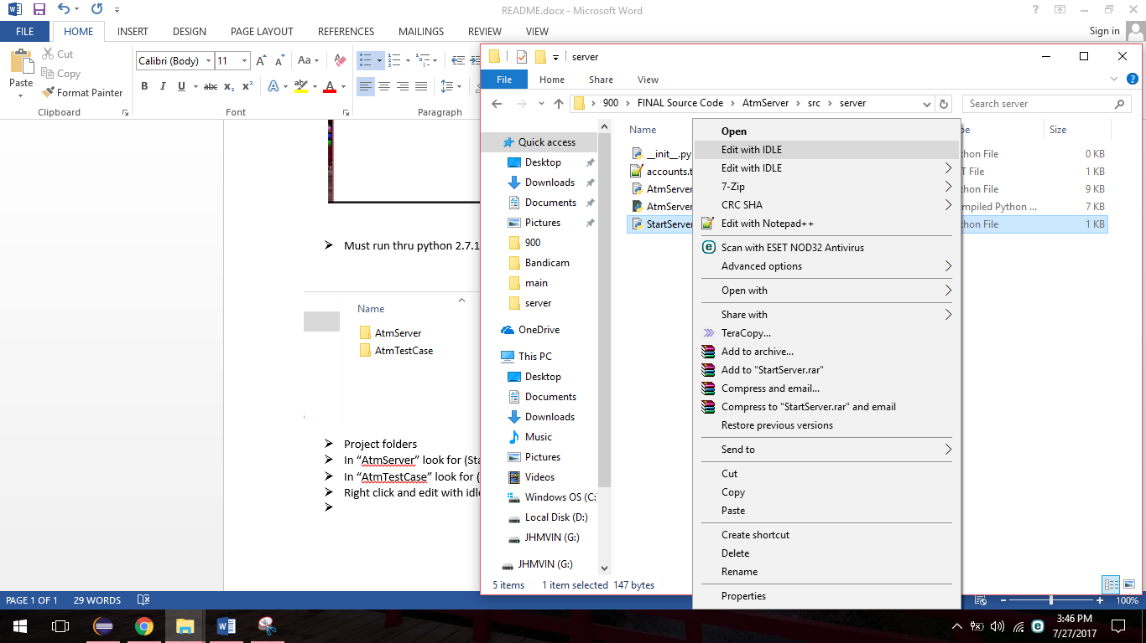
* And press F5 to run
* The server must be run first before the client

General Notes:

If the socket is not properly closed the client will not be able to connect to the server

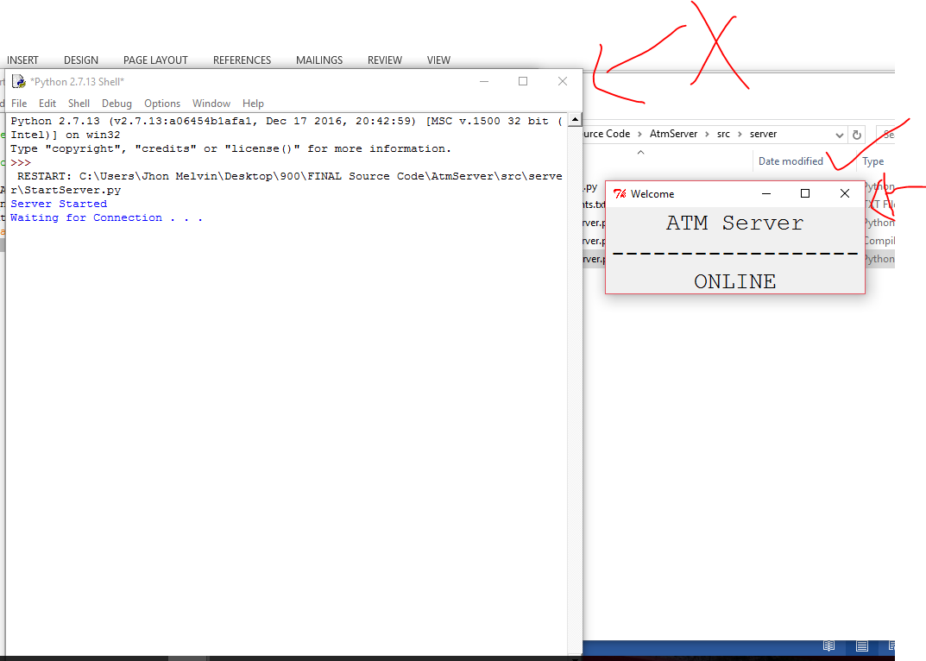

To avoid this always close the server from the graphical interface and not closing the console this will allow the server to terminate properly

If the server was not terminated properly the socket being used will be locked until next restart

And the client will not be able to connect to the server

To fix this change your current port

For the server File: “AtmServer.py”

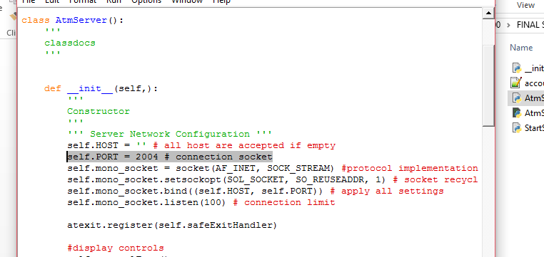

And for the client File: “Depositor.py” – Client and Server Port must be the same

