STUDENT ADMISSION PREDICTION USING XGBOOST
End-to-End Machine Learning and Streamlit Deployment Project

1. Abstract
This project develops an AI-powered student admission prediction application using XGBoost. The system learns relationships between academic/profile attributes and the historical Chance of Admit target, evaluates the model on held-out data, and provides real-time predictions through Streamlit.

2. Problem Statement
Estimate graduate admission probability from GRE Score, TOEFL Score, University Rating, SOP, LOR, CGPA and Research Experience.

3. Dataset Description
Feature | Type | Description
GRE Score | Integer | Graduate Record Examination score
TOEFL Score | Integer | TOEFL score
University Rating | Integer | University rating from 1 to 5
SOP | Float | Statement of Purpose rating
LOR | Float | Letter of Recommendation rating
CGPA | Float | Undergraduate CGPA
Research | Integer | Research experience indicator
Chance of Admit | Float | Target value from 0 to 1
Dataset size after preprocessing: 500 rows. Missing values before cleaning: 0; remaining: 0.

4. Preprocessing
- Removed Unnamed: 0 and Serial No. because they are identifiers.
- Trimmed column-name whitespace.
- Converted modeling columns to numeric.
- Removed rows with missing required modeling values.
- Used an 80:20 train-test split with random_state=42.

5. Exploratory Data Analysis
EDA was used to understand the target distribution, the relationship between CGPA and admission chance, model feature importance, and prediction quality.
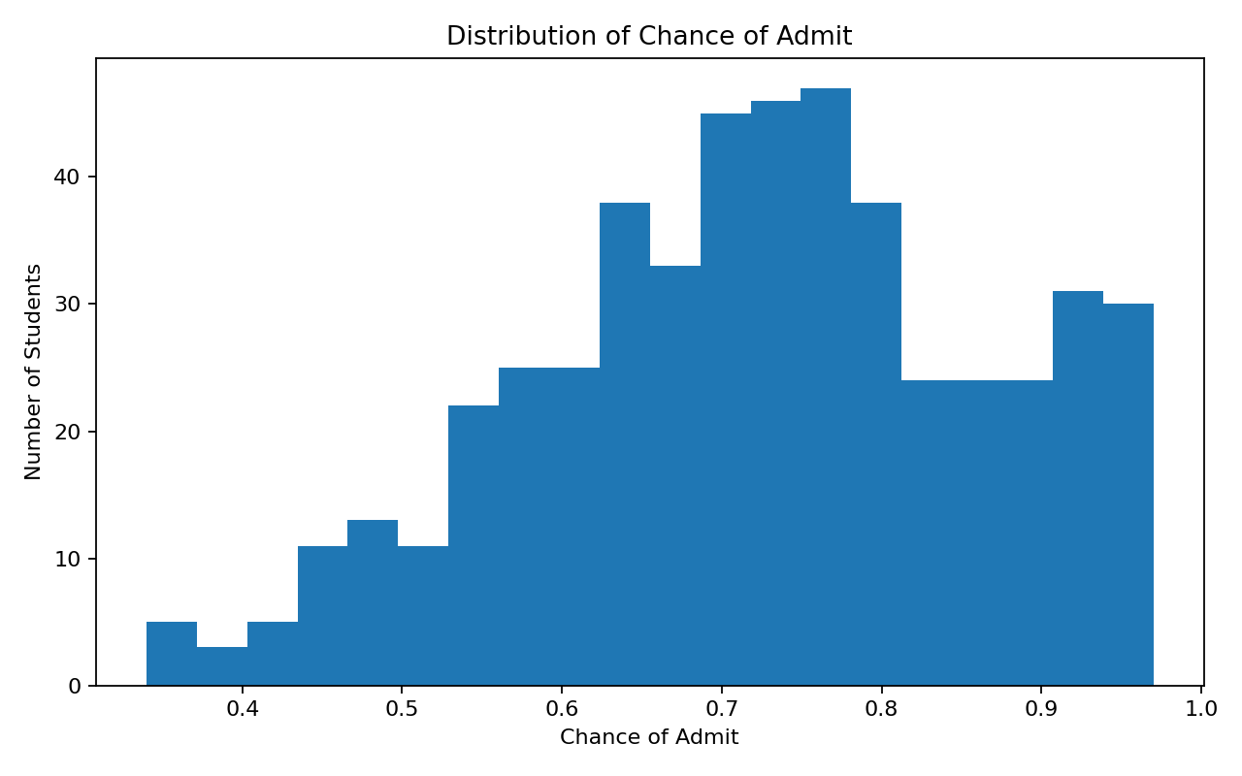
Figure 1. Target distribution
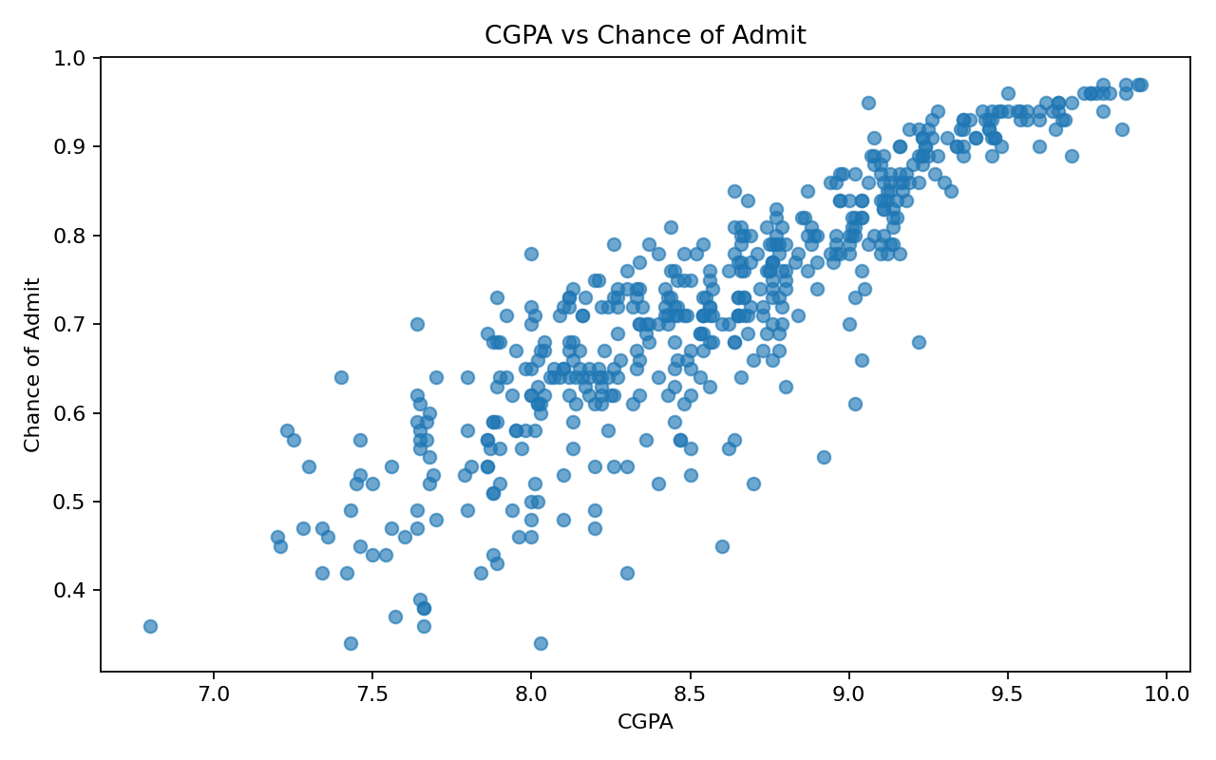
Figure 2. CGPA vs admission chance
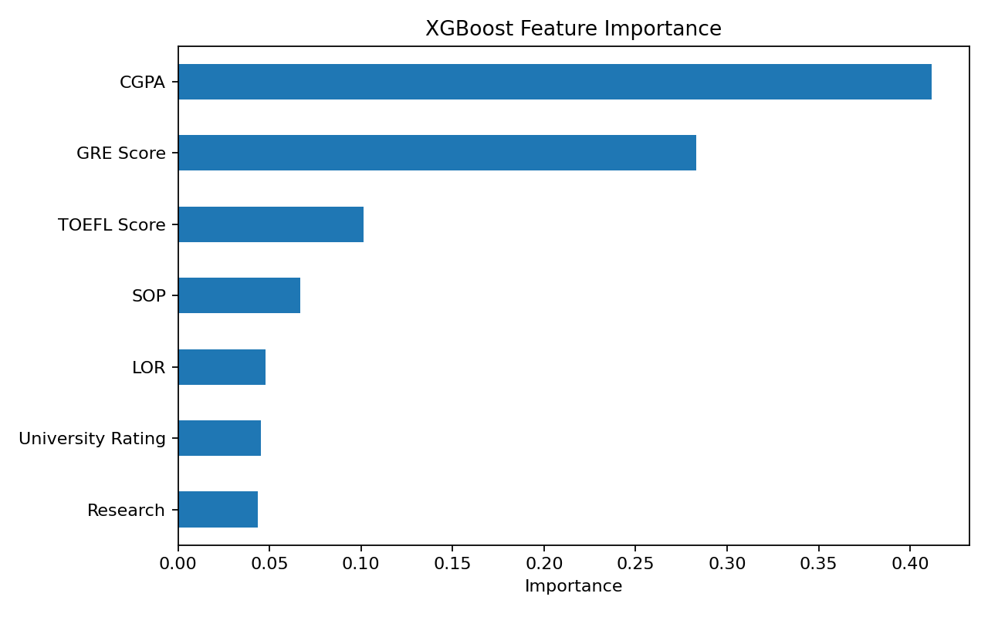
Figure 3. XGBoost feature importance
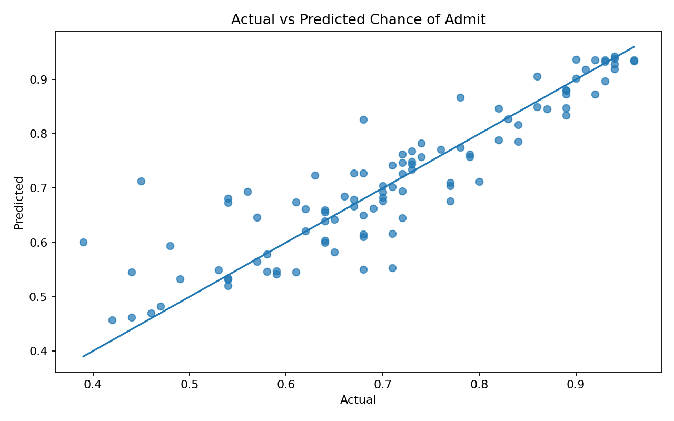
Figure 4. Actual vs predicted values

6. XGBoost Model
XGBoost Regressor was selected because it performs well on structured tabular data and can learn nonlinear relationships. Hyperparameters were selected using five-fold cross-validation.
Best parameters: {'colsample_bytree': 0.8, 'learning_rate': 0.02, 'max_depth': 3, 'n_estimators': 200, 'subsample': 0.8}

7. Model Evaluation
Metric | Test Result
MAE | 0.0427
RMSE | 0.0628
R² | 0.8071
MAE measures average absolute error; RMSE gives greater weight to larger errors; R² measures the proportion of target variance explained on the test set.

8. Streamlit Application
The interface accepts the seven model inputs, creates a one-row DataFrame in the same feature order as training, runs the saved model, clips the estimate to 0–1, and displays the result as a percentage.

9. Limitations
- The dataset is relatively small.
- Historical observations may not represent current admission policies.
- The prediction is an estimate rather than an official admission decision.
- Performance can change on unseen populations.

10. Conclusion
The project implements the complete machine learning lifecycle: preprocessing, EDA, XGBoost training and tuning, evaluation, model serialization, and Streamlit deployment.

11. Dataset Reference
Supplied dataset: data/graduate_admission.csv. Public reference: https://www.kaggle.com/datasets/mohansacharya/graduate-admissions

