WEB-BASED LOT RESERVATION AND MAPPING SYSTEM FOR POLO MEMORIAL PARK

A Capstone Project
Submitted to the Faculty of
National University College of Computing and Information Technologies

In Partial Fulfillment of the Requirements for the Degree
Bachelor of Science in Information Technology

By:

JUILIUS T. DOMONDON
ROMEL R. LERUM JR.
JOHN BRIX T. FRANCISCO
JAYDEE V. RELINGADO

Prof. MARILOU N. JAMIS
Capstone Adviser

APRIL 2019
RECOMMENDATION FOR ORAL EXAMINATION

This capstone titled: “Web-based Lot Reservation and Mapping System for Polo Memorial Park”, prepared and submitted by JULIUS T. DOMONDON, ROMEL R. LERUM JR., JOHN BRIX T. FRANCISCO, and JAYDEE V. RELINGADO in partial fulfillment of the requirements for the degree of Bachelor of Science in Information Technology has been examined and is recommended for acceptance and approval for ORAL EXAMINATION on ___________________.

_____________________________ _____________________________
Prof. Marlou N. Jamis Prof. Marilou N. Jamis
Capstone Adviser Subject Adviser
Date: __________________ Date: ___________________

APPROVAL SHEET

CAPSTONE TITLE: Web-based Lot Reservation and Mapping System for Polo Memorial Park
RESEARCHERS: JULIUS T. DOMONDON
ROMEL R. LERUM JR.
JOHN BRIX T. FRANCISCO
JAYDEE V. RELINGADO
Examined and recommended for acceptance and approval for ORAL EXAMINATION in partial fulfillment of the requirements for the Degree of Bachelor of Science in Information Technology.
PANEL OF EVALUATORS AND EXAMINERS
Approved by the panel of Examiners for Oral Examination with the grade of _____.

_____________________ _____________________ ______________________
Prof. Marilou N. Jamis Prof. Jayson Raymund D. Bermudez Prof. Emeliza R. Yabut
Panel Member 1 Head Panel Panel Member 2

Accepted and approved in partial fulfillment of the requirements for the Degree of Bachelor of Science in Information Technology

_____________________ ______________________
Prof. Marilou N. Jamis Dean Arlene O. Trillanes
Subject Professor CCIT Dean
Date: _____________ Date: _____________



ENGLISH EDITING CERTIFICATE

This is to certify that I have edited the capstone project manuscript titled

Web-based Lot Reservation and Mapping System for Polo Memorial Park

by Julius T. Domondon, Romel R. Lerum Jr., John Brix T. Francisco and Jaydee V. Relingado

and have found it thorough and acceptable with respect to the grammar and composition.

Checked by:

__________________________
Prof. Marilou N. Jamis
Adviser

DEDICATION
We dedicate this research paper to the people who had given us their undying support and had pushed us beyond our limits.

To God who led us through the darkness with light of hope and guidance.

To our parents who taught us any difficult task can be accomplished and perseverance is key to success.

To our Capstone adviser, Capstone Coordinators, friends, and classmates. Thank you! We sincerely appreciate all the support and efforts throughout the process. May God bless us all!

ACKNOWLEDGEMENT

First of all, we are grateful to the Almighty God for guiding us to complete this research from the very start and providing us strength and knowledge. We also dedicate this research for him. The researchers take this opportunity to express sincere gratitude to the following for their significant contribution.
To our Families, for their prayers, advice, encouragement and for supporting us financially as we took this subject.
To our Capstone Adviser, Professor Marilou N. Jamis, thank you for the knowledge that you had shared with us. We are grateful to have you as an adviser. You always make time for the betterment of our study even on rest days and holidays. For accompanying us even though you are teaching in another class, we can still reach out to you for our concerns. For your words of encouragement when things seem impossible to accomplish. We greatly appreciate what you have done.

JULIUS T. DOMONDON
ROMEL R. LERUM JR.
JOHN BRIX T. FRANCISCO
JAYDEE V. RELINGADO

Philippine Copyright 2019

JULIUS T. DOMONDON
ROMEL R. LERUM JR.
JOHN BRIX T. FRANCISCO
JAYDEE V. RELINGADO
Prof. MARILOU N. JAMIS
and NATIONAL UNIVERSITY

All rights reserved. Portions of this manuscript may be reproduced with proper referencing and due to acknowledgement of the authors.
EXECUTIVE SUMMARY

The system replaces the existing manual reservation and mapping system of Polo Memorial Park. Only Polo Memorial Park is entitled to the said system. It provides a database that stores all the data, reservations and mapping by the company. It includes the monitoring of lots and transactions. It has a module for the Record Officer who is in charge of adding and editing the Record Module. It records all transactions made and has a capability to view, add, update, and archive the record that the users do. The system is also focusing on the following: Reservation (the web based reservation system that helps the customers to find or check the lot available in the easiest and most convenient way); Mapping (the web based mapping system that helps the customers or visitors to find the grave of their deceased): SMS Notification (the S.M.S application or system that notifies the customer before the due date of their payment). The system is protected by different set of passwords intended for different parties. The Customer is required to have an account before adding a reservation and viewing of a record. The Record Officer provides a password for the manipulating and monitoring of the records, while Administrator is entitled to a password to allow the access of the entire module. The system also provides a database that can create, add, update and delete the users of Polo Memorial Park. The system has a protected data access control. It can prevent the unauthorized users from having full access to the database by limiting their grasp from certain management or confidential information. Additionally, the system enhances the security reliability and stability or transaction and service. It is also a closed system because it is not connected to any other existing system.
Keywords—Mapping, Reservation, SMS Notification.

Web-Based Lot Reservation and Mapping System for Polo Memorial Park

. Prof. Marilou N Jamis Julius T. Domondon Romel R. Lerum Jr.
National University – Philippines National University – Philippines National University – Philippines
College of Computer Studies College of Computer Studies College of Computer Studies
…@national-u.edu.ph julius.domondon006@yahoo.com Romel27th@gmail.com
John Brix T. Francisco Jaydee V. Relingado
National University – Philippines National University – Philippines
College of Computer Studies College of Computer Studies
franciscojbtf@gmail.com Jhaydzrelingado@gmail.com

Abstract—the ubiquity of promoting businesses through online advertisement in this decade is currently proliferating every single day. The Web-Based Lot Reservation and Mapping System for Polo Memorial Park (PMP) will ameliorate the existing manual system of the polo memorial park. It will not just help the company and employees on their daily operations; it will also help the customers to check the available lot, reserve a lot, locate the grave of their deceased and they will receive a SMS notification before the due date of their payment. The system is evaluated using the ISO9126 evaluation tool in terms of functionality, reliability, usability, and maintainability.

Keywords—Mapping, Reservation, SMS Notification.

- INTRODUCTION
While web mapping is still under development, various factors such as obstacles and changes that involve the feedback of quality, the usability, social benefits, and the legal constraints drive its evolution. A computer reservations system or central reservation system (CRS) is a virtual system used to stock and reacquire information and administer transactions related to air travel, hotels, car rental, or activities. Primarily designated and operated by airlines, CRSes were eventually used for the use of travel agencies. Major CRS assignments that book and sell tickets for numerous airlines are known as Global Distribution System (GDS). The dedicated GDS companies who make systems more accessible to consumers have gained a lot for airlines have divested most of their direct holdings to them. These modern GDSes typically pave way for users to book hotel rooms, rental cars, airline ticket, and even activities and tours. Consequently, they make available the access to railway reservations and bus reservations in some markets
On the other hand, Short Message Service (SMS) is a known as text messaging service component of phone, Web, or mobile communication systems. It makes us of a set standardized communications rules to permit fixed line or mobile phone devices to trade short text messages. Reaching an estimated 3.5 billion active users, SMS is regarded the most widely used data application. The usage of the term “SMS” extends not mainly for the user activity, but even for all types of short text messaging in different areas of the world. Moreover, SMS is also engaged in direct marketing, which is called the SMS marketing. According to statistics, as of September 2014, global SMS business is garnering a worth of over USD 100 billion, and it also has the record for the coverage of almost half of all the revenue earned by mobile messaging. Using standardized phone protocols. SMS has used modern handsets that came from radio telegraphy in radio memo pagers. In 1985, there were demonstrated as part of the Global System for Mobile Communications (GSM) series of standards that can send messages from GSM mobile handsets up to 160 characters. Although majority of SMS messages are mobile-to-mobile, the service has reached and included other mobile technologies, such as ANSI CDMA networks and Digital AMPS, and even satellites and landline networks. Nowadays, most people use the internet, not just in terms of business, but in other day-to-day transactions, as well. The aforementioned statement can be proven by a statistic which shows that more than Three Billion People use the internet. This study can help Polo Memorial Park when it comes to coping with new technology and answering to the modern kind of demand. Having a web-based system which can easily send information, update payments, and information, to be created by the researchers can greatly assist the Polo Memorial Park in improving their manual encoding of records and transactions, and may lead to the boost of the entity’s business. The web-based mapping can aid their customers and visitors to easily know or find where the graves of their deceased are located. Recent year’s competition on the Internet has dramatically increased and the quality of the content of a website is as important as it looks. If you own a store or a business, you would probably keep an eye on your rival and would always strive to deliver differentiated products or services to your customers. Owning a website works the same way and based from the research that the researchers carried out, it is much easier to adopt new techniques for promoting and selling using a website rather than updating flyers, catalogues and brochures which you have already printed.
Digital mapping today and Geographic Information System (GIS) technologies can be used to create a high quality informative and adaptable map product.
Quality graphics and maps is one of the key components of many planning applications and one of the most important components when it comes to involving members of the public in the planning process. When the public views an application, they may not fully understand what the application entails. Therefore, drawings and plans are a valuable communicative tool within the realm of the planning process.
- REVIEW OF RELATED LITERATURE

The Various literatures can be applied in order to prove the significance of creating an online system for a business. First of is the launching of a New Online Park Reservation System by the Bexar County. [8] The innovations of this New Online Park Reservations System bring convenience to the residents of the Bexar County Parks because they are able to reserve space and find out some of the specific information about rentable amenities. The site hosts maps in determining significant places inside the park. The public and commercial parties will find the availability of amenities, costs space capacities and make reservations, as well as payments directly online. According to the manager of Bexar County Park, they want people to be able to take care of their needs in the most efficient manner. Thus, these new reservation systems are dedicated to bring more online services to constituents.
However, not only parks indulge in the vitality of incorporating online sites in their business. French luxury liners sign up for IBS reservation solution [11]. The head of travel and cruise line of business of IBS states that this solution will manage the cruise liner’s entire passenger reservation. This includes the multi-lingual, ocean liner and global clients.
Moreover, the importance of online sites also extends to restaurants, which persuade Livebookings to launch Freebookings[2], a Free Online Restaurant Reservation System. This is an online control panel, enabling viewing and management of online reservation for Restaurants. This system can be used through smart phones and computers so that the restaurants receive information regarding booking, access customer database and control reservations. Freebooking does not require users to register to use the service. Instead, they simply visit the restaurant’s page or website to do reservations, shortening the time allotted for reservations without drastically changing the consumer experience. The demand of online reservation of people has gradually increased due to the innovation of phones and computers. Thus, Freebookings is working flawlessly to meet the consumer’s standards.
Additionally, even transportation businesses incorporate an online system [10]. Pakistan PR (railways) developed a new web-based reservation system for their passengers. This system gives information to passengers thru online. In the future, the system will also utilize Short messaging system to alert passengers about late running trains. It is said that this project has been approved and implemented, and already been introduced in reservation offices to improve the reservation at 41 stations.
Furthermore, the Indian Railways has also employed reservation on mobile travel. Mobile Rail Ticket booking service [9] is a very convenient way of reserving ticket for a travel. This is hassle-free to the people who are rail users. In this kind of service, the people will no longer need to line up in a ticketing booth to book a travel, which is time consuming. Through mobile reservation, the customers can just “show it and travel in easy in Indian Railways.”
Consequently, T-Links, the golf tee reservation system [4] serving premier golf destination in the US has expanded golf courses over the state. The T-Links system allows companies and groups located in specific places to oversee and disseminate tee time inventory on a central platform. T-Links enables the consumer to easily know any event that may happen in golf. This is especially critical for courses in resort and destination environments. Also, it sets apart its ability to book multiple golfers and multiple rounds in the same transactions.
FIND A GRAVE [7], people who we know to have already been laid to rest sometimes sparks an interest, inducing us to pay our respect or homage to the deceased, this idea has been implemented into a massive information repository to locate either famous graves or just graves (ordinary people’s graves). It offers different searches and with more information providing more accurate results. Searches category includes searching by location, bios, tributes, photos, hyperlinks and more.
Online Hotel Reservation and Management System for the College of International Tourism and Hospitality Management (CITHM) [6]. The main aim of this study is to help the CITHM of the Lyceum of the Philippines University, Batangas Campus to design and develop an online hotel reservation and management system. It presents user-friendly that will help the CITHM students to be familiarized with the features of the online hotel reservation system, and it also evaluates and highlights the benefit it can provide to the college and staff. In addition, it can provide supplement material in their front desk operation course. The programming language that was used was the System Development Life Cycle and Microsoft Web Developer and the developed software served as a tool for the students of CITHM to familiarize themselves on how to effectively manage the online hotel reservation system. The developed software was an effective aid for the teaching of the educators in the basic operations of hotel reservation system to their students. It also provided online security to protect privacy and financial information of clients.
Design and performance analysis on adaptive reservation-assisted collision resolution protocol for WLANs [12]. In order to execute channel contention inside the wireless local area networks (WLANs) in traditional IEEE 802.11 medium access control protocol, the distributed coordination function is fitted for the wireless stations (WSs) Packet collision is deliberated as one of the most common issues within this type of contention-based scheme, which can greatly lower network performance on the WLANs. A research study has been made to alter the random back off mechanism to lessen the packet collision problem though the WSs are contending for channel access. However, most of the existing work is only able provide partial throughput enhancement under specific number of WSs within the network. In this study, an “adaptive reservation-assisted collision resolution,” a proposal has been done that (ARCR) protocol can improve packet collision caused from the random-access schemes.
It is said that the contention-based channel access can readily be transfigured into a reservation-based system if there are pending packets required to be transmitted through the WSs and through the access point, with its adaptable reservation period. Analytical model is derived for the proposed ARCR scheme in order to validate and evaluate its data performance. It can be seen from both simulation and analytical results that the proposed protocol outperforms current schemes with enhanced channel utilization and network data.
Performance testing of college online reservation reimbursement system [15] with the development of colleges and universities, there are a lot of universities that have more than one campus. Reimbursement becomes a major problem, specifically after carrying out national treasury centralized payment. This paper was design and implements the online reimbursement system which is based on campus network to solve the problem of common financial reimbursement. Design goal and overall structure of the said system are explored, and then the application of the reimbursement system of online booking or reservation is presented.
Online mapping [14] is the compilation and publication of Web sites that provide text information and exhaustive graphical in the form of maps and databases. Online mapping services are utilized for tasks such as planning some trips, locating the landmarks and businesses, getting addresses and phone numbers, and plotting the storm tracks. MapQuest is the first eminent online mapping service. Launched in 1996, it continues to be popular. Since then, some of the other Internet companies, including Google and Yahoo, have come up with online mapping services. Aside from interactive maps with zooming and re-entering functions (these are universal), there are also services lk weather or climate maps, topographical maps, satellite images, and demographic maps, and traffic information. The Global Positioning System (GPS) is the most cosmopolitan site that works to provide the wireless-equipped mobile user with moment-to-moment position data, as well as directions of the street-by-street to help the user get from the current location to a specific destination. Services like Google Maps and the others have become very popular in mash-up applications. One such mash-up, Housing Maps, is a combination of Google Maps and Craigslist rental ads that displays geographical information for rental properties.
Gateway Mapping president Web site aids grave site research [5]. Visitors can search for deceased person if their name is in the database. It will show them a map to a grave location and its surroundings. The site provides alphabetical listings, as well as the information on the stones.
GIS-based Muslim cemetery information system [13]. Currently, the registration used by the Majlis Bandaraya Shah Alam (MBSA), Jabatan Agama Islam Selangor (JAIS), and native cemetery visitor in looking for death information and grave cemetery location are still operated manually. This paper confirmed the prospective of GIS, GPS, Google earth and other ICT technologies in developing a digital Muslim cemetery evidence system in Section 21, Shah Alam. This proposed system (Islam-21) was developed based on the ordinary System Development Lifecycle (SDLC) which aims to conduct user requirements analysis, design and develop the system and test the presentation of the system. Although only 57 per cent among a total of 30 respondents strongly agreed the necessity of the proposed system, the system was necessary in fulfilling the user's requirement particularly in giving serious direction and loss information. The Islam-21 allowed the user to accomplish database query for grave or death searching, even allowing the user access with map direction of the complete spatial death information. The carrying out of this innovative prototype in the future may be increased between the people of Malaysia, having its functions enhanced by applying interactive and dynamic web-based 3D file information and visualization for public service improvement.
The case study of a semi-automated is Content Alert System [1] implemented at two university libraries, the University of Swaziland, Southern Africa and Bundelkhand University Library at Jhansi in India. Between the various mobile services, Short Message Service (SMS) is one of the most known services commonly used all over the world. The projects started at these libraries that were intended to use the SMS service to offer an active content alert system with least cost effect on the libraries and aimed to increase the usage of library resources among the library patrons simultaneously. The project runs with two phases. In the first phase a successful content alert system was already tested and tried at the University of Swaziland with the support of Emerald Publishers. On a success of completing the project a prototype was developed. Using the prototype, the project’s second phase was planned. In the second phase a related content alert service was published with a large user groups and the alerts were made from a number of establishers and SMS’s was sent to the patrons. This study describes the details in the background, the explanation, details of the project, the ways used and the results of the projects.
Based from the modern market of the system development, indubitably the cemetery systems proposed are the pioneers in cemetery system in Malaysia [3]. If it was commercially applied, it will not be disregarded to be a quandary for the deployment of the cemetery organization in Malaysia. Attributable to the predicament of the cemetery system deployment, the cemetery organization have the potential to own a commercial value from the implementation of the system. Funneling from the facts to precisely defining the cemetery organization as based from the scope of the project development, it is observed that the cemetery organization carries a message that is for the Chinese cemetery sites due to the implication of conflicts between the business currents based from the varied religions existed in Malaysia. However, with few modifications despite the detail that the procedures are consuming numerous times it is able to be converted as a universal national cemetery organization to be applied throughout the Malaysia. As for riposte answers for the significant as the magniloquence questions, the cemetery organization built has the fresh features that different cemetery system existing throughout the world. Firstly, the locator applied functions as the mini GIS system that marked the location on the map for direction according to the documents from the database whereas the console projection from the database is another to implore in front of the tombstones. As for the system growth approaches, the system is dedicated to be an online web-based application organization as the internet is one of the imperious communications nowadays. Inside the core of the data layer that is unswervingly mentioning to the database organization from the architecture.
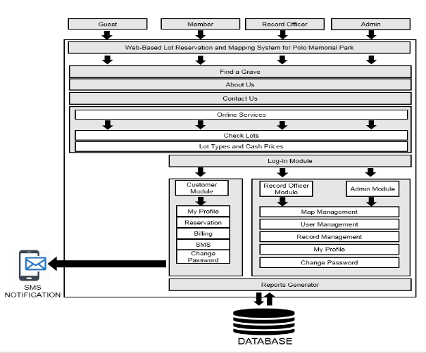

- SYSTEM ARCHITECTURE
Figure 1. System Architecture
In Figure 1, the system architecture of Web-Based Lot Reservation and Mapping Framework for Polo Memorial Park represents the structure of the whole system that the researchers being developed. It shows the different modules, functions, requirements, and users of the study. This describes the specific functions of the system being developed. The researchers use this as a guide while creating the system. It also helps to retain the primary objectives to keep its consistency within the development of the system.

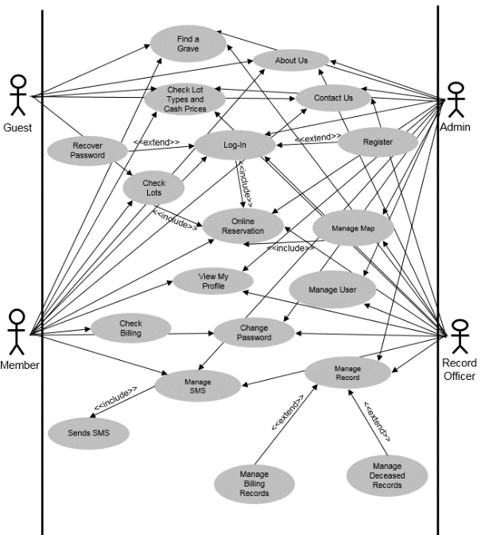

- USE CASE MODEL
Figure 2. Use Case Model
The use case diagram shown in figure 3. Shows the Guest, Member, Record Officer, and Admin serve as the actors of the system. The users have different modules assigned depending on their position, but the admin has access to all the functions of the system while the guest has the least
- SYSTEM FEATURES
The web-based lot reservation and mapping system for polo memorial park is web system that helps people/customers to reserve and find a grave of their deceased in a convenient way. Using the existing manual system as the basis for creating this study, the entire process will be done inside the system which means that everything from the reservation, mapping up until the account management will be automated, with exception of the payment transactions. The advantages of using the system are that the updates will be easily made without conflict to the other files, the process of reservation will be at the convenience of the customer and the reservation is validated upon payment. This web system is composed of nineteen main modules: (1) Log-in Module, (2) Registration Module, (3) Find a Grave Module, (4) Check Lots Module, (5) Lot Types and Cash Prices Module, (6) Online Reservation Module, (7) Billing Module, (8) Admin Account Module, (9) Record Office Module, (10) Customer Account Module, (11) Map Management Module, (12) User Management Module, (13) Record Management Module, (14) My Profile Module, and (15) SMS Notification Module.
- Log-in Module
This module control the access a user has to the system. This login module will be used by the Admin and Customers. In the module, the user is required to input their username and password. When Login button is clicked, the system will validate if the user account exists in the database and if the username and password combination match. If the combination is valid, the system will then allow user access to the intended module. Otherwise, an error message will appear.
- Registration Module
The module is where the website visitors can register for an account to be able to place an online reservation on Polo Memorial Park. The module requires the customer’s name, address, e-mail, password and password verification.
- Find a Grave Module
This module of the web application allows the user to check the deceased information and grave location of Polo Memorial Park.
- Check Lots Module
This module shows the Polo Memorial Park grave map and allows the user to check the status of the lots offered as well as choose available lot for reservation.
- Lot Types and Cash Prices Module
This module shows the user information about the available offers, services and prices of Polo Memorial Park.
- Online Reservation Module
This module of the web application allows the user to reserve their desired lot of the cemetery. This module requires the user to login to their registered account.
- Billing Module
This module of the web application allows the user to check billing information related to their reservation.
- Admin Account Module
This module is the highest account and has access to all management module, functions and permission of the system. This module can also add new account and decide their access level.
- Record Officer Module
This module is for the Record Office employees of Polo Memorial Park. This module mainly handles record management modules as well as the day-to-day system operation.
- Customer Account Module
This module is for customer use, it contains check lots, lot types and cash prices, online reservation, billing, my profile and change password module.
- Map Management Module
This module contains a View, Add and Update functions. View, allows the user to view and interact with a map. Add, allows the user to add new maps. Update, edits and existing map.
- User Management Module
This module has View, Add, Update and Archive functions that allows the user to manage the user database.
- Record Management Module
This module has 2 sub-module the billing record which stores the reservation and payment details and deceased record which is the database of the deceased information, both sub-modules contains a View, Add, Update and Archive function to manage each sub-module.
- My Profile Module
This module shows the basic information of the logged=in account from basic details such as username, contact details and registration date to an optional business details of the user and account access level information.
- SMS Notification Module
This module notifies the members about updates on billing information of account reservation.

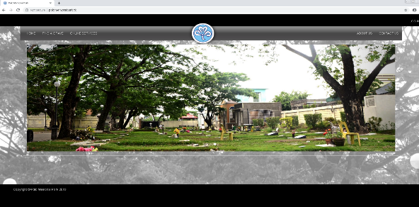
- SCREEN SHOTS
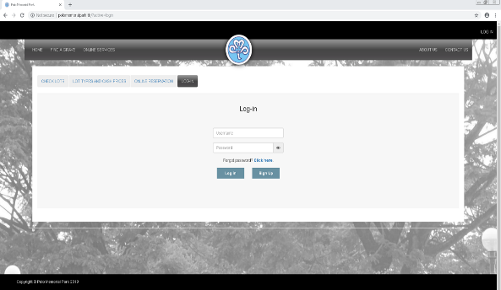
Figure 3. Homepage of Polo Memorial Park
Figure 4. Login Module
The login module of the web system is where the user can register (if they do not have an account yet), recover their password (if they forgot their password), or, login to their Polo Memorial Park account.
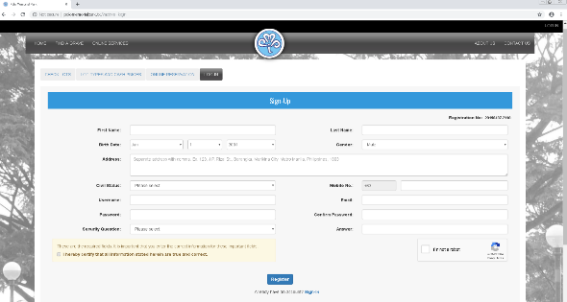
Figure 5. Registration Module
The registration module of the system allows the guest or customer to create an account for the Polo Memorial Park system.
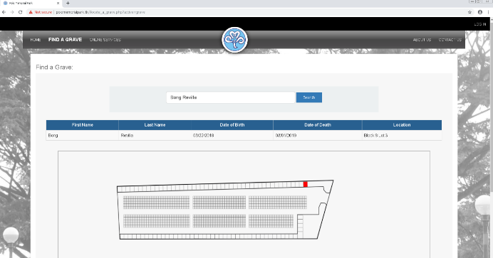
Figure 8. Find a Grave Module
The find a grave module allows the guest or user to search for a deceased basic information which the user can also view the location of the deceased grave.
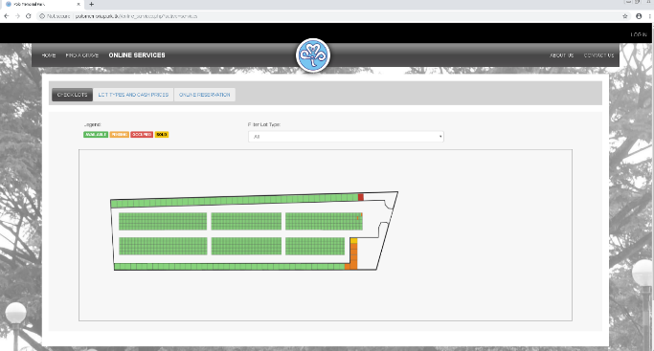
Figure 9. Check lots Module
The check lots module displays the map of the Polo Memorial Park, where the guest or user can distinguish the availability of lots by checking the different colors in the map, or by checking the legend which is located above (top left) of the map.
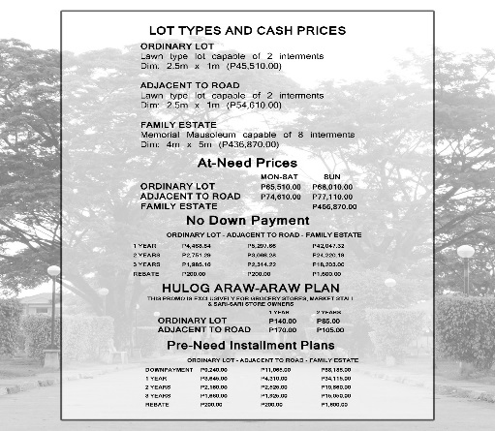
Figure 10. Lot Types and Cash Prices Module
This module shows the user information about the available offers, services and prices of Polo Memorial Park.
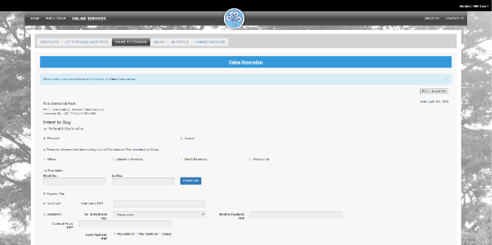
Figure 11. Online Reservation Module
This module of the web application allows the user to reserve their desired lot of the cemetery. This module requires the user to login to their registered account.
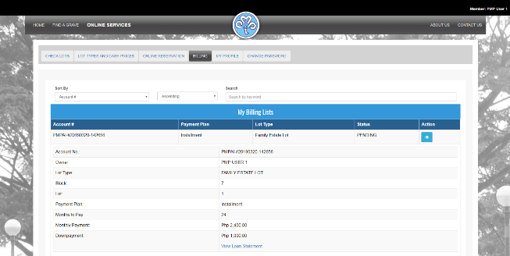
Figure 12. Billing Module
This module of the web application allows the user to check billing information related to their reservations.
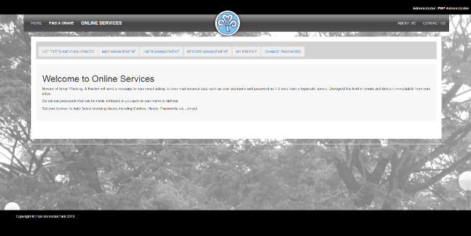
Figure 13. Admin Module
This module is the highest account and has access to all management module, functions and permission of the system. This module can also add new account and decide their access level.
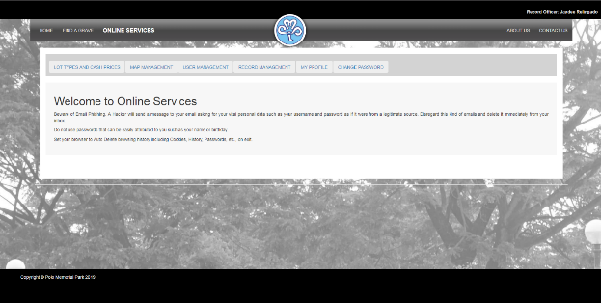
Figure 14. Record Officer Module
This module is for the Record Officer employees of Polo Memorial Park. This module mainly handles record management modules as well as the day-to-day system operations
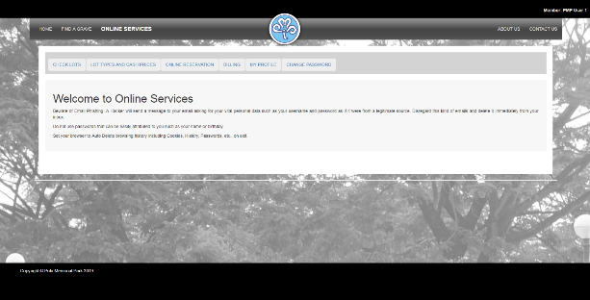
Figure 15. Member Module
This module is for customer use it contains check lots, lot types and cash prices, online reservation, billing, my profile and change password module.
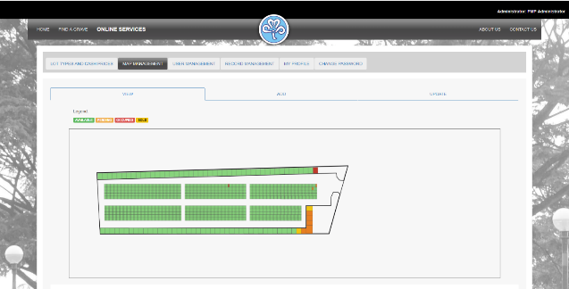
Figure 16. Map Management Module
This module contains a View, Add and Update functions. View, allows the user to view and interact with a map. Add, allows the user to add new maps. Update, edits an existing map.
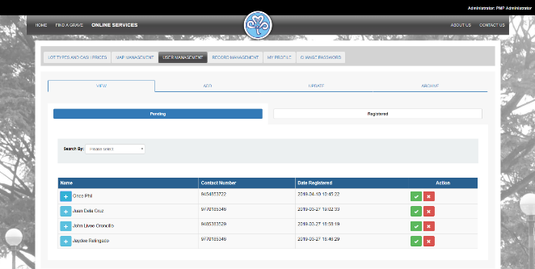
Figure 17. User Management Module
This module has View, Add, Update and Archive functions that allows the user to manage the user database.
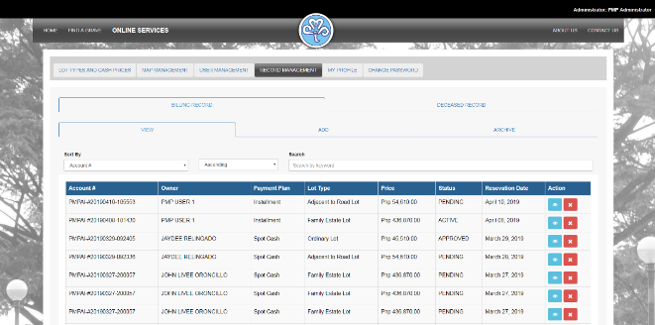
Figure 18. Record Management Module
This module has 2 sub-module the billing record which stores the reservation and payment details and deceased record which is the database of the deceased information, both submodules contains a View, Add, Update and Archive function to manage each sub-module.
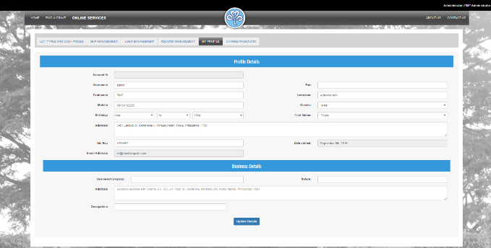
Figure 19. My Profile Module
This module shows the basic information of the logged-in account from basic details such as username, contact details and registration date to an optional business details of the user and account access level information.
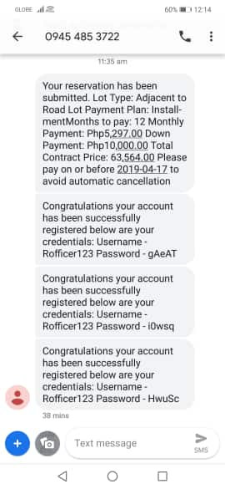
Figure 22. SMS Module
This module notifies the members about updates on billing information of account reservation.
- RESULTS AND CONCLUSION
Integrating technology to traditional way has a positive impact to a business regardless of the location. using a smartphone is a convenient way to obtain data and service regarding such business. It is capable of saving time and for the customer and businesses. They can get information about what they need in the comforts of their own home.
The Polo Memorial Park systems helps the customers to view information and acts as a medium that permits the user to their needs and notifies the businesses about the potential customers. The Polo Memorial Park system gives an alternative way for those customers who were far away to inquire about the business
TABLE I. LIKERT SCALE
Numerical Scale |  | Rating | Verbal Interpretation
5 | 4.51 – 5.00 |  | Excellent
4 | 3.51 – 4.50 |  | Very Satisfactory
3 | 2.51 – 3.50 |  | Satisfactory
2 | 1.51 – 2.50 |  | Needs Improvement
1 | 1.00 – 1.50 |  | Poor
The system is assessed by fifteen (15) customers of Polo Memorial Park Valenzuela. The respondents evaluated the system using the ISO9126 evaluation tool in terms of the following criteria: Functionality, Reliability, Usability, and Maintainability. The four (4) point response scale and their verbal interpretation seen on Table 1.

TABLE II. TECHNICAL EVALUATION RESULT
User evaluation
Criteria | Grand Mean
Functionality | 4.38
Reliability | 4.21
Usability | 4.48
Maintainability | 3.98
The system receives a grand mean of 4.38 as evaluated by the users for functionality, interpreted as “Very Satisfactory”. It is observed that the system generated adequate notification to users. For reliability, it can be perceived that the system gives timely information/notification to users, obtaining mean of 4.21, which is verbally interpreted as “Very Satisfactory”. In usability, it receives a grand mean of 4.48, which is interpreted as “Very Satisfactory”. The process of the system and its function are easy to understand. And for maintainability, the system receives a grand mean of 3.98, verbally interpreted as “Satisfactory” It is observed that the system can handle errors and generates up to date information.

Criteria | Grand Mean
Functionality | 4.98
Reliability | 4.53
Usability | 4.83
Maintainability | 4.60
The system receives a grand mean of 4.98 as evaluated by the users for functionality, interpreted as “Excellent”. It is observed that the system generated adequate notification to users. For reliability, it can be perceived that the system gives timely information/notification to users, obtaining mean of 4.53, which is verbally interpreted as “Excellent”. In usability, it receives a grand mean of 4.83, which is interpreted as “Excellent”. The process of the system and its function are easy to understand. And for maintainability, the system receives a grand mean of 4.60, verbally interpreted as “Excellent” It is observed that the system can handle errors and generates up to date information.

- RECOMMENDATIONS
As for the recommendations, the system can be integrated with other social media application such as Twitter and Instagram to improve the data gathering and to have a bigger crowd of volunteers. Integrating the system to social media apps can help promote your application by sharing its content and effectiveness.
These are the following recommendations that the developers would like to contribute to the future researchers:
1. Improve the system by including online payment, giving the client the ease of easily and instantly paying their reservation fee without leaving their home.
2. Audit log, to trail the time of login and logout of the user, it tracks how long and how regularly the users access of document.
3. Mobile Application, creating a mobile application version of the system has three advantages; speed, volume of information, and advertising. Speed, Mobile Applications takes the wait out of mobile. Volume of information, since most, if not all of the information is kept within the application, there is no need to wait on loading information. Advertise, mobile applications are becoming useful and popular among consumers.
4. It is recommended making this kind of application widely available not only for Android users but also could be used on other mobile operating systems for other users that are not using an Android smartphone to install and use the app.
5. Improve the system by adding more feature to the Map Management module that allows updating map easier.
- REFERENCES
- Anbu (2013).” Content Alert System”
- Businesswire (2011). “Freebookings” a free online restaurant reservation system.
- Cheng (2015). “Cemetery System in Malaysia”
- Computerweekly (2011). “The golf tee reservation system”
- Day (2011). “Gateway Mapping” website aids grave site research.
- Delizo (2013). Online Reservation and Management system for CITHM.
- Graff (2002). Find a Grave
- Heaton (2011). “New online park reservation system”, Bexar County.
- Hindustantime (2011). “Mobile rail ticket booking service”
- HT (2014) “Web-Based Reservation System
- Kurian (2013). “IBS Reservation”
- Lin (2011). Design and Performance analysis on adapted reservation
- A.S. Mazlan (2013). “GIS-based Muslim cemetery information system”
- Rouse (2013). Online Mapping Services
- Zheng (2013) “College online reservation reimbursement system”

TABLE OF CONTENTS

Title Page i
Recommendation for Oral Examination ii
Approval Sheet iii
English Editing Certificate iv
Dedication v
Acknowledgement vi
Executive Summary viii
Publishable Full Paper Format ix
Table of Contents xx
List of Figures xxii
List of Tables xxiii

CHAPTER I. INTRODUCTION 1
1.1 Project Context 3
1.2 Purpose and Description 4
  - Objectives 4
1.4 Scope and Limitation 5
CHAPTER II. REVIEW OF RELATED LITERATURE AND STUDIES 6
2.1 Related Literature 6
2.2 Related Studies 8
CHAPTER III. TECHNICAL BACKGROUND 11
3.1 Details of Technology to be used 11
3.2 Project Technical Description 14
CHAPTER IV. METHODOLOGY, RESULTS AND DISCUSSION 18
4.1 Requirements Analysis and Documentation 18
4.2 Design of Software, Systems, Product, and/or Processes 27
4.3 Development and Testing 42
4.4 Description of the System 50
CHAPTER V. SUMMARY AND RECOMMENDATIONS 62
5.1 Summary 62
5.2 Recommendation 64
REFERENCES 65
APPENDICES 66
Appendix A. Relevant Source Codes 67
Appendix B. Other Screen Layouts 114
Appendix C. Unit Testing 124
Appendix D. Integration Testing 136
Appendix E. Test Case Results (Validation Testing) 148
Appendix F. Software Progress Report (100%) 160
Appendix G. Sample User Evaluation Form 164
Appendix H. Accomplished User Evaluation Form 167
Appendix I. User Evaluation Tabulation of Data 170
Appendix J. Sample IT Professional Evaluation Form 172
Appendix K. Accomplished IT Professional Evaluation Form 175
Appendix L. IT Professional Tabulation of Data 178
Appendix M. Sample Client Acceptance Form 180
Appendix N. Accomplished Client Acceptance Form 184
Appendix O. User’s Manual 188
Appendix P. Letters 214
Appendix Q. Transcripts of Interview 216
Appendix R. Photo Documentation 220

LIST OF FIGURES
Figure 1. System Architecture………………………………………………………………14
Figure 2. Agile Methodology 18
Figure 3. Use Case Diagram 26
Figure 4. System Framework 30
Figure 5. Visual Table of Content 31
Figure 6. Process Flow for Login 32
Figure 7. Process Flow for Registration 33
Figure 8. Process Flow for Password Recovery 33
Figure 9. Process Flow for Change Password 34
Figure 10. Process Flow for Find a Grave 35
Figure 11. Process Flow for Check Lots 35
Figure 12. Process Flow for Lot Types and Cash Prices 36
Figure 13. Process Flow for Online Reservation 36
Figure 14. Process Flow for Billing 37
Figure 15. Process Flow for Admin Module 37
Figure 16. Process Flow for Record Officer Module 38
Figure 17. Process Flow for Member Module 39
Figure 18. Process Flow for Map Management Module 39
Figure 19. Process Flow for User Management Module 40
Figure 20. Process Flow for Record Management Module 40
Figure 21. Process Flow for My Profile 41
Figure 22. Process Flow for Contact Us 41
Figure 23. Process Flow for About Us 41
Figure 24. Homepage of Polo Memorial Park 50
Figure 25. Login Module 50
Figure 26. Registration Module 51
Figure 27. Password Recovery Module 51
Figure 28. Change Password Module 52
Figure 29. Find a Grave Module 52
Figure 30. Check Lots Module 53
Figure 31. Lot Types and Cash Prices Module 54
Figure 32. Online Reservation Module 55
Figure 33. Billing Module 56
Figure 34. Admin Module 56
Figure 35. Record Officer Module 57
Figure 36. Member Module 57
Figure 37. Map Management Module 58
Figure 38. User Management Module 58
Figure 39. Record Management Module 59
Figure 40. My Profile Module 59
Figure 41. SMS Module 60
Figure 42. Contact Us Module 61
Figure 43. About Us Module 61

LIST OF TABLES
Table 1. Software Development Phases, Activities, and List of Deliverables 20
Table 2. System Functional Requirements 20
Table 3. System Non-Functional Requirements 25
Table 4. Use Case Narrative 27
Table 5. Likert Scale 43
Table 6. Gender of Respondents for IT Professionals 44
Table 7. Gender of Respondents for Users 44
Table 8. Feature of the Web-Based Lot Reservation and Mapping System for Polo Memorial Park as Evaluated by IT Professionals for Functionality 45
Table 9. Feature of the Web-Based Lot Reservation and Mapping System for Polo Memorial Park as Evaluated by IT Professionals for Reliability 45
Table 10. Feature of the Web-Based Lot Reservation and Mapping System for Polo Memorial Park as Evaluated by IT Professionals for Usability 46
Table 11. Feature of the Web-Based Lot Reservation and Mapping System for Polo Memorial Park as Evaluated by IT Professionals for Maintainability ......46
Table 12. Summary of IT Professionals Evaluation 47
Table 13. Feature of the Web-Based Lot Reservation and Mapping System for Polo Memorial Park as Evaluated by the Users for Functionality 47
Table 14. Feature of the Web-Based Lot Reservation and Mapping System for Polo Memorial Park as Evaluated by the Users for Reliability 48
Table 15. Feature of the Web-Based Lot Reservation and Mapping System for Polo Memorial Park as Evaluated by the Users for Usability 48
Table 16. Feature of the Web-Based Lot Reservation and Mapping System for Polo Memorial Park as Evaluated by the Users for Maintainability 49
Table 17. Summary of User Evaluation 49

