WINDCON
— Leader of Motor Control —

Permanent Magnet Synchronous Motor Controller
USER MANUAL
Model: FDK3533C-XC (Electric Tricycle Version)
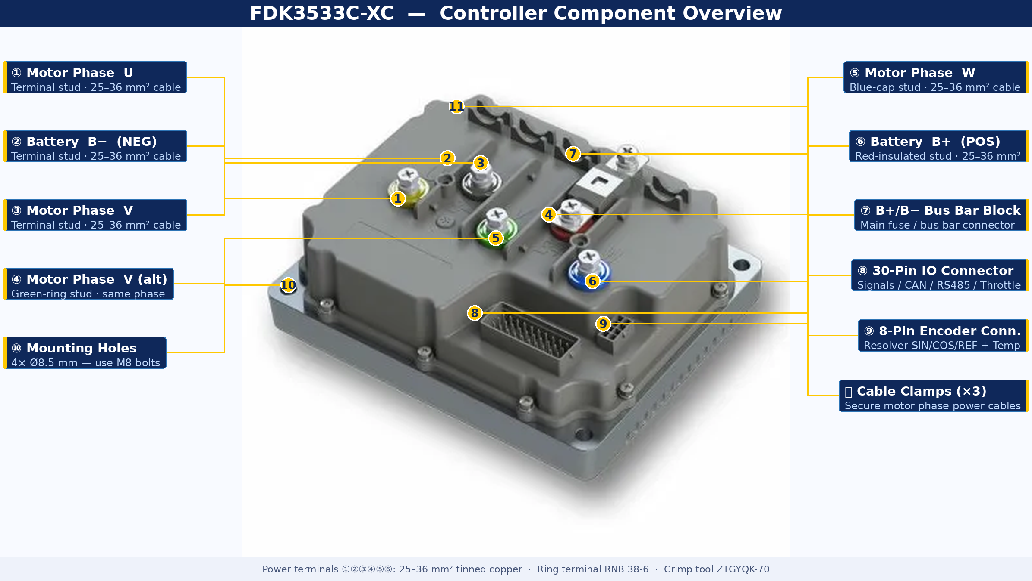
Figure 1 — FDK3533C-XC annotated controller — all major components labelled

Document Information
Version: V1.0 EN | Based on Oct 2023 original | For internal / NDA use only
Guilin Windcon Technology Co., Ltd. | www.windcon.com.cn

Table of Contents
Preface & Version History | 3
1 Safety Information | 3
2 Product Overview | 5
3 Controller Port Description | 6
3.1 Physical Layout | 6
3.2 30-Pin IO Connector (Connector A) | 7
3.3 8-Pin Encoder Connector (Connector B) | 9
3.4 Power & Motor Terminal Studs | 10
4 Controller Resource Configuration | 10
4.1 Signal Inputs | 10
4.2 Signal Output | 11
4.3 Voltage Outputs | 11
4.4 Communication Interfaces | 11
4.5 Encoder & Temperature Feedback | 12
4.6 Original Factory Wiring Diagrams | 12
5 Installation | 14
5.1 Environmental Requirements | 14
5.2 Mechanical Dimensions & Mounting | 14
5.3 Electrical Installation Safety | 15
5.4 Post-Installation Checklist | 15
6 Commissioning | 16
7 Typical Problems & Fault Analysis | 17
8 Fault Alarms & Remedies | 18
Appendix A — List of Figures | 19
Appendix B — List of Abbreviations | 20
Appendix C — Technical Explainer Diagrams | 22
C.1 Resolver Operating Principle | 22
C.2 FOC / SVPWM Control Loop | 23
C.3 Signal Logic Guide | 23
C.4 Fault Beep Code Chart | 24
C.5 Integration Guide | 24
C.6 Commissioning Flowchart | 25

Preface
Thank you for your support of Windcon FDK series motor controllers. This manual covers the FDK3533C-XC: safety information, mechanical and electrical installation, port descriptions, commissioning, maintenance, and integration guidance — with all original diagrams translated and annotated.
Read carefully before use and retain for future reference.

Version History
Date | Version | Description
October 2023 | V1.0 | Initial Chinese release
(current) | V1.0 EN | Full English translation — all 17 original diagrams annotated + 6 new explainer diagrams + 3 appendices

1 Safety Information

1.1 Safety Alert Levels

⚠ DANGER — Death or serious injury WILL result if instructions are not followed.

⚠ WARNING — Death or serious injury MAY result if instructions are not followed.

⚠ CAUTION — Minor injury or equipment damage may result if instructions are not followed.

1.2 Declarations
- Read and follow all safety information before installing, operating, or maintaining this product.
- Use only in environments meeting design specifications. Non-compliance voids warranty.

Windcon assumes no liability for damage caused by:
- Non-compliance with operating instructions
- Unauthorized modification or special-application use (e.g. lifting equipment)
- Improper operation, natural events, or transport damage

1.3 Safety Precautions

Wiring
⚠ DANGER — Wiring
- Non-professionals STRICTLY PROHIBITED from wiring!
- Never wire while power is connected — electric shock risk.
- Cut ALL power; wait ≥15 min before touching — capacitor residual voltage.
- Ensure reliable grounding; follow ESD procedures and wear anti-static wristband.

⚠ WARNING — Wiring
- NEVER connect power to motor output terminals U/V/W — fire risk!
- Phase sequence must match exactly. Reversed polarity damages product or encoder.
- Use shielded cable; ground shield at controller end only.

Power-On
⚠ DANGER — Power-On
- Motor MUST be unloaded for all initial commissioning.
- Confirm supply voltage matches controller rating before power-on.
- Devices may move at power-on — maintain safe distance!
- Never touch terminals, open covers, or disassemble while energized.

Operation
⚠ DANGER — Operation
- Never touch terminals, covers, or components while running.
- Never touch housing/fan/motor to test temperature — burn risk!
- Non-professionals must not probe signals during operation.

⚠ WARNING — Operation
- Prevent foreign objects from falling into equipment.
- Do NOT use a contactor on/off for start/stop control — causes damage.

Maintenance & Repair
⚠ DANGER — Maintenance/Repair
- Non-professionals STRICTLY PROHIBITED!
- Never work on powered equipment. Cut all power; wait ≥15 min.
- After replacement: re-confirm wiring, correct parameters, run unloaded first.

2 Product Overview

2.1 Introduction
The FDK3533C-XC is a low-voltage PMSM controller designed for electric tricycles, developed by Guilin Windcon Technology Co., Ltd. It employs advanced Field-Oriented Control (FOC / SVPWM) for precise torque control across a wide speed range, delivering stable smooth driving with multiple safety protections.

2.2 Key Features
- Resolver encoder: High-temp, non-demagnetizing, vibration/dust/oil-proof. No hall sensors. No encoder damage from heat or water.
- Dual thermal protection in motor and controller — reduces failures and repairs significantly.
- Anti-rollback, downhill speed limiting, regenerative braking.
- Flux weakening + 3-speed mode: Adds up to 8 km/h to top speed.
- Speed: 40–55 km/h | Load: 1 ton | Gradient: 30% | Efficiency: up to 94%
- Soft-start, anti-gear-clash | CAN + RS485 communication

2.3 Technical Specifications

Parameter | Specification
Model | FDK3533C-XC
Dimensions (w/o rain cover) | 205 × 165 × 71.5 mm
Dimensions (with rain cover) | 205 × 176.6 × 82.1 mm
Max Bus Current | DC 140 A
Max Phase Current | 350 A rms
Rated Operating Voltage | 48 / 60 / 72 V DC
Supply Voltage Range | 18 – 96 V DC
Control Method | SVPWM (Space Vector PWM)
Insulation Resistance | >=20 MΩ normal | >=1 MΩ high temp/humidity
Protection Rating | IP65
Cooling | Natural convection — install in ventilated location
Motor Type | PMSM (Permanent Magnet Synchronous Motor)
Encoder | Resolver (rotary transformer)
Operating Temperature | -25°C to +60°C
Storage Temperature | -40°C to +85°C
Humidity | 0–100% RH non-condensing

3 Controller Port Description

3.1 Physical Layout
The FDK3533C-XC has four main connection areas. Figure 1 (cover) shows the annotated photo. Figure 2 shows the original top-view technical drawing.

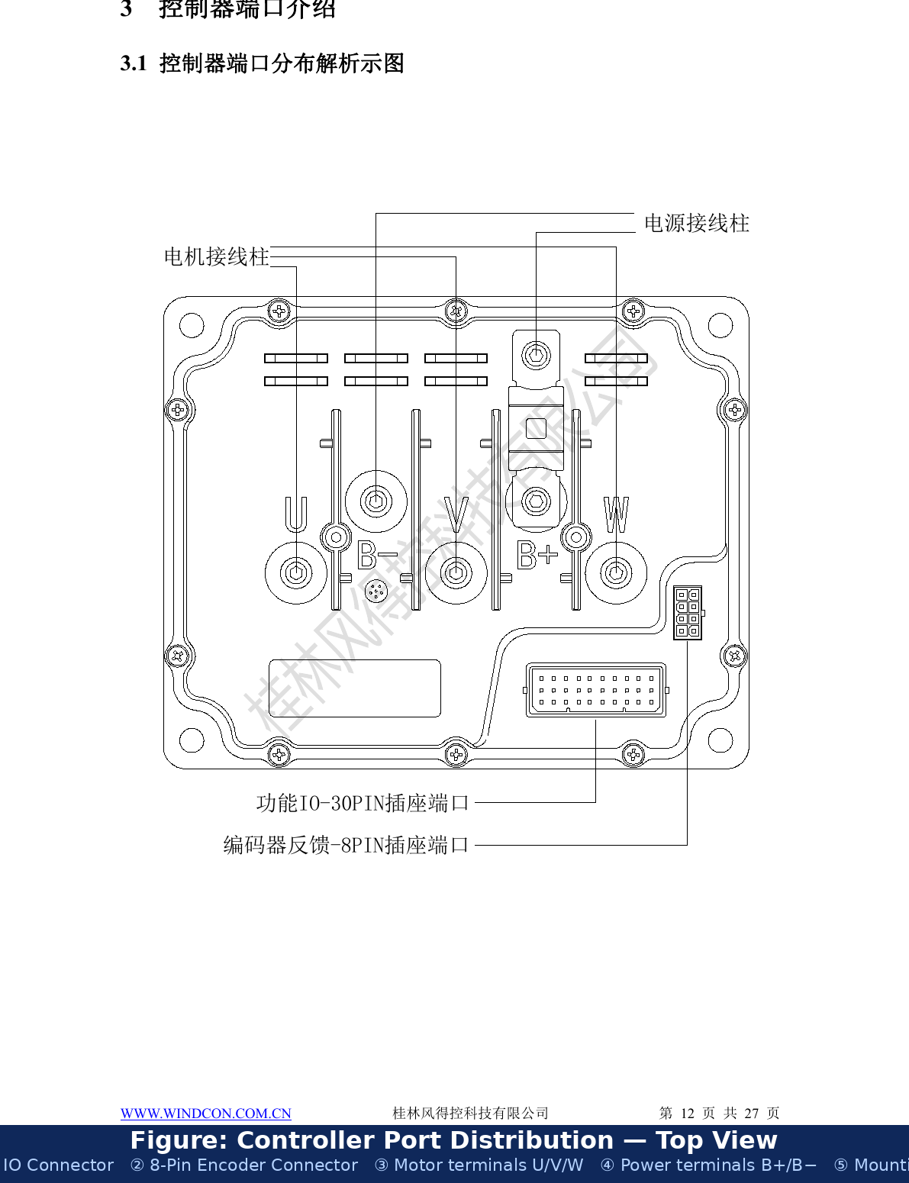
Figure 2 — Controller port distribution — original technical drawing, English labels added

Area | Connector | Contents
Power & Motor | 5× stud terminals (B+, B−, U, V, W) | Battery +/− and motor phases — 25–36 mm²
Functional IO | 30-pin connector (Connector A) | Signals, CAN, RS485, throttle, brakes, key, speed, READY
Encoder Feedback | 8-pin connector (Connector B) | Resolver SIN/COS/REF (±) and motor temperature
Mechanical | 4× mounting holes | Ø8.5 mm, M8 bolts, 185×145 mm pattern

3.2 30-Pin IO Connector (Connector A)
Connector type: Electric vehicle controller 30P harness plug. Wire colors shown are reference only.

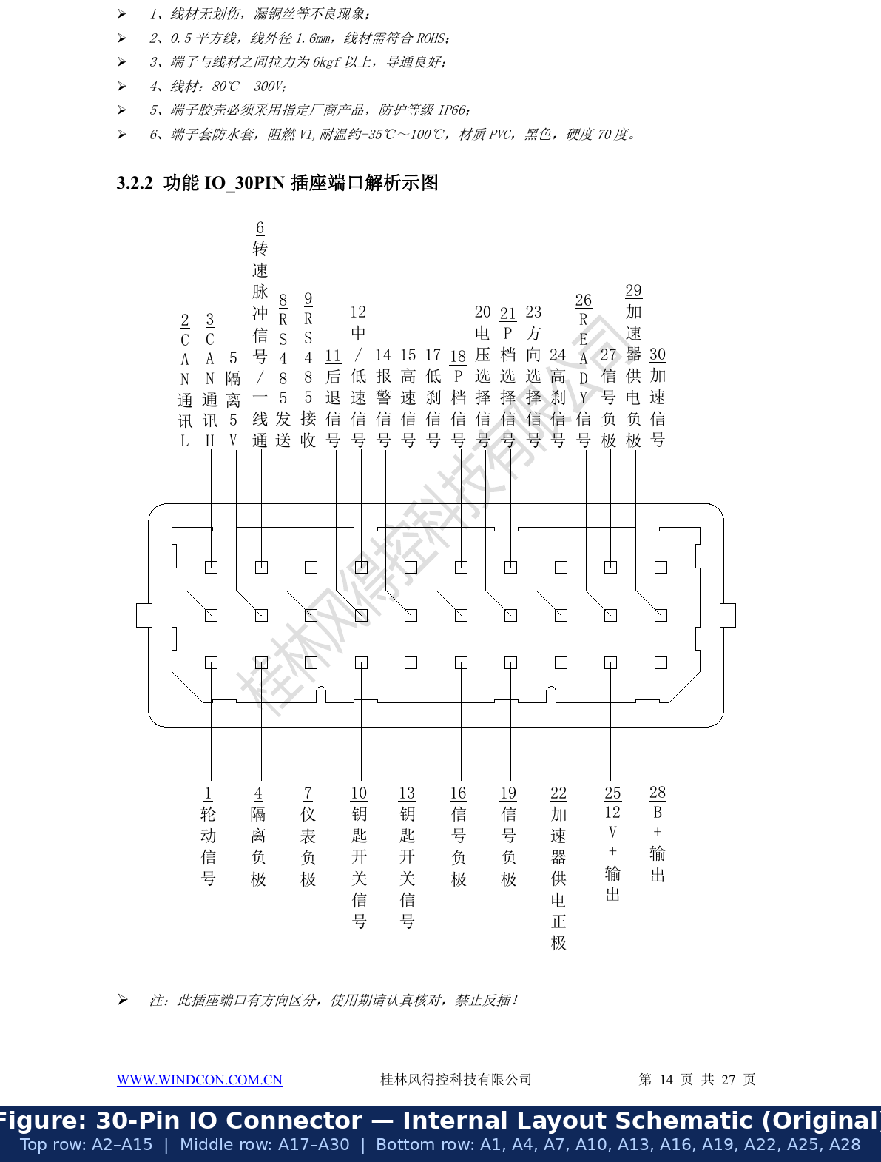
Figure 3 — 30-Pin IO connector — original layout schematic with English labels

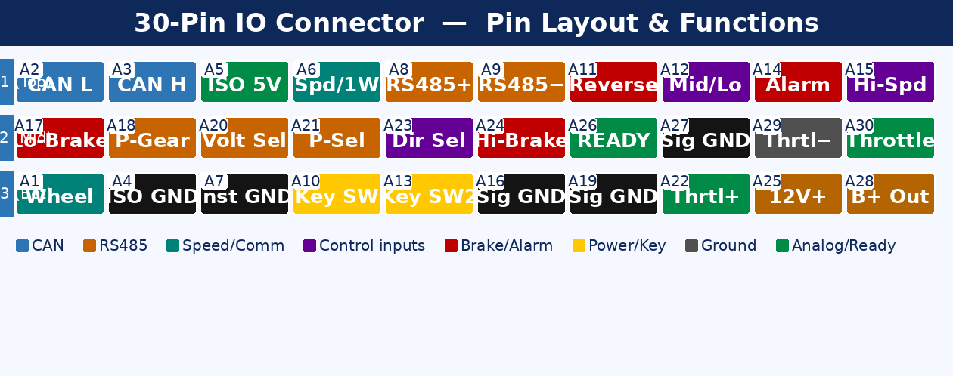
Figure 4 — 30-Pin IO connector — color-coded pin map by signal function

PIN | Wire | Signal | Description
A1 | Brn/Wht | Wheel Motion | Pulse when motor rotates — connect to alarm/buzzer
A2 | Red/Wht | CAN L | CAN bus Low (protocol customizable)
A3 | Red | CAN H | CAN bus High (protocol customizable)
A4 | LGrn/Wht | Isolated GND | CAN/RS485 isolation GND — connect in noisy environments
A5 | Pnk/Wht | Isolated 5V | Isolated 5V out (max 100 mA) — reserved for Bluetooth
A6 | Grn/Wht | Speed Pulse/1-Wire | 8 pulses/rev (5V) for speedometer OR single-wire comm.
A7 | Black | Instrument GND | Ground for pulse speedometer
A8 | Blu/Wht | RS485 T+ | RS485 transmit + — commissioning / command control
A9 | Pur/Wht | RS485 T− | RS485 transmit − — commissioning / command control
A10 | Purple | Key Switch | B+ input to energize controller via key switch
A11 | Brown | Reverse | Active LOW → reverse direction
A12 | Orange | Mid/Low Speed | Active LOW → mid/low speed mode
A13 | Purple | Key SW (Alarm) | Alarm unit sends key-on to start controller
A14 | Lt Blue | Alarm / Lock | Active LOW → alarm active, motor locked
A15 | Blue | High Speed | Active LOW → high speed / flux weakening mode
A16 | Black | Signal GND | Common GND for active-low inputs
A17 | Gray | Low Brake | Active LOW → brake (brake lever switch)
A18 | Yellow | P-Gear | Active LOW → enter/exit parking gear mode
A19 | Black | Signal GND | Common GND for active-low signals
A20 | Org/Wht | Voltage Select | Active LOW → switch voltage profile (48/60/72V)
A21 | Yel/Blk | P-Gear Select | Active LOW → enable/disable P-gear feature
A22 | Pink | Throttle Supply + | 5V out to power throttle sensor (max 200 mA)
A23 | Black | Direction Select | Active LOW → swap motor phase lines
A24 | Gry/Wht | High Brake | Active HIGH (12V) → brake — use A25 as 12V source
A25 | Lt Green | 12V+ Output | 12V out for active-high switch signals (max 200 mA)
A26 | White | READY Signal | 5V out to READY lamp on instrument cluster
A27 | Blk/Wht | Signal GND | Common GND for active-low signals
A28 | Yel/Wht | B+ Output | Battery voltage out for key switch only (max 1 A)
A29 | Black | Throttle GND | Ground for throttle power supply
A30 | Green | Throttle Signal | Throttle analog input 0–5V

⚠ CAUTION — 30-Pin Connector
- Specific insertion direction — reverse insertion PROHIBITED!
- Harness: 0.5 mm² ROHS, pull force ≥6 kgf, IP66 housing, 80°C 300V rated.

3.3 8-Pin Encoder Feedback Connector (Connector B)
Carries resolver signals and motor temperature. Use shielded cable; ground shield at controller end only.

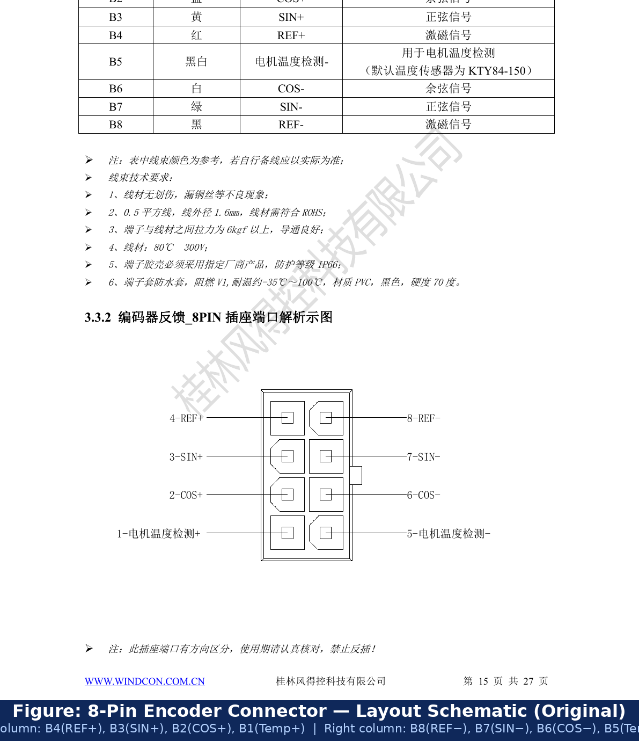
Figure 5 — 8-Pin encoder connector — original layout schematic with English labels

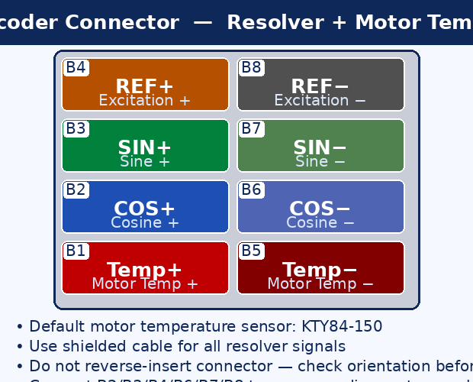
Figure 6 — 8-Pin encoder connector — color-coded SIN/COS/REF + temperature diagram

PIN | Wire | Signal | Description
B1 | Red/Wht | Motor Temp (+) | Motor temp sensor positive — default KTY84-150
B2 | Blue | COS+ | Resolver cosine positive
B3 | Yellow | SIN+ | Resolver sine positive
B4 | Red | REF+ | Resolver excitation positive (~10 kHz AC)
B5 | Blk/Wht | Motor Temp (−) | Motor temp sensor negative — default KTY84-150
B6 | White | COS− | Resolver cosine negative
B7 | Green | SIN− | Resolver sine negative
B8 | Black | REF− | Resolver excitation negative

⚠ CAUTION — 8-Pin Encoder Connector
- Specific insertion direction — reverse insertion PROHIBITED!
- Non-KTY84-150 sensors require Windcon engineering adaptation.
- Use shielded cable. Ground shield at controller end only.

3.4 Power & Motor Terminal Studs

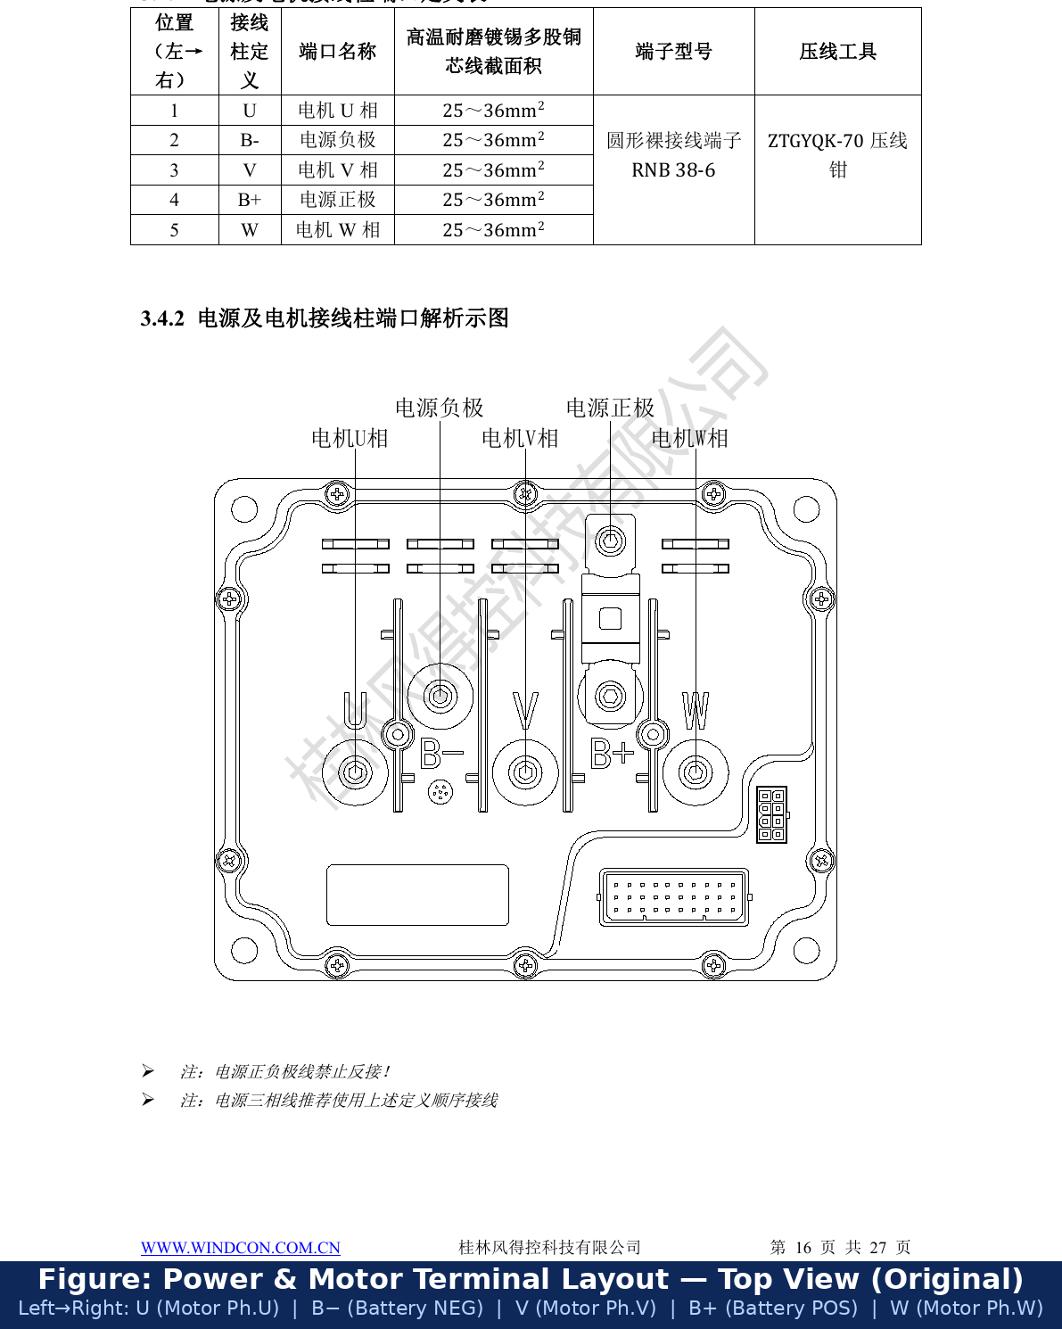
Figure 7 — Power and motor terminal layout — original technical drawing with English labels

Pos. | Label | Function | Cable | Terminal | Tool
1 | U | Motor Phase U | 25–36 mm² | RNB 38-6 | ZTGYQK-70
2 | B− | Battery Negative | 25–36 mm² | RNB 38-6 | ZTGYQK-70
3 | V | Motor Phase V | 25–36 mm² | RNB 38-6 | ZTGYQK-70
4 | B+ | Battery Positive | 25–36 mm² | RNB 38-6 | ZTGYQK-70
5 | W | Motor Phase W | 25–36 mm² | RNB 38-6 | ZTGYQK-70

⚠ WARNING — Power Terminals
- NEVER reverse B+ and B−!
- Wiring order left→right: U → B− → V → B+ → W
- 25–36 mm² tinned copper only. Crimp with ZTGYQK-70.

4 Controller Resource Configuration

4.1 Signal Inputs
PIN | Signal | Trigger | Input Range | Max V
A11 | Reverse | Active Low | 0–0.2V | 24V
A12 | Mid/Low speed | Active Low | 0–0.2V | 24V
A14 | Alarm/Lock | Active Low | 0–0.2V | 24V
A15 | High speed | Active Low | 0–0.2V | 24V
A17 | Low brake | Active Low | 0–0.2V | 24V
A18 | P-gear | Active Low | 0–0.2V | 24V
A20 | Voltage select | Active Low | 0–0.2V | 24V
A21 | P-gear select | Active Low | 0–0.2V | 24V
A23 | Direction select | Active Low | 0–0.2V | 24V
A24 | High brake | Active High (12V) | 10–18V | 24V
A30 | Throttle (analog) | 0–5V nominal | 0–10V | 12V

⚠ CAUTION — Inputs
- Operate within typical voltage range. Exceeding limits may damage controller.
- Inputs are positive-voltage triggered. Reference is B−. Never inject negative voltage.

4.2 Signal Output
PIN | Signal | Voltage | Max Current
A26 | READY | 5V ±2% | 50 mA

4.3 Voltage Outputs
PIN | Signal | Voltage | Max mA | Permitted Use
A5 | Isolated 5V | 5V ±2% | 100 | Bluetooth module only
A22 | Throttle + | 5V ±2% | 200 | Throttle / hall sensor
A25 | 12V+ output | 12V ±2% | 200 | Active-high switch signals only
A28 | B+ output | Battery V | 1000 | Key switch signal only

⚠ CAUTION — Outputs
- ONLY for: throttle, Bluetooth, brake, key switch, active-high IO.
- Do NOT power lights or instruments — overcurrent damages controller.
- Never inject external voltage into output pins.

4.4 Communication Interfaces
Interface | Pins | Type | Notes
CAN Bus | A2 (L), A3 (H) | Isolated CAN | Built-in 120Ω; add 120Ω at each bus end; protocol customized.
CAN Isolation GND | A4 | ISO GND | Connect to chassis in high-interference environments.
RS485 | A8 (T+), A9 (T−) | Isolated RS485 | Built-in 120Ω; for commissioning and command control.
Pulse Speed | A6, A7 | 5V pulse | 8 pulses/rev; A7=instrument GND. Default mode for A6.
Single-Wire | A6 only | 1-wire | Firmware mode; protocol requires Windcon customization.
CAN Instrument | A2, A3 | Isolated CAN | Shared bus with BMS/VCU; protocol customized separately.

4.5 Encoder and Temperature Feedback
Pins | Signal | Notes
B2/B6 (COS+/−) | Cosine differential | Connect to motor resolver cosine winding
B3/B7 (SIN+/−) | Sine differential | Connect to motor resolver sine winding
B4/B8 (REF+/−) | Excitation ~10kHz | Supplied by controller DSP to resolver primary
B1/B5 (Temp+/−) | Motor temperature | Default KTY84-150; other types need Windcon adaptation

4.6 Original Factory Wiring Diagrams
The two original factory schematics below show all connections. Variant A uses a single-output DC-DC; Variant B uses a dual-output DC-DC with 12V+ and 12V−.

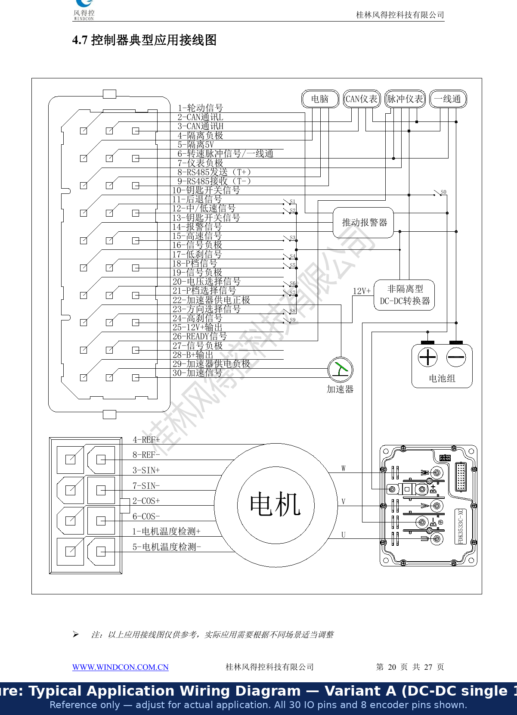
Figure 9 — Typical application wiring diagram — Variant A: single DC-DC (12V only)

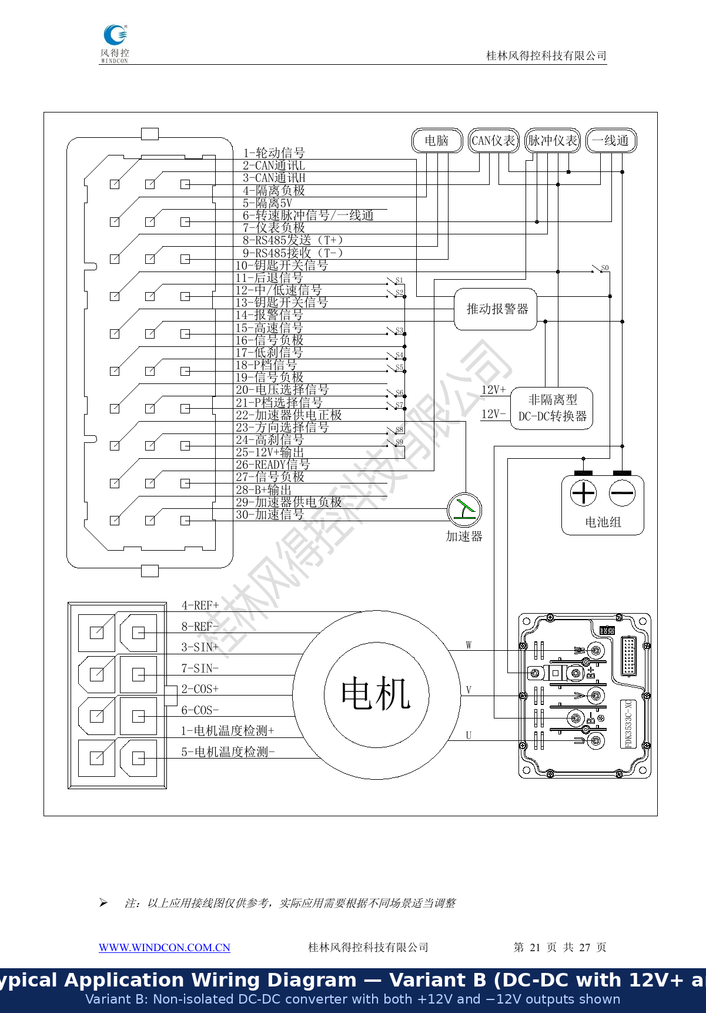
Figure 10 — Typical application wiring diagram — Variant B: DC-DC with 12V+ and 12V−

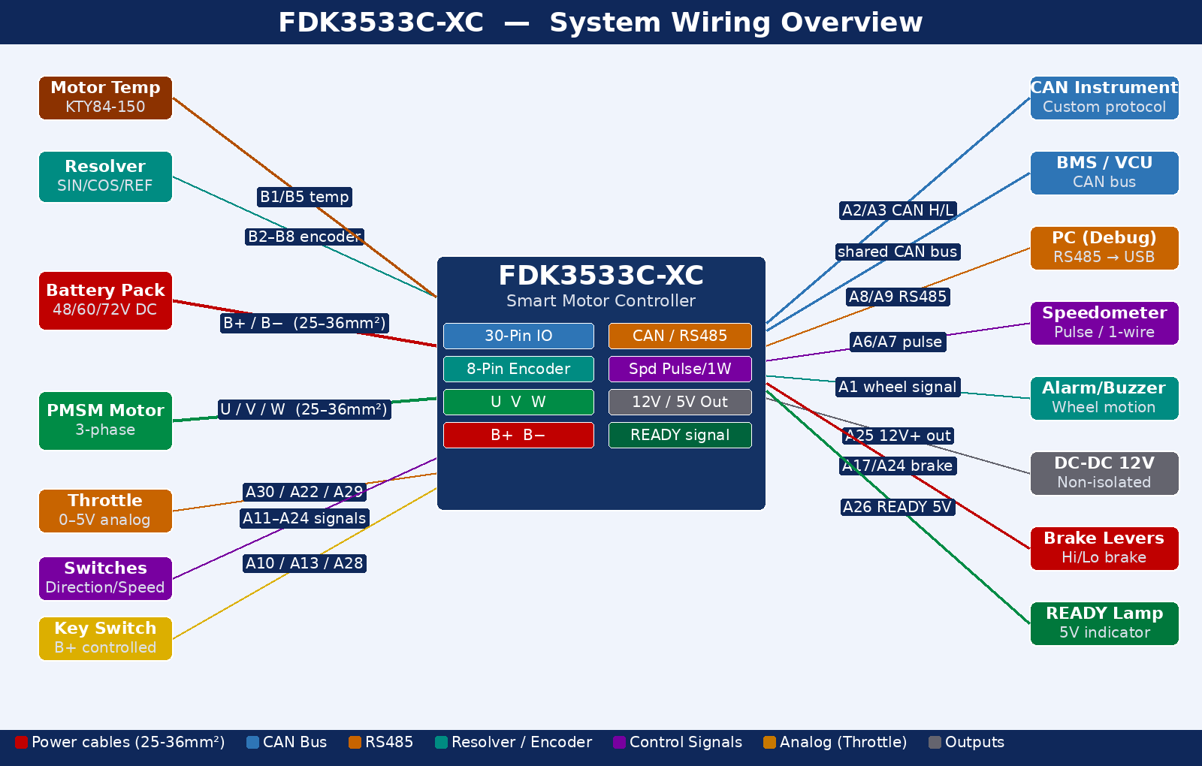
Figure 11 — System wiring overview — all external connections with color-coded signal paths

5 Installation

5.1 Environmental Requirements
- No corrosive gas/liquid, flammable/explosive, water/steam/oil/dust, or high-heat environments
- No severe electromagnetic interference or severe grid fluctuations
- Vibration environments: contact Windcon before installation

5.2 Mechanical Dimensions and Mounting

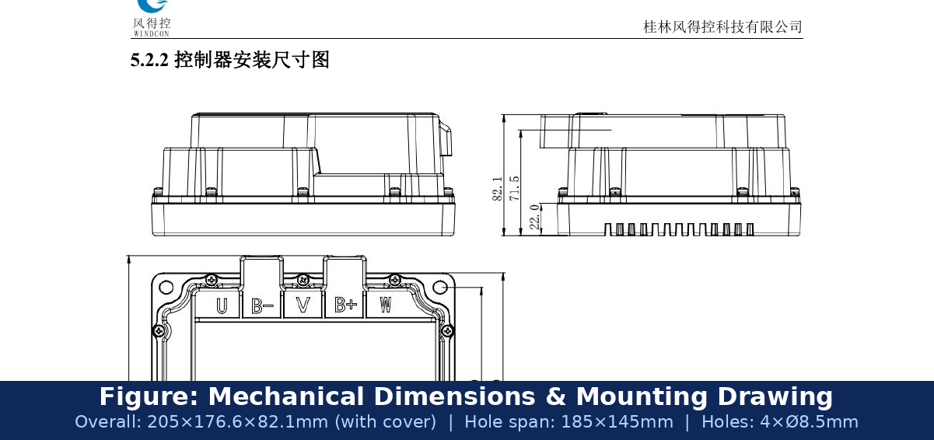
Figure 8 — Mechanical installation dimensions — original factory drawing

Dimension | Value
Overall length | 205.0 mm
Width (w/o rain cover) | 165.0 mm
Width (with rain cover) | 176.6 mm
Height (w/o rain cover) | 71.5 mm
Height (with rain cover) | 82.1 mm
Hole span (length × width) | 185.0 × 145.0 mm (centre-to-centre)
Hole diameter | 4× Ø8.5 mm — M8 bolts
Base-to-datum offset | 22.0 mm

5.3 Electrical Installation Safety
- All wiring by trained, authorized engineers only.
- Verify controller voltage rating before power-on; factory dielectric test done — do not repeat.
- Both controller and motor must be reliably grounded.
- Connect to supply via circuit breaker or fuse (overcurrent protection).
- NEVER connect power supply to motor terminals U, V, or W.

5.4 Post-Installation Inspection Checklist
Inspection Item | Pass Criteria
Controller condition | No damage; securely mounted; heatsink fins clear
Cable condition | No damage; power cables separated from signal/encoder cables
Connectors | All fully mated; no tension; sufficient slack
Power polarity | B+/B− correct; power NOT connected to signal or encoder ports
Motor phases | U/V/W correct sequence; no stripped insulation
Grounding | Correctly and firmly connected
Terminal voltages | All within typical range; no over-voltage
Encoder | Resolver lines correctly matched; shielded cable used; shield grounded at controller end

6 Commissioning
Software: 'Windcon Debug Assistant'. See its user manual. If version mismatch error appears — contact Windcon for startup config file.

6.1 Commissioning Sequence
Step | Action | Critical Notes
1 | Mount in ventilated location | Heatsink must have airflow clearance
2 | Wire B+, B−, U, V, W power terminals | Verify polarity; follow phase order; crimp properly
3 | Wire encoder B2–B8 and temp B1/B5 | Shielded cable; check 8-pin orientation before mating
4 | Wire all 30-pin IO signals | Key switch, throttle (A22/A29/A30), brakes, direction, speed
5 | Set motor to NO LOAD | REQUIRED for all commissioning and angle zeroing
6 | Connect PC via RS485 USB adapter | Open Windcon Debug Assistant
7 | Power ON controller | Listen for alarm beep codes (see Section 8)
8 | Verify PC communication | Read parameters; confirm voltage matches battery
9 | Run current loop test | Feedback RPM MUST be POSITIVE → if negative, swap phase lines (0↔1)
10 | Electrical angle zeroing | Repeat 3+ times; offset error must be <±50
11 | Test throttle response | Slow ramp-up; verify smooth control, no oscillation
12 | Test brakes and direction | All safety inputs must function before load testing
13 | Gradual load testing | Monitor temperatures during extended runs

6.2 Key Parameters
Parameter | Function | Action Required
Motor rated current | Sets motor protection current limit | Must not exceed controller rated value
Motor pole pairs | Used in: RPM = freq×60÷pole pairs | Wrong value causes speed errors and instability
Swap phase lines (0/1) | Reverses motor direction | Set so current-loop feedback speed is POSITIVE
Angle zero offset | Rotor reference for FOC | Must be within ±50 after repeated zeroing
Battery voltage level | Sets 48/60/72V protection thresholds | Must match actual battery pack voltage
Max output current | Limits peak current | Verify before first run — too high damages motor

7 Typical Problems and Fault Analysis

7.1 Vibrates Slowly or Does Not Move After Throttle
Item | Detail
Symptom | Wiring correct; after gentle throttle, vehicle vibrates slowly or does not move
Cause A | Motor phase sequence wrong → toggle Swap Phase Lines (0↔1) until current-loop feedback speed is POSITIVE
Cause B | Encoder abnormal: power issue, wire break, poor contact, wrong sequence, or encoder damage
Note | Swap Phase Lines only works when encoder is functioning correctly

7.2 Does Not Move or Overspeeds (Runaway) After Throttle
Check | Action
1 — Phase direction | Current loop: feedback RPM MUST be POSITIVE and satisfy RPM = freq×60÷pole pairs
2 — Encoder signal | Motor rotates but no speed feedback → inspect B2–B8; replace encoder if wiring is correct
3 — Angle zeroing | Re-zero with Check 1 satisfied; repeat; offset must be within ±50
4 — Hardware | All above pass but fault persists → return to factory

7.3 No Response After Key-On and Throttle
Required Condition | How to Verify
Direction signal present | Check forward or reverse input is active (A11 for reverse)
No brake active | Verify no brake lever pressed; measure A17 and A24
Throttle has output | Measure A30: must rise ~0.8V (idle) to ~4.2V (full)
Supply above threshold | Measure battery voltage vs configured under-voltage limit

8 Fault Alarms and Remedies
Faults are signalled via buzzer using Long (L) + Short (S) beep patterns repeating until resolved.
Timing: Long ≈0.8 s | Short ≈0.2 s | Gap ≈0.2 s

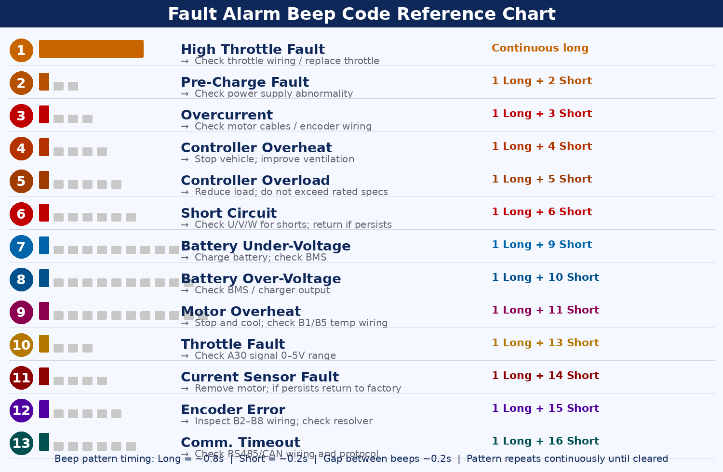
Figure 15 — Fault alarm beep code reference chart — all 13 codes with visual patterns and remedies

No. | Pattern | Fault | Remedy
1 | Continuous long | High Throttle | Throttle held at power-on. Release and restart. Persistent → check A30/A22/A29.
2 | 1L+2S | Pre-Charge | Pre-charge failed. Restart. Persistent → check supply, fuse, BMS.
3 | 1L+3S | Overcurrent | Motor circuit short or encoder fault. Remove motor, restart. Persistent → factory.
4 | 1L+4S | Controller Overheat | Too hot. Stop and cool. Improve mounting ventilation.
5 | 1L+5S | Controller Overload | Current exceeded rated too long. Reduce load.
6 | 1L+6S | Short Circuit | U/V/W short or current loss. Remove motor, restart. Persistent → factory.
7 | 1L+9S | Battery Under-Voltage | Supply below threshold. Charge battery; check BMS; check B+/B−.
8 | 1L+10S | Battery Over-Voltage | Supply above threshold. Check BMS and charger.
9 | 1L+11S | Motor Overheat | Motor too hot. Stop and cool. Persists after cooling → check B1/B5.
10 | 1L+13S | Throttle Fault | Check A30 is 0–5V throughout throttle travel.
11 | 1L+14S | Current Sensor | Abnormal detection. Remove motor, restart. Persistent → factory.
12 | 1L+15S | Encoder Error | Resolver mismatch or signal fault. Inspect all B2–B8 wiring and resolver.
13 | 1L+16S | Comm. Timeout | Communication lost in command mode. Check RS485/CAN wiring.

8.1 Fault Resolution Steps
- Note the exact beep pattern and identify the fault from the table above.
- Power off completely and wait at least 15 minutes.
- Address the specific cause for that fault code.
- Power on and verify fault is cleared.
- If persists, contact Windcon or return to factory.

⚠ DANGER — Never diagnose faults while energized!
- Cut all power; wait ≥15 min before inspecting wiring.
- When returning for repair, document the beep pattern and operating conditions.

Appendix A — List of Figures

Figure 1 FDK3533C-XC Annotated Controller Photo — All Major Components Labelled | see page
Figure 2 Controller Port Distribution — Original Technical Drawing (English Labels) | see page
Figure 3 30-Pin IO Connector — Original Layout Schematic (English Labels) | see page
Figure 4 30-Pin IO Connector — Color-Coded Pin Map by Signal Function | see page
Figure 5 8-Pin Encoder Connector — Original Layout Schematic (English Labels) | see page
Figure 6 8-Pin Encoder Connector — Color-Coded SIN/COS/REF Diagram | see page
Figure 7 Power & Motor Terminal Layout — Original Technical Drawing (English Labels) | see page
Figure 8 Mechanical Installation Dimensions — Original Factory Drawing | see page
Figure 9 Typical Application Wiring Diagram — Variant A (Single 12V DC-DC) | see page
Figure 10 Typical Application Wiring Diagram — Variant B (Dual 12V DC-DC) | see page
Figure 11 System Wiring Overview — All External Connections, Color-Coded | see page
Figure 12 Resolver (Rotary Transformer) — Operating Principle and Signal Waveforms | see page
Figure 13 FOC / SVPWM Vector Control Loop — Complete Block Diagram | see page
Figure 14 Signal Logic Guide — Active High vs. Active Low vs. Analog Throttle | see page
Figure 15 Fault Alarm Beep Code Reference Chart — All 13 Fault Codes | see page
Figure 16 Integration Guide — Connecting Nine External Sub-Systems | see page
Figure 17 Commissioning Flowchart — Complete Initial Setup Procedure | see page

Appendix B — List of Abbreviations

Abbreviation | Full Term | Meaning / Context
ADC | Analog-to-Digital Converter | Converts throttle voltage on A30 (0–5V) to digital speed command inside the DSP
BMS | Battery Management System | Manages battery charge/discharge/protection; connects via CAN (A2/A3)
CAN | Controller Area Network | ISO 11898 serial bus; connected on A2 (CAN L) and A3 (CAN H)
COS | Cosine | Resolver differential output signal; amplitude encodes rotor angle as cosine
DSP | Digital Signal Processor | High-speed processor inside controller for FOC, PWM, and resolver calculations
EMC | Electromagnetic Compatibility | Use shielded cables and proper grounding to ensure compliance
ESD | Electrostatic Discharge | Static electricity that can damage electronics; wear anti-static wristband when wiring
FOC | Field-Oriented Control | Algorithm controlling torque (Iq) and flux (Id) currents independently for smooth operation
GND | Ground | 0V electrical reference. All signal inputs reference to B− (battery negative)
Id | D-axis Current | Direct (flux-producing) current in FOC d-q frame; controls field weakening
Iq | Q-axis Current | Quadrature (torque-producing) current in FOC d-q frame; controls motor torque
IO | Input/Output | Signal pins on the 30-pin connector (Connector A)
IP65 | Ingress Protection 65 | Dust-tight; protected against water jets; the controller housing rating
KTY84-150 | Temp. Sensor Type | Silicon PTC thermistor, −50°C to +150°C; default motor temp sensor (B1/B5)
NDA | Non-Disclosure Agreement | This document is for internal NDA use only — do not distribute externally
PI | Proportional-Integral | Feedback control in FOC speed and current loops to eliminate steady-state error
PMSM | Perm. Magnet Sync. Motor | Three-phase AC motor with permanent magnets on rotor; what this controller drives
PWM | Pulse Width Modulation | High-freq switching to control average voltage/current delivered to motor phases
REF | Reference / Excitation | ~10 kHz AC generated by DSP and fed to resolver primary winding (B4/B8)
ROHS | Restriction of Hazardous Substances | EU directive; all wire harness materials must comply
RPM | Revolutions Per Minute | Motor speed. Formula: RPM = output frequency × 60 ÷ motor pole pairs
RS485 | Recommended Standard 485 | Differential serial standard; commissioning and command control (A8/A9)
SIN | Sine | Resolver differential output; amplitude encodes rotor angle as sine waveform
SVPWM | Space Vector PWM | Advanced modulation in FOC; maximizes voltage utilization, reduces harmonics
VCU | Vehicle Control Unit | Higher-level vehicle computer sending speed/torque commands via CAN bus

Appendix C — Technical Explainer Diagrams
Six original diagrams explaining internal operation and external integration of the FDK3533C-XC.

C.1 Resolver (Rotary Transformer) — Operating Principle
The FDK3533C-XC uses a resolver instead of hall sensors. A resolver is a contactless electromagnetic angle sensor: the controller DSP supplies a ~10 kHz excitation signal (REF+/REF−) to the primary winding; the rotor modulates this into differential SIN and COS outputs whose amplitudes vary with rotor position. The DSP calculates absolute angle (θ = arctan(SIN/COS)) and speed (Δθ/Δt) at ~0.1° resolution — with no breakable parts, no demagnetization risk, and operation from −55°C to +155°C.

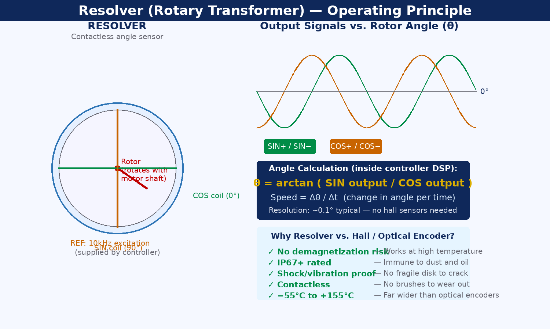
Figure 12 — Resolver operating principle — physical diagram, signal waveforms, angle formula, and advantages

C.2 FOC / SVPWM Vector Control Loop
Full closed-loop Field-Oriented Control: three-phase currents are transformed into a rotating d-q frame; PI regulators independently control torque current (Iq) and flux current (Id); results are inverse-Park-transformed back to three-phase voltage vectors and modulated via Space Vector PWM to drive the three-phase inverter. This delivers smooth, efficient, precise torque at all speeds — far superior to trapezoidal or ON/OFF commutation.

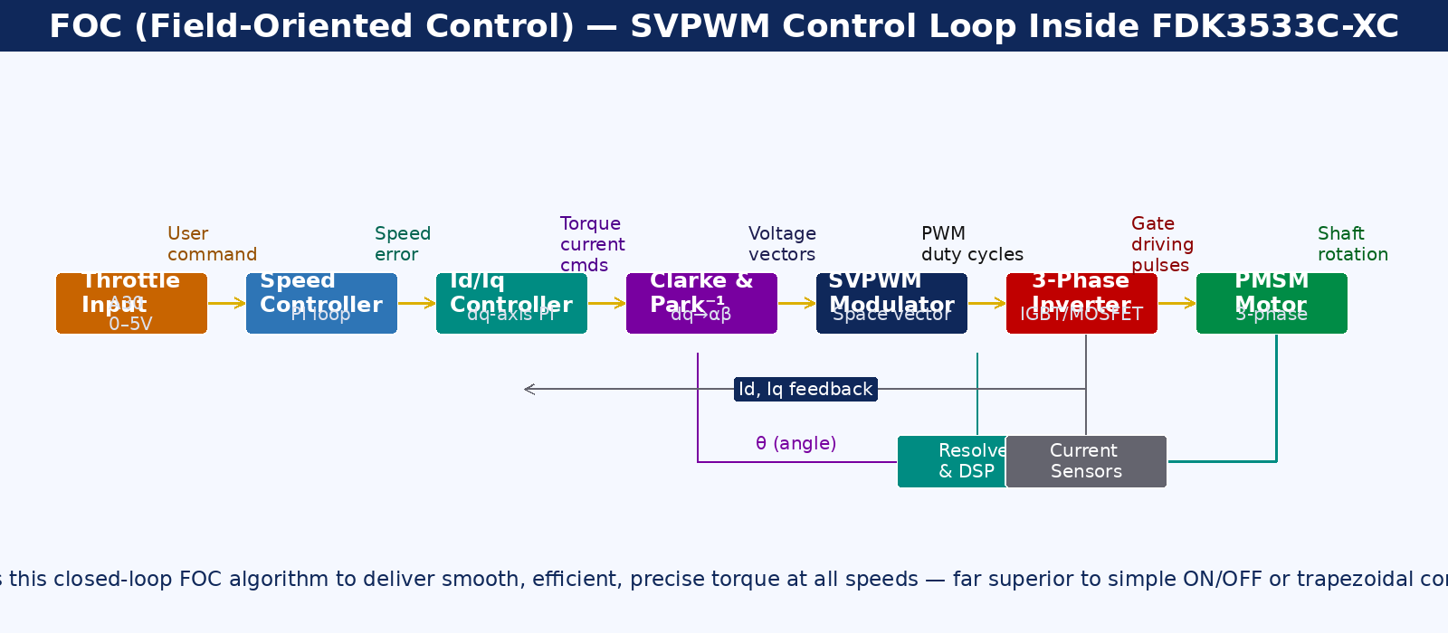
Figure 13 — FOC / SVPWM vector control loop — complete block diagram from throttle input to motor shaft

C.3 Signal Logic Guide — Active High vs. Active Low vs. Analog Throttle
Most control inputs use active-low logic (triggered by pulling to GND). The high-brake A24 uses active-high (12V). The throttle A30 is a 0–5V analog signal powered from A22. Understanding these differences is critical for correct wiring and fault diagnosis.

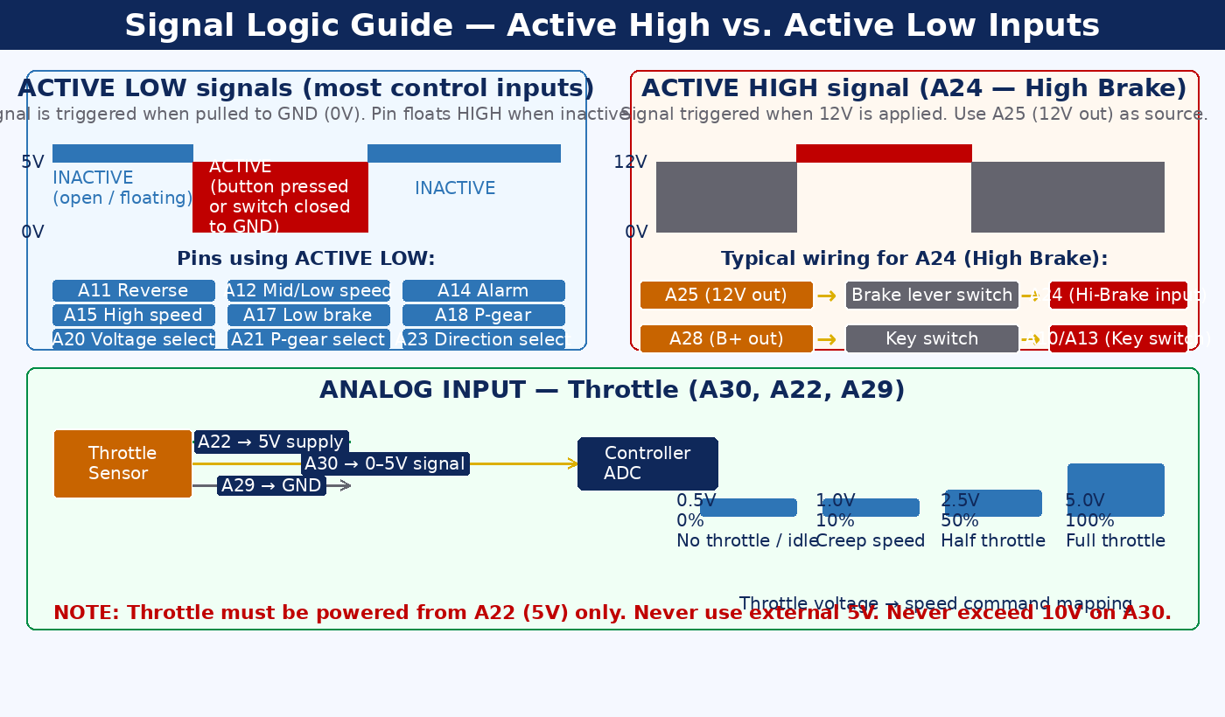
Figure 14 — Signal logic guide — timing diagrams, typical wiring circuits, and throttle voltage-speed mapping

C.4 Fault Alarm Beep Code Reference Chart
Visual chart of all 13 fault codes with beep-pattern bar graphics. Long beep ~0.8 s, short beep ~0.2 s. Print and laminate for field maintenance use. Full descriptions and remedies are in Section 8.

C.5 Integration Guide — Connecting External Systems
Nine-panel diagram showing exact pins, wiring rules, and critical notes for: CAN bus, RS485, instrument types (pulse/single-wire/CAN), throttle, brakes (low/high), 3-speed selector, motor direction, battery voltage selection, and anti-theft lock.

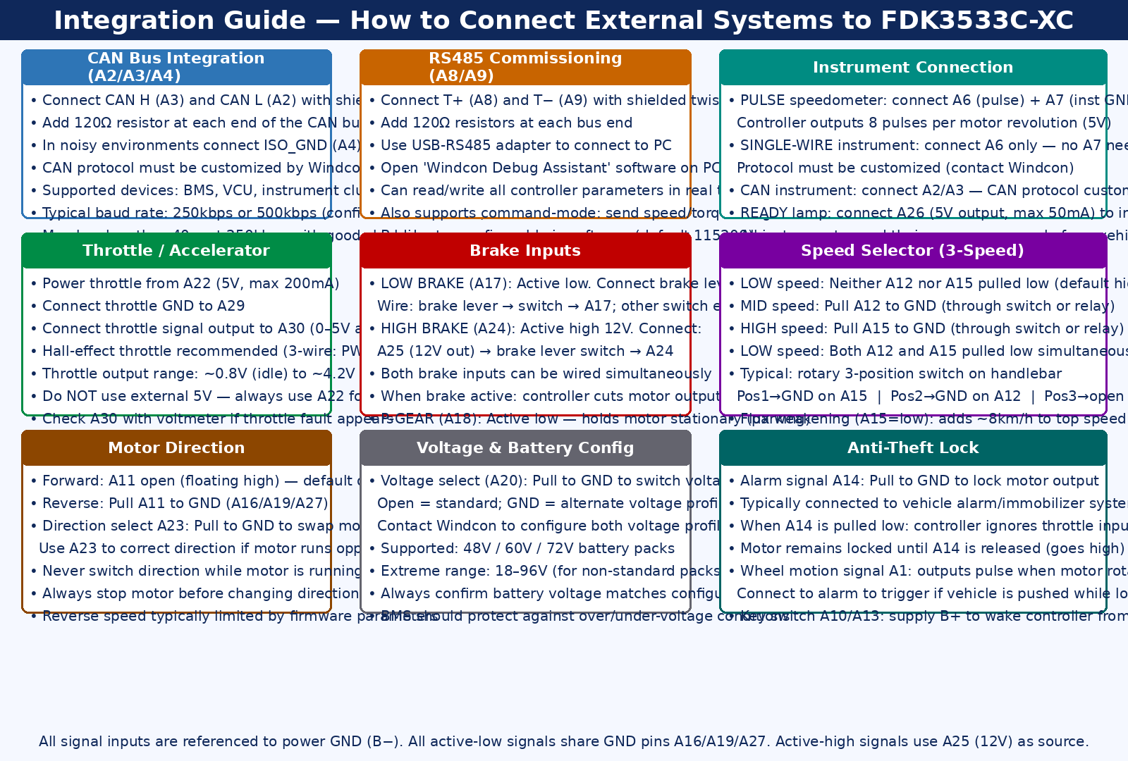
Figure 16 — Integration guide — nine external sub-systems with pin numbers, wiring rules, and critical notes

C.6 Commissioning Flowchart
Step-by-step flowchart for full initial commissioning. Critical decision points: Step 9 (current-loop feedback MUST be POSITIVE), Step 10 (angle zeroing offset MUST be within ±50). Never skip unloaded testing or angle zeroing.

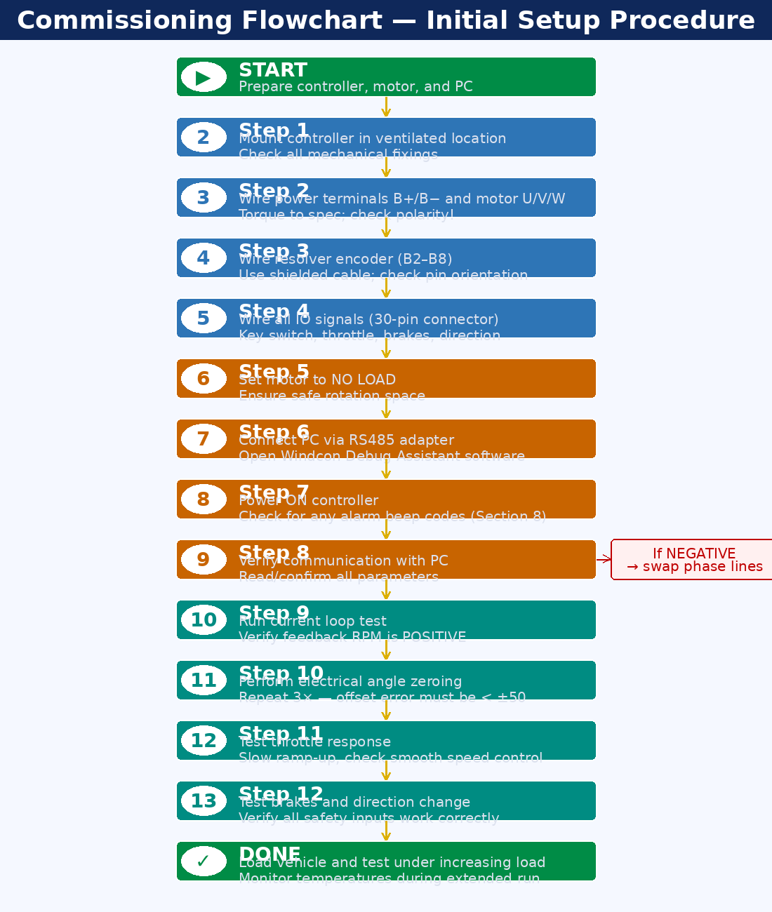
Figure 17 — Commissioning flowchart — complete initial setup procedure with decision points

Guilin Windcon Technology Co., Ltd.
www.windcon.com.cn | FDK3533C-XC User Manual V1.0 EN | For internal / NDA use only

