Micro- and macroevolutionary aspects of body size diversification and thermal adaptation in insects

John Waller

LundUniv_ENG_C2line_Black

DOCTORAL DISSERTATION

To be defended in the Blue Hall, Ecology Building, Sölvegatan 37, Lund Sweden on Friday 26th January, 2018 13.00

*Faculty opponent*Dr. Locke Rowe

Dean of school of graduate studies and vice-provost of graduate research and education.

Distinguished professor of Ecology and Evolutionary Biology

University of Toronto, Canada

|  |  |  |  |
| --- | --- | --- | --- |
| Organization  LUND UNIVERSITY | | Document name  DOCTORAL DISSERTATION | |
| Department of Biology, Evolutionary Ecology, Sölvegatan 37, 223 62, Lund | | Date of issue | |
| Author(s)John Waller | | Sponsoring organization | |
| Title and subtitle Micro- and macroevolutionary aspects of body size diversification and thermal adaptation in insects | | | |
| Abstract  Body size and body temperature are the two most important traits in biology. In this thesis I show how these two variables have shaped the evolution of insects over the last 300 million years. These variables are so important in fact that three rules have been developed to summarize their effects: (1) bigger is better, (2) hotter makes you smaller, and (3) hotter is better.  Using primarily dragonflies and damselflies, I explore the implications of these rules in the evolution of insects. Bigger is better (rule 1) states that larger individuals tend to have higher fitness. In insects larger adult body size is expect to produce higher fitness in terms of higher fecundity in females and higher mating success in males, while potentially increasing longevity in both males and females. I show that there are limits to how large one can get, and stabilizing selection body is expected to be the norm in most populations, mediated through conflicting selection between large adults and costs of increased development time.  Hotter makes you smaller (rule 2), also known as the temperature-size rule in insects, states that within a population insects that develop in warmer regions will be smaller. The hotter makes you smaller rule is typically observed along a latitudinal gradient within the range of a species. This within species trend suggests strong associations between an organism size and its developmental environment, and suggests a possible resolution to of the paradox imposed by the bigger is better rule. While the temperature-size rule is well-established in natural and laboratory populations, I show that other factors such as predation and dispersal are likely determining latitudinal size patterns between species.  The final rule (rule 3), hotter is better, is the least well-established “rule” of the three rules. It states that warmer body temperatures will tend to lead higher performance in adult insects. Since dragonflies and damselflies are ectotherms, they are strongly dependent on ambient temperature to achieve optimal body temperatures, I show that hotter is not always better, and individuals with higher heating rates are favoured only in extreme temperature conditions, and otherwise thermal inertia is preferred, since the mean environment will match an individual’s optimal body temperature. | | | |
| Key words Body Size, Dragonfly, Damselfly, Evolution, Thermoregulation, Macro-Evolution, Calopteryx | | | |
| Classification system and/or index terms (if any) | | | |
| Supplementary bibliographical information | | | Language  English |
| ISSN and key title | | | ISBN 978-91-7753-527-0 (print)  ISBN 978-91-7753-528-7 (pdf) |
| Recipient’s notes | Number of pages | | Price |
|  | Security classification | | |

I, the undersigned, being the copyright owner of the abstract of the above-mentioned dissertation, hereby grant to all reference sources permission to publish and disseminate the abstract of the above-mentioned dissertation.

Signature Date

Micro- and macroevolutionary aspects of body size diversification and thermal adaptation in insects

John Waller

LundUniv_ENG_C2line_Black

|  |
| --- |
| Coverphoto by Petro Buyak  Copyright John Waller  Faculty of Science  Department of Biology  ISBN 978-91-7753-527-0 (print)  ISBN 978-91-7753-528-7 (pdf)  Printed in Sweden by Media-Tryck, Lund University  Lund 2017 |

# Table of Contents

Table of Contents 7

List of Papers 8

Author Contributions 9

Abstract 10

Popular Science Summary 11

Populärvetenskaplig Sammanfattning 12

General Introduction 13

Thesis Aims 14

Background 15

Ecology of dragonflies and damselflies 15

Body size, oxygen, and fossils 17

The comparative method 20

Evolution of thermal performance traits 23

Materials and Methods 25

Measuring selection in natural populations 25

Field work 26

Mark-recapture methods 29

Building the odonate phenotypic database 31

Odonate super tree 32

Major Results 33

Conclusions 35

Acknowledgments 36

References 38

## List of Papers

**I Waller**, J.**,** & Svensson, E.I. (2016). The measurement of selection when detection is imperfect: How good are naïve methods?. *Methods in Ecology and Evolution*, *7*(5), 538-548.

**II.** **Waller**, J., Willink B., Tschol M., & Svensson E.I. (2018). The Odonate Phenotypic Database: a new open data resource for comparative studies of an old insect order. [www.odonatephenotypicdatabase.org](http://www.odonatephenotypicdatabase.org).

(Manuscript).

**III.** **Waller**, J., & Svensson, E.I. (2017). Body size evolution in an old insect order: No evidence for Cope's Rule in spite of fitness benefits of large size. Evolution.

**IV.** **Waller**, J. (2018). Is the blunderbuss a misleading visual metaphor for stasis and punctuated evolution? (Manuscript).

**V.** **Waller**, J., & Svensson, E.I. (2017). Biotic and abiotic drivers of global body size distributions and macroevolutionary diversification in an old insect order. (Manuscript).

**VI.** **Waller**, J., Kell, A., Ballesta, M., Giraud, A., Abbott, J., & Svensson, E. (2017). Limited genetic variation for male mating success reveals low evolutionary potential for thermal plasticity in *Drosophila melanogaster*. bioRxiv, 166801.

**VII.** **Waller**, J. & Svensson, E.I. (2018). Sexual and natural selection on thermal plasticity and thermal canalization in insects at high latitudes. (Manuscript).

Papers I & III are reprinted with permission of the publisher.

Other interesting papers published during thesis but not included:

1. Svensson, E. I., & **Waller**, J. T. (2013). Ecology and sexual selection: evolution of wing pigmentation in calopterygid damselflies in relation to latitude, sexual dimorphism, and speciation. The American Naturalist, 182(5), E174-E195.
2. Gosden, T. P., **Waller**, J.T., & Svensson, E. I. (2015). Asymmetric isolating barriers between different microclimatic environments caused by low immigrant survival. Proceedings of the Royal Society of London B: Biological Sciences, 282(1802), 20142459.
3. Svensson, E. I., Nordén, A., **Waller**, J. T., & Runemark, A. (2016). Linking intra‐and interspecific assortative mating: Consequences for asymmetric sexual isolation. Evolution, 70(6), 1165-1179.

## Author Contributions

1. **Waller** and **Svensson** conceived the study. **Svensson** advised direction of study and assisted in framing manuscript in a broader context. **Waller** performed simulations and data analysis and writing of the manuscript.
2. **Waller**, **Willink** and **Svensson** conceived, planned, and designed the database. **Tschol** contributed a significant amount of data to the database. **Waller**, **Willink**, **Tschol**, and **Svensson** contributed to the manuscript. **Waller** published the website.
3. **Waller** and **Svensson** conceived and planned the study. **Waller** and **Svensson** wrote the manuscript. **Waller** conducted the data analysis and preparation.
4. **Waller** conceived the commentary, wrote the manuscript, and conducted the data analysis and simulations.
5. **Waller** and **Svensson** conceived and designed the study. **Waller** and **Svensson** wrote and contributed to the manuscript. **Waller** prepared the data and conducted the data analysis.
6. **Waller**, **Svensson** and **Abbott** conceived and designed the study. **Kell**, **Ballesta**, and **Giraud** conducted experiments. **Waller**, **Svensson**, **Kell**, **Ballesta**, and **Abbott** contributed to the manuscript. **Waller**, **Kell**, and **Ballesta** prepared the data and conducted data analysis.
7. **Waller** and **Svensson** conceived and designed the study. **Waller** conducted the field experiments. **Waller** prepared and analyzed the data. **Waller** and **Svensson** wrote the manuscript.

## Abstract

Body size and body temperature are the two most important traits in biology. In this thesis I show how these two variables have shaped the evolution of insects over the last 300 million years. These variables are so important in fact that three rules have been developed to summarize their effects: (1) bigger is better, (2) hotter makes you smaller, and (3) hotter is better.

Using primarily dragonflies and damselflies, I explore the implications of these rules in the evolution of insects. Bigger is better (rule 1) states that larger individuals tend to have higher fitness. In insects larger adult body size is expect to produce higher fitness in terms of higher fecundity in females and higher mating success in males, while potentially increasing longevity in both males and females. I show that there are limits to how large one can get, and stabilizing selection body is expected to be the norm in most populations, mediated through conflicting selection between large adults and costs of increased development time.

Hotter makes you smaller (rule 2), also known as the temperature-size rule in insects, states that within a population insects that develop in warmer regions will be smaller. The hotter makes you smaller rule is typically observed along a latitudinal gradient within the range of a species. This within species trend suggests strong associations between an organism size and its developmental environment, and suggests a possible resolution to of the paradox imposed by the bigger is better rule. While the temperature-size rule is well-established in natural and laboratory populations, I show that other factors such as predation and dispersal are likely determining latitudinal size patterns between species.

The final rule (rule 3), hotter is better, is the least well-established “rule” of the three rules. It states that warmer body temperatures will tend to lead higher performance in adult insects. Since dragonflies and damselflies are ectotherms, they are strongly dependent on ambient temperature to achieve optimal body temperatures, I show that hotter is not always better, and individuals with higher heating rates are favoured only in extreme temperature conditions, and otherwise thermal inertia is preferred, since the mean environment will match an individual’s optimal body temperature.

## Popular Science Summary

For every type of animal there is an optimal size, but bigger is often better. 300 million years ago giant crow-sized dragonflies were the largest insects to ever exist. Higher atmospheric oxygen concentrations are thought to have allowed them to both fly and develop into giants. But today the largest dragonflies are no larger than a human hand and take decades to develop into adults. But why become crow-sized or hand-sized in the first place when there are significant risks to developing for decades?

Larger adult insects tend to survive longer, lay more eggs, or have more sex. If bigger is better, why no super giant dragonflies today? Even if dragonflies raised in chambers with high oxygen only become slightly larger. Long development times, is the likely answer, and being eaten as a child is a strong incentive to mature quickly into an adult.

Larger body size means larger muscles, more heat production, and a reduced surface-volume-ratio. Even under ideal conditions, the body temperatures of the largest extinct dragonflies may have exceeded 50 C. How super giant dragonflies were able to fly and not boil their insides is still an open question. If there is an optimal body size, there is also an optimal body temperature.

Surface-to-volume ratio is believed to be responsible for patterns in mammals like Bergman’s rule, but for insects there is another rule called the temperature-size rule: insects raised at higher temperatures tend to be smaller. You might be thinking that the temperature-size rule sounds very similar to Bergman’s rule (getting bigger as it gets colder), and dragonflies in the north tend to be larger than dragonflies in the south. But the reasons why mammals and dragonflies have larger body size in colder temperatures are different. For dragonflies and other insects, warmer temperatures lead to faster development times and smaller sizes. The temperature size-rule, however, is probably not enough to explain the distribution different sized dragonfly species. Or why large species are more likely to be found at temperate latitudes though. In chapter V, I explain why increased threats from birds and greater dispersive ability by larger species might explain why larger dragonflies have been more likely to move out of the tropics.

Over-heating is not the only challenge to being large. Dragonflies and other insects also rely on sunlight and outside temperatures to warm up on cold days, and larger body size will decrease the ability of an individual to reach an optimal body temperature quickly. Natural selection should favour individuals that find a balance between development time, heating gain/loss, and fitness.

## Populärvetenskaplig Sammanfattning

För varje typ av djur finns en optimal storlek, men större är ofta bättre. För 300 miljoner år sedan var jättelika drakeflugor de största insekterna någonsin. Högre atmosfäriska syrekoncentrationer tros ha tillåtit dem att både flyga och utvecklas till jättar. Men idag är de största sländorna inte större än en mänsklig hand och tar decennier att utvecklas till vuxna. Men varför blir kråkmått eller handstorlek i första hand när det finns betydande risker för att utvecklas i årtionden?

Större vuxna insekter tenderar att överleva längre, lägga mer ägg eller ha mer sex. Om större är bättre, varför är ingen super jätte libell idag? Även om sländor som lyfts upp i kamrar med högt syre blir de bara lite större. Långa utvecklingstider, är det troliga svaret, och att ätas som ett barn är ett starkt incitament för att mogna snabbt till en vuxen.

Större kroppsstorlek betyder större muskler, mer värmeproduktion och minskat ytvolymförhållande. Även under idealiska förhållanden kan kroppstemperaturerna hos de största utdöda sländorna ha överskridit 50 C. Hur super jätte sländor kunde flyga och inte koka sina insidor är fortfarande en öppen fråga. Om det finns en optimal kroppstorlek finns det också en optimal kroppstemperatur.

Förhållandet mellan ytan och volymen antas vara ansvarig för mönster i däggdjur som Bergmans regel, men för insekter finns en annan regel som kallas temperaturstorregeln: insekter som höjas vid högre temperaturer tenderar att vara mindre. Du kanske tänker på att temperaturstorregeln låter mycket lik Bergmans regel (blir större när det blir kallare), och sländor i norr tenderar att vara större än sländor i söder. Men anledningarna till att däggdjur och sländor har större kroppsstorlek vid kallare temperaturer är olika. För sländor och andra insekter leder varmare temperaturer till snabbare utvecklingstider och mindre storlekar. Temperaturstorregeln är emellertid förmodligen inte tillräcklig för att förklara fördelningen av olika storlekar av dragonflyarter. Eller varför stora arter är mer benägna att hittas vid tempererade breddgrader. I kapitel V förklarar jag varför ökade hot från fåglar och större spridningsförmåga av större arter kan förklara varför större sländor har varit mer benägna att flytta ur troperna.

Överuppvärmning är inte den enda utmaningen att vara stor. Dragonflies och andra insekter är också beroende av solljus och utetemperaturer för att värma upp på kalla dagar, och större kroppsstorlek minskar individens förmåga att nå en optimal kroppstemperatur snabbt. Naturligt urval bör gynna individer som finner en balans mellan utvecklingstiden, värmeförstärkning / förlust och fitness.

## General Introduction

Kingsolver and Huey (2008) wrote the following three-rule haiku for selection and life history in insects:

*bigger is better*

*hotter makes you smaller*

*hotter is better*

It is not surprising that three rules can explain a lot of insect biology, since body size and temperature are two of the most important variables in biology, and size and temperature also interact and influence the evolution of the other. In this thesis, I will explore the implications of these rules in the evolution of insects.

Bigger is better (rule 1) states that larger individuals tend to have higher fitness. In insects larger adult body size is expect to produce higher fitness in terms of higher fecundity in females and higher mating success in males, while potentially increasing longevity in both males and females. However, there are, of course limits to how large one can get, and stabilizing selection on body size is expected to be the norm in most populations, although it is often not observed in nature (Kingsolver et al. 2001). Fossil lineages of many insect, such as dragonflies and damselflies, also show no net trend of increasing body size despite being good support for rule 1. How can we resolve the paradox of stasis in the fossil record and positive selection in natural populations? I will address these questions in **chapter III**.

Hotter makes you smaller (rule 2), also known as the temperature-size rule in insects, states that within a population insects that develop in warmer regions will be smaller. The hotter makes you smaller rule is typically observed along a latitudinal gradient within the range of a species. This within species trend suggests strong associations between an organism size and its developmental environment, and suggests a possible resolution to of the paradox imposed by the bigger is better rule. While the temperature-size rule is well-established in natural and laboratory populations, it unknown whether this rule will create large-scale geographic patterns between species. In **chapter V**, I look at whether temperature or some other factor primarily shapes body size distributions in dragonflies and damselflies.

The final rule (rule 3), hotter is better, is the least well-established “rule” of the three rules. It states that warmer body temperatures will tend to lead higher performance in adult insects. Since insects are ectotherms, they are strongly dependent on ambient temperature to achieve optimal body temperatures, and it is generally the case the individuals within a population with higher body temperatures will have better performance. Since the rate at which and insect can heat up (say after a cold night) is largely dependent on its body size and mass, rule 1 (bigger is better) and rule 3 (hotter is better) might seem to be opposed to one another. This creates a situation where the winning rule might depend on the environmental context (namely the ambient temperature). In the next section, I will outline how this thesis addresses these three rules of insect evolution and resolves some of the paradoxes these 3 rules create.

## Thesis Aims

I address the complex relationship between body size and body temperature in ectothermic insects. Although the three rules of Kingsolver and Huey (2008) are fairly well established within populations, less research has been done on how these rules interact, and what are the broad patterns between species and across evolutionary time. While population-level biology is useful for understanding ecology, behavior, and selection, there is often a question as to whether the results of any population-level study are applicable over longer macroevolutionary time scales (Arnold *et al.* 2001). Studies attempting to connect macroevolution and population biology are rarely done in practice. However, such comparisons can be informative because what appears to be a paradox at one level can perhaps be resolved at another level. In this thesis, there will be several examples where micro- and macro-evolution inform each other.

All good research starts with methods development, and in **chapter I**, I present important developments in estimating selection on survival when recapture probabilities are not perfect. A large portion of my PhD studies, was spent measuring survival for small insects that were not easy to find (or recapture) in the field, and I address how I was able to measure survival selection, even when I was not completely sure an individual I was following was dead. This paper is published along with an R package **EasyMARK**, which allows for easier processing of capture history data.

From the cover art and article titles, it is obvious that almost all of this thesis is about dragonflies and damselflies. In **chapter II**, I present the **Odonate Phenotypic Database** (opdb)(Odonata being the name for the Order), which was a collaborative project between myself and the co-authors. The opdb is a resource for dragonfly and damselfly phenotypes. The database consists of a variety of morphological, behavioural, and bio-geographical information collected from various sources. The database is not intended for species identification, but for comparative analysis within the group or to be combined with data from other groups. The database is open to use to public and can be found at odonatephenotypicdatabase.org.

In **chapter III**, I integrate field data and phylogenetic comparative analyses to investigate the causes of body size evolution and stasis in dragonflies and damselflies. I address the paradox of if bigger is better, why is there widespread stasis in the fossil record? I find that there is strong evidence for bigger is better in the adult stage in dragonflies and damselflies, and I suggest that the lack of Cope’s rule in this group results from conflicting selection between fitness advantages of large adult size and costs of long larval development. In **chapter IV**, I make a small commentary on Uyeda et al. (2011), and the misuse of the visual metaphor of the blunderbuss as a symbol of stasis and punctuated evolution.

In **chapter V**, I look into the factors influencing geographic body size patterns in dragonflies and damselflies. I find that the temperature-size rule (hotter is smaller), might not explain global geographic size differences between species. I find that temperature is not the primary force driving latitudinal body size trends in this group, and that ecological factors such as bird diversity and dispersal ability may play a larger role in shaping geographic body size patterns.

In **chapter VI**, I investigate the evolutionary potential of phenotypic plasticity in the thermal performance in fruit flies. I find that genetic variance in thermal performance curves might be low for male mating rate, making it unlikely that sexual selection through male mating success would be efficient in mediating evolutionary rescue through changed plasticity in response to changing temperatures. Finally in **chapter VII**, I examine the “hotter is better” rule in damselflies. In the study, I find that temperature extremes have a negative effect on survival and mating rate in our two studies species. I find that sexual selection on thermal plasticity increases in both high and low temperatures, implying that increased heating rate (hotter is better) is only adaptive in non-optimal temperature environments.

## Background

### Ecology of dragonflies and damselflies

Dragonflies and damselflies (odonates) are insects with complex life cycles, wherein growth and reproduction are divided roughly into four stages: 1. Egg 2. Larval 3. Immature 4. Adult. For simplicity it is helpful to informally call stages 1 and 2 the **larval stage** and stages 3 and 4 the **adult stage** (Stoks and Cordoba-Aguilar 2012). Events and conditions in the larval stage have been shown to have carry over effects and morphological and fitness consequences for the adult stage (Corbet 1999; Stoks and Cordoba-Aguilar 2012). In **chapter III**, I discuss how it is likely larval development time that counteracts the “bigger is better” rule in odonates.

The aquatic larval stage (of several molts) is specialized for fast growth, and can last months and years in some species. This is considerable longer than the adult stage, which usually lasts a few days or months. The largest dragonflies of the genus *Petalura* (200 mm body length) are purported to have larval stages lasting decades, uniquely living in burrows, which are probably predator defenses (Baird 2014)(Fig. 1).

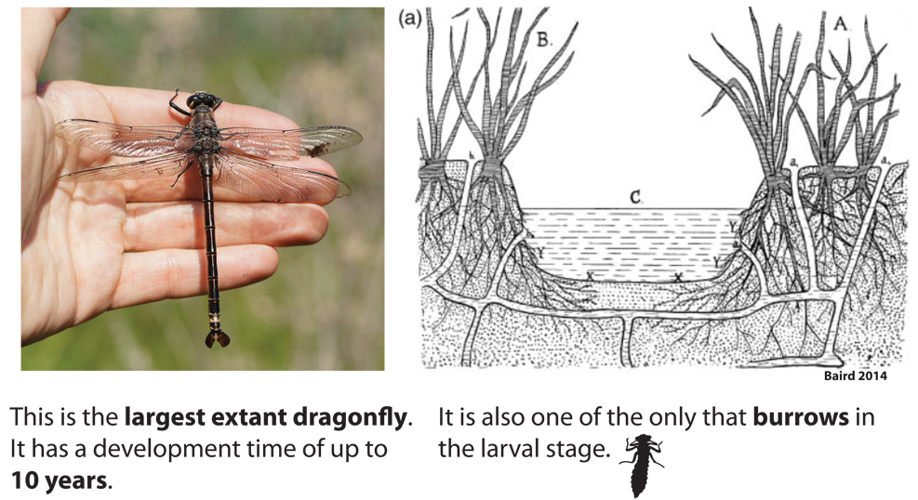

Figure 1.The Largest dragonfly.

The largest extant dragonfly of the genus *Petalura*. Known for having a long larval period of up to 10 years and being one of the few dragonflies that lives in burrows.

Growing larva are subject to predation, parasites, and cannibalism. Larval activity increases mortality from predators (Mcpeek 2004), and time-constrained larvae increase their activity rates (Johansson and Rowe 1999). Larvae are also more active in turbid (cloudy) water than in clear water when fish predators present (van de Meutter *et al.* 2005). Gut parasites and water mites have been shown to reduce mass and adult survival (Braune and Rolff 2001; Tsubaki and Hooper 2004). The longer larvae spends underwater, the higher the probability of infection or predation (Corbet 1999).

The winged adult stage is specialized for dispersal and reproduction. Males can have territorial or opportunistic mating systems (scramble competition). Territories can be important for plant substrates and flowing water, as egg survival usually increases in areas with higher flow rate (Siva-Jothy *et al.* 1995). Sexual selection and visual signaling are important in many dragonflies and damselflies (Tynkkynen *et al.* 2005; Svensson *et al.* 2007; Svensson and Waller 2013). Some species of the genus *Calopteryx* have dark wing pigment, which has been shown to be important for immunity function signaling (Siva-Jothy 2000). In **chapter VII**, I show that dark wing patches are positively related to lifespan and mating success in males.

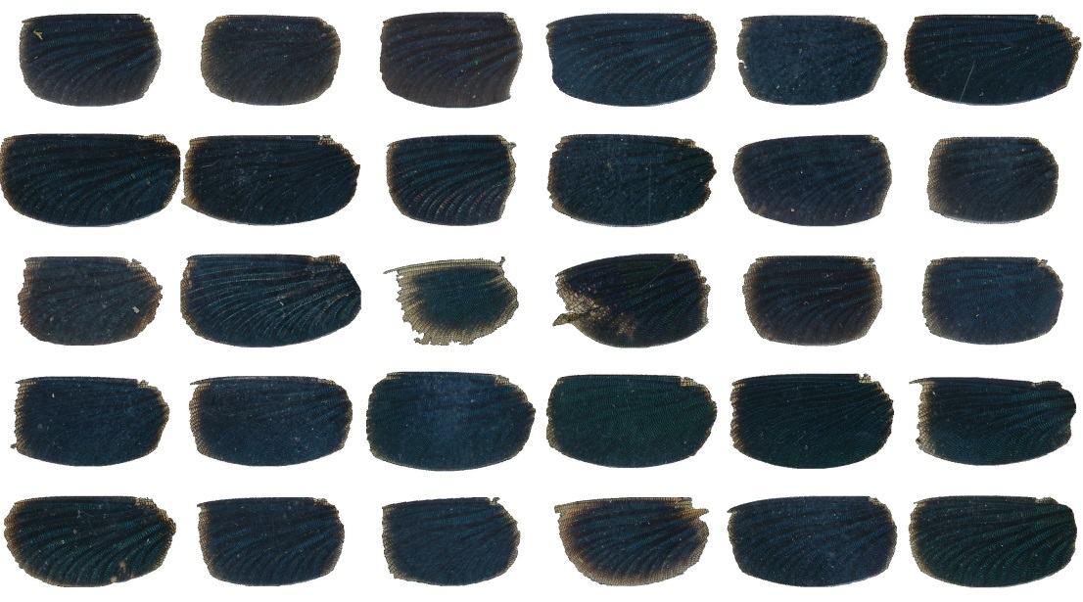

Figure 2. Wing patch variation.

Variation in wing patch darkness in *Calopteryx splendens* males. Wing patches in this species likely signal condition and species identity to females. In **chapter VII**, I show that they are also positively related to heating rate.

Associations between wing pigmentation and male parasite resistance have been interpreted as supporting indicator models, or “good genes” models (Siva-Jothy 2000; Rantala *et al.* 2000). Other sexual selection studies indicate that wing pigmentation is important in male-male interference competition (Grether 1996; Tynkkynen *et al.* 2005), and it has also been demonstrated that pigmentation functions as a species recognition character and in sexual isolation, and shows a signature of latitudinal sorting, with the frequency of pigmented species higher in the temperate zone (Svensson & Waller 2013). In **chapter VII**, I show that males with darker wing patches also have higher heating rates.

### Body size, oxygen, and fossils

In the fossil record, there are odonate (Protodonata) specimens with wing lengths of 350 mm (700 mm wingspans), which are comparable to the size of an adult crow (Harrison *et al.* 2010)(Fig. 3). Higher atmospheric oxygen levels 300 million years ago are thought to be in part responsible for the large body sizes seen in dragonflies and other insects (Harrison *et al.* 2010). This idea is also supported by experimental work on fruit flies (*Drosophila*), which if raised in experimentally increased oxygen for multiple generations, evolve increased mean body size (Klok & Harrison 2009).

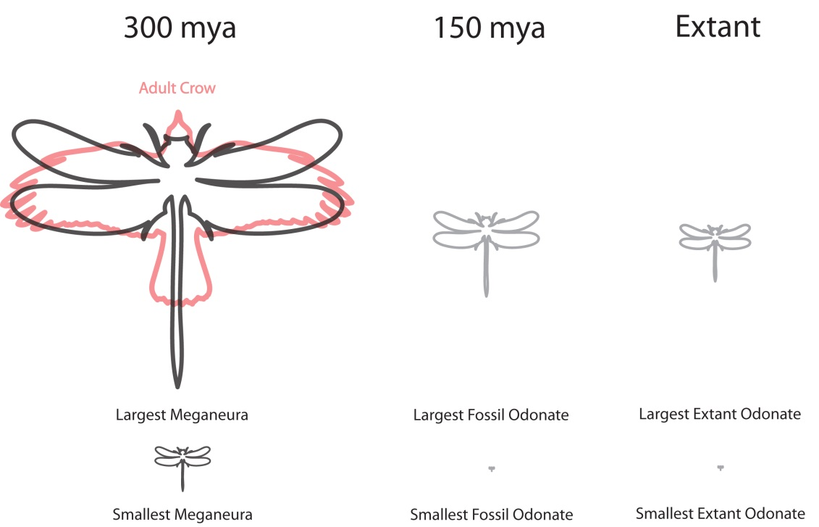

Figure 3. Variation in body size in the fossil record.

Variation in odonate body size found in the fossil record. It is thought that high oxygen content in the atmosphere may have allowed some ancient insects to grow to the size of small birds. However, the relationship between insect body size and oxygen is probably not as simple as once believed.

Figure 4 shows the oxygen percentage in the atmosphere over the last 350 million years (GEOCARBSULF model)(Berner 2009). The peak atmospheric oxygen in this reconstruction corresponds well to the peak seen in giant insects 300 million years ago (Clapham and Karr 2012). A 10% increase in oxygen concentration is thought to be especially important in the energetically intensive process of flight (Harrison *et al.* 2010). Body size also appears to be decoupled from oxygen levels after that initial peak (Clapham and Karr 2012), although other oxygen-record reconstructions might show a different pattern (Harrison *et al.* 2010).

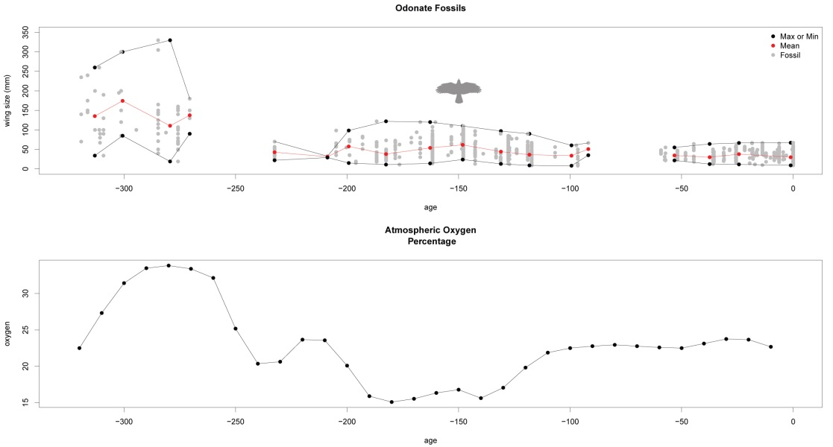

Figure 4. Wing size and oxygen.

The relationship between oxygen and maximum body size in odonates for the past 300 MYA. Oxygen levels predicts maximum body size towards the beginning of the time series (300 MYA), but after the evolution of birds (150 MYA), oxygen level and maximum odonate body size become decoupled.

In the fossil record, small and intermediate lineages have coexisted with the large ones. The response to high oxygen conditions is not uniformly to increase, and some laboratory studies on insects have shown that they actually became smaller in higher oxygen levels (Harrison *et al.* 2010). When oxygen is abundant it may allow insects to overcome some costly physiological constraints, and if growing larger has positive effects on survival, reproduction, or mating success, populations will evolve to become larger. No such evolutionary response would be expected, if there is no fitness benefits to being larger.

Lower atmospheric oxygen is not the only or even the most likely reason why maximum body size in odonates is presently smaller than in the past (Clapham and Karr 2012). Size-dependent predation by flying predators has been suggested as a constraint since 150 MYA (Clapham and Karr 2012), and it has been shown – in an extant population of two Calopterygid species (*Calopteryx splendens* and *C. virgo*) that larger individuals (longer wings) are indeed more likely to be predated by birds (Svensson and Friberg 2007). Odonates may also have occupied niches that are now occupied by vertebrates (Harrison *et al.* 2010). In **chapter V,** I show that bird diversity is negatively related to body size in present-day odonates even after accounting for other environmental variables, such as forest cover, temperature, and precipitation.

### The comparative method

Often there are questions that cannot be answered by experimentation: When did a trait evolve? What is the rate of evolution? Are these two traits convergent? Why does this group have more species than another group? Phylogenetic comparative methods offer ways to address these questions and others (Pagel and Harvey 1988; Pagel 1999; Zsolt 2014).

Generally (although not exclusively), comparative methods use trait data from extant taxa and a phylogenetic tree to perform inferences or detect some pattern (Hansen and Martins 1996). Most comparative methods benefit from having a time-dated phylogenetic tree, which can usually be constructed from aligned genes and fossils after making some assumptions about the rate of mutation. Then typically some hierarchal clustering method is performed to produce a matrix of relatedness (Felsenstein 1984; Saitou and Nei 1987; Yang 1994). This relatedness and the divergence times are then in most cases incorporated into a covariance matrix of multi-variant normal distribution, and some inference is performed (Grafen 1989; Felsenstein 1997; Hansen and Martins 1996).

The inferred covariance matrix need not be perfect (i.e. it does not need to have a topology that exactly reflects evolutionary events) for non-independence to be adequately accounted for. Lacking a phylogeny, a taxonomy-level-based (family, genus, species) covariance matrix will usually suffice (Evans *et al.* 2012; Soul and Friedman 2015), although it is of course better to have a phylogeny that is as “true” as possible, although it should be emphasized that a phylogeny is always a hypothesis of the true underlying evolutionary relationships (Donoghue and Ackerly 1996). Uncertainty about divergence dates and topology can be incorporated if one takes a probabilistic and pragmatic perspective to tree building (Huelsenbeck *et al.* 2001; Pagel *et al.* 2004). While taxonomists strive to construct a fully dichotomous and trees with nodes that have low uncertainty, in some circumstances, a comparative biologist can be more pragmatic about uncertainty, since the exact relationship between taxa is not usually the main objective (Martins and Housworth 2002).

Modern probabilistic approaches to tree building can produce a posterior sample of trees, which can capture the uncertainty present in the topology and divergence dates (Drummond and Rambaut 2007). This sample of trees can then be used in any downstream comparative analysis. This will of course increase the uncertainty of any estimated parameters, but this uncertainty will reflect reality and might be acceptable. This pragmatic strategy allows one to make inferences and test models of evolution without having to wait for the “perfect phylogenetic tree.” It is this type of approach that I have employed in this thesis in **chapter III**.

For continuous characters, a simple model of evolution is a random walk process (Hansen 1997). A random walk can be modeled as draws from a normal distribution at each time step, which are then added (or subtracted) from the previous time step. This process can be run several times, with each path taken representing a lineage drifting randomly though character space (Fig. 5). How quickly a trait evolves will depend on the rate of evolution, which is the variance of the normal distribution described above. The end result should produce a group of extant lineages with an expected phenotypic variance equal to the time multiplied by the rate (Fig. 5).

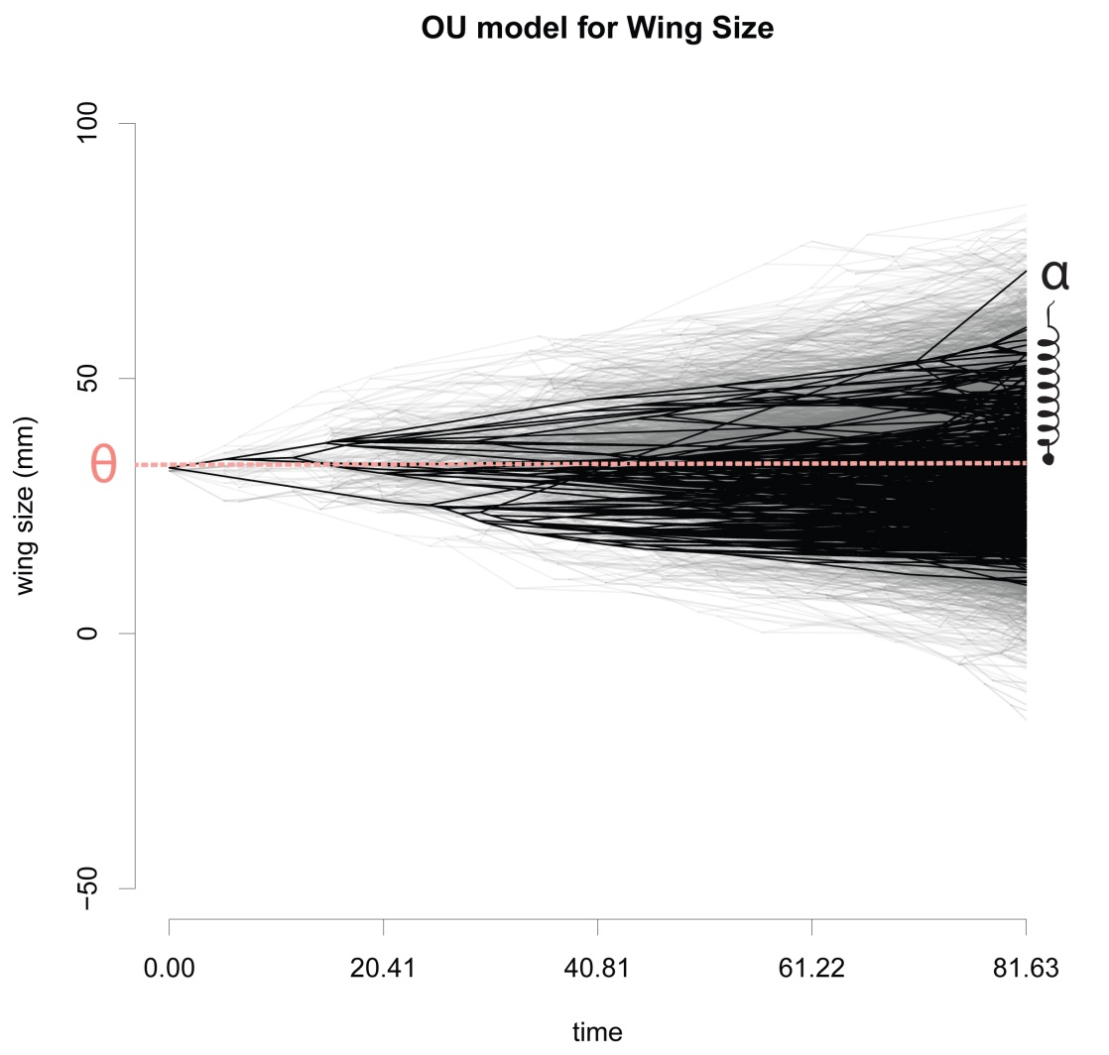

Figure 5. Brownian motion and pullbackforce.

An illustration of a Brownian motion (BM) and an Ornstein-Uhlenbeck (OU) process. BM is shown in light gray while the OU process is in black. The OU process is the same as the BM process except that an OU process includes a constraint terms (α) that acts as a spring pulling extreme values back closer to the lineage mean (θ) wing size.

This Brownian motion model of evolution assumes that there are no constraints on upper or lower bounds of this process. Constraints can however be modelled by adding an extra term to our model, which controls a pullback force as traits drift further away from the mean. This type of model is called Ornstein-Uhlenbeck (OU) model (Hansen 1997; Butler and King 2004).

For odonates, aside from the trivial constraint that body size cannot be negative, several constraints have been proposed on the upper limit of body size. About 300 mya and 150 mya odonates seem to have reached some local maxima in body size, according to the fossil record (Fig. 6). Since that time odonates have become smaller. This has led to the suggestion that birds are constraining maximum body size in this group, since they evolved around 150 mya. Another suggestion is that atmospheric oxygen levels are the limiting force (Harrison *et al.* 2010), since atmospheric oxygen levels were much higher about 300 mya (Fig. 5).

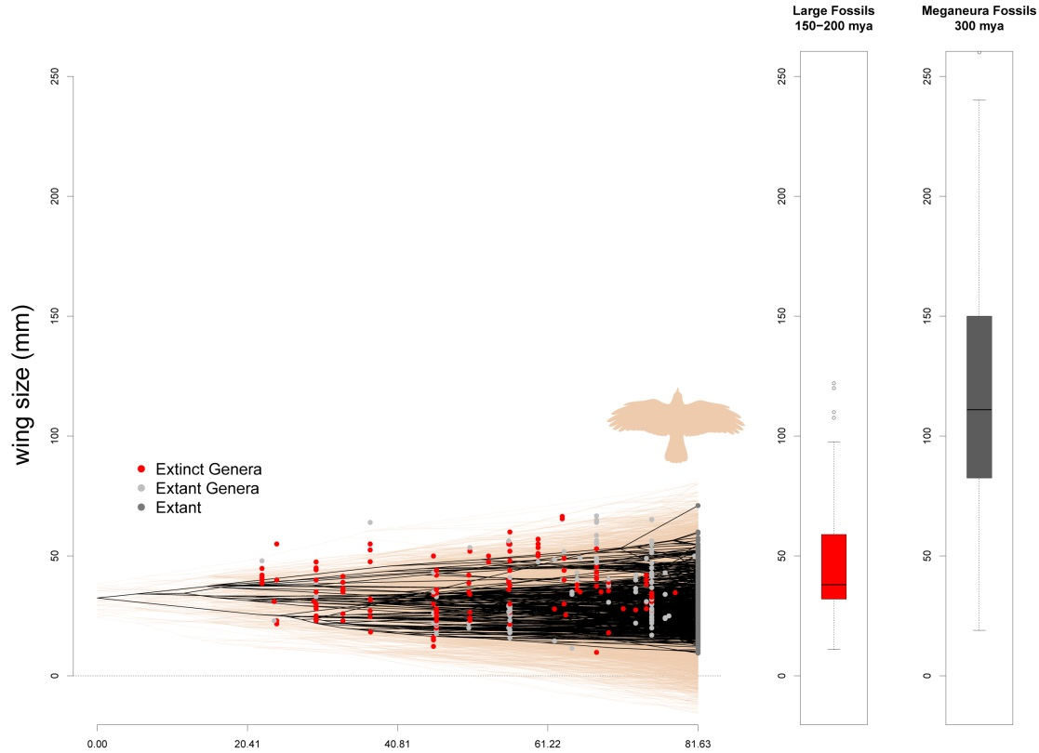

Figure 6. What is constraining body size in odonates?

Comparison of modern-age body sizes with ancient dragonflies and damselflies fossils. Here we see that even if constraints were relaxed (shown in pink) that at the current rate of evolution, dragonflies and damselflies have likely not had enough time to reach the very large sizes seen in the ancient past.

OU models are not able to assign causation to the constraints they measure, but they can tease out the rate of evolution (rate of change in the trait). In Fig. 6, I show that odonates in the modern age (the last 80-65 my since the last major extinction event), likely have not had enough time to reach the sizes observed in the fossil record 300 mya, but they nevertheless and with current selective constraints (caused by oxygen levels, birds, or some other ecological agent), they are likely to remain small until the constraints on their body size are relaxed (Fig. 6).

### Evolution of thermal performance traits

Insects are considered thermal conformers because they allow their body temperature to closely match ambient temperature (Sanborn 2004; Angilletta 2009). In ectotherms, important physiological processes are at the mercy of ambient temperature, and from an enzymatic point of view, being an obligate thermal conformer might not always be optimal (Huey and Berrigan 2001; Blouin-Demers et al. 2005; Martin et al. 2008). Enzymes are less efficient at any non-optimal temperatures, so even though ectotherms will tend to match ambient temperatures without immediate mortality, we might still expect better thermoregulatory ability to be selected for in certain contexts, especially in extreme environments (Huey et al. 2009). While ectotherms have less control over their internal temperature than endotherms by definition, they typically still have the ability to thermoregulate to some degree via behaviour and physiology, and variation in this ability will differ between species and even within individuals in a population (Hoffmann et al. 2011; Somero 2010; Kearney et al. 2009; Buckley et al. 2015). Therefore, the dichotomy of being a thermoregulatory versus a thermal conformer is as false one, and even groups considered to be thermal conformers have fitness incentives to regulate their internal body temperatures to some extent ([Huey and Slatkin 1976](http://rspb.royalsocietypublishing.org/content/276/1664/1939.short#ref-48), Martin et al. 2008).

Climate change will likely increase seasonal variation in temperature in many areas, making the ability to thermoregulate increasingly important for ectotherms ([Deutsch et al. 2008](http://rspb.royalsocietypublishing.org/content/276/1664/1939.short#ref-25)). Many temperate ectotherms appear to have maximum thermal tolerances that are 10–20 °C higher than required to withstand the average summer air temperatures where they live, which might reflect their evolutionary origin in tropical environments (Sanborn 2004; Sunday et al. 2011). There are many behavioral, morphological, and physiological adaptations that might allow ectotherms to survive unfavourable thermal environments (May 1979 ;Heinrich 2013), and the body temperatures of some insects have been recorded more than 35°C above ambient temperature (Sanborn 2004).

A large source of heat in insects is the flight muscles, and insects can increase heat generation through increased muscle activity (May 1979). Basking or changing body orientation to the sun is also a typical method that minimizes the exposed surface area and heat uptake (Porter 1982; Heinrich 2013). Color or melanism might also be a route to increasing the amount of radiation that gets turned into heat energy (True 2003; Trullas 2007; Svensson and Waller 2013). Finally, simply evolving a larger or smaller body size can change the surface-to-volume ratio of an insect, and effectively regulate its body temperature (Kingsolver and Huey 2008).

Thermal plasticity is a measure of an individual’s ability to change its body temperature after a thermal stress (Trotta et al. 2006; Waller et al. 2017). It can be measured by the slope of heating or cooling rate after a thermal stress is applied. This thermal performance measure captures any physiological differences between individuals in terms of their thermal plasticity, but also might capture any behavioral adjustments such as orientation and muscle activity.

The rate of evolution in response to selection on thermal plasticity depends on generation time, the additive genetic variances and covariances underlying phenotypic variation, and the strength of selection on traits that influence performance (Lynch and Walsh 1998), and a large number of studies have demonstrated that there is genetic variation in the slope of thermal reaction norms (Gutteling et al. 2007; Winterhalter and Mousseau 2007). Where environmental temperatures are largely constant, such as in the tropics, it might be expected that genetic variation in thermal traits might be low (Angilletta 2009). In other words, we might expect individuals in populations to be “canalized” by stabilizing into a certain thermal regimes and respond slowly to thermal stresses (Liefting et al. 2009). Conversely, in variable environments one might expect that selection be greater, and individuals might respond quickly to a thermal stress. Unfortunately, very few field studies have looked at selection on thermal traits in natural populations.

In **chapter VII**, I examine selection on thermal sensitivity in two species of damselflies common in southern Sweden, *Calopteryx splendens* (Harris 1780) and *Calopteryx virgo* ([Linnaeus](https://en.wikipedia.org/wiki/Carl_Linnaeus) [1758](https://en.wikipedia.org/wiki/10th_edition_of_Systema_Naturae)). The genus Calopteryx did not evolve in Europe, but has migrated from tropical latitudes (Svensson and Waller 2013), and invaded southern Sweden around 12 000 years ago after the last glacial period (Misof et al. 2000; Clark et al. 2009).

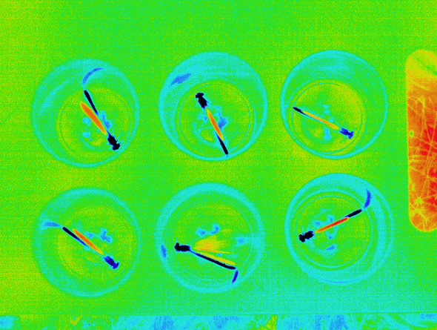

Figure 7. Thermal images.

Thermal images of damselflies taken in the field.

## Materials and Methods

### Measuring selection in natural populations

Simple predictions about expected evolutionary changes in population mean phenotypes can be made using the following equation, as developed from quantitative genetics (Lynch & Walsh 1998)

∆ẑ = Gβ

Where, ∆**ẑ** denotes a vector of changes in phenotypic means of the population, β denotes a directional selection gradient vector, **G** denotes the genetic variance-covariance matrix (Lande 1979). Depending on the structure of the G matrix, and making some assumptions about the multi-variate normality of the measured traits, we can use this information to predict the direction and magnitude of evolutionary change in natural populations (Lande and Arnold 1983).

It is important to emphasize that measuring selection (β) is different from measuring the reaction to selection (∆**ẑ**). If one knows ∆**ẑ** and **G** for a set of phenotypes, it is possible to solve for β, but such information is rarely available in natural populations . Lande and Arnold (1983), pointed out that fitness could be split into different components, such as survival, viability selection (survival to sexual maturity), mating success (the number of mates), or fecundity (the number of eggs). These components of fitness can then be used to quantify selection on the given set of phenotypes. The product of these different components of fitness can be combined to produce selection on total fitness. Such a fitness function could be written as a simple linear model:

w = α + βz + ½γz2

Where w is relative fitness, α is an intercept term, β is a linear selection gradient, z is a standardized trait vector and γ provides information about any curvature in the fitness surface (e. g. disruptive or stabilizing selection). The practical implementation of Lande and Arnold's method involves simply fitting a linear model with standardized response (survival ,mating success, fecundity) and explanatory (trait) variables values with quadratic terms (multiplied by two) (Stinchcombe *et al.* 2008). These straightforward statistical methods have stimulated evolutionary biologists to measure literally thousands selection coefficients using commonly available statistical software (Kingsolver *et al.* 2001).

It is important to remember that genetic covariances (**G**) between traits can change what the response to selection will ultimately be in the next generation. Additionally, un-measured components of total fitness or un-measured traits can change the evolutionary response to selection (Grafen 1989; Hadfield 2008). For example, some individuals might die before a trait is measured or expressed (the so-called “invisible fraction”) (Nakagawa and Freckleton 2008). These types of issues might be especially common in animals with complex lifecycles, such as odonates, where selection in the adult life stage is easier to measure than selection in the aquatic larval stage.

### Field work

Field work in this thesis was all done at the same location and on the same two species (*Calopteryx splendens* and *Calopteryx virgo*)(Fig. 8). For 5 years (2013-2017), field studies were performed in the river system Klingavälsån in the province of Skåne in southern Sweden at Sövdemölla Gård (Lat: 55.601492, Lon: 13.657340). Studies were conducted each summer (June and July). For each year, I collected morphological, life history, and thermal performance data on two damselfly species. My field work typically took place between 10.00 and 15.00 when activity levels were the highest. Damselflies at our field site have very low activity levels when temperature are below 15oC and during rainy and windy days (i.e. no flying or mating behaviour).

Males and females of both study species were captured with handnets and processed in the field. Individual damselflies were measured by placing their wings flat against two layers of transparency paper. A digital scan was then taken with a known scale and the body and wings traits were measured in ImageJ (Schneider et al. 2012; Waller and Svensson 2016; 2017). We measured the following traits: 1) front wing lengths and widths; 2) total body length; 3) abdomen length; 4) thorax length. The mass of each caught individual was taken to the nearest ±0.002 grams. For C. splendens males patch length, width, and darkness were also measured from the scanned images. Patch darkness was taken as the mean intensity of a grayscale image with larger values meaning darker wing patches. Each individual was also marked with a unique 3-digit color code so that their survival could be tracked in the field (Fig. 9).

Throughout the 5 years of study, over 5000 individuals were captured and had their morphology measured. This large amount of data necessitated the implementation of automated procedures to be process this large number of damselflies. I developed a trained machine learning algorithm that was able to recognize the size and position of the wings of the scanned individual damselflies. (Fig. 10)

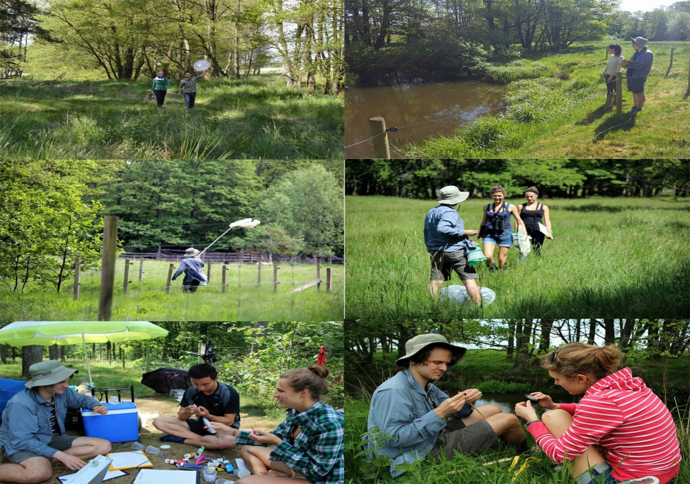

Figure 8. Field Assistants.

Many people helped collecting data from 2013-2017. Some are pictured here.

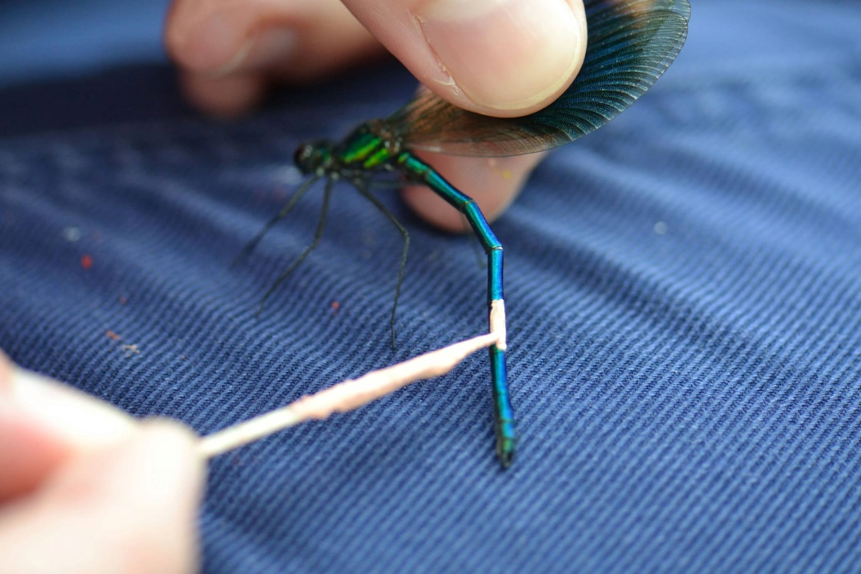

Figure 9. damselfly being painted.

A individual being painted with a color code so that it could be tracked in the field throughout its lifespan.

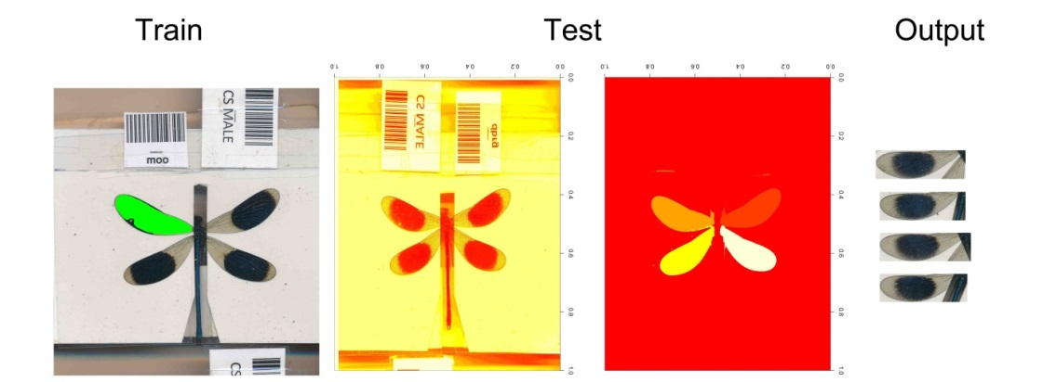

Figure 10. Image processing.

I trained a random forest algorithm to separate background pixels from wing pixels and also to determine the location of the wing (i.e. from, back or right, left). Output wings pictures were later reviewed for accuracy. Wing patches of *C. splendens* males were also able to be measured using a similar procedure.

### Mark-recapture methods

After marking damselflies in the field, I attempted to track how long they were living through repeated attempts to recapture the marked individuals. Not every time I went looking for a marked individual, however, did I find it. This is known as imperfect detection or low recapture probability in the field of mark-recapture methods (Fig. 11). Gimenez et al. (2008) showed, using a field dataset, that even the mode of selection (directional or stabilizing) might be wrongly inferred when variation in recapture probability is ignored.

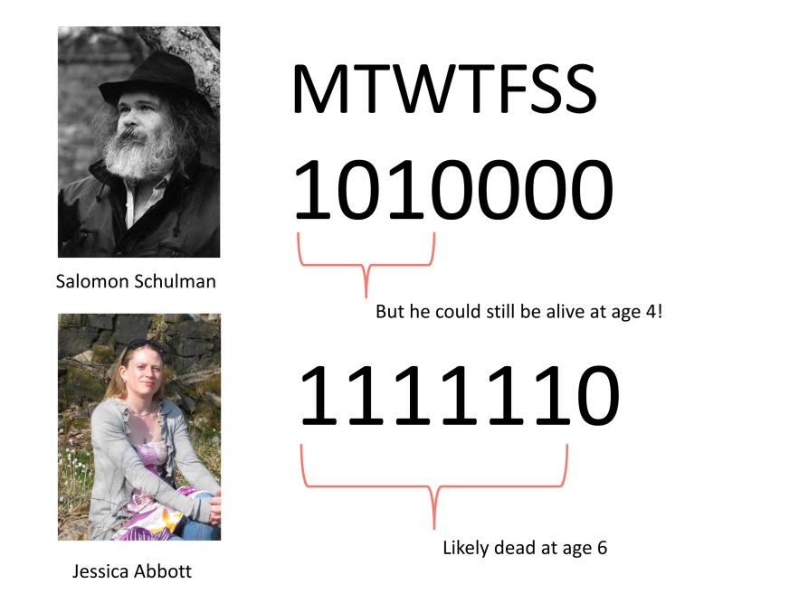

Figure 11. Mark-recapture methods.

Jessica Abbott (co-adviser of the author) and Salomon Schulman (famous doctor in Lund) are two individuals in my life with different resight probabilities (1 = seen, 0 = not seen, on the day of the week). In this scenario, Jessica has a higher likelihood of being dead on Sunday, since she has a higher recapture probability than Salomon who might still be alive on Thursday.

Although imperfect detection has therefore been recognized as a problem, the severity of this problem has never been quantified. In **chapter I**, I use simulations to determine the degree of the problem and develop a new R package to process capture history data.

One statistical solution to imperfect detection is capture-mark-recapture methods (Jolly 1982; Seber 1965; Cormack 1964; Lebreton et al. 1992; Seber & Schwarz 2002). To correct for imperfect detection, mark recapture methods use the extra information within individual capture histories to estimate recapture probability. For example, if an individual is seen on day 1, and then not seen on day 2, but then is seen later on day 3, (a capture history of “101”) a researcher knows that individual was definitely alive on day 2, but was simply not detected

### Building the odonate phenotypic database

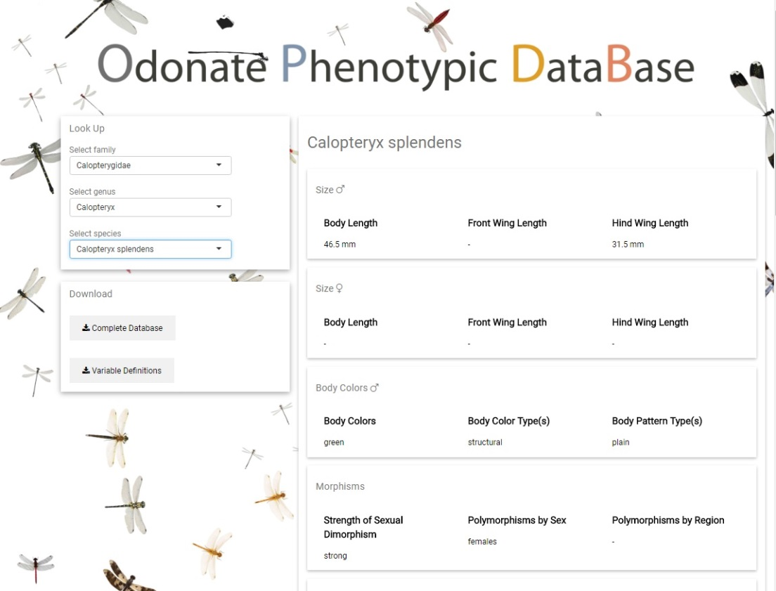

Figure 12. Home page.

Home page of [www.odonatephenotypicdatabase.org](http://www.odonatephenotypicdatabase.org).

The Odonate Phenotypic Database (Fig. 12) is a resource for dragonfly and damselfly phenotypes (Odonates). In **chapter II**, I the discuss construction of the database, which consists of a variety of morphological, behavioral, and bio-geographical information collected from various sources in the literature. The database is not intended for species identification, but for comparative analysis within the group or to be combined with data from other groups. The database is provided along with a large tree (1322 taxa, 21% of known odonates) “The Odonate Super Tree”, which is discussed below.

I discuss how taxon-specific phenotypic databases as becoming an increasing valuable resource in comparative studies. Our database has at least some phenotypic records for 1011 of around 6400 known species. The database is accessible at <http://www.odonatephenotypicdatabase.org/>.

### Odonate super tree

For the comparative analyses done in this thesis (namely in **chapters III and V**, I needed a large phylogenetic tree of dragonflies and damselflies (Fig. 13), which was also time calibrated with fossils (Fig. 14).

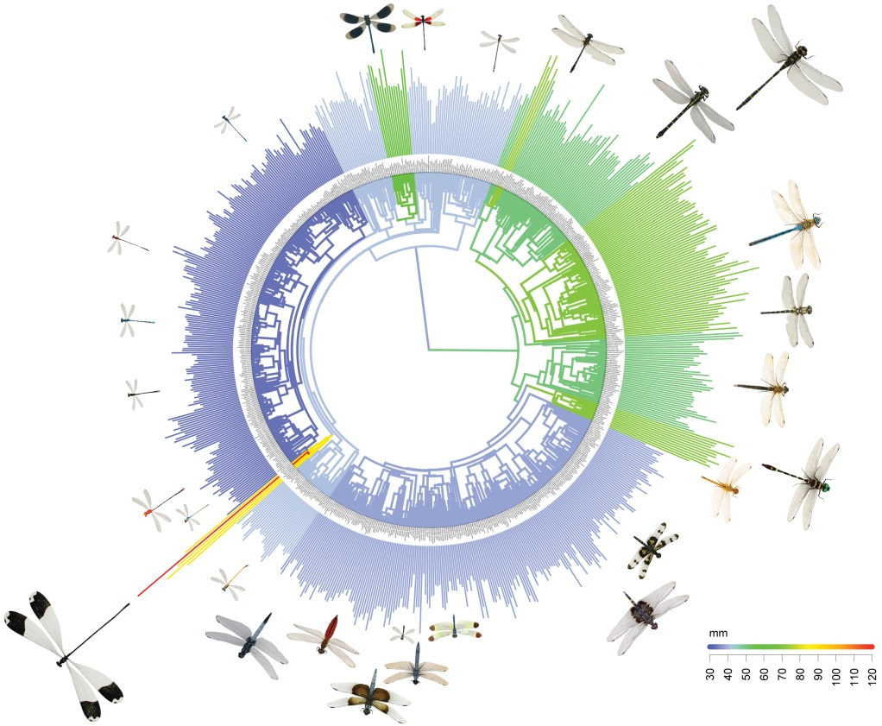

Figure 13. Odonate Super Tree.

The odonate super tree plotted with representative species. The body length of each species is also plotted. See **chapter III**, for more details.

The tree is comprised 1322 taxa, which is around 21% of known odonates (n = 6400). A total of 759 of these taxa were from the suborder Zygoptera (damselflies) and a total of 563) from Anisoptera (dragonflies). All 32 known odonate families are represented in this phylogeny.

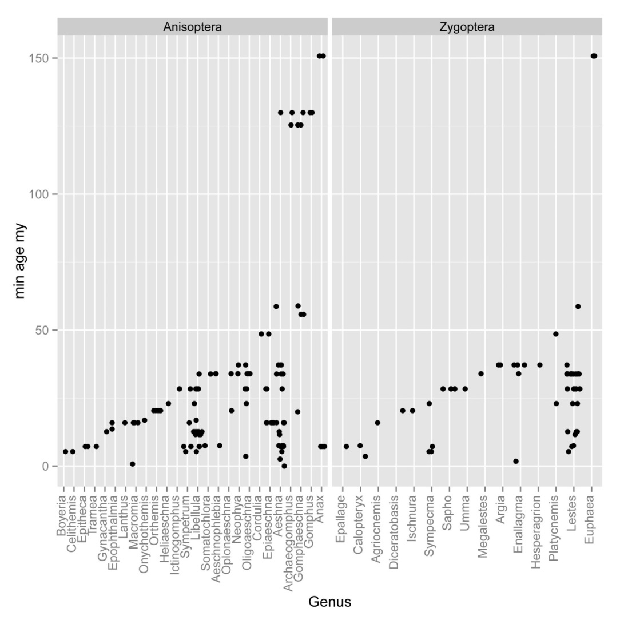

Figure 14. Fossils used for calibration.

Fossils used to time calibrate phylogenetic the odonate super tree.

## Major Results

In **chapter I**, developed new methods in order to obtain selection gradients from mark-recapture models, so that comparable with other selection estimates, while still accounting for variation in recapture probability. Low recapture probability was a problem in my field work, since insects are difficult to track. I find that the main advantage of mark–recapture methods over other methods is the ability to control for hidden trait-dependent recapture probability, as it is often hard to tell a priori if trait dependence is an issue in a particular study. However, when trait-dependent recapture probability is weak, traditional methods and mark–recapture methods perform similarly as long as recapture rates do not become too low, and the main problem of survival selection studies is still low statistical power. I developed the R package **EasyMARK** to facilitate future integration between MR methods and classical selection studies.

In **chapter II**, I discuss how we collected the data we later use in our comparative tests on dragonflies and damselflies. The Odonate Phenotypic Database is an online data resource for dragonfly and damselfly phenotypes (Insecta: Odonata). The database consists of a variety of morphological life-history behavioral traits, and biogeographical information collected from various sources in the literature. I see taxon-specific phenotypic databases becoming an increasing valuable resource in comparative studies. We have collected 34 phenotypic variables, and our database has at least some phenotypic records for 1011 of all 6400 known odonate species. The database is accessible at odonatephenotypicdatabase.org.

In **chapter III**, I integrate field data and phylogenetic comparative analyses to investigate the causes of body size evolution and stasis in dragonflies and damselflies. I address the paradox of if bigger is better, why is there widespread stasis in the fossil record? I find that there is strong evidence for “bigger is better” in the adult stage in dragonflies and damselflies, and I suggest that the lack of Cope’s rule in this group results from conflicting selection between fitness advantages of large adult size and costs of long larval development.

In **chapter IV**, I make a commentary on Uyeda et al. (2011), and the misuse of the visual metaphor of the blunderbuss as a symbol of stasis and punctuated evolution. that was originally put forward in Uyeda et al. (2011) “The million-year wait for macroevolutionary bursts”.

In chapter V, I look into the factors influencing geographic body size patterns in dragonflies and damselflies. I find that the temperature-size rule (“hotter is smaller”), might not explain global geographic size differences between species. In general, I find that temperature may not be the primary force driving latitudinal body size trends in this group, and that ecological factors such as birds and dispersal ability may play a larger role in shaping geographic body size patterns.

In **chapter VI**, I investigate the evolutionary potential of phenotypic plasticity in the thermal performance in fruit flies. I find that genetic variance in thermal performance curves might be low for male mating rate, making it unlikely that sexual selection through male mating success would be efficient in mediating evolutionary rescue through changed plasticity in response to changing temperatures.

Finally in **chapter VII**, I examine the “hotter is better” rule in damselflies. In the study, I find that temperature extremes have a negative effect on survival and mating rate in our two studies species, and that sexual selection on thermal plasticity increases in both high and low temperatures, implying that increased heating rate (“hotter is better”) is only adaptive in non-optimal temperature environments.

## Conclusions

In this thesis I set out to explore the 3 rules of insect evolution proposed by Kingsolver and Huey (2008):

*bigger is better*

*hotter makes you smaller*

*hotter is better*

Do the 3 rules hold up? What are the three rules after this thesis?

*bigger is better, but time in the larval stage is limited.*

*hotter makes you smaller, but so maybe also do birds.*

*hotter is not always better, but thermoregulatory ability is favored in extreme conditions.*

# Acknowledgments

I moved to Lund from the US in August of 2009. At that time I did not really imagine that I would still be living in Sweden almost 10 years, and defending my thesis here. During this time many people have come and gone from Ekologihuset, but the great working atmosphere has stayed the same, and I would like to thank whoever is responsible for that, which is perhaps **Christer Löfstedt**  or many of the seen (**Anne Fogelberg**) and unseen administrators, but probably everyone working here deserves a thank you.

My adviser **Erik Svensson** has been a huge part why my time in Lund has been so great. Truly a great adviser and recommended to anyone seeking a PhD. In Erik’s lab I have gotten to travel to South Africa (2 times) and Argentina, and see more birds than I wanted to see. Throughout this PhD I relied heavily on Erik’s experience, intuition, and surprising insights. My co-adviser **Jessica Abbott** has also be a great inspiration, and I have enjoyed working with her in the classroom, in the lab, and watching her on TV. I would also like to thank my official mentor **Jan-Åke Nilsson** and examiner **Anders Hedenström** who have always been very helpful during many doctoralsamtals.

I would like to thank all of the co-authors on the chapters of my thesis **Anna Kell**, **Mireia Ballestà**, **Aude Giraud**, **Max Tschol**, **Beatriz Willink**, **Jessica Abbot**, and **Erik Svensson**. And I would like to thank other co-authors as well **Anna Runemark**, **Tom Gosden**, and **Anna Norden**.

There were many people that I worked with during the summers of 2010 – 2017. **Sopia Engel** thank you for introducing me to damselflies and field work in Sweden in 2010. I would also like to thank the following people who helped with field work from 2013 to 2017: **Anna Kell**, **Mireia Ballestà, Miguel Gomez, Kaili Boarman**, **Shawn Kutcha**, **Stephany Herman, Kajsa Svensson, Tammy Ho**, **Rasmus Johansson**, **Hanna Bensch**, **Chiara Despasqual**, **Johanna Eklund**, **Emil Fjellstedt**, **Qinyang Li**, **Eric Leach**, **Lisa Winberg**, **Rebecka Thise**,and **Karolina Pehrson**.

And those individuals who helped contribute to the Odonate Phenotypic Database: **Kajsa Svensson**, **Robin Pranter**, **Lisa Winberg**, **Ev Poslin**, **Hanna Bensch**, and **Karolina Pehrson**.

There many current and past members of EXEB, which deserve acknowledgment either for listening to me speak, commenting on a manuscript, or for presenting great papers during lab meetings: **Sophia Engel**, **Machteld Verzijden**, **Maren Wellenreuther**, **Tom Gosden**, **Lesley Lancaster**, **Yuma Takahashi**, **Katrine Lund-Hansen**, **Alex Hegg, Viktor Nilsson**, **Anna Runemark**, **Jessica Abbott**, **Anna Norden**, **Katie Duryea**, **Stephen De Lisle**, **Maarit Mäenpää**, **Hanna Laakkonen**, **Tobias Uller**, **Nathalie Feiner**, **Alfredo Rago**, and **Reinder Radersma**.

I would also like to thank other PhD students who have been good friends and colleagues: **Katrine Lund-Hansen**, **Beatriz Willink**, **Lokeshwaran Manoharan**, **Fredrik Andreasson**, **Tom Evans, Linus Hedh**, **Alex Hegg**, **Marco Klein, Yesbol Manat**, **Cecilia Nilsson**, **Anna Nordén, Gabriel Norevik**, **Pablo Salmon**, **Utku Urhan**, **Kajsa Warfvinge**, **Saeed Alaei**, **Dafne Ram**, **Anna Drews**, **Julian Melgar**, **Kristin Rath**, **Jacob Roved**, **Maja Tarka**, [**Therese Reber**](http://www.lunduniversity.lu.se/lucat/user/0f0ad7ebb71fd4168cfa74015dc71555), **Jonas Håkansson**, **Hanna Sigeman**, **Elin Videvall**, **Lovisa Nilsson**, **Martin Stervander**, **John Kirwan**,and **Shahriar Shakil.**

I would also like to thank members of Evolutionary Ecology, MEMEG, and other groups in the biology department: **Thomas Alerstam**, **Arne Andersson, Anders Brodin**, **Jon Loman**, **Per Lundberg**, **Jörgen Ripa**, **Susanne Åkesson**, **Staffan Bensch**, **Charlie Cornwallis**, **Philip Downing**, **Bengt Hansson**, **Dennis Hasselquist**, **Jane Jönsson**, **Julio Neto**, **Emily O'Connor**, **Suvi Ponnikas**, **Kristaps Sokolovskis**, **Maria Strandh**, and **Håkan Wallander**.

I would also like to thank **Petro Buyak** for painting the cover art.

I would finally like to thank **Liudmyla Lozinska** who has supported me and given great advice during the writing of this thesis.

# References

Angilletta, M. J. (2009). Thermal adaptation: a theoretical and empirical synthesis. Oxford University Press.

Arnold, S. J., Pfrender, M. E., & A. G. Jones. (2001). The adaptive landscape as a conceptual bridge between micro-and macroevolution. *Genetica*. 112: 9-32.

Baird, I. R. (2014). Larval burrow morphology and groundwater dependence in a mire-dwelling dragonfly, Petalura gigantea (Odonata: Petaluridae). *International journal of odonatology*. 17:101-121.

Berner, R. A. (2009). Phanerozoic atmospheric oxygen: New results using the GEOCARBSULF model. *American Journal of Science*. 309:603-606.

Blouin-Demers, G., and P. Nadeau. (2005). The cost–benefit model of thermoregulation does not predict lizard thermoregulatory behavior. *Ecology*. 86:560-566.

Braune, P., and J. Rolff. (2001). Parasitism and survival in a damselfly: does host sex matter?. *Proceedings of the Royal Society of London B: Biological Sciences*. 268:1133-1137.

Buckley, L. B., Ehrenberger, J. C., and M. J. Angilletta. (2015). Thermoregulatory behaviour limits local adaptation of thermal niches and confers sensitivity to climate change. *Functional Ecology*. 29:1038-1047.

Butler, M. A., and A. A. King. (2004). Phylogenetic comparative analysis: a modeling approach for adaptive evolution. *The American Naturalist*. 164:683-695.

Clapham, M. E., and J. A. Karr. (2012). Environmental and biotic controls on the evolutionary history of insect body size. *Proceedings of the National Academy of Sciences*. 109:10927-10930.

Clark, P. U., Dyke, A. S., Shakun, J. D., Carlson, A. E., Clark, J., Wohlfarth, B., Mitrovica, Steven W. Hostetler, and A. M. McCabe. (2009). The last glacial maximum. *Science*. 325:710-714.

Corbet, P. S. (1999). Dragonflies: behaviour and ecology of Odonata. Harley books.

Cormack, R. M. (1964). Estimates of survival from the sighting of marked animals. *Biometrika*. 51:429-438.

Deutsch, C. A., Tewksbury, J. J., Huey, R. B., Sheldon, K. S., Ghalambor, C. K., Haak, D. C., and P. R. Martin. (2008). Impacts of climate warming on terrestrial ectotherms across latitude. *Proceedings of the National Academy of Sciences*. 105:6668-6672.

Donoghue, M. J., and D. D. Ackerly. (1996). Phylogenetic uncertainties and sensitivity analyses in comparative biology. *Philosophical Transactions of the Royal Society of London B: Biological Sciences*. 351:1241-1249.

Drummond, A. J., and A. Rambaut. (2007). BEAST: Bayesian evolutionary analysis by sampling trees. *BMC evolutionary biology*. 7:214.

Evans A. R., Jones D., Boyer A.G., Brown J. H., Costa D. P., Ernest S. M., Fitzgerald E. M., Fortelius M., Gittleman J. L., Hamilton M. J., and L.E. Harding (2012). The maximum rate of mammal evolution. *Proceedings of the National Academy of Sciences*. 109:4187-4190.

Felsenstein, J. (1984). Distance methods for inferring phylogenies: a justification. *Evolution*. 38:16-24.

Felsenstein, J. (1997). An alternating least squares approach to inferring phylogenies from pairwise distances. *Systematic biology*. 46:101-111.

Garamszegi, L. Z. (Ed.). (2014). Modern phylogenetic comparative methods and their application in evolutionary biology: concepts and practice. Springer.

Gimenez O., Viallefont A., Charmantier A., Pradel R., Cam E., Brown C. R., Anderson M.D., Brown M.B., Covas R., and J. M. Gaillard. (2008). The risk of flawed inference in evolutionary studies when detectability is less than one. *The American Naturalist*. 172:441-448.

Grafen, A. (1989). The phylogenetic regression. *Philosophical Transactions of the Royal Society of London. Series B, Biological Sciences*. 326:119-157.

Grether, G. F. (1996). Intrasexual competition alone favors a sexually dimorphic ornament in the rubyspot damselfly *Hetaerina americana*. *Evolution*. 50:1949-1957.

Gutteling, E. W., Riksen, J. A. G., Bakker, J., and J. E. Kammenga. (2007). Mapping phenotypic plasticity and genotype–environment interactions affecting life-history traits in Caenorhabditis elegans. *Heredity*. 98:28-37.

Hansen, T. F. (1997). Stabilizing selection and the comparative analysis of adaptation. *Evolution*. 51:1341-1351.

Hansen, T. F., and E. P. Martins. (1996). Translating between microevolutionary process and macroevolutionary patterns: the correlation structure of interspecific data. *Evolution*. 50:1404-1417.

Harrison, J. F., Kaiser, A., and J. M. VandenBrooks. (2010). Atmospheric oxygen level and the evolution of insect body size. *Proceedings of the Royal Society of London B: Biological Sciences*. 277:1937-1946.

Heinrich, B. (1996). The thermal warriors: strategies of insect survival. *Harvard University Press*.

Hoffmann, A. A., Chown, S. L., and S. Clusella‐Trullas. (2013). Upper thermal limits in terrestrial ectotherms: how constrained are they?. *Functional Ecology*, 27:934-949.

Huelsenbeck, J. P., and F. Ronquist. (2001). MRBAYES: Bayesian inference of phylogenetic trees. *Bioinformatics*. 17:754-755.

Huey, R. B., and D. Berrigan. (2001). Temperature, demography, and ectotherm fitness. *The American Naturalist*. 158:204-210.

Huey, R. B., and M. Slatkin. (1976). Cost and benefits of lizard thermoregulation. *The Quarterly Review of Biology*. 51:363-384.

Huey, R. B., Deutsch, C. A., Tewksbury, J. J., Vitt, L. J., Hertz, P. E., Pérez, H. J. Á., and T. Garland. (2009). Why tropical forest lizards are vulnerable to climate warming. Proceedings of the *Royal Society of London B: Biological Sciences*, 276:1939-1948.

Johansson, F., and L. Rowe. (1999). Life history and behavioral responses to time constraints in a damselfly. *Ecology*. 80:1242-1252.

Jolly, G. M. (1982). Mark-recapture models with parameters constant in time. *Biometrics*. 301-321.

Kearney, M., Shine, R., and W. P. Porter. (2009). The potential for behavioral thermoregulation to buffer cold-blooded animals against climate warming. *Proceedings of the National Academy of Sciences*. 106:3835-3840.

Kingsolver, J. G., and R. B. Huey.(2008). Size, temperature, and fitness: three rules. *Evolutionary Ecology Research*. 10:251-268.

Kingsolver J.G., Hoekstra H. E., Hoekstra J.M., Berrigan D., Vignieri S. N., Hill C. E., Hoang A., Gibert P., P. Beerli. (2001). The strength of phenotypic selection in natural populations. *The American Naturalist*. 157:245-261.

Klok, C. J., Hubb, A. J., and J. F. Harrison. (2009). Single and multigenerational responses of body mass to atmospheric oxygen concentrations in Drosophila melanogaster: evidence for roles of plasticity and evolution. *Journal of evolutionary biology*. 22:2496-2504.

Kuchta, S. R., and E. I. Svensson. (2014). Predator-mediated natural selection on the wings of the damselfly *Calopteryx splendens*: differences in selection among trait types. *The American Naturalist*. 184:91-109.

Lande, R. (1979). Quantitative genetic analysis of multivariate evolution, applied to brain: body size allometry. *Evolution*. 33:402-416.

Lande, R., and S. J. Arnold. (1983). The measurement of selection on correlated characters. *Evolution*. 37:1210-1226.

Lebreton, J. D., Burnham, K. P., Clobert, J., and D. R. Anderson. (1992). Modeling survival and testing biological hypotheses using marked animals: a unified approach with case studies. *Ecological monographs*. 62:67-118.

Liefting, M., Hoffmann, A. A., and J. Ellers. (2009). Plasticity versus environmental canalization: population differences in thermal responses along a latitudinal gradient in *Drosophila serrata*. Evolution. 63:1954-1963.

Lynch, M., and B. Walsh. (1998). Genetics and analysis of quantitative traits (Vol. 1, pp. 535-557). Sunderland, MA: Sinauer.

Martin, T. L., and R. B. Huey. (2008). Why suboptimal is optimal: Jensen’s inequality and ectotherm thermal preferences. *The American Naturalist*.171:102-118.

Martins, E. P., and E. A. Housworth (2002). Phylogeny shape and the phylogenetic comparative method. *Systematic Biology*. 51:873-880.

May, M. L. (1979). Insect thermoregulation. *Annual review of entomology*. 24:313-349.

McPeek, M. A. (2004). The growth/predation risk trade-off: so what is the mechanism?. *The American Naturalist*. 163:88-111.

Misof, B., Anderson, C. L., and H. Hadrys. (2000). A phylogeny of the damselfly genus Calopteryx (Odonata) using mitochondrial 16S rDNA markers. *Molecular Phylogenetics and Evolution*.15:5-14.

Nakagawa, S., and R. P. Freckleton. (2008). Missing inaction: the dangers of ignoring missing data. *Trends in Ecology & Evolution*. 23:592-596.

Pagel, M. (1999). Inferring the historical patterns of biological evolution. *Nature*. 401:877-884.

Pagel, M. D., and P. H. Harvey. (1988). Recent developments in the analysis of comparative data. *The Quarterly Review of Biology*. 63:413-440.

Pagel, M., Meade, A., and D. Barker. (2004). Bayesian estimation of ancestral character states on phylogenies. *Systematic biology*. 53:673-684.

Porter, K. (1982). Basking behaviour in larvae of the butterfly *Euphydryas aurinia*. *Oikos*. 47:308-312.

Rantala, M. J., KoskimÌki, J., Taskinen, J., Tynkkynen, K., and J. Suhonen. (2000). Immunocompetence, developmental stability and wingspot size in the damselfly *Calopteryx splendens*. *Proceedings of the Royal Society of London B: Biological Sciences*. 267:2453-2457.

Saitou, N., and M. Nei. (1987). The neighbor-joining method: a new method for reconstructing phylogenetic trees. *Molecular biology and evolution*. 4:406-425.

Sanborn, A. F. (2004). Thermoregulation and endothermy in the large western cicada *Tibicen cultriformis* (Hemiptera: Cicadidae). *Journal of Thermal Biology*. 29:97-101.

Schneider, C. A., Rasband, W. S., and K. W. Eliceiri. (2012). NIH Image to ImageJ: 25 years of image analysis. *Nature methods*. 9:671-675.

Seber, G. A. F., and E. D. Le Cren. (1967). Estimating population parameters from catches large relative to the population. *The Journal of Animal Ecology*. 44:631-643.

Seber, G. A., and C. J. Schwarz (2002). Capture-recapture: before and after EURING 2000. *Journal of Applied Statistics*. 29:5-18.

Siva–Jothy, M. T. (2000). A mechanistic link between parasite resistance and expression of a sexually selected trait in a damselfly. *Proceedings of the Royal Society of London B: Biological Sciences*. 267:2523-2527.

Siva-Jothy, M. T., Gibbons, D. W., and D. Pain. (1995). Female oviposition-site preference and egg hatching success in the damselfly *Calopteryx splendens* *xanthostoma*. *Behavioral Ecology and Sociobiology*. 37:39-44.

Somero, G. N. (2010). The physiology of climate change: how potentials for acclimatization and genetic adaptation will determine winners and losers. *Journal of Experimental Biology*. 213:912-920.

Soul, L. C., and M. Friedman. (2015). Taxonomy and phylogeny can yield comparable results in comparative paleontological analyses. *Systematic biology*. 64:608-620.

Stinchcombe J. R., Agrawal A. F., Hohenlohe P. A., Arnold S.J., and M.W. Blows.(2008). Estimating nonlinear selection gradients using quadratic regression coefficients: double or nothing?. *Evolution*. 62.9:2435-2440.

Stoks, R., and A. Córdoba-Aguilar. (2012). Evolutionary ecology of Odonata: a complex life cycle perspective. *Annual review of entomology*. 57:249-265.

Sunday, J. M., Bates, A. E., and N. K. Dulvy. (2011). Global analysis of thermal tolerance and latitude in ectotherms. *Proceedings of the Royal Society of London B: Biological Sciences*. 278:1823-1830.

Svensson, E. I., and M. Friberg. (2007). Selective predation on wing morphology in sympatric damselflies. *The American Naturalist*. 170:101-112.

Svensson, E. I., and J. T. Waller. (2013). Ecology and sexual selection: evolution of wing pigmentation in calopterygid damselflies in relation to latitude, sexual dimorphism, and speciation. *The American Naturalist*. 182:174-195.

Trotta, V., Calboli, F. C., Ziosi, M., Guerra, D., Pezzoli, M. C., David, J. R., and S. Cavicchi. (2006). Thermal plasticity in Drosophila melanogaster: a comparison of geographic populations. *BMC evolutionary biology*. 6:67-87.

True, J. R. (2003). Insect melanism: the molecules matter. *Trends in ecology & evolution*. 18:640-647.

Trullas, S. C., van Wyk, J. H., and J. R. Spotila. (2007). Thermal melanism in ectotherms. *Journal of Thermal Biology*. 32:235-245.

Tsubaki, Y., and R. E. Hooper. (2004). Effects of eugregarine parasites on adult longevity in the polymorphic damselfly *Mnais costalis* Selys. *Ecological entomology*. 29:361-366.

Tynkkynen, K., Kotiaho, J. S., Luojumäki, M., and J. Suhonen. (2005). Interspecific aggression causes negative selection on sexual characters. Evolution. 59:1838-1843.

Van de Meutter, F., De Meester, L., and R. Stoks. (2005). Water turbidity affects predator–prey interactions in a fish–damselfly system. *Oecologia*. 144:327-336.

Waller, J. T., Kell, A., Ballesta, M., Giraud, A., Abbott, J., and E. I. Svensson. (2017). Limited genetic variation for male mating success reveals low evolutionary potential for thermal plasticity in *Drosophila melanogaster*. bioRxiv, 166801.

Winterhalter, W. E., and T. A. Mousseau. (2008). The strength of temperature-mediated selection on body size in a wild insect population. *Journal of Orthoptera Research*. 17:347-351.

Yang, Z. (1994). Maximum likelihood phylogenetic estimation from DNA sequences with variable rates over sites: approximate methods. *Journal of Molecular evolution*. 39:306-314.