# The Odonate Phenotypic Database: a new open data resource for comparative studies of an old insect order

### Authors

John Waller1.2, Beatriz Willink1, Maximilian Tschol1, Erik I. Svensson1.2

### Affiliations

1. Lund University, Department of Biology

2. Authors for correspondence: [erik.svensson@biol.lu.se](mailto:erik.svensson@biol.lu.se) and john.waller@biol.lu.se

## Abstract

The Odonate Phenotypic Database is an online data resource for dragonfly and damselfly phenotypes (Insecta: Odonata). The database consists of a variety of morphological life-history behavioral traits, and biogeographical information collected from various sources in the literature. We see taxon-specific phenotypic databases as becoming an increasing valuable resource in comparative studies. Odonata is a relatively small insect order that currently consists of about 6400 species belonging to 32 families. Our database has at least some phenotypic records for 1011 of all 6400 known odonate species. The database is accessible at <http://www.odonatephenotypicdatabase.org/>.

## Background & Summary

The Odonate Phenotypic Database is an online data resource for dragonfly and damselfly phenotypes (Insecta: Odonata). The database consists of a variety of morphological life-history behavioral traits, and bi-ogeographical information collected from various sources in the literature. The database is not intended for species identification, but for comparative analysis within this insect group or to be combined with data from other taxonomic groups. The database is provided along with a large phylogenetic tree (1322 taxa, 21% of known odonates): “The Odonate Super Tree”. This phylogenetic tree was built using DNA-sequences from GenBank in combination with a traditional (morphologically-based) odonate taxonomy (see Waller and Svensson 2017).

Comparative analyses are becoming an increasing common part of evolutionary studies, as researches attempt to bridge the gap between microevolutionary processes and macroevolutionary patterns (Arnold et al. 2001, Estes et al. 2007; Uyeda et al. 2011; Arnold 2014). Almost all comparative analysis rely on high-quality phenotypic data collected from the literature, and often a large amount of time is spent collecting such data. Alternatively, a variable is obtained from live individuals or museum specimens, but an important covariate is often needed from the literature (such as behaviour, habitat, or body size). It seems in the best interest of those working in the field to collect and curate these phenotypic observations, so they can be used in the future and combined with other sources of phenotypic information.

Paradoxically, as a community we have been much more successful at storing and cataloguing genotypes, and DNA-sequences often exist in GenBank for many species, but not even simple phenotypic data (such as body size) exists in an easily accessible form for many organismal groups. This lack of information is likely due to there being no clear structure in which to store phenotypic data. Phenotypic databases, because of the high-dimensional nature of most phenotypes, are also very different from a genetic database such as GenBank. Phenomics, as it has been termed, will always have to prioritize what aspects of the phenotypes to measure (Houle et al. 2010).

From an evolutionary viewpoint, phenotypes are arguably just as important and interesting as genotypes, if not more so (Houle et al. 2010, Kühl et al. 2013, Laughlin and Messier 2015), as selection operates on phenotypes, regardless of their genetic basis (Lande and Arnold 1983). Moreover, the increasingly integrative research practices in evolutionary biology will need not only access to high-quality genomic, molecular and phylogenetic resources, but will also need high-quality phenotypic and biogeographic data, fossil information for time-calibration of phylogenetic trees and other general data provided by biodiversity informatics (Losos et al. 2013). Therefore, the difficulty of the task and the size of the project should not dictate the creation of structures needed to store the data.

One way forward is to create taxon-specific phenotypic databases, as we have done here. Having such databases available that focus on a certain taxonomic group, also allows the recorded phenotypes to be tailored to fit the needs of the specific group and have the advantages that trait definitions are less ambiguous (i.e., there is no need for a wing length variable in a mammal database).

Examples of such open taxon-specific databases with various forms of phenotypic, biogeographic and phylogenetic data include AmphiBIO for amphibian ecological traits (Oliveira et al. 2017), panTHERIA (Jones et al. 2009) and EltonTraits 1.0 (Wilman et al. 2014) for various mammalian traits, TRY for plants (Kattge et al. 2011) and birds (Dyer et al. 2017). However, in the case of animals, they are largely focused on vertebrate groups, while the most speciose animal group – the insects – do not have any such open database available, to our knowledge.

We see taxon-specific phenotypic databases as becoming an increasing valuable resource in comparative studies. Since our research background and expertise is in the order Odonata (dragonflies and damselflies), we have collected 34 phenotypic variables we see as useful to the research community (Table 1). Odonata is a relatively small insect order that currently consists of about 6400 species belonging to 32 families. Odonata are characterized morphologically highly conserved with respect to their overall external morphology (all representatives have six legs and four wings), but they also show considerable diversity in terms of wing and body colouration and shape (Fig. 1). Our database has at least some phenotypic records for 1011 of all 6400 known odonate species. The database is accessible at <http://www.odonatephenotypicdatabase.org/>.

Tabel 1.

Current approximate coverage of variables as of the publication of this document.

|  |  |  |  |
| --- | --- | --- | --- |
| **Table** | **Variables** | **Description** | **Coverage** |
| Taxonomy | GenusSpecies  Genus  Species  Family  SubOrder | Taxonomy of record. Names are taken from the World Odonata List. | 15% |
|  |  |  |  |
| Size | body_lengths  forewing_lengths  hind_wing_lengths | Body size in mm of species record. | 13% |
|  |  |  |  |
| Body Colors | body_colors  body_colortypes  body_patterns |  | 15% |
|  |  |  |  |
| Behaviour | mate_guarding  flight_mode  territoriality | Mating and flight behaviour of species in general. | 15% |
|  |  |  |  |
| Location and Habitat | continents  aquatic_habitats  climates  ecozones  habitat_openness | Location and habitat climates taken from range maps usually. | 15% |
|  |  |  |  |
| Morphisms | sex_polymorphisms  sex_dimorphisms  geo_polymorphisms | Polymorphisms and strength of sexual dimorphism. | 15% |
|  |  |  |  |
| Wing Pigment or Color | has_wing_pigment  wing_pigment_extent_discrete  wing_pigment_extent_continuous  wing_pigment_pattern  wing_pigment_symmetry  wing_pigment_dimorphism  wing_pigment_color  wing_pigment_placement  wing_pigment_color_type | Wing color and pigment variables. | 15% |

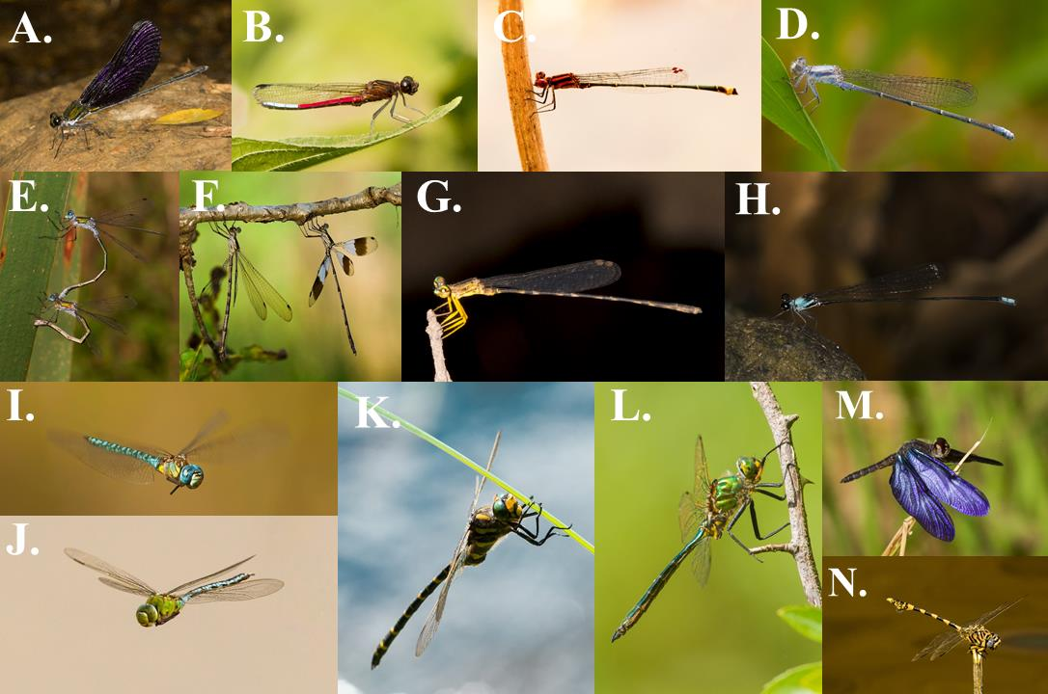

Figure 1 Phenotypic and taxonomic diversity

Phenotypic and taxonomic diversity of 12 representative families of Odonata, an insect order which currently encompasses c. a. 6400 species and a total of 32 families. All 32 odonate families are included in our molecular and time-calibrated phylogeny (Fig. 2; Waller and Svensson 2017). **A.** Family Calopterygidae: *Sapho orichalcea* (Cameroon, Africa, January 2017). **B.** Family Chlorocyphidae: *Chlorocypha curta* (Cameroon, Africa, January 2017). **C-D.** FamilyCoenagrionidae: **C.** *Acanthagrion adustum* (Guyana, South America, January 2015). **D.** *Argia moesta* (Texas, North America, April 2012). **E.** Family Lestidae: *Lestes sponsa* (Sweden, Europe, July 2010). **F.** Family Synlestidae: *Chlorolestes tessellatus* (Eastern Cape, South Africa, Africa, April 2010). **G.** Family Platycnemidae: *Copera congolensis* (Cameroon, Africa, February 2017). **H.** Family Protoneuridae: Elattoneura balli (Cameroon, Africa, January 2017). **I-J.** Family Aeshnidae: **I.** *Aeshna affinis* (Sweden, Europe, August 2010). **J.** *Anax imperator* (Sweden, Europe, August 2015). **K.** Family Cordulegasteridae: *Cordulegaster boltonii* (Sweden, Europe, July 2016). **L.** Family Corduliidae: *Somatochlora flavomaculata* (Sweden, Europe, June 2014). **M.** Family Libellulidae: *Zenithoptera fasciata* (Guyana, South America, January 2015). **N.** Family Gomphidae: *Ictinogomphus ferox* (Namibia, Africa, April 2017). All photographs by Erik Svensson.

## Methods

Phenotypic data has been collected from the scientific literature and field guides. These literature sources are listed in Table 2. Phenotypes were scored by following a specific set of instructions for each variable. The descriptions of each variable can be found Data Records section below. The construction of the Odonate Super Tree has been described elsewhere (see Waller and Svensson 2017).

Table 2.

The primary references used to gather the data. Most of time these are field guides. Below is a list of resources that the database currently is based on.

|  |  |  |
| --- | --- | --- |
| **Authors** | **Title and Publisher** | **Year** |
| Theischinger and Hawking | Complete Field Guide to Dragonflies of Australia; CSIRO Publishing | 2006 |
| Kawashima and Futahashi | Dragonflies of Japan; Bunichi-Sogo Syuppan | 2012 |
| Dijkstra and Lewington | Field Guide to the Dragonflies of Britain and Europe; British Wildlife Publishing | 2006 |
| Paulson | Dragonflies and Damselflies of the West; Princeton University Press | 2009 |
| Samways | Dragonflies and Damselflies of South Africa; Penguin Random House South Africa | 2008 |
| Tarboton and Tarboton | A Fieldguide to the Dragonflies of South Africa; Warwick & Michèle Tarboton | 2002 |
| Heckman | Encyclopedia of South American Aquatic Insects: Odonata-Anisoptera; Springer | 2006 |
| Paulson | Dragonflies and Damselflies of the East; Princeton University Press | 2011 |
| Tang Hung Bun et al | A Photographic Guide to the Dragonflies of Singapore; Raffles Museum of Biodiversity Research | 2010 |
| Subramanian | Dragonflies and Damselflies of Peninsular India: A Field Guide; Indian academy of Sciences | 2005 |
| Hamalainen and Pinratana | Atlas of the Dragonflies of Thailand Distribution Maps by Provinces; Brothers of St. Gabriel in Thailand | 1999 |
| Esquivel | Dragonflies and damselflies of Middle America and the Caribbean; INBio | 2006 |
| Garrison et al | Dragonfly Genera of the New World An Illustrated and Annotated Key to the Anisoptera; John Hopkins University Press | 2010 |
| Nair | Dragonflies and Damselflies of Orissa and Eastern; Orissa Wildlife Organisation | 2011 |
| Tarboton and Tarboton | A Fieldguide to the Dragonflies of South Africa; Tarboton and Tarboton | 2005 |
| Okudaira et al | Dragonflies of the Japanese Archipelago in Color; Hokkaido UP | 2001 |
| Lencioni | Damselflies of Brazil: An illustrated identification guide 2 Coenagrionidae; F.A.A Lencioni | 2006 |
| Suhling and Martens | Dragonflies and Damselflies of Namibia; Gamsberg Macmillan | 2007 |
| Askew | The Dragonflies of Europe; Great Horkesley | 1988 |
| Dunkle | Dragonflies through Binoculars: A Field Guide to Dragonflies of North America (Butterflies Through Binoculars); Oxford University Press | 2000 |
| Manolis | Dragonflies and Damselflies of California; University of California Press | 2003 |
| Abbott | Dragonflies and Damselflies (Odonata) of Texas Volume 5; John C. Abbot | 2011 |
| Dijkstra and Clausnitzer | The Dragonflies and Damselflies of Eastern Africa; RMCA | 2014 |
| Tze-wai et al | The Dragonflies of Hong Kong; Cosmos | 2011 |
| Michalski | The Dragonflies and Damselflies of Trinidad and Tobago; Kanduanum Books | 2015 |
| Kompier | A Guide to the Dragonflies and Damselflies of the Serra dos Orgaos South-eastern Brazil; Regua publications | 2015 |
| Marinov and Waqa-Sakiti | An Illustrated Guide to Dragonflies of Viti Levu Fiji; The University of the South Pacific Institute of Applied Sciences | 2013 |
| Polhemus and Asquith | Hawaiian Damselflies: A Field Identification Guide; Bishop Museum | 1996 |
| Biggs | Common Dragonflies of California; Azalea Creek Publishing | 2000 |

## Code availability

All code used to generate the website and Odonate Super Tree are available in the supplementary material and on github (<https://github.com/jhnwllr/shiny-server/tree/master/odonates>).

## Data Records

The following file have been deposited in Dryad. Additionally, up-to-date data can be explored and downloaded at: <http://www.odonatephenotypicdatabase.org/>.

1. opdb.csv

* A flat data file 39 variables of all of the phenotypic data within the database. See Table 1 and Fig. 2 for a description and coverage of variables.

1. variable definitions.pdf A file that describes each of the variables within the opdb.csv and how they were collected.

## Technical Validation

All of the phenotypic data were collected from published field guides or reliable internet sources. The field guides are listed in Table 2. All of the field guides have been published by respected odonatologists and experts on species identification. Our database is also not static, and additional data will be added as it becomes available. We encourage readers to contribute to this database by contacting the two authors for correspondence. We will accept data both from already published sources (e. g. scientific papers) even if it has already been deposited in other databases such as Dryad, as well as data that is not intended to be published elsewhere, as long as it can tailored to the format of the Odonate Phenotypic Database. Each species has a reference list, which lists the references from which the data was gathered, so it is possible to check each entry against these primary sources.

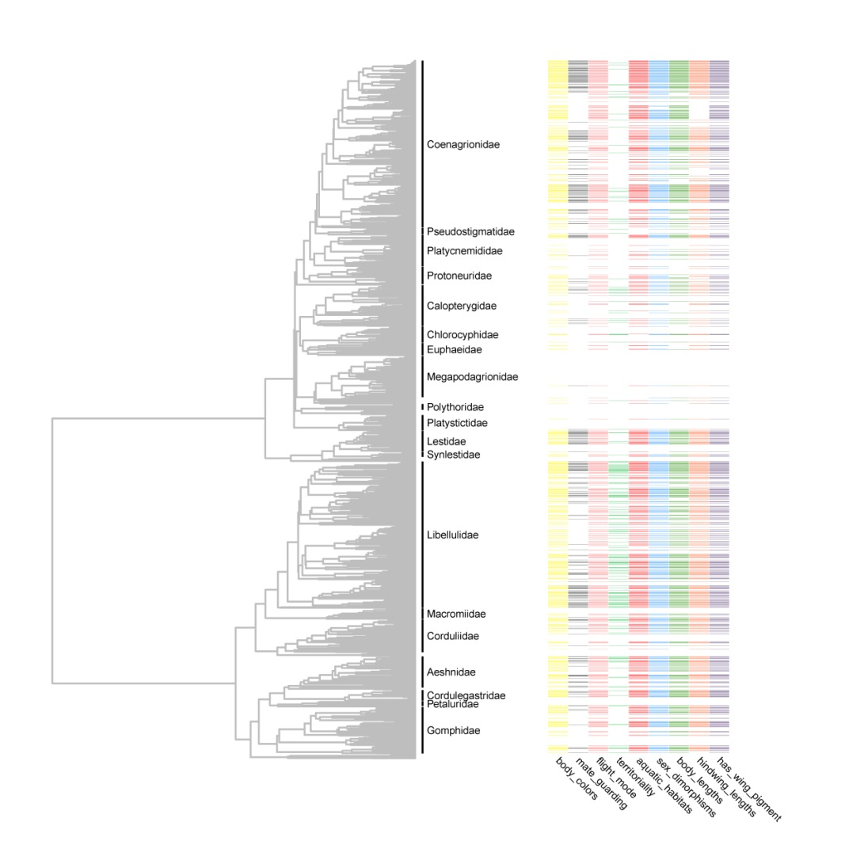

Figure 2

Our molecular time-calibrated phylogenetic tree, encompassing 1322 dragonfly and damselfly species (Waller and Svensson 2017a,b). Some representative data is annotated on the tree showing coverage of some of the variables in the database.

## Usage Notes

The database is intended to be used in comparative analyses of odonate trait evolution. We therefore provide a previously published phylogenetic tree (Waller and Svensson 2017) along with the phenotypic data. Past problems that we have addressed using the phylogenetic comparative methods one these and similar data include the relationship between latitude and wing pigmentation (Svensson and Waller 2013) and macroevolutionary dynamics of body size (Waller and Svensson 2017). We have also investigated diversification dynamics (speciation and extinction rates) in relation to body size and wing pigmentation (Svensson and Waller 2013; Waller and Svensson 2017). Other potentially interesting future questions to pursue, include the evolutionary and ecological consequences of colour polymorphism in females (Svensson et al. 2005; Le Rouzic et al. 2015; Willink and Svensson 2017), biogeographical and ecological influences on various phenotypic traits such as body size and colouration and the role of climatic niche conservatism in the evolution and biogeography of odonates (Wiens et al. 2005; Wellenreuther et al. 2012).

## Acknowledgements

We would like to acknowledge the students and laboratory assistants that helped us to collect the data from the literature, and in particular Anna Kell, Ev Poslin, Hanna Bensch, Robin Pranter, Kajsa Svensson, Lisa Winberg, Karolina Pehrson, Mireia Balesta, Tammy Ho. We would like to also thank the many authors of the field guides from which our database references. Our database is by no means nor intends to be a substitute for these valuable books.

## Author contributions

**John Waller**: constructed the website <http://www.odonatephenotypicdatabase.org/> as part of his PhD-work, collected data, helped create variable definitions, wrote this manuscript.

**Beatriz Willink**: collected data, helped plan and organize data collection.

**Maximilian Tschol**: collected wing pigment data, created variable definitions.

**Erik I. Svensson**: created variable definitions, supervised data collection, came up with the original idea to create the database.

## Competing interests

We declare no competing interests and the data published within this database is done so without bias.

# References

Arnold, S. J. (2014). Phenotypic Evolution: The Ongoing Synthesis. The American Naturalist. 183:729-746.

Arnold, S.J., M. E. Pfrender, and A.G. Jones. (2001). The adaptive landscape as a conceptual bridge between micro-and macroevolution. Genetica 112: 9-32.

Dyer, E. E., Redding, D. W., and T.M. Blackburn. (2017) The global avian invasions atlas, a database of alien bird distributions worldwide. Scientific Data 4, sdata201741.

Estes, S., and S. J. Arnold. (2007). Resolving the paradox of stasis: models with stabilizing selection explain evolutionary divergence on all timescales. The American Naturalist 169.2: 227-244.

Houle, D., Diddahally, R. G., and S. Omholt (2010). Phenomics: the next challenge. Nature Reviews Genetics. 11.12: 855.

Jones K.E., Bielby J., Cardillo M., Fritz S.A., O'Dell J., Orme C.D., Safi K., Sechrest W., Boakes E.H., Carbone C., and C. Connolly. (2009). PanTHERIA: a species‐level database of life history, ecology, and geography of extant and recently extinct mammals. Ecology. 90:2648-2648.

Kattge, J., Diaz, S., Lavorel, S., Prentice, I.C., Leadley, P., Bönisch, G., Garnier, E., Westoby, M., Reich, P.B., Wright, I.J. and J.H.C. Cornelissen. (2011). TRY–a global database of plant traits. Global change biology. 17:2905-2935.

Kühl, H.S. and T. Burghardt. (2013). Animal biometrics: quantifying and detecting phenotypic appearance. Trends in ecology & evolution. 28:432-441.

Lande, R. and S.J., Arnold. (1983). The measurement of selection on correlated characters. Evolution. 37:1210-1226.

Laughlin, D.C. and J. Messier. (2015). Fitness of multidimensional phenotypes in dynamic adaptive landscapes. Trends in Ecology & Evolution. 30:487-496.

Losos, J.B., Arnold, S.J., Bejerano, G., Brodie III, E.D., Hibbett, D., Hoekstra, H.E., Mindell, D.P., Monteiro, A., Moritz, C., Orr, H.A. and D.A. Petrov. (2013). Evolutionary biology for the 21st century. PLoS Biology. 11: p.e1001466.

Oliveira, B.F., São-Pedro, V.A., Santos-Barrera, G., Penone, C., and G.C. Costa. (2017). AmphiBIO, a global database for amphibian ecological traits. Scientific Data. 4: p.sdata2017123.

Svensson, E.I. and J.T. Waller. (2013). Ecology and sexual selection: evolution of wing pigmentation in calopterygid damselflies in relation to latitude, sexual dimorphism, and speciation. *The American Naturalist*. 182:174-195.

Uyeda, J.C., Hansen, T.F., Arnold, S.J. and J. Pienaar. (2011). The million-year wait for macroevolutionary bursts. *Proceedings of the National Academy of Sciences*. 108:15908-15913.

Waller J.T. and E.I. Svensson. (2017a). Data from: Body size evolution in an old insect order: no evidence for Cope’s Rule in spite of fitness benefits of large size. Evolution http://dx.doi.org/10.5061/dryad.755d6.

Waller, J.T. and E.I. Svensson. (2017b). Body size evolution in an old insect order: No evidence for Cope's Rule in spite of fitness benefits of large size. *Evolution*. 71:2178-2231.

Wellenreuther, M., Larson, K.W., and E.I. Svensson. (2012). Climatic niche divergence or conservatism? Environmental niches and range limits in ecologically similar damselflies. *Ecology*. 93:1353-1366.

Wiens, J.J. and C.H. Graham. (2005). Niche conservatism: integrating evolution, ecology, and conservation biology. *Annu. Rev. Ecol. Evol. Syst.* 36:519-539.

Willink, B. and E.I. Svensson. (2017). Intra-and intersexual differences in parasite resistance and female fitness tolerance in a polymorphic insect. *Proc. R. Soc. B* 284:2346-2407.

Wilman, H., Belmaker, J., Simpson, J., de la Rosa, C., Rivadeneira, M. M., and W. Jetz (2014). EltonTraits 1.0: Species‐level foraging attributes of the world's birds and mammals. *Ecology*. *95*:2027-2027.