Title
The Odonate Phenotypic Database

Authors
John Waller¹, Beatriz Willink¹, Maximilian Tschol¹, Erik I. Svensson¹

Affiliations
1. Lund University, Department of Biology
corresponding author(s): John Waller (john.waller@biol.lu.se)

Abstract

Background & Summary
The Odonate Phenotypic Database is a resource for dragonfly and damselfly phenotypes (Odonates). The database consists of a variety of morphological life-history behavioral traits, and bio-geographical information collected from various sources in the literature. The database is not intended for species identification, but for comparative analysis within the group or to be combined with data from other groups. The database is provided along with a large phylogenetic tree (1322 taxa, 21% of known odonates) “The Odonate Super Tree”, which was built from sequences on GenBank (see Waller and Svensson 2017).
Comparative analyses are becoming an increasing common part of evolutionary studies, as researches attempt to bridge the gap between micro- and macro-evolutionary processes (Arnold et al. 2001, Estes et al. 2007; Uyeda et al. 2011; Arnold 2014). Almost always, any comparative analysis relies on phenotypic data collected from the literature, and often a large amount of time is spent collecting it. Alternatively, a variable is obtained from live or museum specimens, but an important covariate is needed from the literature (such as behaviour, habitat, or body size). It seems in the best interest of those working in the field to collect and curate these phenotypic observations, so they can be used in the future and combined with other phenotypic information.
Paradoxically, as a community we have been much more successful at storing and cataloging genotypes, and genetic sequences often exist in GenBank for a certain species, but not even simple phenotypic data (such as body size) exists in an easily accessible form.
This lack of information is likely due to there being no clear structure in which to store phenotypic data. Phenotypic databases, because of the almost infinite nature of phenotypes, are also very different from a genetic database such as GenBank. Phenomics, as it has been termed, will always have to prioritize what aspects of the phenotypes to measure (Houle et al. 2010).
Yet, from an evolutionary viewpoint, phenotypes are arguably just as important and interesting as genotypes, if not more so (Houle et al. 2010, Kühl et al. 2013, Laughlin and Messier 2015), as selection operates on phenotypes, regardless of their genetic basis (Lande and Arnold 1983). Moreover, the increasingly integrative research practices in evolutionary biology will need not only access to high-quality genomic, molecular and phylogenetic resources, but will also need high-quality phenotypic and biogeographic data, fossil information for time-calibration of phylogenetic trees and other general data provided by biodiversity informatics (Losos et al. 2013). Therefore, the difficulty of the task and the size of the project should not dictate the creation of structures needed to store the data.
One way forward, is the creation of taxon-specific phenotypic databases, as we have done here. Having the databases focus on a certain taxonomic group, also allows the recorded phenotypes to be tailored to fit the needs of the specific group and has the advantage that trait definitions are less ambiguous (i.e., there is no need for a wing length variable in a mammal database).
Examples of such open taxon-specific databases with various forms of phenotypic, biogeographic and phylogenetic data include AmphiBIO for amphibian ecological traits (Oliveira et al. 2017), panTHERIA (Jones et al. 2009) and EltonTraits 1.0 (Wilman et al. 2014) for various mammalian traits, TRY for plants (Kattge et al. 2011) and birds (Dyer et al. 2017). However, in the case of animals, they are largely focused on vertebrate groups, while the most speciose animal group – the insects – do not have any such open database available, to our knowledge.
We see taxon-specific phenotypic databases as becoming an increasing valuable resource in comparative studies. Since our research background and expertise is in the order Odonata (“dragonflies and damselflies”) , we have collected 34 phenotypic variables we see as useful to the research community (Table 1). Odonata is a relatively small insect order that currently consists of about 6400 species belonging to 32 families. Odonata are characterized by both morphological conservatism with respect to external morphology (all representatives have six legs and four wings), but also considerable diversity in terms of wing and body colouration and shape (Fig. 1). Our database has at least some phenotypic records for 1011 of around 6400 known species. The database is accessible at http://www.odonatephenotypicdatabase.org/.

Methods
Phenotypic data has been collected from the scientific literature and field guides. These literature sources are listed in Table 2. Phenotypes were scored by following a specific set of instructions for each variable. The descriptions of each variable can be found Data Records section below. The construction of the Odonate Super Tree (http://www.odonatephenotypicdatabase.org/shiny/shinyTree/) has been described elsewhere (see Waller and Svensson 2017).
Code availability
All code used to generate the website and Odonate Super Tree are available in the supplementary material and on github.
https://github.com/jhnwllr/shiny-server/tree/master/odonates

Data Records

The following file have been deposited in Dryad. Additionally, up-to-date data can be explored and downloaded at: http://www.odonatephenotypicdatabase.org/.

- opdb.csv
- A flat data file 39 variables of all of the phenotypic data within the database. See Table 1 for a description and coverage of variables.
- variable definitions.pdf
- A file that describes each of the variables within the opdb.csv and how they were collected.

Technical Validation

All of the phenotypic data were collected from published field guides or reliable internet sources. The field guides are listed in Table 2. All of the field guides have been published by respected odonatologists and experts on species identification. Our database is also not static, and additional data will be added as it becomes available. Each species has a reference list, which lists the references from which the data was gathered, so it is possible to check each entry against these primary sources.

Usage Notes

The database is intended to be used in comparative analyses of odonate trait evolution. We therefore provide a previously published phylogenetic tree (Waller and Svensson 2017) along with the phenotypic data. Past problems that we have addressed using the phylogenetic comparative methods one these and similar data include the relationship between latitude and wing pigmentation (Svensson and Waller 2013) and micro- and macroevolutionary dynamics of body size (Waller and Svensson 2017a). We have also investigated diversification dynamics (speciation and extinction rates) in relation to body size and wing pigmentation (Svensson and Waller 2013; Waller and Svensson 2017a). Other potentially interesting future questions to purse, some of which we are already addressing in our research group, include the evolutionary and ecological consequences of colour polymorphism in females (Svensson et al. 2005; Le Rouzic et al. 2015; Willink and Svensson 2017), biogeographical and ecological influences on various phenotypic traits such as body size and colouration and the role of climatic niche conservatism in the evolution and biogeography of odonates (Wiens et al. 2005; Wellenreuther et al. 2012).

Acknowledgements
We would like to acknowledge the many people that helped collect the data from the literature: Anna Kell, Ev Poslin, Hanna Bensch, Robin Pranter, Kajsa Svensson, Lisa Winberg, Karolina Pehrson, Mireia Balesta, Tammy Ho. We would like to also thank the many authors of the field guides from which our database references. Our database is by no means nor intends to be a substitute for these valuable manuals.

Author contributions
John Waller: constructed the website http://www.odonatephenotypicdatabase.org/ as part of his PhD-work, collected data, helped create variable definitions, wrote this manuscript.
Beatriz Willink: collected data, helped plan and organize data collection.
Maximilian Tschol: collected wing pigment data, created variable definitions.
Erik I. Svensson: created variable definitions, supervised data collection, came up with the original idea to create the database.

Competing interests
We declare no competing interests and the data published within this database is done so without bias.

Figures

Figure Legends

Figure 1. Phenotypic and taxonomic diversity of 12 representative families of Odonata, an insect order which currently encompasses c. a. 6400 species and a total of 32 families. All 32 odonate families are included in our molecular and time-calibrated phylogeny (Fig. 2; Waller and Svensson 2017). A. Family Calopterygidae: Sapho orichalcea (Cameroon, Africa, January 2017). B. Family Chlorocyphidae: Chlorocypha curta (Cameroon, Africa, January 2017). C-D. Family Coenagrionidae: C. Acanthagrion adustum (Guyana, South America, January 2015). D. Argia moesta (Texas, North America, April 2012). E. Family Lestidae: Lestes sponsa (Sweden, Europe, July 2010). F. Family Synlestidae: Chlorolestes tessellatus (Eastern Cape, South Africa, Africa, April 2010). G. Family Platycnemidae: Copera congolensis (Cameroon, Africa, February 2017). H. Family Protoneuridae: Elattoneura balli (Cameroon, Africa, January 2017). I-J. Family Aeshnidae: I. Aeshna affinis (Sweden, Europe, August 2010). J. Anax imperator (Sweden, Europe, August 2015). K. Family Cordulegasteridae: Cordulegaster boltonii (Sweden, Europe, July 2016). L. Family Corduliidae: Somatochlora flavomaculata (Sweden, Europe, June 2014). M. Family Libellulidae: Zenithoptera fasciata (Guyana, South America, January 2015). N. Family Gomphidae: Ictinogomphus ferox (Namibia, Africa, April 2017). All photographs by Erik Svensson.

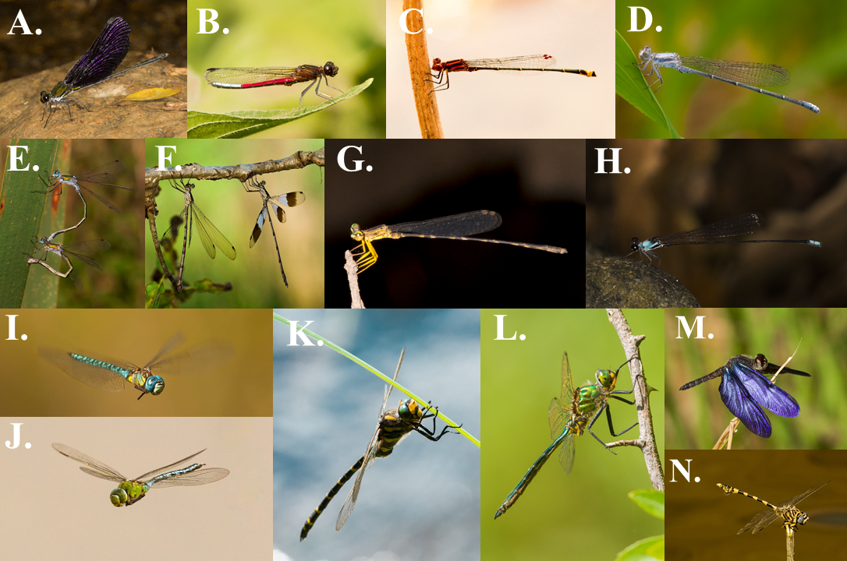

Figure 2. Our molecular time-calibrated phylogenetic tree, encompassing 1322 dragonfly and damselfly species (Waller and Svensson 2017a,b). Some representative data is annotated on the tree showing coverage of some of the variables in the database.

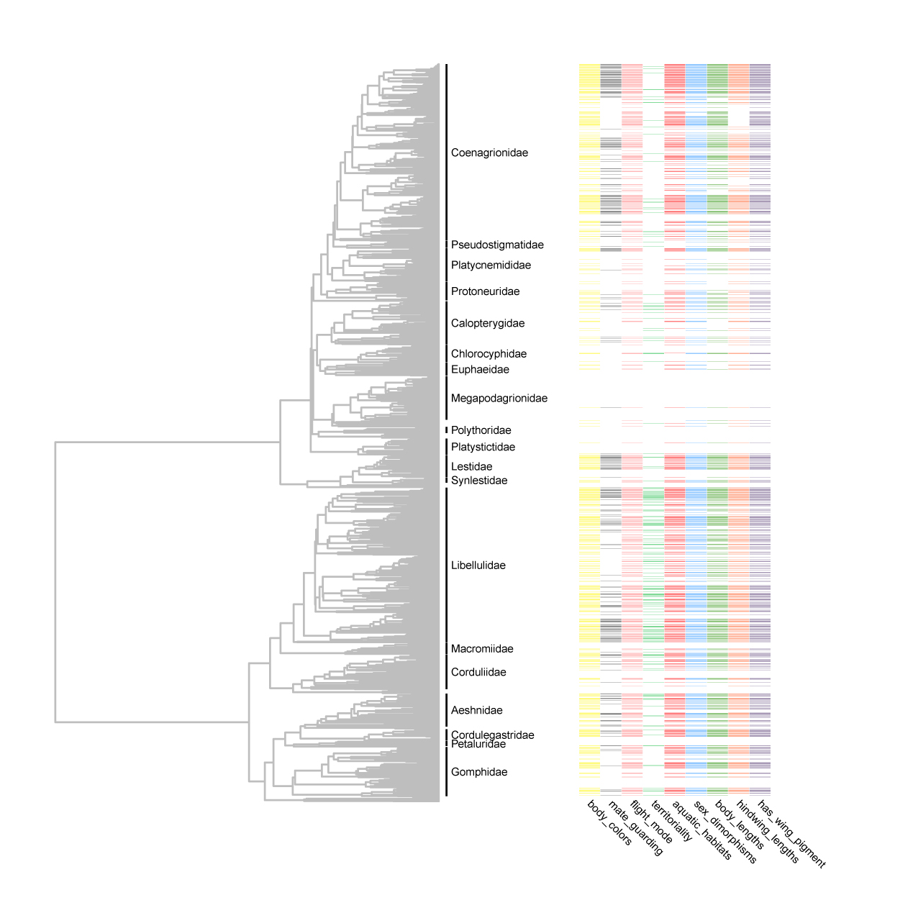

Tables
Table 1. Current approximate coverage of variables as of the publication of this document.

Table | Variables | Description | Coverage  (% of 6500 species)
Taxonomy | GenusSpecies  Genus  Species  Family  SubOrder | Taxonomy of record. Names are taken from the World Odonata List. | 15%
Size | body_lengths  forewing_lengths  hind_wing_lengths | Body size in mm of species record. | 13%
Body Colors | body_colors  body_colortypes  body_patterns | Visually perceived colors, patterns, and color types of species. | 15%
Behaviour | mate_guarding  flight_mode  territoriality | Mating and flight behaviour of species in general. | 15%
Location and Habitat | continents  aquatic_habitats  climates  ecozones  habitat_openness | Location and habitat climates taken from range maps usually. | 15%
Morphisms | sex_polymorphisms  sex_dimorphisms  geo_polymorphisms | Polymorphisms and strength of sexual dimorphsism. | 15%
Wing Pigment or Color | has_wing_pigment  wing_pigment_extent_discrete  wing_pigment_extent_continuous  wing_pigment_pattern  wing_pigment_symmetry  wing_pigment_dimorphism  wing_pigment_color  wing_pigment_placement  wing_pigment_color_type | Wing color and pigment variables. | 15%

Table 2. The primary references used to gather the data. Most of time these are field guides. Below is a list of resources that the database currently is based on.

Authors | Title and Publisher | Year
Theischinger and Hawking | Complete Field Guide to Dragonflies of Australia; CSIRO Publishing | 2006
Kawashima and Futahashi | Dragonflies of Japan; Bunichi-Sogo Syuppan | 2012
Dijkstra and Lewington | Field Guide to the Dragonflies of Britain and Europe; British Wildlife Publishing | 2006
Paulson | Dragonflies and Damselflies of the West; Princeton University Press | 2009
Samways | Dragonflies and Damselflies of South Africa; Penguin Random House South Africa | 2008
Tarboton and Tarboton | A Fieldguide to the Dragonflies of South Africa; Warwick & Michèle Tarboton | 2002
Heckman | Encyclopedia of South American Aquatic Insects: Odonata-Anisoptera; Springer | 2006
Paulson | Dragonflies and Damselflies of the East; Princeton University Press | 2011
Tang Hung Bun et al | A Photographic Guide to the Dragonflies of Singapore; Raffles Museum of Biodiversity Research | 2010
Subramanian | Dragonflies and Damselflies of Peninsular India: A Field Guide; Indian academy of Sciences | 2005
Hamalainen and Pinratana | Atlas of the Dragonflies of Thailand Distribution Maps by Provinces; Brothers of St. Gabriel in Thailand | 1999
Esquivel | Dragonflies and damselflies of Middle America and the Caribbean; INBio | 2006
Garrison et al | Dragonfly Genera of the New World An Illustrated and Annotated Key to the Anisoptera; John Hopkins University Press | 2010
Nair | Dragonflies and Damselflies of Orissa and Eastern; Orissa Wildlife Organisation | 2011
Tarboton and Tarboton | A Fieldguide to the Dragonflies of South Africa; Tarboton and Tarboton | 2005
Okudaira et al | Dragonflies of the Japanese Archipelago in Color; Hokkaido UP | 2001
Lencioni | Damselflies of Brazil: An illustrated identification guide 2 Coenagrionidae; F.A.A Lencioni | 2006
Suhling and Martens | Dragonflies and Damselflies of Namibia; Gamsberg Macmillan | 2007
Askew | The Dragonflies of Europe; Great Horkesley | 1988
Dunkle | Dragonflies through Binoculars: A Field Guide to Dragonflies of North America (Butterflies Through Binoculars); Oxford University Press | 2000
Manolis | Dragonflies and Damselflies of California; University of California Press | 2003
Abbott | Dragonflies and Damselflies (Odonata) of Texas Volume 5; John C. Abbot | 2011
Dijkstra and Clausnitzer | The Dragonflies and Damselflies of Eastern Africa; RMCA | 2014
Tze-wai et al | The Dragonflies of Hong Kong; Cosmos | 2011
Michalski | The Dragonflies and Damselflies of Trinidad and Tobago; Kanduanum Books | 2015
Kompier | A Guide to the Dragonflies and Damselflies of the Serra dos Orgaos South-eastern Brazil; Regua publications | 2015
Marinov and Waqa-Sakiti | An Illustrated Guide to Dragonflies of Viti Levu Fiji; The University of the South Pacific Institute of Applied Sciences | 2013
Polhemus and Asquith | Hawaiian Damselflies: A Field Identification Guide; Bishop Museum | 1996
Biggs | Common Dragonflies of California; Azalea Creek Publishing | 2000

References

Arnold, Stevan J., Michael E. Pfrender, and Adam G. Jones. "The adaptive landscape as a conceptual bridge between micro-and macroevolution." Genetica 112.1 (2001): 9-32.

Arnold, Stevan J. "Phenotypic Evolution: The Ongoing Synthesis: (American Society of Naturalists Address)." (2014): 729-746.

Wellenreuther, Maren, Keith W. Larson, and Erik I. Svensson. "Climatic niche divergence or conservatism? Environmental niches and range limits in ecologically similar damselflies." Ecology 93.6 (2012): 1353-1366.

Svensson, Erik I., and John T. Waller. "Ecology and sexual selection: evolution of wing pigmentation in calopterygid damselflies in relation to latitude, sexual dimorphism, and speciation." The American Naturalist 182.5 (2013): E174-E195.

Wiens, John J., and Catherine H. Graham. "Niche conservatism: integrating evolution, ecology, and conservation biology." Annu. Rev. Ecol. Evol. Syst. 36 (2005): 519-539.

Kattge, J., Diaz, S., Lavorel, S., Prentice, I. C., Leadley, P., Bönisch, G., ... & Cornelissen, J. H. C. (2011). TRY–a global database of plant traits. Global change biology, 17(9), 2905-2935.

Jones, Kate E., et al. "PanTHERIA: a species‐level database of life history, ecology, and geography of extant and recently extinct mammals." Ecology 90.9 (2009): 2648-2648.

Waller JT, Svensson EI (2017b) Data from: Body size evolution in an old insect order: no evidence for Cope’s Rule in spite of fitness benefits of large size. Evolution http://dx.doi.org/10.5061/dryad.755d6

Dyer, Ellie E., David W. Redding, and Tim M. Blackburn. "The global avian invasions atlas, a database of alien bird distributions worldwide." Scientific Data 4 (2017): sdata201741.

Wilman, H., Belmaker, J., Simpson, J., de la Rosa, C., Rivadeneira, M. M., & Jetz, W. (2014). EltonTraits 1.0: Species‐level foraging attributes of the world's birds and mammals. Ecology, 95(7), 2027-2027.

Oliveira, Brunno Freire, et al. "AmphiBIO, a global database for amphibian ecological traits." Scientific Data 4 (2017).

Willink, B., & Svensson, E. I. (2017, January). Intra-and intersexual differences in parasite resistance and female fitness tolerance in a polymorphic insect. In Proc. R. Soc. B (Vol. 284, No. 1847, p. 20162407). The Royal Society.

Losos, Jonathan B., et al. "Evolutionary biology for the 21st century." PLoS Biology 11.1 (2013): e1001466.

Lande, Russell, and Stevan J. Arnold. "The measurement of selection on correlated characters." Evolution 37.6 (1983): 1210-1226.

Uyeda, Josef C., et al. "The million-year wait for macroevolutionary bursts." Proceedings of the National Academy of Sciences 108.38 (2011): 15908-15913.

Estes, Suzanne, and Stevan J. Arnold. "Resolving the paradox of stasis: models with stabilizing selection explain evolutionary divergence on all timescales." The American Naturalist 169.2 (2007): 227-244.

Houle, David, Diddahally R. Govindaraju, and Stig Omholt. "Phenomics: the next challenge." Nature Reviews. Genetics 11.12 (2010): 855.

Kühl, Hjalmar S., and Tilo Burghardt. "Animal biometrics: quantifying and detecting phenotypic appearance." Trends in ecology & evolution 28.7 (2013): 432-441.

Laughlin, Daniel C., and Julie Messier. "Fitness of multidimensional phenotypes in dynamic adaptive landscapes." Trends in Ecology & Evolution30.8 (2015): 487-496

