**Environmental and ecological factors determining geographic body size patterns in odonates.**

**John Waller and Erik Svensson**

**Abstract**

We examine the environmental and ecological factors that influence body size evolution in odonates. We find a complex relationship between body size and latitude in odonates in general and between the major groups (dragonflies and damselflies). Dragonflies (Anisoptera) are larger in temperate regions, while damselflies (Zygoptera) are typically larger in tropical regions. Additionally, using fossils, we show that the relationship between body size and latitude in dragonflies has shifted from a negative relationship to a positive one following the evolution of birds 150 mya. This shift could be due to several ecological factors, bird predation, niche competition, or dispersal ability of larger dragonflies. When looking statistically inferred optima shifts, we find that shifts to larger size are more likely to occur at tropical latitudes, and that these lineages are more to migrate to temperate latitudes. Once these lineages have shifted to temperate habitats, temperature has a very limited direct effect on body size, but rather influences body size via development times. Finally, we show that bird diversity and temperature are both negatively related to body size in odonates, although bird diversity has a surprisingly large effect. In general we find that temperature may not be the primary force driving latitudinal body size trends in this group, and that ecological factors such as birds and dispersal ability may play a larger role in shaping geographic body size patterns.

**Introduction**

While geographic and latitudinal body size patterns of mammals and birds can partly be explained using Bergmann’s rule (Ashton et al. 2000), which predicts an increase in body size towards cold environments, consistent support for such a rule is lacking in insects (Shelomi 2012). Typically no straightforward predictions can be made from first principals about the relationship of body size and latitude in insects, and environmental influences on body size in insects lacks a generally theoretical framework (Shelomi 2012).

In the case of temperature, the body size of ectothermic animals typically increases with decreasing developmental temperatures, a phenomenon known as the temperature-size rule, and may be due to accelerated maturation at higher temperatures, and most ectothermic organisms mature at smaller body sizes when reared in warmer conditions (Atkinson [1996](http://onlinelibrary.wiley.com/doi/10.1111/j.1600-0706.2010.18670.x/full#b12); [Angilletta and Dunham 2003](http://onlinelibrary.wiley.com/doi/10.1111/j.1600-0706.2010.18670.x/full" \l "b5" \o "Link to bibliographic citation); [Kingsolver and Huey 2008](http://onlinelibrary.wiley.com/doi/10.1111/j.1600-0706.2010.18670.x/full#b38)). However, warm temperatures could also lead to the opposite effect, as metabolic rate and season length increase with temperature, allowing larger growth under warm climates. Additionally, differences in moisture and precipitation may increase or decrease desiccation resistance, since larger individuals may be more resistant than smaller to desiccation (Marron et al. [2003](http://onlinelibrary.wiley.com/doi/10.1002/ece3.2355/full#ece32355-bib-0013); Harrison et al. [2013](http://onlinelibrary.wiley.com/doi/10.1002/ece3.2355/full#ece32355-bib-0019); Bujan et al 2016). Starvation resistance may also increase with increasing size, and may correlate with latitude in some insects (McCue 2010). Since insects are ectotherms, the balance between heat gain and heat loss is also important, and may lead to variables patterns with latitude ([Olalla-Tárraga et al. 2006](http://onlinelibrary.wiley.com/doi/10.1111/j.1600-0706.2010.18670.x/full#b46)). Finally, past events (such as glacial periods) (Bhagwat 2008) may lead to different size assemblages at different latitudes, as dispersal, extinction, and speciation may all correlate with body size (Clauset and Erwin 2008; Rainford et al. 2016; Waller and Svensson 2017). Many abiotic and biotic variables are correlated with latitude and could be responsible for producing latitudinal differences in body size in certain insect groups even if clear predictions are not always possible for insects in general ([Blackburn et al. 1999](http://onlinelibrary.wiley.com/doi/10.1111/j.1600-0706.2010.18670.x/full#b15), [Ashton et al. 2000](http://onlinelibrary.wiley.com/doi/10.1111/j.1600-0706.2010.18670.x/full#b10), [Stillwell 2010; Stillwell et al.](http://onlinelibrary.wiley.com/doi/10.1111/j.1600-0706.2010.18670.x/full#b56) [2008](http://onlinelibrary.wiley.com/doi/10.1111/j.1600-0706.2010.18670.x/full#b57)).

Body size evolution in odonates has a dramatic history (Waller and Svensson 2017; Fig. 1). Over the last 350 mya, maximum odonate wing length has varied by more than 60 mm (Waller and Svensson 2017), from crow-sized to less than about a human hand (Baird 2014). Oxygen has been put forward as a major source of body size variation through time in this lineage, and larger extant odonates will adjust their flight behaviour in experimentally reduced oxygen (Henry and Harrison 2014). Additionally odonates, unlike other insects, lack the ability to ventilate via abdominal pumping, but must rely on actual wing beats in order to ventilate their bodies (Henry and Harrison 2014), so they might be even more dependent on atmospheric oxygen levels.

Over the last 65 mya, however, atmospheric oxygen levels have remained constant, and oxygen levels are uniform in the atmosphere (Glasspool and Scott 2010), (although lower oxygen levels are observed in colder water (Verberk and Atkinson 2013)). This decoupling of body size from oxygen has led some authors to argue that the evolution of flying competitors, starting around 150 mya, is the primary force keeping odonates and other flying insects small (Damuth 1981; Blackburn and Gaston 1994; Clapham and Karr 2012). No study however has looked whether competition from birds is predictive of geographic body size patterns in extant odonates.

Here we examine the environmental and ecological factors involved in the geographic patterning of body size in Odonates. Waller and Svensson (2017) found evidence that multi-shifts have occurred within the Odonate lineage, and these shifts could be associated with movement into new environments or differences in predation pressure. Sokolovska et al. (2000) and Waller and Svensson (2017) found that selection on adult body size is largely positive, but this positive selection has not lead to a directional trend in the fossil record. Additionally, Waller and Svensson (2017) argued that development time might be the main force counter- acting positive selection in the adult stage, leading to net stabilizing or conflicting selection in most lineages. In other words, despite there being widespread stabilizing, major bursts of body size evolution have likely occurred within the odonate lineage. This simple model of multiple burst of phenotypic evolution between long periods of stabilizing selection fits with empirical data from other groups (Uyeda et al. 2011).

Therefore, present-day variation in body size in odonates could be due to multi-causes, including differences in development times, temperatures, habitat choice, or predation. In this study, we find that temperature might only have an indirect effect on body size, with dispersal ability, predation, and niche filling by birds perhaps playing a larger role in determining the geographic distribution of body size within dragonflies and damselflies.

**Methods**

*Phylogenetic tree*

The phylogenetic tree that we use in this study was constructed from odonate DNA sequences downloaded GenBank. This phylogenetic tree has been used in a previous study on odonate body size (Waller and Svensson 2017). The phylogeny comprised 1322 taxa, about 21% of all known extant odonate species (about 6400 in total) (Schorr and Paulson 2015). See our Supplementary Material for a detailed description of the construction of the phylogenetic trees used in this study, and how we accounted for phylogenetic uncertainty.

*Continuous patterns of body size with latitude*

We examined the continuous relationship between latitude and body size (wing length) in both fossils and extant taxa (Fig. 2). We divided the fossils into periods between extinction events and major events: 1) Around 210 mya marks the beginning of the dragonfly radiation after the Triassic–Jurassic extinction event 2)150 mya marks the beginning of the radiation of birds 3) 80 mya approximately after the Cretaceous–Tertiary (K–T) extinction event**.** For the fossils,paleolatitude was extracted from the Paleobiology Database (Alroy et al. 2012). Mean latitude from gbif occurrence records was used for the extant taxa. Absolute latitude (the distance in degrees from 0o) was used in all analyses.

*Odonate body size data*

Odonate body size data were taken from the Odonate Phenotypic Database (opdb) ([www.odonatephenotypicdatabase.org](http://www.odonatephenotypicdatabase.org)). This database is a general resource for comparative studies using odonates. This body size data has also been used in a previous publication, and a description of how it was collected can be found there (Waller and Svensson 2017). Fossil body size data was taken from Clapham and Karr (2012).

*Occurrences tropical and temperate classification*

We considered 23oN and 23oS to be the boundaries for temperate latitudes, so any species with a mean distribution of occurrence records above or below these boundaries was considered temperate. Conversely, species with a mean distribution between these two points was considered tropical. Occurrence records were downloaded from the global biodiversity information facility (gbif). All occurrences for each odonate species under 500 records were downloaded using the R-package rgbif (Chamberlain 2017). When a species had more than 500 occurrence records, a randomly chosen sample of 5000 records was chosen. This procedure was done to avoid downloading species with prohibitively large occurrence histories, but still be able to accurately capture their geographic distribution.

*Spatial data*

Spatial data was used in to determine mean values for each of our odonates species in terms of temperature, tree cover, precipitation, and bird diversity. All spatial data was processed in the R packages raster (Hijmans et al. 2016) and sp (Bivand et al. 2013). Temperature and precipitation data was downloaded from the worldclim datasets(Fick and Hijmans 2017). WorldClim is a set of global climate layers (gridded climate data) with a spatial resolution of about 1 km2. These data can be used for mapping and spatial modeling. These WorldClim datasets were downloaded using the R-package raster at 5m accuracy. Mean values for temperature (BIO1 = Annual Mean Temperature) and precipitation (BIO12 = Annual Precipitation) were computed for each species in our occurrences dataset.

Tree cover data was downloaded from the global land cover facility (glcf)(http://glcf.umd.edu/data/landsatTreecover/) (Sexton et al. 2013). Tree cover is the proportional, vertically area of vegetation (including leaves, stems, and branches) of woody plants above a given height. The continuous classification scheme of glcf product enables a better depiction of land cover gradients than traditional discrete classification schemes (Sexton et al. 2013). Bird diversity spatial data was downloaded from biodiversitymapping.org (http://biodiversitymapping.org/wordpress/index.php/birds/) (Jenkins et al. 2013). These maps were generated based on the Bird Species Distribution Maps of the World (BirdLife International 2011). We used total bird diversity in our analyses. Additionally, to control for a possible effect of a “biodiversity hotspot,” we also used mammal data from the same source (Jenkins et al. 2013).

*Phylogenetic path analysis*

To test whether temperature had a direct effect on our body size in European odonates, we performed a phylogenetic path analysis using the R-package phylopath. We also collected data on larval development from the literature (Sandhall 1987). This is the same larval development time data that has been used in a previous study (Waller and Svensson 2017). We compared 5 nested models of the relationships between larval development time, temperature (annual mean temperature).

*Correlated evolution between optima shifts and temperate latitudes*

We tested the relationship between positive shifts in body size optima with temperate latitudes, using the corDISC function in the R-package corHMM (Beaulieu et al. 2017). Optima shifts were taken from the multi-optimum OU-model inferred in Waller and Svensson (2017), using the l1ou R-package (Khabbazian et al. 2016). A positive shift in optimum was defined as an increase from the background inferred process. A negative optimum shift was classified the same as neutral background optima. It is important to realize that a positive shift in optima does not necessarily imply that species within the positively shifted group will be largest odonates species, but they will be larger than closely related species not within the optimum. These shifts in optima can also roughly be interpreted as past selective events for larger or smaller size (Khabbazian et al. 2016).

*Linear modeling of hind wing length and spatial variables*

To quantify the relationships between body size and environmental variables, we conducted a phylogenetic generalized least square (PGLS) regression using the corBrownian function in ape (Paradis et al. 2004). A model comparison procedure was conducted based on AIC (Table 1). The best performing models coefficients were then interpreted, using standardized coefficients. Five spatial variables were considered: 1) Temperature (Annual Mean Temperature), 2) Precipitation (Annual Precipitation), 3) Tree Cover, 4) Bird Diversity, and 5) Mammal Diversity (to control for a possible “diversity hostspot” effect).

Results

**Latitude**

After controlling for variation due to phylogenetic relatedness, we found that dragonfly body size in temperate regions was on average larger than tropical regions. (Anisoptera; tbl, trop: 42.3 mm, temp: 51.4 mm P = 0.025; hwl, trop: 31.4 mm, temp: 34.5 mm, P = 0.093). The opposite pattern was found for damselflies, with larger body size being more common in tropical regions. (Zygoptera; tbl, trop: 41.9 mm, temp: 35.8 mm, P = 0.843; hwl, trop: 24.3 mm, temp: 20.8 mm, P = < 0.001). These patterns were the same whether looking at total body length or hind wing length (Fig. 1).

**Fossil patterns of body size with latitude**

In the fossil record, damselflies showed a consistent pattern of negative body size with increasing latitude (Fig. 2). Dragonflies show a more varied pattern with decreasing body size with increasing latitude prior to 80 mya and then increasing size with latitude after the last major extinction event (80 mya) (Fig. 2).

**Path analysis**

A phylogenetic path analysis revealed that temperature has only an indirect effect on body size in European Odonates (Fig 3). The best model (model 1) was one in which development time has a direct effect on body size (tbl), and temperature has a direct effect on development time. Model averaged coefficient estimates (over the 5 models tested), showed that temperature only had a weak and non-significant negative effect on total body length when compared to development time (Fig. 3).

**Correlated evolution of temperate species with positive shifts in body size**

A binary test of correlated evolution confirmed that evolutionary shifts to larger body size were associated with range shifts to temperate latitudes, but that these optima shifts to larger size do not occur at temperate latitudes (Fig. 4). Then we tested a series of nested models in order to identify the best fitting model using the corDISC function in the R-package corHMM (Fig. 4). We tested 3 models: the “all rates different” (ARD), “equal rates”(ER), and “symmetric rates” (SYM) models in corHMM. We found that the ARD had the lowest AIC score, implying that transition rates were not equal (AIC: ARD = 662.62, SYM = 699.39, ER = 804.09).

**Linear modeling of hind wing length with spatial variables**

Various spatial variables (Fig. 5) were compared against hind wing length (hwl) in a series of nested phylogenetic generalized least squares (pgls) models (Table 1). In Model 1, we modelled the effect of temperature on wing length. Model 1, indicated that when considered alone, temperature has a negative effect on wing length (Table 1). However, after accounting for the confounding variables of tree cover, precipitation, and bird diversity, temperature had a reduced effect on body size and bird diversity had a large negative effect (Table 1). Bird diversity had a surprisingly large negative effect on hind wing length (hwl) in odonates. To test whether bird diversity was simply measuring a general “diversity hotspot” effect, mammal diversity was included as a covariate (since mammals are unlikely predate on dragonflies or fill habitat niches occupied by odonates). After accounting for Mammal diversity, bird diversity still had a strong and significant negative effect on body size (hwl).

**Discussion**

We find significant latitudinal variation in body size in dragonflies and damselflies, with dragonflies being larger in temperate regions and damselflies being larger at tropical latitudes (Fig. 1). This difference between dragonflies and damselflies implies that temperature does not have a direct effect on the evolution of larger body size, but rather perhaps plays a secondary role (Fig 2). It might also imply that generally larger bodied dragonflies are more sensitive to the temperature-size rule than damselflies (Forster et al. 2012). However, the fact that dragonflies have changed the sign of their latitudinal relationship over geological time indicates that the temperature size rule might not be sufficient to explain the latitude patterns observed (Fig. 2). It is also uncertain that the temperature-size rule would be strong enough to structure interspecific geographic size assemblages between species (Kingsolver and Heuy 2008).

A phylogenetic path analysis revealed that, at least at temperate latitudes in Europe, temperature does not have a direct effect on body size, but rather only significantly affects body size via development time. A direct effect of temperature on body size, would imply that temperature is the primary variable determining the geographic patterns of adult body size in Europe (Fig. 3). The negative effect of temperature on development time gives support for the temperature-size, but the lack of a direct effect of temperature on adult size can be interpreted as their being no preference for larger-sized odonates to live cooler habitats. Looking at evolutionary shifts to larger body size optima compared with the evolution of temperate or tropical range, we found that positively-shifted temperate lineages have not evolved in-situ in temperate regions (Fig. 4). Again, this result does not support the idea that cold temperature selects for larger body size in dragonflies or odonates in general. Instead lineages that have shifted to larger size are more likely to shift to temperate latitudes, perhaps because of better dispersive ability or some other factor.

In our linear model of spatial variables, temperature had a negative effect on body size in both dragonflies and damselflies (after controlling for phylogenetic non-independence). However, after accounting for other confounding variables, such as tree cover, precipitation, and diversity, this effect of temperature was reduced (Table 1), although still negative and significant. Surprisingly, bird diversity (the average number of bird species in an area) had the strongest effect on body size (hind wing length) in our model. This negative effect of bird diversity remained even after accounting for other confounding variables, such as temperature, tree cover, and precipitation.

It is of course unknown whether bird diversity is measuring some effect of birds or some unmeasured third variable, but it does seem reasonable that birds might have a negative impact on body size in odonates and insects in general. Birds have been proposed as a major constraint on body size in insects (Clapham and Karr 2012). Bird predators have also shown been to select against larger size within extant damselfly populations (Kuchta and Svensson 2014). The relationship of latitude and body size in the fossil record showed interesting patterns in both dragonflies and damselflies. Largely prior to the evolution of birds (210-80mya) (Padian and Chiappe 1998), dragonflies showed a pattern of decreasing body size with increasing paleo-latitude. Then, after the last major extinction event (80 mya), dragonflies begin to show the reverse pattern of increasing body size with latitude (Fig. 2). This reversal might reflect that prior to the evolution of birds, dragonflies were able to fill niches in lower latitudes that are now occupied by birds or perhaps that predation is higher at lower latitudes. This pattern might also reflect that larger dragonflies have been more successful in colonizing temperate latitudes after glacial maximums.

To test whether bird diversity was simply measuring some un-measured biodiversity effect, we used mammal diversity as a control. It is unlikely that mammals would fill the same niches as odonates and are not known to be significant predators of odonates, but it is likely that they would roughly follow the same increasing diversity in the tropics and occupy the same “diversity hotspots” as birds (Fig S1). After including mammal diversity in a model with precipitation, tree cover, temperature, and bird diversity (Table 1; model 5), bird diversity still had a large and negative effect on body size in odonates. So it seems unlikely that our bird diversity effect is merely due to some very general biodiversity effect. However, even given this control, there might still be some third variable that is correlated with bird diversity that is causing the observed pattern. Whether birds diversity is measuring niche competition, predation, or both is not possible to test with the current datasets. These results do, however, fit with a growing consensus that biotic factors might be more important in explaining insect size than environmental ones (Clapham and Karr 2012).

**Conclusion**

We conclude from various phylogenetic comparative tests, that environmental factors (temperature, precipitation, and forest density) may play a secondary role when compared to ecological factors (dispersal, predation, or niche filling) in the geographic patterning of body size in odonates, and perhaps particularly so in dragonflies. We have argued that the relationship between latitude and odonate body size is not straightforward, and neither the temperature-size rule nor a type of Bergman’s rule for insect is sufficient to explain the observed body size patterns. Surprisingly, bird diversity had the largest standardized effect (even after controlling for a possible diversity hotspot effect), on body size when looking at global spatial data and body size. By what mechanism bird diversity acts on odonate body size, is not yet known. Potential likely explanations are niche filling and predation. With more studies on predation and selection in the tropics, it might be possible in the future to see why bird diversity predicts geographic body size patterns in dragonflies and damselflies.

Table 1. PGLS models of spatial data and hind wing length. Five models of the relationship between hind wing length and spatial data were tested. All models corrected for phylogenetic non-independence using the corBrownian function in ape (Paradis et al. 2004), using the same tree (N = 674) and species for structuring the covariance matrix. The best performing model (Model 4) is bolded. The intercept term is not presented for simplicity. All spatial variables were scaled to have mean 0 and variance of 1, so as to be comparable between one another.

|  |  |  |  |  |  |  |  |
| --- | --- | --- | --- | --- | --- | --- | --- |
| **Model** | **Var.** | **Est.** | **SE** | **P value** | **N** | **AIC** | **Rank** |
| 1 | Temp. | -0.964 | 0.159 | < 0.001 | 674 | 4157.17 | 3 |
|  |  |  |  |  |  |  |  |
| 2 | Temp. | -0.814 | 0.179 | < 0.001 | 674 | 4157.21 | 4 |
| 2 | Prec. | -0.366 | 0.200 | 0.0677 |  |  |  |
|  |  |  |  |  |  |  |  |
| 3 | Temp. | -0.789 | 0.181 | < 0.001 | 674 | 4159.82 | 5 |
| 3 | Prec. | -0.394 | 0.203 | 0.0525 |  |  |  |
| 3 | Tree Cover | -0.174 | 0.204 | 0.3933 |  |  |  |
|  |  |  |  |  |  |  |  |
| **4** | **Temp.** | **-0.437** | **0.191** | **0.0223** | **674** | **4136.57** | **1** |
| **4** | **Prec.** | **-0.253** | **0.201** | **0.2083** |  |  |  |
| **4** | **Tree Cover** | **0.187** | **0.212** | **0.3776** |  |  |  |
| **4** | **Bird Div.** | **-1.421** | **0.276** | **< 0.001** |  |  |  |
|  |  |  |  |  |  |  |  |
| 5 | Temp. | -0.451 | 0.192 | 0.0192 | 674 | 4138.09 | 2 |
| 5 | Prec. | -0.237 | 0.203 | 0.2433 |  |  |  |
| 5 | Tree Cover | 0.166 | 0.215 | 0.4403 |  |  |  |
| 5 | Bird Div. | -1.597 | 0.411 | < 0.001 |  |  |  |
| 5 | Mammal Div. | 0.248 | 0.428 | 0.5625 |  |  |  |
|  |  |  |  |  |  |  |  |

Table 2. Models of continuous body size (hind wing length) evolution fit using the fitContinuous function in the R package geiger (Harmon et al. 2008). Three nested models were fit 1) Ornstein–Uhlenbeck (OU), 2) Brownian motion (BM), 3) Early Burst (EB).

|  |  |  |  |  |  |
| --- | --- | --- | --- | --- | --- |
| **Model** | **LnLik** | **Param.** | **Est.** | **AIC** | **Rank** |
| **OU** | -2371.0 | Alpha | 0.0089 | 4748.007 | 1 |
|  |  | sigma sq. | 1.364 |  |  |
|  |  |  |  |  |  |
| **BM** | -2389.306 | sigma sq. | 1.085 | 4782.612 | 2 |
|  |  |  |  |  |  |
| **EB** | -2389.308 | A | -1.00e-06 | 4784.616 | 3 |
|  |  | sigma sq. | 1.085 |  |  |

**Figure Legends**

Figure 1. Here we show the body size (hind wing length and total body length) means of dragonflies and damselflies in relation to temperate and tropical latitudes. We considered tropical latitudes to occur between 23oN and 23.0oS, and areas north and south of these regions were considered temperate. We see that while in general odonates are larger in temperate regions (after controlling for phylogenetic non-independence). However, when looking at dragonflies and damselflies separately, we see that only dragonflies are actually larger in temperate regions, and damselflies are in fact larger in tropical regions.

Figure 2. Plots of the continuous relationship between latitude (absolute) and hind wing length for fossils and extant dragonflies. Here we show that the relationship between latitude and body size has been mostly negative for the major part of the radiation of Odonata for both dragonflies and damselflies. However, after the last extinction (80 mya) event we see that dragonflies have shifted to a positive relationship with latitude. Plot have been divided according to major geological events, namely major extinction events and the beginning of the radiation of birds (150 mya). For all plots we used absolute latitude, which is the distance in decimal degrees from the equator. Latitude for the fossils is paleo-latitude, which takes into account continental drift.

Figure 3. The evolution of temperate range plotted against the evolution of positive shifts in body size. The matrix diagram in the upper right, plots the transition matrix from our corDISC all rates different correlated evolution model (Beaulieu et al. 2017). In this matrix we see that the largest transition rate is from lineages with tropical ranges and positively-shifted body size optima to temperate ranges and positively-shifted optima. This indicates that larger body size optima are not evolving at temperate latitudes, but are instead evolving in the tropics and then dispersing to temperate latitudes. This implies that temperature is not the primary factor driving geographic patterns in body size, and perhaps dispersal ability after glacial events has been more important in establishing a body size latitude gradient in odonates, since the last major extinction event 80 mya.

Figure 4. Diagrams of five nested phylogenetic path models illustrating the cause-effect relationships between larval development time, temperature (annual mean temperature), and body size (total body length). Models are plotted in order of their AIC score (lowest first). The best model (model 1) was one in which development time has a direct effect on body size (tbl), and temperature has a direct effect development time but not on body size. Model averaged coefficient estimates (over the 5 models tested), showed that temperature had only a weak and non-significant negative effect on total body length when compared to development time (right panel). This implies that temperature might not directly influence the geographic distribution of body size in Europe. All models were fit using the R-package phylopath.

Figure 5. Spatial hexagon plots of the 5 main spatial datasets used in our PGLS modelling of body size. Each hexagon represents the mean value of the variable over which the hexagon cover, but not over the entire space but only from points drawn from the odonate occurrence dataset. In this way the value of the hexagon represents only the values of that spatial variable that are relevant to odonates. Hexagons are spaced by around 5o between each hexagon. Plots are shown just to illustrate the global distribution of the data. Mean values for each species were used in all analyses, which limits the effect of spurious spatial auto-correlation. See methods for a description of the spatial variables used.

**Fig. 1**

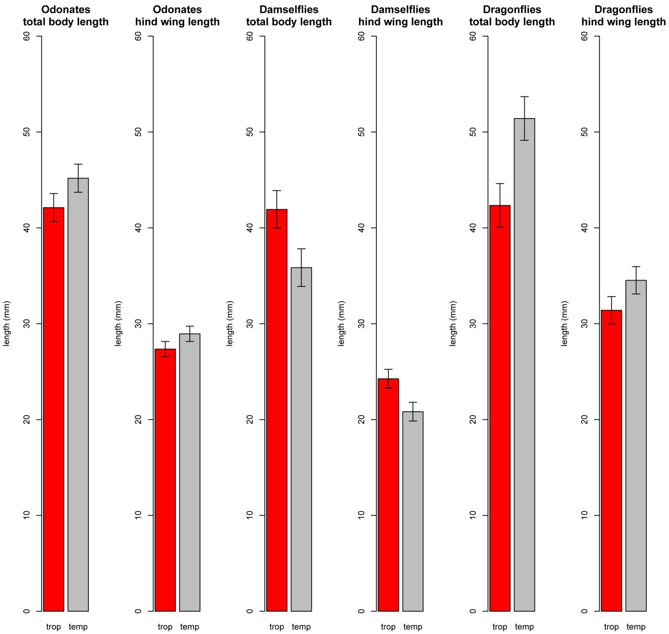

**Fig. 2**

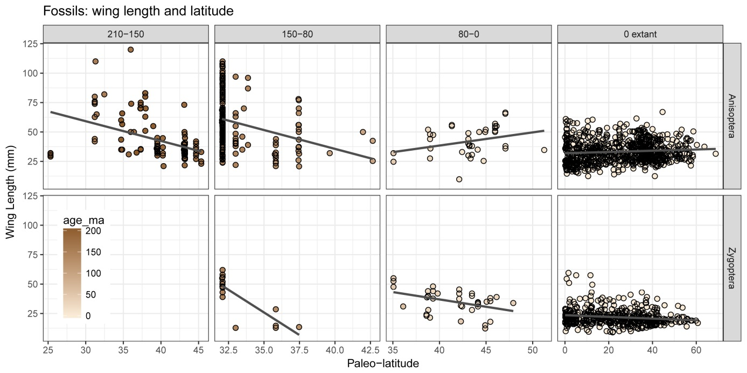

**Fig. 3**

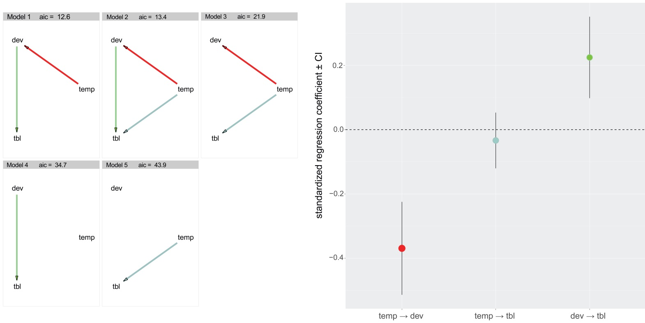

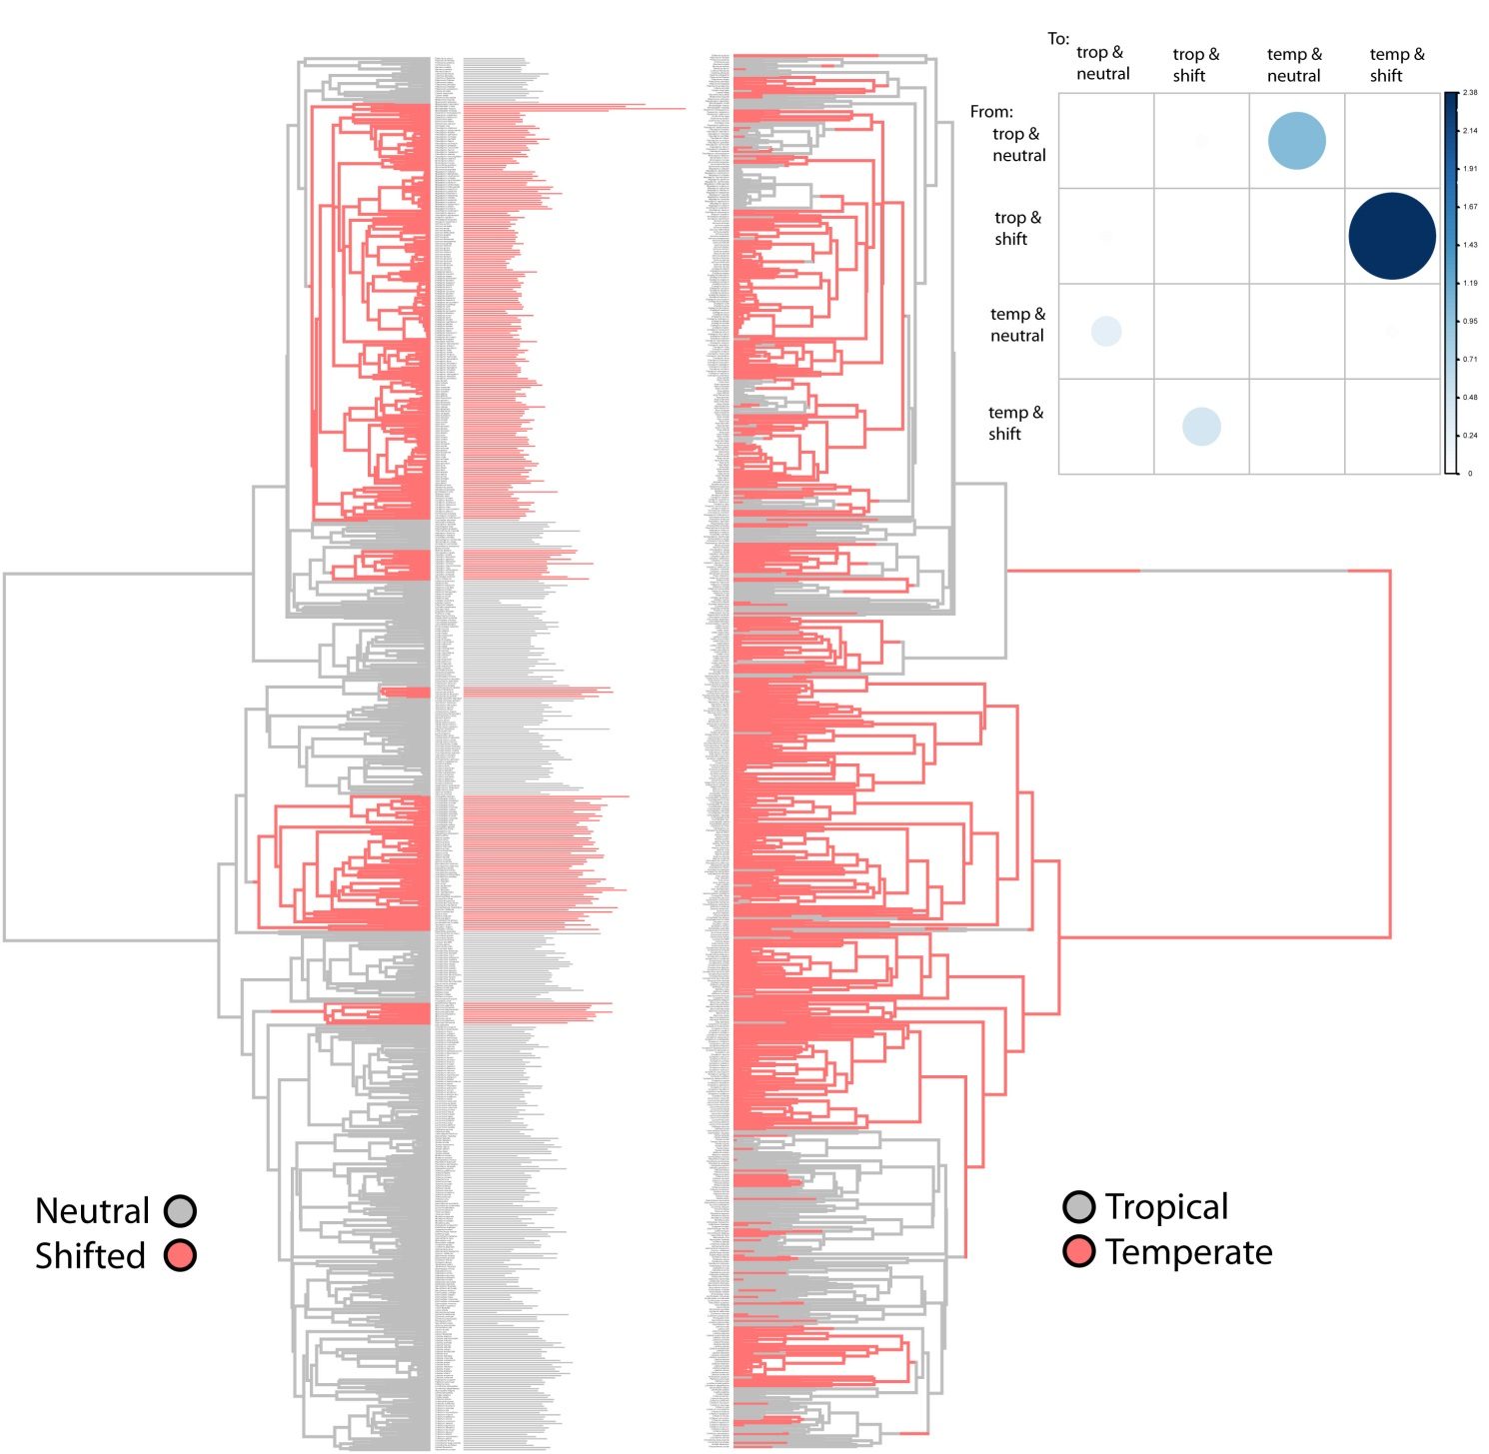

**Fig. 5**

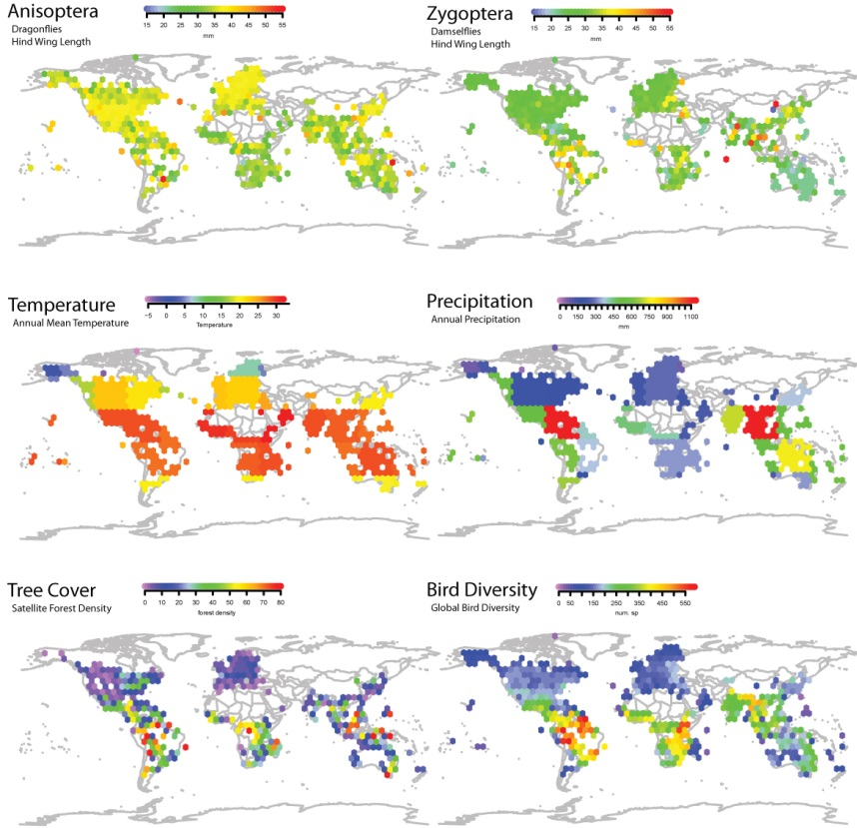

**References**

Alroy, J., Marshall, C., & Miller, A. (2012). The paleobiology database. See <http://paleodb.org>.

Angilletta, Jr, M. J., & Dunham, A. E. (2003). The temperature-size rule in ectotherms: simple evolutionary explanations may not be general. *The American Naturalist*, *162*(3), 332-342.

Ashton, K. G., Tracy, M. C., & Queiroz, A. D. (2000). Is Bergmann’s rule valid for mammals?. *The American Naturalist*, *156*(4), 390-415.

Atkinson, D. (1996). Ectotherm life-history responses to developmental temperature. *Animals and temperature: Phenotypic and evolutionary adaptation*, 183-204.

Baird, I. R. (2014). Larval burrow morphology and groundwater dependence in a mire-dwelling dragonfly, Petalura gigantea (Odonata: Petaluridae). *International journal of odonatology*, *17*(2-3), 101-121.

Bhagwat, S. A., & Willis, K. J. (2008). Species persistence in northerly glacial refugia of Europe: a matter of chance or biogeographical traits?. *Journal of Biogeography*, *35*(3), 464-482.

Bivand, R. S., Pebesma, E. J., Gomez-Rubio, V., & Pebesma, E. J. (2008). *Applied spatial data analysis with R* (Vol. 747248717). New York: Springer.

Blackburn, T. M., & Gaston, K. J. (1994). Animal body size distributions: patterns, mechanisms and implications. *Trends in Ecology & Evolution*, *9*(12), 471-474.

Blackburn, T. M., Gaston, K. J., & Loder, N. (1999). Geographic gradients in body size: a clarification of Bergmann's rule. *Diversity and distributions*, *5*(4), 165-174.

Bujan, J., Yanoviak, S. P., & Kaspari, M. (2016). Desiccation resistance in tropical insects: causes and mechanisms underlying variability in a Panama ant community. *Ecology and evolution*, *6*(17), 6282-6291.

Clapham, M. E., & Karr, J. A. (2012). Environmental and biotic controls on the evolutionary history of insect body size. *Proceedings of the National Academy of Sciences*, *109*(27), 10927-10930.

Clauset, A., & Erwin, D. H. (2008). The evolution and distribution of species body size. *Science*, *321*(5887), 399-401.

Damuth, J. (1981). Population density and body size in mammals. *Nature*, *290*(5808), 699-700.

Fick, S. E., & Hijmans, R. J. (2017). WorldClim 2: new 1‐km spatial resolution climate surfaces for global land areas. *International Journal of Climatology*.

Glasspool, I. J., & Scott, A. C. (2010). Phanerozoic concentrations of atmospheric oxygen reconstructed from sedimentary charcoal. *Nature Geoscience*, *3*(9), 627-630.

Harrison, J. P., Gheeraert, N., Tsigelnitskiy, D., & Cockell, C. S. (2013). The limits for life under multiple extremes. *Trends in microbiology*, *21*(4), 204-212.

Henry, J. R., & Harrison, J. F. (2014). Effects of body size on the oxygen sensitivity of dragonfly flight. *Journal of Experimental Biology*, *217*(19), 3447-3456.

Hijmans, R. J., van Etten, J., Cheng, J., Mattiuzzi, M., Sumner, M., Greenberg, J. A., ... (2016). Package ‘raster’. *R package. https://cran. r-project. org/web/packages/raster/index. html (accessed 1 October 2016)*.

Jenkins, C. N., Pimm, S. L., & Joppa, L. N. (2013). Global patterns of terrestrial vertebrate diversity and conservation. *Proceedings of the National Academy of Sciences*, *110*(28), E2602-E2610.

Khabbazian, M., Kriebel, R., Rohe, K., & Ané, C. (2016). Fast and accurate detection of evolutionary shifts in Ornstein–Uhlenbeck models. *Methods in Ecology and Evolution*, *7*(7), 811-824.

Kingsolver, J. G., & Huey, R. B. (2008). Size, temperature, and fitness: three rules. *Evolutionary Ecology Research*, *10*(2), 251-268.

Marron, M. T., Markow, T. A., Kain, K. J., & Gibbs, A. G. (2003). Effects of starvation and desiccation on energy metabolism in desert and mesic Drosophila. *Journal of Insect Physiology*, *49*(3), 261-270.

McCue, M. D. (2010). Starvation physiology: reviewing the different strategies animals use to survive a common challenge. *Comparative Biochemistry and Physiology Part A: Molecular & Integrative Physiology*, *156*(1), 1-18.

Olalla‐Tárraga, M. Á., Rodríguez, M. Á., & Hawkins, B. A. (2006). Broad‐scale patterns of body size in squamate reptiles of Europe and North America. *Journal of Biogeography*, *33*(5), 781-793.

Paradis, E., Claude, J., & Strimmer, K. (2004). APE: analyses of phylogenetics and evolution in R language. *Bioinformatics*, *20*(2), 289-290.

Rainford, J. L., Hofreiter, M., & Mayhew, P. J. (2016). Phylogenetic analyses suggest that diversification and body size evolution are independent in insects. *BMC evolutionary biology*, *16*(1), 8.

Sandhall, A. (1987). Trollsländor i Europa. *Stenströms Bokförlag (in Swedish)*.

Schorr, M., and D. Paulson. (2015).World Odonata List. Electronic Database accessible at http://www.pugetsound.edu/academics/academic-resources/ slater-museum/biodiversity-resouces/dragon flies/world-odonata-list2/. Accessed 11 (2015)

Sexton, J. O., Urban, D. L., Donohue, M. J., & Song, C. (2013). Long-term land cover dynamics by multi-temporal classification across the Landsat-5 record. *Remote Sensing of Environment*, *128*, 246-258.

Shelomi, M. (2012). Where are we now? Bergmann’s rule sensu lato in insects. *The American Naturalist*, *180*(4), 511-519.

Sokolovska, N., Rowe, L., & Johansson, F. (2000). Fitness and body size in mature odonates. *Ecological Entomology*, *25*(2), 239-248.

Stillwell, R. C. (2010). Are latitudinal clines in body size adaptive?. *Oikos*, *119*(9), 1387-1390.

Stillwell, R. C., Moya‐Laraño, J., & Fox, C. W. (2008). Selection does not favor larger body size at lower temperature in a seed‐feeding beetle. *Evolution*, *62*(10), 2534-2544.

Uyeda, J. C., Hansen, T. F., Arnold, S. J., & Pienaar, J. (2011). The million-year wait for macroevolutionary bursts. *Proceedings of the National Academy of Sciences*, *108*(38), 15908-15913.

Verberk, W. C., & Atkinson, D. (2013). Why polar gigantism and Palaeozoic gigantism are not equivalent: effects of oxygen and temperature on the body size of ectotherms. *Functional Ecology*, *27*(6), 1275-1285.

Waller, J. T., & Svensson, E. I. (2017). Body size evolution in an old insect order: No evidence for Cope's Rule in spite of fitness benefits of large size. *Evolution*.