**Macroecological factors and environmental drivers of body size evolution and latitudinal size variation in an old insect order**

**John T. Waller and Erik I. Svensson**

**Abstract**

Global body size distributions in ectotherms (like flying insects) are shaped by multiple ecological factors and evolutionary processes, including abiotic factors like temperature which influence development times, natural and sexual selection on adults and biotic factors like natural enemies in the form of predators or parasites. However, little is known how these factors interact and shape global body size distributions, such as latitudinal gradients in body size, including “Bergmann’s Rule” (i.e. larger body sizes at higher latitudes). Here, we investigated the environmental drivers and macroecological factors shaping body size evolution, latitudinal gradients and global body size distributions in an old insect order (Odonata; “dragonflies and damselflies”). We use a global database of odonate phenotypic traits and phylogenetic comparative methods for this purpose. Interestingly, global body size distributions differ between the two sub-orders in this group: dragonflies (Anisoptera) are larger in the temperate region, while damselflies (Zygoptera) are typically larger in the tropical region. Using fossil data, we show that the relationship between body size and latitude in dragonflies has shifted from negative positive one following evolutionary emergence of birds 150 MYA, which are important predators on extant species of these insects. We argue that this reversal in the geographic body size-latitude trend is likely to be driven by a combination of bird predation in combination with high dispersal ability of large dragonflies. Phylogenetic comparative analyses of significant body size shifts revealed that shifts to larger size are more likely to occur at tropical latitudes, and that these larger lineages were in turn more likely to move their distributions towards higher latitudes. Once these lineages have shifted to temperate habitats, temperature has a very limited direct effect on body size, but rather influences body size via increased larval development times. Interspecific body size variation in odonates is negatively influenced by both regional avian diversity and temperature with a surprisingly large effect of the former. In conclusion, environmental temperatures is not the primary force shaping latitudinal body size variation in this group, and it is instead predator diversity and dispersal ability that play more important roles in shaping geographic patterns of interspecific body size variation. Thus, latitudinal body size gradients are shaped by both evolutionary processes leading to the emergence of large taxa in the tropics, followed by ecological processes such as increased dispersal ability of large clades.

**Introduction**

Body size is a fundamental phenotypic trait that is often target to multiple and opposing selection pressures and it is therefore also a trait that strongly influences organismal fitness (Blanckenhorn 2000). Consequently, body size is one of the most commonly used phenotypic traits by comparative biologists who use phylogenetic comparative methods to study evolutionary processes and outcomes (Baker et al. 2015; Waller and Svensson 2017). For instance, in vertebrates such as birds, mammals, reptiles, and amphibians, body size has been investigated in relation to “Cope’s Rule”, the tendency for lineages to become larger over evolutionary time (Baker et al. 2015) and to evaluate the relative role of cladogenetic (“speciational”) vs. anagenetic (“gradual”) evolution (Mattila and Bokma 2008), as well as timing of body size diversification in adaptive radiations, where researchers have been searching for signs of so-called “early bursts” of body size evolution in comparative data (Harmon et al. 2010). In addition to these evolutionary focused studies, body size is also of interest for researchers interested in physiological ecology, development and biogeography, as well as the intersection between these fields. For instance, the classical “Bergman’s Rule” states that body size in endotherms should increase with latitude, as larger bodies conserve more heat due to thermal inertia in colder environments (Ashton et al. 2000; Shelomi 2012).

While geographic and latitudinal body size patterns of mammals and birds can at least partly be attributed to Bergmann’s rule (Ashton et al. 2000), which predicts an increase in body size in colder environments at high latitudes, consistent support for rule is lacking in insects (Shelomi 2012). It is difficult to make straightforward predictions from first principles about the expected relationship of body size and latitude in ectotherms (Mousseau 1997), and environmental influences on body size in insects lacks a general theoretical framework (Shelomi 2012). Although there are some documented cases of Bergmann’s rule in ectotherms (VanVoorhies 1997), the interpretation of the causes behind such latitudinal patterns is subject to controversy (Mousseau 1997; Partridge and Coyne 1997). There is currently no consensus on the evolutionary and ecological causes behind latitudinal size gradients in ectotherms, or even the consistency of Bergmann’s rule, with different species showing no latitudinal trend, positive body size trends with latitude and negative trends with latitude (Mousseau 1997; Shelomi 2012).

In the case of temperature, the body size of ectothermic animals typically increases with decreasing developmental temperatures, a phenomenon known as the temperature-size rule (Kingsolver and Huey 2008). The explanation that has been put forward for this rule is accelerated maturation at higher temperatures, and most ectothermic organisms mature at smaller body sizes when reared in warmer conditions (Atkinson [1996](http://onlinelibrary.wiley.com/doi/10.1111/j.1600-0706.2010.18670.x/full#b12); [Angilletta and Dunham 2003](http://onlinelibrary.wiley.com/doi/10.1111/j.1600-0706.2010.18670.x/full" \l "b5" \o "Link to bibliographic citation); [Kingsolver and Huey 2008](http://onlinelibrary.wiley.com/doi/10.1111/j.1600-0706.2010.18670.x/full#b38)). However, warm temperatures could also lead to the opposite effect, as metabolic rate and season length increase with temperature, allowing higher growth rates under warmer climatic conditions. Additionally, differences in moisture and precipitation may increase or decrease desiccation resistance, since larger individuals may be more resistant than smaller to desiccation (Marron et al. [2003](http://onlinelibrary.wiley.com/doi/10.1002/ece3.2355/full#ece32355-bib-0013); Harrison et al. [2013](http://onlinelibrary.wiley.com/doi/10.1002/ece3.2355/full#ece32355-bib-0019); Bujan et al 2016). Starvation resistance can also increase with increasing size, and such starvation resistance is also associated with latitude in some insects (McCue 2010). For both endotherms and ectotherms like insects, the balance between heat gain and heat loss is also important, which might cause associations between body size and latitude ([Olalla-Tárraga et al. 2006](http://onlinelibrary.wiley.com/doi/10.1111/j.1600-0706.2010.18670.x/full#b46)). Finally, past geological and climatological events (such as glacial advances and retreats; Bhagwat 2008) can also lead to different size assemblages at different latitudes, as dispersal, extinction, and speciation may all correlate with body size (Clauset and Erwin 2008; Rainford et al. 2016; Waller and Svensson 2017). Many abiotic and biotic variables are thus associated with latitude and could potentially produce latitudinal differences in body size for different insect groups, even if clear predictions are not always possible for insects in general ([Blackburn et al. 1999](http://onlinelibrary.wiley.com/doi/10.1111/j.1600-0706.2010.18670.x/full#b15); [Ashton et al. 2000](http://onlinelibrary.wiley.com/doi/10.1111/j.1600-0706.2010.18670.x/full#b10); Stillwell 2008, 2010).

Body size evolution in odonates has a dramatic and interesting history (Waller and Svensson 2017; their Fig. 1). Over the last 350 mya, maximum odonate wing length has varied by more than 60 mm (Waller and Svensson 2017), from crow-sized to less than the width of a human hand (Baird 2014). Oxygen has been put forward as a major driver of body size variation through time in this lineage (Clapham and Karr 2012). Larger extant dragonflies will adjust their flight behaviour in experimentally reduced oxygen (Henry and Harrison 2014). Additionally dragonflies, unlike other insects, lack the ability to ventilate via abdominal pumping, but they must rely on actual wing beats in order to ventilate their bodies (Henry and Harrison 2014), so they might be more constrained by atmospheric oxygen than other insects.

Over the last 65 myr, however, atmospheric oxygen levels have remained constant, and oxygen levels are uniform in the atmosphere (Glasspool and Scott 2010), (although lower oxygen levels are observed in colder water (Verberk and Atkinson 2013)). This has led some authors to argue that the evolution of flying competitors, starting around 150 mya, is now the primary force keeping odonates and other flying insects small (Damuth 1981; Blackburn and Gaston 1994; Clapham and Karr 2012). Studies of predator-mediated selection by birds on damselflies have shown that avian predation favors smaller individuals (birds eat larger individuals more often) (Svensson and Friberg 2007; Outomoro and Johansson 2015). No study however has looked at whether the presence of birds is predictive of geographic body size patterns in extant dragonflies and damselflies.

Here we investigate the environmental and global macro-ecological factors involved in the biogeographic patterns of body size distributions in Odonata. In a recent study (Waller and Svensson 2017), we found evidence for multiple non-neutral body size shifts within the Odonata. These non-neutral body size shifts are likely to be associated with the invasions in to new habitats with novel selective environments, for instance with novel predator faunas or differences in overall predation pressures (McPeek et al. 1996). Sokolovska et al. (2000) and Waller and Svensson (2017) found that selection on adult body size is largely positive, but this positive selection has not lead to a directional body size trend in the fossil record, at least not since the last mass extinction about65MYA (Waller and Svensson 2017). Additionally, Waller and Svensson (2017) argued that development time is the main selective counterforce opposing the consistent positive selection in the adult stage, leading to net stabilizing or conflicting selection in most lineages. However, despite there being widespread conflicting selection on body size, major bursts of body size evolution have still occurred within Odonates (Waller and Svensson 2017). This observed pattern of multiple body-size bursts in Odonata fits with a recently proposed multiple burst model of phenotypic evolution, where bursts are rare and are separated by long periods of phenotypic stasis (Uyeda et al. 2011).

Therefore, present-day variation in body size in odonates could be due to multiple and sometimes conflicting environmental factors and associated selection pressures including differences in development times, environmental temperatures, habitat choice, or predation. Based on the results in this study, we suggest that temperature primarily has indirect effects on body size, with dispersal ability, predation, and niche filling by birds perhaps playing more important roles in shaping the geographic body size distributions and latitudinal gradients in dragonflies and damselflies.

**Methods**

*Phylogeny used*

The phylogenetic tree that we use in this study was constructed from odonate DNA-sequences downloaded GenBank, using a traditional morphological taxonomy as our backbone (Waller and Svensson 2017). This phylogenetic tree has been used in a previous study on odonate body size (Waller and Svensson 2017). Our phylogeny comprised 1322 taxa, about 21% of all known extant odonate species (about 6400 in total) (Schorr and Paulson 2015). See our Supplementary Material for a detailed description of the construction of the phylogenetic trees used in this study, and how we accounted for phylogenetic uncertainty.

*Geographic variation in body size in relation to latitude*

We quantified the relationship between latitude and two measures of body size (wing length and total body length) in both fossils and extant taxa. For the fossil data, we used wing length as our size measure, which is justified by the fact that overall body length and wing length are highly correlated (r = 0.90) with each other (Waller and Svensson 2017). For the extant taxa, we used both total body length (in mm; when available from the literature) and hindwing length (also in mm) in different analyses. We divided the fossils into different time periods between extinction events and other major evolutionary events: 1) Around 210 MYA marks the beginning of the dragonfly radiation after the Triassic–Jurassic extinction mass extinction; 2)150 MYA marks the beginning of the radiation of birds; 3) 80 MYA approximately after the Cretaceous–Tertiary (K–T) extinction event (there is a large gap in the fossil record between 80-65 MYA)**.** For the fossils,paleolatitude was extracted from the Paleobiology Database (Alroy et al. 2012). Mean latitude from the Global Biodiversity Information Facility (GBIF: [**https://www.gbif.org/**](https://www.gbif.org/)) occurrence records was used to obtain distribution data from extant taxa. Absolute latitude (the distance in degrees from 0o) was used in all analyses.

*Odonate size data*

Odonate size data were taken from the Odonate Phenotypic Database (opdb) ([www.odonatephenotypicdatabase.org](http://www.odonatephenotypicdatabase.org)). This open database is a general resource for comparative studies on phenotypic trait evolution using odonates. These size data has also been used in a previous publication, and a description of how it was collected can be found there (Waller and Svensson 2017). Size data from fossil odonate taxa were obtained from Clapham and Karr (2012).

*Geographical occurrences and tropical and temperate classifications*

We considered 23oN and 23oS to be the boundaries for temperate latitudes, in accordance with the Köppen-Geiger climate classification system (Peel et al. 2007). Any species with a mean distribution of occurrence records above or below these latitudinal boundaries was classified as temperate. Conversely, species with a mean distribution between these two points was considered as tropical. Occurrence records were downloaded from the GBIF. All occurrences for each odonate species under 500 records were downloaded using the R-package rgbif (Chamberlain 2017). When a species had more than 500 occurrence records, a randomly chosen sample of 5000 records was chosen. This procedure was done to avoid downloading species with prohibitively large occurrence histories, but still be able to accurately capture their geographic distribution.

*Spatial environmental data*

Spatial data was used in to determine environmental data for each of our odonates species in terms of environmental temperature, tree cover, precipitation, and bird diversity. All spatial data was processed in the R packages raster (Hijmans et al. 2016) and sp (Bivand et al. 2013). Temperature and precipitation data were downloaded from the worldclim datasets(Fick and Hijmans 2017). WorldClim is a set of global climate layers (gridded climate data) with a spatial resolution of about 1 km2. These data can be used for mapping and spatial modeling. These WorldClim datasets were downloaded using the R-package raster at 5m accuracy. Mean values for temperature (BIO1 = Annual Mean Temperature) and precipitation (BIO12 = Annual Precipitation) were computed for each species in our occurrences dataset.

Tree cover data was downloaded from the global land cover facility (glcf: http://glcf.umd.edu/data/landsatTreecover/) (Sexton et al. 2013). Tree cover is the proportional, vertical area of vegetation (including leaves, stems, and branches) of woody plants above a given height. The continuous classification scheme of glcf product enables a better depiction of land cover gradients than traditional discrete classification schemes (Sexton et al. 2013).

Avian species diversity spatial data was downloaded from biodiversitymapping.org (<http://biodiversitymapping.org/wordpress/index.php/birds/>: Jenkins et al. 2013). These maps were generated based on the Bird Species Distribution Maps of the World (BirdLife International 2011). We used total bird diversity in our analyses. Additionally, to control for a possible effect of a biodiversity in general we also used mammal biodiversity data from the same source (Jenkins et al. 2013). The rationale here is that while birds are known predators on odonates, mammals are not, and hence we would expect an ecological effect of the former on odonate size distributions, but not the latter.

*Phylogenetic path analysis*

To investigate whether temperature had a direct effect on our body size in European odonates, we performed a phylogenetic path analysis using the R-package phylopath. We also collected data on larval development from the literature of European odonates (Sandhall 1987). This is the same larval development time data that has been used in a previous study (Waller and Svensson 2017). We compared five nested models of the relationships between larval development time, temperature (annual mean temperature).

These path models differed in their final causal structure, but they all contained three variables: adult body size (a quantitative trait), environmental temperature at the locality of the species (at the midpoint of the species range; another quantitative trait) and development time (an integer trait that ranges from one to several years; Sandhall 1987; Waller and Svensson 2017). In these models, body size was always the dependent variable and it could be affected directly by development (i.e. longer development leads to larger adult body size) and both directly and indirectly by environmental temperature. For instance, adult body size could be directly influenced (either negatively or positively) by environmental temperatures, through physiological effects or interactions with other organisms that leads to selection for larger or smaller body size. Alternatively, but certainly not mutually exclusively, body size could be indirectly influenced by environmental temperatures through changes in larval development time, e. g. in warmer climates odonates would develop faster but at a smaller size, consistent with many previous studies on larval ecology and thermal adaptation in this group (e.g. Johansson 2003; Stoks and Aguilar 2012; Örtman et al. 2012).*Correlated evolution between optima shifts and invasion of the temperate zone*

We tested the relationship between positive shifts in size optima with invasion in to the temperate zone, using the corDISC function in the R-package corHMM (Beaulieu et al. 2017). Optima shifts were taken from the multi-optimum OU-model inferred in Waller and Svensson (2017), using the l1ou R-package (Khabbazian et al. 2016). A positive shift in optimum was defined as an increase from the background inferred neutral process. A negative optimum shift was classified the same as neutral background optima. It is important to realize that a positive shift in optima does not necessarily imply that species within the positively shifted group will be largest odonates species, but they will be larger than closely related species that are not within the optimum. These shifts in optima can also roughly be interpreted as past selective regimes favouring larger or smaller size (Khabbazian et al. 2016).

*Linear modeling of hindwing length and spatial environmental variables*

To quantify the relationships between body size and environmental variables, we conducted a phylogenetic generalized least square (PGLS) regression using the corBrownian function in ape (Paradis et al. 2004). We used a model comparison procedure based on AIC (Table 1). The best performing models coefficients were then interpreted, using standardized coefficients. Five spatial variables were considered: 1) temperature (annual mean temperature), 2) precipitation (annual precipitation), 3) tree cover, 4) avian diversity, and 5) mammal diversity (to control for a possible “diversity hostspot”-effects rather than avian diversity).

**Results**

**Latitude**

After controlling for phylogenetic relatedness, we found that dragonfly body and wing sizes in temperate regions were on average larger than in tropical regions. (Total body length: tropics: 42.3 mm; temperate: 51.4 mm *P* = 0.025; Hindwing length: tropics: 31.4 mm, temperate: 34.5 mm, *P* = 0.093). The opposite pattern was found for damselflies, which were on average larger in the tropical regions (Total body length: tropics: 41.9 mm, temperate: 35.8 mm, *P* = 0.84; Hindwing length: tropics: 24.3 mm, temperate: 20.8 mm, P < 0.001). Although there was only a nearly significant tendency for hind wing length of dragonflies to differ between the tropics and the temperate region, and no significant effect of total body length for damselflies, the general picture that emerged was that these two suborders showed different latitude-size patterns (Fig. 1).

**Trends in the fossil record between wing size and latitude**

In the fossil record, damselflies showed a consistent pattern of decreasing body sizes with increasing latitude (Fig. 2). Dragonflies show a more varied pattern with decreasing body size with increasing latitude prior to 65-80 MYA (large gap in the fossil record), followed by increasing size with latitude Fig. 2).

**Path analysis**

Our phylogenetic path analysis revealed that temperature has only an indirect influence on body size distribution in European Odonata (Fig 3). Our best model (model 1) was one in which development time has a direct negative effect on total body length, and temperature has a direct negative effect on development time. Model averaged coefficient estimates (over all five models tested), showed that temperature only had a weak and non-significant direct negative effect on total body length compared to development time (Fig. 3), which means that temperature may not play a major role in structuring the distributions of larger and smaller species in Europe.

**Correlated evolution between invasion in the temperate zone with positive shifts in body size**

A binary test of correlated evolution confirmed that evolutionary shifts to larger body size were associated with range movement in to the temperate zone, but that the optima shifts to larger size did not occur in the temperate zone, but rather the shift to larger body size occurred in the tropics followed by range shift in to the temperate zone (Fig. 4). We tested a series of nested models in order to identify the best fitting model using the corDISC function in the R-package corHMM (Fig. 4). We tested three different models: the “all rates different” (ARD), “equal rates”(ER), and “symmetric rates” (SYM) models in corHMM. We found that the ARD had the lowest AIC score, implying that transition rates were not equal (AIC: ARD = 662.62, SYM = 699.39, ER = 804.09)(Fig. 4).

**Geographic variation in hind wing length in relation to spatial variables**

We investigated the effect of different environmental variables (Fig. 5) were compared against hindwing length in a series of nested phylogenetic generalized least squares (pgls) models (Table 1). In Model 1, we explored how temperature affected wing length. Model 1, indicated that when considered alone, temperature has a negative effect on wing length (Table 1). However, after accounting for the confounding variables of tree cover, precipitation, and bird diversity, temperature had a reduced effect on body size and bird diversity had a large negative effect (Table 1). Bird diversity had a surprisingly large negative effect on hindwing length in odonates (Table 1). To test whether bird diversity was simply measuring a general diversity effect, mammal diversity was included as a covariate, since mammals are unlikely predate on dragonflies or fill habitat niches occupied by odonates. After accounting for mammal diversity, bird diversity still had a strong and significant negative effect on hind wing length.

**Discussion**

Here, we demonstrate interesting differences in geographic body size distributions in dragonflies and damselflies, with dragonflies being larger in temperate regions and damselflies being larger at tropical latitudes (Fig. 1). This difference between these two suborders might indicate that temperature does not affect these two otherwise phenotypically similar and closely related groups similarly, and temperature might even have a secondary role compared to other factors (Fig 2). This difference between the two suborders might also imply that they follow different temperature-size rules in terms how temperature structures the geographic organization of body size variation. For instance, these results imply that the generally larger bodied dragonflies might be more sensitive to the temperature-size rule than damselflies (Forster et al. 2012). However, the fact that dragonflies have changed the sign of their latitudinal relationship over geological time indicates that a simple version of the temperature-size rule is not sufficient to explain such latitudinal gradients, as the relationship is not stable over geological time (Fig. 2). It is also unclear if and how the classical intraspecific temperature-size rule (Kingsolver and Huey 2008) would be strong enough to structure interspecific geographic size assemblages over the entire globe.

Our phylogenetic path analysis revealed that, at least for the odonates that inhabit temperate latitudes in Europe, temperature does not have a direct effect on body size, but instead influences body size indirectly via development time. A direct effect of temperature on body size, would suggest that temperature is the primary variable structuring geographic interspecific variation of adult body size in Europe (Fig. 3). The negative effect of temperature on development time provides interspecific support for the classical intraspecific temperature-size rule (Kingsolver and Huey 2008). The lack of any direct effect of temperature on adult size can be interpreted as the absence of any habitat preference for cooler habitats among large-bodied odonates, such as dragonflies. Linking evolutionary shifts towards larger body size optima to the evolution of temperate or tropical range, our analyses suggested that large-size odonate lineages in the temperate lineages zone did not evolve *in situ* but rather invaded from the tropics after they had evolved larger body size (Fig. 4). This suggests that the pattern of larger dragonfly species in the temperate region compared to the tropics does not result from the classical intraspecific temperature-size rule (Kingsolver and Huey 2008), but rather reflects higher dispersal and/or colonization ability of large-bodied dragonflies. Again, this result does not support the idea that lower temperatures doe necessarily favor the evolution of larger body size in dragonflies or odonates in general, but rather that lineages that have shifted to larger size are more likely to shift to temperate latitudes.

In our linear model of spatial variables, temperature had a negative effect on hind wing size in both dragonflies and damselflies (after controlling for phylogenetic non-independence; Table 1)). Accounting for other confounding variables, such as tree cover, precipitation, and bird and mammal diversity, this effect of temperature was reduced, although still significantly negative (Table 1) Interestingly, regional bird diversity (the average number of bird species in an area) was the strongest predictor of hind wing length in our model (Table 1). This negative effect of bird diversity remained even after accounting for other confounding variables, such as temperature, tree cover, and precipitation.

There is some empirical evidence from ecological field studies that birds can impact selection on body size and/or wing length, and there are good reasons to believe that predators in general are a major selective pressure against large body size in insects (Gotthard et al. 2007; Clapham and Karr 2012). Avian predators (white wagtails, *Motacilla alba*) have also shown been to select against larger size in two different extant damselfly populations of the damselfly *Calopteryx splendens* (Svensson and Friberg 2007; Outomuro and Johansson 2015). In two other studies of the same species at other localities there was no evidence for significant selection on fore or hindwing length (Rantala et al. 2011) and stabilizing selection on forewing length, respectively (Kuchta and Svensson 2014).

The relationship of latitude and wing size in the fossil record showed interesting and opposing patterns in both dragonflies and damselflies. Prior to, and up to the start of the major evolutionary radiation of birds (210-80mya) (Padian and Chiappe 1998), dragonflies showed a pattern of decreasing body size with increasing paleo-latitude, i.e. a reversed Bergmann’s Rule. Then, after the last major extinction event (65-80 mya), this latitudinal trend became reversed (Fig. 2). We suggest that this reversal might reflect that prior to the radiation of major bird groups, dragonflies might have occupied aerial niches in lower latitudes that are now occupied by birds. Alternatively, predation and other biotic interactions might be higher at lower latitudes, such as in the tropics, compared to higher latitudes, for which there is some empirical evidence (Schemske et al. 2009; Freestone et al. 2011; Roslin et al. 2017) This pattern also reflects that the larger dragonflies might be more successful in colonizing temperate latitudes after glacial retreats than damselflies, most likely due to a positive relationship between size, flight performance and by extension colonization ability. In general, damselflies are smaller and less mobile than dragonflies and all the known long-distance migrants among odonates are dragonfly species, not damselflies (Wikelski et al. 2006; Anderson 2009; Chapman et al. 2015; Troast et al. 2016).

To investigate whether the effects of avian diversity on geographic size distribution of odonates is simply due to some confounding and unknown role of high biodiversity in general, we used mammal diversity as a control variable. It is unlikely that mammals would compete for same niches as odonates and mammals are not known to be significant predators of odonates, while mammals still show high species diversity in the tropics, just like birds (Fig S1). After including mammalian diversity in a model with precipitation, tree cover, temperature, and bird diversity, we found that avian diversity still had a large and negative effect on body size in odonates (Table 1; model 5). We conclude that the significant effect of avian diversity on odonate body size geographic distributions cannot simply be explained away as a simple as a general biodiversity effect. However, even given this control, there might of course still be some third variable that is correlated with avian diversity that is driving the relationship between this factor and geographic structuring of odonate body size variation. Whether the effects of avian diversity is reflecting niche competition, predation, or a combination of the two is not possible to test with the current datasets. These results do, however, fit with a growing consensus that biotic factors are as in important in explaining insect size evolution as are than environmental abiotic factors such as atmospheric oxygen levels (Clapham and Karr 2012).

**Conclusion**

We conclude from various phylogenetic comparative tests, that environmental factors (temperature, precipitation, and forest density) may play a secondary role when compared to ecological factors (dispersal, predation, or niche filling) in the geographic patterning of body size in odonates, and perhaps particularly so in dragonflies. We have argued that the relationship between latitude and odonate body size is not straightforward, and neither the temperature-size rule nor a type of Bergman’s rule for insect is sufficient to explain the observed body size patterns. Surprisingly, bird diversity had the largest standardized effect (even after controlling for a possible diversity hotspot effect), on body size when looking at global spatial data and body size. By what mechanism bird diversity acts on odonate body size, is not yet known. Potential likely explanations are niche filling and predation. With more studies on predation and selection in the tropics, it might be possible in the future to see why bird diversity predicts geographic body size patterns in dragonflies and damselflies.

Table 1. Phylogenetic Generalized Least Squares (PGLS) models of global geographic variation in odonate hind wing lengths. Five models of the relationship between hind wing length and geographic position were compared. All models corrected for phylogenetic non-independence using the corBrownian function in ape (Paradis et al. 2004), using the same phylogenetic tree (N = 674) and species set for structuring the covariance matrix. The best performing model (Model 4) is show in bold. The intercept term is not presented for simplicity. All spatial variables were scaled to have mean 0 and variance of 1, so as to be comparable to each other.

|  |  |  |  |  |  |  |  |
| --- | --- | --- | --- | --- | --- | --- | --- |
| Model | Variable | Est | SE | P value | N | AIC | Rank |
| 1 | Temp. | -0.964 | 0.159 | < 0.001 | 674 | 4157.17 | 3 |
|  |  |  |  |  |  |  |  |
| 2 | Temp. | -0.814 | 0.179 | < 0.001 | 674 | 4157.21 | 4 |
| 2 | Prec. | -0.366 | 0.200 | 0.0677 |  |  |  |
|  |  |  |  |  |  |  |  |
| 3 | Temp. | -0.789 | 0.181 | < 0.001 | 674 | 4159.82 | 5 |
| 3 | Prec. | -0.394 | 0.203 | 0.0525 |  |  |  |
| 3 | Tree Cover | -0.174 | 0.204 | 0.3933 |  |  |  |
|  |  |  |  |  |  |  |  |
| **4** | **Temp.** | **-0.437** | **0.191** | **0.0223** | **674** | **4136.57** | **1** |
| **4** | **Prec.** | **-0.253** | **0.201** | **0.2083** |  |  |  |
| **4** | **Tree Cover** | **0.187** | **0.212** | **0.3776** |  |  |  |
| **4** | **Bird Div.** | **-1.421** | **0.276** | **< 0.001** |  |  |  |
|  |  |  |  |  |  |  |  |
| 5 | Temp. | -0.451 | 0.192 | 0.0192 | 674 | 4138.09 | 2 |
| 5 | Prec. | -0.237 | 0.203 | 0.2433 |  |  |  |
| 5 | Tree Cover | 0.166 | 0.215 | 0.4403 |  |  |  |
| 5 | Bird Div. | -1.597 | 0.411 | < 0.001 |  |  |  |
| 5 | Mammal Div. | 0.248 | 0.428 | 0.5625 |  |  |  |
|  |  |  |  |  |  |  |  |

Table 2. Models of continuous body size (hind wing length) evolution. Models were fit using the fitContinuous function in the R package geiger (Harmon et al. 2008). Three nested models were compared: 1) Ornstein–Uhlenbeck (OU), 2) Brownian motion (BM) and 3) Early Burst (EB).

|  |  |  |  |  |  |
| --- | --- | --- | --- | --- | --- |
| **Model** | **LnLik** | **Param.** | **Est.** | **AIC** | **Rank** |
| **OU** | -2371.0 | Alpha | 0.0089 | 4748.007 | 1 |
|  |  | sigma sq. | 1.364 |  |  |
|  |  |  |  |  |  |
| **BM** | -2389.306 | sigma sq. | 1.085 | 4782.612 | 2 |
|  |  |  |  |  |  |
| **EB** | -2389.308 | Alpha | -1.00e-06 | 4784.616 | 3 |
|  |  | sigma sq. | 1.085 |  |  |

**Figure Legends**

**Fig. 1.** Mean body size (hind wing length and total body length) of dragonflies and damselflies in temperate and tropical regions. We considered the tropical region to occur between 23oN and 23.0oS, whereas areas north and south of these regions were considered to be temperate, following the Köppen-Geiger geographical classification scheme. Across both suborders, odonates are larger in body size in temperate regions (controlling for phylogenetic non-independence). However, when we compared body sizes of the two suborders dragonflies (Anisoptera) and damselflies (Zygoptera) separately, we find that only dragonflies are actually larger in the temperate region, whereas damselflies are larger in tropical regions.

**Fig. 2.** Plots showing the continuous relationship between absolute latitude and hind wing length for fossils and extant dragonflies. The relationship between latitude and body size has been negative for the major part of the evolutionary radiation of Odonata, including both dragonflies (Anisoptera) and damselflies (Zygoptera). However, after the last extinction (65 MYA) event, dragonflies have shifted towards a positive relationship with latitude. Plot have been divided according to major geological events, namely major extinction events and following the beginning of the radiation of birds (150 MYA). For all plots we used absolute latitude, which is the distance in decimal degrees from the equator. Latitude for the fossils is paleo-latitude, which takes into account the effect of continental drift.

**Fig. 3.** The evolution of temperate range plotted against the evolution of positive shifts in body size. The matrix diagram in the upper right visualizes the transition matrix from our corDISC model (all rates different) (Beaulieu et al. 2017). In this matrix we see that the largest transition rate is from lineages with tropical ranges and positively-shifted body size optima to temperate ranges and positively-shifted optima. This matrix indicates that larger body sizes are primarily not evolving at temperate latitudes, but are instead evolving in the tropics, followed by dispersal by such shifted clades in to temperate region. These analyses suggest that temperature is not the primary factor driving geographic patterns in body size, but instead suggest that increased dispersal ability of large clades after glacial events might have been more important in establishing the current body size latitudinal gradient in odonates, at least since the last major extinction event 65 MYA.

**Fig. 4.** Diagrams of five nested phylogenetic path models evaluating the statistical support for different cause-effect relationships between larval development time, temperature (annual mean temperature), and body size (total body length). Models are plotted in order of their AIC score (lowest first). The best model (model 1) was one in which development time has both a direct effect on body size (tbl), and temperature has a direct effect development time, but no direct effect on body size, only an indirect effect through its effect on development time. Model averaged coefficient estimates (over all the 5 models that were compared) illustrates this weak non-sigificant effect of temperature on total body length, compared to development time (right panel). This implies that temperature does not directly influence the geographic distribution of body size in Europe, but temperature might indirectly influence body sizes through longer or shorter development time. All models were fit using the R-package phylopath.

**Fig. 5.** Spatial hexagon plots of the five main geographic datasets used in our PGLS modelling of body size. Each hexagon represents the mean value of the variable over which the hexagon cover, but not over the entire space but only from points drawn from the odonate occurrence dataset. Thus, the value from each hexagon represents only the values of that spatial variable that are relevant to odonates. Hexagons are spaced by around 5o between each hexagon. Plots are shown to illustrate the global distribution of the data. Mean values for each species were used in all analyses, which limits the effect of spurious spatial auto-correlation. See methods for a description of the spatial variables that we used.

**Fig. 1**

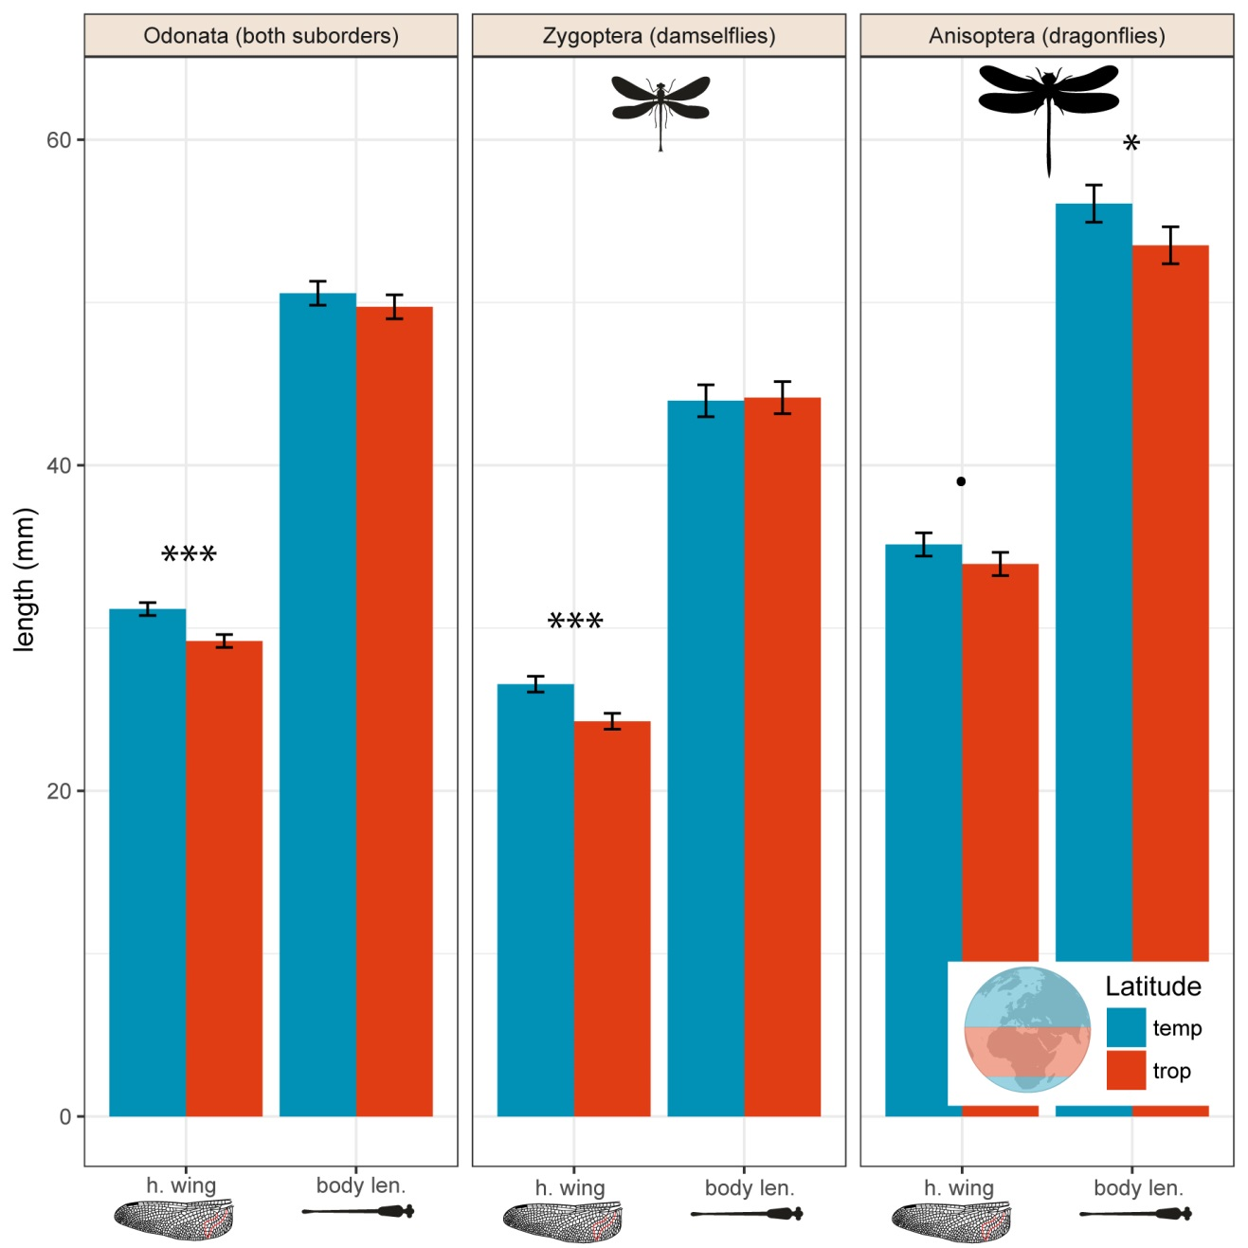

**Fig. 2**

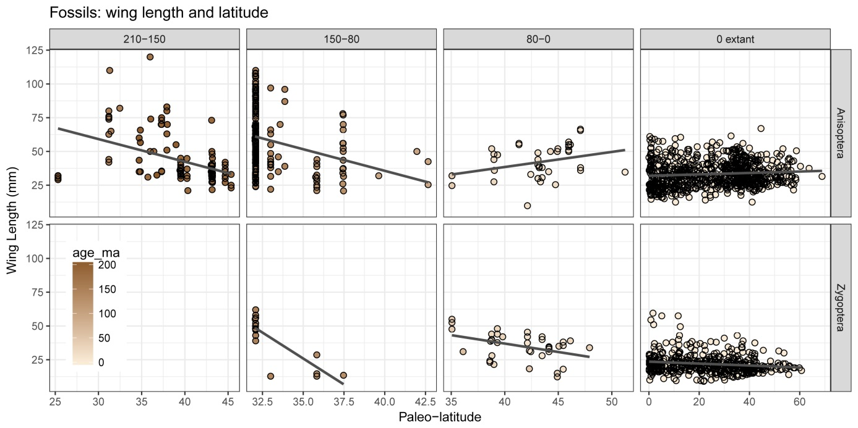

**Fig. 3**

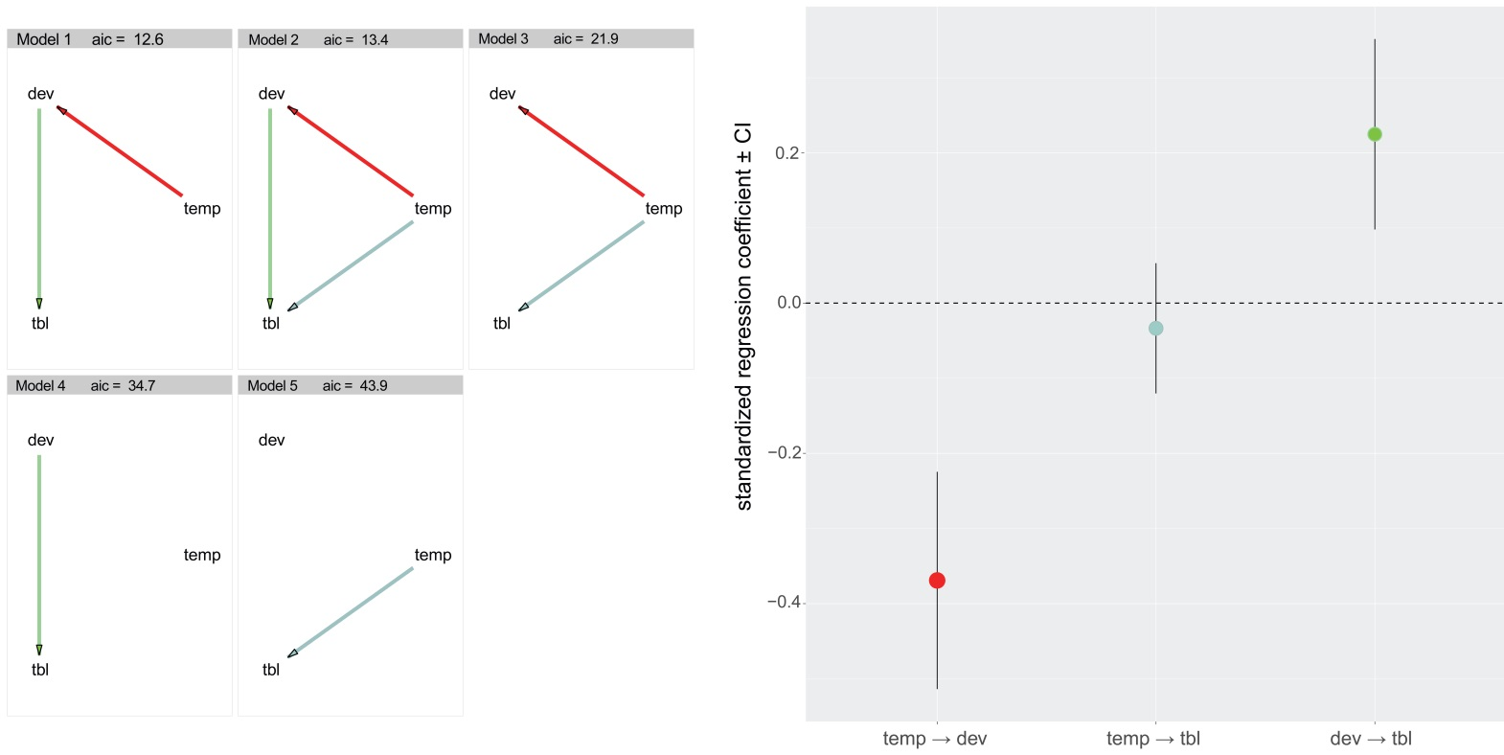

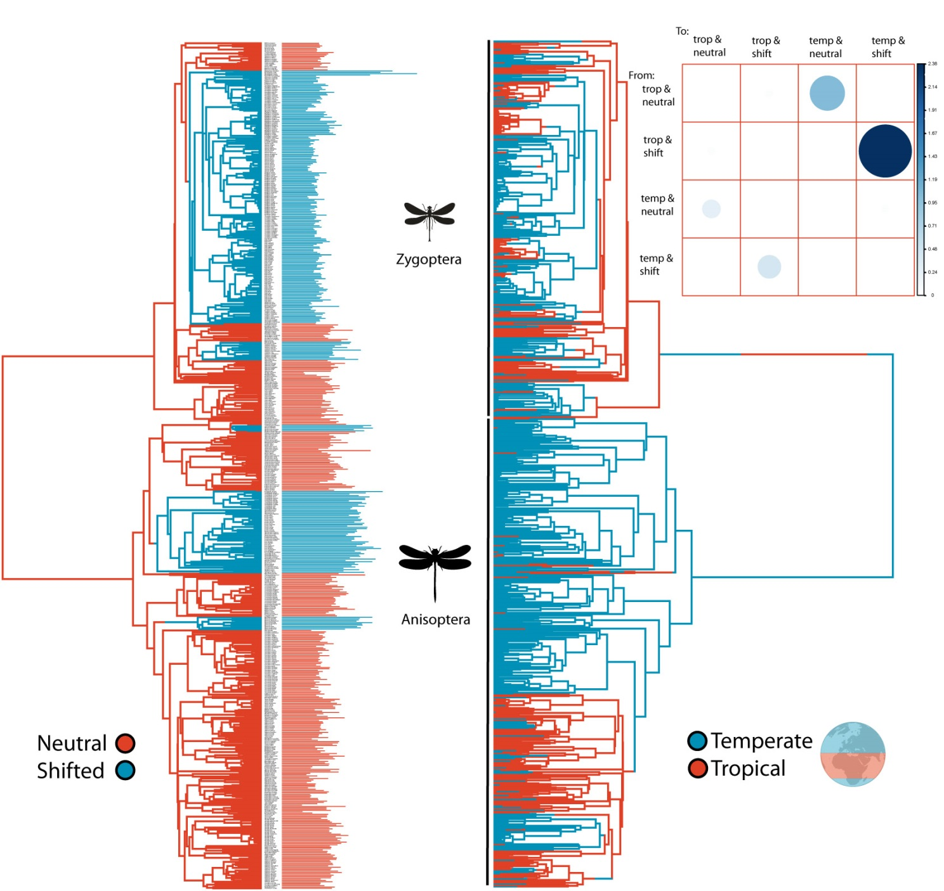

**Fig. 5**

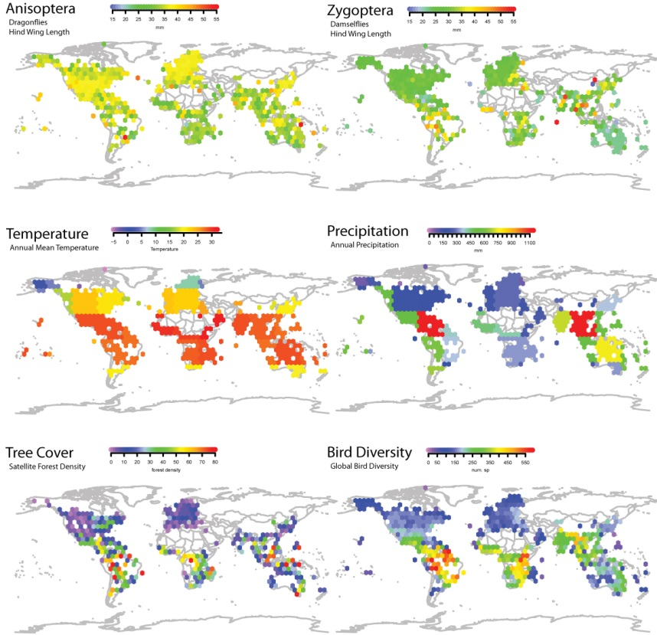

**References**

Alroy, J., Marshall, C., & Miller, A. (2012). The paleobiology database.  <http://paleodb.org>.

Anderson, R. C. (2009). Do dragonflies migrate across the western Indian Ocean?. *Journal of Tropical Ecology*, *25*(4), 347-358.

Angilletta, Jr, M. J., & Dunham, A. E. (2003). The temperature-size rule in ectotherms: simple evolutionary explanations may not be general. *The American Naturalist*, *162*(3), 332-342.

Ashton, K. G., Tracy, M. C., & Queiroz, A. D. (2000). Is Bergmann’s rule valid for mammals? *The American Naturalist*, *156*(4), 390-415.

Atkinson, D. (1996). Ectotherm life-history responses to developmental temperature. *Animals and temperature: Phenotypic and evolutionary adaptation*, 183-204.

Baird, I. R. (2014). Larval burrow morphology and groundwater dependence in a mire-dwelling dragonfly, Petalura gigantea (Odonata: Petaluridae). *International journal of odonatology*, *17*(2-3), 101-121.

Baker, J., Meade, A., Pagel, M., & Venditti, C. (2015). Adaptive evolution toward larger size in mammals. *Proceedings of the National Academy of Sciences*, *112*(16), 5093-5098.

Bhagwat, S. A., & Willis, K. J. (2008). Species persistence in northerly glacial refugia of Europe: a matter of chance or biogeographical traits? *Journal of Biogeography*, *35*(3), 464-482.

Bivand, R. S., Pebesma, E. J., Gomez-Rubio, V., & Pebesma, E. J. (2008). *Applied spatial data analysis with R* (Vol. 747248717). New York: Springer.

Blackburn, T. M., & Gaston, K. J. (1994). Animal body size distributions: patterns, mechanisms and implications. *Trends in Ecology & Evolution*, *9*(12), 471-474.

Blackburn, T. M., Gaston, K. J., & Loder, N. (1999). Geographic gradients in body size: a clarification of Bergmann's rule. *Diversity and distributions*, *5*(4), 165-174.

Blanckenhorn, W. U. (2000). The evolution of body size: what keeps organisms small?. *The quarterly review of biology*, *75*(4), 385-407.

Bujan, J., Yanoviak, S. P., & Kaspari, M. (2016). Desiccation resistance in tropical insects: causes and mechanisms underlying variability in a Panama ant community. *Ecology and evolution*, *6*(17), 6282-6291.

Chapman, J. W., Reynolds, D. R., & Wilson, K. (2015). Long‐range seasonal migration in insects: mechanisms, evolutionary drivers and ecological consequences. *Ecology letters*, *18*(3), 287-302.

Clapham, M. E., & Karr, J. A. (2012). Environmental and biotic controls on the evolutionary history of insect body size. *Proceedings of the National Academy of Sciences*, *109*(27), 10927-10930.

Clauset, A., & Erwin, D. H. (2008). The evolution and distribution of species body size. *Science*, *321*(5887), 399-401.

Damuth, J. (1981). Population density and body size in mammals. *Nature*, *290*(5808), 699-700.

Fick, S. E., & Hijmans, R. J. (2017). WorldClim 2: new 1‐km spatial resolution climate surfaces for global land areas. *International Journal of Climatology*.

Freestone, A. L., Ruiz, G. M., & Torchin, M. E. (2013). Stronger biotic resistance in tropics relative to temperate zone: effects of predation on marine invasion dynamics. *Ecology*, *94*(6), 1370-1377.

Glasspool, I. J., & Scott, A. C. (2010). Phanerozoic concentrations of atmospheric oxygen reconstructed from sedimentary charcoal. *Nature Geoscience*, *3*(9), 627-630.

Gotthard, K., Berger, D., & Walters, R. (2007). What keeps insects small? Time limitation during oviposition reduces the fecundity benefit of female size in a butterfly. *The American Naturalist*, *169*(6), 768-779.

Harmon, L. J., Losos, J. B., Jonathan Davies, T., Gillespie, R. G., Gittleman, J. L., Bryan Jennings, W., ... & Purvis, A. (2010). Early bursts of body size and shape evolution are rare in comparative data. *Evolution*, *64*(8), 2385-2396.

Harrison, J. P., Gheeraert, N., Tsigelnitskiy, D., & Cockell, C. S. (2013). The limits for life under multiple extremes. *Trends in microbiology*, *21*(4), 204-212.

Henry, J. R., & Harrison, J. F. (2014). Effects of body size on the oxygen sensitivity of dragonfly flight. *Journal of Experimental Biology*, *217*(19), 3447-3456.

Hijmans, R. J., van Etten, J., Cheng, J., Mattiuzzi, M., Sumner, M., Greenberg, J. A., ... (2016). Package ‘raster’. *R package. https://cran. r-project. org/web/packages/raster/index. html (accessed 1 October 2016)*.

Jenkins, C. N., Pimm, S. L., & Joppa, L. N. (2013). Global patterns of terrestrial vertebrate diversity and conservation. *Proceedings of the National Academy of Sciences*, *110*(28), E2602-E2610.

Johansson, F. (2003). Latitudinal shifts in body size of Enallagma cyathigerum (Odonata). *Journal of Biogeography*, *30*(1), 29-34.

Khabbazian, M., Kriebel, R., Rohe, K., & Ané, C. (2016). Fast and accurate detection of evolutionary shifts in Ornstein–Uhlenbeck models. *Methods in Ecology and Evolution*, *7*(7), 811-824.

Kingsolver, J. G., & Huey, R. B. (2008). Size, temperature, and fitness: three rules. *Evolutionary Ecology Research*, *10*(2), 251-268.

Marron, M. T., Markow, T. A., Kain, K. J., & Gibbs, A. G. (2003). Effects of starvation and desiccation on energy metabolism in desert and mesic Drosophila. *Journal of Insect Physiology*, *49*(3), 261-270.

Mattila, T. M., & Bokma, F. (2008). Extant mammal body masses suggest punctuated equilibrium. *Proceedings of the Royal Society of London B: Biological Sciences*, *275*(1648), 2195-2199.

McCue, M. D. (2010). Starvation physiology: reviewing the different strategies animals use to survive a common challenge. *Comparative Biochemistry and Physiology Part A: Molecular & Integrative Physiology*, *156*(1), 1-18.

McPeek, M. A., Schrot, A. K., & Brown, J. M. (1996). Adaptation to predators in a new community: swimming performance and predator avoidance in damselflies. *Ecology*, *77*(2), 617-629.

Mousseau, T. A. (1997). Ectotherms follow the converse to Bergmann's rule. *Evolution*, *51*(2), 630-632.

Nilsson-Örtman, V., Stoks, R., De Block, M., & Johansson, F. (2012). Generalists and specialists along a latitudinal transect: patterns of thermal adaptation in six species of damselflies. *Ecology*, *93*(6), 1340-1352.

Olalla-Tárraga, M. Á., Rodríguez, M. Á., & Hawkins, B. A. (2006). Broad-scale patterns of body size in squamate reptiles of Europe and North America. *Journal of Biogeography*, *33*(5), 781-793.

Outomuro, D., & Johansson, F. (2015). Bird predation selects for wing shape and coloration in a damselfly. *Journal of evolutionary biology*, *28*(4), 791-799.

Padian, K., & Chiappe, L. M. (1998). The origin and early evolution of birds. *Biological reviews*, *73*(1), 1-42.

Paradis, E., Claude, J., & Strimmer, K. (2004). APE: analyses of phylogenetics and evolution in R language. *Bioinformatics*, *20*(2), 289-290.

Partridge, L., & Coyne, J. A. (1997). Bergmann's rule in ectotherms: is it adaptive?. *Evolution*, *51*(2), 632-635.

Peel, M. C., Finlayson, B. L., & McMahon, T. A. (2007). Updated world map of the Köppen-Geiger climate classification. *Hydrology and earth system sciences discussions*, *4*(2), 439-473.

Rainford, J. L., Hofreiter, M., & Mayhew, P. J. (2016). Phylogenetic analyses suggest that diversification and body size evolution are independent in insects. *BMC evolutionary biology*, *16*(1), 8.

Rantala, M. J., Honkavaara, J., Dunn, D. W., & Suhonen, J. (2011). Predation selects for increased immune function in male damselflies, Calopteryx splendens. *Proceedings of the Royal Society of London B: Biological Sciences*, *278*(1709), 1231-1238.

Roslin, T., Hardwick, B., Novotny, V., Petry, W. K., Andrew, N. R., Asmus, A., ... & Cameron, E. K. (2017). Higher predation risk for insect prey at low latitudes and elevations. *Science*, *356*(6339), 742-744.

Sandhall, A. (1987). Trollsländor i Europa. *Stenströms Bokförlag (in Swedish)*.

Schemske, D. W., Mittelbach, G. G., Cornell, H. V., Sobel, J. M., & Roy, K. (2009). Is there a latitudinal gradient in the importance of biotic interactions?. *Annu. Rev. Ecol. Evol. Syst.*, *40*, 245-269.

Schorr, M., and D. Paulson. (2015).World Odonata List. Electronic Database accessible at http://www.pugetsound.edu/academics/academic-resources/ slater-museum/biodiversity-resouces/dragon flies/world-odonata-list2/. Accessed 11 (2015)

Sexton, J. O., Urban, D. L., Donohue, M. J., & Song, C. (2013). Long-term land cover dynamics by multi-temporal classification across the Landsat-5 record. *Remote Sensing of Environment*, *128*, 246-258.

Shelomi, M. (2012). Where are we now? Bergmann’s rule sensu lato in insects. *The American Naturalist*, *180*(4), 511-519.

Sokolovska, N., Rowe, L., & Johansson, F. (2000). Fitness and body size in mature odonates. *Ecological Entomology*, *25*(2), 239-248.

Stillwell, R. C. (2010). Are latitudinal clines in body size adaptive?. *Oikos*, *119*(9), 1387-1390.

Stillwell, R. C., Moya-Laraño, J., & Fox, C. W. (2008). Selection does not favor larger body size at lower temperature in a seed-feeding beetle. *Evolution*, *62*(10), 2534-2544.

Stoks, R., & Córdoba-Aguilar, A. (2012). Evolutionary ecology of Odonata: a complex life cycle perspective. *Annual review of entomology*, *57*, 249-265.

Svensson, E. I., & Friberg, M. (2007). Selective predation on wing morphology in sympatric damselflies. *The American Naturalist*, *170*(1), 101-112.

Troast, D., Suhling, F., Jinguji, H., Sahlén, G., & Ware, J. (2016). A global population genetic study of Pantala flavescens. *PloS one*, *11*(3), e0148949.

Uyeda, J. C., Hansen, T. F., Arnold, S. J., & Pienaar, J. (2011). The million-year wait for macroevolutionary bursts. *Proceedings of the National Academy of Sciences*, *108*(38), 15908-15913.

Van Voorhies, W. A. (1997). On the adaptive nature of Bergmann size clines: a reply to Mousseau, Partridge and Coyne. *Evolution*, *51*(2), 635-640.

Verberk, W. C., & Atkinson, D. (2013). Why polar gigantism and Palaeozoic gigantism are not equivalent: effects of oxygen and temperature on the body size of ectotherms. *Functional Ecology*, *27*(6), 1275-1285.

Waller, J. T., & Svensson, E. I. (2017). Body size evolution in an old insect order: No evidence for Cope's Rule in spite of fitness benefits of large size. *Evolution*.

Wikelski, M., Moskowitz, D., Adelman, J. S., Cochran, J., Wilcove, D. S., & May, M. L. (2006). Simple rules guide dragonfly migration. *Biology letters*, *2*(3), 325-329.