# Biotic and abiotic drivers of global body size distributions and macroevolutionary diversification in an old insect order

John T. Waller and Erik I. Svensson

## Abstract

Global body size distributions in ectotherms are shaped by multiple ecological and evolutionary processes, including abiotic factors like temperature, natural and sexual selection on adults and biotic factors like natural enemies such as predators and parasites. However, little is known how these factors interact and shape global interspecific body size distributions, and latitudinal gradients in body size, such as “Bergmann’s Rule” (larger body sizes at higher latitudes). Here, we investigated the macroecological and evolutionary factors shaping latitudinal gradients and global body size distributions in an old insect order (Odonata; dragonflies and damselflies), using a global database of odonate phenotypic traits, fossils and phylogenetic comparative methods. Controlling for phylogeny, we find that extant species of both odonate suborders are larger in the temperate region than in the tropics. Next, using fossil data, we show that the relationship between body size and latitude in has shifted over macroevolutionary time scales from having negative slopes in both suborders to become more shallow or even positive following the evolutionary emergence of birds 150 MYA. As birds are important predators on extant species of these insects, we argue that these macroevolutionary changing temporal pattern in the geographic body size-latitude trend is likely to be driven by avian predation in combination with high dispersal ability of large dragonflies. In further support of this, we show that interspecific body size variation of extant odonate taxa is negatively influenced by both regional avian diversity and temperature with a surprisingly large effect of the former. Finally, evolutionary shifts to larger body size were more likely to occur in the tropics, followed by dispersal of large clades in to the temperature region. Once lineages invaded the temperate region, temperature had a limited direct effect on body size, but indirectly influences body size via prolonged larval development time. Ambient temperatures are therefore not the primary force shaping latitudinal body size variation in odonates, and instead predator diversity and dispersal ability might play more important roles in shaping interspecific geographic body size patterns. Thus, latitudinal body size gradients are shaped by both evolutionary processes leading to the emergence of large taxa in the tropics, followed by ecological processes such as increased dispersal ability of large clades.

## Introduction

Body size is a fundamental phenotypic trait that is important to fitness and which is often the target of multiple and opposing selection pressures (Blanckenhorn 2000). Consequently, body size is one of the most popular phenotypic traits used by evolutionary biologists who employ phylogenetic comparative methods to study evolutionary processes and outcomes (Baker et al. 2015; Waller and Svensson 2017). For instance, in vertebrates such as birds, mammals, reptiles, and amphibians, body size has been investigated in relation to “Cope’s Rule”, the tendency for lineages to become larger over evolutionary time (Baker et al. 2015) and to evaluate the relative role of cladogenetic (“speciational”) vs. anagenetic (“gradual”) evolution (Mattila and Bokma 2008). In addition, researchers have tried to understand the temporal macroevolutionary pattern of body size diversification in adaptive radiations, looking for so-called “early bursts” of body size evolution in comparative data (Harmon et al. 2010). In addition to these evolutionary studies, body size is also of interest for researchers interested in physiological ecology, development and biogeography, and the intersection between these fields. For instance, the classical “Bergman’s Rule” states that body size in endotherms should increase with latitude, as larger bodies conserve more heat due to higher thermal inertia, which might be beneficial in colder environments (Ashton et al. 2000; Shelomi 2012).

While geographic and latitudinal body size patterns of mammals and birds can at least partly be attributed to Bergmann’s rule (Ashton et al. 2000), which predicts an increase in body size in colder environments at high latitudes, strong support for this rule is lacking in insects (Shelomi 2012). It is also difficult to make straightforward predictions from first principles about the expected relationship of body size and latitude in ectotherms (Mousseau 1997), and studies of environmental influences on body size in insects often lack a general theoretical framework (Shelomi 2012). Although there are some documented cases of Bergmann’s rule in ectotherms (VanVoorhies 1997), the interpretation of such latitudinal patterns is subject to controversy (Mousseau 1997; Partridge and Coyne 1997). There is currently no consensus on the evolutionary and ecological causes behind latitudinal size gradients in ectotherms, or even the consistency of Bergmann’s rule (Mousseau 1997; Shelomi 2012). Different species show either no latitudinal trends, positive trends or even negative body size trends with latitude (Mousseau 1997; Shelomi 2012).

In the case of temperature, the body size of ectothermic animals typically increases with decreasing developmental temperatures, a phenomenon known as the temperature-size rule (Kingsolver and Huey 2008). The explanation that has been put forward for this rule is accelerated maturation at higher temperatures, and it is supported by the fact that most ectothermic organisms mature at smaller body sizes when reared in warmer conditions (Atkinson [1996](http://onlinelibrary.wiley.com/doi/10.1111/j.1600-0706.2010.18670.x/full#b12); [Angilletta and Dunham 2003](http://onlinelibrary.wiley.com/doi/10.1111/j.1600-0706.2010.18670.x/full#b5); [Kingsolver and Huey 2008](http://onlinelibrary.wiley.com/doi/10.1111/j.1600-0706.2010.18670.x/full#b38)). However, warm temperatures could also lead to the opposite effect, as metabolic rate and season length increase with temperature, allowing higher growth rates under warmer climatic conditions. Additionally, differences in moisture and precipitation may increase or decrease desiccation resistance, since larger individuals may be more resistant than smaller to desiccation (Marron et al. [2003](http://onlinelibrary.wiley.com/doi/10.1002/ece3.2355/full#ece32355-bib-0013); Harrison et al. [2013](http://onlinelibrary.wiley.com/doi/10.1002/ece3.2355/full#ece32355-bib-0019); Bujan et al 2016). Starvation resistance can also increase with increasing size, and starvation resistance has been associated with latitude in some insects (McCue 2010). For both endotherms and ectotherms like insects, the balance between heat gain and heat loss is also important, which might cause associations between body size and latitude ([Olalla-Tárraga et al. 2006](http://onlinelibrary.wiley.com/doi/10.1111/j.1600-0706.2010.18670.x/full#b46)). Finally, past geological and climatological events (such as glacial advances and retreats; Bhagwat 2008) can lead to different size assemblages at different latitudes, as dispersal, extinction, and speciation may all correlate with body size (Clauset and Erwin 2008; Rainford et al. 2016; Waller and Svensson 2017). Many abiotic and biotic variables are therefore associated with latitude and could potentially produce latitudinal differences in body size for different insect groups, even if clear predictions are not always possible for insects in general ([Blackburn et al. 1999](http://onlinelibrary.wiley.com/doi/10.1111/j.1600-0706.2010.18670.x/full#b15); [Ashton et al. 2000](http://onlinelibrary.wiley.com/doi/10.1111/j.1600-0706.2010.18670.x/full#b10); Stillwell 2008, 2010).

Body size evolution in odonates has a dramatic and interesting history (Waller and Svensson 2017; their Fig. 1). Over the last 350 MYA, maximum odonate wing length has varied by more than 60 mm (Waller and Svensson 2017), from crow-sized animals to those smaller than the width of a human hand (Baird 2014). Oxygen has been suggested to be a major driver of body size variation through time in this lineage (Clapham and Karr 2012). In support of this, larger extant dragonflies has been shown adjust their flight behaviour in experimentally reduced oxygen (Henry and Harrison 2014). Moreover, dragonflies, unlike other insects, lack the ability to ventilate via abdominal pumping, but they must rely on actual wing beats in order to ventilate their bodies (Henry and Harrison 2014), so they might be more constrained by atmospheric oxygen than other insects.

Over the last 65 MYA, however, atmospheric oxygen levels have remained constant, and oxygen levels are uniform in the atmosphere (Glasspool and Scott 2010), (although lower oxygen levels are observed in colder water (Verberk and Atkinson 2013)). This has led some authors to argue that the evolution of flying competitors, starting around 150 MYA, is now the primary force keeping odonates and other flying insects small (Damuth 1981; Blackburn and Gaston 1994; Clapham and Karr 2012). Some field studies of predator-mediated selection by birds on damselflies have shown that avian predation favors smaller individuals Svensson and Friberg 2007; Outomoro and Johansson 2015). So far, however, no study have investigated whether the presence of birds is predictive of geographic body size patterns in extant dragonflies and damselflies.

Here we investigate the environmental and global macroecological factors involved in the biogeographic patterns of body size distributions in Odonata. In a recent study (Waller and Svensson 2017), we found evidence for multiple non-neutral body size shifts within this insect order. These non-neutral body size shifts are likely to be associated with the invasions in to new habitats with novel selective environments, for instance with novel predator faunas or differences in overall extent of predation pressure (McPeek et al. 1996). Sokolovska et al. (2000) and Waller and Svensson (2017) found that selection on adult body size is largely positive, but this positive selection has not lead to a directional body size trend in the fossil record, at least not since the last mass extinction about 65 MYA (Waller and Svensson 2017). Waller and Svensson (2017) argued that long development time is the main selective counterforce opposing the consistent positive selection in the adult stage, leading to weak net selection due to conflicting selection in most lineages. However, although such conflicting selection is likely to operate on body size in odonates, there are nevertheless several documented bursts of body size evolution within this order (Waller and Svensson 2017). This observed pattern of multiple body-size changes in Odonata fits with a recently proposed multiple burst model of phenotypic evolution, where bursts are rare and are separated by long periods of phenotypic stasis (Uyeda et al. 2011).

Therefore, present-day variation in body size in odonates could be due to multiple and sometimes conflicting environmental factors and associated selection pressures including differences in development times, environmental temperatures, habitat choice, or predation. Based on the results in this study, we suggest that ambient temperatures have indirectly influenced body size distributions, with dispersal ability, predation, and niche filling by birds playing more important roles in shaping latitudinal body size gradients in this insect order.

## Methods

### Phylogeny used

The phylogenetic tree that we use in this study was constructed from odonate DNA-sequences downloaded GenBank, using a traditional morphological taxonomy as our backbone (Waller and Svensson 2017). This phylogenetic tree has been used in a previous study on odonate body size (Waller and Svensson 2017). Our phylogeny comprised 1322 taxa, which is about 21% of all known extant odonate species (about 6400 in total; Schorr and Paulson 2015). See our Supplementary Material for a detailed description of the construction of the phylogenetic trees used in this study, and how we accounted for phylogenetic uncertainty.

### Geographic variation in body size in relation to latitude

We quantified the relationship between latitude and two measures of body size (wing length and total body length) in both fossils and extant taxa. For the fossil data, we used wing length as our size measure, which is justified by the fact that overall body length and wing length are highly correlated (*r* = 0.90) with each other (Waller and Svensson 2017). For the extant taxa, we used both total body length (in mm; when available from the literature) and hindwing length (also in mm) in different analyses. We divided the fossils into different time periods between extinction events and other major evolutionary events: 1) Around 210 MYA marks the beginning of the dragonfly radiation after the Triassic–Jurassic extinction mass extinction; 2)150 MYA marks the beginning of the radiation of birds; 3) 80 MYA right before the Cretaceous–Tertiary (K–T) extinction event (there is a large gap in the fossil record between 80-65 MYA).For the fossils,paleolatitude was extracted from the Paleobiology Database (Alroy et al. 2012). Mean latitude from the Global Biodiversity Information Facility (GBIF: <https://www.gbif.org/>) occurrence records was used to obtain distribution data from extant taxa. Absolute latitude (the distance in degrees from 0o) was used in all analyses.

### Odonate size data

Odonate size data were taken from the Odonate Phenotypic Database (opdb) ([www.odonatephenotypicdatabase.org](http://www.odonatephenotypicdatabase.org)). This open database is a general resource for comparative studies on phenotypic trait evolution using odonates. These size data has also been used in a previous publication, and a description of how it was collected can be found there (Waller and Svensson 2017). Size data from fossil odonate taxa were obtained from Clapham and Karr (2012).

### Geographical occurrences and tropical and temperate classifications

We considered 23oN and 23oS to be the boundaries for temperate latitudes, in accordance with the Köppen-Geiger climate classification system (Peel et al. 2007). Any species with a mean distribution of occurrence records above or below these latitudinal boundaries was classified as temperate. Conversely, all species with a mean distribution between these two points was classified as tropical. Occurrence records were downloaded from the Global Biodiversity Information Facility (GBIF: <https://www.gbif.org/>). All occurrences for each odonate species under 500 records were downloaded using the R-package rgbif (Chamberlain 2017). When a species had more than 500 occurrence records, we used a randomly chosen sample of 5000 records. This procedure was done to avoid downloading species with prohibitively large occurrence histories, while still accurately capture their geographic distributions.

### Spatial environmental data

Spatial data was linked to quantify and investigate the environmental influences on these odonate species in terms of ambient temperatures, tree cover, precipitation, and bird diversity. These spatial environmental datasets were processed in the R packages raster (Hijmans et al. 2016) and sp (Bivand et al. 2013). Temperature and precipitation data were downloaded from the worldclim datasets(Fick and Hijmans 2017). WorldClim is a set of global climate layers (gridded climate data) with a spatial resolution of about 1 km2. These data can be used for mapping and spatial modeling. These WorldClim datasets were downloaded using the R-package raster at 5m accuracy. Mean values for temperature (BIO1 = Annual Mean Temperature) and precipitation (BIO12 = Annual Precipitation) were computed for each species in our occurrences dataset.

Tree cover data was downloaded from the global land cover facility (glcf: http://glcf.umd.edu/data/landsatTreecover/) (Sexton et al. 2013). Tree cover is the proportional, vertical area of vegetation (including leaves, stems, and branches) of woody plants above a given height. The continuous classification scheme of glcf product enables a better depiction of land cover gradients than traditional discrete classification schemes (Sexton et al. 2013).

Avian species diversity spatial data was downloaded from biodiversitymapping.org (http://biodiversitymapping.org/wordpress/index.php/birds/ Jenkins et al. 2013). These maps were generated based on the Bird Species Distribution Maps of the World (BirdLife International 2011). We used total bird diversity in our analyses. To control for a possible effect of a biodiversity in general we also used mammal biodiversity data from the same source (Jenkins et al. 2013). The rationale here is that while birds are known predators on odonates, mammals are not, and hence we would expect an ecological effect of the former on odonate size distributions, but not the latter.

### Phylogenetic path analysis

To investigate whether temperature had a direct effect on our body size in European odonates, we performed a phylogenetic path analysis using the R-package phylopath (Van der Bijl 2017). We also collected data on larval development from the literature of European odonates (Sandhall 1987). This is the same larval development time data that has been used in a previous study (Waller and Svensson 2017). We compared five nested models of the relationships between larval development time, temperature (annual mean temperature).

These path models differed in their final causal structure, but they all contained three variables: adult body size (a quantitative trait), environmental temperature at the locality of the species (at the midpoint of the species range; another quantitative trait) and development time (an integer trait that ranges from one to several years; Sandhall 1987; Waller and Svensson 2017). In these models, body size was always the dependent variable and it could be affected directly by development (i.e. longer development leads to larger adult body size) and both directly and indirectly by ambient temperature. For instance, adult body size could be directly influenced (either negatively or positively) by ambient temperatures, through physiological effects or competitive interactions with con- or heterospecific individuals leading to selection for larger or smaller body size. Alternatively, body size could be indirectly influenced by environmental temperatures through changes in larval development time, e.g. in warmer climates odonates would develop faster but at a smaller size, consistent with many previous studies on larval ecology and thermal adaptation in this group (e.g. Johansson 2003; Stoks and Aguilar 2012; Örtman et al. 2012).

### Optima shifts and invasion of the temperate zone

We tested the relationship between positive shifts in size optima with invasion in to the temperate zone, using the corDISC function in the R-package corHMM (Beaulieu et al. 2017). Optima shifts were taken from the multi-optimum OU-model inferred in Waller and Svensson (2017), using the l1ou R-package (Khabbazian et al. 2016). A positive shift in the body size optimum shift was defined as an increase from the background inferred neutral process. A negative body size optimum shift was classified the same as neutral background optima for this analysis. It is important to realize that a positive shift in optima does not necessarily imply that species within the positively shifted group will be largest odonates species, but they will be larger than closely related species that did not evolve toward that new inferred optimum. These shifts in optima can also roughly be interpreted as the signature of past selective regimes favouring larger or smaller size (Khabbazian et al. 2016).

### Models linking hindwing length to spatial environmental data

To quantify the relationships between body size and environmental variables, we conducted a phylogenetic generalized least square (PGLS) regression using the corBrownian function in ape (Paradis et al. 2004). We used a model comparison procedure based on AIC. The best performing models coefficients were then interpreted, using standardized coefficients. Five spatial environmental variables were considered: 1) temperature (annual mean temperature), 2) precipitation (annual precipitation), 3) tree cover, 4) avian diversity, and 5) mammal diversity. The last of these variables was included to control for a possible “diversity hostspot”-effect rather than avian diversity.

## Results

### Global variation in wing length and geographic pattern in wing length and body size

We first compared three different models of body size evolution, using our entire global dataset, our phylogeny, and hindwing length as our measure of body size (Table 1). We found the highest support for an Ohrnstein-Uhlenbeck (OU) model, followed by a Brownian Motion (BM) model and the lowest support for an Early Burst (EB) model (Table 1).

Tabel 1. Models of continuous body size (hind wing length) evolution.

Models were fit using the fitContinuous function in the R package geiger (Harmon et al. 2008). Three nested models were compared: 1) Ornstein–Uhlenbeck (OU), 2) Brownian motion (BM) and 3) Early Burst (EB).

|  |  |  |  |  |  |
| --- | --- | --- | --- | --- | --- |
| **Model** | **LnLik** | **Parameter** | **Estimate** | **AIC** | **Rank** |
| OU | -2371.0 | Alpha | 0.0089 | 4748.007 | 1 |
|  |  | sigma sq. | 1.364 |  |  |
|  |  |  |  |  |  |
| BM | -2389.306 | sigma sq. | 1.085 | 4782.612 | 2 |
|  |  |  |  |  |  |
| EB | -2389.308 | Alpha | -1.00e-06 | 4784.616 | 3 |
|  |  | sigma sq. | 1.085 |  |  |

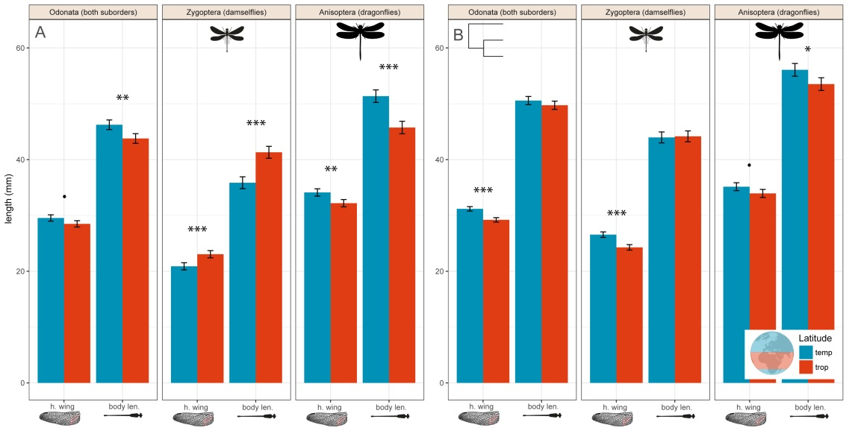

Figure 1. Body size in temperate and tropical regions.

Mean body size (hind wing length and total body length) of dragonflies and damselflies in temperate and tropical regions, when using individual species as independent datapoints (A) and controlling for phylogenetic relationships (B). We considered the tropical region to occur between 23oN and 23.0oS, whereas areas north and south of these regions were considered to be temperate, following the Köppen-Geiger geographical classification scheme. Across both suborders, odonates are larger in body size in temperate regions (controlling for phylogenetic non-independence; **B**).

We proceed bycomparing wing and body sizes of dragonflies and damselflies of the tropical and the temperate regions (Fig. 1). We found that dragonflies were significantly larger in the temperate region whereas damselflies were significantly larger in the tropical regions, i.e. opposite geographic patterns in these two different suborders (Fig. 1A). After controlling for phylogeny using a phylogenetic generalized linear model (PGLM), however, we found that this latitudinal size-pattern was reversed in damselflies, and now both suborders were larger in the temperate region (Fig. 1B). This indicates that the geographic pattern in the non-corrected analysis for damselflies was partly confounded by phylogeny. This might suggest that some large damselfly clades are overrepresented in the tropics and these clades have not yet dispersed in to the temperate region (Fig. 1A,B).

### Macroevolutionary trends in the fossil record between wing size and latitude

In the fossil record, damselflies showed a consistent pattern of decreasing body sizes with increasing reconstructed latitude (Paleo-Latitude) across all geological time periods, although the slope became shallower closer to the present (Fig. 2; Tables 2-3). Dragonflies showed a more varied temporal pattern with decreasing body size with increasing latitude prior to 65-80 MYA (large gap in the fossil record), followed by a reversal and more recently increasing size with latitude Fig. 2; Tables 2-3). The slopes of the relationship between wing size and latitude differed significantly between the time periods for both suborders, as shown by significant interaction terms between paleo-latitude and time period (Table 2). The general conclusion is that in the past, both dragonflies and damselflies were larger in the tropics than in the temperate region, but this strong negative relationship became less pronounced and even reversed as we move towards the present (Fig. 2; Table 3).

Evolutionary shifts in body size followed by invasions in the temperate regions

A binary test of correlated evolution suggest that evolutionary shifts to larger body sizes occurred in the tropics followed by range shift in to the temperate zone (Fig. 3). We tested a series of nested models in order to identify the best fitting model using the corDISC function in the R-package corHMM (Fig. 3). We compared three different models: the “all rates different” (ARD), “equal rates”(ER), and “symmetric rates” (SYM) models in corHMM. We found that the ARD had the lowest AIC score, implying that transition rates were not equal (AIC: ARD = 662.62, SYM = 699.39, ER = 804.09)(Fig. 4).

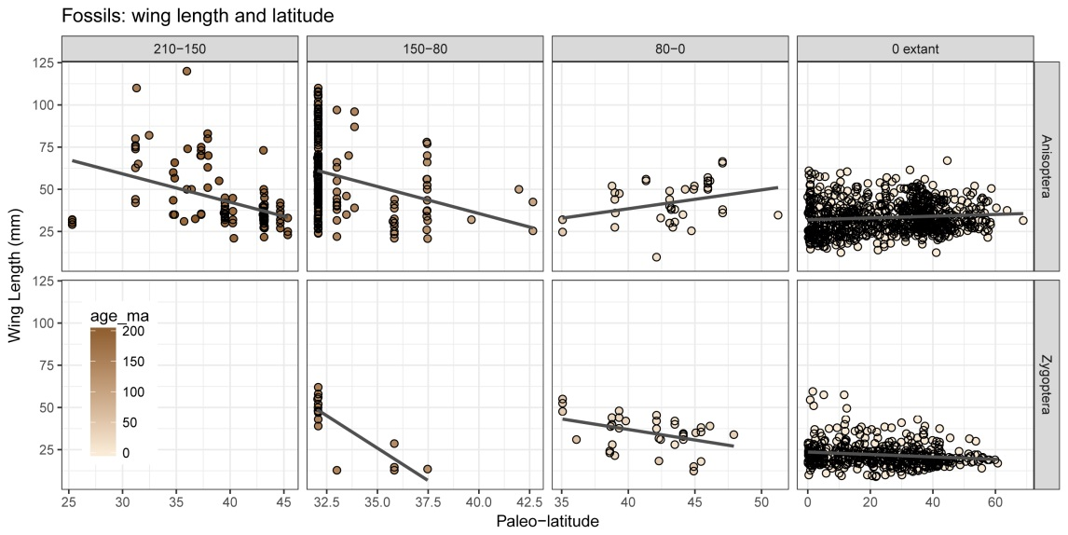

Figure 2. The continuous relationship between absolute latitude and hind wing length for fossils and extant dragonflies.

The relationship between latitude and body size has been negative for the major part of the evolutionary radiation of Odonata, including both dragonflies (Anisoptera) and damselflies (Zygoptera). However, immediately before and after the last mass extinction (65 MYA) event, dragonflies have shifted towards a positive relationship with latitude. Plot have been divided according to major geological events, namely major extinction events and following the beginning of the radiation of birds (150 MYA). See Tables 2-3 for statistical tests of these relationships, as well as slope differences between the time periods for both fossil taxa. For all plots we used absolute latitude, which is the distance in decimal degrees from the equator. Latitude for the fossils is paleo-latitude, which takes into account effects of continental drift.

Table 2. General linear model (glm) of the relationship between size and latitude in Zygoptera and Anisoptera fossils.

Period is a discrete categorical variable with 4 levels corresponding to the panels in Fig. 2 (extant, 80-0 mya, 150-80 mya, 210-150 mya). Latitude is absolute latitude.

|  |  |  |  |  |  |
| --- | --- | --- | --- | --- | --- |
| **Suborder** | **Term** | **Df** | **N** | **P-value** | **Significance** |
| Zygoptera | Period | 2 | 529 | < 0.0001 | *** |
|  | Latitude | 1 |  | < 0.0001 | *** |
|  | Period x Latitude | 2 |  | < 0.0001 | *** |
|  |  |  |  |  |  |
| Anisoptera | Period | 3 | 1219 | < 0.0001 | *** |
|  | Latitude | 1 |  | < 0.0001 | *** |
|  | Period x Latitude | 3 |  | < 0.0001 | *** |
|  |  |  |  |  |  |

Table 3. Linear models of the relationship between size and latitude in Zygoptera and Anisoptera extant taxa and fossils.

Analyses in this table are not corrected for phylogeny, but use species as single datapoints. Note that in Zygoptera, the phylogenetically un-corrected analysis shows that species are larger in the tropical region, wheras when we correct for phylogeny, we find that the reverse, i. e. both damselflies and dragonflies are larger in the temperate region. Period is a discrete categorical variable with four levels, corresponding to the panels in Fig. 2 (extant, 80-0 mya, 150-80 mya, 210-150 mya). Latitude is absolute latitude.

|  |  |  |  |  |  |  |
| --- | --- | --- | --- | --- | --- | --- |
| **Suborder** | **Period** | **Variable** | **Estimate** | **N** | **P-value** | **Significance** |
| Zygoptera | extant | Latitude | -0.071 | 473 | < 0.0001 | *** |
|  |  |  |  |  |  |  |
|  | 80-0 mya | Paleo-Latitude | -1.248 | 39 | 0.007 | ** |
|  |  |  |  |  |  |  |
|  | 150-80 mya | Paleo-Latitude | -7.689 | 17 | < 0.0001 | *** |
|  |  |  |  |  |  |  |
| Anisoptera | extant | Latitude | 0.052 | 798 | 0.008 | ** |
|  |  |  |  |  |  |  |
|  | 80-0 mya | Paleo-Latitude | 1.117 | 39 | 0.058 | . |
|  |  |  |  |  |  |  |
|  | 150-80 mya | Paleo-Latitude | -3.198 | 252 | < 0.0001 | *** |
|  |  |  |  |  |  |  |
|  | 210-150 mya | Paleo-Latitude | -1.676 | 130 | < 0.0001 | *** |
|  |  |  |  |  |  |  |

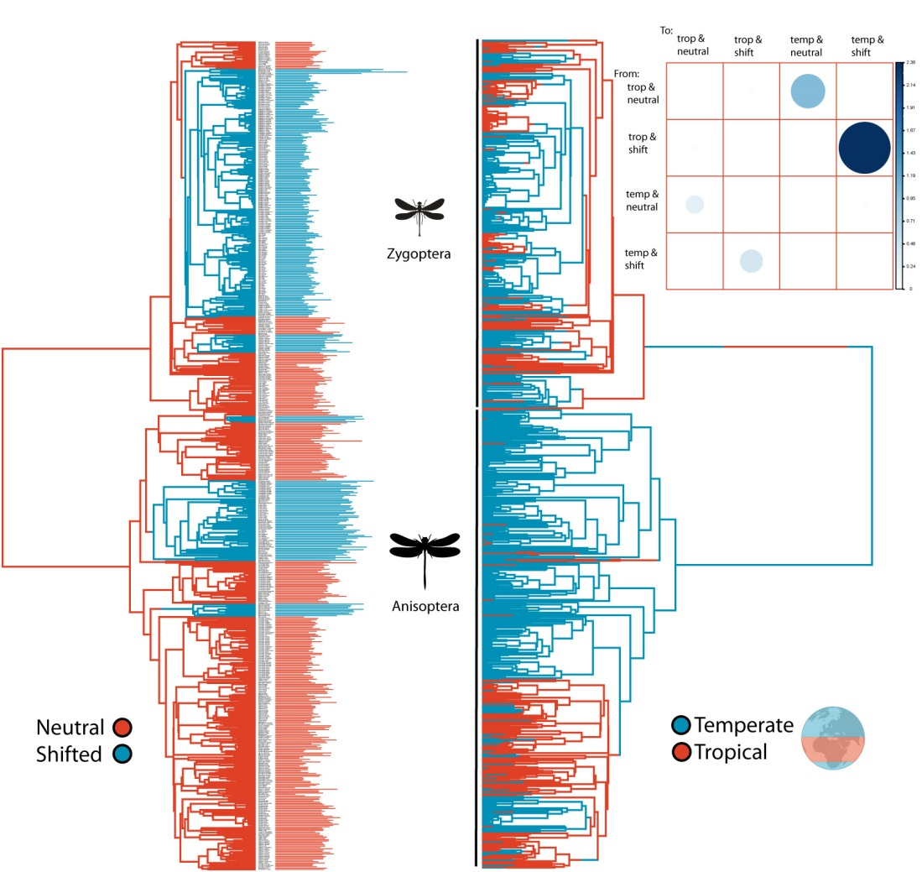

Figure 3. The continuous relationship between absolute latitude and hind wing length for fossils and extant dragonflies.

The evolution of temperate range plotted against the evolution of positive shifts in body size. The matrix diagram in the upper right visualizes the transition matrix from our corDISC model (all rates different) (Beaulieu et al. 2017). In this matrix we see that the largest transition rate is from lineages with tropical ranges and positively-shifted body size optima to temperate ranges and positively-shifted optima. This matrix indicates that larger body sizes are primarily not evolving at temperate latitudes, but instead emerge first in the tropics, followed by dispersal by such shifted clades in to temperate regions. This suggests that temperature is not the primary factor driving geographic patterns in body size, but instead that increased dispersal ability of large clades after glacial events might have been more important in establishing the current body size latitudinal gradient in odonates.

### Direct and indirect relationship between temperature and body size

Our phylogenetic path analysis revealed that temperature has only an indirect influence on body size distribution in European Odonata (Fig 4). Our best model (model 1) was one in which development time has a direct negative effect on total body length, and temperature has a direct negative effect on development time. Model averaged coefficient estimates (over all five models tested), showed that temperature only had a weak and non-significant direct negative effect on total body length compared to development time (Fig. 4), which means that temperature may not play a major role in structuring the distributions of larger and smaller species in Europe.

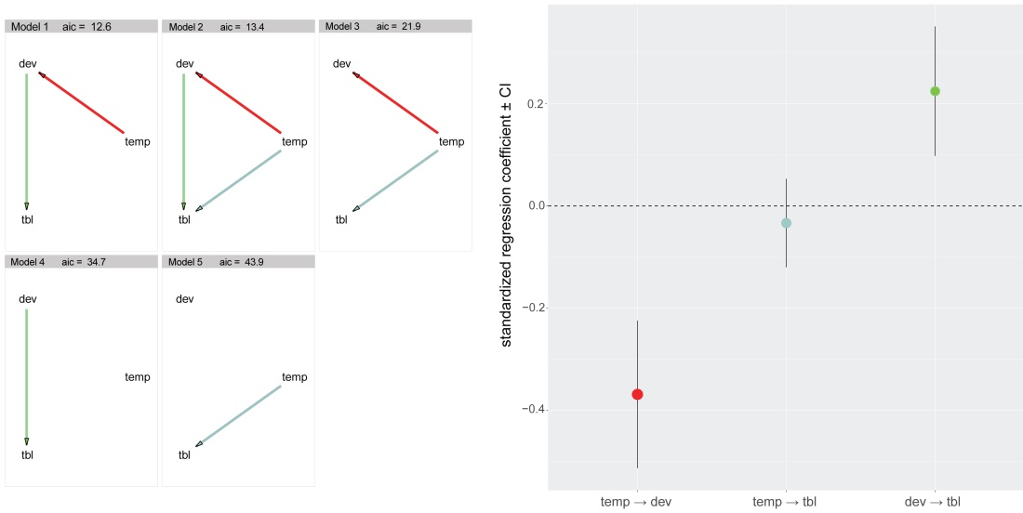

Figure 4. Diagrams of five nested phylogenetic path models.

These models show the statistical support for different cause-effect relationships between larval development time, temperature (annual mean temperature), and body size (total body length). Models are plotted in order of their AIC score (lowest first). The best model (model 1) was one in which development time has a direct positive effect on body size (tbl: total body length), and temperature has a direct negative effect on development time. However, we found no support for a direct effect of temperature on body size, only an indirect negative effect through the effect of temperature on development time. Model averaged coefficient estimates (over all the 5 models) illustrates this weak non-sigificant effect of temperature on total body length, compared to development time (right panel). This implies that temperature does not directly influence the geographic distribution of body size in Europe, but that temperature might only indirectly influence body sizes through its effect on development time. All models were fit using the R-package phylopath (Van der Bijl 2017).

### Geographic variation in hind wing length in relation to spatial environmental variation

We quantified how different environmental variables (Fig. 5) affected hindwing length in a series of nested phylogenetic generalized least squares (PGLS) models (Table 4). In Model 1, we explored how temperature affected wing length. Model 3 suggested that when considered alone, temperature has a significant negative effect on wing length (Table 4). However, after accounting for other potentially important ecological variables such as tree cover, precipitation, and avian diversity (species richness), the effect of temperature on interspecific size variation was reduced, whereas avian diversity was found to have a strong and large negative effect (Table 4). To investigate whether avian diversity was simply measuring a general species diversity effect, mammal diversity was included as a covariate, since mammals are unlikely predate on dragonflies or to occupy the same habitat niches as odonates. After accounting for mammal diversity, avian diversity still had a strong and significant negative effect on hind wing length (Table 4).

**Table 4. Phylogenetic** **Generalized Least Squares (PGLS).**

Phylogenetic Generalized Least Squares (PGLS) models of global geographic variation in odonate hind wing lengths. Five models of the relationship between hind wing length and geographic position were compared. All models corrected for phylogenetic non-independence using the corBrownian function in ape (Paradis et al. 2004), using the same phylogenetic tree (N = 674) and species set for structuring the covariance matrix. The best performing model (Model 4) is show in bold. The intercept term is not presented for simplicity. All spatial variables were scaled to have mean 0 and variance of 1, so as to be comparable to each other.

|  |  |  |  |  |  |  |  |
| --- | --- | --- | --- | --- | --- | --- | --- |
| **Model** | **Variable** | **Est** | **SE** | **P value** | **N** | **AIC** | **Rank** |
| 1 | Temperature | -0.964 | 0.159 | < 0.001 | 674 | 4157.17 | 3 |
|  |  |  |  |  |  |  |  |
| 2 | Temperature | -0.814 | 0.179 | < 0.001 | 674 | 4157.21 | 4 |
| 2 | Precipitation | -0.366 | 0.200 | 0.0677 |  |  |  |
|  |  |  |  |  |  |  |  |
| 3 | Temperature | -0.789 | 0.181 | < 0.001 | 674 | 4159.82 | 5 |
| 3 | Precipitation | -0.394 | 0.203 | 0.0525 |  |  |  |
| 3 | Tree Cover | -0.174 | 0.204 | 0.3933 |  |  |  |
|  |  |  |  |  |  |  |  |
| **4** | **Temperature** | **-0.437** | **0.191** | **0.0223** | **674** | **4136.57** | **1** |
| **4** | **Precipitation** | **-0.253** | **0.201** | **0.2083** |  |  |  |
| **4** | **Tree Cover** | **0.187** | **0.212** | **0.3776** |  |  |  |
| **4** | **Avian** **Diversity.** | **-1.421** | **0.276** | **< 0.001** |  |  |  |
|  |  |  |  |  |  |  |  |
| 5 | Temperature | -0.451 | 0.192 | 0.0192 | 674 | 4138.09 | 2 |
| 5 | Precipitation | -0.237 | 0.203 | 0.2433 |  |  |  |
| 5 | Tree Cover | 0.166 | 0.215 | 0.4403 |  |  |  |
| 5 | Avian Diversity | -1.597 | 0.411 | < 0.001 |  |  |  |
| 5 | Mammal Diversity | 0.248 | 0.428 | 0.5625 |  |  |  |
|  |  |  |  |  |  |  |  |

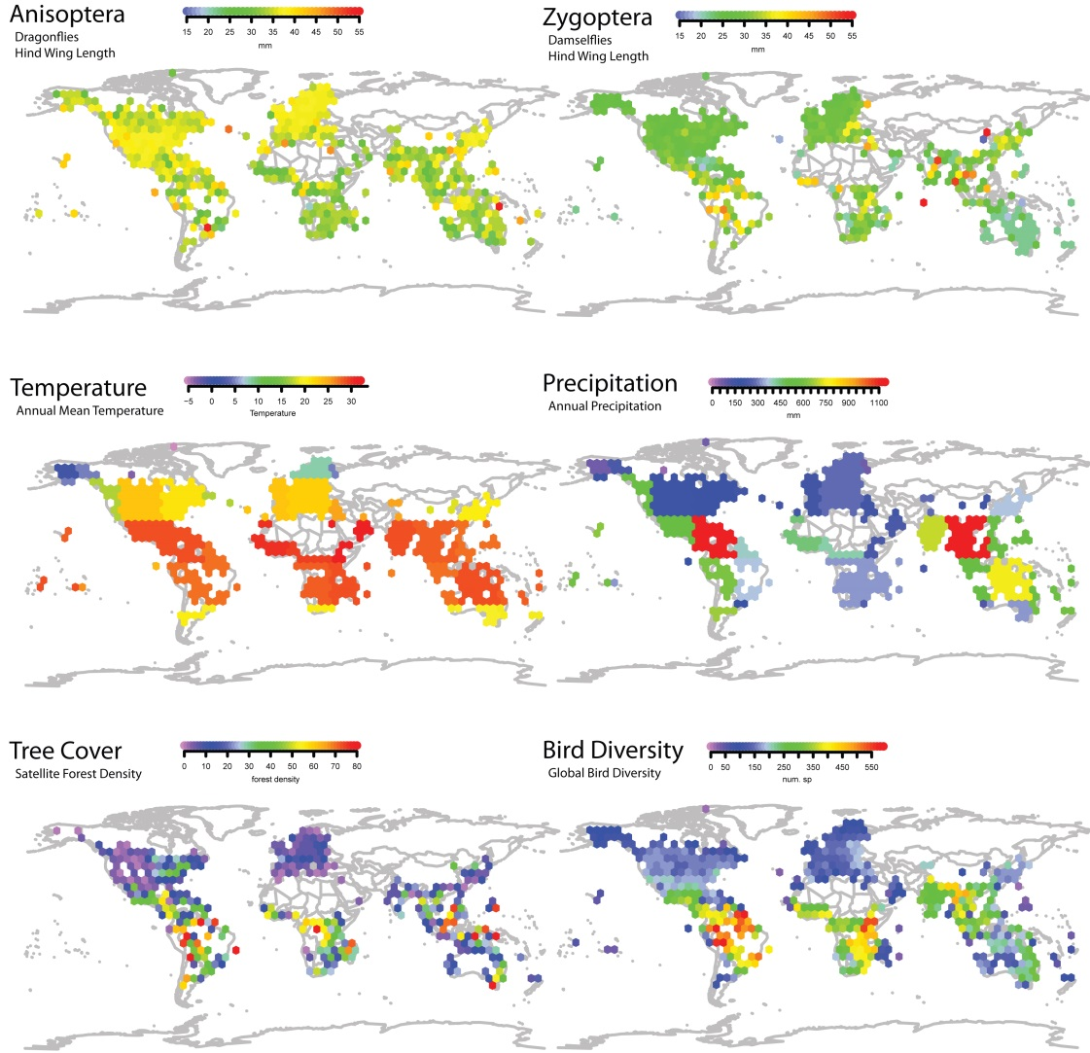

Figure 5. Spatial hexagon plots.

Spatial hexagon plots of the five main geographic datasets used in our PGLS-models of factors influencing odonate body sizes across the globe. Each hexagon represents the mean value of the variable over which the hexagon cover, but not over the entire space but only from points drawn from the odonate occurrence dataset. Thus, the value from each hexagon represents only the values of that spatial variable that are relevant to odonates. Hexagons are spaced by around 5o between each hexagon. Plots are shown to illustrate the global distribution of the data. Mean values for each species were used in all analyses, which limits the effect of spurious spatial auto-correlation. See Materials and Methods for a description of the spatial variables that we used.

## Discussion

Overall, body size evolution and interspecific diversification in odonates show signs of constrained divergence (Waller and Svensson 2017), where accumulation of body size diversity is clearly non-neutral (Table 1), but there is no signature of a so-called “early burst”, which is one expected pattern in adaptive radiations (Schluter 2000; Harmon et al. 2010). This prediction is, however, often discussed in the context of adaptive radiations driven by ecological resource competition and niche divergence, which might not apply to odonates, which are characterized by only weak ecological niche differentiation, as these are generalist predators with no or little differentiation in thermal or climatic niches (McPeek and Brown 2000; Siepielski et al. 2010; Wellenreuther et al. 2012; Svensson 2012; Svensson et al. 2018). Based on the ecological features and the natural history of odonates, we would argue that we should not even a priori expect such an early burst pattern, neither for body size nor for other traits, as phenotypic evolution in these ectothermic insects is more likely to be driven by environmental tolerance to temperature and other abiotic factors, dispersal and natural enemies, like predators and parasites, rather than competition for resources or feeding niches. Results in this study supports this view, as further discussed below.

We found some interesting differences in geographic body size distributions in dragonflies and damselflies, with dragonflies being larger in temperate regions and damselflies being larger at tropical latitudes (Fig. 1A; Table 3). This difference between the two suborders disappeared, however, when we corrected for phylogeny (Fig. 1B). This difference between the two types of analyses can be explained by the fact that some large damselfly clades in the tropics that have not invaded the temperate regions (e.g. the large helicopter damselflies in the genus *Megaloprepus*; Waller and Svensson 2017), and such clades might partly drive this latitudinal pattern, which becomes reversed when phylogeny is taken in to account (Fig. 1). The general picture that emerges is that both dragonflies and damselflies are on average larger in the temperate regions, compared to the tropics, when phylogeny is taken in to account. Interestingly, this latitudinal trend might have appeared more recently, judged by significant negative trends between latitude and body size in the fossil record (Fig. 2; Tables 2-3).

On macroevolutionary time scales, the relationship between latitude and wing size in the fossil record revealed changing temporal patterns in both dragonflies and damselflies (Fig. 2; Tables 2-3). Prior to, and up to the start of the major evolutionary radiation of birds (210-80 MYA) (Padian and Chiappe 1998), dragonflies showed a pattern of decreasing body size with increasing paleo-latitude, i.e. a reversed Bergmann’s Rule. Then, right before and after the last major extinction event (65-80 MYA), this latitudinal trend became reversed (Fig. 2).

These results indicate that temperature is only one of several factors driving the dynamically changing latitudinal-size trend, among both extant and fossil taxa. Temperature might even play a secondary role compared to many other important ecological factors, both abiotic and abiotic (Figs. 2-5). The macroevolutionary temporal difference between the two suborders might also imply that they follow different temperature-size rules in terms how temperature structures the geographic organization of body size variation (Fig. 2). For instance, the generally larger bodied dragonflies might be more sensitive to the temperature-size rule than damselflies (Forster et al. 2012). However, the fact that both suborders have changed the slope sign (dragonflies) or slope magnitude (damselflies) of their latitudinal relationship over geological time (Fig. 2) indicates that a simple version of the temperature-size rule is not sufficient to explain the latitudinal size gradients. As this latitudinal relationship is not stable over geological time (Fig. 2), it is unclear exactly to what extent and how the classical temperature-size rule at the intraspecific level (Kingsolver and Huey 2008) contributes to structure the interspecific geographic size assemblages over the entire globe (Figs. 2 and 5).

Our phylogenetic path analysis revealed that, at least for the odonates that inhabit temperate latitudes in Europe, temperature does not directly influence on body size, but do instead indirectly influence body size indirectly via development time. A direct effect, if present, would have been consistent with temperature as the primary variable structuring geographic interspecific variation of adult body size in Europe. However, we instead found evidence for an indirect negative effect of temperature on body size through its effect on development time (Fig. 3). The lack of any direct effect of temperature on adult size can be interpreted as there are no habitat preference for cooler habitats among large-bodied odonates, such as dragonflies.

When we linked our previously demonstrated evolutionary shifts towards larger body size optima (Waller and Svensson 2017) to temperate or tropical ranges, we found that relatively large-sized odonate lineages in the temperate zone did not evolve there *in situ* but rather invaded those high latitude areas after they had evolved larger body size in the tropics (Fig. 4). This suggests that the pattern of larger dragonfly species in the temperate region compared to the tropics is not a simple consequence of the classical temperature-size rule documented in many intraspecfic experimental studies (Kingsolver and Huey 2008). Instead, this latitudinal pattern is likely to partly result from higher dispersal rates and/or colonization ability of large-bodied dragonflies from the tropics, where they originated, in to the temperate zone. Thus, lower temperatures do not necessarily lead to the evolution of larger body size in dragonflies or odonates at the macroevolutionary level, but it is rather so that lineages that have evolved larger body sizes are more likely to invade the temperate region (Fig. 4).

Across our global dataset, we found that temperature had a negative effect on hind wing size in both dragonflies and damselflies, after controlling for phylogenetic non-independence (Table 4). Accounting for other confounding variables, such as tree cover, precipitation, and bird and mammal diversity (Fig. 5), this effect of temperature was reduced, although still significantly negative (Table 4) Interestingly, regional avian diversity (species richness) was found to be the strongest predictor of hind wing length (Table 4). This negative effect of bird diversity on odonate size remained even after accounting for other confounding variables, such as temperature, tree cover, and precipitation (Table 1).

There is empirical evidence from ecological field studies and suggestive indications from paleontological time series that predators are a major selective pressure against large body size in odonates and other insects (Gotthard et al. 2007; Clapham and Karr 2012). More specifically for odonates, it has been shown that avian predators (white wagtails, *Motacilla alba*) selected against longer wings in two different extant damselfly populations of the damselfly *Calopteryx splendens* in Sweden (Svensson and Friberg 2007; Outomuro and Johansson 2015). In a third study of *C. splendens* in Finland, the researchers found no evidence for significant selection on neither fore- nor hindwing length (Rantala et al. 2011), whereas in a fourth independent study in Sweden, there was evidence for stabilizing selection on forewing length (Kuchta and Svensson 2014).

Based on these data, we suggest that the macroevolutionary changing body size-latitude pattern (Fig. 2; Tables 2-3) might reflect that prior to the evolutionary adaptive radiation of the major bird groups, dragonflies might have occupied aerial niches in lower latitudes that gradually and subsequently became occupied by birds. Alternatively, although not mutually exclusive, predation from birds and other biotic interactions gradually increased at the lower latitudes in the tropics as bird diversity accumulated, compared to higher latitudes in the temperate region. There is indeed a small but growing body of empirical evidence suggesting that predation rates on insects are higher in the tropics compared to the temperate region (Schemske et al. 2009; Freestone et al. 2011; Roslin et al. 2017). Whatever the exact mechanism behind these geographic patterns of body size in relation to latitude, these relationships might suggest that the larger dragonflies could be more successful in colonizing temperate latitudes after glacial retreats than are damselflies, given that extant dragonfly taxa show a stronger positive relationship with latitude (Fig. 2; Tables 2-3). This stronger relationship in dragonflies could be due to a positive relationship between size, flight performance and by extension colonization ability. In general, damselflies are smaller and less mobile than dragonflies and, not surprisingly, all the known long-distance migrants among odonates are dragonfly species, not damselflies (Wikelski et al. 2006; Anderson 2009; Chapman et al. 2015; Troast et al. 2016).

To investigate whether the effects of avian diversity on geographic size distribution of odonates (Fig. 5) was due to some confounding and unknown role of high biodiversity in general, we used mammal diversity as a control variable (Fig. S1). It is unlikely that mammals would compete for same niches as odonates and mammals are not known to be significant predators of odonates. Mammals still show high species diversity in the tropics, just like birds (Fig S1). After including mammalian diversity in a model with precipitation, tree cover, temperature, and bird diversity, we found that avian diversity still had a large and negative effect on body size in odonates (Table 4; model 5). We therefore conclude that the effect of avian diversity on odonate body size geographic distributions cannot simply be explained away as a simple general biodiversity effect. Even given this control, however, we cannot of course exclude that some third variable that is correlated with avian diversity is the causal factor that structures geographic body size variation in odonates. Whether the effects of avian diversity is reflecting niche competition, predation, or a combination of the two is not possible to test with the current data and using phylogenetic comparative analyses alone. These results do, however, fit with suggestions that biotic factors might be as in important in explaining macroevolution in insects and other organisms (Voje et al. 2015) as are environmental abiotic factors such as atmospheric oxygen levels (Clapham and Karr 2012).

## Conclusions

We conclude, based on the results of the phylogenetic comparative analyses in this study, that environmental factors (temperature, precipitation, and forest density) may play a secondary role when compared to ecological factors (dispersal, predation, or niche filling) in shaping geographic distributions of body size in odonates. We have argued that neither the temperature-size rule nor a simple version Bergman’s rule for insect are sufficient in themselves to fully explain the observed geographic pattern in body size among odonate lineages. Rather surprisingly we found that bird diversity had strong influence on odonate body size distributions even when we controlled for a possible diversity hotspot effect by comparing with mammalian diversity.

The exact mechanisms by which bird diversity shape interspecific geographic variation in odonate body sizes is not yet known. Potential likely explanations are niche filling and avian predation. With more studies on predation and selection in the tropics, it might be possible to better understand why bird diversity can so strongly predict geographic body size patterns in odonates. Combined with the changing latitudinal patterns of body size distributions on the macrevolutionary time scale, the findings in this study are consistent with a scenario whereby odonate taxa evolve large body sizes at lower latitudes, followed by dispersal out of the tropics, possibly partly driven by the emergence of modern birds and associated competition and predation. Large dragonfly clades presumably had a higher dispersal propensity or capacity and were the first to invade the temperate regions followed by glacial retreats, whereas many of the large damselfly clades have remained in the tropics, resulting in a geographical size-pattern that changes depending on if phylogeny is considered (Fig. 1B) or ignored (Fig. 1A).

# References

Alroy, J., Marshall, C., & Miller, A. (2012). The paleobiology database. <http://paleodb.org>.

Van der Bijl, W. (2017). phylopath: Perform phylogenetic path analysis.R package version 0.3.1. https://github.com/Ax3man/phylopath.

BirdLife International (2011) http://www.birdlife.org/

Anderson, R. C. (2009). Do dragonflies migrate across the western Indian Ocean? *J. Trop. Ecol*. 25: 347-358.

Angilletta, Jr, M. J., & Dunham, A. E. (2003). The temperature-size rule in ectotherms: simple evolutionary explanations may not be general. *Am. Nat.* 162: 332-342.

Ashton, K. G., Tracy, M. C., & Queiroz, A. D. (2000). Is Bergmann’s rule valid for mammals? *Am. Nat.* 156: 390-415.

Kuchta, S. R., & Svensson, E. I. (2014). Predator-mediated natural selection on the wings of the damselfly Calopteryx splendens: differences in selection among trait types.  *Am. Nat.* 184: 91-109.

Atkinson, D. (1996). Ectotherm life-history responses to developmental temperature. *Animals and temperature: Phenotypic and evolutionary adaptation*.

Baird, I. R. (2014). Larval burrow morphology and groundwater dependence in a mire-dwelling dragonfly, *Petalura gigantea* (Odonata: Petaluridae). *Int. J. Odonatol.* 17: 101-121.

Beaulieu, J. M., J, Oliver, C., & O'Meara, B. (2017) corHMM: Analysis of Binary Character Evolution. R package version 1.22 .https://CRAN.R-project.org/package=corHMM.

Baker, J., Meade, A., Pagel, M., & Venditti, C. (2015). Adaptive evolution toward larger size in mammals. *Proc. Natl. Acad. Sci*., USA 112: 5093-5098.

Bhagwat, S. A., & Willis, K. J. (2008). Species persistence in northerly glacial refugia of Europe: a matter of chance or biogeographical traits? *J. Biogeogr.* 35: 464-482.

Bivand, R. S., Pebesma, E. J., Gomez-Rubio, V., & Pebesma, E. J. (2008). *Applied spatial data analysis with R* (Vol. 747248717). New York: Springer.

Blackburn, T. M., & Gaston, K. J. (1994). Animal body size distributions: patterns, mechanisms and implications. *Trends Ecol. Evol.* 9: 471-474.

Blackburn, T. M., Gaston, K. J., & Loder, N. (1999). Geographic gradients in body size: a clarification of Bergmann's rule. *Div. Distrib.* 5: 165-174.

Blanckenhorn, W. U. (2000). The evolution of body size: what keeps organisms small?

*Q. Rev. Biol.* 75: 385-407.

Bujan, J., Yanoviak, S. P., & Kaspari, M. (2016). Desiccation resistance in tropical insects: causes and mechanisms underlying variability in a Panama ant community. *Ecol. Evol.* 6: 6282-6291.

Chapman, J. W., Reynolds, D. R., & Wilson, K. (2015). Long‐range seasonal migration in insects: mechanisms, evolutionary drivers and ecological consequences. *Ecol. Lett.*18: 287-302.

Clapham, M. E., & Karr, J. A. (2012). Environmental and biotic controls on the evolutionary history of insect body size. *Proc. Natl. Acad. Sci*., USA 109: 10927-10930.

Clauset, A., & Erwin, D. H. (2008). The evolution and distribution of species body size. *Science* 321: 399-401.

Damuth, J. (1981). Population density and body size in mammals. *Nature* 290: 699-700.

Fick, S. E., & Hijmans, R. J. (2017). WorldClim 2: new 1‐km spatial resolution climate surfaces for global land areas. *Int. J. Climatol.*

Freestone, A. L., Ruiz, G. M., & Torchin, M. E. (2013). Stronger biotic resistance in tropics relative to temperate zone: effects of predation on marine invasion dynamics. *Ecology* 94: 1370-1377.

Glasspool, I. J., & Scott, A. C. (2010). Phanerozoic concentrations of atmospheric oxygen reconstructed from sedimentary charcoal. *Nature Geosci*. 3: 627-630.

Gotthard, K., Berger, D., & Walters, R. (2007). What keeps insects small? Time limitation during oviposition reduces the fecundity benefit of female size in a butterfly. *Am. Nat*. 169: 768-779.

Harmon, L. J., Losos, J. B., Jonathan Davies, T., Gillespie, R. G., Gittleman, J. L., Bryan Jennings, W., Kozak, K. H., McPeek, M.A., Moreno‐Roark, F., Near, T.J., & Purvis, A. (2010). Early bursts of body size and shape evolution are rare in comparative data. *Evolution* 64: 2385-2396.

Harrison, J. P., Gheeraert, N., Tsigelnitskiy, D., & Cockell, C. S. (2013). The limits for life under multiple extremes. *Trends Microbiol.* 21: 204-212.

Henry, J. R., & Harrison, J. F. (2014). Effects of body size on the oxygen sensitivity of dragonfly flight. *J. Exp. Biol*. 217: 3447-3456.

Hijmans, R. J., van Etten, J., Cheng, J., Mattiuzzi, M., Sumner, M., Greenberg, J. A., ... (2016). Package ‘raster’. *R package. https://cran. r-project. org/web/packages/raster/index. html (accessed 1 October 2016)*.

Jenkins, C. N., Pimm, S. L., & Joppa, L. N. (2013). Global patterns of terrestrial vertebrate diversity and conservation. *Proc. Natl. Acad. Sci*., USA 110: E2602-E2610.

Johansson, F. (2003). Latitudinal shifts in body size of *Enallagma cyathigerum* (Odonata). *J. Biogeogr*. 30: 29-34.

Khabbazian, M., Kriebel, R., Rohe, K., & Ané, C. (2016). Fast and accurate detection of evolutionary shifts in Ornstein–Uhlenbeck models. *Methods Ecol. Evol.* 7: 811-824.

Kingsolver, J. G., & Huey, R. B. (2008). Size, temperature, and fitness: three rules. *Evol. Ecol. Res.* 10: 251-268.

Marron, M. T., Markow, T. A., Kain, K. J., & Gibbs, A. G. (2003). Effects of starvation and desiccation on energy metabolism in desert and mesic *Drosophila*. *J. Insect Physiol.* 49: 261-270.

Mattila, T. M., & Bokma, F. (2008). Extant mammal body masses suggest punctuated equilibrium. *Proc. R. Soc. Lond.* B. 275: 2195-2199.

McCue, M. D. (2010). Starvation physiology: reviewing the different strategies animals use to survive a common challenge. *Comp. Biochem. Physiol. A: Mol. Integr. Physiol*. 156: 1-18.

McPeek, M. A. and J. M. Brown. 2000. Building a regional species pool: diversification of the *Enallagma* damselflies in Eastern North America. *Ecology* 421: 904-920.

McPeek, M. A., Schrot, A. K., & Brown, J. M. (1996). Adaptation to predators in a new community: swimming performance and predator avoidance in damselflies. *Ecology* 77: 617-629.

Mousseau, T. A. (1997). Ectotherms follow the converse to Bergmann's rule. *Evolution* 51: 630-632.

Nilsson-Örtman, V., Stoks, R., De Block, M. & Johansson, F. (2012). Generalists and specialists along a latitudinal transect: patterns of thermal adaptation in six species of damselflies. *Ecology* 93: 1340-1352.

Olalla-Tárraga, M. Á., Rodríguez, M. Á. & Hawkins, B. A. (2006). Broad-scale patterns of body size in squamate reptiles of Europe and North America. *J. Biogeogr.* 33: 781-793.

Outomuro, D. & Johansson, F. (2015). Bird predation selects for wing shape and coloration in a damselfly. *J. Evol. Biol.* 28: 791-799.

Padian, K. & Chiappe, L. M. (1998). The origin and early evolution of birds. *Biol. Rev*. 73: 1-42.

Paradis, E., Claude, J., & Strimmer, K. (2004). APE: analyses of phylogenetics and evolution in R language. *Bioinformatics* 20: 289-290.

Partridge, L., & Coyne, J. A. (1997). Bergmann's rule in ectotherms: is it adaptive? *Evolution* 51: 632-635.

Peel, M. C., Finlayson, B. L., & McMahon, T. A. (2007). Updated world map of the Köppen-Geiger climate classification. *Hydrol. Earth Syst. Sci. Discuss*. 4: 439-473.

Rainford, J. L., Hofreiter, M., & Mayhew, P. J. (2016). Phylogenetic analyses suggest that diversification and body size evolution are independent in insects. *BMC Evol. Biol*. 16: 8-30.

Rantala, M. J., Honkavaara, J., Dunn, D. W., & Suhonen, J. (2011). Predation selects for increased immune function in male damselflies, *Calopteryx splendens*. *Proc. R. Soc. Lond.* B. 278: 1231-1238.

Roslin, T., Hardwick, B., Novotny, V., Petry, W. K., Andrew, N. R., Asmus, A., Barrio I. C., Basset Y., Boesing A. L., Bonebrake, T. C., & Cameron, E. K. (2017). Higher predation risk for insect prey at low latitudes and elevations. *Science* 356: 742-744.

Sandhall, A. (1987). Trollsländor i Europa. *Stenströms Bokförlag (in Swedish)*.

Schemske, D. W., Mittelbach, G. G., Cornell, H. V., Sobel, J. M., & Roy, K. (2009). Is there a latitudinal gradient in the importance of biotic interactions? *Annu. Rev. Ecol. Evol. Syst*. 40: 245-269.

Schluter, D. (2000). The Ecology of Adaptive Radiation. Oxford University Press, Oxford.

Schorr, M., and D. Paulson. (2015).World Odonata List. Electronic Database accessible at http://www.pugetsound.edu/academics/academic-resources/ slater-museum/biodiversity-resouces/dragon flies/world-odonata-list2/. Accessed 11 (2015)

Sexton, J. O., Urban, D. L., Donohue, M. J., & Song, C. (2013). Long-term land cover dynamics by multi-temporal classification across the Landsat-5 record. *Remote Sens. Environ.* 128: 246-258.

Shelomi, M. (2012). Where are we now? Bergmann’s rule sensu lato in insects. *Am. Nat*. 180: 511-519.

Siepielski, A. M., K. L. Hung, E. E. B. Bein & M. A. McPeek. 2010. Experimental evidence for neutral community dynamics governing an insect assemblage. *Ecology* 91: 847-857.

Sokolovska, N., Rowe, L., & Johansson, F. (2000). Fitness and body size in mature odonates. *Ecol. Entomol*. 25: 239-248.

Stillwell, R. C. (2010). Are latitudinal clines in body size adaptive? *Oikos* 119: 1387-1390.

Stillwell, R. C., Moya-Laraño, J., & Fox, C. W. (2008). Selection does not favor larger body size at lower temperature in a seed-feeding beetle. *Evolution* 62: 2534-2544.

Stoks, R., & Córdoba-Aguilar, A. (2012). Evolutionary ecology of Odonata: a complex life cycle perspective. *Ann. Rev. Entomol.* 57: 249-265.

Svensson, E. I. (2012). Non-ecological speciation, niche conservatism and thermal adaptation: how are they connected? *Org. Div. Evol.* 12: 229-240.

Svensson, E. I., & Friberg, M. (2007). Selective predation on wing morphology in sympatric damselflies. *Am. Nat*. 170: 101-112.

Svensson, E. I., Gomez-Llano, M., Rivas Torres, A. & Bensch, H. M. (2018). Frequency-dependence and ecological drift shape coexistence of species with similar niches. *Am. Nat.* (in press).

Troast, D., Suhling, F., Jinguji, H., Sahlén, G., & Ware, J. (2016). A global population genetic study of Pantala flavescens. *PLOS* ONE: 11(3): e0148949.

Uyeda, J. C., Hansen, T. F., Arnold, S. J., & Pienaar, J. (2011). The million-year wait for macroevolutionary bursts. *Proc. Natl. Acad. Sci*., USA 108: 15908-15913.

Van Voorhies, W. A. (1997). On the adaptive nature of Bergmann size clines: a reply to Mousseau, Partridge and Coyne. *Evolution* 51: 635-640.

Verberk, W. C., & Atkinson, D. (2013). Why polar gigantism and Palaeozoic gigantism are not equivalent: effects of oxygen and temperature on the body size of ectotherms. *Funct. Ecol.* 27: 1275-1285.

Voje, K. L., Holen, Ø. H., Liow, L. H. & Stenseth, N. C. (2015). The role of biotic forces in driving macroevolution: beyond the Red Queen. Proc. R. Soc. Lond. B. 282: 20150186; DOI: 10.1098/rspb.2015.0186

Waller, J. T. & Svensson, E. I. (2017). Body size evolution in an old insect order: No evidence for Cope's Rule in spite of fitness benefits of large size. *Evolution*. 71:2178-93.

Wellenreuther, M., K. W. Larson & E. I. Svensson. (2012). Climatic niche divergence or conservatism? Environmental niches and range limits in ecologically similar damselflies. Ecology 93: 1353-1366.

Wikelski, M., Moskowitz, D., Adelman, J. S., Cochran, J., Wilcove, D. S., & May, M. L. (2006). Simple rules guide dragonfly migration. Biol. Lett. 2: 325-329.