Odonate Phenotypic DataBase

[**www.odonatephenotypicdatabase.org**](http://www.odonatephenotypicdatabase.org)

A project by John Waller, Beatriz Willink, Maximilian Tschol, and Erik Svensson

**Taxonomy**

**GenusSpecies, Genus, Species, Family, SubOrder**

Taxonomy of record. Names are taken from the World Odonata List.

<https://www.pugetsound.edu/academics/academic-resources/slater-museum/biodiversity-resources/dragonflies/world-odonata-list2/>

The names used in the database were downloaded from the list in 2015. In the future we hope include synonyms in the database, so as to track taxonomic changes.

**Sex**

The database currently has more phenotypic descriptions for males than for females. This reflects the current distribution in the literature, and the fact that females are typically more difficult to identify in the field.

**Size**

**body_lengths or female_body_lengths**

Total length (mm). Mean or mid-point values are used when a range is given in the source material.

**forewing_lengths or female_forewing_lengths**

Length of the front wing (mm). Mean or mid-point values are used when a range is given in the source material.

**hindwing_lengths or female_hindwing_lengths**

Length of the hind wing (mm). Mean or mid-point values are used when a range is given in the source material. Hind wing lengths are reported in the literature much more often than front wing lengths.

**Body Colors**

**body_colors**

Body colors (head, thorax, abdomen, legs). The human visual perception of a body color in an image or illustration. The database uses the following colors: **black**, **blue**, **brown**, **green**, **orange**, **red**, **yellow**. When mixed, multiple colors are reported. In the future, we hope to incorporate machine-read colors (i.e. rgb-values) into the database.

**body_colortypes**

Body color type (head, thorax, abdomen, legs) or how the color is produced physically. The database uses the following classifications: **pigment** (has matte appearance), **structural** (has metallic appearance), or **pruinescence** (has powder appearance). When a species has multiple color types, all are listed. Mixed can be any body part (head, thorax, abdomen, legs). For example, structural legs and pigmented body would be “**pigment** **structural**.” More fine-grained classifications might be possible in the future.

**body_patterns**

Body patterns (head, thorax, abdomen, legs). The patterns found on any part of the body. The database uses the following classifications: **plain** (no pattern, matte color), **striped** (have some strip-like pattern), **spotted** (has dot or spot-like pattern). When more than one pattern type is present both are listed, such as “**spotted**, **striped**.”

**Behaviour**

**mate_guarding**

The type of mate guarding behavior listed in the literature. The database has the following classifications: **contact** (male holds female after mating), **noncontact** (male guards female but does not hold after mating), **none** (male does not guard female).

**flight_mode**

Primary type of flight behaviour in listed in the literature. The database currently uses two classifications: **flier** (more often flying) or **percher** (more often perching). If mixed behaviour, both are listed.

**territoriality**

The territoriality of the male as listed in the literature. The databases uses two classifications: **nonterritorial** and **territorial.**

**Location and Habitat**

**continents**

What continents are populations known to exist. The database uses the following continents: **afrika**, **asia**, **australia**, **europe**, **north** **america**, and **south** **america**. When on several continents multiple are listed.

**aquatic_habitats**

The type of aquatic habitat that the adults primarily exist in and around. The database uses the following classifications: **ephemeral** (a small pool that dries up quickly), **lake**, **pond**, **river**, **stream**, **wetland**.

**climates**

Climates where they populations are known to be found according to distributions maps.

See: Climate classification: Discrete climate classifications, using the 30 categories in Köppen-Geiger classification scheme (Peel et al. 2007 Hydrol. Earth Syst. Sci 11: 1633–1644).

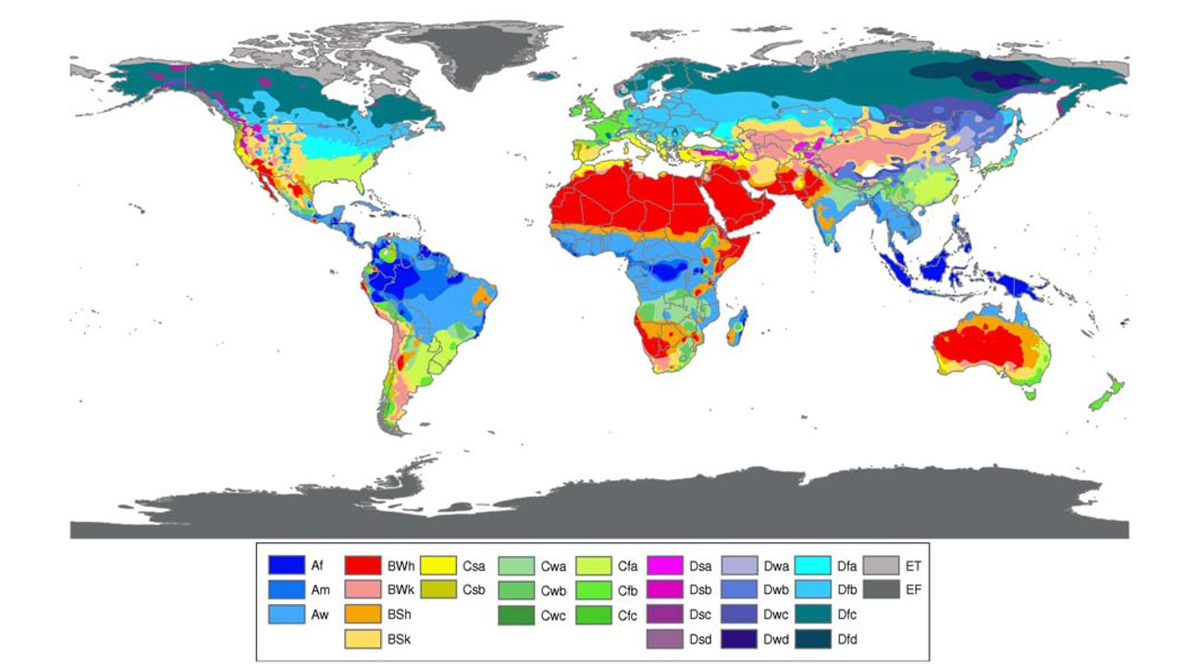

**ecozones**

Which “ecozone” are populations known to exists from looking at distribution maps. The database uses the following: **afrotropical**, **antarctica**, **australasia**, **indomalaya**, **nearctic**, **neotropical**, **oceania**, and **palearctic** . Eight different ecozones exist, and their locations and borders are shown on the World map below.

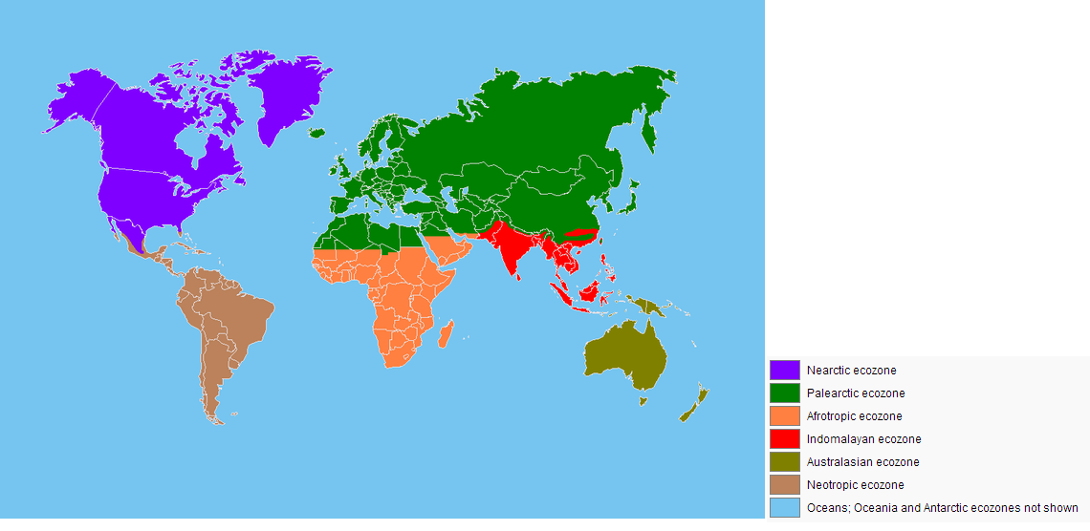

**habitat_openness**

Habitat openness: **closed**, **open**, **semi**. When mixed more than one can be recorded.

**Morphisms**

**sex_polymorphisms**

Is the species polymorphic? The following categories are used in the database: **females** (females are polymorphic), **males** (males are polymorphic), and **monomorphic** (both sexes known to be monomorphic). If both males and females are polymorphic, both are listed “**males** **females**.”

**sex_dimorphisms**

Is the species sexually dimorphic? The database uses the following classifications: **medium**, **strong**, or **weak**. Since all species are likely to be at least slightly dimorphic, “**weak**” dimorphism implies very few differences, while “**strong**” dimorphisms implies that the sexes are easily distinguished in the field.

**geo_polymorphisms**

Is the species polymorphic geographically? In other words, are there different types of morphs in different regions. The following categories are used in the database: **females polymorphic**, **males polymorphic**, and **monomorphic**. For example, if males of one species has black spots in north Africa but orange spots in southern Africa, that would be recorded as “**males polymorphic”**. If both sexes are known to be the same across their range, that species is recorded as “**monomorphic**.”

**Wing Pigment or Color**

**has_wing_pigment**

Does the species have wing color? **yes** or **no**. If the species has clear wings, the database records “**no**”. If the wings have color, “**yes”** is recorded.

**wing_pigment_extent_discrete**

Discrete levels of coloration that cover the wing. It is recorded in the database as : **10%**, **25%** ,**50%** ,**75%** ,or **100%**.

**wing_pigment_extent_continuous**

Continuous measure of wing coloration. Proportion of the wing that is colored (0-1) colored area of the wing divided by total area of the wing.

**wing_pigment_pattern**

The pattern of wing color on the wings. In the database, we record three types: **stripes**, **patch**, or **dots**. If more than one type, multiple are listed.

**wing_pigment_symmetry**

Dofront and hind wings have color to an equal extent? If yes we record **symmetric pigment**, if no then: we put either **hindwing more pigment** or **forewing more pigment.**

**wing_pigment_dimorphism**

Wing sexual dimorphism. The differences in wing pigment between the sexes. The scale that takes differences in coloration into account: male and female have roughly the same amount of colouration on the wings +/- 10 % and have the same colors present, can be classified as **not dimorphic**. If males and females differ in coloration by more than 10 percent, and/or differ in the colors present on the wing, classified as **weakly dimorphic**  in their wing coloration. If males and females differ by more than 50% and may have different colors present, they are classified as **strongly dimorphic**. If males and females have both fully pigmented wings, but differ in colors present (for example, male dark brown, female amber), **weakly dimorphic** is recorded.

**wing_pigment_color**

The colors present in the wing.The database records the following colors: **brown**, **red**, **yellow**, **black**, **orange**, **iridescent**, **amber** (amber covers light brown to orange), **prunescence**, and **blue.** If multiple colors are present in the wing, multiple colors are listed.

**wing_pigment_placement**

Where the pigment or color is located. If the wing color or pigment is found at the bottom of the wing, **basal** is recorded. If the pigment is found in the center of the wing, **middle** is recorded. If the pigment is found at the tip of the wing, **tip** is recorded. If the wing is fully covered in color or pigment, **full** is recorded. If multiple areas are covered by color or pigment, multiple areas are listed, such as “**tip middle**”.

**wing_pigment_color_type**

Wing color type present. If color is matte in appearance, than **pigment** recorded. If color has metallic or is known to be generated by structures, **structural** is recorded. If both pigment and structural colors are present, then both **pigment** and **structural** are recorded. Since the basis for structural coloration is often pigment, pigment and structural often appear together for the same species.

**female_has_wing_pigment**

Does the species have wing color? **Yes** or **no**. If the species has clear wings, the database records “no”. If the wings have color, yes is recorded. If the wings are slightly transparent and not completely opaque, **smokey** is recorded.

**female_wing_pigment_extent_discrete**

Discrete levels of coloration that cover the wing. It is recorded in the database as : **10%**, **25%** ,**50%** ,**75%** ,or **100%**.

**female_wing_pigment_extent_continuous**

Continuous measure of wing coloration. Proportion of the wing that is colored (0-1) colored area of the wing divided by total area of the wing.

**female_wing_pigment_placement**

Where the pigment or color is located. If the wing color or pigment is found at the bottom of the wing, **basal** is recorded. If the pigment is found in the center of the wing, **middle** is recorded. If the pigment is found at the tip of the wing, **tip** is recorded. If the wing is fully covered in color or pigment, **full** is recorded. If multiple areas are covered by color or pigment, multiple areas are listed, such as “**tip middle**”.

**citations**

The primary references used to gather the data. Most of time these are field guides. Below is a list of resources that the database currently is based on.

|  |  |  |
| --- | --- | --- |
| Authors | Title and Publisher | Year |
| Theischinger and Hawking | Complete Field Guide to Dragonflies of Australia; CSIRO Publishing | 2006 |
| Kawashima and Futahashi | Dragonflies of Japan; Bunichi-Sogo Syuppan | 2012 |
| Dijkstra and Lewington | Field Guide to the Dragonflies of Britain and Europe; British Wildlife Publishing | 2006 |
| Paulson | Dragonflies and Damselflies of the West; Princeton University Press | 2009 |
| Samways | Dragonflies and Damselflies of South Africa; Penguin Random House South Africa | 2008 |
| Tarboton and Tarboton | A Fieldguide to the Dragonflies of South Africa; Warwick & Michèle Tarboton | 2002 |
| Heckman | Encyclopedia of South American Aquatic Insects: Odonata-Anisoptera; Springer | 2006 |
| Paulson | Dragonflies and Damselflies of the East; Princeton University Press | 2011 |
| Tang Hung Bun et al | A Photographic Guide to the Dragonflies of Singapore; Raffles Museum of Biodiversity Research | 2010 |
| Subramanian | Dragonflies and Damselflies of Peninsular India: A Field Guide; Indian academy of Sciences | 2005 |
| Hamalainen and Pinratana | Atlas of the Dragonflies of Thailand Distribution Maps by Provinces; Brothers of St. Gabriel in Thailand | 1999 |
| Esquivel | Dragonflies and damselflies of Middle America and the Caribbean; INBio | 2006 |
| Garrison et al | Dragonfly Genera of the New World An Illustrated and Annotated Key to the Anisoptera; John Hopkins University Press | 2010 |
| Nair | Dragonflies and Damselflies of Orissa and Eastern; Orissa Wildlife Organisation | 2011 |
| Tarboton and Tarboton | A Fieldguide to the Dragonflies of South Africa; Tarboton and Tarboton | 2005 |
| Okudaira et al | Dragonflies of the Japanese Archipelago in Color; Hokkaido UP | 2001 |
| Lencioni | Damselflies of Brazil: An illustrated identification guide 2 Coenagrionidae; F.A.A Lencioni | 2006 |
| Suhling and Martens | Dragonflies and Damselflies of Namibia; Gamsberg Macmillan | 2007 |
| Askew | The Dragonflies of Europe; Great Horkesley | 1988 |
| Dunkle | Dragonflies through Binoculars: A Field Guide to Dragonflies of North America (Butterflies Through Binoculars); Oxford University Press | 2000 |
| Manolis | Dragonflies and Damselflies of California; University of California Press | 2003 |
| Abbott | Dragonflies and Damselflies (Odonata) of Texas Volume 5; John C. Abbot | 2011 |
| Dijkstra and Clausnitzer | The Dragonflies and Damselflies of Eastern Africa; RMCA | 2014 |
| Tze-wai et al | The Dragonflies of Hong Kong; Cosmos | 2011 |
| Michalski | The Dragonflies and Damselflies of Trinidad and Tobago; Kanduanum Books | 2015 |
| Kompier | A Guide to the Dragonflies and Damselflies of the Serra dos Orgaos South-eastern Brazil; Regua publications | 2015 |
| Marinov and Waqa-Sakiti | An Illustrated Guide to Dragonflies of Viti Levu Fiji; The University of the South Pacific Institute of Applied Sciences | 2013 |
| Polhemus and Asquith | Hawaiian Damselflies: A Field Identification Guide; Bishop Museum | 1996 |
| Biggs | Common Dragonflies of California; Azalea Creek Publishing | 2000 |