6060 Practice: RMarkdown

Jordan Ho

# Relations among variables for women

Below are the correlations among the variables for all participants (men and women). Note you will need to use just women in your rmarkdown document.

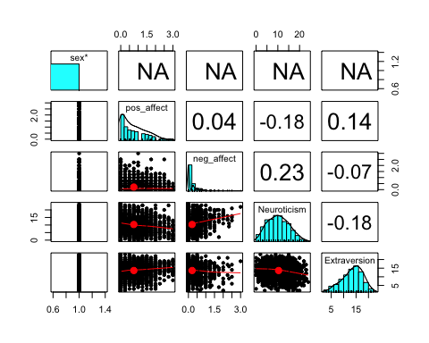

# Distributions

## Distributions of negative affect scores

Below we can see the distribution of negative affect scores is skewed.

print(my.hist.2)

## Neuroticism Distribution

Below we can see the distribution of neuroticism scores is relatively normal.

print(my.hist)

# Relations among variables

## Scatter plot for Negative Affect and Neuroticism

Below you can see the correlation between negative affect and neuroticism with a regression line.

print(my.plot)