Establishing the MRP ring tutorial:

For getting started with the example, you will need following Hardware and SW:
- Tia Portal installed on your PC
- Scalance XC208 or another switch with the support of the MRP
- PLC from CPU 1500 Family
- Distributed I/O Interface Module ET200MP for example: IM 155-5 PN HF
- Distributed DQ module, for example 32x24VDC/0.5A HF: 6ES7 522-1BL01-0AB0
- Different connections cables
- External network card

Getting started:

Preparing the HW
Connect the device Scalance XC208, CPU and ET200MP to the ring topology (see schematics below). Always use the same interface for example X1P1 and X1P2 on the CPU.
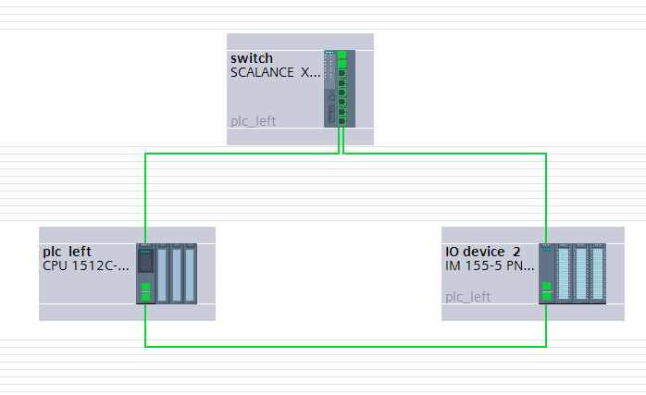
NOTE: Leave the ring open and close it just after the project is downloaded to the CPU, otherwise loop communication and error can occur.

Connect external network card from your PC to the Scalance switch.

Configuring the TIA Portal project

Use TIA portal to create a new project. Create a HW config with the S7 device and Scalance modules you are using
Configure the devices in the TIA Portal (give it PROFINET name, IP Address). Make the Topology in TIA Portal same as you have connected the device in you rack. See schematics above.

NOTE: The topology itself is not a prerequisite for the correct functioning of MRP, although I find it helpful to do it.

No configure the interfaces

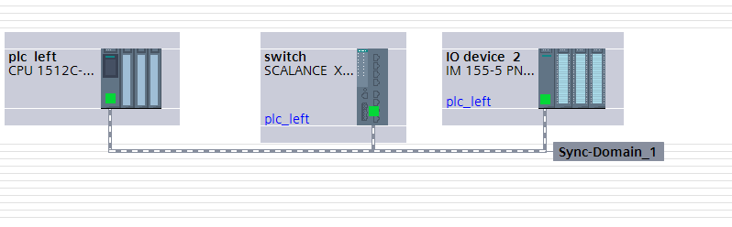
NOTE: You need to assign IO device to the controller CPU (on the picture is blue text plc_left in the IO device. You might realised that in your project is written „Not assigned“, then click to it and select the corresponding CPU)

Adjust the update time. The reconfiguration time for MRP is 200 ms. Accordingly, a watchdog time
of > 200 ms has to be selected for the PROFINET communication. The watchdog time is not configured directly, but as a number of accepted update cycles without IO data. The update cycle can be configured separately for any IO device. In the default setting, STEP 7 calculates the update time automatically for any IO device of the PROFINET IO system. In order not have the update time calculated automatically, you can change the setting. Proceed as follows:
- In the network view of in the device view, select the PROFINET interface of the IO Device
- The properties are siplayed in the inspector window under „Advanced options> Real time settings > IO cycle”. Go to the “Update time” section
- Select “Can be reset” to define the update time and enter the desired time, which must be higher than 200 ms in summary. This will be reached increasing the update time or the accepted update cycles without IO data. See there is also a “Watchdog time” which multiplied the update time by factor given in Update time to calculate Watchdog time.
This will update time for all PROFINET IO devices
Picture below shows the necesarry configuration
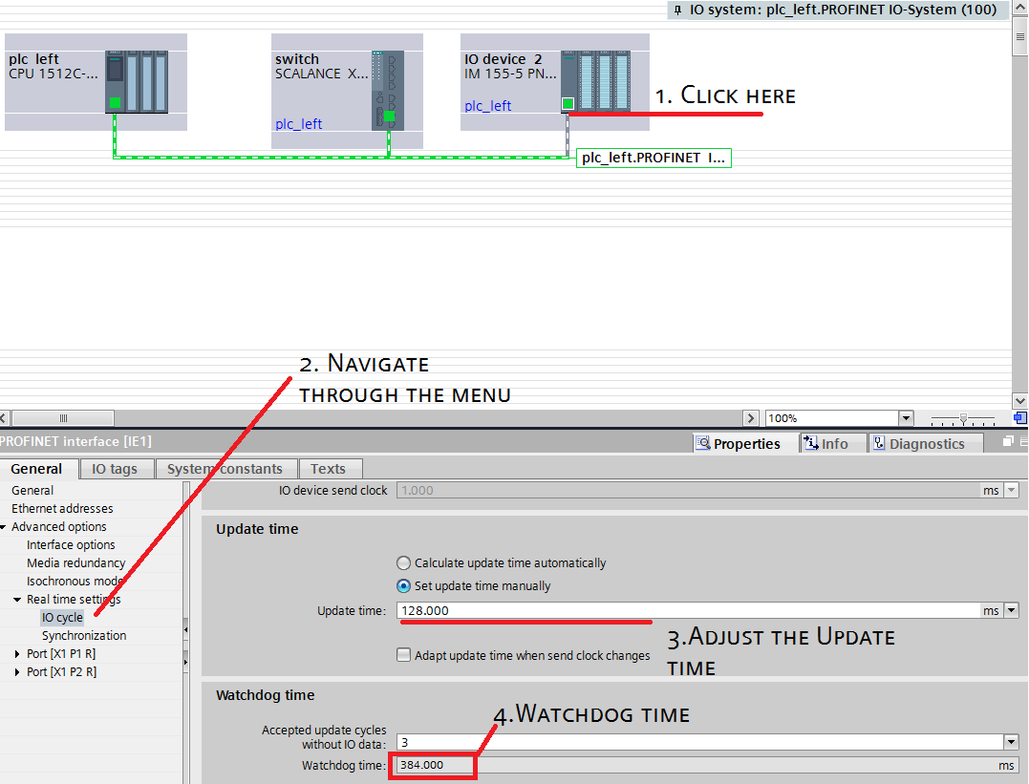

Configuring MRP

Now you will need to configuring the MRP itself by setting the role in the ring (Client/Manager) and defining the ports.
- Configuration of the MRP domains will be done following these steps:
- Select the Network view
- Put the mouse cursor over the network so the blue-grey box appeared and select the Sync-Domain_1 or simillar in you project
- In the Properties of the Inspector window you should see on the card General Domain management.
- Go to “Domain management > “MRP domains”> “mrpdomain-1”>”Device”
- Select the role of the devices. Please be sure that there is just one Manager
See the picture on the next page for further details
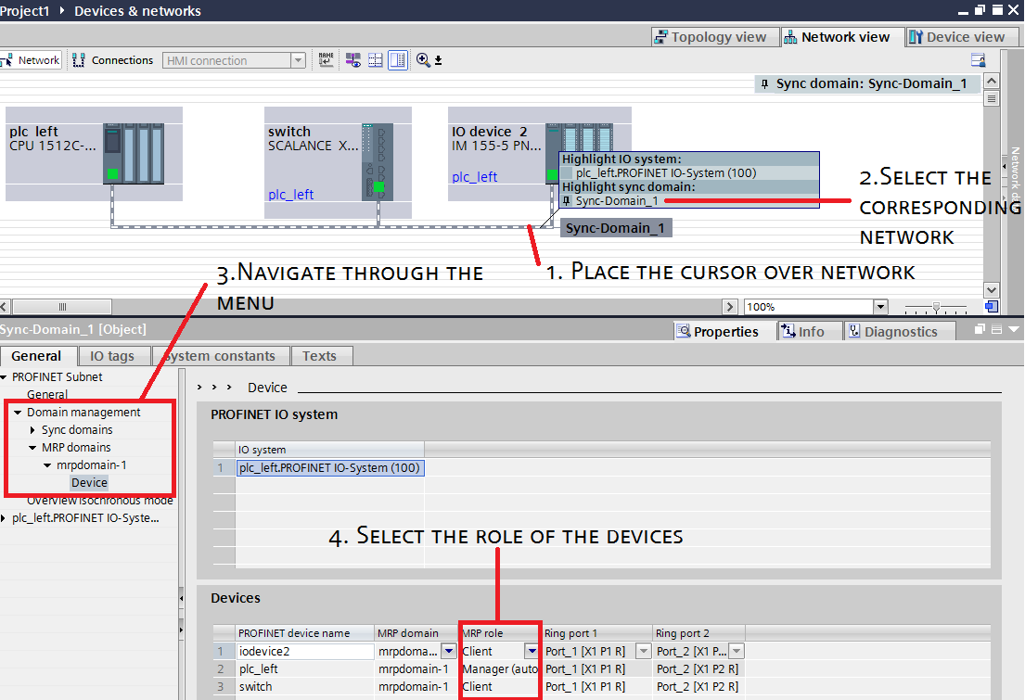

Enabling diagnostics interrupts
Last thing you will need to configure is the diagnostics interrupts. To be able to determine the status of the MRP ring via the user program of the CPU (e. g. via the diagnostics OB 82), the diagnostics interrupt in the modules must be enabled. To do that, please follow the steps:
- In the network view of the device view, select the PROFINET interface of the IO device
- The properties are displayed in the inspector window. Under “Advanced options”> “Media redundancy”>, and enable the “Diagnostics interrupts” function
- Do the same for the other nodes of the MRP ring as well (on the other devices)
Picture on the other page shows the process
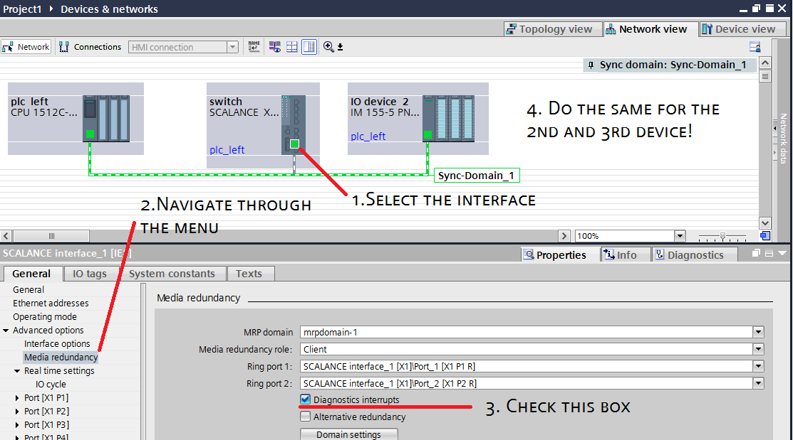

Creating testing project and running the program
Now it is time to create easy program for testing. Go to the PLC to the main OB and create following in the LAD:
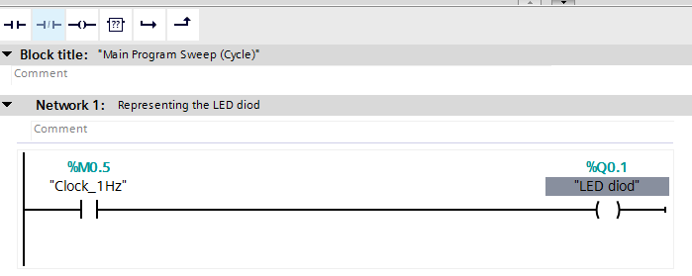
NOTE: If you cannot see the M0.5 Clock then you have to allowed them in the Properties window of the PLC under the System and clock memory and check the “Enable the use of clock memory byte”
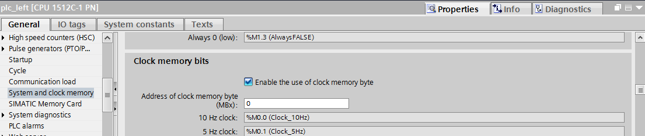
IMPORTANT NOTE: If you are using a rack with Switch PLC which is connected to the same Scalance switcher and the Switcher PLC was already configured to switched on and off the connectors and relays. Then please disconnected it from the Scalance, because this PLC is configured by the TIA Portal project as the MRP Manager and as was mentioned above, this is not allowed in the Ring and will caused a problem to your project because there will be a two MRP Manager (Switch PLC and your Control and configured PLC)!
Save the project, compile it and download it to the CPU. Afterwards connect the last wire into the switch to create the ring.

Checking the function
You should observe that there is no error led blinking in the devices and on the IO Device the 2nd LED on the byte 0 is blinking. If you open the ring by disconnecting the wire, you will get noticed that Ring is open in the Diagnostic buffer of the PLC and also on the PLC Display and maintenance LED will begin the blink. That serves as an indicator for the operator that some problem occurred although the IO device continue to blink. This is the proof that CPU still can communicate via other side of the ring to the device.
Also in TIA Portal you can see the difference between the No open ring and open ring, where you can see where is the problem in the connection. Picture below shows the open ring between the plc_left and IO device.

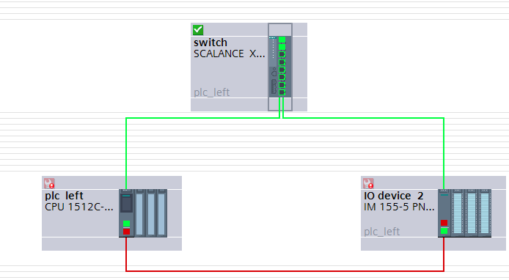

Moreover you are able to see status of the ring via Diagnostics of the PLC or other devices by going to the Online Access and Diagnostic panel:
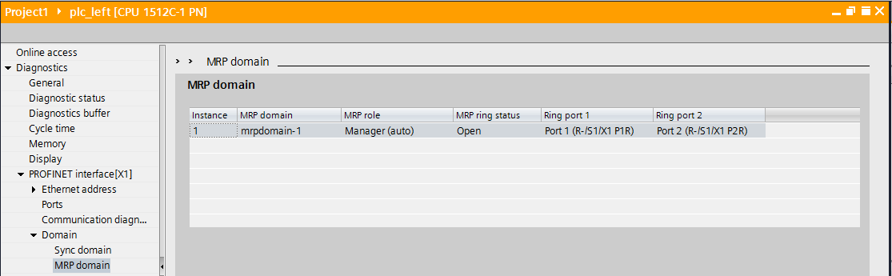
Similar informations can be easily obtain from Web based Manager site. Cards called Redundancy, where you can find also the information about the ring.

