Contents
Logon Screen 2
Browse Doctors 3
Add a New Doctor/Edit a Doctor 4
Doctor Info 5
Add Doctor Note 6
Browse Practices 7
Add a New Practice 8
Edit a Practice 9
Browse Hospitals 10
Add a New Hospital 11
Edit a Hospital 12
Browse PVG Members 13
Edit a PVG Member 14
Add a New PVG Member 15
Browse Users 16
Edit a User 17
Add a New User 18

Logon Screen

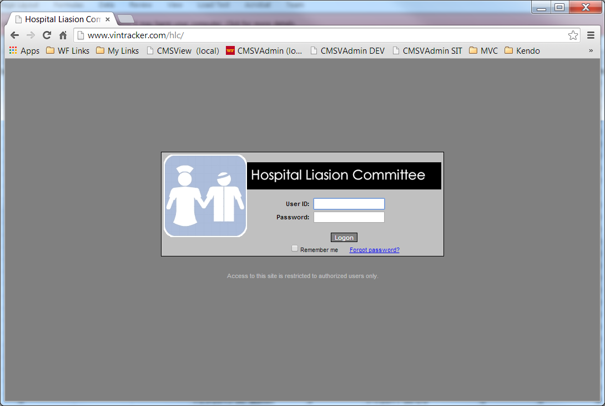

Browse Doctors

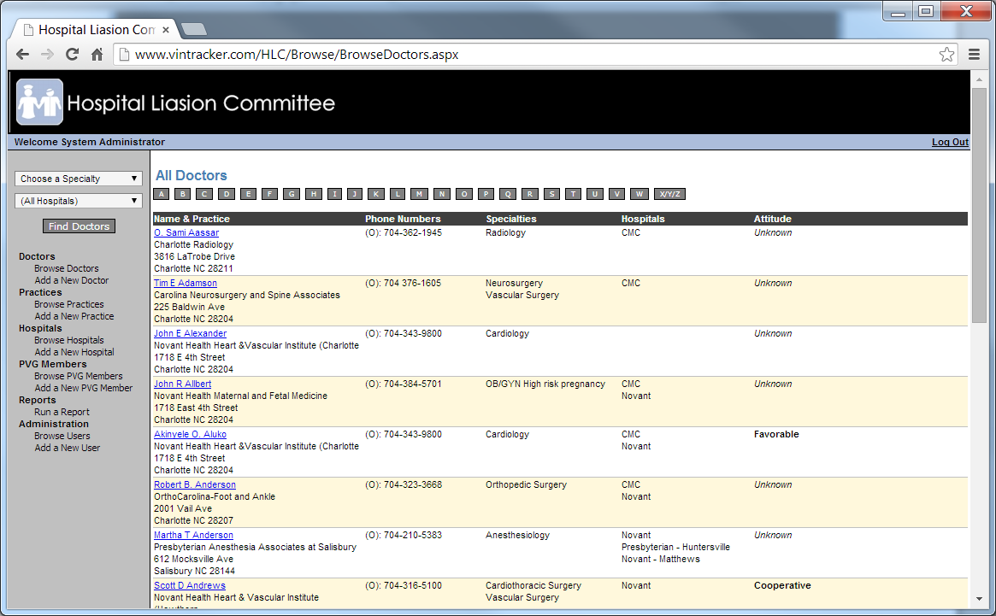

- This is the initial screen that appears. Clicking the alpha buttons will change the listing to Doctors with last name starting with that letter

Add a New Doctor/Edit a Doctor

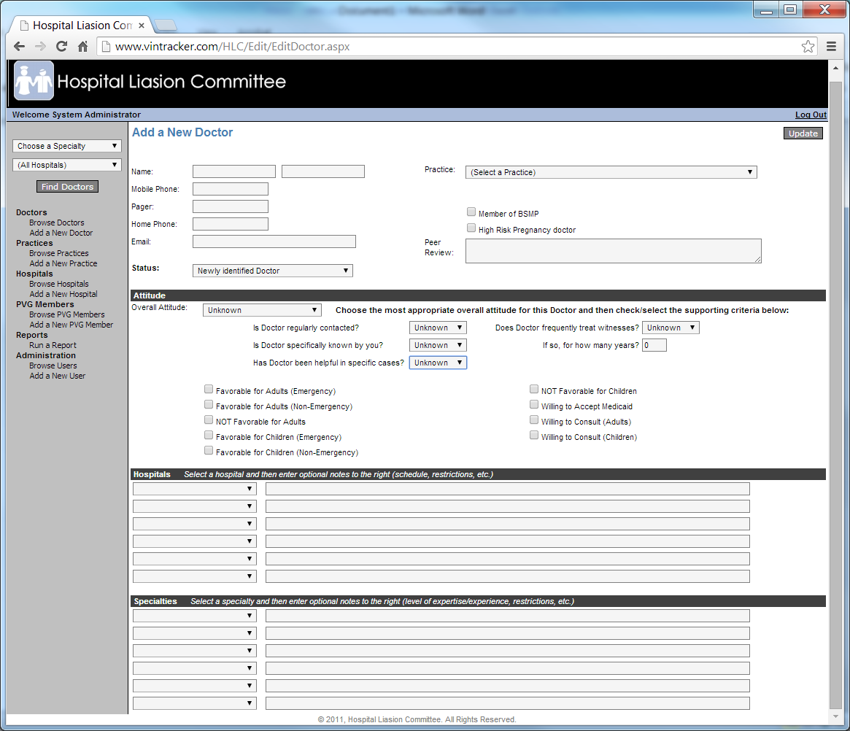

- Overall Attitude:

Doctor Info

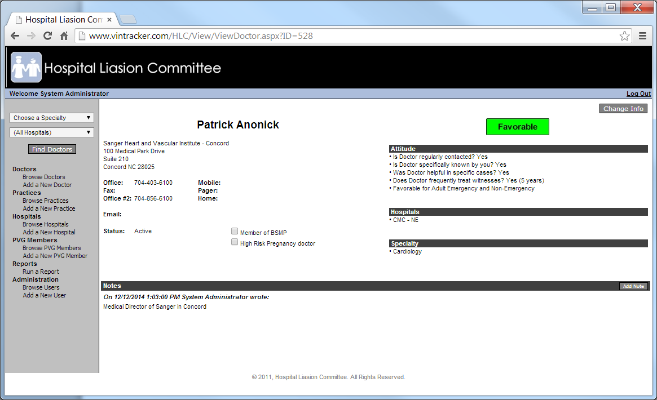
- This screen initially appears when you click on a Doctor’s name on the Browse Doctors listing
- To edit the Doctor’s information click the “Change Info” button
- To add additional notes click the “Add Note” button on the Note bar

Add Doctor Note

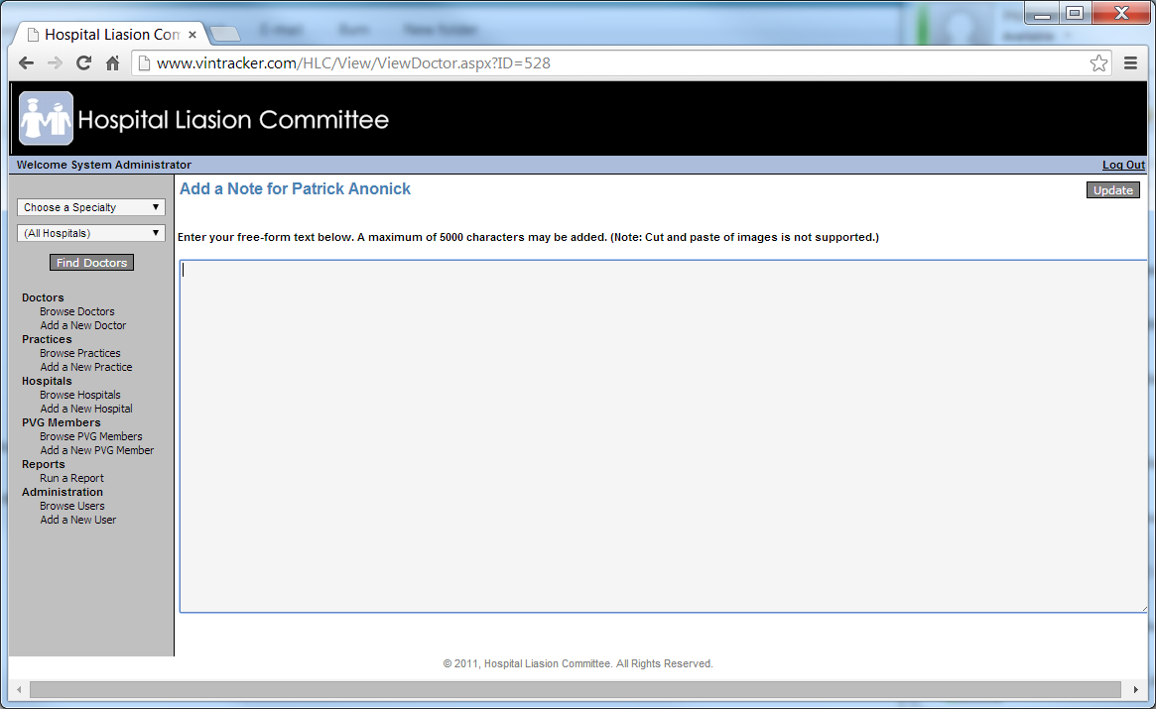

Browse Practices

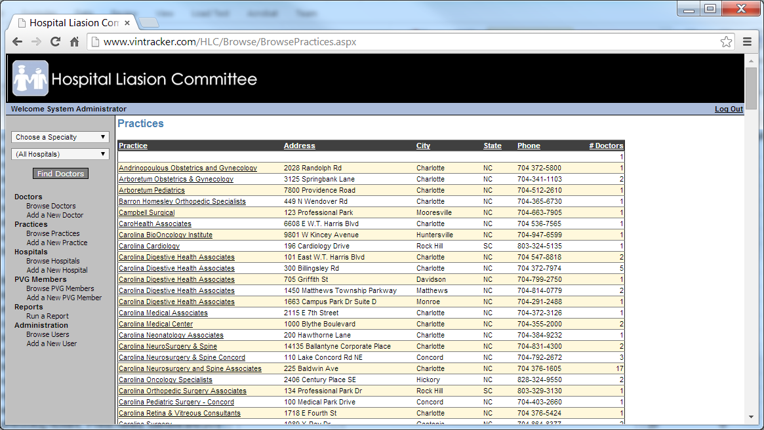

Add a New Practice

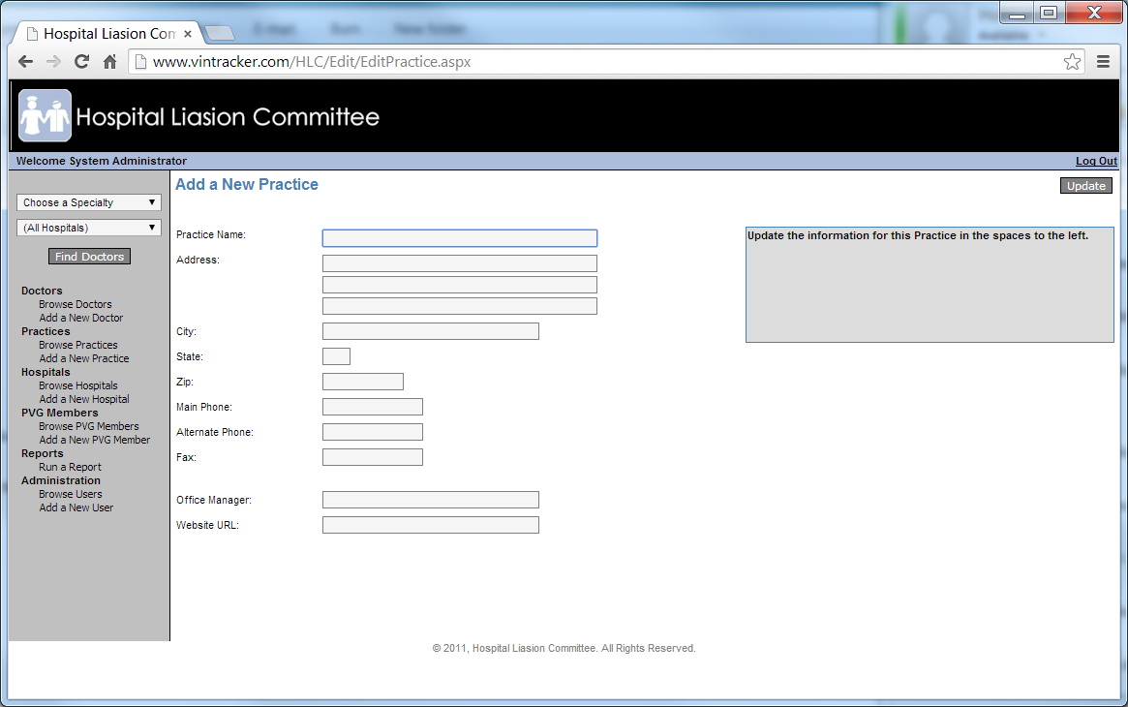

Edit a Practice

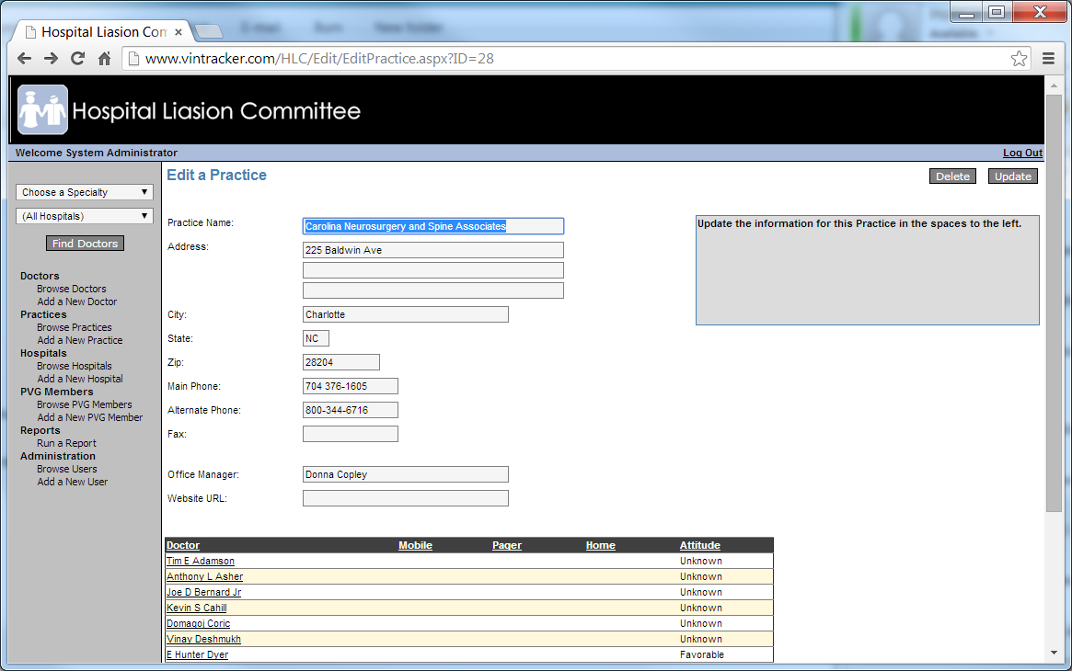

Browse Hospitals

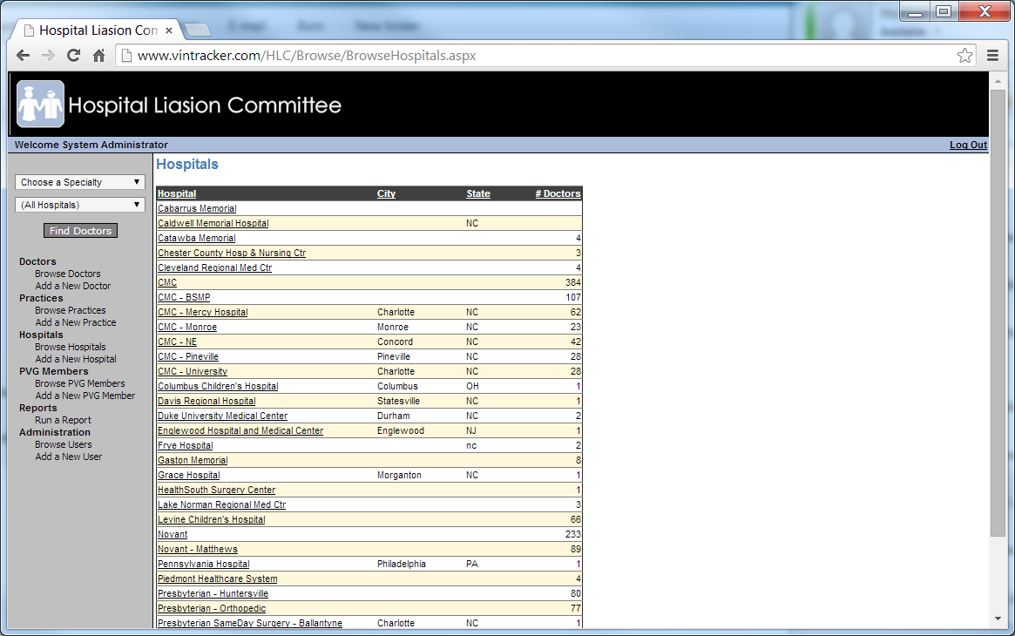

Add a New Hospital

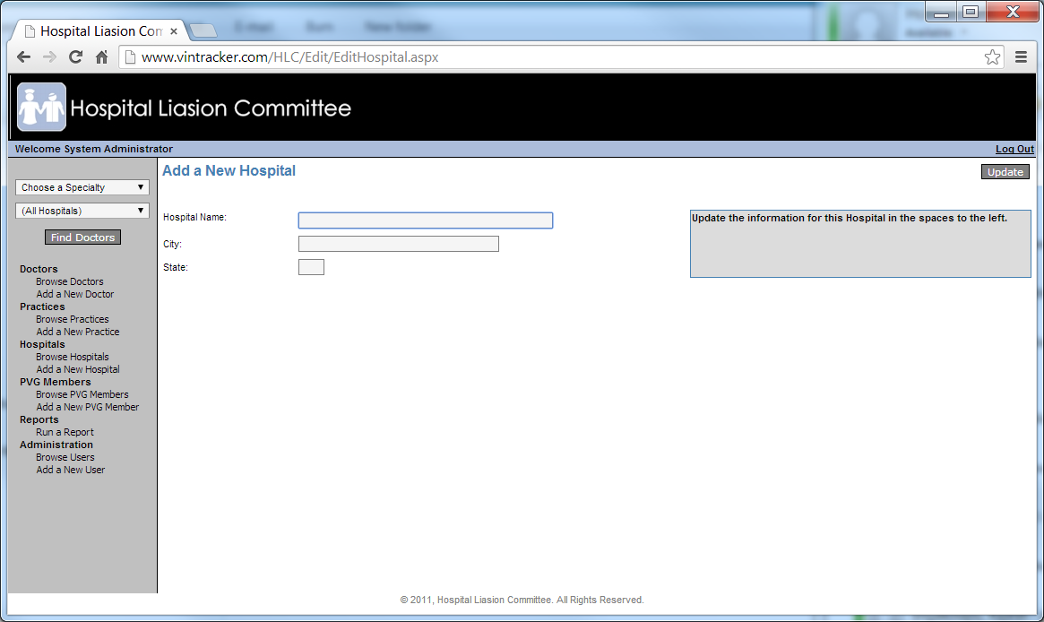

Edit a Hospital

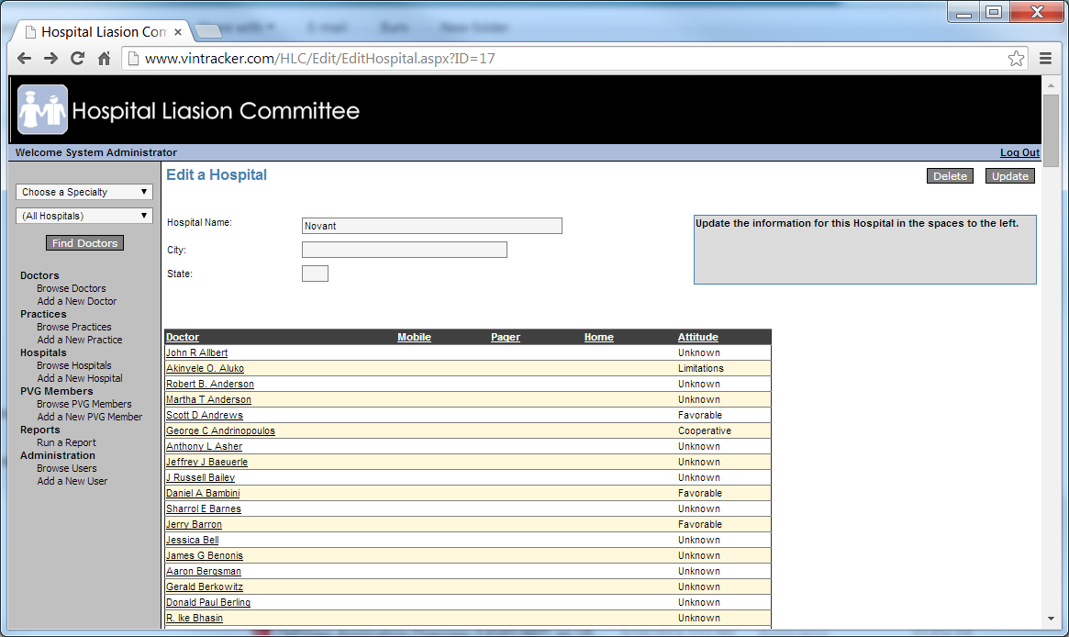

Browse PVG Members

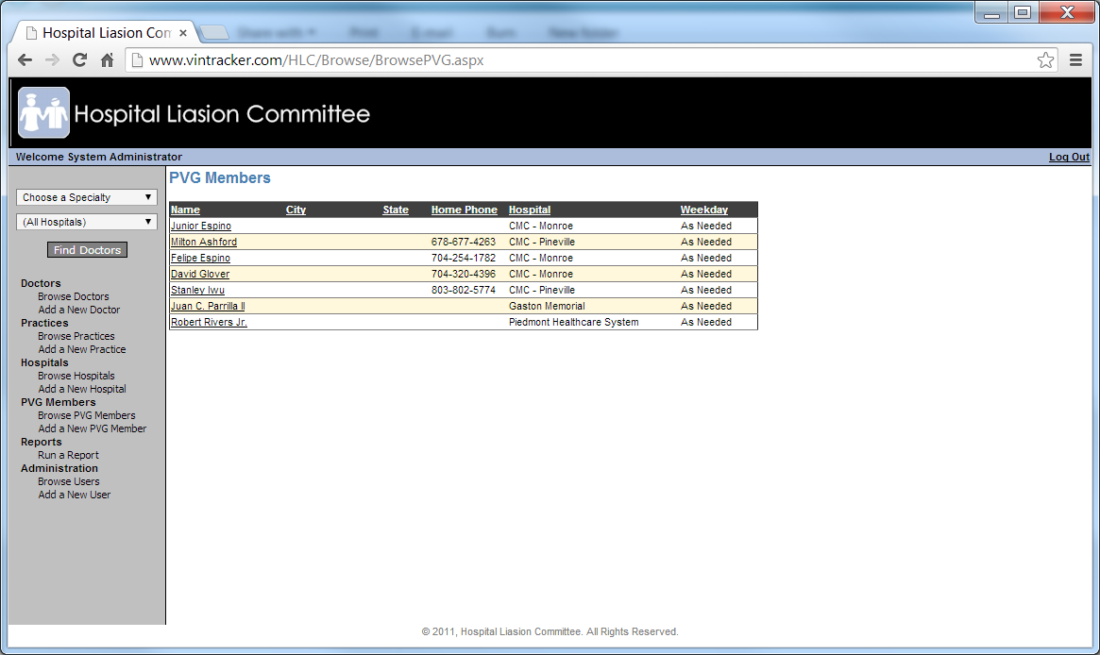

Edit a PVG Member

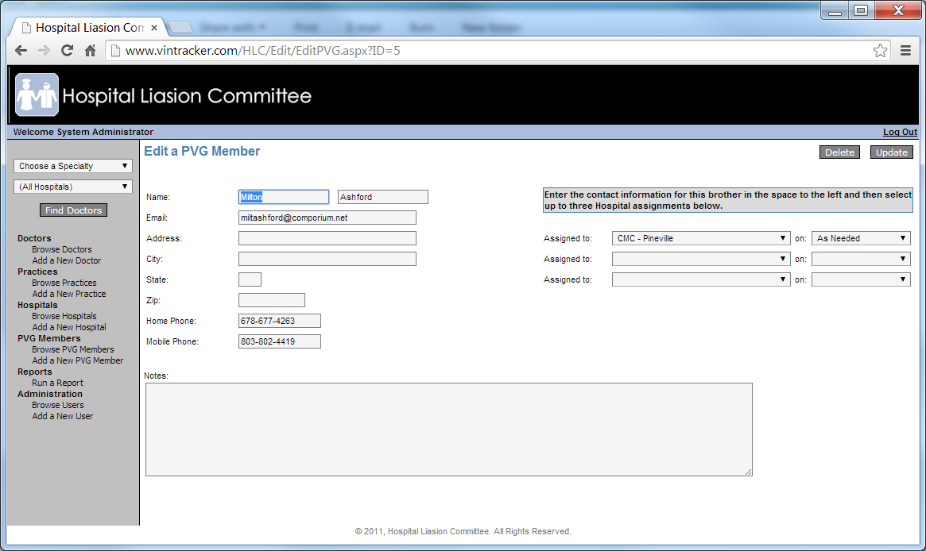

Add a New PVG Member

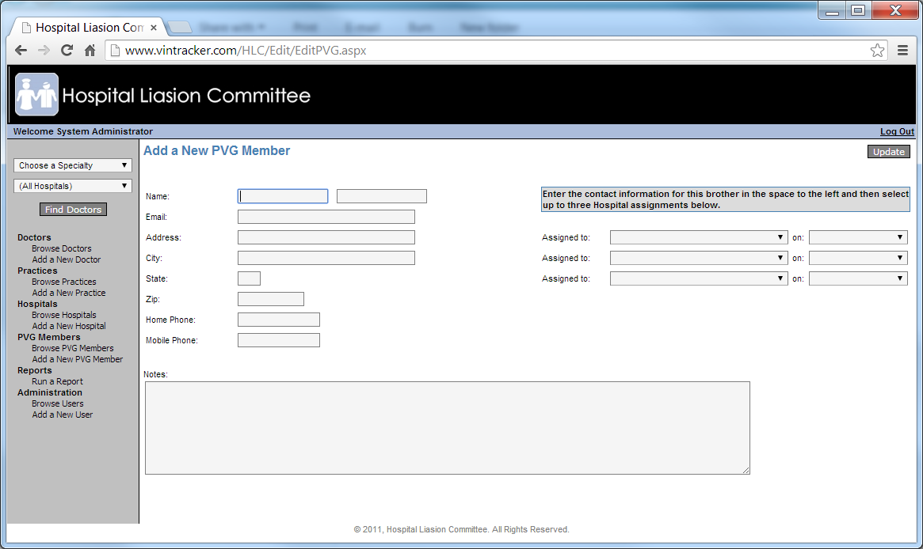

Browse Users

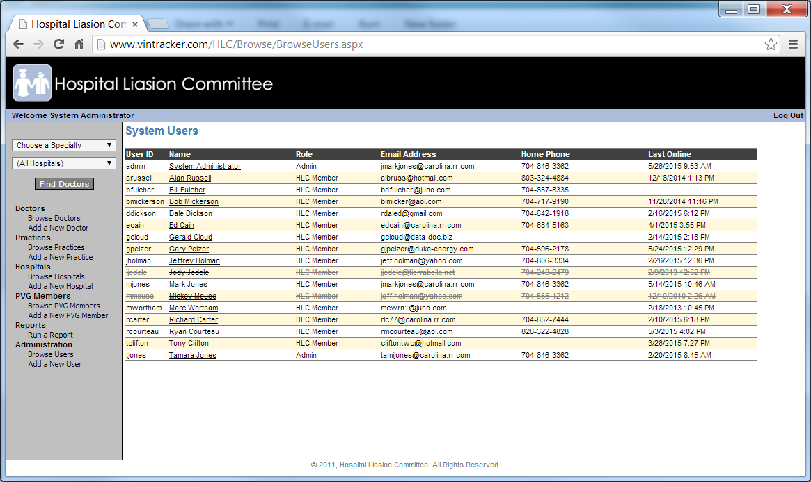

Edit a User

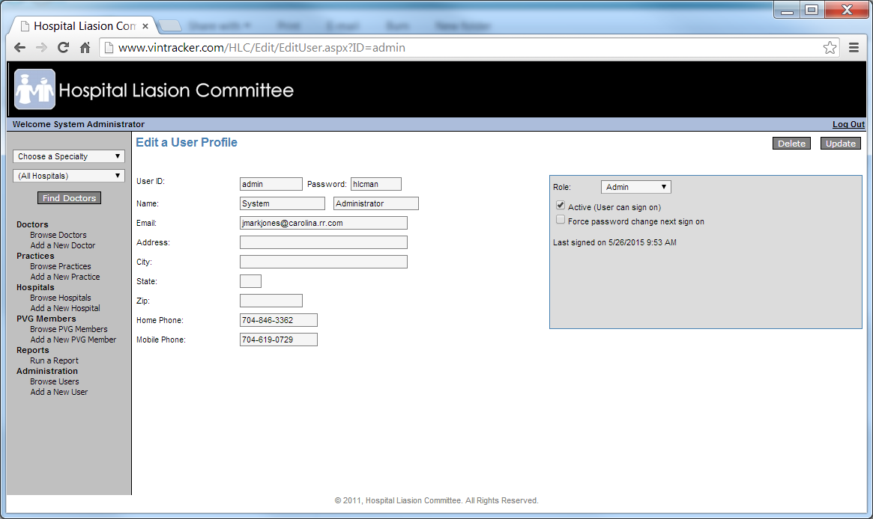

Add a New User

