Jake Holovka

CS 215

Assignment 2.2

1. My original plan for this assignment was to use a multiple stacks. I first pushed each character the user types onto one stack using a for loop then set that stack equal to another stack. Then I would take the original stack and pop off the elements while setting a new stack equal to the elements being popped off. I would then compare the first copied stack with the last copied stack to check if they were a palindrome. I realized though that the first copied stack was being decremented also even though it was out of the for loop and before the for loop even took place. I was unsure why this was happening and figured only one stack should be used to do this. I then figured out instead of using multiple stacks to compare, you can just pop off the stack and add those elements to an instance variable in the same for loop and then compare the two variables to see if they were a palindrome.

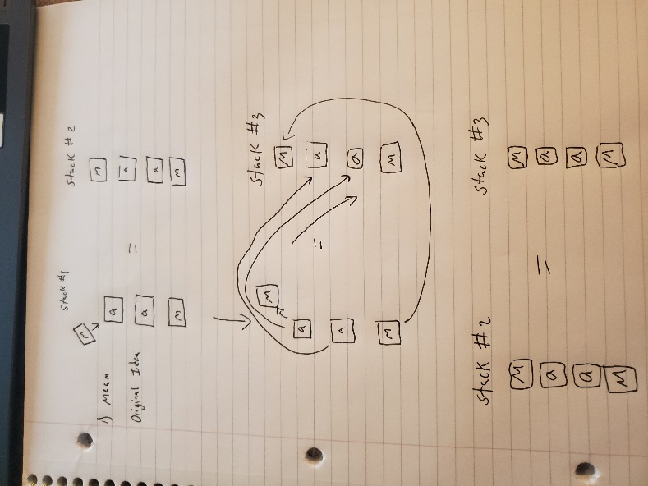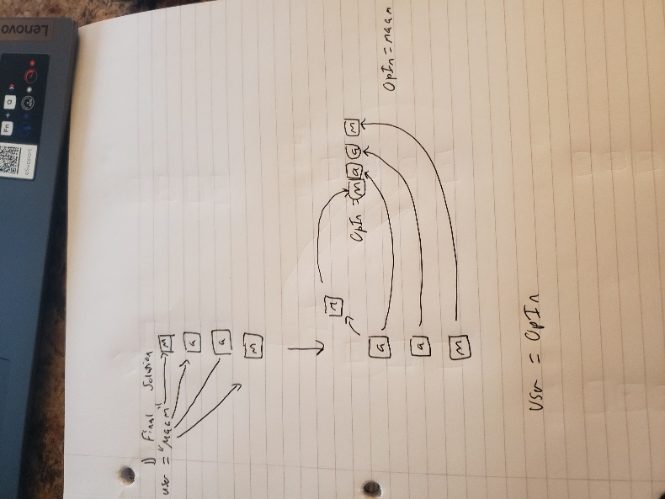

5)

a) My basic operations in this assignment were addition because I have for loops that increment one based on how long the user types in

b) The for loops I have do the addition based on how long the string is that the user inputs.

c) 2n where n is the length of the string the user inputs

d) It would be O(n) + O(n) = O(2n) drop the constant 2 and its O(n). You add the for loop big Os because they are independent of each other. If they were nested, then you would multiply.

e) In a stack data structure, the order of which things are added is important because how things are removed is related to the order of which they were added. An item added first is going to be at the bottom of the stack and an item added last is going to be at the top. In a bag data structure, the order is irrelevant because you’re just adding and removing the individual objects and order is not tracked. A stack is useful to solve the palindrome problem because when you add the word to a stack, it puts the first character of the word at the bottom of the stack and the last character of the word at the top. The whole point of a palindrome is a word that is the same front and backwards so when you decrement the stack, it pulls the top of the stack which is the last character of the word and you can store it to another variable. As you decrement the stack it keeps pulling the characters from the back of the word essentially flipping the word you initially started with. Then you can compare the original word with the flipped version to see if it was a palindrome or not.