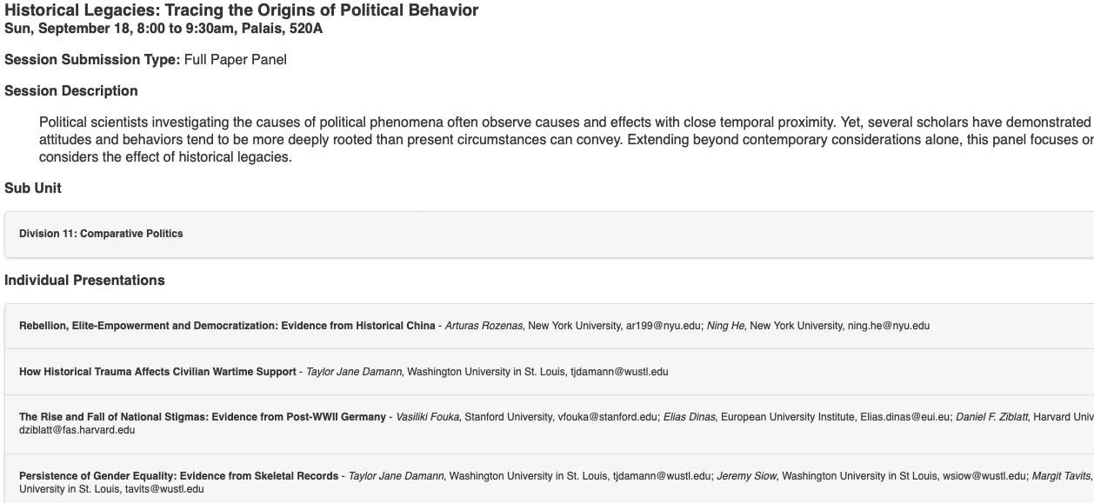

\*\* General points

- Legacy studies as a field rapidly growing, even more rapidly developing: a few years ago correlations, now causal, mechanisms, breaking legacies, constantly new (types of) data (Taylor, Arturas), clever experiments (Vicky), going further and further back in time, studying effects today, ...

\* Arturas

- Obviously important and great motivation: we have (imperfect) explanation for the West, basically nothing outside of it

- Incredible data (sources), would have loved to see some originals (perhaps in Appendix, quota data, list of Assemblymen and jinshis, revolutionary data and maps)

- New DiD methods, all cutting edge

- Big framing (why and how did parliaments emerge -- outside the West), which is great. Do you think this specific case is generalizable/has important implications beyond China?

- Set up often: what is a story without fiscal considerations, but then first step of the argument always starts with "sharing power to get money or military".

- Causal chain is relatively long, perhaps illustrate in a figure? Money from ports - donations - quotas - jinshis - assemblymen - revolutionary events (last step, implied: representation). Perhaps this is even two papers/a book, especially if you can go down deeper on the individual steps? Also, out of curiosity (not super causal): do we see overarching effect: ports -- revolutionary events?

- This also means you have A LOT of history to go through. Extremely interesting and all new for me (so important to understand what's going on), but in single paper format leaves less room for all your equally interesting empirics. Perhaps some has to go to the Appendix?

- Central government had hoped to increase efficiency... but ultimately lost power/broke down. Democracy/representation by accident?

\* Minor points

- Especially in the early parts of the paper, you often speak of "the imperial power" and "the elite". Put this way, I found it easy to confuse them. Later on, you more often use "local elites" which makes the difference a bit clearer.

- Table 1: Could one potentially/did any place get quotas for donations AND quotas for fighting, or only one or the other?

- Fig 6: Why do we see this 10 year gap between quota change and jinshi increase? Does this correspond to some special process? Perhaps a chance to further validate the data?

- Table 2: Fascinating that the old quota has no effect with controls. Does this make sense? (Similar for Table 3, Models 5-6 where new quota is even negative on average!)

- Also fascinating that new quotas were converted more efficiently, would love to know more. Are these usually bigger/wealthier counties? Or simply with more experience/expertise?

- Regular revolt models in Table 3 are very clever and convincing!

\* Vicky

- As a German myself, so obviously important and interesting, in day-to-day settings

- Great to see it studied so carefully and with the fascinating wrinkle of the experimental manipulation

- Huge sample size with over 5k respondents! And pre-registered!

- Currently the paper has no real theoretical argument. Instead, it asks a (very important and interesting) question and then studies it extremely carefully. Perfectly fine with me, but some people seem to struggle with that approach.

- Sometimes I would have liked to know if you found some patterns surprising or not. For example, the analysis by cohort (Figures 3+4) finds that pride and positive feelings go down for more recent cohorts. Do we see this in other countries too? Could we not have thought that these cohorts are much further removed from WWII etc and therefore should feel less conflicted about this?

- Instead, relatively long section about nations confronting their past. All interesting explanations and examples. Some cases perhaps a bit far removed from the one studied here. One that felt missing to me: European colonial powers. Also, perhaps rather some more discussion of East/West differences, currently one short paragraph on p. 9.

- Empirics still seem to be a bit work in progress. Right now, first part is mostly descriptives. Interesting and important, but first real findings (of experiment) start at the bottom of p. 26, feels very late. Perhaps some more descriptives can go to the Appendix because experiment more interesting.

- Are the effect sizes substantively meaningful? If I read the Appendix correctly (Table A3), many items seem to have a SD of around 1. So then effects like in Figure 9 or 11 of -0.02 would be 2% of a SD?

- Findings are mostly 0, but "moving on from the past" finding is mentioned in abstract, conclusion, and elsewhere prominently. But it's only 90%, small effect, 1/19 (or 1/38) coefficients, multiple comparisons issue, 5k respondents, why not just consider it a 0 too?

- Next steps in fn 22: heterogeneous effects for ageXeast, I would also be REALLY interested in effects by women vs men, and/or left-right self-placement or party choice (even if not pre registered)!

\* Minor points

- How was the sample recruited and by who? Online survey? Does the mode suggest any conditional considerations regarding sensitive questions/answers?

- School topics questions: in contrast to the other items I thought here the subtraction approach perhaps makes a bit less sense. Mostly because the answers don't seem mutually exclusive (i.e., someone could simply find all topics very important). (But of course you also show the results item by item.)

- PAP mentions list experiment that also sounds very interesting? Mostly null there too?