Visualization for the analisis on why colombians don’t go to watch films produced in Colombia
Group: Jhon Lotero, Nicolas Aguilar, Raul Blanco
Professors: Jhon Alexis Guerra, Jose Tiberio Hernandez
System and computer Engineering Department
Course: Visual Analitics
Universidad de los Andes
Client: 64A Films
Bogota, Colombia
{jm.lotero10, ne.aguilar, rf.blanco1140}@uniandes.edu.co

Abstract—This paper describe the visualization made in order to analyze the absence of Colombian people going to see Colombian made films, a request made by 64A Films and supported by the direction of cinematography in the Ministry of Culture of Colombia. The issue of people not going to watch independent movies is not limited to Colombia but is worldwide phenomena, which, as we discover, hasn’t been analyzed in its majority. The visualization made, allows the analysis of dozens of movies through multiple characteristics of interest at the same time, as well as allowing the user to filter information as she/he sees fit, all of this. In this paper we first discuss what compose this problem, then we will talk about the state of art, followed by the solution we proposed in the form of a visualization and finally, the results and conclusions we came to.
Keywords-Visualization; data exploring; identification of tedencies; outliers; independent cinema; comparisons; parallel coordinates; embeded infromation

Introduction
In Colombia, as in the rest of the world, independent movies are generally praised in film festivals and by critics but also are poorly received by the general audiences and as a result create a difficult environment for the non-blockbuster producers. As a difficult problem as it is, there is room for analysis and making use of the advances in computer visualization this paper proposes a visualization product based on the framework of Tamara Munzner.
First, we would like to defined what we consider an independent film to be, this is one which is not made by one of the following six producers: Warner Bros. Pictures, 20th Century Fox, Paramount Pictures, Universal Pictures, Sony Pictures Entertainment and Disney Studios. Second, for the sake of formality we will define the actors in this problem to be the producers of the movies; the distributors, those who connect the producers with the exhibitors; the exhibitors, those who present the movies on the cinema and finally, the consumers, anyone who goes to the cinema.
We have defined the following as the main tasks of this project. First, the identification of trends of independent movies that were rare cases of success as well as from the film industry in Colombia, these outliers have already been identified by the industry. Second, to compare the different trends follow by the movies through the years.

State of art
We observed examples of parallel coordinates being used to compare multiple entries through various dimensions, for example this visualization of an analysis of baseball players in different dimensions of the sport.
http://peltiertech.com/composite-baseball-player-evaluation/
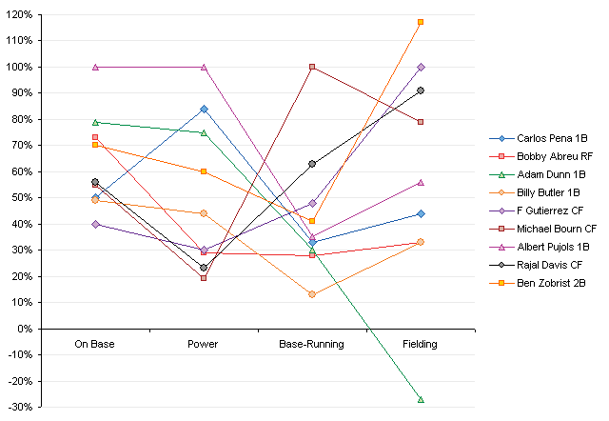
From this example in specific we saw how using different colors we can differentiate the entries in the visualization allowing the comparison. But we also notice that we cannot put dozens of entries because the colors won’t be enough to differentiate them all, reason why we decide to cluster them by the year it came out.

We also look at the example provide by the professor in which alongside the parallel coordinates there was other idioms (like tables) showing additional information of the data that was being show in the parallel coordinates. This data change as the user start filtering the data.
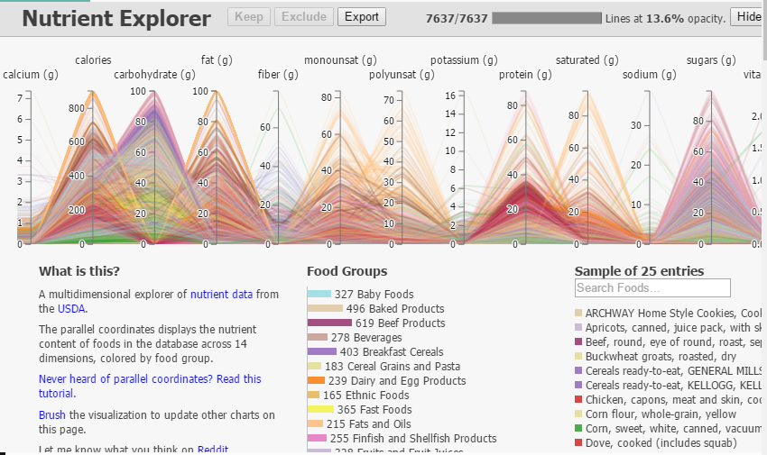
Based on this we decide that we will use other idioms to show infor so the main visualization is not too overwelming for the user.

From the site http://proimagenescolombia.com/ we obtein a series of visulizations that show analisis of diferent carateristics of colombian cinema, specilly analisis that made comparisons through time. Form these visulizations we saw that some analysis seem to shown some kind of relations, and from these we start deciding wich dimension we will use in the parallel coordinates so it coul be easier to identify if there were trends being follow by the succesful and the unsuccesful movies. Some of the more interesting visualizations were:
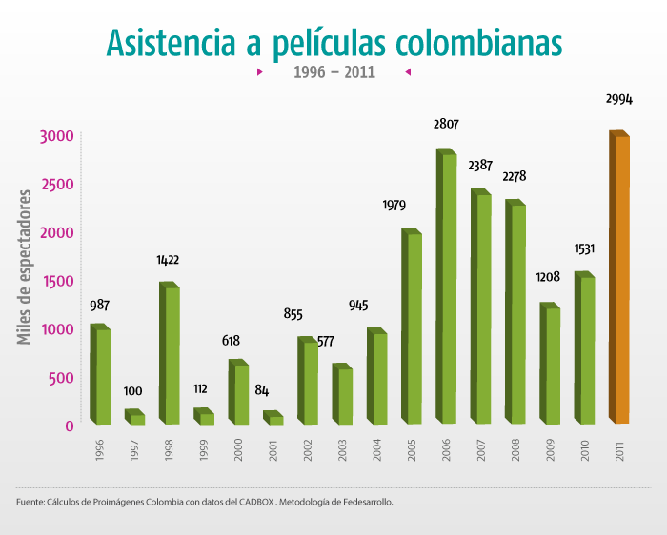

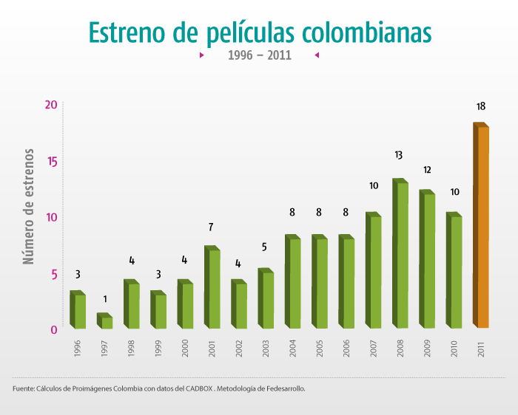

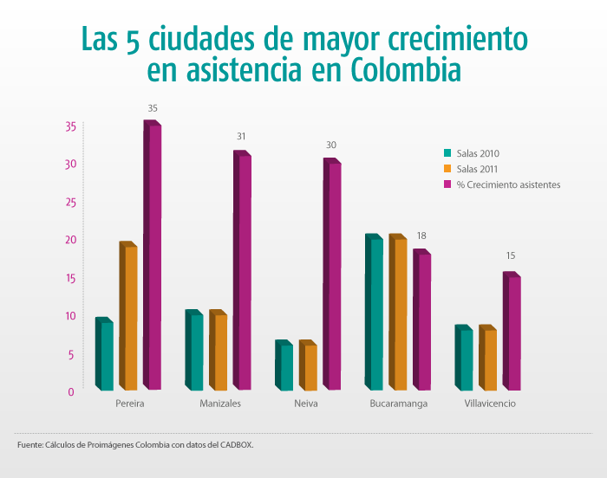

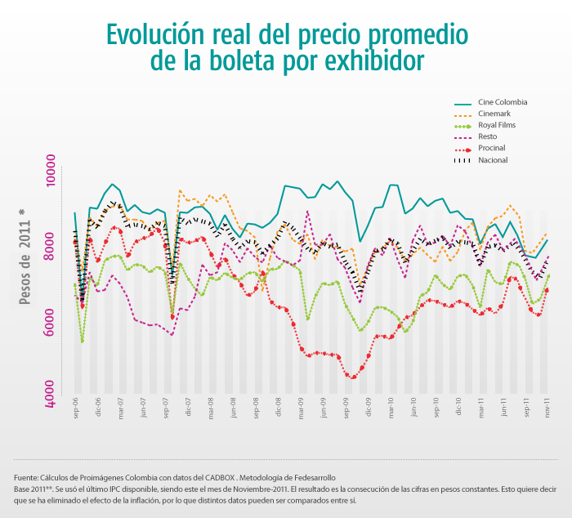
http://proimagenescolombia.com/secciones/cine_colombiano/cine_en_cifras/cine_en_cifras_2/espanol/internas-html/informe-completo.html

We didn’t use any of these visualizations in specific but these gave us ideas of what was worth comparing and analyzing.

Visulization Proposal

Use of multiple Idioms
We propose the use of multiple idioms in order to complete the tasks of exploring the data, comparing trends and identifying outliers. The main idiom is the parallel coordinates, in which the users can explore data with ease, compare the entries of their interest and identify outliers by applying filters. The other idioms used in the visualization provide additional information based on the interaction in the parallel coordinates

Main Idiom: Parallel Coordinates
Parallel Coordinates is an idiom used in analysis of multidimensional data, being especially useful to compare the behavior of the different entries through all the dimensions. In our proposal we join movies by year differentiating them by color, this meaning that the color don’t represent anything, it’s only used to differentiate lines.
We used 6 (six) dimensions, year of release, revenue in millions of Colombian pesos made by the movie, which exhibitors were confirmed to show the movie, the number of spectators, the duration of the movie in minutes and the age of the spectators at which the movie was aiming. The last one, age of audience, only appeared in the data from 2015 because the ministry of culture start taking it into account since that year.
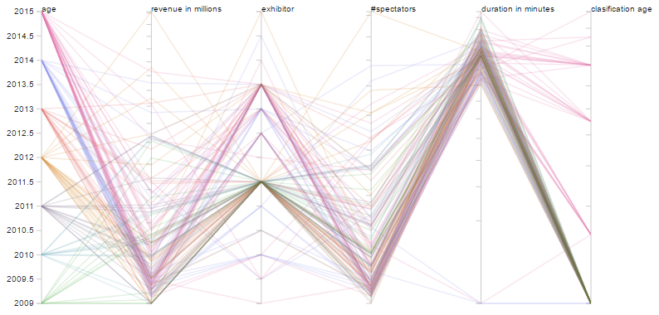

- Parallel Coordinates displaying all the data.
It is possible to filter the data by selecting a range in the different dimensions, allowing the users to explore the data and to make the comparisons they are most interested in. It is also possible to identify outliers by filtering.
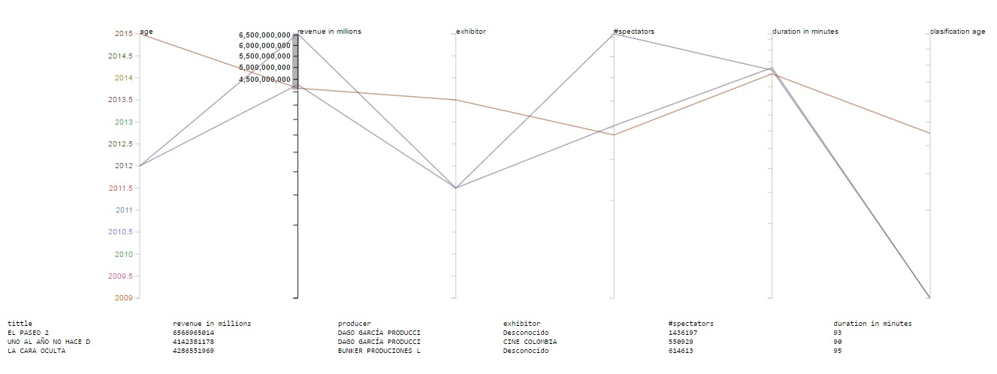
- Parallel Coordinates filtering in search of insigths
If the user put the mouse over one of the dimension columns more information regarding that dimension will appear like the categories that compose it or the numerical values, it can take.
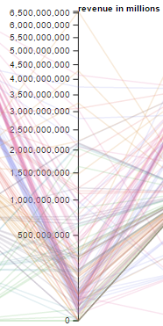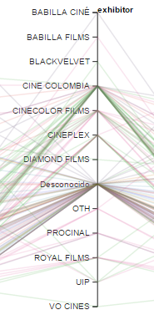

- Information that appera when the mouse is over a dimension column.

Support Idioms
The other idioms used in this visualization are a table with the detail information of each entry in display, a bar chart showing the number of producers that release a movie on a given month of a given year, and lastly, a line chart of the behavior of the revenue per month.

Results
Before you begin to format your paper, first write and save the content as a separate text file. Keep your text and graphic files separate until after the text has been formatted and styled. Do not use hard tabs, and limit use of hard returns to only one return at the end of a paragraph. Do not add any kind of pagination anywhere in the paper. Do not number text heads-the template will do that for you.
Finally, complete content and organizational editing before formatting. Please take note of the following items when proofreading spelling and grammar:

Insigths
Define abbreviations and acronyms the first time they are used in the text, even after they have been defined in the abstract. Abbreviations such as IEEE, SI, MKS, CGS, sc, dc, and rms do not have to be defined. Do not use abbreviations in the title or heads unless they are unavoidable.

Previous knoledge re-confirmed
- Use either SI (MKS) or CGS as primary units. (SI units are encouraged.) English units may be used as secondary units (in parentheses). An exception would be the use of English units as identifiers in trade, such as “3.5-inch disk drive”.
- Avoid combining SI and CGS units, such as current in amperes and magnetic field in oersteds. This often leads to confusion because equations do not balance dimensionally. If you must use mixed units, clearly state the units for each quantity that you use in an equation.
- Do not mix complete spellings and abbreviations of units: “Wb/m2” or “webers per square meter”, not “webers/m2”. Spell out units when they appear in text: “. . . a few henries”, not “. . . a few H”.
- Use a zero before decimal points: “0.25”, not “.25”.

Equations
The equations are an exception to the prescribed specifications of this template. You will need to determine whether or not your equation should be typed using either the Times New Roman or the Symbol font (please no other font). To create multileveled equations, it may be necessary to treat the equation as a graphic and insert it into the text after your paper is styled.
Number equations consecutively. Equation numbers, within parentheses, are to position flush right, as in (1), using a right tab stop. To make your equations more compact, you may use the solidus ( / ), the exp function, or appropriate exponents. Italicize Roman symbols for quantities and variables, but not Greek symbols. Use a long dash rather than a hyphen for a minus sign. Punctuate equations with commas or periods when they are part of a sentence, as in
       
Note that the equation is centered using a center tab stop. Be sure that the symbols in your equation have been defined before or immediately following the equation. Use “(1)”, not “Eq. (1)” or “equation (1)”, except at the beginning of a sentence: “Equation (1) is . . .”

Some Common Mistakes
- The word “data” is plural, not singular.
- The subscript for the permeability of vacuum μ₀, and other common scientific constants, is zero with subscript formatting, not a lowercase letter “o”.
- In American English, commas, semi-/colons, periods, question and exclamation marks are located within quotation marks only when a complete thought or name is cited, such as a title or full quotation. When quotation marks are used, instead of a bold or italic typeface, to highlight a word or phrase, punctuation should appear outside of the quotation marks. A parenthetical phrase or statement at the end of a sentence is punctuated outside of the closing parenthesis (like this). (A parenthetical sentence is punctuated within the parentheses.)
- A graph within a graph is an “inset”, not an “insert”. The word alternatively is preferred to the word “alternately” (unless you really mean something that alternates).
- Do not use the word “essentially” to mean “approximately” or “effectively”.
- In your paper title, if the words “that uses” can accurately replace the word “using”, capitalize the “u”; if not, keep using lower-cased.
- Be aware of the different meanings of the homophones “affect” and “effect”, “complement” and “compliment”, “discreet” and “discrete”, “principal” and “principle”.
- Do not confuse “imply” and “infer”.
- The prefix “non” is not a word; it should be joined to the word it modifies, usually without a hyphen.
- There is no period after the “et” in the Latin abbreviation “et al.”.
- The abbreviation “i.e.” means “that is”, and the abbreviation “e.g.” means “for example”.
An excellent style manual for science writers is [7].

COnclusions
After the text edit has been completed, the paper is ready for the template. Duplicate the template file by using the Save As command, and use the naming convention prescribed by your conference for the name of your paper. In this newly created file, highlight all of the contents and import your prepared text file. You are now ready to style your paper.

Authors and Affiliations
The template is designed so that author affiliations are not repeated each time for multiple authors of the same affiliation. Please keep your affiliations as succinct as possible (for example, do not differentiate among departments of the same organization). This template was designed for two affiliations.

For author/s of only one affiliation (Heading 3): To change the default, adjust the template as follows.

Selection (Heading 4): Highlight all author and affiliation lines.

Change number of columns: Select Format >
Columns >Presets > One Column.

Deletion: Delete the author and affiliation lines for the second affiliation.

For author/s of more than two affiliations: To change the default, adjust the template as follows.

Selection: Highlight all author and affiliation lines.

Change number of columns: Select Format >
Columns > Presets > One Column.

Highlight author and affiliation lines of affiliation 1 and copy this selection.

Formatting: Insert one hard return immediately after the last character of the last affiliation line. Then paste the copy of affiliation 1. Repeat as necessary for each additional affiliation.

Reassign number of columns: Place your cursor to the right of the last character of the last affiliation line of an even numbered affiliation (e.g., if there are five affiliations, place your cursor at end of fourth affiliation). Drag the cursor up to highlight all of the above author and affiliation lines. Go to Format > Columns and select “2 Columns”. If you have an odd number of affiliations, the final affiliation will be centered on the page; all previous will be in two columns.

Identify the Headings
Headings, or heads, are organizational devices that guide the reader through your paper. There are two types: component heads and text heads.
Component heads identify the different components of your paper and are not topically subordinate to each other. Examples include Acknowledgments and References and, for these, the correct style to use is “Heading 5”. Use “figure caption” for your Figure captions, and “table head” for your table title. Run-in heads, such as “Abstract”, will require you to apply a style (in this case, italic) in addition to the style provided by the drop down menu to differentiate the head from the text.
Text heads organize the topics on a relational, hierarchical basis. For example, the paper title is the primary text head because all subsequent material relates and elaborates on this one topic. If there are two or more sub-topics, the next level head (uppercase Roman numerals) should be used and, conversely, if there are not at least two sub-topics, then no subheads should be introduced. Styles named “Heading 1”, “Heading 2”, “Heading 3”, and “Heading 4” are prescribed.

Figures and Tables

Positioning Figures and Tables: Place figures and tables at the top and bottom of columns. Avoid placing them in the middle of columns. Large figures and tables may span across both columns. Figure captions should be below the figures; table heads should appear above the tables. Insert figures and tables after they are cited in the text. Use the abbreviation “Fig. 1”, even at the beginning of a sentence.
- Table Type Styles
Table Head | Table Column Head
Table Head | Table column subhead | Subhead | Subhead
copy | More table copyª
a. Sample of a Table footnote. (Table footnote)
We suggest that you use a text box to insert a graphic (ideally 300 dpi), with all fonts embedded) because, in an MSW document, this method is somewhat more stable than directly inserting a picture.
To have non-visible rules on your frame, use the MSWord pull-down menu, select Format > Borders and Shading > Select “None”.
- Example of a ONE-COLUMN figure caption.
Please see last page of this document for AN EXAMPLE of a 2-COLUMN Figure.
Figure Labels: Use 8 point Times New Roman for Figure labels. Use words rather than symbols or abbreviations when writing Figure axis labels to avoid confusing the reader. As an example, write the quantity “Magnetization”, or “Magnetization, M”, not just “M”. If including units in the label, present them within parentheses. Do not label axes only with units. In the example, write “Magnetization (A/m)” or “Magnetization {A[m(1)]}”, not just “A/m”. Do not label axes with a ratio of quantities and units. For example, write “Temperature (K)”, not “Temperature/K”.

Footnotes
Use footnotes sparingly (or not at all) and place them at the bottom of the column on the page on which they are referenced. Use Times 8-point type, single-spaced. To help your readers, avoid using footnotes altogether and include necessary peripheral observations in the text (within parentheses, if you prefer, as in this sentence).

Copyright Forms and Reprint Orders
You must submit the IEEE Electronic Copyright Form (ECF) per Step 7 of the CPS author kit’s web page. THIS FORM MUST BE SUBMITTED IN ORDER TO PUBLISH YOUR PAPER.
Please see Step 9 for ordering reprints of your paper. Reprints may be ordered using the form provided as <reprint.doc> or <reprint.pdf>.

Acknowledgment
The preferred spelling of the word “acknowledgment” in America is without an “e” after the “g”. Avoid the stilted expression, “One of us (R.B.G.) thanks . . .” Instead, try
“R.B.G. thanks”. Put applicable sponsor acknowledgments here; DO NOT place them on the first page of your paper or as a footnote.

References
List and number all bibliographical references in 9-point Times, single-spaced, at the end of your paper. When referenced in the text, enclose the citation number in square brackets, for example [1]. Where appropriate, include the name(s) of editors of referenced books. The template will number citations consecutively within brackets [1]. The sentence punctuation follows the bracket [2]. Refer simply to the reference number, as in [3]—do not use “Ref. [3]” or “reference [3]” except at the beginning of a sentence: “Reference [3] was the first . . .”
Number footnotes separately in superscripts. Place the actual footnote at the bottom of the column in which it was cited. Do not put footnotes in the reference list. Use letters for table footnotes.
Unless there are six authors or more give all authors’ names; do not use “et al.”. Papers that have not been published, even if they have been submitted for publication, should be cited as “unpublished” [4]. Papers that have been accepted for publication should be cited as “in press” [5]. Capitalize only the first word in a paper title, except for proper nouns and element symbols.
For papers published in translation journals, please give the English citation first, followed by the original foreign-language citation [6].

- J. Peltier, Composite Baseball Player Evaluation, http://peltiertech.com/composite-baseball-player-evaluation/, September 2009.
- Proimagenes Colombia , “http://proimagenescolombia.com/secciones/cine_colombiano/cine_en_cifras/cine_en_cifras_2/espanol/internas-html/informe-completo.html,” 2012.
- J. A. Guerra, “Visualizing Multivariate Data,” “http://johnguerra.co/lectures/visualAnalytics_fall2016/05_Multivariate_data/#/,” Visual Analitics, 2016.
- T. Munzner, “Visualization Analysis & Desing,” 2014.
- R. Nicole, “Title of paper with only first word capitalized,” J. Name Stand. Abbrev., in press.
- Y. Yorozu, M. Hirano, K. Oka, and Y. Tagawa, “Electron spectroscopy studies on magneto-optical media and plastic substrate interface,” IEEE Transl. J. Magn. Japan, vol. 2, pp. 740–741, August 1987 [Digests 9th Annual Conf. Magnetics Japan, p. 301, 1982].
- M. Young, The Technical Writer’s Handbook. Mill Valley, CA: University Science, 1989.
- Electronic Publication: Digital Object Identifiers (DOIs):
Article in a journal:
- D. Kornack and P. Rakic, “Cell Proliferation without Neurogenesis in Adult Primate Neocortex,” Science, vol. 294, Dec. 2001, pp. 2127-2130, doi:10.1126/science.1065467.
Article in a conference proceedings:
- H. Goto, Y. Hasegawa, and M. Tanaka, “Efficient Scheduling Focusing on the Duality of MPL Representatives,” Proc. IEEE Symp. Computational Intelligence in Scheduling (SCIS 07), IEEE Press, Dec. 2007, pp. 57-64, doi:10.1109/SCIS.2007.357670.

- Example of a TWO-COLUMN figure caption: (a) this is the format for referencing parts of a figure.

