Data visualization for the analisis on why colombians don’t go to watch films produced in Colombia
Group: Jhon Lotero, Nicolas Aguilar, Raul Blanco
Professors: Jhon Alexis Guerra, Jose Tiberio Hernandez
System and computer Engineering Department
Course: Visual Analytics
Universidad de los Andes
Client: 64A Films
Bogota, Colombia
{jm.lotero10, ne.aguilar, rf.blanco1140}@uniandes.edu.co

Abstract— This paper describes the data visualization made in order to analyze the absence of Colombian people going to see Colombian made films, a request made by 64A Films and supported by the direction of cinematography in the Ministry of Culture of Colombia. The issue of people not going to watch independent movies is not limited to Colombia but is a worldwide phenomenon, which, as we discovered, hasn’t been analyzed in its majority. The data visualization made allows the analysis of dozens of movies through multiple characteristics of interest at once, as well as allowing the user to filter information as she/he sees fit. In this paper, we first discuss what composes this problem, then we will talk about the state of art, followed by the solution we proposed in the form of a data visualization and finally, the results and conclusions we came to.
Keywords-Visualization; data exploring; identification of tendencies; outliers; independent cinema; comparisons; parallel coordinates; embeded infromation

Introduction
In Colombia, as in the rest of the world, independent movies are generally praised in film festivals and by critics but also are poorly received by the general audiences and as a result create a difficult environment for the non-big producers. As a difficult problem as it is, there is room for analysis, and by making use of the advances in computer visualization this paper proposes a data visualization product based on the framework of Tamara Munzner.
Before anything else, we would like to define what we consider an independent film to be. We are going to define it as a movie which is not made by one of the following six producers: Warner Bros. Pictures, 20th Century Fox, Paramount Pictures, Universal Pictures, Sony Pictures Entertainment and Disney Studios. Now, for the sake of formality we will define the participants in this problem to be the producers of the movies; the distributors, those who connect the producers with the exhibitors; the exhibitors, those who present the movies on the cinema and finally, the consumers, anyone who go to the cinema.
We have defined the following as the main tasks of this project. First, the identification of trends in independent movies. Some of these outliers have already been identified by the industry. Second, to compare the different trends follow by the movies through the years.

State of art
We observed examples of parallel coordinates being used to compare multiple entries through various dimensions, for example this data visualization of an analysis of baseball players in different dimensions of the sport. [1]
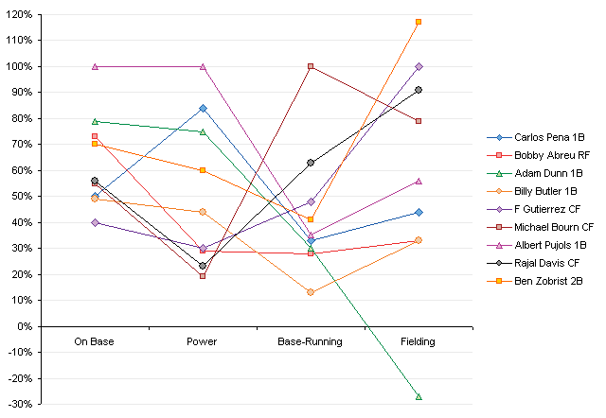
- Parallel coordinates in a baseball analysis
We were able to discern from this example how using different colors we are able to differentiate the entries in the data visualization, thus, allowing the comparison. However, we also noticed that we cannot put dozens of entries because the colors won’t be enough to differentiate them all, therefore, we decided to cluster them by the year the entries came out.

We also analyzed at the example provided by the professor in which alongside the parallel coordinates there were other idioms (like tables) showing additional information of the data that was being shown in the former. This data changes as the user starts to filter the data. [3]
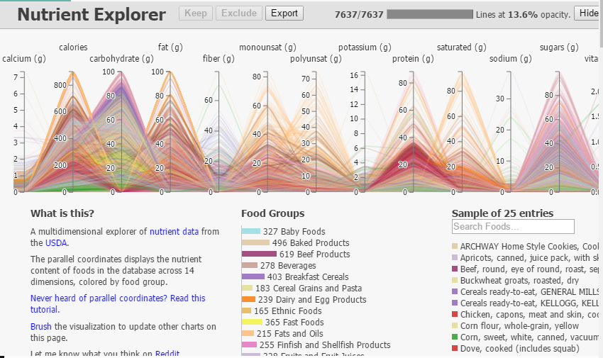
- Parallel coordinates example from the VA course
Based on this, we decided that we will use other idioms to show information, so the main data visualization is not too overwelming for the user.

From the site http://proimagenescolombia.com/ we obtained a series of data visualizations that show analyses of different charateristics from the colombian cinema, specially, analyses that made comparisons through time.[2] Form these data visualizations we noticed that some analyses seemed to show some similarities, thus, allowing us to decide from the start of the project which dimensions were going to be used in the parallel coordinates, facilitating the identification of trends followed by succesful and unsuccesful movies. Some of the more interesting data visualizations were:
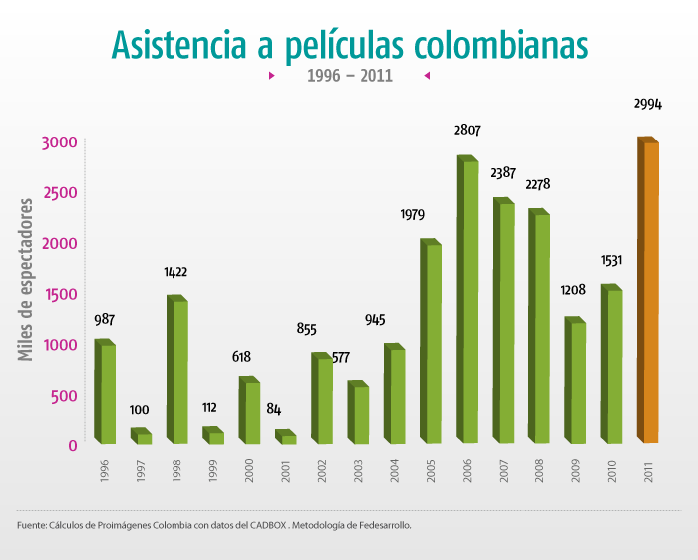
- Bar chart of abstinence in colombian movies by year
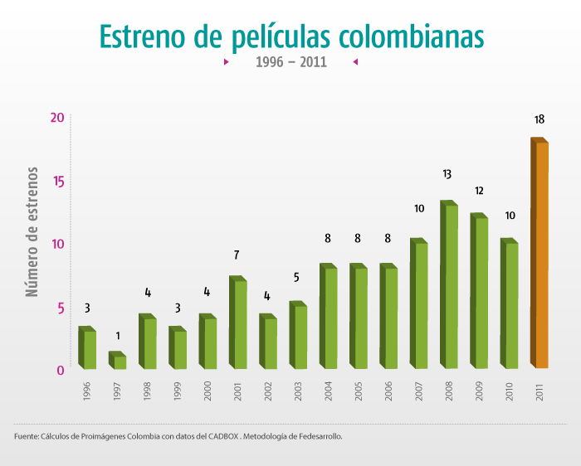
- Number of Colombian movies made by year
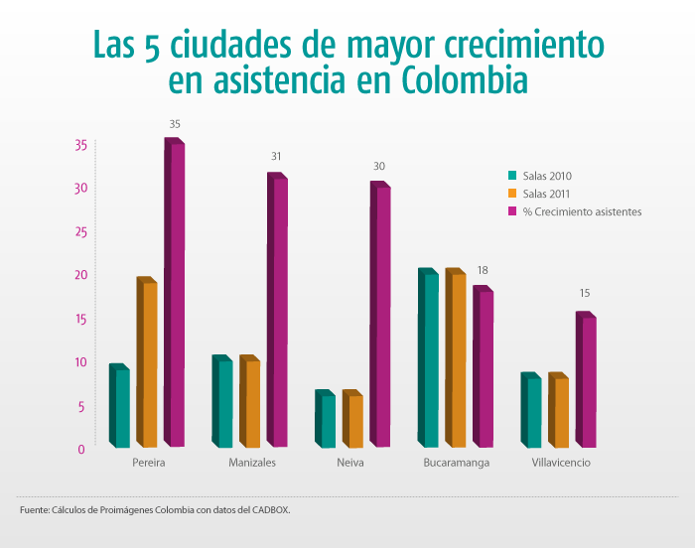
- Bar Chart of the five cities with the most abstinence in consuming national cinema
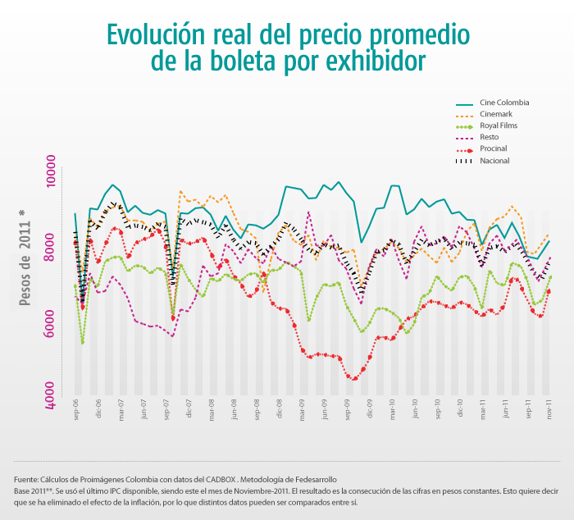
- Evolution of the price of tickets by year for different exhibitors.

We didn’t use any of these data visualizations in specific but they gave us ideas of what was worth comparing and analyzing.

Visualization Proposal

Use of multiple Idioms
We propose the use of multiple idioms in order to complete the tasks of exploring the data, comparing trends and identifying outliers. The main idiom is the parallel coordinates, in which the users can explore data with ease, compare the entries of their interest and identify outliers by applying filters. The other idioms used in the visualization should provide additional information based on the interaction in the parallel coordinates

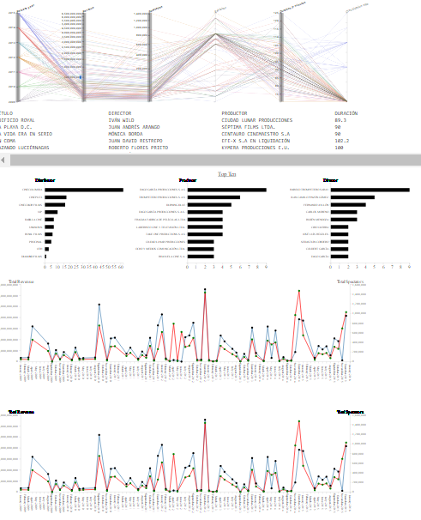

- The complete data visualization.

Main Idiom: Parallel Coordinates
Parallel Coordinates is an idiom used in analysis of multidimensional data, being especially useful for comparing the behavior of the different entries through all the dimensions. In our proposal, we matched movies by year of release differentiating them by color, in other words, the color doesn’t represent anything in special and it’s only used to differentiate lines.
We used 6 (six) dimensions, year of release, revenue in millions of Colombian pesos made by the movie, which exhibitors were confirmed to show the movie, the number of spectators, the duration of the movie in minutes and the age of the spectators at which the movie was aiming. The last one, age of audience, only appeared in the data from 2015 because the Ministry of Culture started taking it into account since that year.

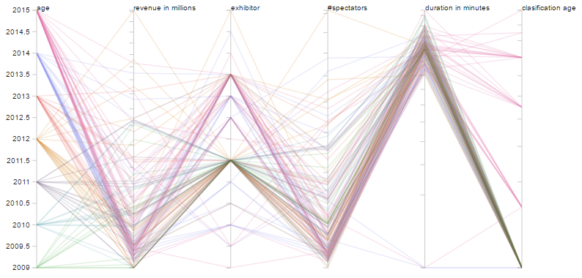

- Parallel Coordinates displaying all the data.
It is possible to filter the data by selecting a range in the different dimensions, allowing the users to explore the data and to make the comparisons they are most interested in. It is also possible to identify outliers by filtering.

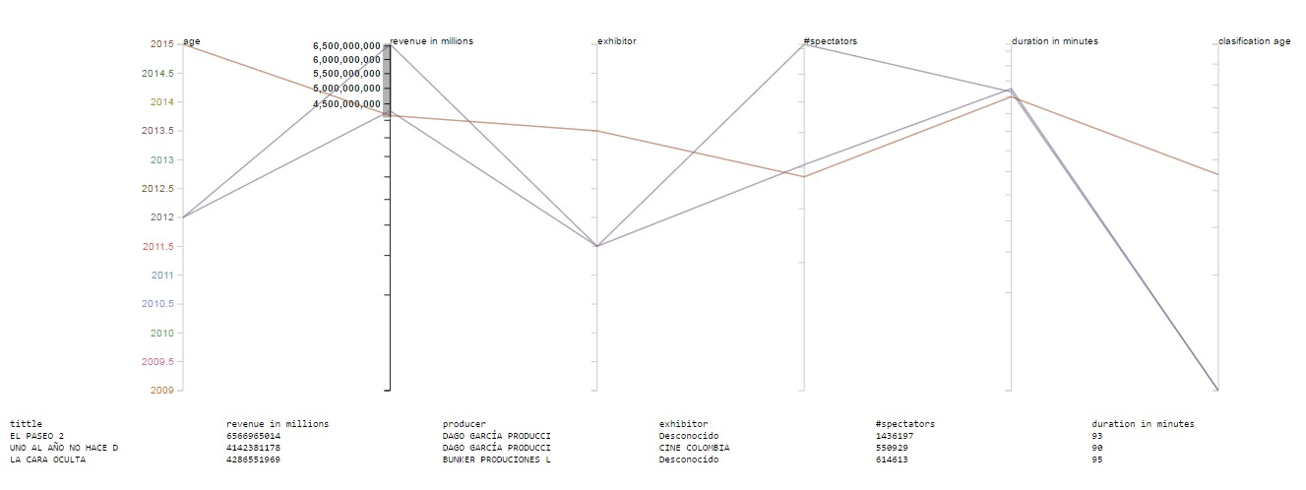
- Parallel Coordinates filtering in search of insights
If the user puts the mouse over one of the dimensions columns, more information regarding that specific dimension will appear, like the categories that compose it or the numerical values it can take.

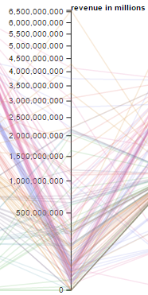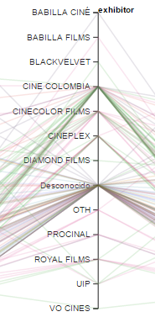

- Information that appears when the mouse is over a dimension column.

Support Idioms
The other idioms used in this visualization are a table with detailed information of each entry in display, a bar chart showing the number of movies a producer have produced that follows the filter, the top 10 directors, the number of movies directed that follows the filter and the number of movies that follow the filter being proven to be shown by a distributor. Lastly, a line chart of the behavior of the revenue per month through many years.
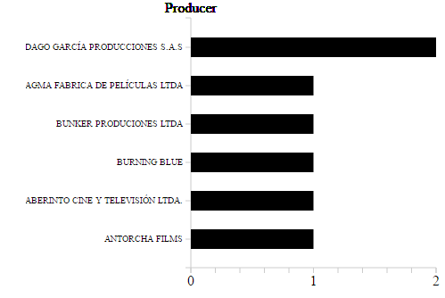
- The top ten producers, organized by number of movies produced that follow a filter.

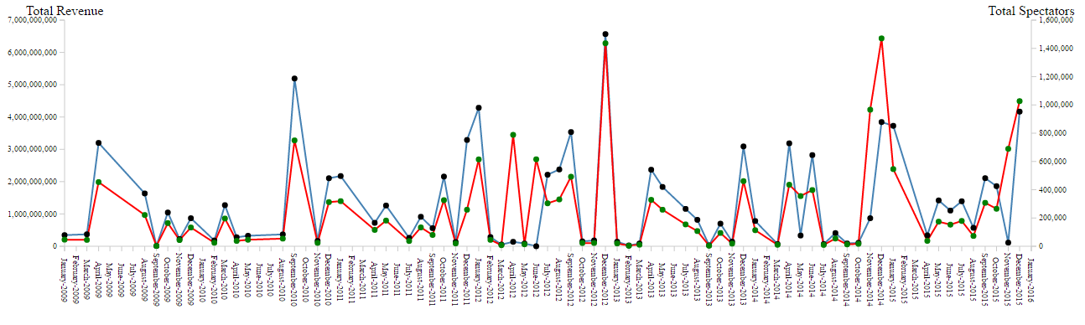
- Timeline of revenue that follows a filter
We decided to use three bar-charts because they have the most effective marks to express data to users. We chose these supplementary idioms because, even if the parallel coordinates show the information that we considered to be the most useful for the user to identify trends, this other information may be interesting in order to understand the data that follows the filters defined by the user. For example, if the user finds some outliers interesting, it may be useful to know if these share directors or if those directors have worked in other movies.

Results
We put the data we obtained from the Ministry of Culture in the visualization in order to analyze it. This information only goes back up to 2009.

Knowledge re-confirmed
First and foremost, we checked if the information that was already known in the industry as true also appeared as such in our visualization. Knowing this, we could see that most of the general concepts and conclusions that the Colombian cinema industry already has, are shared with the information shown in our work.
One of those concepts is that more than half the movies make less than 200.000 spectators. Another one, is that December is the month that represents the most earning for the industry. And finally, movies that are oriented for older audiences have a poor revenue.
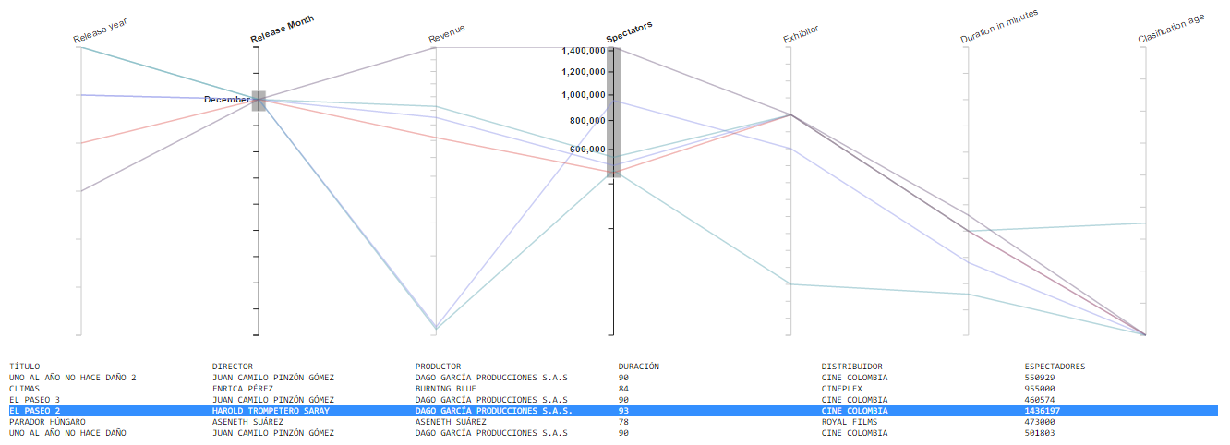
- Example of movies that were expected to be on the top

New Discoveries
We have also found some new information that seems to be useful, here is what we considered the most important ones.
We have found an outlier that hasn’t received a lot of fame, yet still managed to be the third movie to make the most revenue, as well as, being one of a small group of films with the most spectators.
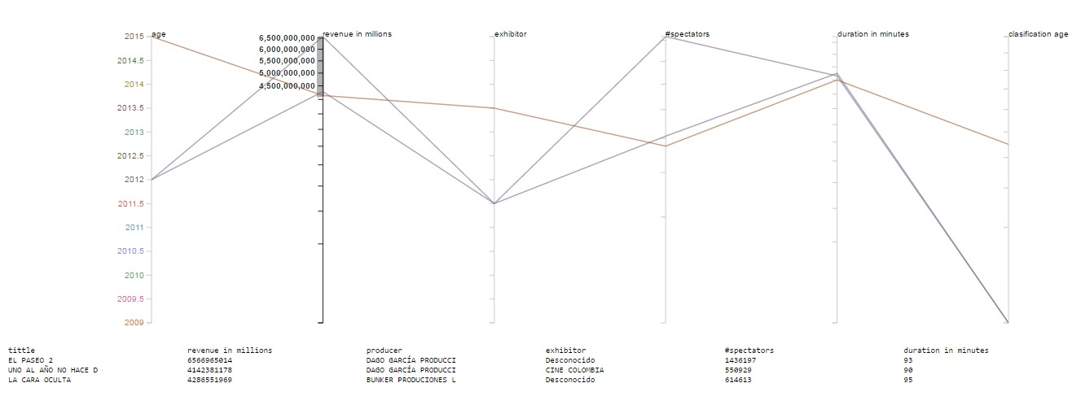
- A outlier

Also, we found that having a lot of spectators doesn’t imply that the movie is receiving a lot of revenue.
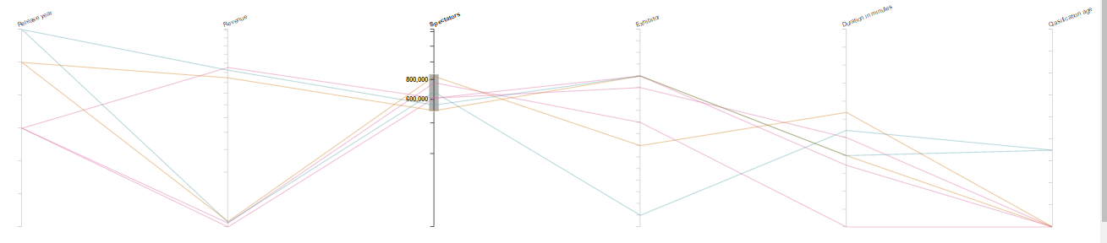

- Many spectators doesn’t mean a lot of revenue

Another interesting discovery was seeing how much the behavior of movies directed to kids between 6 and 8 years fluctuates, making any predictions for these movies an especially hard task.
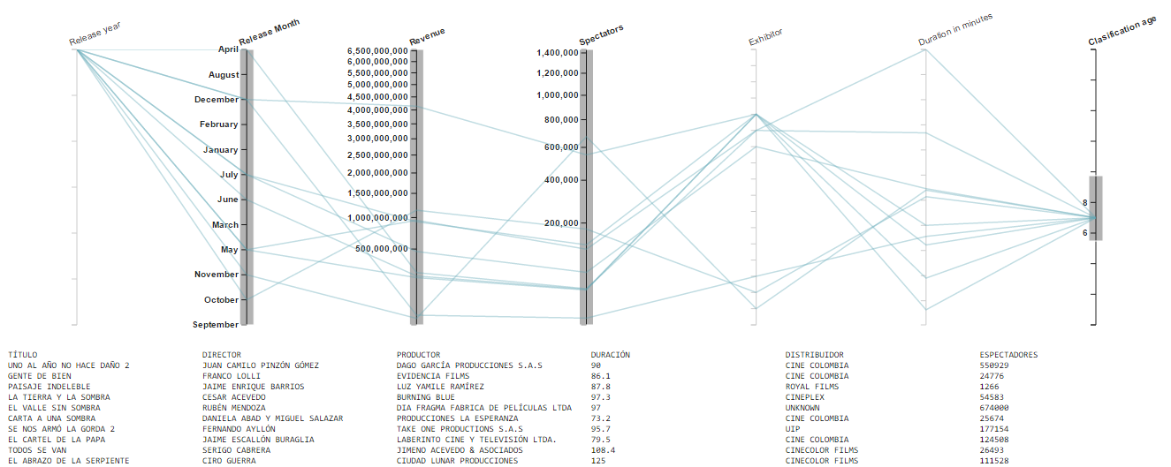

- Behaviour of movies for 6 to 8 year old kids
For this analysis we didn’t have much data because the classification of movies by age is something the Ministry of Culture has done only in the past year. Still, looking at this specific data, it seems to show an absence of any pattern, so it indicates that this is something to pay attention for future analyses.

Finally, we saw that most directors only direct one movie. This is especially worrisome because this is not limited to the great majority that didn´t do very well but also to the ones that have been successful.

COnclusions
First, as the data visualization shows results that have been investigated numerous times, and that are generally accepted as true, we are safe to say that it does represents the real state of the industry.
From the new discoveries we came to many conclusions, the first being that there are movies that don’t receive half the promotion the typically successful ones do but still manage to have a very similar behavior. It is still needed more information to define what they did to overcome the bad omens, but is reassuring that finding the outliers is an easy task.
Secondly, it seemed to us that it’s very important to understand how some movies might have many spectators but almost no incomes. There may be errors in the data when taken but if that isn’t the case then it’s important to know why this happened and so directors and producers won’t follow a path that will lead them to financial problems.
Also, we found it crucial to have in mind that kid films seem to be quite unpredictable, yet are a big part of the movies made in 2015. If film directors want to keep on making movies for the younger ones it’s important that they know the dangers it represents.
Finally, the fact that most film directors don’t make many movies is worrisome because a lot of experiences are being lost into oblivion just because the industry is not interested in keeping those who have made these very complex products. And the fact that even successful directors don’t keep working on is especially worrisome because that means that there is something that is keeping back those with big potential even after a big success, what is the source of this problem is a topic of great importance.

References
- J. Peltier, Composite Baseball Player Evaluation, http://peltiertech.com/composite-baseball-player-evaluation/, September 2009.
- Proimagenes Colombia , “http://proimagenescolombia.com/secciones/cine_colombiano/cine_en_cifras/cine_en_cifras_2/espanol/internas-html/informe-completo.html,” 2012.
- J. A. Guerra, “Visualizing Multivariate Data,” “http://johnguerra.co/lectures/visualAnalytics_fall2016/05_Multivariate_data/#/,” Visual Analitics, 2016.
- T. Munzner, “Visualization Analysis & Desing,” 2014.

[5] Ministerio of Culture, Cinematografy http://www.mincultura.gov.co/areas/cinematografia/publicaciones/Paginas/default.aspx,
[6] Idartes, “Instituto distrital de las artes”, http://www.idartes.gov.co/content/lista-de-distribuidoras-de-pel%C3%ADculas-en-colombia-0
[7] 64A Films, http://www.64afilms.com/
[8] Congress of Colombia, Law No. 1556, http://www.cancilleria.gov.co/sites/default/files/tramites_servicios/visas/archivos/ley_1556_de_2012.pdf, July 9, 2012
[9] Congress of Colombia, Law No. 814, http://www.alcaldiabogota.gov.co/sisjur/normas/Norma1.jsp?i=8796, July 2, 2003

